EXPLORING EMPLOYEE ENGAGEMENT PRACTICES IN INFORMATION TECHNOLOGY
Munagala Bala Naga Sai Seshu, Roll No. 22481E0033, Department of Business and Management Studies, Seshadri Rao Gudlavalleru Engineering College, Gudlavalleu-521356.
Abstract:
Employee engagement is a critical factor in the success of organizations, particularly in the IT industry where the demand for skilled professionals is high. This study explores various employee engagement practices implemented by IT companies to foster a motivated and productive workforce. Through a comprehensive review of existing literature and case studies, the research identifies key strategies such as effective communication, opportunities for professional development, recognition and rewards programs, and the creation of a positive organizational culture. The findings suggest that companies which invest in these areas experience higher employee satisfaction, reduced turnover rates, and enhanced overall performance. This paper aims to provide actionable insights for IT firms looking to improve their employee engagement initiatives and highlights the importance of continuous evaluation and adaptation of these practices to meet the evolving needs of the workforce.
Keywords:
Employee Engagement, Leadership, Organizational Culture, Communication, Workforce Development, Employee Satisfaction, Professional Growth.
Introduction:
Employee engagement is the level of commitment and involvement an employee has towards their organization and its values. An engaged employee is aware of the business context and works with colleagues to improve performance within the job for the benefit of the organization. The organization must work to develop and nurture engagement, which requires a two-way relationship between employer and employee.’ Thus, employee engagement is a barometer that determines the association of a person with the organization.
From a human resource perspective, employee engagement is not merely a matter of employee satisfaction but a strategic imperative for organizational success. HR practices play a pivotal role in cultivating a culture of engagement within the organization. Recruitment and selection processes that align with organizational values and goals can contribute to attracting individuals who are more likely to become engaged employees. Moreover, effective onboarding, training, and development programs can enhance employees' skills and confidence, fostering a sense of competence and autonomy in their roles.
Engaged employees are more likely to demonstrate higher levels of discretionary effort, creativity, and innovation, thereby contributing positively to organizational outcomes such as productivity, profitability, and customer satisfaction.
Importance of Engagement:
Engagement is important for managers to cultivate, given that disengagement or alienation is central to the problem of workers’ lack of commitment and motivation. Meaningless work is often associated with apathy and detachment from one's work. In such conditions, individuals are thought to be estranged from themselves. Other research using a different resource of engagement (involvement and enthusiasm) has linked it to such variables as employee turnover, customer satisfaction, loyalty, safety, and, to a lesser degree, productivity and profitability criteria.
An organization’s capacity to manage employee engagement is closely related to its ability to achieve high performance levels and superior business results. Some of the advantages of engaged employees are
- Engaged employees will stay with the company, be advocates of the company and its products and services and contribute to bottom-line business success.
- They will normally perform better and be more motivated.
- There is a significant link between employee engagement and profitability.
- They form an emotional connection with the company. This impacts their attitude towards the company’s clients and thereby improves customer satisfaction and service levels.
- It builds passion, commitment, and alignment with the organization’s strategies and goals.
- Increases employees’ trust in the organization
- Creates a sense of loyalty in a competitive environment.
- Provides a high-energy working environment
- Boosts business growth
- Makes the employees effective brand ambassadors for the company.
A highly engaged employee will consistently deliver beyond expectations. In the workplace, research on employee engagement has repeatedly asked employees ‘whether they have the opportunity to do what they do best every day'. While one in five employees strongly agrees with this statement, those work units scoring higher on this perception have substantially higher performance.
Thus, employee engagement is critical to any organization that seeks to retain valued employees. Watson Wyatt consulting companies have proven that there is an intrinsic link between employee engagement, customer loyalty, and profitability. As organizations globalize and become more dependent on technology in a virtual working environment, there is a greater need to connect and engage with employees to provide them with an organizational ‘identity.’
Objectives of Study:
1. To Study the perception of employees about the activities that has been conducting within the organisation.
2. To examine the level of satisfaction of employees towards the Employee Engagement Activities provided by the IT Industry.
3. To identify whether Recognitions and Rewards have an impact on Employee Engagement.
4. To suggest improvements regarding various Engagement activities taken by IT Industry, to gain a better environment for employees.
Literature Review:
Employee engagement has emerged as a crucial determinant of organizational success, particularly in the IT industry, where innovation and productivity are paramount. The concept encompasses the emotional and intellectual commitment employees have towards their organization, influencing their willingness to contribute to organizational goals.
Historical Development
The historical development of employee engagement theories includes several key models. Maslach and Leiter (1997) contrasted engagement with burnout, suggesting that engagement is characterized by energy, involvement, and efficacy, whereas burnout is characterized by exhaustion, cynicism, and inefficacy. The Job Demands-Resources (JD-R) Model (Bakker & Demerouti, 2007) posits that job resources (e.g., autonomy, social support) and personal resources (e.g., self-efficacy) foster engagement, while job demands (e.g., workload, role conflict) deplete it.
Theoretical Frameworks and Definitions
Kahn (1990) introduced the concept of personal engagement and disengagement, where employees express themselves physically, cognitively, and emotionally during role performances. Later, Schaufeli et al. (2002) defined employee engagement as a positive, fulfilling, work-related state of mind characterized by Vigor, dedication, and absorption. These foundational theories have paved the way for understanding how engagement affects organizational outcomes.
The importance of employee engagement in IT
The IT industry, characterized by rapid technological advancements and high competition for talent, places a premium on employee engagement. Engaged employees are more likely to exhibit innovative behaviours, drive customer satisfaction, and contribute to the company’s competitive advantage (Saks, 2006). Additionally, engagement is linked to lower turnover rates, which is critical in an industry plagued by skill shortages and high attrition rates.

Key drivers of employee engagement:
Effective Communication: Research by Bakker and Demerouti (2008) highlights the importance of transparent and open communication in fostering engagement. In the IT sector, where project success often hinges on collaborative efforts, regular and clear communication helps align individual and organizational goals.
Professional Development: Opportunities for growth and learning are pivotal in the IT industry. Studies (e.g., by Tims, Bakker, & Derks, 2013) show that career development programs, continuous training, and skill enhancement initiatives significantly boost engagement levels by making employees feel valued and invested in.
Recognition and Rewards: Recognition programs, whether through formal rewards or informal acknowledgments, play a crucial role in maintaining high engagement levels. According to Deci and Ryan's (2000) Self-Determination Theory, intrinsic motivation, which is fostered through recognition, enhances engagement more effectively than extrinsic rewards alone.
Organizational Culture: A positive and inclusive organizational culture is essential for employee engagement. Research by Schein (2010) indicates that a culture promoting diversity, inclusion, and work-life balance not only attracts top talent but also retains it by ensuring employees feel a sense of belonging and purpose.
Challenges in the IT Industry
Despite the recognized benefits of employee engagement, the IT industry faces unique challenges. The fast-paced nature of the industry often leads to high stress and burnout, which can negatively impact engagement levels (Maslach, Schaufeli, & Leiter, 2001). Moreover, the prevalence of remote work and virtual teams requires innovative approaches to maintain engagement without physical presence.
Case Studies and Best Practices
Numerous case studies provide insights into successful employee engagement practices. For example, Google’s emphasis on innovation and employee autonomy is a model for fostering engagement through trust and empowerment. Similarly, Microsoft’s comprehensive employee development programs underscore the importance of continuous learning in keeping employees engaged.
How to measure Employee Engagement?
Gallup research consistently confirms that engaged workplaces, compared with those that are least engaged, are much more likely to have lower employee turnover, higher than average customer loyalty, and above-average productivity and earnings. These are all good things that prove that engaging and involving employees makes good business sense and builds shareholder value. Negative workplace relationships may be a big part of why so many employees are not engaged with their jobs.
Step I: Listen
The employer must listen to his employees and remember that this is a continuous process. The information the employee's supply will provide direction. This is the only way to identify their specific concerns. When leaders listen, employees respond by becoming more engaged. This results in increased productivity and employee retention. Engaged employees are much more likely to be satisfied in their positions, remain with the company, be promoted, and strive for higher levels of performance.
Step II: Measure the current level of employee engagement.
Employee engagement needs to be measured at regular intervals to track its contribution to the success of the organization. But measuring engagement without planning how to handle the result can lead employees to disengage. It is therefore not enough to feel the pulse—the action plan is just as essential.
Employee engagement determines the current level of employee engagement. A well-administered satisfaction survey will let us know at what level of engagement the employees are operating. A customizable employee will provide a starting point for efforts to optimize employee engagement.
key to successful employee satisfaction surveys is to pay close attention to the feedback from the staff. It is important that employee engagement is not viewed as a one-time action. Employee engagement should be a continuous process of measuring, analysing, defining, and implementing.
Know what is expected of me at work. Employees should know exactly what is expected of them. If expectations are unclear, employees will inevitably face frustration and will be open to other opportunities where they do know what's expected of them and where their contributions are measured and recognized.
Materials and equipment: Employees need the right tools and equipment to support their skills, experience, and talents and perform their jobs at an optimum level. Supervisor/Someone at Work Cares: Managers must spend most of their time with their most productive talent. Many managers give their greatest degree of attention to employees who are falling behind. Talented, productive people crave time and attention from their managers and will leave your company if they have a weak relationship (or no relationship) with their manager or supervisor.
Co-workers committed to quality: many companies arbitrarily put teams together without considering that employees only psychologically commit to teams if they perceive their team members will support their high level of commitment and performance. Talented employees set high standards and depend on those around them to support their growth toward excellence.
opportunities to learn and grow: The company should create an environment that encourages employees to drive towards innovation or to create better systems for more productive results. Great managers always ask what skills and knowledge are needed to accompany talent to result in the greatest outcome for each.
Step II: Identify the problem areas.
Identify the problem areas to see which are the exact areas that lead to disengaged employees.
Step IV: Taking action to improve employee engagement by acting upon the problem areas
Nothing is more discouraging to employees than to be asked for their feedback and see no movement toward resolution of their issues. Even the smallest actions taken to address concerns will let the staff know how valued their input is. Feeling valued will boost morale, motivate, and encourage future input. Taking action starts with listening to employee feedback, and a definitive action plan will need to be put in place.
Research Methodology:
Methodology is the systematic, theoretical analysis of the methods applied to a field of study, or the theoretical analysis of the body of methods and principles associated with a branch of knowledge. The purpose of the research methodology is to describe the research procedure. This includes the overall sampling design, like the sampling procedure, the data collection method, and the analysis procedure.
Sampling Design:
A research design is the arrangement of conditions for the research purpose with an economy in mind. Once the problem is identified, the next step is the basic framework, which provides guidelines for the rest of the research process.
Sample Size:
The type of sampling technique is probability sampling; according to the study, simple random sampling was chosen. The sample size taken for this study is 100 employees from various companies in the IT industry in Visakhapatnam.
Data collection:
The data is mainly collected through primary and secondary data.

Primary data:
The research is carried out with the collection of primary data that was collected fresh and for the first time and thus happen to be original in character. The source of primary data is collected through the distribution of questionnaires to the employees of the IT industry.
Secondary data:
The secondary data was collected from the company's web sites, journals, the company's annual reports, etc. Secondary data has been collected from both internal and external sources. Internal sources include information from the company, old records, product profiles, etc.
The external data has been collected from various books, journals, and books from cellular web sites, etc.

Limitations:
1. The minimum sample size which cannot be applicable to the whole population.
2. Employees are not clearly understood the objectives of employee engagement activities.
3.Some internal factors may affect the survey results because the employees are busy in their working hours.
4.The result of the study is confined only to the IT industry and cannot be generalised.

Data Analysis:
1. Are you clearly aware of Employee Engagement Activities in organisation?

S. No | Variables | % of Respondents
1 | Yes | 89%
2 | No | 11%
 | TOTAL | 100%

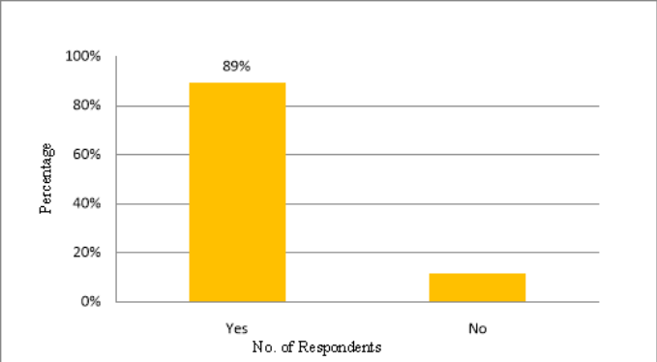

Interpretation:
From the above table it is interpreted that,89% of IT employees were aware of their Employee Engagement Activities in the organization and 11% were not so clear of all the activities being conducted.

2. Do you feel rewards(or)recognition given in Employee Engagement Activity is fair?

S. No | Variables | % of Respondents
1 | Strongly Agree | 30%
2 | Agree | 20%
3 | Neither Agree nor Disagree | 30%
4 | Disagree | 20%
5 | Strongly Disagree | 0%
 | TOTAL | 100%

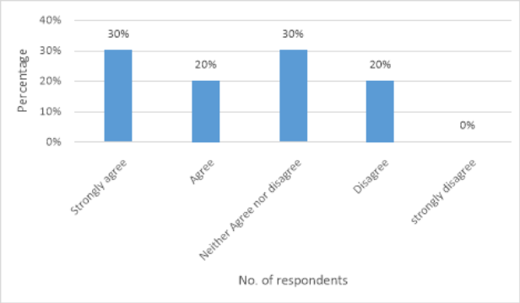

Interpretation:
From the above table, it is interpreted that 30% of employees strongly feel that there are fair practices for rewards and recognition in the organization, 20% agreed with the practices that were done in the company, 30% were neither agreeing nor disagreeing, and 20% disagreed.

3. Which Employee Engagement Activities help in your Career Enhancement?
(please put a tick mark wherever it is applicable)
S.no | Variables | % of Respondents
1. | Think Tank Meeting | 40%
2. | Knowledge Sharing Session | 25%
3. | Employee Connect | 15%
4. | ICON Awards | 20%
 | TOTAL | 100%

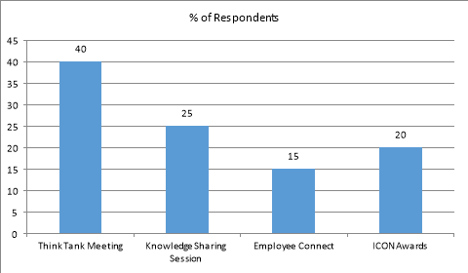

Interpretation:
From the provided table, it is interpreted that 40% of employees are advancing their careers through Think Tank Meetings. Additionally, 25% are enhancing their careers by attending Knowledge Sharing Sessions, while 20% believe that receiving ICON awards contributes to their career development.
Most of the employees feel that Think Tank Meetings helps them to interact with their superiors to gain knowledge and skills for their job roles where others think that ICON awards help them to shape themselves and get motivated.

- Do you feel that your jobs are challenging and exciting?

S. No | Variables | % of Respondents
1 | Sometimes | 46%
2 | Always | 42%
3 | Not at All | 22%
 | TOTAL | 100%

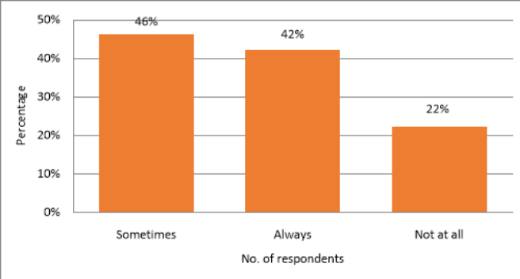

Interpretation:
From the above table, it can be interpreted that 46% of respondents feel that their job roles are exciting and challenging, 42% feel their job is always challenging, and 22% feel their job roles lack these qualities.

5. Is the Knowledge Sharing Sessions being helpful for you to improve your skills?

S. No | Variables | % of Respondents
1 | Sometimes | 57%
2 | Always | 35%
3 | Not at all | 8%
 | TOTAL | 100%

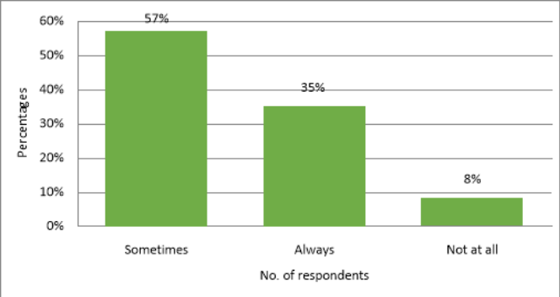

Interpretation:
From the above table, it can be interpreted that 46% of respondents feel that their job roles are exciting and challenging, 42% feel their job is always challenging, and 22% feel their job roles lack these qualities.

- Are you satisfied with the Employee Engagement Activities provided in IT Industry?

S. No | Variables | % of Respondents
1 | Highly Satisfied | 26%
2 | Satisfied | 61%
3 | Dissatisfied | 13 %
 | TOTAL | 100%

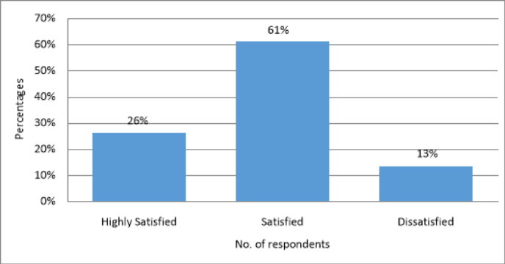

Interpretation:
From the given table, it is interpreted that 61% of employees were satisfied with the employee engagement activities, 26% were highly satisfied, and 13% were dissatisfied.
As 87% of employees were satisfied with the various activities provided by the company, the remaining 13% were shop floor employees, as they were not provided with many employee engagement activities compared to those of plant-level employees.

Findings:
The collected data was carefully analyzed, and the following findings were drawn:
- From the study, it is identified that 89% of the employees are aware of all the employee engagement activities and have been participating in the various employee engagement activities conducted in the organization.

- 80% of the employees find employee engagement helps them attain reward and recognition. 95% of the employees agree that their participation is appreciated.

- 66% of the employees find that they have opportunities at work to learn and grow. 95% of the employees feel that their new ideas and initiatives help the organization improve its products and services.

- 92% of the respondents accept that knowledge-sharing sessions help them improve their skills. It is also inferred that the quality of the topics covered reflects a high level of satisfaction among the employees at the organization.

- According to the study, 90% of the employees who are aware of the employee engagement activities are satisfied with the activities conducted by the company, which helps them to increase their productivity, reduce stress, and also helps in their career enhancement.

Suggestions:
- Individual attention may be provided to the employees to encourage their participation and make them perform better at their job and shop floor employees must be focused well under the employee engagement activities.

- Employee’s feedback should be regularly obtained to understand the effectiveness of the employee engagement activities. In this study, 13% of the employees are not satisfied with the employee engagement activities. It is important to understand why these employees are not satisfied with the employee engagement activities and what can be done to satisfy these employees.
- Actively disengaged employees find that their job boring and monotonous. Encourage them to take part in extracurricular activities like self- management workshop, spark at work, etc., the management must concentrate not only on the engaged employees but also on the disengaged employees by giving them a chance to prove themselves.

Conclusion:
Employee engagement has emerged as a pivotal factor in the success and sustainability of organizations, particularly in the fast-paced and innovation-driven IT industry. This extensive literature review has revealed the multifaceted nature of employee engagement, underscoring its critical importance in driving organizational performance, enhancing productivity, fostering innovation, and ensuring talent retention. The synthesis of various theoretical frameworks, empirical studies, and case analyses has provided a comprehensive understanding of the key drivers, challenges, and best practices associated with employee engagement in the IT sector.
Employee retention continues to remain a top priority at many organizations and is one that companies increasingly view as a driver of business strategy. Business-critical knowledge can walk out the door when an employee leaves the company. While employee retention figures have long been used by companies as a measure of their performance in developing an effective organization, this view of employee retention is not only outdated, but these figures may not be comprehensive enough to truly determine the organization's effectiveness.
The business strategy of employee retention lies with employee engagement; retention is an outcome of engagement. What most organizations fail to realize is that employee engagement is the biggest retention factor they have control over. Engaged employees not only stay longer with the organization, but they are also more productive, more conscientious, make fewer errors, and take better care of customers. The business strategy for employee retention must incorporate methods that achieve a high level of employee engagement among the organization's top performers, not necessarily the entire work force.
Employee engagement is a vital determinant of organizational success, particularly in the IT industry, where innovation, productivity, and talent retention are paramount. The reviewed literature highlights the multifaceted nature of employee engagement, emphasizing its impact on both individual and organizational performance. Effective engagement practices not only enhance employee satisfaction and motivation but also drive organizational outcomes such as increased productivity, innovation, and lower turnover rates.

References:
- Leelavati, T. S., Madhavi, S., Kamal, G., Raju, P. V. M., Susmitha, K., Vinod, M., & Aminabee, S. (2023). Revolutionizing Healthcare Delivery: Telemedicine's Influence on Access and Patient Satisfaction. International Journal of Chemical and Biochemical Sciences, 24(5), 106-115.
- V., Kumari, Y. N., Kumar, T. H., Lakshmi, B. P., Manikanta, K. C., Kusumadhar, P., & Charan, G. S. (2022). A Study on Effectiveness of Training and Development in the Soft Drink Industry. NeuroQuantology, 20(10), 1641.
- Vinod, M., & Kamal, G. Employee Welfare Measures Towards Productivity-A Study of Selected Jute Units in West Godavari District, Andhra Pradesh.
- Mutyala, Vinod & Tummalapalli, Hemanth. (2018). Challenges of Recruitment and Selection in Indian Healthcare Industry. 4. 232-234. 10.18231/2454-9150.2018.0615.
- Kumar, H., & Mutyala, V. (2021). HR ANALYTICS AND METRICS. ROLE OF HUMAN RESOURCE AND CUSTOMER RELATIONSHIP MANAGEMENT IN THE CURRENT SCENARIO, 187.
- Kumar, H., Rao, N. A., Kamal, G., Vinod, M., Leelavathi, T. S., Sripathi, M., & Kumari, N. Y. (2023). The role of organizational citizenship behaviour as an intervening variable in the relationship between employee engagement and gig workers’ productivity in India. Организационная психология, 13(4), 183-198.
- Leelavati, T. S., Madhavi, S., Kamal, G., Raju, P. V. M., Susmitha, K., Vinod, M., & Aminabee, S. (2023). Revolutionizing Healthcare Delivery: Telemedicine's Influence on Access and Patient Satisfaction. International Journal of Chemical and Biochemical Sciences, 24(5), 106-115.

- Kamal, G., Vinod, M., Kumar, J. S., & Thanveer, A. (2024). The Silent Epidemic: Understanding and Addressing Child Sexual Abuse in India. In Child Sexual Abuse: A Public Health Problem in India (pp. 125-134). Singapore: Springer Nature Singapore.
- Bass, B. M., & Avolio, B. J. (1994). Improving organizational effectiveness through transformational leadership. Sage Publications.
- Harter, J. K., Schmidt, F. L., & Hayes, T. L. (2002). Business-unit-level relationship between employee satisfaction, employee engagement, and business outcomes: A meta-analysis. Journal of Applied Psychology, 87(2), 268.
- Kahn, W. A. (1990). Psychological conditions of personal engagement and disengagement at work. Academy of Management Journal, 33(4), 692-724.
- Markos, S., & Sridevi, M. S. (2010). Employee engagement: The key to improving performance. International Journal of Business and Management, 5(12), 89-96.
- Maslach, C., & Leiter, M. P. (2008). Early predictors of job burnout and engagement. Journal of Applied Psychology, 93(3), 498.
- Men, L. R. (2014). Strategic internal communication: Transformational leadership, communication channels, and employee satisfaction. Management Communication Quarterly, 28(2), 264-284.
- Schaufeli, W. B., Salanova, M., González-Romá, V., & Bakker, A. B. (2002). The measurement of engagement and burnout: A two-sample confirmatory factor analytic approach. Journal of Happiness Studies, 3(1), 71-92.
- Schein, E. H. (2010). Organizational culture and leadership (4th ed.). Jossey-Bass.
- Anon, 2010. Seaworks boss makes his point with a chainsaw. Human Resource Management International Digest,18(1), pp, 8,
- Bryman, A, and Bell, E., 2007, Business Research Methods, 2nd edition. Oxford University Press, Oxford.
- Casison, J., 2008. One Size Does Not Fit All. Incentive, 182(6), pp. 44.
- Evans, D, 2010. An engaging performance, Training Journal, pp. 40.
- Frauenheim, E., 2009. Commitment Issues. Workforce Management, 88 (12), pp. 20.
- Gallup, Inc, http://www.gallup.com/consulting/126806/Q12-Meta-Analysis.aspx
- http://bw.businessworld.in/PDF_upload/hrspecial_survey.pdf
- http://www.scribd.com/doc/3071101/Employee-Engagement-Impact-on-Business-outcomes
- http://forewordcommunications.wordpress.com/2016/06/03/what-is-employee-engagement/
- http://ebn.benefitnews.com/asset/article/524821/staying-current/understanding-employee-engagement-through-globai-lens.html
- http://week.manoramaonline.com/cgibin/MMOnline.dll/portal/ep/theWeekContent.do?contentType=EDITORIALandsectionName=COVER%20STORYandprogramId=1073755753andBV_ID=@@@andcontentId=2504208
- http://www.bayt.com/job/career-article-1681.adp

