A TWO CLASS CLASSIFICATION OF SKIN CANCER IMAGES USING SVM CLASSIFIER
Suryanshu ¹, Amit Ranjan²
¹M.Tech Student, Department of Computer Science Engineering, BRCM College of Engineering & Technology
² Assistant Professor, Department of Computer Science Engineering, BRCM College of Engineering & Technology

ABSTRACT
Skin cancer is one of the most prevalent types of cancer worldwide. Early and accurate detection is crucial for effective treatment and improved patient outcomes. Classification techniques have shown great potential in assisting dermatologists in the screening of images. This paper presents a two-class classification approach for skin cancer image detection using Cubic Support Vector Machine (SVM). SVMs are powerful supervised learning models that have been widely employed in various classification tasks, including medical image analysis. The proposed approach utilizes a set of carefully engineered features extracted from skin cancer images from MedNode dataset to capture relevant diagnostic information for distinguishing between Melanoma and naevus skin cancers. The texture features like Difference theoretic texture features (DTTF), First Order Statistics (FOS), Fractal Texture (FT), Grey Level Difference Statistics (GLDS), Statistical Feature Matrix (SFM), Local Binary Patterns (LBP), Segmentation Based Fractal Texture Analysis (SFTA) and Tamura features are calculated to creature a feature set for classification using cubic SVM. The evaluation of the proposed methodology is performed using accuracy, sensitivity, specificity, F1 Score and precision. The results obtained for performance parameters outperformed the state of the art methods.
Keywords: Skin cancer, Two class classification, Texture features, SVM.
- INTRODUCTION
Skin cancer is a major public health concern, with melanoma being the most dangerous and deadly form. According to the American Cancer Society, approximately 1 in 5 Americans will develop skin cancer by the age of 70 [1]. Early detection and accurate diagnosis are crucial for effective treatment and improved patient outcomes. However, the visual inspection and diagnosis of skin lesions can be challenging, even for experienced dermatologists, due to the subtle variations in the appearance of different cancers.
Proper screening of the skin cancer images have emerged as a great tool for assisting dermatologists in the analysis and classification of skin cancer images. These systems leverage advanced image processing and machine learning techniques to extract relevant diagnostic features from images and classify lesions as melanoma and naevus [2]. Among various machine learning models, support vector machines (SVMs) have gained significant attention in the field of medical image analysis due to their ability to handle high-dimensional data, their robustness to overfitting, and their flexibility in incorporating different kernel functions [3]. SVMs have been successfully applied to various medical imaging tasks, including lesion classification, tumor segmentation, and disease prediction [4],[5],[6]. In the context of skin cancer classification, several studies have explored the use of SVMs for classifying skin cancer images as melanoma and naevus [7], [8]. However, these studies often rely on a limited set of hand-crafted features or focus on specific lesion types or imaging modalities. Moreover, the selection of appropriate features and the choice of kernel functions can significantly impact the classification performance of SVMs.
This paper presents a comprehensive two-class classification approach for skin cancer classification using SVMs. The proposed methodology involves a systematic evaluation of various feature extraction techniques, to capture relevant diagnostic information from images. Furthermore, we employ mrmr technique for identifying discriminative subset of features for classification.
- LITERATURE REVIEW

Enhancement is a crucial preprocessing step in analysis of skin cancer from images. The classification of skin cancer as melanoma and naevus is a critical task in the early detection and classification of skin cancer, particularly melanoma, which is the deadliest form of skin cancer.. Among various machine learning models, support vector machines (SVMs) have gained significant attention in the field of medical image analysis due to their ability to handle high-dimensional data, robustness to overfitting, and flexibility in incorporating different kernel functions. Early work on SVM-based skin lesion classification dates back to the early 2000s. Rubegni et al. [9] developed an SVM-based system for the classification of melanocytic lesions using features extracted from dermoscopic images. They evaluated different kernel functions, including linear, polynomial, and radial basis function (RBF) kernels, and reported promising results with an accuracy of up to 86%. Ganster et al. [10] proposed an SVM-based approach for the classification of melanoma and nevus, utilizing a combination of color, texture, and shape features. Their study highlighted the importance of feature selection and demonstrated the effectiveness of the SVM classifier in this binary classification task.
As research in this field progressed, researchers explored more advanced feature extraction techniques to improve classification performance. Barata et al. [11] developed an SVM-based system that incorporated features derived from color constancy algorithms and texture descriptors, achieving an accuracy of 92% in distinguishing melanoma from nevus lesions. Viknesh et al. [2] proposed classification approach, where an SVM was used to classify lesions as melanocytic or non-melanocytic, followed by automatic classification. Their work demonstrated the potential of using a hierarchical classification strategy to improve overall performance.
In recent years, the integration of handcrafted features with deep learning-based feature representation has gained traction in the field of skin lesion classification. Bi et al. [12] proposed a hybrid approach that combined traditional texture and shape features with deep convolutional features extracted from a pre-trained network. These features were then fed into an SVM classifier, achieving state-of-the-art performance on several public datasets. Similarly, Mahbod et al. [13] developed a framework that fused handcrafted color and texture features with deep features from a convolutional neural network (CNN), utilizing an SVM for the final classification task.
While the majority of studies have focused on the binary classification of benign and malignant lesions. Despite the numerous studies on SVM-based skin lesion classification, several challenges and research gaps remain. One key challenge is the selection of the most discriminative feature subset, as the inclusion of irrelevant or redundant features can degrade classification performance. Various feature selection techniques have been explored.
Furthermore, the interpretability of SVM-based classifiers is an important consideration in the context of medical applications. While deep learning models have shown superior performance in many image classification tasks, they often lack interpretability, which can hinder their adoption in clinical settings. SVMs, on the other hand, offer the potential for interpretability through the analysis of support vectors and feature weights. However, further research is needed to develop effective techniques for interpreting SVM-based skin cancer classifiers and enhancing their transparency for clinical decision support. In summary, the literature review highlights the extensive research efforts in developing SVM-based classifiers for skin cancer detection, particularly for the two-class classification of melanoma and naevus images

- PROPOSED METHODOLOGY

In the proposed methodology, Melanoma skin cancer images from MedNode dataset is taken, and experimentation work related to classification of images based on features is carried out using Matlab 2021a software. The MedNode dataset is one of the large publicly available dataset of skin cancer images collected by the MedNode research group. The figure1 demonstrates the steps for the classification of skin cancer images. The various steps involved are explained as below.
3.1 RGB channel splitting
In the first step a color skin cancer image is considered and resized into 512 x 512 pixels. RGB image is split into individual channels red, green. The outcomes from operations on each component is better as compared to combined RGB.
3.2 Median filtering
The median filter of 3×3 size is applied to eliminate noise within each component. Unwanted noise in each component will be removed to obtain an enhanced image. The presence of noise may produce unwanted artifacts that must be removed in initial steps in order to obtain best features .

3.3 RGB color model LAB color model conversion
The new RGB of the skin cancer image is obtained using new red, green, and blue components acquired after applying median filtering. RGB color model is then converted into LAB color model for further processing. The LAB color model is quite efficient to simulate with human perception and vision.

3.1.4 CLAHE on ‘L’ component of LAB color model
In LAB, "L" component represents the lightness component. It may be used to represent grayscale images while maintaining the brightness information. The CLAHE is applied on L component that successfully increases the local contrast without causing any undesirable color distortions or artifacts. It ensures that the skin cancer image have maintained the original color features.
3.1.5 LAB color model RGB color model conversion
For creating the LAB color model of the skin cancer image, the updated "L" and "AB" components are merged again. The LAB color model is then converted back to original RGB channel. This updated RGB color model denotes the updated skin cancer image which will provide more enhanced features than of the original image.

L
A
B
RGB Skin Image
R
G
B
Median filter
Median filter
Median filter
RGB’
RGB to LAB model Conversion
CLAHE
RGB’’
Intensity Adjustment
R”
G”
B”
Log Ratio Difference
Enhanced RGB Skin Image
LAB to RGB model Conversion
RGB image resized
Y component (YIQ model)
Features extraction

SFM
LBP
SFTA
Tamura
DTTFS
FOS
FT
GLDS

Data Balancing
Data Normalization
Melanoma
Naevus
Feature selection
SVM classifier
Feature selection and extraction

Classification
Enhanced RGB Skin Image

Figure1. Proposed methodology for classification of skin cancer images.

3.1.6 Intensity Adjustment
The updated RGB image is used further while adjusting its intensity. During the adjustment the intensity of the RGB color model, the scaling of the values of each three color components is performed by using a fixed amount of factor so as to adjust the overall brightness of the skin cancer image.
3.1.7 Log Ratio Difference on Green channel
The green channel is taken from updated RGB image and is applied with the log ratio difference technique. Subtle changes in the green channel can be seen after its application that can be hard to see in the original RGB image. It is helpful in identifying and examining small-scale features, patterns or traits associated with the properties of the image.
3.1.8 Enhanced skin cancer image
The enhanced RGB image is obtained in the end while combining green channel image updated earlier with rest of the components. The final skin cancer image provides desirable features for evaluating the presence of skin cancer.
3.1.9 Y component (YIQ model)
The YIQ color model have into three components: luminous (Y) and two color components (I and Q). The brightness and color information helps in mitigating the impact of changing illumination conditions. This helps in observing robust features for extraction and classification. Using the Y component of YIQ model color model, image analysis algorithms can better represents the relevant diagnostic information about the type of skin cancer present.
3.1.10 Features Extracted
The selection and extraction of discriminative features, such as texture features using classification techniques provides the information regarding the intricate patterns. By combining various features the classification models leads to improved accuracy and robustness. The process of extracting relevant features from skin cancer images create a reliable and accurate classification systems for skin cancer images. The different type of features used are mentioned as below:
3.1.10.1 Difference theoretic texture features (DTTF)
Difference theoretic texture features are based on the difference between pairs of pixel values in an image, than the actual pixel values themselves. The spatial relationships between pixels in a texture region is captured by analyzing the differences in their grey levels. These features are used in classification performance for getting improved accuracy for skin cancer image classification and [14].
3.1.10.2 First Order Statistics (FOS) texture features
First Order Statistics (FOS) texture features are fundamental metrics calculated for skin cancer image. FOS features focus on individual pixel value property. FOS features include mean, variance, skewness, kurtosis, and entropy. The mean gives the average intensity, variance denotes the dispersion of intensity values, skewness describes the asymmetry, kurtosis indicates the peakedness, and entropy measures the randomness. These features are essential for quantify skin cancer characteristics [15].
3.1.10.3 Fractal Texture (FT) features
Fractal Texture (FT) features are a set of features that provides the complexity and self-similarity of textures of an image. The fractal dimension provides a numerical value that indicates how completely a fractal appears. Higher fractal dimensions denotes more complex and detailed textures. FT features consists of fractal dimension, lacunarity, and the Hurst exponent. The fractal dimension gives a measure of the roughness of the texture, while lacunarity describes inhomogeneity [16]. The Hurst exponent describes the long-range dependencies and self-similarity in the texture.
3.1.10.4 Grey Level Difference Statistics (GLDS)
Grey Level Difference Statistics (GLDS) denotes texture features from the grey-level differences between neighboring pixels of an image. These features provides a measure of the spatial variation and homogeneity. The GLDS features are calculated using the absolute differences between pairs of pixel values separated by a fixed displacement vector. These differences are then quantized into a fixed number of bins, and statistics are computed based on the resulting histogram. GLDS is particularly effective in highlighting fine texture details and capturing subtle differences in image patterns, making it useful in fields such as skin cancer image classification and detection [17].

3.1.10.5 Statistical Feature Matrix (SFM)
The Statistical Feature Matrix (SFM) is a matrix that represents various statistical measures computed over local neighborhoods or specific regions of the image. These measures typically include mean, variance, skewness, kurtosis, and other higher-order statistics that describe the distribution and relationships of pixel intensities. By encapsulating these statistics in a matrix form, SFM provides a comprehensive representation of the texture, enabling the analysis of patterns and structures at multiple scales and orientations. This approach is particularly useful in fields such as skin cancer image classification. The richness of the statistical information captured by SFM makes it a versatile and robust method for texture characterization [18]. There are four features calculated for proposed methodology under SFM features that are coarseness, contrast, periodicity, and roughness.
3.1.10.7 Local Binary Patterns (LBP)
Local Binary Patterns (LBP) are generated by comparing each pixel of an image along with its neighboring pixels, providing result as a binary. This binary pattern is converted to a decimal value. LBP features provide robust texture information invariant to illumination and rotation change. This makes it essential for classification. The LBP codes creates a comprehensive representation of the texture, used as a source in machine learning models for performing accurate and reliable classification [3]. In the proposed methodology, 59 LBP features are calculated.
3.1.10.8 Segmentation Based Fractal Texture Analysis (SFTA)
Segmentation Based Fractal Texture Analysis (SFTA) combines fractal geometry with image segmentation techniques for effectively capturing and analyzing texture patterns. These features excels in capturing the intricacies of textures for classification of skin cancer images. SFTA enhances the ability of classifier for making distinction between different texture classes with high accuracy. In proposed method, 21 features are extracted in SFTA for classification of images [19].
3.1.10.9 Tamura Features
Tamura features include coarseness, contrast, directionality, line-likeness, regularity, and roughness, each capturing different aspects of texture that are intuitive to human observers. Coarseness denotes the granularity of the texture, contrast assesses the intensity variation, and directionality describes the orientation uniformity of edges. These features are evaluated using statistical and spatial method. Tamura features facilitate accurate and meaningful image classification [20].
3.1.11 Data Balancing
Data balancing is performed for dealing with imbalanced datasets. While dealing with skin cancer image classification, the dataset have less samples for minority classes as compared to the other. This imbalance affects accurate classification. To get rid of this problem the Synthetic Minority Over-sampling Technique (SMOTE) is used in proposed methodology. SMOTE generates synthetic samples of the minority class. These synthetic samples are added to the original dataset that potentially improving its performance for that class [21].
3.1.12 Data Normalization
Data normalization is a technique used for making the data more robust and efficient for classification. In proposed methodology, Pareto scaling normalization is applied to standardize variables. In Pareto scaling, each variable is divided with square root of standard deviation. Pareto scaling is useful when dealing with data containing outliers or when variables have significantly different scales, as it reduces the influence of extreme values and brings all variables to a similar range. This method helps to improve the performance of models by confirming that all variables contribute equally [22].
3.1.13 Feature selection
For feature selection, the Minimum Redundancy Maximum Relevance (MRMR) method is applied which selects the most relevant and non-redundant features. MRMR algorithm iteratively selects features based relevancy and redundancy. By focusing on both relevance and redundancy simultaneously, MRMR effectively identifies a compact and discriminative feature set that improves the efficiency and performance of machine learning models.
3.1.14 Classification using SVM classifier
An SVM classifier is used to find the optimal hyperplane that differentiates data points of different classes in a feature space. With the features extracted, the cubic SVM classifier is applied on the preprocessed dataset. The choice of kernel function, such as linear, polynomial, or radial basis function (RBF), influences the SVM's ability to model complex decision boundaries. The efficiency of the SVM classifier is measured in terms of accuracy, sensitivity, specificity, F-1 score and precision.
Accuracy (Acc): The accuracy denotes a metric that measures the number of correct predictions made by a classification model from total number of predictions. The accuracy is defined as per equation 1.
Accuracy = (TP+TN)/(TP+TN+FP+FN) (1)
TP is true positive is the number of instances correctly classified as positive, TN is true negative that denotes the number of instances correctly classified as negative, FP is false positive that denotes the number of instances incorrectly classified as positive and FN is false negative that denotes the number of instances incorrectly classified as negative [23].
Sensitivity (Sen): The sensitivity (also known as recall or true positive rate) denotes a metric that calculates the proportion of actual positive instances that are correctly captured by the classification model. The expression for sensitivity is given in equation 2.
Sen = TP/(TP+FN) (2)
Specificity (Sp): The specificity is an evaluation metric that can be defined as the ratio of true negative to the sum of true negative and false positive. Mathematically it can be expressed as per equation 3.
Sp = TN/(TN+FP) (3)
F1 Score (F1): F1 score is a metric used for evaluating the performance of classification models, especially in binary classification tasks. It combines both precision and recall in a single value. The expression for F1 score can be written as per equation 4.
F1 = TP/(TP+1/2(FP+FN)) (4)
Precision (Pr): Precision can be defined as the ratio of true positive to sum of true positive and false positive. Mathematically the expression for precision can be written as per equation 5.
Pr = TP/(TP+FP) (5)

- RESULTS AND DISCUSSION

The MedNode dataset is utilized in the suggested approach for skin cancer image classification into Melanoma and naevus. The experimentation work is performed using MATLAB 2021a for evaluation of proposed classification work. The MedNode dataset have 70 melanoma images and 100 naevus images. The RGB skin cancer images are converted into its equivalent YIQ and Y component is selected for further processing. The texture features like DTTFS, FOS, FT, GLDS, SFM, LBP, SFTA and Tamura features are evaluated from skin cancer images. A total 109 features are extracted from the skin cancer. The details of these total features is provided in the table 1.
Table 1: Extracted Features for classification of retinal images
Feature | Number of extracted features
Difference Theoretic Texture Features (DTTF) | 11
First Order Statistics (FOS) | 04
Fractal Texture (FT) | 01
Grey Level Difference Statistics (GLDS) | 05
Statistical Feature Matrix (SFM) | 04
Local Binary Patterns (LBP) | 59
Segmentation based Fractal Texture Analysis (SFTA) | 21
Tamura | 02
Total features | 107

The MedNode dataset is found to be in unbalanced form. The Synthetic Minority Oversampling Technique (SMOTE) technique is applied for overcoming this problem. It increases the samples with respect to the ground truth. For proposed methodology, a total of 410 samples are added in original data after SMOTE. The normalization using Pareto method is performed for making feature values of the balanced dataset in normalized form for proposed methodology. The feature selection is then performed using MRMR technique for getting best features. In proposed methodology, 102 features are selected from 107.
The table 2 represents the performance of proposed methodology using different classifiers. The cubic SVM performs with respect to other classifiers. The performance parameters like accuracy, specificity and precision have shown maximum values as compared to other classifiers. The graphical representation of the different classifier performance is shown in figure 4.2.
Table 2: Performance comparison using selected features for different classifiers
Classifier used | $${Acc}_{(clas.)}$$ | $${Sp}_{(clas.)}$$ | $${Se}_{(clas.)}$$ | $${Pr}_{(clas.)}$$ | $${F1 score}_{(clas.)}$$
Fine Tree | 0.8948 | 0.9900 | 0.5500 | 0.9900 | 0.5906
Logistic Regression | 0.9379 | 0.9990 | 0.5500 | 0.9990 | 0.7097
Linear discriminant | 0.9190 | 0.9900 | 0.4850 | 0.9950 | 0.6179
Quadratic SVM | 0.9224 | 0.9989 | 0.4375 | 0.9998 | 0.6087
Ensemble boosted tree | 0.9241 | 0.9940 | 0.4875 | 0.9990 | 0.6393
Fine KNN | 0.9172 | 0.9990 | 0.4000 | 0.9995 | 0.5714
Cubic SVM | 0.9520 | 0.9999 | 0.6500 | 0.9999 | 0.7879

Figure 2: Comparative analysis of different classifiers for MedNode dataset.

The outcomes from the proposed methodology for classification using different classifiers are examined using the confusion matrices obtained. The figure 3, describes the various confusion matrices obtained during experimentation.
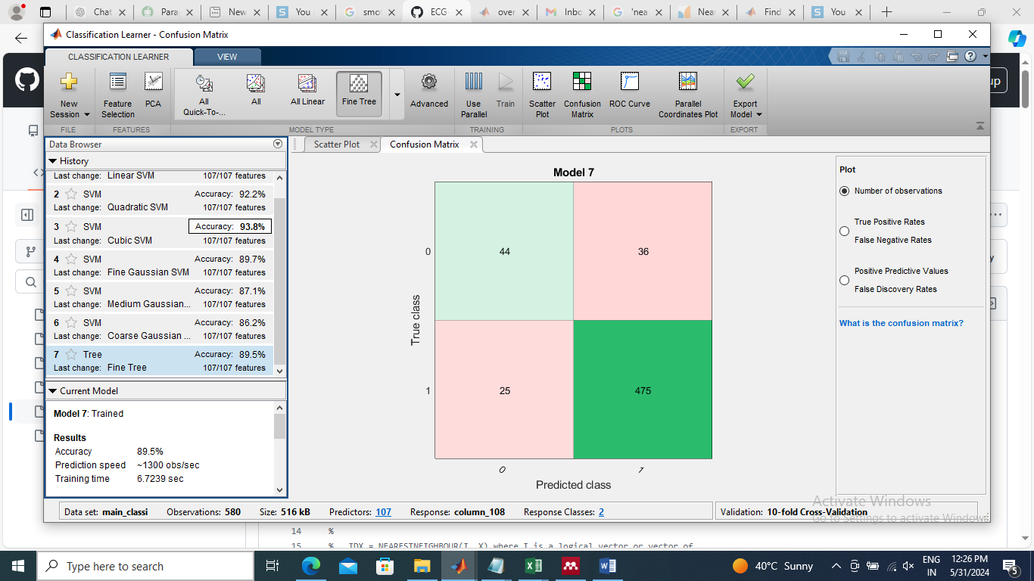 | 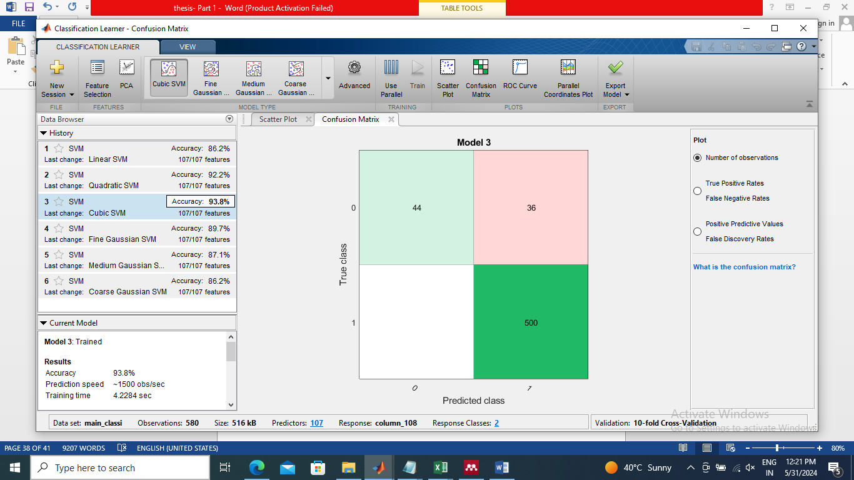
(a) | (b)
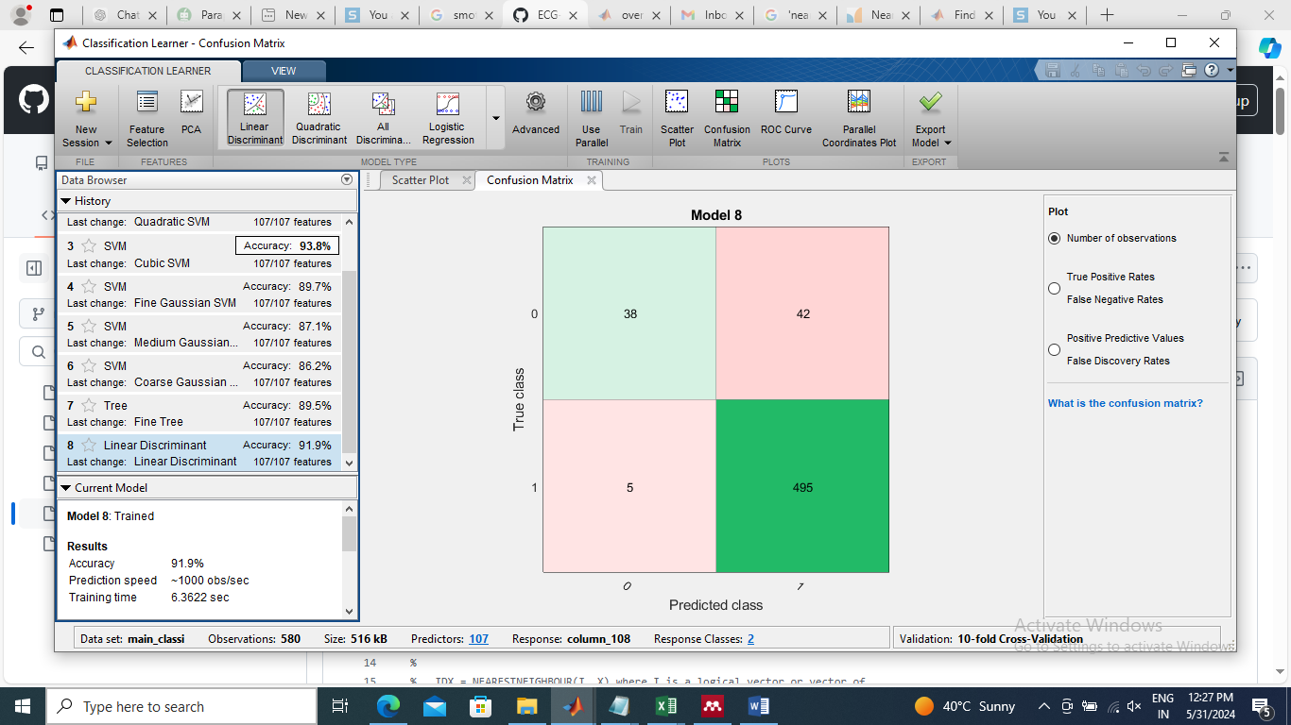 | 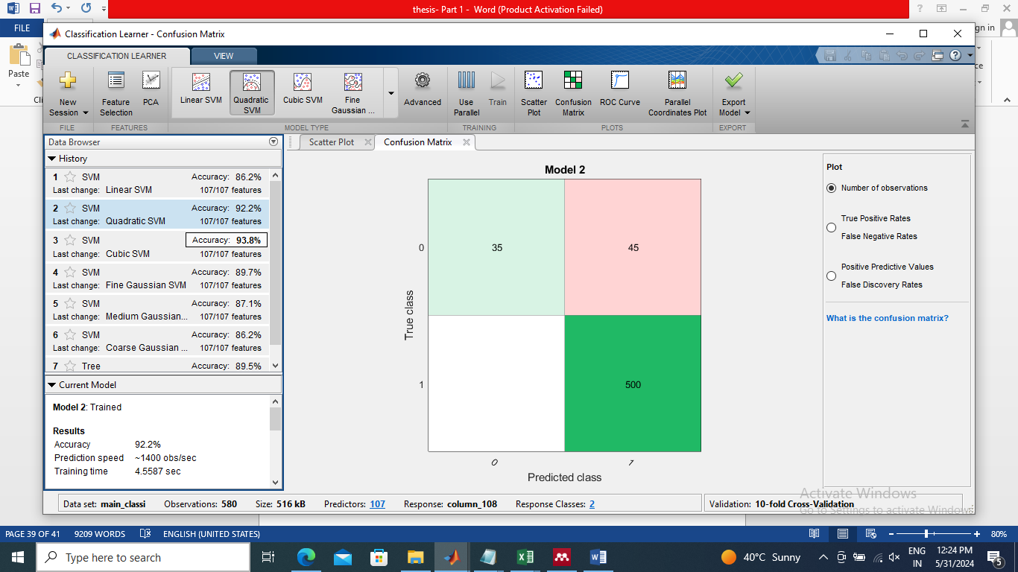
(c) | (d)
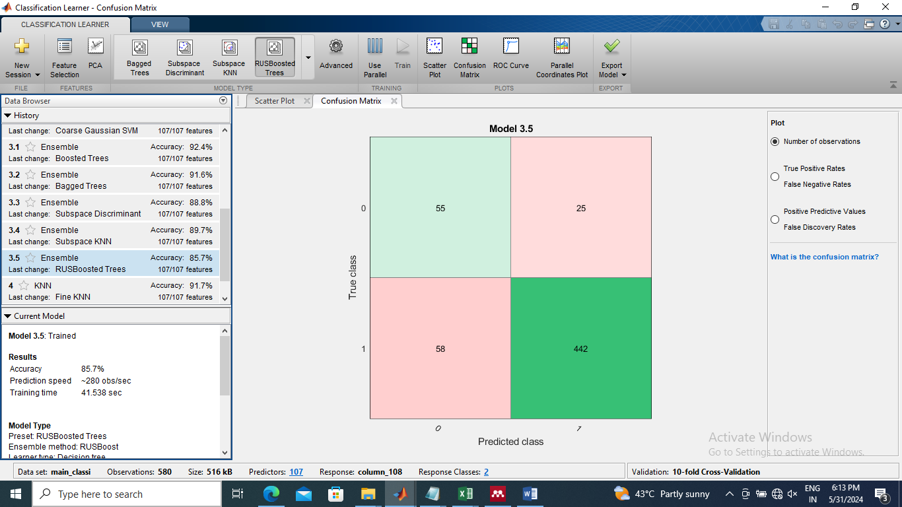 | 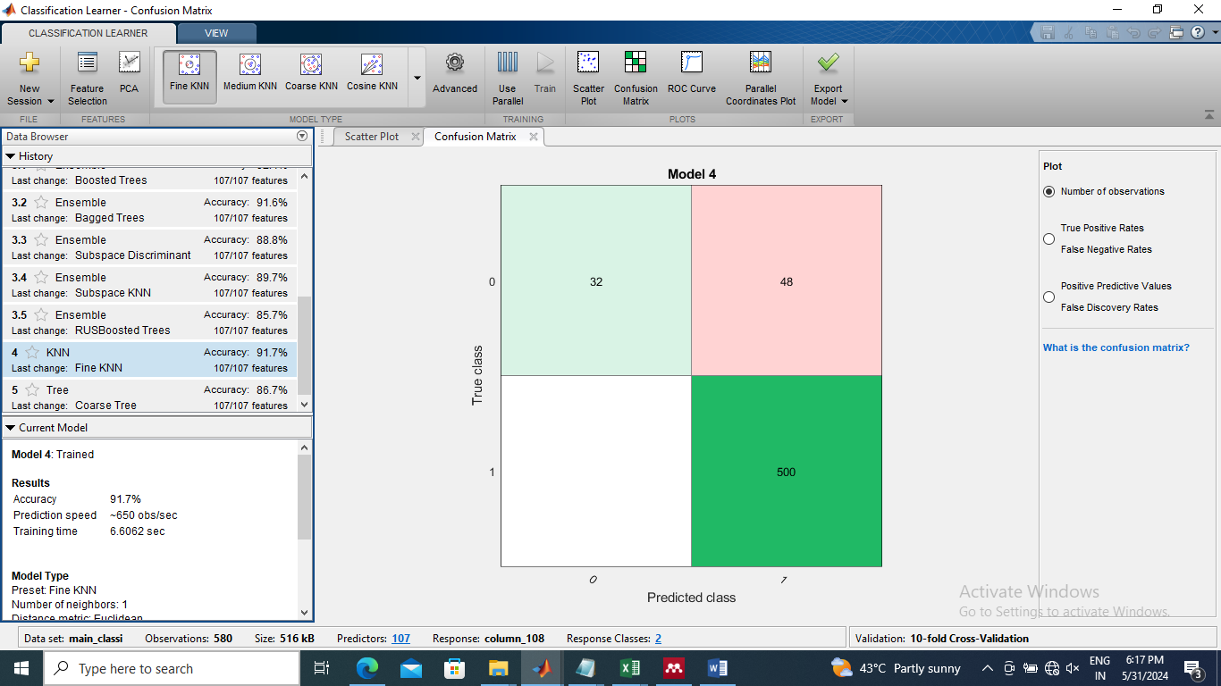
(e) | (f)
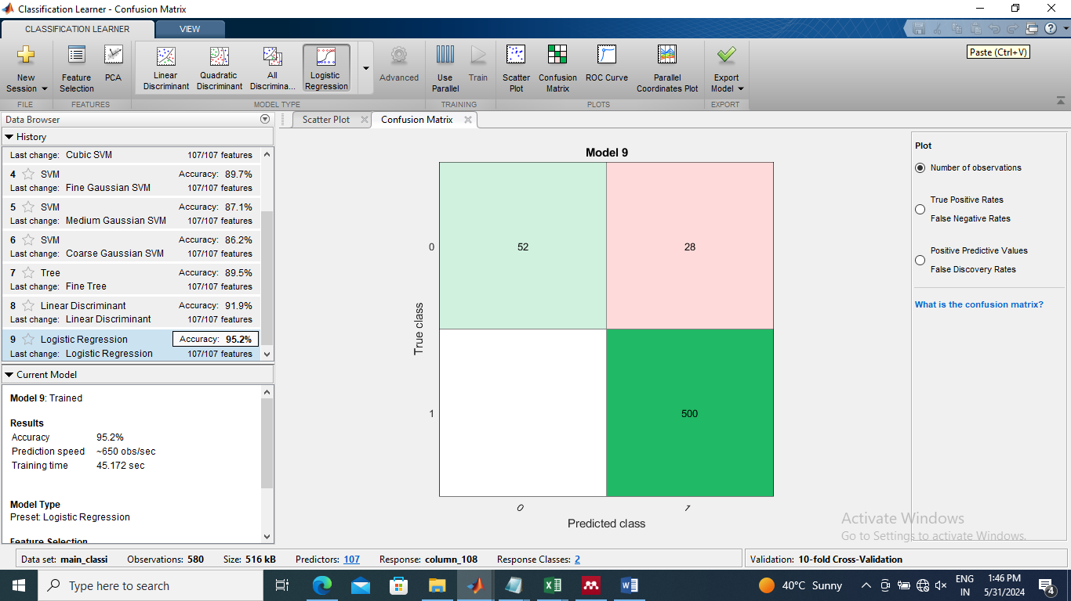
(g)

Figure 3. Confusion matrix (105 features) (a) Fine tree, (b) Logistic regression, (c) Linear Discriminant, (d) Quadratic SVM, (e) Ensemble Boosted Trees, (f) Fine KNN and (g) Cubic SVM.

The state of art methods in which classification of skin cancer images is tabulated in table 3. It has been observed that the accuracy, sensitivity and specificity parameters is highest in proposed methodology as compared to others.

Table 3: Performance comparison of proposed methodology with state of the artmethods
Author | Year | Accuracy | Sensitivity | Specificity | F1 Score | Precision
Giotis et al. [24] | 2015 | 0.8100 | - | - | - | -
Shalu et al. [25] | 2018 | 0.8235 | - | - | - | -
Soumen et al [26] | 2020 | 0.8333 | 0.8677 | 0.7278 | - | -
Shalu et al. [27] | 2021 | 0.8411 | - | - | - | -
Moldovanu et al.[6] | 2021 | 0.9471 | - | - | - | -
Soumen et al. [28] | 2021 | 0.8769 | - | - | - | -
Alyami et al. [29] | 2022 | 0.9470 | - | - | - | -
Mihaela et al. [30] | 2023 | 0.8500 | - | - | - | -
Bakheet et al. [4] | 2023 | 0.9400 | 1 | 0.9200 | - | -
Moldovanu et al. [31] | 2023 | 0.8740 | - | - | 0.8850 | 0.8950
Proposed methodology | 2024 | 0.9517 | 0.6500 | 0.9999 | 0.7879 | 0.9999

- CONCLUSION
In the proposed methodology for skin cancer image classification, the Y component from YIQ form of skin cancer image is opted. The texture features are calculated using enhanced images to obtain feature data. The dataset is made in balanced form using SMOTE technique. Pareto technique is applied for normalization of feature data. For getting better results, the selection of features is performed using minimum redundancy maximum relevance feature selection mechanism. The skin cancer images are then classified into melanoma and naevus with the help of Cubic SVM classifier. The effectiveness of proposed methodology for classification of skin cancer images is illustrated using classification accuracy 95.17%, specificity 99.99% and precision of 99.99%. The experimentation performed using proposed methodology outperforms state of the art methods.
- REFERENCES

[1] N. S. Zghal and N. Derbel, “Melanoma Skin Cancer Detection based on Image Processing,” Curr. Med. Imaging Former. Curr. Med. Imaging Rev., vol. 16, no. 1, pp. 50–58, Jan. 2020, doi: 10.2174/1573405614666180911120546.
[2] C. K. Viknesh, P. N. Kumar, R. Seetharaman, and D. Anitha, “Detection and Classification of Melanoma Skin Cancer Using Image Processing Technique,” Diagnostics, vol. 13, no. 21, p. 3313, Oct. 2023, doi: 10.3390/diagnostics13213313.
[3] M. Sharma, Richa; Lal, “SKIN CANCER LESION CLASSIFICATION USING LBP BASED HYBRID CLASSIFIER.,” Int. J. Adv. Res. Comput. Sci., vol. Vol 8, no. Issue 7, p. p993, 2017, doi: 10.26483/ijarcs.v8i7.4469.
[4] S. Bakheet, S. Alsubai, A. El-Nagar, and A. Alqahtani, “A Multi-Feature Fusion Framework for Automatic Skin Cancer Diagnostics,” Diagnostics, vol. 13, no. 8, p. 1474, Apr. 2023, doi: 10.3390/diagnostics13081474.
[5] L. I. Mampitiya, N. Rathnayake, and S. De Silva, “Efficient and Low-Cost Skin Cancer Detection System Implementation with a Comparative Study Between Traditional and CNN-Based Models,” J. Comput. Cogn. Eng., vol. 2, no. 3, pp. 226–235, Dec. 2022, doi: 10.47852/bonviewJCCE2202482.
[6] S. Moldovanu, F. A. Damian Michis, K. C. Biswas, A. Culea-Florescu, and L. Moraru, “Skin Lesion Classification Based on Surface Fractal Dimensions and Statistical Color Cluster Features Using an Ensemble of Machine Learning Techniques,” Cancers (Basel)., vol. 13, no. 21, p. 5256, Oct. 2021, doi: 10.3390/cancers13215256.
[7] M. Q. Khan et al., “Classification of Melanoma and Nevus in Digital Images for Diagnosis of Skin Cancer,” IEEE Access, vol. 7, pp. 90132–90144, 2019, doi: 10.1109/ACCESS.2019.2926837.
[8] H. Alquran et al., “The melanoma skin cancer detection and classification using support vector machine,” in 2017 IEEE Jordan Conference on Applied Electrical Engineering and Computing Technologies (AEECT), IEEE, Oct. 2017, pp. 1–5. doi: 10.1109/AEECT.2017.8257738.
[9] P. Rubegni et al., “Automated diagnosis of pigmented skin lesions,” Int. J. Cancer, vol. 101, no. 6, pp. 576–580, Oct. 2002, doi: 10.1002/ijc.10620.
[10] H. Ganster, P. Pinz, R. Rohrer, E. Wildling, M. Binder, and H. Kittler, “Automated melanoma recognition,” IEEE Trans. Med. Imaging, vol. 20, no. 3, pp. 233–239, Mar. 2001, doi: 10.1109/42.918473.
[11] C. Barata, M. Ruela, M. Francisco, T. Mendonca, and J. S. Marques, “Two Systems for the Detection of Melanomas in Dermoscopy Images Using Texture and Color Features,” IEEE Syst. J., vol. 8, no. 3, pp. 965–979, Sep. 2014, doi: 10.1109/JSYST.2013.2271540.
[12] L. Bi, J. Kim, E. Ahn, A. Kumar, M. Fulham, and D. Feng, “Dermoscopic Image Segmentation via Multistage Fully Convolutional Networks,” IEEE Trans. Biomed. Eng., vol. 64, no. 9, pp. 2065–2074, Sep. 2017, doi: 10.1109/TBME.2017.2712771.
[13] I. E. Amirreza Mahbod, Gerald Schaefer, Chunliang Wang, Rupert Ecker, “Skin Lesion Classification Using Hybrid Deep Neural Networks,” Comput. Vis. Pattern Recognit., 2017, doi: https://doi.org/10.48550/arXiv.1702.08434.
[14] S. Susan and M. Hanmandlu, “Difference theoretic feature set for scale‐, illumination‐ and rotation‐invariant texture classification,” IET Image Process., vol. 7, no. 8, pp. 725–732, Nov. 2013, doi: 10.1049/iet-ipr.2012.0527.
[15] S. Jacob and J. D. Rosita, “FRACTAL MODEL FOR SKIN CANCER DIAGNOSIS USING PROBABILISTIC CLASSIFIERS,” Int. J. Adv. SIGNAL IMAGE Sci., vol. 7, no. 1, pp. 21–29, Mar. 2021, doi: 10.29284/IJASIS.7.1.2021.21-29.
[16] S. Chatterjee, D. Dey, and S. Munshi, “Development of an efficient fractal based texture analysis technique for improved classification of dermoscopic images,” in 2016 IEEE Uttar Pradesh Section International Conference on Electrical, Computer and Electronics Engineering (UPCON), IEEE, 2016, pp. 183–188. doi: 10.1109/UPCON.2016.7894649.
[17] V. Tanos, M. Neofytou, A. S. A. Soliman, P. Tanos, and C. S. Pattichis, “Is Computer-Assisted Tissue Image Analysis the Future in Minimally Invasive Surgery? A Review on the Current Status of Its Applications,” J. Clin. Med., vol. 10, no. 24, p. 5770, Dec. 2021, doi: 10.3390/jcm10245770.
[18] C. S.-R. Vanesa Gómez-Martínez, David Chushig-Muzo, Marit B. Veierød, Conceição Granja, “Ensemble feature selection and tabular data augmentation with generative adversarial networks to enhance cutaneous melanoma identification and interpretability,” BioData Min., 2024, doi: https://doi.org/10.21203/rs.3.rs-4402096/v1.
[19] M. F. Omar, M. N. Mansor, and S. A. Saidi, “SFTA and GLCM via LDA Classifier for Skin Cancer Detection,” IOP Conf. Ser. Mater. Sci. Eng., vol. 932, no. 1, p. 012068, Sep. 2020, doi: 10.1088/1757-899X/932/1/012068.
[20] O. O. Myakinin, A. G. Khramov, D. S. Raupov, S. G. Konovalov, S. V. Kozlov, and A. A. Moryatov, “Texture Analysis in Skin Cancer Tumor Imaging,” in Multimodal Optical Diagnostics of Cancer, Cham: Springer International Publishing, 2020, pp. 465–504. doi: 10.1007/978-3-030-44594-2_13.
[21] H. Han, W.-Y. Wang, and B.-H. Mao, “Borderline-SMOTE: A New Over-Sampling Method in Imbalanced Data Sets Learning,” 2005, pp. 878–887. doi: 10.1007/11538059_91.
[22] X. Cao et al., “Application of generated mask method based on Mask R-CNN in classification and detection of melanoma,” Comput. Methods Programs Biomed., vol. 207, p. 106174, Aug. 2021, doi: 10.1016/j.cmpb.2021.106174.
[23] A. H. Alasadi and B. Alsafy, “Diagnosis of Malignant Melanoma of Skin Cancer Types,” Int. J. Interact. Multimed. Artif. Intell., vol. 4, no. 5, p. 44, 2017, doi: 10.9781/ijimai.2017.458.
[24] I. Giotis, N. Molders, S. Land, M. Biehl, M. F. Jonkman, and N. Petkov, “MED-NODE: A computer-assisted melanoma diagnosis system using non-dermoscopic images,” Expert Syst. Appl., vol. 42, no. 19, pp. 6578–6585, Nov. 2015, doi: 10.1016/j.eswa.2015.04.034.
[25] Shalu and A. Kamboj, “A Color-Based Approach for Melanoma Skin Cancer Detection,” in 2018 First International Conference on Secure Cyber Computing and Communication (ICSCCC), IEEE, Dec. 2018, pp. 508–513. doi: 10.1109/ICSCCC.2018.8703309.
[26] A. A. and M. R. Soumen Mukherjee, “Malignant melanoma detection using multi layer preceptron with visually imperceptible features and PCA components from MED-NODE dataset,” Int. J. Med. Eng. Inform., vol. 12, no. 2, 2020.
[27] N. A. Shalu, R. Rani, and A. Kamboj, “Automated melanoma skin cancer detection from digital images,” Int. J. Biomed. Eng. Technol., vol. 37, no. 3, p. 275, 2021, doi: 10.1504/IJBET.2021.119928.
[28] M. R. Soumen Mukherjee, Arunabha Adhikari, “Melanoma Detection From Lesion Images Using Optimized Features Selected by Metaheuristic Algorithms,” Int. J. Healthc. Inf. Syst. Informatics, vol. 16, no. 4, p. 22, 2021, doi: 10.4018/IJHISI.288542.
[29] J. Alyami, A. Rehman, T. Sadad, M. Alruwaythi, T. Saba, and S. A. Bahaj, “Automatic skin lesions detection from images through microscopic hybrid features set and machine learning classifiers,” Microsc. Res. Tech., vol. 85, no. 11, pp. 3600–3607, Nov. 2022, doi: 10.1002/jemt.24211.
[30] M. Mihaela, A. L. Culea-Florescu, and S. Moldovanu, “A Convolutional Neural Network for skin lesion classification in Dermoscopic Images using discrete wavelet transform,” in 2023 European Control Conference (ECC), IEEE, Jun. 2023, pp. 1–5. doi: 10.23919/ECC57647.2023.10178364.
[31] S. Moldovanu, M. Miron, C.-G. Rusu, K. C. Biswas, and L. Moraru, “Refining skin lesions classification performance using geometric features of superpixels,” Sci. Rep., vol. 13, no. 1, p. 11463, Jul. 2023, doi: 10.1038/s41598-023-38706-5.

