**Analysis and Design of Multi-storied Building**

**Sananadan Kumar Singh1, Sanjeev Jangde2, Vagesh Kumar3**

**1M.Tech Schoolar, ISBM University Gariyaband Chhattisgarh, India**

**2’3Assistant Professor, ISBM University Gariyaband Chhattisgarh, India**

**ABSTRACT**

Analysis and Design of Multi-storied building, In this project a real life multi-storied RC moment resisting framed structure building with shear wall in Bhopal city (Indian seismic zone 2) is considered for analysis and design. The building is designed with and without seismic provisions and cost is compared. For working out the extra cost implications of constructing the same building in other seismic zones, three more cities are chosen namely Mumbai (zone 3), Delhi (zone 4) and Guwahati (zone 5). Extra cost is involved due to increase in member sizes (leading to change in volume of concrete) and increase in reinforcement steel bars. Hence, quantities of concrete and steel are worked out in each analysis/ design and compared.

**INTRODUCTION**

Our main aim to complete a Multi-storey building is to ensure that the structure is safe against all possible loading conditions and to full fill the function for which they have built.

Safety requirements must be met so that the structure is able to serve its purpose with the maintain cost.

Detailed planning of the structure usually comes from several studies made by town planners, investors, users, architects and other engineers. On that, a structural engineer has the main influence on the overall structural design and an architect is involved in aesthetic details.

For the design of the structure, the dead load, live loads, seismic and wind load are considered. The analysis and design for the structure done by using a software package STAAD PRO.

In this project multistoried construction, we have adopted limit state method of analysis and design the structure. The design is in confirmation with IS456-2000.the analysis of one frame is worked out manually and simultaneously it has been checked using STAAD PRO.

Therefore an attempt has been made to present the multistoried building for residential purpose in the busy city of Hyderabad. The complex consisting of five storeys The structure is design based on the theory of LIMITSTATE METHOD which provides adequate strength, serviceability and durability besides economy.

STATEMENT OF PROJECT

Salient Features : The design data shall be as follows.

Utility Of Buildings : Residential Building

Area of each floor : 160 sq.m

No Of Storey : G+5

Shape of the Building : Rectangular

No. Of Staircases : Six

No. Of Lifts : One

Types Of Walls : Brick Wall

Geometric Details

Ground Floor : 9.0

M Floor-To-Floor Height : 3.0 M

Height of Plinth : 0.6 M above G.L

Depth of Foundation : 2 M below G.L

Material Details

Concrete Grade : M25

All Steel Grades : HYSD REINFORCEMENT of Grade Fe415

Bearing Capacity of Soil : 200 KN/M2

Type Of Construction : R.C.C FRAMED structure

**LITERATURE SURVEY**

Major advances in both design and new material assisted roman architecture. Design was enhanced architectural developments in the construction of arches and roof domes. Arches improved the efficiency and capability of bridges and aqueducts (fewer supports columns were needed to support the structure), while domed roofs not only permitted the building of larger open areas undercover, but also lent the exterior an impressive.

The social unit that lives in a house is known as a household. Most commonly, a household is family unit of a same kind, though households can be other social groups, such as single person, or groups of unrelated individuals. Settled agrarian and industrial societies are composed of household units living permanently in housing of various types, according to a variety of farms of lands tenure. English-speaking people generally call any building there routinely occupy “home”. Many people leave their houses during the day for work and recreation, and return to them to sleep or for other activities.

**ARCHITECTURE**

Architecture is the art and science of designing buildings and structures. A wider definition would include within its scope also the design of the total built environment, from the macro level of creating furniture. In the field of building architecture, the skill demanded of an architect range from the more complex, such as for a hospital or stadium, to the apparently simpler, such as planning residential houses. Many architectural works may be seen also as cultural and political symbols, and /or work of art. The role of architect though changing, has been central to the successful design and implementation of pleasing built environments in which people live.

**Scope:** Architectural is an interdisciplinary field, drawing upon mathematics, science, art technology, social sciences, politics, history and philosophy. Vitrifies states: “architecture is a science, arising out of many other sciences, and adorned with much and varied learning: by the help of which is judgment is formed of those works which are result of other arts”.

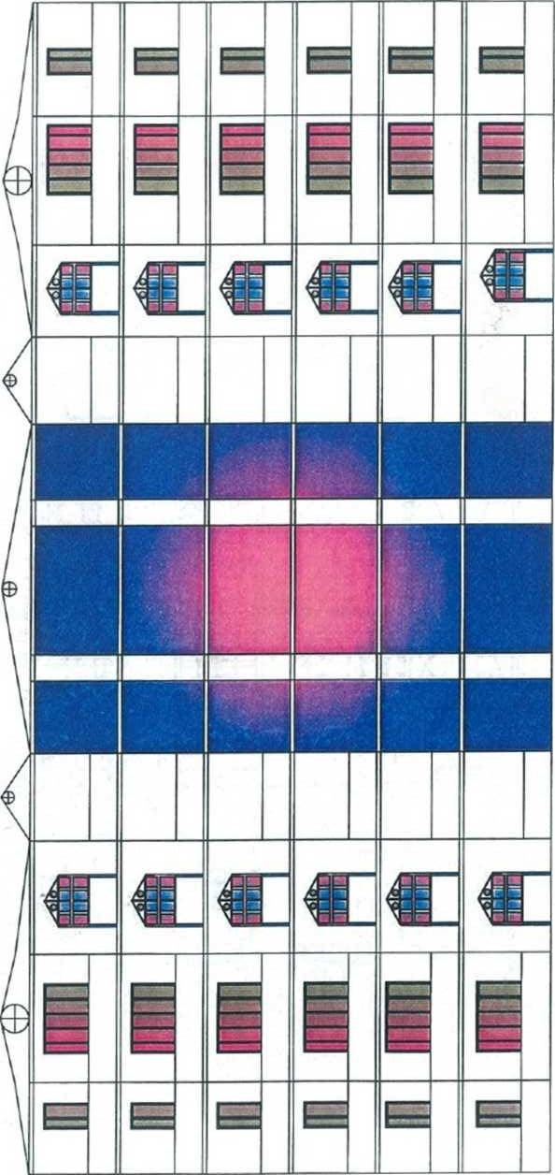LAYOUT DRAWINGS

ELEVATION

Plan

sTRUCTURAL ANALYSIS

The procedure of structural analysis is simple in concept but complex. In detail. It involves the analysis of a proposed structure to show that its resistance or strength will meet or exceed a reasonable expectation. This expectation is usually expressed by a specified load or the demand and an acceptable margined of safety that constitutes a performance goal for a structure. The performance goals structural design is multifaceted. Foremost, a structure must perform its intended function safely over its useful life.

The concept of useful life implies consideration of durability and established the basis for considering the cumulative exposure to time varying risks (i.e. corrosive environments, that performance is inextricably linked to cost, owners, builders, and designer must considers economic limit to the primary goal of safety and durability.

ARCHITECTURAL LAYOUT

STRUCTURAL MODELING ↓

STRUCTURAL MODEL

STRUCTURAL ANALYSIS ↓

RESPONSE OF STRUCTURAL MODEL IN SERVICES

STRUCTURAL DESIGN ↓

ADEQUACY

CONSTRUCTION ↓

CONSTRUCTED STRUCTURE

**Design of Multistoried Residential Building**

**General:**

A structure can be defined as a body, which can resist the applied loads without appreciable deformations. Civil engineering structures are created to serve soma specific like, Human habitation, transportation, bridges, storage etc. in safe and economical way.

A structure is assembling of individual elements like pinned elements (truss elements), beam elements, column, shear wall slab able or arch. Structural engineering is concerned with the planning, designing and the construction of structures.

Structural analysis involves the determination of the forces and displacements of the structures or components of a structure that make up the structural system.

The main object of reinforced concrete design is to achieve a structure that will result in a safe economical solution.

The objectives of the design are,

* 1. Slab Design.
  2. Beam Design.
  3. column Design.
  4. Foundation Design.

**Foundation Design**

Foundations are the structure elements that transfer loads from buildings or individual column to earth this loads are to be properly transmitted foundations must be designed to prevent excessive settlement are rotation to minimize differential settlements and to provide adequate safety isolated footings for the multistoried buildings. These may be square rectangle or circular in plan that the choice of types of foundation to be used in a given situation depends on a number of factors.

* + 1. Bearing capacity of soil.
    2. Types of structure.
    3. Types of loads.
    4. Permissible differential settlements.
    5. Economy.

**Column Design**

A coloumn may be defines as an element used primarily to support axial compressive loads and with a height of at least three times its lateral dimensions. The strength of column depends up on the strength of material, shape and size of cross section length and degree of proportional and dedicational restrains at the ends.

1. Shape of cross section.
2. Slenderness ratio (A=L+D)
3. Type of loading, land.
4. Pattern of lateral reinforcement.

The ration of effective coloumn length to least lateral dimension is released to as slenderness ratio.

**Beam Design**

A reinforced concrete beam should be able to resist tensile, compressive and shear stress induced in it by loads on the beam.

There are three types of reinforced concrete beams.

* 1. Single reinforced beams.
  2. Double reinforced concrete.
  3. Flanged beams

**Slab Design**

A slab is a thin flexural member used in floor and roofs of structure to carry loads,, which are usually supported by wall or beams along its edges. Slabs are plate elements forming floor and roofs of buildings carrying distributed loads primarily by flexure.

**One- Way Slab**

One-way slabs are those in which the length is more than twice the breadth it can be simply supported beam or continuous beam.

**Two-Way Slab**

When the slab is supported on four edges and aspect ratio(Ly/Lx)<2 the slabs are designed as two way slabs. When slabs are supported to four sides two wayspanning action occurs.

In two way slabs when loaded it bends in surface along both short and long span direction causing bending moments in both direction.

Corners held down and bending moments coefficient obtained from table 26 of IS 456- 2000. In slabs M25 grade concrete and Fe415 grade steel is used.

**Loads for Residential Buildings**

Loads are primary consideration in any buildings design because they define the nature and magnitude of hazards or external forces that a building must resist to provide reasonable performance (i.e.; safety and serviceability) throughout the structure’s useful life.

The anticipated loads are influenced by a building’s intended use (occupancy and function), configuration (shape and size) and location (climate and site conditions). Ultimately, the type and magnitude of the design loads affect critical decisions such has the material selection, construction details, and architectural configuration.

Thus to optimize the value (i.e. performance versus economy) of the finished product, it is essential to apply design loads realistically. While the building consider in this guide are primary single-family detached and attached dwellings, the principles and concepts related to building loads also apply to other similar types of construction, such as low-rise apartment’s buildings.

In general, the design loads recommended in this guide are based on:

1. Dead load.
2. Live load.
3. Imposed loads.

**Dead Loads**

This is the permanent of the stationary load like self weight of the structural elements.

This include the following

1. Self-weight
2. Weight of the finished structure part.
3. Weight of partition walls etc.

Dead loads are based upon the unit weights of elements, which are established taking in account materials specified for construction, given IS 1911-1967

Dead loads consists of the permanent construction material loads compressing the roof, floor, wall, and foundation system, including claddings finishes and fixed equipment. Dead load is the total load of all of the components of the building that generally do not change over time, such as the steel columns, concrete floors, bricks, roofing material etc.

**Live loads**

These loads are not permanent or moving loads. The following loads includes in this type of loading: imposed loads(fixed) weight of the fixed seating in auditoriums, fixed machinery, partition walls these loads through fixed in positions cannot be relieved upon to act permanently throughout the life of the structure.

Imposed loads (not fixed) these loads change either in magnitude or position very often such as the traffic loads, weight of the furniture etc.

Live loads are produced by the use occupancy of the building. Loads include those from human occupants, furnishings, no fixed equipment, storage, and constriction and maintenance activities. As required to adequately define the loading condition, loads are presented in terms of uniform are loads, concentrated loads, and uniform line loads.

**Imposed loads:**

Loads produced by intended use occupancy of a building including the weight movable portions distributed concentrated loads and loads that vibration and impact called imposed loads estimated by IS 456-2000.

**CONCLUSIONS**

Staad Pro software has become more and more critical in the analysis of engineering and scientific problems. Much of the reason for this change from manual methods has been the advancement of computer techniques development by the research community and in particular universities.

As technology and engineering adoptions are advertising new methodology of interlinking and completing the industries via computer applications are created with a similar improvement in hardware capacities. This is turn facilities the implementations of more effective and professional engineering software. As the applications adventure in functionality, one can hope that they will be more affordable to promote their widespread usage amongst civil engineering at a global scale.

Taking into account the technological advance, this project has been dealt with using the latest design.

**References**

1. Is: 456-2000 design for reinforced.
2. IS: 875(part – 3)- 1987 code of practice for design loads for building and structures.
3. SP: 16 designs for reinforce concrete.
4. AUTO CAD & STAAD PRO- 2007
5. Reinforcement concrete design by N.KRISHNA RAJU & R.N.PRANESH
6. Design of reinforced concrete structure by S.RAMAMURTHAM.