**A STUDY ON CRYPTOCURRENCY AND ITS IMPACT ON INDIAN ECONOMY**

**Mr. Dr. PRATHAP B.N**

ASSOCIATE PROFESSOR, Department of MBA, Sridevi Institute of Engineering and Technology, Tumkur, Karnataka, India (prathap.bn@gmail.com)

**MUNAF MALIK DM**

2nd Year MBA Student, Department of MBA, Sridevi Institute of Engineering and Technology, Tumkur, Karnataka, India (malikmunaf20@gmail.com)

**ABSTRACT**

Cryptographic money is an imaginative idea of virtual/advanced cash that has drawn in significant premium in most recent couple of years from the daring people, benefit searchers, overall population and scholarly specialists. Cryptographic money is an advanced cash intended to function as a mechanism of trade through a PC network that isn't dependent on any focal power, like an RBI or government, to maintain or keep up with it. Crypto normally utilize decentralized control rather than a National Bank Computerized Cash (CBDC). Crypto has ended up being another road of venture instrument in India like gold. The traits of digital money system like decentralized network, discounted reliance on cash, no middle people, and the absence of stable valuing factors don't allow it to open its actual potential. The Indian digital currency economy has been positioned second in worldwide digital currency reception, simply behind Vietnam. The size of the crypto-tech market in India is expected to reach $241 million by 2030, developing at a CAGR of 14%, with the capability of making 877,000 positions by then. The crypto-tech biological system is growing quickly with in excess of 230 new businesses expanding and nearly $270 million put resources into Indian block chain and crypto new companies till 2021. Around 1.8% of India's grown-up populace has put resources into crypto until 2021, a development of 2.2 × over a year. This study centers around understanding what's truly going on with digital currency and its general effect on the Indian economy. The future of digital currency is dubious. The concentrate additionally centers on the current situation and future possibilities of digital money in India.

**INTRODUCTION**

A crypto/digital currency is a web-based vehicle of trade that executes monetary exchanges utilizing cryptographic capabilities. Digital currency utilizes block bind innovation to accomplish straightforwardness, decentralization and permanence (the capacity of a block tie record to stay unaltered, unaltered, and permanent).

With the rapid development of Data and Correspondence Innovations (ICT), a ton of day-to-day exercises have been digitized and become additional efficient and adaptable. A ton of e-clients have changed to the virtual world and cryptographic money has made another business peculiarity to advance exchanging, trading computerized resources. Crypto addresses significant and theoretical articles utilized web-based in different organizations and applications, for example, internet games, informal communities, P2P organizations, and virtual universes. Digital currency has been utilized broadly in various frameworks throughout the years [1]. Over in the new past crypto has been a topic of conversation among the general population at large. In the realm of mechanical

Financial backers who value security and production of cash. In these days digital currencies, for example, touch coin, ethereal, Wave, Lit coin, and so on are moving in the monetary market as individuals are showing revenue in purchasing cryptographic forms of money. In an emerging nation like India, digital currencies have an extraordinary potential to change the monetary status of the two people and firms. Crypto can diminish handling expenses and exchange cost which will help cross-line installments. This is helpful to settlement installments, unfamiliar exchange, and shared funding.

India is one of the world's quickest creating cryptographic money markets. As per a new report, the digital money area in India is becoming the quickest around the world. Its pace of advancement has been emphatically advancing lately, outperforming that of specific different countries. The Indian government isn't yet persuaded about digital currency. The public authority and the national bank of India are worried about the different antagonistic impacts of cryptographic money. One among them was the job that crypto resources could play in supporting psychological warfare and illegal tax avoidance. In 2017, the national bank of India gave an admonition that computerized monetary forms are not a lawful delicate in India. Be that as it may, no restriction on advanced monetary standards occurred. In 2019, RBI gave that mining, exchanging, holding or moving/utilization of digital currencies is dependent upon discipline in India with a monetary punishment or/and detainment as long as 10 years. RBI likewise uncovered that it might send off e-rupee/computerized rupee as a lawful delicate in India in future. In 2020, the High Court of India eliminated the restriction on digital currencies forced by RBI In 2022, the GOI plainly referenced in the association spending plan 2022-23 that the exchange of any virtual cash/cryptographic money resource will be dependent upon 30% duty derivation. Gifts as virtual resources/cryptographic forms of money will be burdened in the possession of the recipient. In July 2022, The RBI suggested a prohibition on digital currencies referring to 'weakening impacts' for the nation's financial and monetary wellbeing

**LITERATURE REVIEW:**

1.Satoshi Nakamoto (Bitcoin Whitepaper):

Definition: "A purely peer-to-peer version of electronic cash would allow online payments to be sent directly from one party to another without going through a financial institution."

2. Chris Burniske and Jack Tatar (Crypto assets):

Definition: "Cryptocurrencies are a subset of crypto assets that function primarily as a medium of exchange, a unit of account, or a store of value."

**3.** Andreas M. Antonopoulos (Mastering Bitcoin):

Definition: "A cryptocurrency is a digital or virtual currency that uses cryptography for security. A cryptocurrency is difficult to counterfeit because of this security feature."

**OBJECTIVES:**

* Evaluate the potential for cryptocurrencies to act as an alternative investment vehicle or currency, impacting traditional financial markets.
* Analyze the current regulatory environment surrounding cryptocurrencies in India.
* Examine the potential effects of cryptocurrencies on traditional banking systems in India.
* Evaluate the implications of cryptocurrencies on tax collection and revenue generation for the Indian government.

**METHODOLOGY:**

This paper is solely based on secondary information collected from different sources like books, journal articles, reports of various government organization and commission, websites etc.

**LIST OF PRIVATE CRYPTO CURRENCY IN INDIA**

In the present market, different private digital currencies exist in India. Regardless of being the most well-known cryptographic money, government associations actually use Spot coin (BTC) (Figure 1).

Here is the private digital currencies list in India. They are:

• Bit coin (BTC)

• Tie (USDT)

• Swell (XRP)

• Shaba Innu (SHIB)

• Light coin (LTC)

• Elrond (EGLD)

• USD Coin (USDC)

• Ethereal (ETH)

• Swell (XRP)

• Doge coin (DOGE

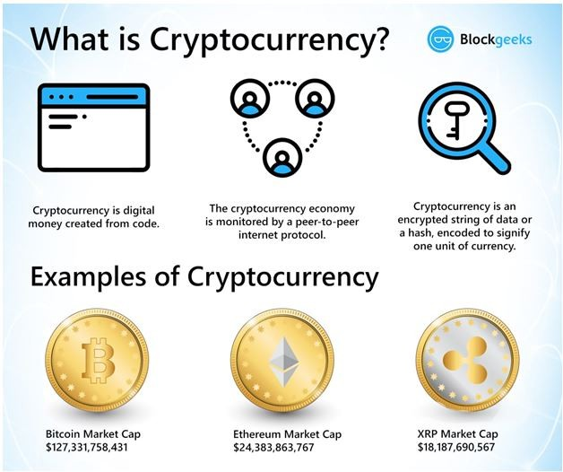

**Definition and instances of digital currency.**

Phrasings utilized

Digital currency: It is computerized cash. Being safer that the genuine money is thought of.

Cryptography: It is a technique for changing over intelligible information into confounded codes which are hard to break.

**Advantages of digital currency**

•Intrinsic security: Utilization of pen names record frameworks disguises the characters.

•Low exchange cost: Extremely low expenses and charges for exchanges.

•Absence of impedance from the financial framework: Outside ambit of banking frameworks.

•Lower section boundaries: No passage hindrances, in contrast to ordinary financial frameworks. General acknowledgment: Loads of cryptographic forms of money and adequate in numerous countries.

Targets to concentrate on the ongoing status and future possibilities of cryptographic money in India. To assess the effect of digital currency on Indian economy.

**Writing Survey**

Technique: To satisfy the above research goals, this study depends on optional information gathered from different solid web-based sources, for example, high effect diaries, research papers, news stories, and other confided in stages

•Bering and Muller directed a monetary examination of "illegal tax avoidance" with digital currencies which are decentralized and convertible advanced monetary forms depending on cryptography. As per them, the rising fame of digital currencies is looking for the consideration of researchers and professionals, particularly because of expanding worries on illegal tax avoidance episodes. They made sense of the course of illegal tax avoidance and existing enemy of tax evasion measures. It helps in breaking down value-based and relevant elements about the effect on advantages of involving it for illegal tax avoidance by digital lawbreakers.

Wonglimpiyarat features that there are impediments of uncivilized delicate where Spot coin believes the public authority's regulation should help the reasonability of this new money. Bit coin (BTC) cash

May change the eventual fate of banking in non-industrial nations yet it is difficult to substitute a money-based society.

•Kithara and Fukushima, made sense of, it isn't advanced money, which has won from one side of the planet to the other. Dissimilar to government and national bank gave cash, Spot coin can be swelled freely; the inventory of Touch coin is restricted to a specific volume, which can't be changed.

Malik and Malik decided the connection between the authority "Indian Monetary forms unfamiliar exchange rates or ICX (GBP, USD, YEN, EURO, and so forth)" and digital currencies like "Money Coin", "Light coin", Ethereal and Spot coin with everyday examination during December 17, 2019 to June, 17, 2021. There is a "pivotal positive relationship" between "Money Coin and Ethereal" with Spot coin, "Money Coin and Touch coin" with Ethereal, "Money Coin" with light coin, and light coin with "Money Coin". There is a negative connection between light coin and USD. Subsequently, light coin can be helpful for broadening and supporting.

There is likewise negligible effect on crypto markets from unfamiliar trade markets in India, perhaps due to the absence of a lawful system for acknowledgment by the public authority. It likewise causes absence of public worthiness.

•Digital money trade Kuching distributed a report on India's cryptographic money biological system. It includes the consequences of a review, led from October 2021 to June 2022, which the organization depicted as "a top to bottom investigate the improvement of the block chain industry and crypto space" in India. The overview respondents were 2,042 Indian grown-ups matured 18 to 60, the organization made sense of, adding that 1,541 of them were self-recognizing crypto financial backers and 501 were crypto-inquisitive customers, who were keen on putting resources into digital currency in the approaching a half year.

Kithara and Fukushima, made sense of, it isn't computerized cash, which has won everywhere. Not at all like national bank and government provided money, Spot coin can be expanded voluntarily, the stock of Spot coin is restricted to a specific volume, which can't be changed

**PRESENT STATUS AND FUTURE POSSIBILITIES OF DIGITAL FORMS OF MONEY IN INDIA**

Crypto is currently known as advanced gold. Be that as it may, stakes are in every case high in crypto venture. The cost of the slightest bit coin was just $123 in October 2013. As of Jan 2021, its cost has crossed an incredible US$ 34,000. Gold is likewise a significant resource in India. As of now, the cost of 10 g of 24 k gold has crossed Rest. 50,000. An individual could have multiplied the speculation by putting resources into gold, while bit coin has given multiple times more return throughout the long term. This is known as "Computerized gold" which is as it should be. There are so many crypto banks in India that have begun working here like. Vault, Kasha, and Simple Organization. As indicated by Vault's President, they have given around $25 billion as credit.

A physical crypto bank has likewise been laid out "Unicast" with the consolidation of "Kasha" and Gujarat and Rajasthan. On the off chance that somebody has Wave, Spot coin, or any digital money, they can get up to half credit of the current market cost of crypto by giving digital money as security. It is because of the way that digital currency is exceptionally unpredictable and dependent upon vacillation. There is no set course of events for returning the credit, however the borrower needs to pay interest Banks generally energize to 24% of premium, while crypto banks energize to 15% of premium on digital currency with up to 5% of handling charge. This is the reason cryptographic money sticks out. In addition, the advance cycle is likewise extremely basic in digital currency and there is no bar on CRISIL scores and reliability. There is 4% premium on keeping crypto in the banks. That the prohibition on cryptographic money and presentation of RBI's computerized cash will raise a great deal of worries to the financial backers.

Like in different nations, digital forms of money have become well known additionally in India because of the greatest volume of INR being exchanged crypto after demonetization. The Indian Rupee ruled crypto has created the third biggest volume followed by USD and Yen. The demonetization in 2016 may have carried out digital forms of money among an enormous populace however real factors began coming out rapidly with stifled development in the Indian market. India has simply 2% of commitment to the worldwide market capitalization of digital money, in spite of being positioned second in populace after China. There are not many limits of digital currencies in India, for example,

• Security and trust.

• Market chances.

• No guideline.

• Taxability issues.

• KYC rule and unpredictability of costs.

Security and Trust-Being the computerized method of exchange, digital money has been digital forms of money accessible. Every one of them don't bring about great returns for financial backers. The digital forms of money have become well known in India because of the greatest volume of INR being exchanged crypto after demonetization. The Indian Rupee ruled crypto has produced the third biggest volume followed by USD and Yen. The demonetization in 2016 may have carried out digital forms of money among a tremendous populace however real factors began coming out rapidly with stifled development in the Indian market. No guidelines however different nations have previously made a few moves in regards to the cryptographic forms of money accessible. Every one of them don't bring about great returns for financial backers. India has simply 2% of commitment to the worldwide market capitalization of cryptographic money, notwithstanding being positioned second in populace after China. As per the Worldwide Crypto Reception file outfitted by Chain lysis, the overall utilization of digital forms of money will increment by 880% in 2021. India positioned second after Vietnam, with a file score of 0.37. The Indian cryptographic money market expanded by 641% in a solitary year. The worldwide cryptographic money business has a ton of commitment and is growing rapidly. It has all the earmarks of being a possible area for India too. The likelihood of digital currencies supplanting government issued currency is somewhat low. All things considered, there can be a serene conjunction of digital currencies and government issued currency later on. It will assist people and firms with utilizing any cash they decide for different purposes The Indian crypto economy has been positioned second in worldwide digital money reception, simply behind Vietnam. As indicated by Chain lysis, for positioning, it thought about three measurements. These remember for chain esteem got, the on-chain retail esteem got and P2P trade exchange volume. Vietnam positions ahead of all comers with a file score of 1.00. India comes in at second situation with a file score of 0.37, a very short ways off of Pakistan with a record score of 0.37. India's generally high score on the P2P trade exchange volume metric added to its high positioning

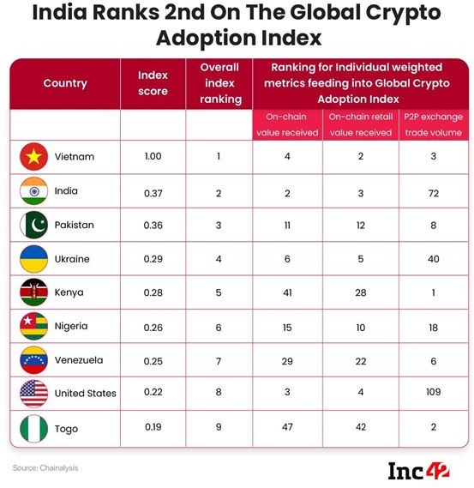

India positions second on the worldwide crypto reception record. In view of the measurements, for example, on-chain Deify value got, on-Chain number of Revere stores and on-chain retail Idolize esteem got, India has been positioned sixth in the Worldwide Exalt File by Chain lysis. Over the most recent couple of months, India has seen the ascent of a few new companies and the endeavor speculations kept by the new businesses in the Over the most recent couple of months, India has seen the ascent of a few new companies and the endeavor ventures kept by the new companies in the Exalt portion India record high development in crypto esteem got as far as the cryptographic money esteem got, India recorded the most noteworthy development contrasted

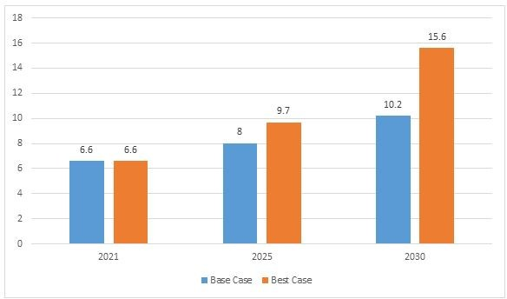

**DISCUSSION**

The effect of digital currencies on Indian economy

India is a non-industrial nation and consequently has a huge economy to make due. Albeit most couple of financial experts have figured out how to communicate their perspectives on the legitimization of digital money in India, welcoming more sure effects on our economy is normal. A large portion of the new financial backers and business visionaries have articulated their satisfaction as it will permit broadening their business skyline.

Following are the five huge effects cryptographic forms of money will have on the Indian economy:

**POSITIVE EFFECT**

Business development: The crypto business presently utilizes around 50,000 people. According to a new report, the business is ready to see enormous work valuable open doors, fixed at north of 800,000 by 2030. India as of now has serious areas of strength for a pool of Fitch experts and IT specialists. Also, the ability is accessible at financially savvy rates. With the ascent of the digital money market, we can see India turning into a significant center point and worldwide objective for the digital currency market. This will assist with setting out adequate work open doors in the BFSI, IT, client care and administration, and numerous different businesses. In the present times, the digital money market keeps on prompting further developing the work rate the country over.

Straightforwardness improvement: Digital currency upgrades straightforwardness where each exchange can be followed back to the source. Also block chain, the innovation on which digital currency is based, is permanent. This implies that exchange chronicles are super durable and unalterable. This could help financial area at any point can get vast conceivable outcomes terms of business valuable open doors and abroad money convergence. Furthermore, with the public authority bringing solid administrative measures and making regulations for an authority computerized money, it will draw in tremendous unfamiliar ventures. This will give an immense lift to the Fitch area and push the Indian economy forward.

Adverse consequence

Terrible for financial backers: No convey forward misfortunes will be a mishap for financial backers as digital currencies are profoundly unpredictable. This dread will constantly put financial backers down (explicitly retail financial backers) from exchanging digital forms of money. The high duty chunk will chop down the net benefit of financial backers and with impact from first April 2023, the 115BBH arrangements on pay created from virtual monetary standards will be in force. Dilemma: Forcing charge on digital forms of money doesn't totally and expressly proclaim cryptographic forms of money legitimate in light of the fact that personal expense in India is dependent upon resources not on the strategy/way of procuring those assets. Bad for Indian financial framework: The Hold Bank of India authorities said it will adversely affect the Indian financial framework as these being appealing resources individuals might put their well-deserved reserve funds in these monetary forms which might bring about banks having lesser assets to loan. Additionally, in the long haul, the graves air pocket will explode and would prompt the deficiency of hard-acquired reserve funds of the overall population, the authorities cautioned. Way forward Defining digital money: Digital forms of money ought to be expressly characterized as protections or other monetary instruments under the important public regulations. Connecting startup environment with crypto: India's startup biological system can be renewed by digital money and block chain which can set out work open doors, from block tie engineers to fashioners, project chiefs and business investigators to advertisers and advertisers. India towards CBDC: The money clergyman of India declared the presentation of a National Bank Computerized Cash (CBDC) for India as advanced rupee/e-rupee. It will give a gigantic lift to the Indian computerized economy. Digital money/E-cash will likewise prompt a more productive and less expensive money the board framework. Notwithstanding, national bank computerized money ought to exist as one with other digital currencies to receive the full rewards of the block chain innovation.

Guideline: is expected to forestall difficult issues, to guarantee that digital currencies are not abused, and to shield clueless financial backers from exorbitant market unpredictability and likely tricks. The guideline should be clear, straightforward, and intelligent, and it should be vivified by a dream of what it looks to accomplish. A legitimate and administrative structure should clarify cryptographic forms of money as protections or other monetary instruments under relevant public regulations and distinguish the administrative expert in control End The public authority of India ought to stand firm in the realm of digital money as it can possibly carry mechanical transformation to the country. The duty on cryptographic money gains likewise amounts to a colossal number of direct charges which goes to the I-T division which can additionally push the general development of the economy. The Indian government ought to anticipate managing it rather than declaring the sweeping boycott. There is a need to make it straightforward, more secure and more solid. Residents ought to be more mindful of the general working of cryptographic money to contribute more on it, particularly in India which stands second concerning populace. Cryptographic money holds a splendid future which is empowering about e-ventures, e-business, and e-installments. Regulations should be made about cryptographic forms of money, taking into account a few legitimate, monetary viewpoints towards an additional customer well-disposed and secure framework.

**CONCLUSION**

The government of India should take a stand in the world of crypto currency as it has huge potential to bring technological revolution to the country. The tax on crypto currency gains also adds up to a huge sum of direct taxes which goes to the I-T department which can further push the overall growth of the economy. The Indian government should look forward to regulating it instead of Announcing the blanket ban. There is a need to make it transparent, safer and more reliable. Citizens should be more aware of the overall functioning of crypto currency to invest more on it, especially in India which stands second in terms of population. Crypto currency holds a bright future which is encouraging about e-investments, e- business, and e-payments. Laws must be made about crypto currencies, considering several legal, financial aspects towards a more consumer friendly and secure system.