**TUNNELING WITH NATM / CONVENTIONAL AND TBM METHODS**

**Chandan Kumar1, Gautam Kumar2**

1M. tech Student, Department of Civil Engineering, KK University, Nalanda, Bihar, India

2Assistant Professor, Department of Civil Engineering, KK University, Nalanda, Bihar, India

**ABSTRACT**

Construction of tunnels is an infrastructure project, which is to enhance the transportation networks, especially in congested cities. Tunnelling projects are of long duration, they require large capital, they are complex in nature, construction work is repetitive, high in risk and with uncertainties. There are many construction methods have been developed in recent years for tunnel construction, which help to increase the pace of construction, also reduces the impacts on the surrounding structure and helps in decreasing accidents and mis-happenings.

With the growing demand in public transportation in urban cities and space available on surface is less or no space for expansion, tunnels have become an alternative mode of transportation, it helps in saving environment by using eco-friendly fuel and land above tunnel for other purposes. Every tunnel has its unique complexity depending upon function, safety & local code requirements and duration of construction. There are many functional systems attach with tunnel they are lighting, ventilation, drainage, fire detection and alarms, fire suppression, communications, and traffic control. This paper also talks about the monitoring system deployed at tunnel sites to measure and monitor deformations inside the tunnel as well as above the tunnel. Automatic Deformation Monitoring System (ADMS) system is a group of interacting, interrelated or interdependent software and hardware elements forming a complex whole for deformation monitoring, that does not require human input to function.

**Keywords:** Tunneling, NATM, TBM, Automatic Deformation Monitoring System, fire suppression

1. **INTRODUCTION**

A tunnel is an underground passageway, which is Dugged through the surrounding of soil /earth/rock and enclosed except for exit and entrance. A tunnel may be constructed for pedestrian movement, vehicular movement, rail movement or may be for service utilities. Tunnels are constructed in ancient time by kings for defensive purposes in the vicinities of important military posts, as an escape route from their palace to a remote area for safe exit at the time of war, and for the water supply and irrigation. In early modern world secret tunnels are built or military purposes, or by civilians or smuggling of weapons or people. In ancient time construction of tunnels are generally done manually, later it was improved by the application of the fire technique. Tunnel construction is one of the important and large infrastructure projects (like Underground Metro systems, cross passages, subways etc.), which are important for the development in the transportation networks, in major cities like Mumbai, Delhi, Chennai and Bangalore etc. Tunnel projects require large budget, construction of tunnel take long duration, it involves high risk, and they are complex. Tunnels are dug in different types of materials varying from soft soil to hard rock, the method of tunnel construction depends on factors such as the ground conditions, the underground water conditions/level, length and diameter of the tunnel, the depth of tunnel, final use and shape of tunnel and approximate risk management. There are several tunnel construction methods are available like Cut and cover method, Conventional method / NATM method and TBM method. Which have been developed in the tunnel construction industry to improve the constructability of tunnels and decrease the impact on surrounding structures and reduce ground settlement conditions with proper supporting system. Conventional method / NATM are the drilling and blasting method, this method is suitable in rocky strata having varying properties. It is generally used for short distance tunnelling project, where TBM is not considered suitable for use. By this method the shape of tunnel construction is non-circular cross-sections. These methods are very flexible and adaptable process with respect to the excavation of the underground strata or any shape and size of cross sections. TBM or Tunnelling Boring Machine method is the most mechanized method of tunnel construction. In this circular head consist of disk cutter, cutter head which helps it to excavate with conveyor system the excavated soil/rock are removed and the TBM moves ahead. Mainly, circular shaped type of tunnel is constructed, the diameter of tunnel varies from 1m to 16m. It is the most expensive method of tunnelling, but the cost of tunnel reduces with the length of tunnel. Tunnel boring machines have limited disturbance to the surrounding ground structures and also gives smooth wall of tunnel. Deformation of ground surface due to construction of tunnel beneath ground which effects the structures, monitoring of deformation is very important aspect in the urban area tunnel construction process. In advance, appropriate measures need to be considered for monitoring of deformation. Automatic Deformation Measuring System (ADMS), Tiltmeters and Structure Settlement Markers (SSM) are used to monitor settlements and accordingly appropriate measures are placed in advance to avoid further damages to surrounding structures.

|  |  |
| --- | --- |
|  |  |
| **Figure 1:** Tunneling | |

1. **OBJECTIVE**

* Aim to provide a comprehensive understanding of the strengths, weaknesses, and practical considerations of using NATM and TBM methods for tunneling projects.
* To evaluate the sustainability of NATM and TBM methods, considering energy consumption, material use, and long-term environmental impact.
* To explore recent technological advancements in NATM and TBM, and their impact on tunneling efficiency and safety.
* To evaluate the technical performance and operational challenges associated with NATM and TBM in different soil and rock types.
* To develop and evaluate design methodologies for tunnel segments, focusing on enhancing structural efficiency and load distribution.
* To investigate the impact of segment shape, size, and joint design on the overall stability and durability of the tunnel structure.

1. **INSTRUMENTATION & MONITORING OF DEFORMATION**

**Automatic Deformation Monitoring System (ADMS)**

Whenever tunnelling project proposed in an urban area, during construction activities there are possibilities that upper part of tunnel may get caved in, which will result in deformations in the building structures which are coming over the tunnel and near the tunnel route, or uneven settlement of building, which may lead to cracks in structures and the building may be not safe for occupancy.

To avoid such unforeseen circumstances, continuous monitoring of the tunnel construction and adjoining structures is of importance. For continuous monitoring Automatic Deformation Monitoring System (ADMS) are widely used in tunnel projects.

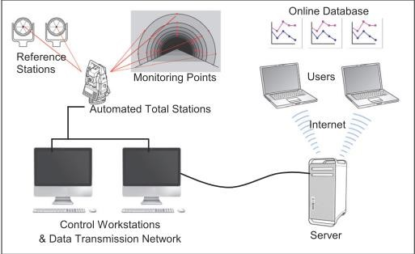

**Figure 2:** Vulnerability Curve

**Crack Width Monitoring**

Most of the buildings crack at some time during their service life. Cracks are the first indication of a serious defect which may affect the serviceability or the stability of building. Monitoring changes in crack width across a crack helps determine the cause of cracking and the necessary remedial measures. Incorrect assessment can lead to an expensive and unnecessary remedial work. It is important to develop a systematic methodology to gather information and assess the significance of cracks.

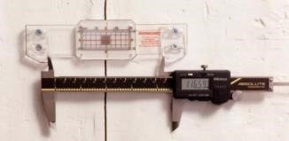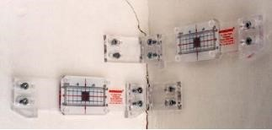

**Figure 3:** Crack Monitoring Equipment

**Tiltmeters**

A tiltmeter is a sensitive inclinometer designed to monitor changes in the inclination of the structure. Tiltmeter data can provide accurate history of movement of a structure and early warning of potential structural damage. It consists of a rugged stainless-steel frame with aluminum sensor housing containing the MEMS (Micro-electro-mechanical) technology inclinometer. Measurements for rotation of buildings / structures can be done on horizontal or vertical surface.

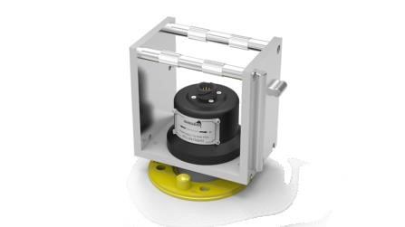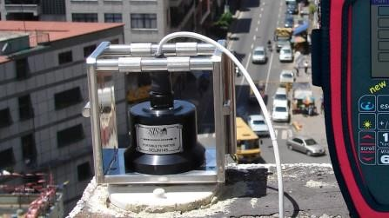

**Figure 4:** Tiltmeters

1. **ANALYSIS**

**Patna Metro Rail Line 3 Project**

The TBM was commissioned in the month of May 2023 at Moin Ul Haq stadium, which constructed a 1.5 km long tunnel between MUH and Patna university.

TBM-1 has worked around the clock to build a 1.5 km of fully lined tunnel, which completes the first drive of its 1.5 km journey towards the Gandhi Maidan. The tunnel construction is performed by Conventional Method (NATM) and Tunnel Boring Machines (TBM), the total stretch was divided in 7 packages. Since the tunnel work is going to be under many important and high-rise building structures it is important to monitor the deformation of the existing building structures coming near by the tunnel passage.

So, various instrumentation is installed to monitor the deformation at different time and different location throughout the length, here providing some of the report to understand process of monitoring and reporting system of deformation.

**Table 1**. Instrumentation Details for Seepz Ramp Shaft

|  |  |  |
| --- | --- | --- |
| **Instrumentation Details for Seepz Ramp Shaft** | |  |
| **S.No.** | **Description** | **Numbers** |
| 1 | SSM (Soil/Pavement Settlement Marker) | 67 |
| 2 | BSM (Building Settlement Marker) | 3 |
| 3 | Strain Gauge | 8 |
| 4 | Load Cell | 4 |
| 5 | Stand Pipe Piezometer | 1 |
| 6 | Inclinometer | 6 |
| 7 | CM (Crack Meter) | 4 |
| 8 | Optical Target | 21 |
|  | Total | 114 |

**Daily Monitoring Data**

Soil Settlement Monitoring Report

Soil Settlement Monitoring Graph-Seepz Ramp Shaft

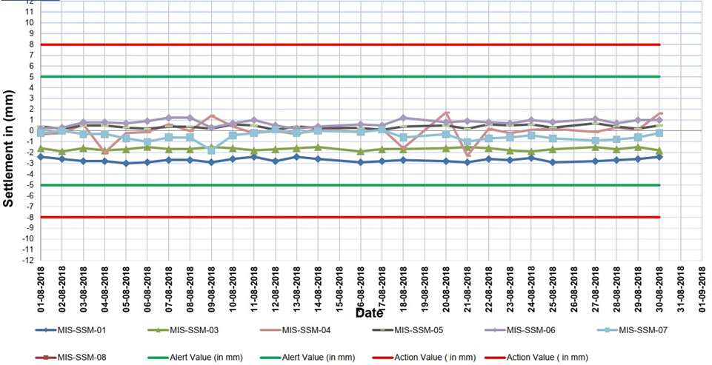

**Figure 5:** Soil Settlement Monitoring Report

**Pavement Marker Monitoring Graph-Seepz Ramp Shaft**

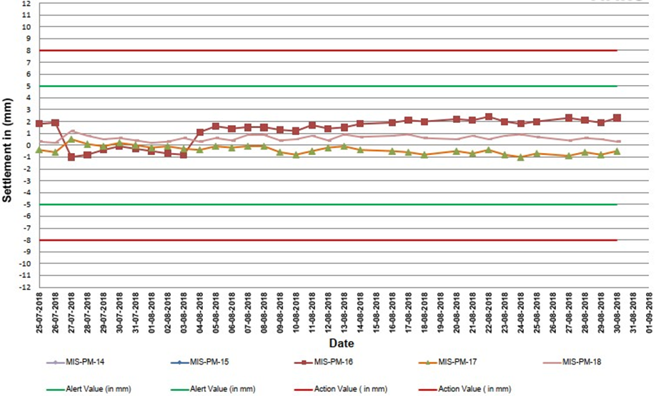

**Figure 6:** Pavement Marker Monitoring Graph

**Table 2**. Strain Gauge Report

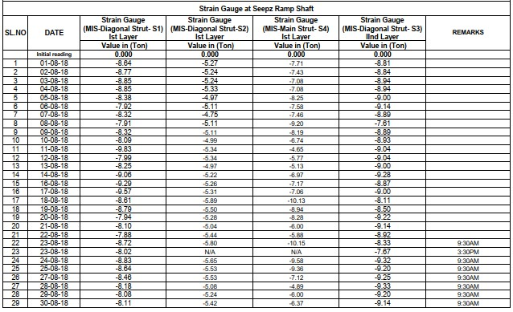

1. **DESIGN OF TUNNEL SEGMENT**

This design pertains to precast concrete segments, which is the final inner lining for TBM (Tunnel Boring Machine) tunnel section. Designed internal diameter of the finished tunnel for a single track is 5800mm (5.8m) including all tolerances. The thickness of final lining is 275mm. The analysis of the bored tunnel linings is done considering the interaction between the lining and the ground, the deflection of the lining and the redistribution of the loading dependent upon the relative flexibility of the lining, the variability and compressibility of the ground.

The Loads acting on the lining includes earth pressure and water pressure, dead load, reactions, surcharge. The lining shall also be checked to resist the various loads arising due to handling, stacking, temporary grout load pressure, TBM thrust, Load on Bolts & erector, gasket forces etc.

**Table 3.** Surcharge Loads

|  |  |
| --- | --- |
| **Description** | **Load Value** |
| Equivalent Traffic Surcharge Load | 20 kN/m2 |
| Surcharge Load | 50 kN/m2 |
| Loads from existing or known future adjacent structures above or within the area of influence, which will remain in place above the bored tunnels, or any specified future loading | To be computed based on the type and use of the foundation, and the known loads. |
| Loads and load changes due to known construction activity in the vicinity of the bored tunnel. | To be computed based on the activity, otherwise 50kN/m2 assumed. |
| **Figure 7:** FEM model showing ground as per General case and surface loading | |

Maximum Overburden and General ground condition Surcharge = 50kN/m2

Output Diagrams of RS2 file:

Axial Force

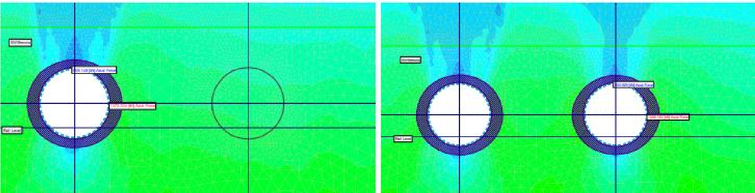

Axial Force in liner at stage 2Axial Force in liner at stage 3

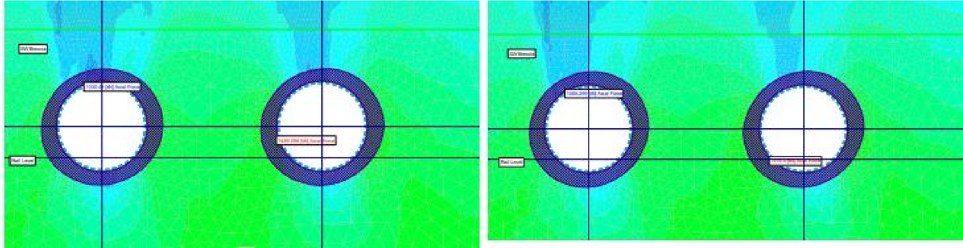

Axial Force in liner at stage 4 Axial Force in liner at stage 5

**Figure 8:** Axial Force Diagram for tunnel segment

**Bending Moment**

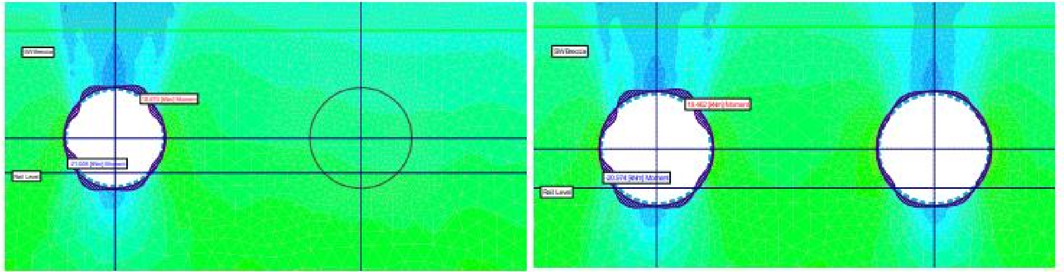

Bending moment in liner at stage 2 Bending moment in liner at stage 3

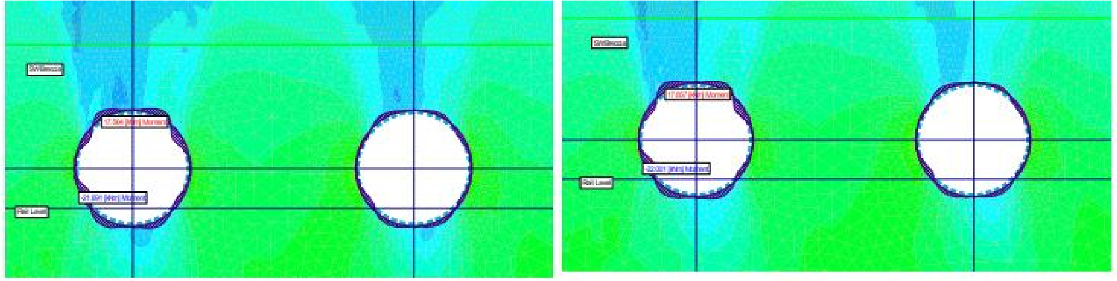

Bending moment in liner at stage 4 Bending moment in liner at stage 5

**Figure 9:** Axial Force Diagram for tunnel segment

1. **CONCLUSION**

Tunnels are very important construction work in contest of space, facility, modern technology, and comfort. Both the tunnelling method (TBM and NATM) are suitable for all type of tunnel construction, mechanized way of tunnelling is costlier and faster than NATM based tunnelling.

The invention of tunnel boring machine (TBM) has revolutionized tunnelling construction, it has created spaces under cities allowing Metro rail systems, water and sewage systems and underground cable networks, all to be built in a safe and sustainable manner. These machines have advantages of limiting the disturbance to the surrounding ground and producing a smooth tunnel wall. This significantly reduces the cost and makes it suitable for heavily urbanized areas. The major disadvantage is the difficulties to transport and the upfront cost which reduces as the tunnel gets longer. TBM is used for tunnel construction in most of the infrastructure projects like, hydropower, sewerage, water supply, irrigation and transportation in various geological circumstances.

NATM is based on the observational approach whole outcome depends on the geological interpretation and monitoring data. This method provides flexibility to change the support systems at regular intervals depending on received data from face logs and monitoring. It helps in quick analysis and applies on the field which saves times. Monitoring data ease outs to identify the exact locations deformation, so that additional supports can be introduced thus reduces the number of mis-happenings. NATM provides better options to choose between anticipated conditions and actual conditions due to its flexible nature thus save time, money and material and provides better progress in such unexpected conditions.

There are various measuring instruments used to monitor the deformation of tunnels and surrounding existing structure and non-structural elements which helps the designer to introduce additional temporary support to avoid caving and lose of man hours due to any mishappening.

Based on the geological and geotechnical study of the subgrade, the behaviour of the rock mass and surrounding soil to the tunnel are anticipated, based on those temporary supports are used. Software like STAAD Pro and RS2 are used to design the final lining of tunnel for the various loads which are to be directly or indirectly exerted on them.

1. **REFERENCES**

[1] Soil Nailing for Radial Reinforcement of NATM Tunnels by Prof. Dr. Emad Abd Elmonem Osman, Prof. Dr. Mostafa Z. Abd Elrehim, Eng. Ibrahim Abed, Journal of American Science 2015.

[2] New Austrian Tunneling Method (NATM) in Himalayan Geology: Emphasis on Execution Cycle Methodology by Aejaz Ahmad, Natasha Ahirwar and Mayank Sinha, International Journal of Engineering Research & Technology (IJERT), June 2019

[3] Performance Review of Tunnel Boring Machines by Saikat Gope, Indrajan Ghosh, Satadal Bhattacharya, Jaydip Ghosh, Dr. Sandip Ghosh, International Journal of Engineering Research & Technology (IJERT), 2021

[4] Tunnels and Tunneling Operations: Introduction to Old and New Era, Akshay kumar Ardeshana, Jayeshkumar Pitroda, J.J. Bhavsar, International Conference on: “Emgineering: Issues, opportunities and Challenges for Development.

[5] Review on Tunnel Construction by New Austrian Tunneling Method by Mr. Sandesh S. Barbole, Mr. Rajdeep D. Pawar, International Research Journal of Engineering and Technology (IRJET), Jan 2021.

[6] Analysis for Tunnel Construction Technology by Areeb Ahmad, Masoom Reza, International Journal of Engineering Research & Technology (IJERT), Oct 2020.

[7] Technical Manual for Design of Construction of Road Tunnels, American Association of State Highway and Transportation Officials (AASHTO).

[8] Guidelines for the Design of Tunnels, ITA Working Group.

[9] General Report on Conventional Tunnelling Method from ITA Working Group.

[10] General Report on Mechanized Tunnelling Method from ITA Working Group

[11] An insight into the New Austrian Tunnelling Method (NATM) by M. Karakus (Department of Mining Engineering Enonu University, Malaty 44069, Turkey) & R.J. Fowell (Department of Mining & Mineral Engineering in Leeds University, LS2 9JT, UK), Research Gate.

[12] Design of Fiber-Reinforced Tunnel Segmental Lining According to New ACI Report, Mehdi Bakhshi & Verya Nasri, AECOM, New York, USA, Resilient Infrastructure, June1-4, 2016

[13] Technical Manual for Design and Construction of Road Tunnels – Civil Elements, FHWA-10-034, December 2009