**DAMAGE ASSESSMENT OF INTEGRAL BRIDGE UNDER EARTHQUAKES**

**Abhinav Kumar Singh1, Mirza Aamir Baig2**

1M. tech Student, Department of Civil Engineering, KK University, Nalanda, Bihar, India

2Assistant Professor, Department of Civil Engineering, KK University, Nalanda, Bihar, India

**ABSTRACT**

The bridge damage due to the past earthquake hugely affect the transportation systems. Many such bridges were designed with outdated regulation codes. The strong motion in several elements show how vulnerable such structures are. Generally, conventional bridges are low-cost construction but it requires high maintenance cost hence integral bridges reduced life-cycle cost and long-term maintenance. The integral bridge gives improved design efficiency and improved riding quality more than the conventional type of bridges. This study analytically determines the seismic fragility of an Integral box girder bridge. A set of 10 excitation records of ground motion considering near field area is utilized for nonlinear dynamic analysis of the bridge. A 3-D finite component model theme is employed during this study considering nonlinearity within the bridge piers. The part fragility curves area unit combined to judge the fragility curves for the complete bridge system at completely different injury states. The unstable demand consists in a set of nearfield ground motions to judge the probability of exceeding the unstable capability of the mentioned bridges.

**Keywords:** Earthquake, Bridge damage, Vulnerability curve, Box Girder, IDA Curve

1. **INTRODUCTION**

There is an old saying that, ‘a chain is as weak as its weakest link’. Bearings and expansion joints are the weak links. Hence, interest in integral Bridges or jointless Bridge is increasing and their performance has gained international attention. Presumably, the primary reason for this interest is due to the acceptance of integral Bridges by many transportation departments throughout the world. Integral Bridges are constructed without any bearings or joints between spans or between spans and abutments.

Integral Bridges are Bridges where the deck is continuous and connected with monolithically with the abutment with a moment resisting connection. As an effect we obtain a structure acting as one unit.

One of the most important aspects of design, which can affect structure life and maintenance costs is the reduction or elimination of roadway expansion joints and associated expansion bearings. Unfortunately, this is too often overlooked or avoided. Joints and bearings are expensive to buy, install, maintain and repair and more costly to replace. The most frequently encountered corrosion problem involves leaking expansion joints and seals that permit salt-laden run-off water from the roadway surface to attack the girder ends, bearings and supporting reinforced concrete substructures. Elastomeric glands get filled with dirt, rocks and trash, and ultimately fail to function. Many of our most costly maintenance problems originated with leaky joints.

Integral abutment construction has become an increasingly popular alternative to conventional construction in recent years. In conventional construction, the superstructure typically consists of a series of simply supported spans separated by expansion joints and resting on bearings at the abutments and intermediate piers. In integral construction, the superstructure and abutments form a continuous, monolithic structure. The structure may be made integral with the intermediate piers or may rest on elastomeric bearings. Integral construction has increased in popularity because it eliminates maintenance associated with joints and bearings. However, in the absence of the joints and bearings used in conventional construction, the abutments and foundations must accommodate the movements associated with both thermal and seismic movements.

One of the most common problems in the seismic resistance of traditional Bridge construction is unseating of the superstructure from the support bearings. This problem is eliminated in integral abutment construction as there are no support bearings. However, the system of joints and bearings used in traditional construction allows superstructure movements during a seismic event which result in a decreased demand on the foundation. In integral abutment construction, the foundation piles and abutment must be able to accommodate these increased demands.

|  |  |
| --- | --- |
|  |  |
| **Figure 1:** Integral Bridge | |

1. **METHODOLOGY**

A fundamental requirement for estimating the seismic performance of a particular structure is the ability to quantify the potential for damage as a function of earthquake intensity (e.g., peak ground acceleration). A probabilistic seismic performance analysis (PSPA) based on fragility curves provides a framework to estimate the seismic performance and reliability of the structures (Ellingwood et al. 2004; Razzaghi and Eshghi 2014; Jeon et al. 2015). Fragility functions relate the probability that the demand on a particular structure exceeds its capacity to an earthquake severity measure. It can be expressed as follows:



where Fr = fragility function, Sd = structural demand, Sc = structural capacity and SM = earthquake severity measure. Assuming that the demand and capacity are random variables represented by a standard lognormal function, the Eq. (1) becomes:

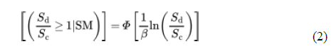

where Φ[.] = the standard normal distribution function and β = logarithmic standard deviation of the variables.

To develop the fragility curves using the analytical method, a few popular simulation methods need to be applied. The assessment can be categorized into two main groups, namely, Nonlinear Static Analysis and Nonlinear Dynamic Analysis.

Nonlinear static analysis or pushover analysis (POA) is one of the methods used to develop fragility seismic curves. a capacity curve initially evaluated the appropriateness of POA in damage analysis, from which the fragility curve.

The capacity curves can represent mean or mean plus/minus with one/two/three times the standard deviation of capacity curves. From these capacity curves, the results can be compared with those of the Performance-Based Seismic Design (PBSD) in generating fragility curve.

It is important to choose a nonlinear analysis tool while considering its limitation. Such a toll can provide an accurate investigation and stable NTHA of the structure.

1. **MODELING AND ANALYSIS**

Integral Bridges are Bridges where the deck is continuous and connected with monolithically with the abutment with a moment resisting connection. As an effect we obtain a structure acting as one unit. Till today India practicing deck slab Bridges and a recent integral Bridge concept has been introduced in Delhi metro project and Hyderabad metro project.

For the design and analysis of integral Bridges, the dimension of Bridge is considered and some data are assumed in the present work of modelling of integral and conventional Bridge is as follows;

**Table 1.** Bridge Modelling Data

|  |  |
| --- | --- |
| Dimension of Bridge | |
| Total Length of Bridge | 60m |
| Number of spans | 3 (each of 20m length) |
| Width of deck | 10.5m |
| Number of lanes | 2 |
| Shape of pier | circular |
| Diameter of pier | 1.2m |
| Height of pier | 7 m |
| Materials | |
| Concrete | M40 |
| Steel | Fe415 |

In the quick general bridge template, we entered layout data, superstructure and substructure data and live load data. In this model we consider the length of the Bridge is 60m having 3 spans each of 20m length. Taking bridge section type as concrete box girder - AASTHO-PCI-ASBI Standard bridge.

|  |  |
| --- | --- |
|  |  |



**Figure 2:** Bridge Model

*3.1 Ground motion selection*

In order to conduct non-linear (partial) dynamic analysis, 10 Near-Field ground motions were selected from the PEER website (https://ngawest2.berkeley.edu/) based on the Zone V MCE level hazard. The Zone V MCE level hazard has been selected as per the target performance objective mentioned earlier, where the friction dampers are expected to slip and dissipate seismic energy. The details of each individual earthquake have been summarized in Table below. For assessing the structure using the time-history analyses, the mean spectrum of all these ground motions has to be more than 90% of the target demand spectrum (ASCE7-16) for a range a time period of the structure. The range of time period has been selected as 0.2T to 2T with the lower 0.2T again lowered to include 90% of mass participation in each principal direction of the building. The target response spectra here corresponding to Zone V MCE level hazard, considering 1.5 load factor for earthquake loading.

**Table 2.** Ground Motions

|  |  |  |  |  |  |  |  |
| --- | --- | --- | --- | --- | --- | --- | --- |
| **Earthquake Name** | **Year** | **Magnitude** | **Rjb (km)** | **Rrup**  **(km)** | **Vs30 (m/sec)** | **PGA** | **PGV** |
| "Imperial Valley02" | 1940 | 6.95 | 6.09 | 6.09 | 213.4 | 0.28 | 30.9 |
| "Gazli_ USSR" | 1976 | 6.8 | 3.92 | 5.46 | 259.5 | 0.70 | 66.1 |
| "Tabas_ Iran" | 1978 | 7.35 | 0 | 13.94 | 471.5 | 0.32 | 22.2 |
| "Corinth_ Greece" | 1981 | 6.6 | 10.27 | 10.27 | 361.4 | 0.23 | 22.9 |
| "Nahanni_ Canada" | 1985 | 6.76 | 2.48 | 9.6 | 605.0 | 1.28 | 40.9 |
| "Superstition Hills02" | 1987 | 6.54 | 0.95 | 0.95 | 348.6 | 0.43 | 134.2 |
| "Loma Prieta" | 1989 | 6.93 | 3.85 | 10.72 | 476.5 | 0.45 | 51.3 |
| "Erzican_ Turkey" | 1992 | 6.69 | 0 | 4.38 | 352.0 | 0.49 | 78.1 |
| "Cape Mendocino" | 1992 | 7.01 | 0 | 8.18 | 422.1 | 0.59 | 49.3 |
| "Landers" | 1992 | 7.28 | 11.03 | 11.03 | 379.3 | 0.27 | 27 |

**Table 3.** Damage state and maximum story drift Ratio

|  |  |
| --- | --- |
| Damage State | Maximum drift Ratio |
| No Damage | 0.2 |
| Slight Damage | 0.5 |
| Moderate Damage | 1.5 |
| Heavy Damage | 2.5 |
| Major Damage | 5 |

#### **Table 4.** Damage state and maximum Base Shear

|  |  |
| --- | --- |
| Damage State | Maximum Base Shear |
| No Damage | 5%W |
| Slight Damage | 10% W |
| Moderate Damage | 15%W |
| Major Damage | 20%W |

Seismic weight of bridge = 11221.951 KN

1. **RESULTS AND DISCUSSION**

The selected bridge model is analyzed using upper bound pushover analysis. This chapter presents elastic modal properties of the bridge, pushover analysis results and discussions. Pushover analysis was performed first in a load control manner to apply all gravity loads on to the structure (gravity push). Then a lateral pushover analysis in transverse direction was performed in a displacement control manner starting at the end of gravity push. The results obtained from these analyses are checked against the seismic demand corresponds to the Zone V (PGA = 0.36g) of India. Modal properties of the bridge model were obtained from the linear dynamic modal analysis. Table 5.

**Table 5.** Modal Period and Frequencies

|  |  |  |  |  |  |  |
| --- | --- | --- | --- | --- | --- | --- |
|  | Case | Step | Period | Frequency | Circular Frequency | Eigen Value |
| MODAL | Mode | 1 | 0.408543 | 2.4477257 | 15.37951436 | 236.52946 |
| MODAL | Mode | 2 | 0.150933 | 6.6254777 | 41.6291044 | 1732.9823 |
| MODAL | Mode | 3 | 0.121004 | 8.2641639 | 51.92527327 | 2696.234 |
| MODAL | Mode | 4 | 0.100875 | 9.9132643 | 62.28687672 | 3879.655 |
| MODAL | Mode | 5 | 0.089646 | 11.155015 | 70.08902732 | 4912.4718 |
| MODAL | Mode | 6 | 0.084027 | 11.900899 | 74.77555611 | 5591.3838 |
| MODAL | Mode | 7 | 0.084016 | 11.902524 | 74.78576442 | 5592.9106 |
| MODAL | Mode | 8 | 0.08195 | 12.20262 | 76.67132239 | 5878.4917 |
| MODAL | Mode | 9 | 0.074456 | 13.430693 | 84.38753452 | 7121.256 |
| MODAL | Mode | 10 | 0.04847 | 20.631292 | 129.6302307 | 16803.997 |

Incremental dynamic analysis is a parametric analysis in which the structure is subjected to a series of ground motions having multiple levels of intensity to estimate thorough structural performance by producing curves of response parameter versus intensity measure. The ground motions may be selected from the data base of real ground motions or artificially generated ground motion. Real ground motions are more realistic and contain all the actual characteristics of strong ground motions i.e., amplitude, duration, frequency content, energy content etc. In the present study, a set of 10 real ground motions are selected from strong motion record database (http://ngawest2.berkeley.edu/). The selected ground motions are having relatively larger magnitude ranging from 6.24 to 7.37 and PGA values from 0.24g to 1. 21g.The results for incremental dynamic analysis for drift ratio and maximum base shear shear are plotted.

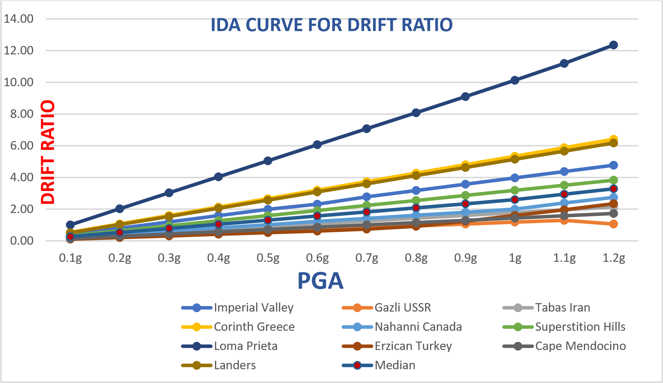

**Figure 2:** Drift ratio IDA curve

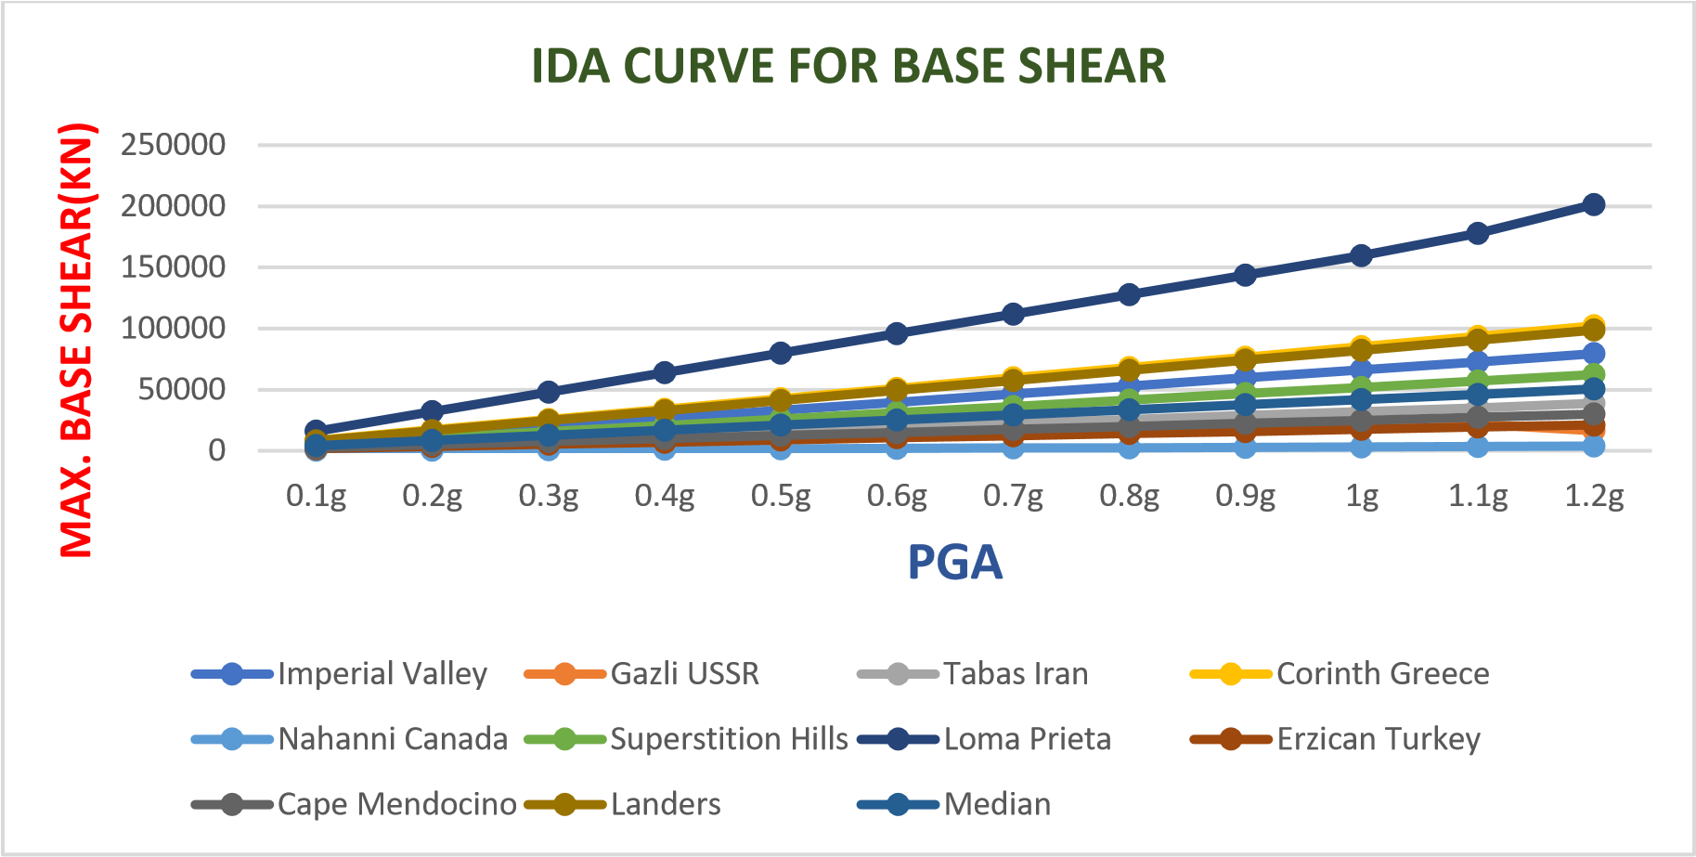

**Figure 3:** Base Shear IDA curve

In this study, the seismic fragility is presented in the damage probability curve (fragility curve). All set of fragility curves were plotted. For instance, Fig. shows the fragility curve based on the near-field ground motions. According to the figure illustrated, the performance of structure can be determined in terms of probability. For example, the probability of OP level is 0% when the PGA is 0.2 g which is considered as weak ground motions, but the probability of OP level is 48% when exposed to strong ground motion at PGA .6 g. In CP level, it starts to occur at PGA .4 g. The probability of CP level is 100% when the PGA is more than .8 g. Hence, this fragility curve can provide some ideas about the condition of the structure, in which the PGA starts from 0.2 g until 0.8 g based on the percentage of drift. In addition, the loss of damage can also be predicted using the fragility curve.



**Figure 4:** Fragility Curve Drift Ratio



**Figure 5:** Fragility Curve Base Shear

1. **CONCLUSION**

* The design procedure outlined in IRC codes does not account for the possibility of plastic hinge formation in an extreme seismic event. Non-linearity is completely neglected in seismic analysis.
* For Bent 1: Base shear before yielding from pushover analysis comes out to be

2.1*103kN and displacement of 21 mm.

* Base shear after yielding from pushover analysis comes out to be 2500 kN and displacement of 42 mm.
* For Bent 2: Base shear before yielding from pushover analysis comes out to be

2220 kN and displacement of 23 mm.

* Base shear after yielding from pushover analysis comes out to be 2.5*103kN and displacement of 44 mm.
* Demand capacity ratio is found to be 0.25.
* Bridge section forces found to be Max=3480.755 kN-m & Min=5192.95 kN-m.
* Bridge section stresses found to be Max= 962.95 kN/m2 & Min=1252.43 kN/m.
* The POE for different types of earthquakes was compared at three levels of PGA including 0.2g (low), 0.4g (medium), and 0.8g (high) and 1.2 g (severe). The highest POE is provided by NF earthquake of the order of 1.43 % at 0.2g, 6.7 % at 0.4g, 21.28 % at 0.8g and 34.8 % at 1.2g.

1. **REFERENCES**

[1] Amit Bamnali, P.J. Salunke, “A Review and Comparison of the Integral Bridge and Conventional Bridge”, International Research Journal of Engineering and Technology (IRJET), www.irjet.net, Volume: 05, Issue: 12 Dec 2018, e-ISSN: 2395-0056, pISSN: 2395-0072.

[2] Apurwa Yawale, Mr. P. S. Lande, “Seismic Vulnerability Assessment of Bridge using Pushover Analysis”, International Journal of Engineering Research & Technology (IJERT), Vol. 3, Issue 2, February – 2014, ISSN: 2278-0181.

[3] Babitha Elizabeth Philip, “An Exploratory Study on Integral Abutment Bridges(IAB)”, IJSRD - International Journal for Scientific Research & Development| Vol. 5, Issue 08, 2017 | ISSN (online): 2321-0613.

[4] Byung H. Choi, Lorenz B, Churl-Soo Lim, Duy-Duan, Tae-Hyung Lee, “Seismic Performance Evaluation of a Fully Integral Concrete Bridge with End-Restraining

[5] Abutments”, Hindawi Advances in Civil Engineering Volume 2019, Article ID 6873096, 12 pages, https://doi.org/10.1155/2019/6873096.

[6] Jozsef Simon, Laszlo Gergely Vigh, “Seismic fragility assessment of integral precast multi-span bridges in areas of moderate seismicity”, Bull Earthquake Eng , DOI 10.1007/s10518-016, Accepted: 28 May 2016 Springer Science+ Business Media Dordrecht 2016.

[7] Mohammad Farhan and Mohd Tasleem, “Pushover analysis of reinforced concrete bridge pier designed as per IRC-6 codal provision”, Journal of Civil & Environmental Engineering, Volume 10:5, 2020, DOI: 10.37421/jcce.2020.10.356, Published 24 August 2020.

[8] M.P.Bastwadkar , S.S.Manekari(2017), “Analysis of integral bridge for dead load and moving loads”, IJRET: International Journal of Research in Engineering and Technology, eISSN: 2319-1163, pISSN: 2321-7308, Volume: 06 Issue: 06 Jun 2017, Available @ http://www.ijret.org.

[9] Prital G. Kalasur and R.Shreedhar, “Study Of Integral Abutment Bridges With Soil Structure Interaction”, International Journal of Advance Foundation And Research In Science & Engineering (IJAFRSE) Volume 1, Special Issue , TACE 2015.

[10] Semih Erhan · Murat Dicleli, “Comparative assessment of the seismic performance of integral and conventional bridges with respect to the differences at the abutments”,