Experimental Investigation on Fly Ash & Glass Powder As Partial Replacement of Cement For M-25 Grade Concrete

**Yasir Arafat1, M.P. Verma2**

Department of Civil Engineering

1 M. Tech. Scholar, Madhyanchal Professional University,Bhopal, Madhya India.

2 Prof. Madhyanchal Professional University, Bhopal, Madhya Pradesh, India.

Offivialyasarafat[r@gmail.com](mailto:r@gmail.com), dr.mpverma@mpu.ac.in

***Abstract-****Preservation of environment and conservation of natural resources is the essence of any development. Also the present R and D continuously deal with technological and industrial development on waste management. In order to address environmental effects associated with cement manufacturing, it is crucial to advance alternative binders to compose concrete. Consequently extensive delving is continuing, on substitution of cement by differing waste materials and industrial offshoot. As partial replacement of cement attempts on fly ash, waste glass, rice husk etc. have already been accomplished in concrete industries. If little waste material found convenient and economical for concrete manufacturing, a major gain will be achieved in disposal of waste management and depression in construction cost. The work audits the feasibility of fly ash, glass powder as partial substitute of cement respectively. The initial stage proceeds with replacing 25% cement content by variant proportions of fly ash (FA) and glass powder (GP). After then it is analyzed for flexural and compressive strength, at 7, 14 & 28 days and correlated with traditional concrete. The adequate results were attained with the combination of cement 75% and fly ash 25% in ratio, w.r.t properties tested.*

***Keywords****-*Compressive Strength, Flexural strength, Fly Ash, Glass powder, Replacement.

# INTRODUCTION

During recent years the consciousness regarding environmental atrocity has increased as a result the interest of construction community in using waste or recycled materials in concrete has also aggravated. If we see around us, we can see so many materials we consider waste which rather must be seen as opportunities. The waste glass pieces from the shops are disposed of as waste material but glass being an inert substance can be recycled without any chemical reaction. The fly ash is produced in abundance in the thermal power plants as abate product which is not easy to be disposed of and is dangerous to the environment. Recycled concrete aggregate is produced by crushing concrete to reclaim the aggregate.

Recycled aggregate can be used for many purposes. The primary market is road base for information on recycling asphalt pavement into new asphalt pavement. Reused aggregates obtained demolished construction and graded for use as an aggregate in the production of further concrete.

Glass material used in daily construction and other purposes will be a perfect material for reusing. The utilization for reused glass on new compartment aides spare from claiming vitality. The measure for waste glass will be bit by bit expanded through those late a considerable length of time because at any point developing utilization of glass results. When waste glass is reused to make cement products, the creation expense of cement will go down. Pounded glass or cullet, in appropriately measured and processed, could show aspects similar to that of gravel or sand. Cement organizations must treat a mix of OPC and fly ash as a benchmark, As far as workability, cost, strength, etc., when setting execution focuses to the generation for PPC. The utilization of PPC or a mix of OPC and fly ash are needed to get the pressing necessity about today to keep up manageability for development. Significantly investigations have been carried out looking into properties of concrete having fly ash as reinstatement for cement. It is a well-known truth that fly ash holds large advantages as far as safety against sulphate attack, soluble base silica reaction, carbonation, chloride attacks and economy is concerned.

# MATERIALS & METHODOLOGY

1. **MATERIALS USED**
   1. Cement (OPC)
   2. Sand
   3. Aggregate
   4. Fly ash
   5. Glass Powder
   6. CEMENT: Cement having cohesive & adhesive properties providing a binding medium for the separated ingredients.

Chemically cement constitutes 60-67% Lime (CaO), 17-25% Silica (SiO2), 3-8% Alumina (Al2O3), 0.5-6% Iron Oxide (Fe2O3), 0.1-6% Magnesia (MgO), 1-3% Sulphur Trioxide (SO3), 0.5-3% Soda And Potash (Na2O+K2O).

* 1. SAND: Sand is a naturally happening granular material made of finely isolated rocks and mineral particles. It is characterized by size, being finer than gravel and coarser than silt. Sand could additionally be referred as textural class of soil or soil type; i.e. a soil holding more than 85% sand-sized particles (by mass).
  2. NATURAL COARSE AGGREGATE: Construction aggregate, or essentially “Aggregate”, is a material used in construction which includes mix particles of slag gravel, sand, recycled concrete, crushed stone etc. The majorly mined materials in the universe are aggregates. Aggregates comprise composite materials for example, concrete and asphalt concrete; the aggregate serves as reinforcement for overall composite material. Because of the relatively high hydraulic conductivity value as contrasted with most soils, aggregates are generally utilized within waste requisitions for example, foundations and French drains, septic drain fields, retaining wall drains, and road side edge drains. Aggregates are likewise utilized as base material under foundations, roads, and railroads.
  3. FLY ASH: Fly ash, otherwise called flue-ash, may be a standout amongst the residues created under combustion, and comprises those fine particles that rise with flue gases. Ash that doesn’t rise is called bottom ash. In mechanical context, fly ash typically alludes with burning of coal. Fly ash is obtained by electrostatic precipitators and suction pumps before the gasses goes through coal-fired power plant’s chimneys. Since, it depends upon the source of the coal burning continuously and the contents for fly ash particles.
  4. GLASS POWDER: Glass being transparent material produced by melting a mixture of silica, soda ash, and CaCO3 at temperature emulated by cooling during which hardening happens without crystallization. Glass products are normally used in our daily fabricated items. Since the increase of waste glass leads over the recent years and these waste glass pieces have been dumped and occasionally not in use. The waste glass fill areas are not in use since glass is less eco-friendly and is not biodegradable.

on the specimen as per the same IS code. Calculations are done by dividing the maximum applied compressive load by area of cross section of compressive face of the specimen. As there are three specimens for each batch mix, the average of the three values is taken.

3. FLEXURAL STRENGTH: Beams of size 10cm*10cm*50cm are casted for determining flexural strength. Test on beams are performed at the age of 28 days of the specimen. Placement of specimen in machine is done as per IS: 516-1959 in the clause no 8.3.1 page no 17. Load is applied at increasing rate of 108KN/min. Load is applied until specimen fails and load at which specimen fails is recorded. As specified in the IS code flexural strength is calculated.

# RESULT & DISCUSSION

Table 1: Compressive Strength Result

|  |  |  |  |  |
| --- | --- | --- | --- | --- |
| **Mix** | **COMBINATION**  **( % Replacement**) | **Compressive Strength**  **(N/mm2)** | | |
| **7**  **days** | **14**  **days** | **28**  **days** |
| M-1 | C+S+NCA | 18.17 | 20.63 | 24.13 |
| M-2 | C(75%)+S+NCA+  FA(25%)+GP(0%) | 23.20 | 26.40 | 30.61 |
| M-3 | C(75%)+S+NCA+ FA(20%)+GP(5%) | 21.74 | 24.72 | 28.67 |
| M-4 | C(75%)+S+NCA+FA  (15%)+GP(10%) | 21.08 | 24.03 | 27.36 |
| M-5 | C(75%)+S+NCA+FA  (10%)+GP(15%) | 18.91 | 21.75 | 25.16 |
| M-6 | C(75%)+S+NCA+  FA(5%)+GP(20%) | 21.08 | 19.87 | 22.86 |
| M-7 | C(75%)+S+NCA+  FA(0%)+GP(25%) | 21.56 | 17.71 | 20.32 |

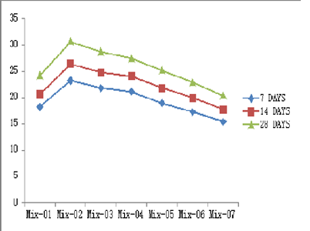

Graph 1: Compressive Strength in N/mm2 at various age (Days)

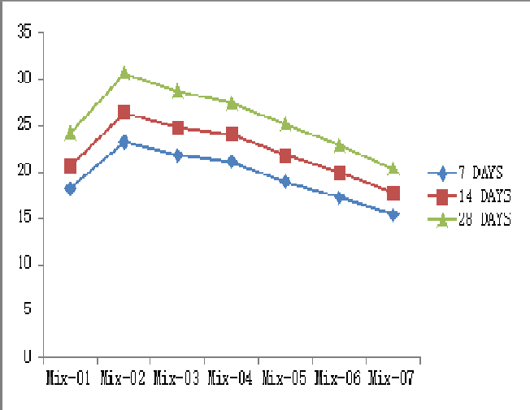

1. COMPRESSIVE STRENGTH: A minimum of three cubesare casted in each batch mix for determining compressive

strength. Tests are performed at the age of 28 days of the specimens. Specimens are placed in the test machine as per IS: 516-1959 clause no 5.5.1 page no 11, also loading is applied

Table 2: Flexural Strength Result

|  |  |  |  |  |
| --- | --- | --- | --- | --- |
| **Mi x** | **COMBINATION**  **( % Replacement)** | **Flexural Strength**  **(N/mm2)** | | |
| **7**  **days** | **14**  **days** | **28**  **days** |
| M-  1 | C+S+NCA | 3.88 | 4.45 | 5.14 |
| M-  2 | C(75%)+S+NCA+FA(2 5%)+GP(0%) | 4.85 | 5.58 | 6.43 |
| M-  3 | C(75%)+S+NCA+FA(2 0%)+GP(5%) | 4.53 | 5.34 | 6.02 |
| M-  4 | C(75%)+S+NCA+FA(1 5%)+GP(10%) | 4.46 | 5.19 | 5.98 |
| M-  5 | C(75%)+S+NCA+FA(1 0%)+GP(15%) | 4.21 | 4.89 | 5.57 |
| M-  6 | C(75%)+S+NCA+FA(5  %)+GP(20%) | 3.88 | 4.43 | 5.13 |
| M-  7 | C(75%)+S+NCA+FA(0  %)+GP(25%) | 3.62 | 4.20 | 4.75 |

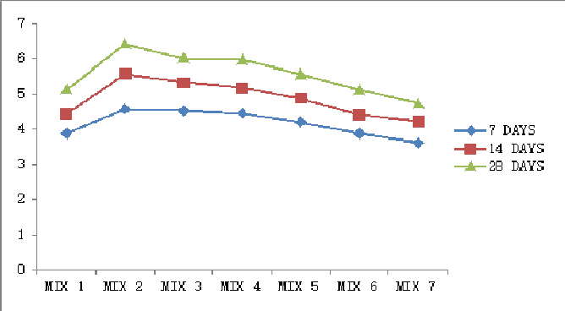

Graph 2: Flexural Strength in N/mm2 at various age (Days)

# CONCLUSIONS

From the above graphs and previous discussion, following conclusion has been drawn:-

Overall MIX 2 have a great efficiency of flexural and compressive strengths.

# REFERENCE

1. R. Nagalakshmi, Experimental Study On Strength Characteristics Onm25 Concrete With Partial Replacement Of Cement With Fly Ash And Coarse Aggregate With Coconut Shell, International Journal Of Scientific & Engineering Research, Volume 4, Issue 1, January-2013, ISSN 2229-5518.
2. D.N. Parekh and Dr. C. D. Modhera, Characterization Of Recycled Aggregate Concrete, International Journal of Advanced Engineering Technology E-ISSN 0976-3945 IJAET/Vol. II/ Issue IV/October-December, 2011/321- 330.
3. M. R. Karim, M. F. M. Zain, M. Jamil, F. C. Lai and M.

N. Islam, Strength Development Of Mortar And Concrete Containing Fly Ash, International Journal Of The Physical Sciences Vol. 6(17), pp. 4137-4153, 2 September, 2011.

1. Chandana Sukesh, Katakam Bala Krishna, P. Sri Lakshmi Sai Teja, S. Kanakambara Rao, Partial Replacement of Sand with Quarry Dust in Concrete, International Journal of Innovative Technology and Exploring Engineering (IJITEE) ISSN: 2278-3075, Volume-2, Issue-6, May 2013.
2. C.Marthong, T.P. Agrawal, Effect of Fly Ash Additive on Concrete Properties, International Journal of Engineering Research and Applications Vol. 2, Issue 4, July-August 2012, pp.1986-1991.
3. Dr. G. Vijayakumar, Ms H. Vishaliny, Dr. D. Govindarajulu, Studies on Glass Powder as Partial Replacement of Cement in Concrete Production, International Journal of Emerging Technology and Advanced Engineering, Volume 3, Issue 2, February 2013.
4. B. Damodhara Reddy, S. Aruna Jyothy , Fawaz Shaik, Experimental Analysis Of The Use Of Coconut Shell As Coarse Aggregate, IOSR Journal of Mechanical and Civil Engineering (IOSR-JMCE) e-ISSN: 2278-1684,p-ISSN: 2320-334X, Volume 10, Issue 6 (Jan. 2014), PP 06-13.
5. The replacement of cement at an optimum percentage by FA (25%), improved compressive and flexural strengths as compared to traditional concrete.
6. On decreasing percentage replacement of FA (25% to 0%) by increasing percentage replacement of GP(0% to 25%), a decreased strength is determined, i.e. When GP is used as a replacement material, strength of concrete gets reduced.
7. P. Padma Rao, A. Pradhan Kumar, B. Bhaskar Singh, A Study On Use Of Rice Husk Ash In Concrete, IJEAR Vol. 4, Issue Spl-2, Jan - June 2014.
8. Umapathy U 1, Mala C2, Siva K, Assessment Of Concrete Strength Using Partial Replacement Of Coarse Aggregate For Waste Tiles And Cement For Rice Husk Ash In Concrete, Umapathy U Et Al Int. Journal Of Engineering Research And Applications ISSN : 2248- 9622, Vol. 4, Issue 5( Version 1), May 2014, pp.72-76.