Design of Multi storey (G+7) Residential Building

**GUGULOTHU NAGESH**

Associate Professor

Civil Engineering

Bomma Institute of Technology & Science, Khammam, Telangana, India.

**KASHIMALLA RAVINDRA**

Associate Professor

Civil Engineering

Bomma Institute of Technology & Science, Khammam, Telangana, India.

**ABSTRACT:**

Urbanization and population increase led to the development of unusual housing alternatives. G+7 residential complexes offer a realistic solution for increasing land use efficiency while accommodating an expanding metropolitan population. The use of G+7 residential buildings, which include a ground floor and eight extra levels, has grown more common in urban development. This architectural decision tackles a variety of current housing difficulties, particularly in highly populated locations. This abstract investigates the numerous applications and advantages of G+7 residential buildings in the modern day.

The aim of our work is to design, estimate and to calculate the cost of a G+7, 3-BHK Residential building according to Indian Standard codes. The design of a building can be done manually or with the help of Software. We have chosen partly manual and partly software because complete manual design consumes a lot of time, effort and can contain errors, but employing partial approaches allows us to save time and get errorless outcomes.

**Key Words: G+7, Residential Building, Plan, Design**

1. **INTRODUCTION:**

The design of G+7 residential buildings must address several key factors to ensure functionality, safety, and sustainability. Architectural aesthetics, structural integrity, and compliance with safety regulations are fundamental components that drive the design process.

This journal provides a comprehensive overview of the design principles and considerations specific to G+7 residential buildings. By focusing on the design of G+7 residential buildings, this journal seeks to contribute to the ongoing discourse on sustainable urban development.

1. **METHODOLOGY:**

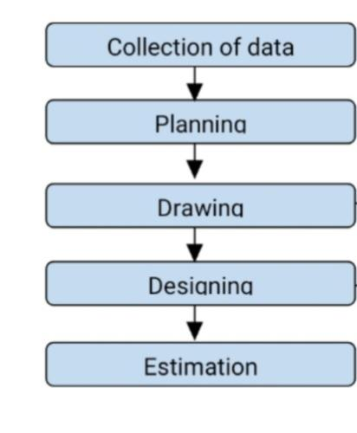

1. **BUILDING DATA FOR ANALYSIS:**

* Live Load: 3.0 KN/Sq.m
* Thickness of slab: 150 mm
* Type of Soil: Medium Soil, (Type-II as per IS: 1893 (Part-1))
* Allowable bearing pressure: 200 KN/Sq.m
* Each Storey Height: 3 m
* No of Floors: Ground+7
* External Wall Thickness: 230 mm
* Internal Wall Thickness: 150 mm
* Column Size: 300x550 mm
* Beam Size: 300x400 mm
* Wind Load: As per IS: 875-1987 (Part-3)

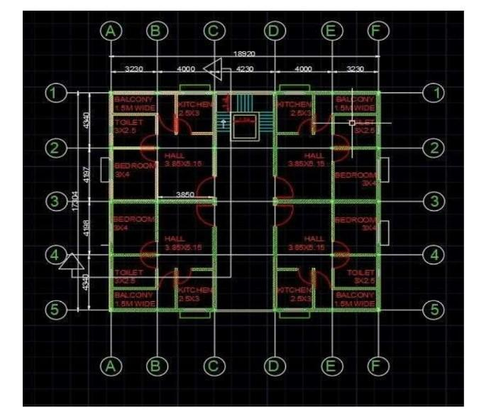**Typical Plan View of G+7 Residential Building**

**III. LOADS**

1. **DEAD LOAD:**

A dead load refers to the permanent, static weight of the structural components of a building or structure. This includes the weight of materials such as:

* Beams
* Columns
* Floors
* Roofs
* Walls

Dead loads are considered constant over time and are a crucial factor in structural design as they affect the stability and integrity of the building. Unlike live loads, which can vary over time (e.g., people, furniture, vehicles), dead loads are predictable and do not change

* **LOAD CALCULATIONS:**

SELF - WEIGHT OF SLAB LOAD:

Floor loads for 150mm thick slab

Thickness of slab -150mm

Unit weight of reinforced concrete - 25.00kN/m3

= 0.150 x 25

= 3.75 KN/m2

Dead load of slab = 3.75kN/m2

Floor finishes = 1kN/ m2

= 3.75+1 = 4.75 KN/m2

Total load of slab = 4.75 KN/ m2

* **SELF-WEIGHT OF BEAM LOAD:**

Beam Size- 300x450mm

Unit weight of reinforced concrete - 25.00kn/m3

= 0.3 x 0.4 x 25 = 3 KN/m3

* **WALL LOADS:**

**EXTERNAL WALL**

230mm thick wall for 3.0 heights

Thickness of wall ,b : 0.23m

Height of walls , h - 3.0mm

Unit weight of brick masonry, γ – 19 KN/m3

= 0.23 x 3.0 x 19

Total load h*b* γ = -13.11 KN/m

**INTERNAL WALLS**

150mm thick wall for height 3.0m

Thickness of wall , b - 0.15m

Height of walls ,h - 3.0m

Unit weight of brick masonry, γ– 19 KN/m3

= 0.15 x 3.0 x 19

Total load h*b* γ = 8.55 KN/m

**BALCONY WALL LOAD**

Thickness of wall ,b - 0.230m

Parapet wall ,h - 1.00m

Unit weight of brick masonry ,γ – 19 KN/m3

= 0.230 x 1 x 19

Total load h*b* γ = 4.37 KN/m3

1. **LIVE LOADS (OR) IMPOSED LOADS:**

A live load refers to the variable weight that a structure must support in addition to its own weight (dead load). Live loads are not constant and can change over time, depending on the use and occupancy of the structure. Examples of live loads include:

* People
* Furniture
* Vehicles
* Equipment and machinery that can be moved
* Snow, if it accumulates on the roof

Live loads are considered when designing buildings to ensure safety and functionality under various conditions. The magnitude and nature of live loads depend on the type of building and its intended use.

LIVE LOAD AS PER CODE IS: 875 (PART-2)

* Living rooms 2.000 KN/ m2
* Staircase, corridor 3.000 KN/ m2
* Terrace 1.5 KN/ m2

**C. WIND LOADS:**

The horizontal load caused by the wind is called wind loads. It depends upon the velocity of wind and shape

and size of the building. Complete details of calculating wind loads on structures are given in IS 875(part -3)-

1987. For low rise building say up to four to five stories, the wind load is not critical because the moment of resistance

provided by the continuity of floor system to column connection and walls provided between columns are

sufficient to accommodate the effect of these forces.

Design Wind Speed ,**Vz = Vb x K1 x K2 x K3**

Where

Vb- Design Wind Speed

K1- Probability factor

K2 – Terrain factor

K3- Topography Factor

Exposure factor is -1.0 (As per code)

**D.EARTHQUAKE FORCES:**

Earthquake forces are horizontal forces caused by earthquake and shall be computed in accordance with IS

1893-1984.

**SEISMIC LOAD CALCULATIONS**

Length of the building ,lx = 18.69 m

Width of the building ,lz = 17.074 m

Height of the building ,h = 21.0 m

Ta = 0.09h/d^0.5

Zone factor Z = 0.1 ((Page 16 of 1893-2002)

X-DIRECTION

T = 0.09h/d2 = 0.09 x 21/18.69 Sq. Root

Px = 0.101 sec

Z-DIRECTION

T = 0.09h/d2 = 0.09 x 21/17.074 Sq. Root

Pz = 0.11 sec

Response reduction factor R = 3.0 (Page 23 of 1893-2002)

Px = 0101

Pz = 0.110

Importance factor I = 1.0 (Table 6 of 6.4.2)

Soil interaction factor SS = 2.0 For Medium soil

Self- weight -1(As per Code) Member weight -18.5Kn/m2

**DESIGN CONSTANTS:**

Using M25 and Fe 415 grade of concrete and steel for beams, slabs, footings, columns

Therefore: -

Fck= characteristic strength for M25 N/mm2

Fy= Characteristic strength of steel – 415N/mm2

**CONCLUSION**:

STAAD (Structural Analysis and Design) is a comprehensive software tool used for structural engineering analysis and design.

STAAD can be used to analyze the results and to calculate the required reinforcement for various structural elements. This includes the amount, spacing, and placement of rebar needed to resist by calculating internal forces and ensuring structural integrity

**REFERENCES**:

1. Scarlet A (1997), “Design of Soft Stories-A Simplified Energy Approach,” Earthquake Spectra, 13: 305–315
2. Piyush Tiwari et al. 07 Oct 2015 International Research Journal Of Engineering And Technology (IRJET).
3. Dr. S.R. Karve & Dr. V.L. Shah - “Illustrated design of Reinforced concrete Buildings”
4. N. Krishna Raju - “Advanced Reinforced Concrete design”
5. Misam.A and Mangulkar Madhuri.N., “Structural Response of Soft Story-High Rise Buildings Under Different Shear Wall Location”, International Journal of Civil Engineering & Technology (IJCIET), Volume 3, Issue 2, 2012, pp. 169 - 180, ISSN Print: 0976 – 6308,ISSN Online: 0976 – 6316
6. Khan, P. I., and Dhamge, N.R., ―Seismic analysis of multistoried RCC building due to mass irregularity, IJEDR,Vol:14, Issue: 03 pp.65-69, 2016
7. Mayuri D. Bhagwat, Dr. P.S.Patil, ―Comparative Study of Performance of RCC Multistory Building for Koyna and Bhuj Earthquakes‖ in IJATES, Vol: 02, Issue: 07, pp.67-72, 2014.
8. <https://www.academia.edu/42837130/Analysis_Design_and_Estimation_of_G_7_Storey_Building_Structure_by_using_IS_Code_Methods_and_by_Softwares>
9. <https://www.journal-dogorangsang.in/no_1_sept-dec_20/46.pdf>
10. <https://www.ijsr.net/archive/v8i5/ART20198123.pdf>

**AUTHORS**

**GUGULOTH. NAGESH**,

Associate Professor in Civil Engineering,Bomma institute of technology and science Khammam, Telangana, India.

**KASHIMALLA. RAVINDRA,**

Associate Professor in Civil Engineering,Bomma institute of technology and science Khammam, Telangana, India.

**KILARU. POOJA,**

Received the B. Tech degree in Civil Engineering from the University of JNTUH,The college of Bomma institute of technology and science in the year of 2024.

**BATTEM. SWETHA,**

Received the B. Tech degree in Civil Engineering from the University of JNTUH,The college of Bomma institute of technology and science in the year of 2024.

**REPAKULA. SHIVA RAMA KRISHNA,**

Received the B. Tech degree in Civil Engineering from the University of JNTUH,The college of Bomma institute of technology and science in the year of 2024.

**PITTALA. MANISHA,**

Received the B. Tech degree in Civil Engineering from the University of JNTUH,The college of Bomma institute of technology and science in the year of 2024.

**GUDIPALLI. SANDEEP,**

Received the B. Tech degree in Civil Engineering from the University of JNTUH,The college of Bomma institute of technology and science in the year of 2024.