IOT BASED GARBAGE MONITORING SYSTEM

Bomma Satya prasad
Associate Professor
Electronics and Communication Engineering
Bomma institute of technology and science
Khammam, Telangana, India
Kanaparthi Raju
Assistant Professor
Electronics and Communication Engineering
Bomma institute of technology and science
Khammam, Telangana, India

Abstract: Proper Management of waste should be a priority to ensure the safety of public health. Waste management and awareness is a new concept in developing countries. The conventional method of manually monitoring waste in waste bins is a complicated procedure that requires more human work, time, and money, and it is no way compatible with modern technologies. This paper proposes and discusses a very unique technique that will assist in keeping cities clean. This system monitors the waste bins and provides web-based information regarding the amount of garbage collected in the bins.

KeyWords: Arduino Microcontroller, Ultrasonic sensor, Wifi module, GPS Module, LCD

I.INTRODUCTION
Garbage carries the unwanted materials that are left over in city, public space, society, college, home etc. This project can be used in the "Smart City" and is based on the "Internet of Things" (IoT). cleanliness is needed and cleanliness begins with the way the garbage bin is being utilized and maintained. This system will help to eradicate or minimize the garbage disposal problem. However, due to the increasing population, garbage management has decreased and the pollution levels have also been increased a lot. Many parts of the city still lack public garbage bins. The open garbage containers create problems for the people living in that vicinity as it becomes the breeding ground for insects like mosquitoes, germs, which spreads numerous diseases. In order to clean up the bins and to avoid this, smart waste management and monitoring systems ought to be adopted. Open selling and dropping of waste within open dumpsites result in serious health risks like skin infection and chronic diseases. Whenever the garbage bin is filled to a maximum level, this system will send the degree of filling alert message to the work station. Then the garbage is collected by the specific authorities, as they receive a notification from the system. This paper focuses on developing a wise smart garbage system for observance of the amount of the garbage collected inside the garbage bin using improvised technologies.

II.EXISTING SYSTEM
Device-to-device communication, which allows data access across a short distance, has yet to find an efficient solution. Moreover, the garbage is collected by corporation, once or twice in a week or on alternated days or on a daily basis.
Though the garbage stinks and overflows, the garbage meets the roads and cause malady to kith and kin. It results in lot of traffic and noise and also an unsanitary environmental condition. As the price of the hardware and software system programs are valuable, it is highly tough to implement and also the existing systems consumes lot of power.
III.PROPOSED SYSTEM
The system proposed in this paper is developed for an IoT based real time monitoring of garbage that ensures the real time monitoring and ensures that it saves the time and money for garbage monitoring and collection. A network of garbage. In this system, an account of their monitoring and collection has been proposed and implemented in bins and are laid under observation for this piece of work. In this system of the designed network of the garbage bins, each of the garbage bin is equipped with Wifi containing an advanced feature of built in Wifi capabilities and ultrasonic sensor. This system enables to transfer the data collected by the sensor to garbage monitoring system. Through the monitored data, it informs to garbage collection truck drivers to collect garbage from that particular garbage bin.
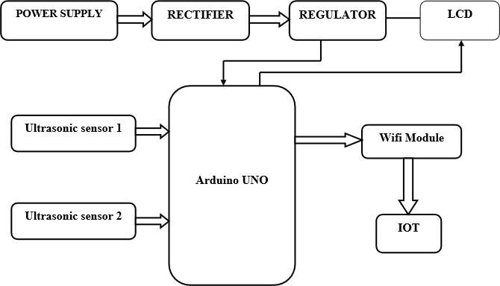
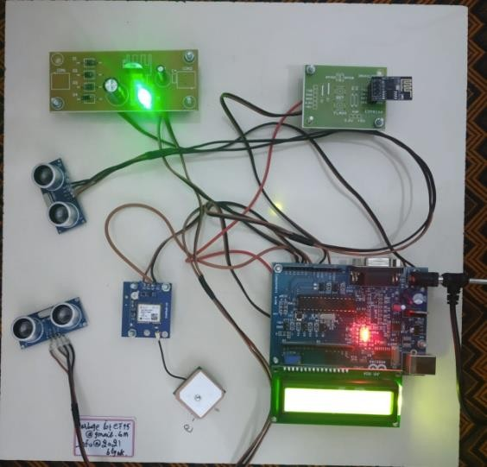

Fig.1. BLOCK DIAGRAM

The figure depicts the proposed system's basic block diagram, which shows two ultrasonic sensors used to determine the distance, which is essentially the level or degree to which the garbage bin is dumped with waste. The system includes an Arduino microcontroller, an LCD screen, a Wi-Fi modem for data transmission, and a buzzer. A 12V transformer provides electricity to the system. The LCD panel shows the current status of the garbage collection in the bins. The web page displays a graphical representation of the garbage bins and color-codes the waste collected to indicate the amount of garbage collected. The garbage level is displayed on the LCD panel. When the amount of garbage collected exceeds the set limit, the system activates the buzzer. As a result, this technology contributes to keeping the city clean by providing a graphical image of the bins via a web page that informs about the garbage levels in the bins.

IV.EXPERIMENTAL SETUP
  - ULTRASONIC SENSOR: This sensor detects the distance between the garbage level in the bin and sends the data to the Arduino microcontroller.
  - ARDUINO UNO: It plays an important role. It collects and processes data from the Ultrasonic sensor. It compares the receiver data to the threshold level and generates the appropriate output.
  - POWER SUPPLY: We use 5V power supply to provide the DC voltage in the board.

Fig.2. External Structure Model

  - GPS MODULE: This module is mostly used to determine the location of the waste bin. After that, the garbage was collected.

  - WI-FI MODULE: Through IoT, the information available from the Arduino is delivered to the user through this Wifi module.
V.RESULTS AND DISCUSSION
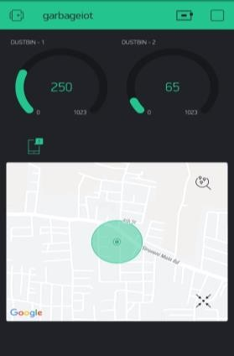
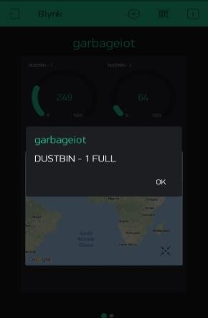
In this paper, a smart garbage bin is attached with the distance measuring sensor implemented with the help of IoT technology. This system doesn’t require a special training to the user to handle. It is a user-friendly device and even an illiterate can operate easily as the values are displayed in the LCD display with colour codes indicating the level of filling. It reminds the user, by sending the notification through the android application if the garbage bin is filled. Cleaning the garbage waste at right time, will reduce the serious health problems.
Fig.3. Filled State of Garbage Bin 1
The information of the filled status of dustbin one, as well as its geographical location, is shown in the diagram above. "DUSTBIN- 1 FULL" is the information provided or sent by the system for this filled state.
On the android application supported by the GPS system, the above figure shows the driving map to reach the filled garbage bin, which facilitates in finding and locating the filled garbage bin.
VI.CONCLUSION
In this paper, an integrated system comprising Wi-Fi electronic equipment, IoT, built-in GPS module, and inaudible sensor element for garbage collection monitoring and maintenance is developed. Overflow of waste from the container in residential areas, which was previously either filled manually or with the use of loaders in traditional trucks, can be avoided by applying this technology. It has the ability to automatically monitor the garbage level and provide data to the garbage pickup truck. The technologies employed in the proposed system are sufficient to ensure that the solid waste collection process is monitored and managed in a way that is both practical and environmentally friendly.
References
[1] Neha shinde, Sayli Bhambre, Shraddha Thakur, Varsha Devkule. (2018)."ASurvey on Garbage Collection and Monitoring System for Smart cities using IOT", ISSN 2395-0072, Volume: 05 Issue: 02, IRJET,
[2]. Sayali Suryakant Chalke, Mohini Bhalerao, Swapnali Bangar, Dhanashree Gaikwad, S. G. Dhengre. (2018)."A Survey on IOT Based Smart Garbage Monitoring System", ISSN 2454-132X, Volume:04, Issue 02, IJARIIT.
[3]. Prajakta More, Shelkikar R.P. (2019). "A Survey on Garbage Monitoring using IOT", ISSN 2319- 8753, Vol. 8, Issue.
[4]. Minhaz Uddin Sohag, Amit Kumer Podder. (2020)"Smart garbage management system for a sustainable urban life”, Volume 11.
[5]. Innu Sosu nova, Jari Porras. (2022)."IoT-Enabled Smart Waste Management Systems for Smart Cities: A Systematic Review", IEEE.
[6]. Harshita Chugh, Dushyant singh, Shahensha shaik, Ashwani Singla (2019)."IOT Based Smart Bin", eISSN: 2395-0056, Volume: 04 Issue: 09.
[7]. Muruga anandam S, Ganapathy V and Balaji R, (2018)."Efficient IOT Based Smart Bin for Clean Environment", Research Gate.
[8]. Tulsiram Reddy, Shivashankar Kb, Rahul M Govin. (2016)."Efficient IOT Based Smart Bin for Clean Environment", ISSN: 2348-409, National Conference on Communication and Image Processing, 2019 International Journal on Recent and Innovation Trends in Computing and Communication, ISSN: 2321-8169, Volume: 4, Issue: 5, pp. 225 - 229 IJRITCC.
[9]. Dr. N. Sathish Kumar, B. Vijayalakshmi, R. Jenifer prarthana, A Shankar. (2019)."IOT Based Smart Garbage alert system using Arduino UNO", IEEE.
[10]. Mohammad Hossein Ghahramani, Meng Chu Zhou, Anna Molter, and Francesco Pilla. (2022)"IoT Based Route Recommendation for an Intelligent Waste Management System", IEEE INTERNET OF THINGS JOURNAL, VOL. 9, NO.

AUTHORS
- BOMMA SATYA PRASAD Associate Professor Electronics and communication Engineering Bomma institute of technology and science Khammam, Telangana, India.
- Kanaparthi Raju Assistant Professor Electronics and Communication Engineering Bomma institute of technology and science Khammam, Telangana, India.
- Purnakanti Sriram received the B. Tech degree in Electronics and Communication Engineering from the University of JNTUH, the college of Bomma institute of technology and science in the year of 2024. Interested topics are VLSI Design, Digital Signal Processing, Antennas, Microwave Engineering, Optical Communication and Embedded system.
- Kadari Poojitha received the B. Tech degree in Electronics and Communication Engineering from the University of JNTUH, the college of Bomma institute of technology and science in the year of 2024. Interested topics are VLSI Design, Digital Signal Processing, Antennas, Microwave Engineering, Optical Communication and Embedded system.
- Lakkakula Sruthi received the B. Tech degree in Electronics and Communication Engineering from the University of JNTUH, the college of Bomma institute of technology and science in the year of 2024. Interested topics are VLSI Design, Digital Signal Processing, Antennas, Microwave Engineering, Optical Communication and Embedded system.
- Sanigarapu pooja received the B. Tech degree in Electronics and Communication Engineering from the University of JNTUH, the college of Bomma institute of technology and science in the year of 2024. Interested topics are VLSI Design, Digital Signal Processing, Antennas, Microwave Engineering, Optical Communication and Embedded system.

