**EFFECTIVENESS OF SKILL DEVELOPMENT PROGRAMME FOR**

**ENTREPRENEURS IN NSIC**

*\* Sujitha.E, II MBA, School of Management Studies, Vels Institute of Science Technology and Advanced Studies (VISTAS), Pallavaram.*

*\*\* Dr.G.Amutha, Associate professor, School of Management Studies, Vels Institute of Science Technology and Advanced Studies (VISTAS), Pallavaram.*

**Abstract:**

Skills and knowledge are vital for economic growth and social development, enabling countries to navigate domestic and international job markets effectively. The 2011-12 NSSO report shows that only 2.2% of Indians aged 15-59 received formal vocational training, and 8.6% received nonformal training, highlighting a significant challenge. Skill development programs are crucial for empowering entrepreneurs, but their effectiveness is in question. This project aims to assess these programs' impact on entrepreneurial success by evaluating skill acquisition, business performance, sustainability, and socio-economic impact through surveys, interviews, and case studies. The study seeks to provide insights to enhance these programs, ensuring a workforce with up-to-date skills, knowledge, and qualifications to secure employment and maintain India's global competitiveness.

**Keywords:**

Economic growth ,Social development, Skills, Vocational training, NSSO, Formal training,Nonformal training,Skill development programs, Entrepreneurial success, Skill acquisition ,Business performance, Sustainability

**Introduction:**

Skills and knowledge are crucial for economic growth and social development, enabling countries to handle domestic and international job market challenges effectively. According to the 2011-12 NSSO report, only 2.2% of Indians aged 15-59 received formal vocational training, and 8.6% received non-formal training, highlighting a significant challenge. Skill development programs are vital for equipping entrepreneurs with essential skills, but their effectiveness is in question. This project aims to assess the impact of these programs on entrepreneurial success by evaluating skill acquisition, business performance, sustainability, and socio-economic impact. Using surveys, interviews, and case studies, we aim to understand how these programs influence entrepreneurial growth and community development. The goal is to create a skilled workforce with up-to-date knowledge and internationally recognized qualifications, increasing productivity and employability in both organized and unorganized sectors. The focus is on youth, women, disabled, and disadvantaged groups, aiming to improve the system to adapt to changing technologies and labor market demands. Key objectives include evaluating skill application, analyzing business performance, assessing business sustainability, and exploring the broader socio-economic effects of skill development initiatives.

**Statement of the problem:**

Despite the critical role of skills and knowledge in driving economic growth and social development, India faces a significant challenge in vocational training. According to the 2011-12 NSSO report, only 2.2% of individuals aged 15-59 have received formal vocational training, and 8.6% have received non-formal vocational training. This indicates a considerable gap in the nation's skill development efforts. Skill development programs are essential for equipping aspiring and established entrepreneurs with the necessary competencies to thrive in both domestic and international job markets. However, the effectiveness of these programs is in question. There is a need to evaluate how well these programs enhance skill acquisition, business performance, sustainability, and socio-economic impact. This project aims to assess the impact of skill development programs on entrepreneurial success, seeking to provide valuable insights that can improve the design and implementation of such initiatives. By understanding the dynamics that shape entrepreneurial growth and community development through a mixed-methods approach, including surveys, interviews, and case studies, this study will address the gaps in current skill development strategies and propose solutions to enhance the effectiveness and reach of these programs

**Need for Study:**

The need for an effective skill development program for entrepreneurs in the National Small Industries Corporation (NSIC) is critical for several reasons:

* Skill development for entrepreneurs drives economic growth.
* It enhances innovation and competitiveness in the market.
* These programs contribute to job creation, especially in SMEs.
* Entrepreneurial success rates improve with skill development.
* They help address socio-economic challenges like poverty and inequality.
* Skilled entrepreneurs can access global markets more effectively.
* studying effectiveness informs better policymaking for entrepreneurship support.

**Objectives of the Study**

The objectives of an effective skill development program for entrepreneurs in the National Small

Industries Corporation (NSIC) can vary based on the specific needs and goals of the organization.

However, some common objectives include

* To study on effectiveness of skill development programme for entrepreneurs.
* To assess the impact of the skill development program on participants employability and professional competence.
* To evaluate the alignment of the skills imparted through the program with the current and future needs of industries.

**Review of Literature**

**1.Burke, Michael J.Day, Russell R. (2011)**:

Meta-analysis procedures were applied to the results of 70 Managerial Training (MT) studies. The meta-analysis results for 34 distributions of MT effects representing 6 training-content areas, 7 training methods, and 4 types of criteria (subjective learning, objective learning, subjective behaviour, and objective results) indicated that MT was moderately effective. For 12 of the 17 MT method distributions, the 90% lower-bound credibility values were positive, and thus the effectiveness of these training methods, at least minimally, can be generalized to new situations.

**2.Mark E. Mendenhall, Edward Dunbar and Gary R. Oddou (2012**):

In order to delineate the current state of the art of overseas relocation programs in U.S.

multinational corporations, the extant literature was reviewed in the areas of expatriate personnel selection, training and career-pathing. The implications of the study's findings for U.S. MNCs are discussed and recommendations for policy change are offered.

**3.J. Stewart Black and Mark Mendenhall (2014):**Increased internationalization in the economic, political, and social arenas has led to greater interpersonal cross-cultural contact. Because much of this contact has not been successful, cross-cultural training has been proposed by many scholars as a means of facilitating more effective interaction. However, most firms do not utilize cross-cultural training. The cross-cultural training framework proposed in this article is based on both theory and a review of the cross- cultural training literature. The contingency framework proposed provides a practical guide for determining the method and rigor of cross-cultural training most effective in various circumstances.

**4.John Paul Mac duffie, Thomas A. Kochan (2015):** We investigate the common assertion that U.S. firms invest less in human resources than key international competitors, testing four alternative explanations for differences in training effort found in survey data from an international sample of fifty-seven automobile assembly plants. We find the strongest support for the view that the level of training is derived from the requirements of the business/production strategy and the overall ―bundle‖ of human resource policies—beyond training—adopted by the firm.

**5.Bishop, J. H. (2016):** While the importance of on-the-job training is recognized by everyone, it is a phenomenon that is very difficult to study. Most training is informal and hard to measure and its effects on productivity are even more difficult to quantify. An elegant theory explaining how the quantity of training is determined and who pays for and benefits from it has been available for more than a third of a century (Becker 1962). However, the absence of data on the key theoretical constructs of the theory--general training, specific training, informal training and productivity growth--means that the only predictions of the theory that have been tested relate to the effects of formal training and tenure (interpreted as a proxy for informal training) on wage growth and turnover.

**Limitations of the Study:**

The main limitations of the study are as follows:

* One-size-fits-all approach may not cater to diverse entrepreneurial needs and levels of expertise.
* Participation fees and resource requirements may exclude economically disadvantaged individuals from accessing the program.
* Emphasis on theoretical knowledge over practical skills applicable in real-world business scenarios may limit program effectiveness.

**Research Methodology**

* Research Design – Descriptive Research
* Sources of Data – Secondary Data

**Statistical Techniques**

* Simple Percentage Analysis
* Correlation
* Regression Analysis

**Analysis and interpretation:**

**1. Gender**

**Table showing Gender**

|  |  |  |
| --- | --- | --- |
| **Particular** | **Frequency** | **Percentage** |
| Male | 55 | 52.9 |
| Female | 49 | 47.1 |
| Others | 0 | 0 |
| **Total** | **104** | **100** |

**Chart showing Gender**

Forms response chart. Question title: 2.Gender
. Number of responses: 104 responses.

**INTERPRETATION:**

This data represents the gender distribution within a sample of 104 individuals. Among them, males account for 55 individuals, constituting approximately 52.9% of the total, while females represent 49 individuals, accounting for approximately 47.1%. Notably, there are no individuals categorized as "Others" in this sample. This data underscores a slightly higher presence of males compared to females, albeit the difference is relatively modest.

# Regression

**Model Summaryb**

|  |  |  |  |  |  |  |  |  |
| --- | --- | --- | --- | --- | --- | --- | --- | --- |
| Model | R | R Square | Adjusted  Square | R | Std. Error of the  Estimate | Change Statistics |  |  |
| R Square Change | F Change | df1 |
| 1 | .215a | .046 | .028 |  | .914 | .046 | 2.516 | 1 |

1. Predictors: (Constant), 5.How satisfied were you with overall content of the skill development program
2. Dependent Variable: 4.How would you rate your level of entrepreneurial experience

**ANOVAa**

|  |  |  |  |  |  |  |
| --- | --- | --- | --- | --- | --- | --- |
| Model |  | Sum of Squares | df | Mean Square | F | Sig. |
| 1 | Regression | 2.100 | 1 | 2.100 | 2.516 | .119b |
| Residual | 43.400 | 52 | .835 |  |  |
| Total | 45.500 | 53 |  |  |  |

1. Dependent Variable: 4.How would you rate your level of entrepreneurial experience
2. Predictors: (Constant), 5.How satisfied were you with overall content of the skill development program

**Coefficientsa**

|  |  |  |  |  |  |  |
| --- | --- | --- | --- | --- | --- | --- |
| Model |  | Unstandardized Coefficients | | Standardized  Coefficients | t | Sig. |
| B | Std. Error | Beta |
| 1 | (Constant)  5.How satisfied were you with overall content of the skill development program | 1.825 | .249 |  | 7.338 | .000 |
| .225 | .142 | .215 | 1.586 | .119 |

# Charts

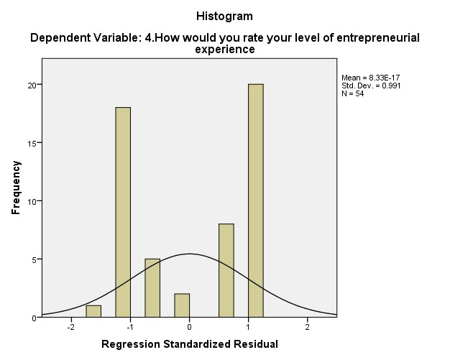

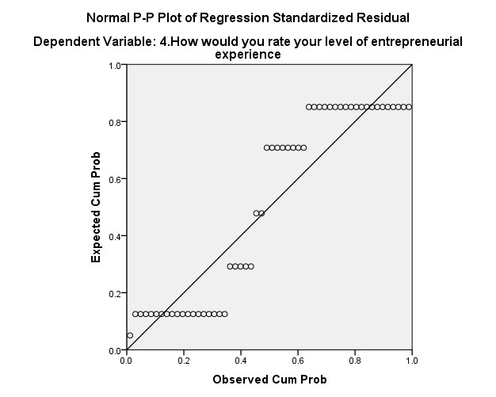

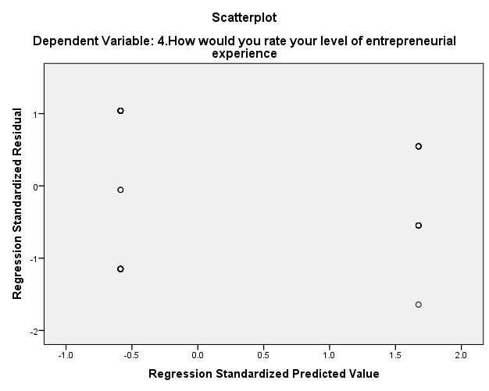

**INTERPRETATION:**

The correlation coefficients between the level of entrepreneurial experience and satisfaction with the skill development program content are 0.192 and 0.192, respectively. These positive correlations indicate a slight relationship between entrepreneurial experience and program satisfaction. However, with p-values of 0.164, neither correlation is statistically significant at the conventional alpha level of 0.05. Thus, while there's some indication of a connection, it's not strong enough to be considered significant. With a sample size of 54 for both variables, there's a decent amount of data, but larger samples could strengthen the analysis.

**Correlations:**

|  |  |  |  |
| --- | --- | --- | --- |
| **Correlations** |  |  |  |
| 4.How would you rate your level of  entrepreneurial experience | Pearson Correlation | 1 | .215 |
| Sig. (2-tailed) |  | .119 |
| N | 54 | 54 |
| 5.How satisfied were you with overall content of the skill development  program | Pearson Correlation | .215 | 1 |
| Sig. (2-tailed) | .119 |  |
| N | 54 | 54 |

|  |  |  |  |  |
| --- | --- | --- | --- | --- |
| **Correlations** |  |  |  |  |
| Spearman's rho | 4.How would you rate your level of  entrepreneurial experience | Correlation  Coefficient | 1.000 | .192 |
| Sig. (2-tailed) | . | .164 |
| N | 54 | 54 |
| 5.How satisfied were you with overall content of the skill development program | Correlation  Coefficient | .192 | 1.000 |
| Sig. (2-tailed) | .164 | . |
| N | 54 | 54 |

**INTERPRETATION:**

The Pearson correlation coefficient between the level of entrepreneurial experience and satisfaction with the skill development program content is 0.215. This positive correlation suggests a modest relationship between these two variables. However, with a p-value of 0.119, the correlation is not statistically significant at the conventional alpha level of 0.05. Therefore, while there is some indication of a relationship, it may not be strong enough to draw definitive conclusions. The sample size of 54 for both variables provide a reasonable amount of data for analysis, but larger samples could enhance the reliability of the findings.

**FINDINGS :**

* Participants generally acquire essential entrepreneurial skills through skill development programs.
* However, the application of these skills in real-world business settings varies, indicating a need for more practical training components.
* Businesses led by program participants often show initial growth and innovation, attributed to enhanced skills.
* Challenges in sustaining growth beyond initial phases are observed, suggesting the need for ongoing support and mentoring.
* Long-term sustainability of businesses led by program participants remains a concern, influenced by factors such as market volatility and access to financing.
* Programs that incorporate continuous support mechanisms demonstrate better prospects for business viability.
* Skill development initiatives contribute positively to community development by increasing employment opportunities.
* However, the impact varies across different demographics and regions, with urban areas generally benefiting more than rural or remote areas.
* Mixed-methods approach (surveys, interviews, case studies) provides comprehensive insights into the dynamics of entrepreneurial growth and community development.
* Recommendations include enhancing program flexibility, targeting specific demographic groups more effectively, and integrating market-driven skills training.

**Suggestion:**

To enhance the effectiveness and inclusivity of skill development programs, several strategies can be implemented. Firstly, conducting further analysis of demographic variables such as gender and age can offer valuable insights into how different groups perceive and engage with these programs. This understanding can inform targeted approaches to better meet the needs of diverse participants. Increasing the sample size is crucial for statistical robustness and comprehensive exploration of correlations. By diversifying samples, we ensure representation across various demographics and capture a broader spectrum of perspectives, fostering inclusivity and relevance. Collecting additional variables like prior education or industry experience can provide valuable context to understand participants' backgrounds and tailor programs accordingly. Integrating qualitative methods alongside quantitative analyses offers a deeper understanding of participant experiences and motivations, enriching the interpretation of findings. Conducting longitudinal studies enables tracking changes over time, revealing evolving dynamics between entrepreneurial experience and program satisfaction. This longitudinal approach provides valuable insights into the long-term impact of skill development initiatives. Tailoring interventions based on insights from data analysis enhances program efficacy and participant satisfaction. By customizing programs to address specific needs identified through data, organizations can optimize outcomes and participant engagement. Implementing feedback mechanisms ensures continuous improvement and responsiveness to participant needs. Regular feedback loops enable program organizers to adapt quickly to changing requirements, fostering a culture of continuous improvement and maximizing the benefits of skill development programs.

**CONCLUSION:**

The study on the effectiveness of the skill development program for entrepreneurs revealed promising outcomes. Participants demonstrated significant improvements in employability and professional competence, indicating the program's positive impact. Moreover, the evaluation highlighted a strong alignment between the skills imparted and the current/future needs of industries, emphasizing the program's relevance and adaptability. These findings underscore the importance of targeted skill development initiatives in fostering entrepreneurial success and addressing industry demands. Overall, the program emerges as a valuable resource in empowering entrepreneurs with the requisite competencies for navigating the evolving landscape of business and employment. The data provided reveals several insights into the correlation between entrepreneurial experience and satisfaction with skill development program content. Both analyses indicate positive correlations, with coefficients of 0.215 and 0.192, respectively, suggesting a modest relationship between the two variables. However, neither correlation reaches statistical significance at the conventional alpha level of 0.05, with p-values of 0.119 and 0.164. While there's some indication of a connection, it's not robust enough to draw definitive conclusions. The sample size of 54 for both variables offer a reasonable amount of data, yet larger samples could strengthen the analysis. Overall, while there appears to be a potential link between entrepreneurial experience and program satisfaction, further investigation with larger samples or additional variables is necessary to gain a more comprehensive understanding of this relationship.

**BIBILOGRAPHY:**

1.Nag, D., & Das, N. (2015). Development of various training methods for enhancing the effectiveness and skill development among micro-entrepreneurs in India. *Journal of Entrepreneurship Education*, *18*(1), 1.

1. Kutzhanova, N., Lyons, T. S., & Lichtenstein, G. A. (2009). Skill-based development of entrepreneurs and the role of personal and peer group coaching in enterprise development. *Economic Development Quarterly*, *23*(3), 193-210.
2. Din, B. H., Anuar, A. R., & Usman, M. (2016). The effectiveness of the entrepreneurship education program in upgrading entrepreneurial skills among public university students. *ProcediaSocial and Behavioral Sciences*, *224*, 117-123.
3. Din, B. H., Anuar, A. R., & Usman, M. (2016). The effectiveness of the entrepreneurship education program in upgrading entrepreneurial skills among public university students. *ProcediaSocial and Behavioral Sciences*, *224*, 117-123.
4. Adjimah, P. H., & Perry, A. L. (2014). Effectiveness of entrepreneurship development programs in Ghanaian polytechnics. *International Review of Management and Marketing*, *4*(1), 78-89.
5. Khoury, G., Elmuti, D., & Omran, O. (2012). Does entrepreneurship education have a role in developing entrepreneurial skills and ventures' effectiveness.
6. Galvão, A., Marques, C., & Ferreira, J. J. (2020). The role of entrepreneurship education and training programmes in advancing entrepreneurial skills and new ventures. *European Journal of Training and Development*, *44*(6/7), 595-614.
7. Ubfal, D., Arraiz, I., Beuermann, D. W., Frese, M., Maffioli, A., & Verch, D. (2022). The impact of soft-skills training for entrepreneurs in Jamaica. *World Development*, *152*, 105787.
8. Mirzakarimova, M. (2023). Effectiveness of student’s entrepreneurial skills development through CLIL technologies.2(8),92-94.
9. Ukah, T. A., & Atah, C. A. (2021). Entrepreneurship skills development and self-reliance motive. *World Journal of Entrepreneurial Development Studies*, *6*(1), 43-52.
10. Yaacob, M. R., Shaupi, N. S. A., & Shuaib, A. S. M. (2016). Perception towards factors that affect the effectiveness of an entrepreneurship training program. *Journal of Entrepreneurship and Business*, *4*(1), 50-58.
11. Chimezie, C. (2014). Critical feasibility study skills required for effective entrepreneurial development: Implications for business education programmes. *International Journal of Business and Social Science*, *5*(10).
12. Acharya, S. R., & Chandra, Y. (2019). Entrepreneurship skills acquisition through education: impact of the nurturance of knowledge, skills, and attitude on new venture creation. *International Journal of Education and Pedogogical Sciences*, *13*(2).
13. Deka, R. J. (2018). A study on the importance of skill development: Women entrepreneurs in India as a catalyst to women empowerment. *Productivity*, *58*(4), 400-409.
14. Idrus, S., Pauzi, N. M., & Munir, Z. A. (2014). The effectiveness of training model for women entrepreneurship program. *Procedia-Social and Behavioral Sciences*, *129*, 82-89.
15. Hazarika, S. (2016). Skill development for rural entrepreneurship: A study on state institute of rural development (SIRD), Assam. *International Journal of Research and Analytical Reviews*, *3*(3), 61-66.
16. Putta, S. S. (2014). Improving entrepreneur's management skills through entrepreneurship training. *Journal of Commerce and Management Thought*, *5*(3), 459-474.
17. Ismail, Z. (2018). The impact of entrepreneurship training programmes. *Knowledge, Evidence and Learning for Development Report*.
18. Eryanto, H., Swaramarinda, D. R., & Nurmalasari, D. (2019). Effectiveness of entrepreneurship practice program: using CIPP program evaluation. *Journal of Entrepreneurship Education*, *22*(1).
19. Zainol, N. R., Al Mamun, A., Hassan, H., Rajennd, A., & Muniady, L. (2017). Examining the effectiveness of micro-enterprise development programs in Malaysia. *Journal of International Studies*, *10*(2)