Automatic Floor Cleaning Robot

## Rohan Talware1, Dipak Thorat2,Arti Tupe3, ,Shweta Manmothe4,Prof.H.G.Ambhore Electronics &Telecommunication Engineering

**Shreeyash Pratishtan’s Shreeyash Collage of Engineering And Technology,Chh.Sambhajinagar-431010**

**ABSTRACT:** This paper describes the creation of a floor-cleaning robot that you can control with Bluetooth. The robot uses sensors to navigate and clean, and you can manage it through a mobile app. An Arduino controller is used to steer the robot, avoid obstacles, and change direction. The robot moves with three DC motors, controlled by an L298D Motor Driver Board, and another motor adjusts the cleaner's speed and operates a fan to dry the floor. Bluetoothis used to establish a wireless connection between the robot and the remote control. A 12V rechargeable battery powersthe robot, and an Arduino UNO with an ATmega328P microcontroller is the brain of the system. This study looks intohow Bluetooth communication can be used in robots, highlighting its benefits, challenges, and possible uses for home automation.

# INTRODUCTION

The development of autonomous robots for household chores has significantly progressed in recent years, driven by the growing demand for convenience and efficiency in daily life. One of the most popular applications of this technology is in floor-cleaning robots, which offer the ability to maintain clean living spaces with minimal human intervention. These robots are equipped with advanced navigation systems and cleaning mechanisms that allow them to operate independently, navigating around obstacles and adapting to different floor types.

In this study, we focus on the design and implementation of an autonomous floor-cleaning robot that is controlled via Bluetooth technology. Bluetooth provides a simple, low-cost, and energy-efficient way to control and monitor the robot using a smartphone application. This makes it easier for users to start, stop, and schedule cleaning tasks, as well as to control the robot's movements and monitor its status remotely.

The robot is powered by an Arduino-based system, which is responsible for managing the various components and functions of the robot. It uses a combination of sensors to detect obstacles and navigate through different environments, ensuring thorough and efficient cleaning. The system also includes a set of DC motors for movement and a motor-driven cleaning mechanism that can adjust its speed and operate a fan for drying the floor.

Existing autonomous floor-cleaning robots typically utilize conventional control interfaces or limited wireless options, which may not fully meet the evolving demands of users for intuitive and flexible control mechanisms. This poses challenges in terms of user experience, convenience, and adaptability to modern smart home environments. Consequently, there is a need for innovative solutions that leverage wireless technologies to enhance user interaction with autonomous robots, particularly in the context of floor cleaning.

Main objective of develop a robot equipped with smart sensors and cleaning features to effectively clean different types of floors. Incorporate Bluetooth technology so you can control the robot from your smartphone, making it more convenient and accessible. Create a simple and intuitive mobile app interface for controlling the robot, scheduling cleaning sessions, and checking its status. Evaluate how well the robot works and how satisfied users are with it. Use feedback to make any necessary improvements for a better experience. In this project we also use Arduino UNO microcontroller. By this project, we tried to reduce the cost of mopping robot as compare with other mopping robots.

# LITERATURE SURVEY

Traditionally, floor cleaning required significant manual effort, using hands or handmade tools. With the advent of electricity, vacuum cleaners revolutionized cleaning by requiring minimal physical exertion. However, as technology advanced further, the introduction of mobile robots reshaped the cleaning landscape. [1] These robots are programmed to autonomously navigate their environment, offering a hands-free cleaning experience. Today, numerous companies dominate the market with a variety of robotic floor cleaners, each tailored to specific cleaning needs, whether dry or wet. Major players include Dyson, iRobot, and Neato Robotics, among others. [2] However, despite their efficiency in routine cleaning tasks, current floor cleaners face limitations when it comes to removing infections. While existing floor cleaners excel at routine dry or wet cleaning tasks, they fall short in effectively

removing infections. This poses a significant challenge, particularly in environments where hygiene and sanitation are paramount, such as healthcare facilities or homes with vulnerable occupants. [3] This research work presents the development of a novel tetris inspired reconfigurable floor cleaning robot - hTetro, utilizing the hinged dissection theory of polyominoes. The developed robot platform is capable of transforming between any of the seven set of one- sided tetromino morphologies according to the perceived environment with an objective of maximizing the coverage area. [4] A new sliding-mode trajectory-tracking wheeled mobile robots (WMR) control is proposed. Dynamic model with uncertainties parameters (unknown or time varying mass and moment of inertia) of the WMR is considered. Robust stability depending on upper bound uncertainties, is guaranteed. A mobile platform, PatrolBot, with two driving wheels and two rear wheels is used in order to check proposed sliding-mode control. [5] Results obtained in a reduced scenario show that floor-cleaning coverage is complete in all cases if the path-planning exploration algorithm has some random dependence. [6] One microcontroller with 4 ultrasonic sensors is attached to it. This has 2 bread boards for circuit connection which ultimately can be replaced after welding. 6 For scrubbing we are using the brushes instead of cloths .The scrubber rotates at very high speed which performs very good mopping action. [7] Navigation system of the robot is basically dependent on the sensors and microcontroller and algorithm fed to it. Basically the data acquisition system (here sensor) first collects the data from the environment and feeds to microcontroller .The microcontroller uses 2 algorithms. [8] Basically, after sensing the obstacle distance from outside environment, if the robot has sufficient space on its 4 sides it will move in spiral path at first half of its running. [9] The spiral path can be anti-clockwise and clockwise. The spiral path can be generated by the decreasing ratio of left motor encoder and right motor encoder. Basically random straight path searches from one node to another by the help of natural heuristic search. [10] After the spiral motion the robot if detects a collision then it follows the edge of the wall until it gets enough free space for spiral motion again. After some moment if it doesn’t get any specific clear area for spiral motion then it will movein random path for some time and the obstacle detection and avoidance system will be carried out by the help of ultrasonic sensors. After that robots stop rotating if the timer is over. [12] In this process we can divide a particular area in the floor as grids and move accordingly so that it will have very confine control over the robot. So it will have grid based search over the floor for movement. Finally we implemented computer vision by the help of ultrasonic imaging and analyzing the image for the dust particles by the helpof supervised learning and clustering the data. [13] We have implemented here a search algorithm for motion planning. Automatic floor cleaner is a compact robotics system which provides floor cleaning service in room and big offices reducing human labor. Basically, as a robot it eliminates human error and provide cleaning activity with much more efficiency. [14] If we clean the floor manually then there is a possibility that the operator will leave some portion of the floor. Also due to manual labor involved this is time consuming and irritating to clean the floor. Also, in big offices floor area is very huge and the people involved there for cleaning purpose cannot clean it much more efficiently. [15] This is where the robot comes as an advantage. Also the robot is small and compact in size. So we can carry it and place it wherever we can on the house

# PROPOSED SYSTEM

This circuit is designed to control two DC motors and a fan using an Arduino UNO microcontroller. It includes a Bluetooth HC-06 module for wireless communication and two L298N DC motor drivers to handle the motor control. The circuit is powered through the Arduino UNO's Vin pin, which also supplies power to the motor drivers. Ground connections are shared across the components to complete the circuit. Microcontroller board based on the ATmega328P. It has 14 digital input/output pins, 6 analog inputs, a 16 MHz quartz crystal, a USB connection, a power jack, an ICSP header, and a reset button. Wireless communication module. Used for Bluetooth serial communication. DC Motor (x2): Electric motor that runs on direct current electricity. L298N DC Motor Driver (x2): Dual H-bridge motor driver. Capable of driving two DC motors or one stepper motor. DC Motor (x2): Electric motor that runs on direct current electricity. Fan: Electronic device that creates airflow. Water Pump: Device used to move liquids.

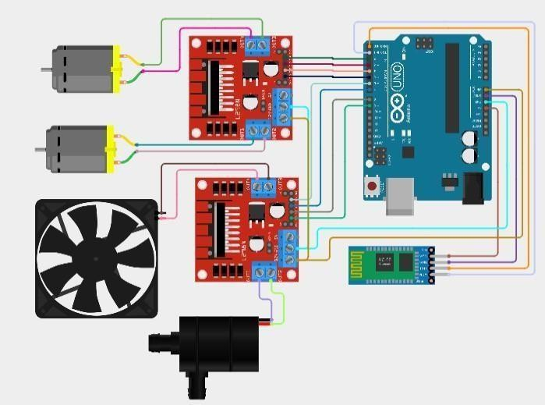

Fig.1: Schematic diagram of automatic floor cleaning

In figure.1, D2 connected to L298N DC motor driver IN4. D3 connected to L298N DC motor driver IN3. D4 connected to L298N DC motor driver IN2. D5 connected to L298N DC motor driver IN1. D6 connected to second L298N DC motor driver IN4. D7 connected to second L298N DC motor driver IN3. D8 connected to second L298N DC motor driver IN2. D9 connected to second L298N DC motor driver IN1. 5V connected to Bluetooth HC-06 VCC. GN connected

to Bluetooth HC-06 GND, both L298N DC motor drivers GND. Vin connected to both L298N DC motor drivers 12V. D0 (RX) connected to Bluetooth HC-06 TXD. D1 (TX) connected to Bluetooth HC-06 RXD.

# SYSTEM DEVELOPMENT

## Microcontroller

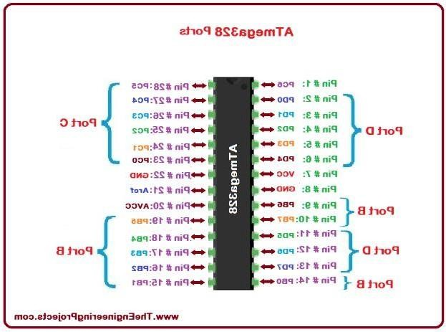ATmega328/328P is an Advanced Virtual RISC (AVR) microcontroller. It supports 8-bit data processing. ATmega-328/328P has 32KB internal flash memory. ATmega328/328P has 1KB Electrically Erasable Programmable Read-Only Memory (EEPROM). This property shows if the electric supply supplied to the micro-controller is removed, even then it can store the data and can provide results after providing it with the electric supply. Moreover, ATmega-328 has 2KB Static Random- Access Memory (SRAM). ATmega328/328P is a 28-Pin AVR Microcontroller, manufactured by Microchip, follows RISC Architecture and has a flash-type program memory of 32KB

## 7805 Voltage Regulator

Voltage regulators are very common in electronic circuits. They provide a constant output voltage for a varied input voltage. In our case the 7805 IC is an iconic regulator IC that finds its application in most of the projects. The name 7805 signifies two meaning, “78” means that it is a positive voltage regulator and “05” means that it provides 5V as output. So our 7805 will provide a +5V output voltage. The output current of this IC can go up to 1.5A. But, the IC suffers from heavy heat loss hence a Heat sink is recommended for projects that consume more current. For example if the input voltage is 12V and you are consuming 1A, then (12-5) * 1 = 7W. This 7 Watts will be dissipated as heat.

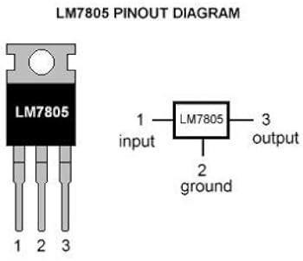

## Crystals 16MHz

An electronic circuit or electronic device that is used to generate periodically oscillating electronic signal is called as an electronic oscillator. The electronic signal produced by an oscillator is typically a sine wave or square wave. An electronic oscillator converts the direct current signal into an alternating current signal. The radio and television transmitters are broad casted using the signals generated by oscillators. The electronic beep sounds and video game sounds are generated by the oscillator signals. These oscillators generate signals using the principle of oscillation. There are different types of oscillator electronic circuits such as Linear oscillators – Hartley oscillator, Phase-shift oscillator, Armstrong oscillator, Clapp oscillator, Colpitts oscillator, and so on, Relaxation oscillators – Royer oscillator, Ring oscillator, Multivibrator, and so on, and Voltage Controlled Oscillator (VCO). In this article, let us discuss in detail about Crystal oscillator like what is crystal oscillator, a crystal oscillator circuit, working, and use of crystal oscillator in electronic circuits.

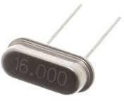

## DC Motor

DC motors are configured in many types and sizes, including brush less, servo, and gear motor types. A motor consists of a rotor and a permanent magnetic field stator. The magnetic field is maintained using either permanent magnets or electromagnetic windings. DC motors are most commonly used in variable speed and torque. Motion and controls cover a wide range of components that in some way are used to generate and/or control motion. Areas within this category include bearings and bushings, clutches and brakes, controls and drives, drive components, encoders and resolves, Integrated motion control, limit switches, linear actuators, linear and rotary motion components, linear position sensing, motors (both AC and DC motors), orientation p osition sensing, pneumatics and pneumatic components, positioning stages, slides and guides, power transmission (mechanical), seals, slip rings, solenoids, springs. Motors are the devices that provide the actual speed and torque in a drive system. This family includes AC motor types (single and multiphase motors, universal, servo motors, induction, synchronous, and gear motor) and DC motors (brush less, servo motor, and gear motor) as well as linear, stepper and air motors, and motor contactors and starters.

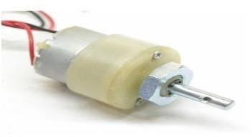

## Motor Driver

The L298N is a dual H-Bridge motor driver which allows speed and direction control of two DC motors at the same time. The module can drive DC motors that have voltages between 5 and 35V, with a peak current up to 2A. The module has two screw terminal blocks for the motor A and B, and another screw terminal block for the Ground pin, the VCC for motor and a 5V pin which can either be an input or output. This depends on the voltage used at the motors VCC. The module has an onboard 5V regulator which is either enabled or disabled using a jumper. If the motor supply voltage is up to 12V we can enable the 5V regulator and the 5V pin can be used as output, for example for powering our Arduino board. But if the motor voltage is greater than 12V we must disconnect the jumper because those voltages will cause damage to the onboard 5V regulator. In this case the 5V pin will be used as input as we need connect it to a 5V power supply in order the IC to work properly.

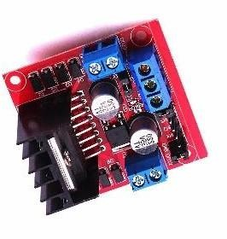

## Relay Module

Relay is an electromechanical device that uses an electric current to open or close the contacts of a switch. The single-channel relay module is much more than just a plain relay, it comprises of components that make switching and connection easier and act as indicators to show if the module is powered and if the relay is active or not. First is the screw terminal block. Adding screw terminals makes it easier to connect thick mains cables, which might be difficult to solder directly. The three connections on the terminal block are connected to the normally open, normally closed, and common terminals of the relay. The second is the relay itself, which, in this case, is a blue plastic case. Lots of information can be gleaned from the markings on the relay itself. The part number of the relay on the bottom says “05VDC”, which means that the relay coil is activated at 5V minimum – any voltage lower than this will not be able to reliably close the contacts of the relay.

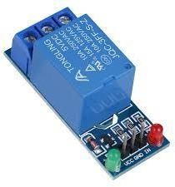

## Bluetooth Module

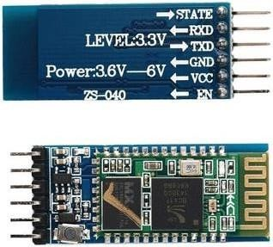The HC-05 is a popular module which can add two-way (full-duplex) wireless functionality to your projects. You can use this module to communicate between two microcontrollers like Arduino or communicate with any device with Bluetooth functionality like a Phone or Laptop. There are many android applications that are already available which makes this process a lot easier. The module communicates with the help of USART at 9600 baud rate hence it is easy to interface with any microcontroller that supports USART. We can also configure the default values of the module by using the command mode. So if you looking for a Wireless module that could transfer data from your computer or mobile phone to microcontroller or vice versa then this module might be the right choice for you. However do not expect this module to transfer multimedia like photos or songs; you might have to look into the CSR8645 module for that**.**

## Arduino IDE

The Arduino Integrated Development Environment (IDE) is a cross-platform application (for Windows, macOS, Linux) that is written in functions from C and C++. It is used to write and upload programs to Arduino compatible boards, but also, with the help of third-party cores, other vendor development boards. The source code for the IDE is released under the GNU General Public License, version 2. The Arduino IDE supports the languages C and C++ using special rules of code structuring. The Arduino IDE supplies a software library from the Wiring project, which provides many common input and output procedures. User-written code only requires two basic functions, for starting the sketch and the main program loop, that are compiled and linked with a program stub main() into an executable cyclic executive program with the GNU tool chain, also included with the IDE distribution. The Arduino IDE employs the program avr dude to convert the executable code into a text file in hexadecimal encoding that is loaded into the Arduino board by a loader program in the board's firmware. By default, avrdude is used as the uploading tool to flash the user code onto official Arduino boards.

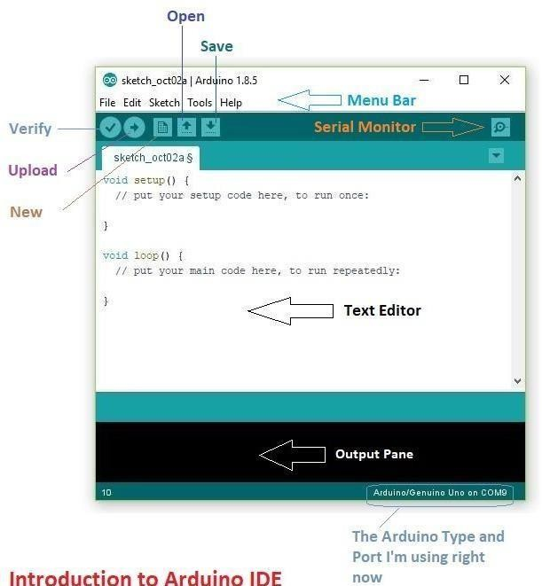

# BLUETOOTH TERMINAL

Bluetooth Terminal is a versatile application designed to mimic a Bluetoothterminal, facilitating seamless connectivity to any Bluetooth-Serial adapter device. Noteworthy for its bidirectional communication capabilities, it boasts broad compatibilitywith a wide array of devices. Leverage the benefits of streamlined wireless connections and experience efficient device communication with this leading Bluetooth utility. Enhance your tech toolkit with a top feature-rich solution to your wireless needs.

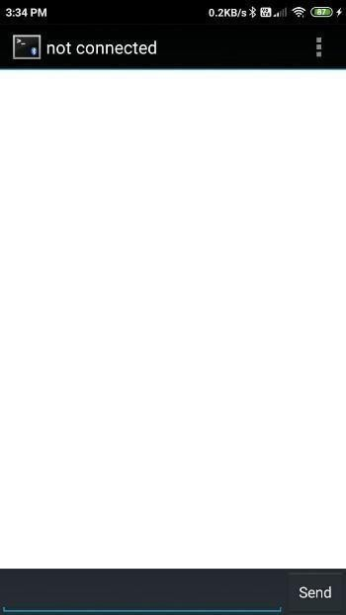

**Bluetooth terminal Bluetooth terminal display**

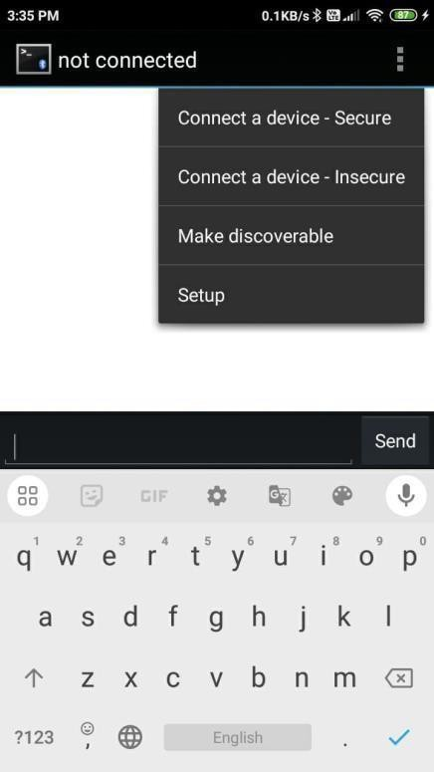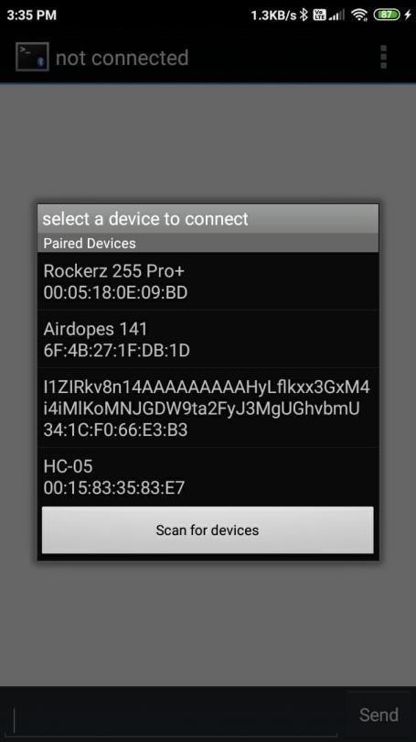

**Paired device**

**Connect a device**

# WORKING

The objective of this project is to develop an autonomous robotic floor cleanerthat enhances user convenience and efficiency in cleaning tasks. Utilizing the Arduino microcontroller, specifically the Atmega 328, the system integrates various components including DC motors, a Bluetooth module, motor driver (L298), relay module, and a pump for automated cleaning operations. The floor cleaner is designed to respond to commands sent via Bluetooth, enabling users to control its movements (forward, backward, left, right) and activate cleaning functions such as water spraying and mop operation. Commands like '1' activate the water pump for a specified duration, '3' engage the mop, and '4' deactivate the motor, ensuring precise control over cleaning actions. Through rigorous testing and validation, the project aims to ensure seamless functionality and reliability, while maintaining a cost-effective design to enhance accessibility. Ultimately, the goal is to create a user-friendly floor cleaning solution that combines advanced robotics with practical usability for both residential and commercial applications.

This circuit is designed to control two DC motors and a fan using an Arduino UNO microcontroller. It includes a Bluetooth HC-06 module for wireless communication and two L298N DC motor drivers to handle the motor control. The circuit is powered through the Arduino UNO's Vin pin, which also supplies power to the motor drivers. Ground connections are shared across the components to complete the circuit. Microcontroller board based on the ATmega328P. It has 14 digital input/output pins, 6 analog inputs, a 16 MHz quartz crystal, a USB connection, a power jack, an ICSP header, and a reset button. Wireless communication module. Used for Bluetooth serial communication. DC Motor (x2): Electric motor that runs on direct current electricity. L298N DC Motor Driver (x2): Dual H-bridge motor driver. Capable of driving two DC motors or one stepper motor. DC Motor (x2): Electric motorthat runs on direct current electricity. Fan: Electronic device that creates airflow. Water Pump: Device used to move liquids

1. **RESULT**

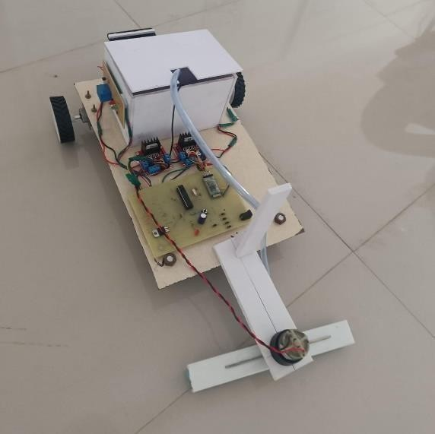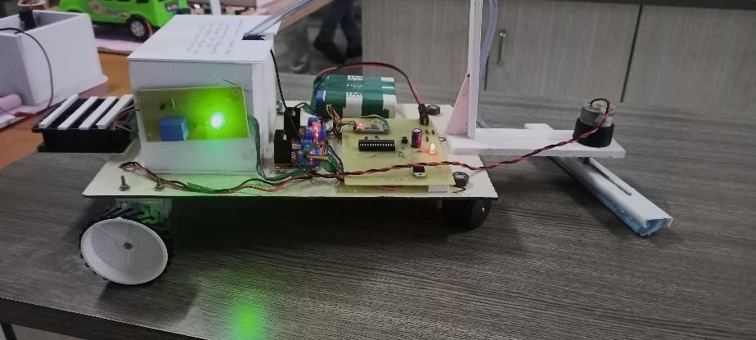

1. **ADVANTAGES AND DISADVANTAGES**
2. **ADVANTAGES**.
   * Saves time on cleaning
   * Reduces physical effort
   * You can clean your home when you are away from home
   * Perform best on hard floor
   * Require only weekly maintenances

# ADVANTAGES

* + Risk of getting stuck.
  + Risk of flipped over.
  + Long cleaning time.
  + Some models can be costly.

# APPLICATION

* + Floor Scrubbers: They are widely used in schools, hospitals, hospitality and retail environments.
  + Sweepers: A sweeper can be used indoors or outdoors to collect dust, dirt.
  + Steam cleaners: They use high-temperature steam to remove dirt, destroy viruses, disinfect, sanitise ANDdeodorise different types of floor surfaces and can be usedin above ground surface cleaning.
  + Carpet Cleaners and Extractors Cleaners

# CONCLUSION

In conclusion, this project has explored the design and implementation of an autonomous floor- cleaning robot controlled via Bluetooth technology. We aimed to bridge the gap between traditional robotic control interfaces and modern user expectations for wireless, smartphone-based control. Through the development of our robot, we have successfully integrated Bluetooth communication, allowing users to control and monitor the robot conveniently from their smartphones. This innovation enhances user experience, making floor cleaning more accessible and adaptable tomodern smart home environments.

# REFERENCES

[1]. G Tuangzhi Dai and Tiequn Chen "Design on measurement and control system of cleaning robot based on sensor array detection", IEEE International conference on control automation Guangzhou, May 30 to June 1, 2007, China.

[2]. Youngkak Ma, seungwoo Kim, Dongik Oh and Youngwan Cho, "A study on the development of home mess- cleanup robot McBot", IEEE/ASME international conference on advanced mechatronics, July 2- 5, 2008, Xian, China.

[3]. Zheng Zhao, Weihai Chen, Chen C.Y. Peter and Xingming Wu "A novel navigation system for indoor cleaning robot", IEEE International Conference on Robotics and Biomimetics (ROBIO), Dec. 3 to Dec. 7, 2016, Qingdao, China.

[4]. V.Prabakaran, M.Rajesh Elara, T.Pathmakumar and S. Nansai "HTetro: A Tetris inspired shape-shifting floor cleaning robot", IEEE International Conference on Robotics and Automation (ICRA), May 29 to June 3, 2017, Singapore.

1. Razvan Solea, Adrian Filipescu and Grigore Stamatescu” Sliding-mode real-time mobile platform control in the presence of uncertainties”, Decision and Control (2009) 32 16-18
2. T. Palleja, M. Tresanchez, M. Teixido, J. Palacin" Modeling floor-cleaning coverage performances of some domestic mobile robots in a reduced scenario", Robotics and Autonomous Systems (2010) 58 37- 4
3. M.R.B. Bahara, A.R. Ghiasib, H.B. Bahara, "Grid roadmap based ANN corridor search for collision free, path planning "Scientia Iranica (2012) 19 1850-1855.
4. Ayoub Bahmanikashkoolia, Majid Zareb, Bahman Safarpourc, Mostafa Safarpourd" Application of Particle SwarmOptimization Algorithm for Computing Critical Depth of Horseshoe Cross Section Tunnel "APCBEE Procedia (2014)9 207–211
5. Spyros G. Tzafestas"9 – Mobile Robot Control V: Vision-Based Methods", Introduction to Mobile Robot Control (2014) 319–384.
6. J Frolizzi C.Disalvo. Service robots in the domestic environment: A study of Roomba vacuum in the home”. In int. conference on human robot interaction HRI, PAGE 258- 265 March 2006.
7. J Frolizzi C.Disalvo. Service robots in the domestic environment: A study of Roomba.
8. Manreet Kaur, Preeti Abrol “Design and Development of Floor Cleaner Robot (Automatic and Manual) “International Journal of Computer Applications (0975 – 8887) Volume 97– No.19, July 2014.
9. Manya Jain, Pankaj Singh Rawat “Automatic Floor Cleaner” International Research Journal of Engineering and Technology (IRJET) Volume: 04 Issue: 04 | Apr -2017 e-ISSN: 2395 -0056 p-ISSN:

2395-0072.

1. Uman Khalid , Muhammad Faizan Baloch , Haseeb Haider, Muhammad Usman Sardar , Muhammad Faisal Khan,Abdul Basit Zia1 and Tahseen Amin Khan Qasuria Faculty of Electronic Engineering, Ghulam Ishaq Khan “Smart Floor Cleaning Robot (CLEAR)” Institute of Engineering Sciences and Technology, Pakistan Hamdard Instituteof Engineering & Technology, Hamdard University, Karachi, Pakistan 2015.
2. Xueshan Gao, Kejie Li, Yan Wang, Guangliang Men, Dawei zhou and Koki Kikuchi. A floor cleaner robot usingSwedish wheels.In IEEE international conference on robotics and biomimetics December 15-18, 2007, Sanya, China