**To Analyze the Impact of Process Parameters Such as Gas Flow Rate and Welding Current on Tensile Strength and Hardness of TIG Welding for Dissimilar Steel Metals**

Vishal Chhipa1, Suryabhan Kumar2

Research Scholar, Department of Mechanical Engineering, Aryabhatta College of Engineering and Research Center, Ajmer Rajasthan India1

Asst. Professor, Department of Mechanical Engineering, Aryabhatta College of Engineering and Research Center, Ajmer Rajasthan India2

**ABSTRACT**

The aim of this research work is to predict and optimize TIG welding of some economically important dissimilar materials in industry through applying as a DOE approach to design the experiments. This can be achieved by controlling selected welding parameters as per ASME Section IX for; gas flow rate and welding current to relate the ultimate tensile strength and Hardness to the selected input welding parameters. The dissimilar materials studied in this work are Stainless steel 304 and SA-515 (Grade-60). The effect of different gas flow rate (8, 10 and 12 Lit/min), different welding current (80, 100 and 120 Amp) on ultimate tensile strength and Hardness of dissimilar welding, are used to find out the significance of input parameter on output by using DOE method. The Analysis of Variance (ANOVA) technique is used for Optimization.

**Keywords:**  Ultimate tensile strength, Analysis of object (ANSYS), Tungsten inert gas Welding (TIG), Analysis of Variance (ANOVA).

**1. INTRODUCTION**

In industry most of the materials are fabricated into the desired shape mainly by one of the following methods viz. casting, forming, machining and welding. The selection of a particular technique depends upon different factors which may include shape and size of the component, precision required, cost, material and its availability. Sometimes one specific process may be used to achieve the desired object.

However, more often it is possible to have a choice between the processes available for making the end product. Among the available options economy plays the decisive role in making the final choice. “Welding is a process of joining two similar or dissimilar metals by fusion, with or without the application of pressure and a filler metal may be used if required.”The fusion of metal takes place by means of heat and is obtained from electric arc, electric resistance, chemical reaction, friction or radiant energy. The result of welding process is a homogeneous material (weld pool) of the composition and characteristics of two parts which are being joined together. It is defined as the capability of being welded into inseparable joints having specified properties such as weld strength, proper microstructure etc.

Weld ability of a metal is decided by the weld quality and the ease with which it can be obtained. Manual gas tungsten arc welding is very difficult amongst all the welding processes commonly used in industry. To prevent electrode great care and skill are required and the welders must maintain a short arc length. Welder manually feed a filler metal into the weld area with one hand. While manipulating the welding torch in the other hand. However some welds combining small material without filler mater. For strike welding arc, high frequency generator provides an electric spark.

This spark is the conductive path for welding current through shielding gas and it allows arc to be initiated while the electrode and their work pieces are separated, typically about 1.5-3 mm apart. This high voltage, high frequency burst can be damaging to some vehicle electrical systems and electronics in which it includes voltages on vehicle wiring can also cause small conductive spark in the vehicle wiring.

These currents can be specifically destructive as to disable the vehicle. Warning is given to disconnect to vehicle power +12 voltages and ground before using the welding equipment’s on vehicles. An alternate to initiate the arc is the “scratch start”. Starching the electrode against the work with the power is also serves to strike an arc, in the way as SMAW arc welding. When starch starting it will cause contamination of the electrode. Some TIG equipment is capable of a mode cal end “touch start” or “lift arc”. Their equipment’s are reduce the voltage on electrodes to only a few volts with a current limit of amps. Limit that causes metal to transfer contamination of weld or electrode.

Once the arc is struck, welders move the torch in small circle to create a welding pool. Whose size depends on size of electrode and amount of the current? While maintaining a constant separation between the electrode and work piece welder moves the torch back across the welding arc into the weld when alternating current is used. Helium allows for greater penetration in thicker work pieces, make starting of arc difficult. Direct current of positive and negative polarity can be used to weld aluminum and magnesium.



Figure 1: Schematic diagram of TIG weld area

Direct current with negatively charged electrode allows for high penetration. Argon is mostly used in shielding gas for DCEN welding of metals like aluminum. High helium with shielding gases is generally used for higher penetration in thicker material. Tungsten electrons are suitable used for DCEN welding of aluminum. Direct current with positively charged electrode DCEP is used or shallow welds especially joins with joints thickness of less the 1.6mm.

**2. MATERIAL AND EXPERIMENTAL PROCEDURE**

**2.1 Base metal and its composition**

From the literature survey of past researchers it is show that the material selection in manufacturing process is most important think as per process availability and customer’s requirement. There is number of material used in modern industry but steel have corrosion resistive property and high strength, so it is widely use in modern industry. The materials used to carry out experiment are Stainless steel AISI 304 and Carbon steel. The chemical composition and various mechanical properties of SS-304 and carbon steel are shown in table respectively.

**Table 1.** Composition of Material

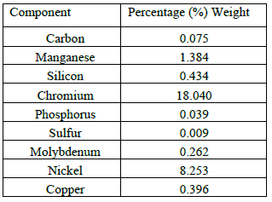

**2.2 Workpiece geometry**

SS-304 and SA 515 (Grade-60) plates with the dimensions of 100×25×6 mm are prepared with the bevel heights of 6 millimeter, bevel angle of 45°. These specimens are then welded with a root gap distance 2 millimeter. Figure shows the single V groove butt joint preparations.



**Figure 2:** Geometry of work piece

1. Material SS-304 & SA 515 (Grade-60)

2. Dimension of work piece

3. 100x25x6 mm

4. Groove made on shaping m/c

5. Groove angle 45°

**2.3 Parameter influence on TIG welding process**

Process parameter is the most effective in any welding process. So the parameter that effect on the TIG welding is as under:

1. Welding speed

2. Welding current

3. Gas flow rate

4. Voltage

5. Electrode diameter

6. Tip to surface distance

7. Weld geometry

There is other parameter also effect like, welding position, environment condition, temperature etc. from above parameter I select welding current and gas flow rate.

**Table 2:** Working Parameter

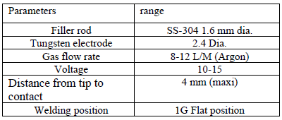

After preparing work piece welding operation perform as per DOE and as setup described in 5.2.welding operation is perform on TIG welding m/c. Other than the input parameter is selected as per below table. Welding is done manually and only single pass is made on work piece. Welding is done on both side of work piece front side and back side.



(a) (b) (c)

TIG welding is done on the work pieces which are coated with the fluxes and without flux.

**3. RESULTS**

After perfuming welding some tests is carry to check the quality of welding. Tensile test and hardness test is done as an output parameter.

**3.1 Tensile Test**

Tensile test is done as per ASTM standard. As per standard work piece is prepare for tensile test. Size of the work piece is decided as per ASTM A370. Prepared work piece after machining is shown in below figure.



**Figure 4:** Workpiece after tensile test

Table 3: Tensile Test Results

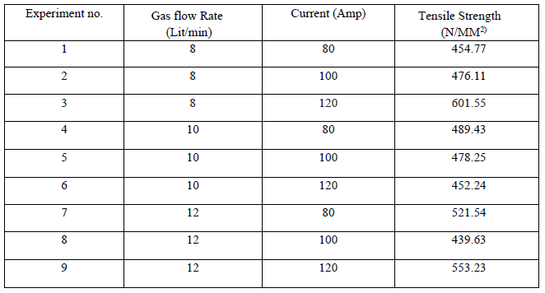

As per above result maximum tensile test is indicated in specimen no 3. So above result clarify that at 120 Current and 8 lit/min gas flow rate we find maximum tensile test. And the load vs. displacement graph for specimen no 3 is gives in below.



**Figure 5:** Load v/s displacement graph

**3.2 Hardness Test**

Hardness is test at base metal, HAZ and weld metal for all 9 pieces. Result for hardness test is in below table.

**Table 4:** Hardness Test Results

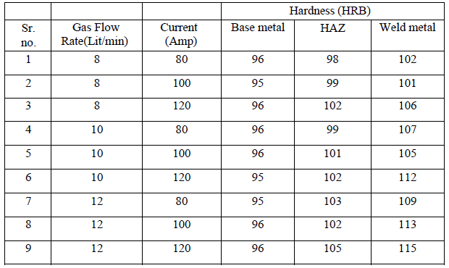

From above shown in table it is clear that hardness is increase at increasing in gas flow rate and current both. And also it clear that hardness is more at weld metal compare to both base metal and HAZ and hardness of HAZ is more than base metal.

**3.3 Analysis of Variance (ANOVA)-Tensile Strength**

ANOVA is carried out for finding out the highly effective factor as shown in Table.22 It is found that welding current is highly effective.

**Table 5:** ANOVA Results

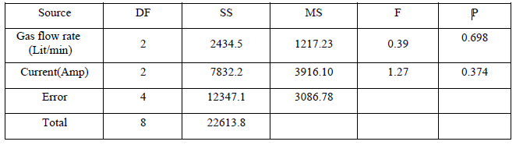

**3.4 Analysis of Variance (ANOVA)-Hardness**

ANOVA is carried out for finding out the highly effective factor as shown in Table.23 It is found that welding current is highly effective.

**Table 6:** ANOVA Results

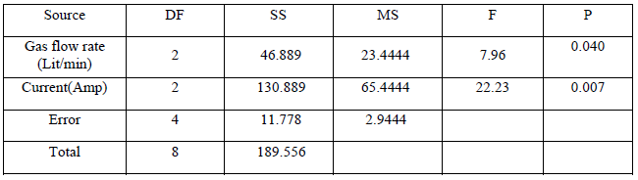

**4. CONCLUSIONS**

In this present work, experiments are Carried out to study effect of variation in Gas flow rate (Lit/min) and Current (Amp) of TIG welding process on Tensile Strength & Hardness of dissimilar weld SS-304 (ASS) and Carbon steel SA 515 (Grade-60) is used as test metal for dissimilar weld.

The following conclusions emerge from experiments results:

**4.1. Tensile test**

From analysis and experiments result it is conclude that maximum result achieved at 120 Amp Current and 8 Lit/min Gas flow rate. At this parameter obtain value for Tensile Strength 601.55 N/mm2.

**4.2 Hardness Test**

It is clear that hardness is increase at increasing in gas flow rate and current both. And also it clear that hardness is more at weld metal compare to both base metal and HAZ and hardness of HAZ is more than base metal. From all experiment and Analysis of Variance (ANOVA) technique it I cleared that for better result and welding current is highly effective as compared to gas flow rate.

**ACKNOWLEDGEMENT**

The First author wish to express his thanks to the Principal, Aryabhatta College of Engineering and Research Center, Ajmer, Rajasthan, India, to carry out the above work in Department of Mechanical Engineering and wish to express his sincere thanks to the Former Chairman Prof. Amit Shastri for their encouragement and support to undertake the present work and providing the facilities in Department of Mechanical Engineering. He also expresses his thanks to his colleagues in Department of Mechanical Engineering for their support.

**REFERENCES**

[1] Yashar javadi, Masoud Ashoori, “Sub surface stress measurement of cross welds in a dissimilar welded pressure vessel”, materials and design 82-90 Elsevier, 2015.

[2] Navid Moslemi, Norizah Redzuan, “Effect of Current on Characteristic for 316 Stainless Steel Welded Joint Including Microstructure and Mechanical Properties”. 12th global conference on suitable manufacturing, Procedia 560-564, Elsevier, 2015.

[3] Anil Hemant, B Hajantri, “Robust design approach to set the process parameter of TIG welding” advanced engineering and applied science international journal,5 (3):46-52,2015.

[4] A. Sivasankaran, Taguchi Optimization of TIG Welding for Maximizing Weld Strength of Aluminium 8011” International Journal of Innovative Research in Science, Engineering and Technology, Vol. 4, Special Issue 6, May 2015.

[5] Lokesh Kumar G, Karthikeyan, “Microstructure and mechanical properties of ASS(304) and FSS (430) dissimilar joints in SMAW & GTAW process, IJESRT, 4(6): june, 2015.

[6] P.Bharath, “Optimization of 316 stainless steel weld joint characteristics using Taguchi Technique”,7th International Conference on Materials for Advanced Technologies, May 2014.

[7] Rajkumar V., “Studies on welding of maraging steels”, 7th international conference on materials for advance technology, Elsevier, 2014.

[8] V. Anand Rao, “Experimental Investigation for welding Aspects of Stainless steel”.

[9] 310 for the process of TIG Welding” 12th international conference on materials for advance technology, Elsevier, 2014.

[10] K. Devendranath, Ramkumar, “Influence of filer metals and welding techniques on the structure property relationships of Inconel 718 and AISI 316 L dissimilar weldments”, materials and design 82-90 Elsevier, 2014.