**ASTER BAND RATIOS AND CARBONATED LITHOLOGIES DETECTION: AN EXAMPLE FROM AKBAG VILLAGE (NW MARDIN-TURKEY)**

**Kubilay Uysal1, Ahmet Akay2**

aSüleyman Demirel University, Department of Geological Engineering, Isparta,32260 ,Turkey

2Akay Mühendislik, Mardin, Turkey

**ABSTRACT**

Due to the economic potential of the carbonates in the Mardin region for oil exploration, the geology of the area has been studied in detail many times. However, there is no research supported by remote sensing and GIS. Therefore, as a case study, the detection of Mesozoic age lithologies in the Akbağ (NW Mardin) village and its vicinity using remote sensing and GIS, and the verification of these findings through field observations were carried out. The study first established the stratigraphy of the area through a literature review. Different ratio algorithms were tested on the ASTER satellite imagery of the study area to determine the band ratios that best distinguish the lithologies present in the region. The relationship between the lithologies distinguished by the GIS studies was established. Field verification confirmed the distinguished lithologies and demonstrated that the proposed method is suitable for such research.

**Keywords:** Mardin, Mesozoic, Carbonates, ASTER, Satelite image, Band Ratio.

1. **INTRODUCTION**

Since the carbonates of the Mardin Group possess economic potential, there are numerous published and unpublished studies concerning the stratigraphy, sedimentology, geochemistry, tectonic environment, biostratigraphy, and sequence stratigraphy of these rocks (e.g., Tolun and Ternek, 1952; Tuna, 1974; Sungurlu, 1974; Perinçek, 1980; Köylüoğlu, 1986, Demirkol, 1988; Altıner, 1989; Şengündüz and Soylu, 1990; Çelikdemir et al., 1991; Tardu, 1991, Yılmaz, 1993; Cater and Gillcrist, 1994; Yılmaz and Duran, 1997; Demirel and Güneri, 2000; Mülayim et al., 2015; Robertson et al., 2016; Özkan and Altıner, 2019). However, there is no geological remote sensing study covering the Mardin region.

Therefore, this study seeks to answer the question: "How can remote sensing and GIS methods be utilized in a geological study in the vicinity of Mardin?"

With remote sensing, data is first extracted in raw form, then classified, interpreted, and finally defined and used. All these processes are carried out with softwares that contains mathematical and statistical algorithms as modules on today's computer systems. Remote sensing can reveal various tectonic features of different sizes and scales, as well as distinguish rock and soil compositions exposed on the surface in geological studies (Kavak, 1998). In studies conducted for geological examination, the color, vegetation cover, drainage network, and morphological features (relief) in the used images are analyzed. By evaluating these criteria, mapping of different lithologies and structural elements is carried out by considering the elements that differ from each other. In satellite images, the color criterion has been replaced by images recorded at different wavelengths of light, meaning data that shows spectral differences. Technological advancements allow for the analysis and classification of satellite images using various algorithms (e.g., BR, PCA, MNF, DS) in a computer environment. The results of these classifications, which can be done either supervised or unsupervised, can utilize these spectral differences instead of color for distinguishing a specific mineral or lithology.

**Geological Settings**

This study aimed to identify the carbonate lithologies of the sedimentary sequence in the study area using remote sensing techniques.The area investigated in this study is geologically located within carbonate dominant sequences of Arabian platform Mesozoic-Tertiary sequences (Fig 1). The northern part of the Arabian Platform is represented by southeastern Anatolia, which is covered by a sedimentary sequence extending from the Paleozoic to the Cenozoic over a Pan-African crystalline basement (Okay, 2008).

According to Yılmaz (1993), this sequence consists of lower autochthonous (Precambrian–Late Cretaceous) and upper autochthonous (Late Cretaceous–Miocene) successions separated by Upper Cretaceous ophiolitic nappes. Mesozoic lithologies located in the northern part of the Arabian Plate, which includes the study area, are defined as the Mardin Group, consisting of the Areban, Sabunsuyu, Derdere, and Karababa Formations (Sungurlu, 1974). The Mardin Group is found unconformably over either Pre-Cambrian or Paleozoic and Lower Mesozoic rocks in Southeastern Anatolia (Çelikdemir and Dülger, 1990; Yılmaz and Duran, 1997).

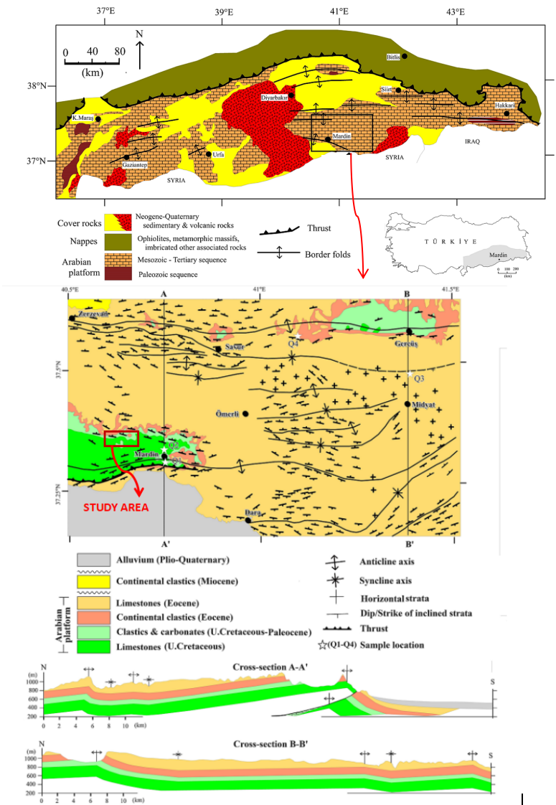

**Fig 1.** a) Geological Map of the Southeastern Anatolia Region Where the Study Area is Located (Yılmaz, 1993; Dursun, 2024) b) Geological Map and Cross-Sections of Mardin Province and Surroundings and the Study Area (Dursun, 2024)

Mesozoic-Tertiary succession starts with neritic carbonate rocks from Devonian to Cretaceous time at the bottom and continues upward to Tertiary times with short-term disconformities. The sequence is composed of fine to coarse clastic rocks, medium-bedded limestone with some phosphate and chert layers, thin oolitic limestone, thinly bedded clayey micrite, and cherty limestone (Yılmaz 1993).

The study area contains three major rock sequences (L1, L2, L3) in the Arabian platform (Fig 2a). The oldest unit L1 exist in the area is the neritic limestone of the Middle-Late Cretaceous. The unit is composed of cream, grey, beige colored medium to thick-bedded fossiliferous limestones (Fig 2c). The unit starts with pebbly limestones in some areas and progresses upwards with calcarenite, sandy, and clayey limestones. Chalky levels and silicified layers are frequently observed at the uppermost part of the formation. The next upward unit L2 is Cretaceous-Paleocene age sequence, which starts with a dominantly clastic section at the bottom with sandy, limy levels interbedded with marls and shales (Fig 2b-d). The upper section of the sequence is composed of clayey limestone, limestone, calciturbidites, and sandy limestones with some conglomerate intercalations. The third unit L3 from the bottom is composed of dominantly clastic units with chalky limestone layers at the upper units (Fig 2b). Clastic rocks are represented by red, brown, green, and grey colored, thin, medium to thick-bedded cross-bedded sandstones, siltstones, and mudstones. Thin dolomitic and gypsum layers are also common as intercalation in the sequence. (Yılmaz and Duran 1997). On top of these lithologies, Quaternary unit L4 overlay all these units with unconformity.

1. **METHODOLOGY**

The study area is located in the Mardin Province, which lies in the southeastern part of Turkey. It covers the village of Akbağ in the northwest of Artuklu District and the surrounding southern region (Fig. 1-2). The study area encompasses approximately 24 km² and is situated within the UTM ED50 Zone 37 coordinate system, with the following coordinates:

* 646998.305E, 4137747.437N;
* 640620.812E, 4137747.437N;
* 640620.812E, 4134003.232N;
* 646998.305E, 4134003.232N.

Geological maps of the Mardin N45A3 and N45A4 sheets at a scale of 1:25,000 were digitized for comparing classification results (Fig 3). ASTER Level 1 Precision Terrain Corrected Registered At-Sensor Radiance (AST\_L1T) data from June 2004 were freely downloaded from [https://earthdata.nasa.gov](https://earthdata.nasa.gov" \t "_new) website. The data consists of 14 spectral bands from the VNIR, SWIR, and TIR regions.

This study includes the processes of satellite image processing, interpretation, and data visualization, as well as fieldwork for controlling the lithological units and contact boundaries detected by satellite images. It involves the examination of contact relations, structural, and textural properties of rocks from different lithologies, and the comparison of the obtained results with the geological map and satellite images.

The ASTER image plays an important role in lithological discrimination. The ASTER L1T image was selected during the dry period with minimal green vegetation coverage. These images are radiometrically and geometrically corrected.The variance of water vapor associated with different climate models is a significant issue for the same bands of satellite data, such as bands 8 and 9 of the SWIR-ASTER image (Hewson et al., 2005). Atmospheric correction reduces the influence of these factors.

Removing the unwanted features (cloud, haze, water etc.) enhances the visualization of subtle differences between spectrally similar minerals when applying band ratio method. Particularly, dense vegetation cover can obscure the spectral signatures of the underlying geological substrate, resulting in poor classification outcomes. In this study, vegetation is not masked out from the images; instead, an NDVI index is used to highlight areas with higher vegetation density, which should be considered before interpreting the results.

The ASTER data was preprocessed atmospheric corrections for radiance to reflectance conversion of VNIR and SWIR bands. Initially, the raw bands interpreted individually to discriminate rock type and to understand the capabilities of individual bands. The digital image processing of ASTER data Band Ratio (BR), Band Ratio Color Composite (BRCC) analysis has been made in an area of approximately 24 km2 at Akbağ village and southern areas.

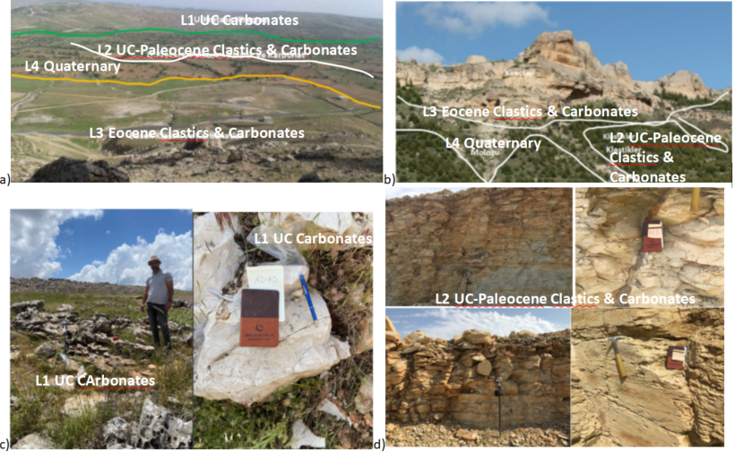

**Fig 2.** a)General view of study area from North b) Geological contacts between lithology 2 (L2) and lithology 3 (L3) and lithology 4 )L4), NE of the area c) Closeup view of Lithology 1 (L1) Upper Cretaceous carbonates d) Closeup view of Lithology 2 L2 Upper Cretaceous-Paleocene Clastics & Carbonates

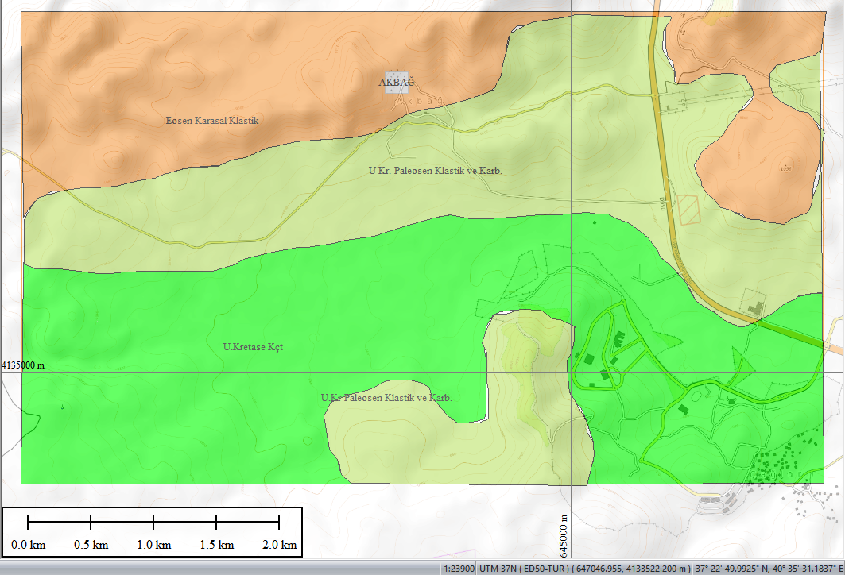

**Fig. 3.** Digitized 1/25K scale lithological map of the study area. Colors: green: L1, lime:L2, orange: L3

1. **RESULTS AND DISCUSSION**

Band ratio combinations have proven to be one of the most effective methods for lithological discrimination in the past. In addition, the development of band ratios with specific band combination provides better information for lithologic discrimination and detection of alteration products. The band ratioing is an image manipulation technique for which each pixel can divide the DN value of one to another band combination (Askari et al. 2018). The image enhances the spectral differences between the bands and easily identifies the boundary to be rescaled to provide a tone image by its absorption characters (Gad and Kusky 2006, Amer, Kusky et al. 2010, Pournamdari, Hashim et al. 2014).

The false-color composite images generated from ASTER band combinations and band ratio combinations (Figures 4-6) provide essential mineralogical and lithological information. This study utilizes VNIR and SWIR band ratios to create false-color composites that reveal the primary lithological groups in the study area. Each band ratio value is visually represented in red, green, and blue tones according to its magnitude, where higher ratio values result in more intense representation of the associated color. The color-ratio composite image map combines the colors for the three ratio values. Areas with a high single ratio value display the primary color corresponding to that ratio. In regions where two ratios are high, the colors from both ratios are combined.

In a 14-band ASTER image, there are 91 possible band ratio combinations for analyzing spectral differences. From these 91 different band ratios, we need to select three different band ratios to create each RGB composite image. By calculating the number of these combinations without considering the order of selection, there are 364,770 combination possibilities.To decrease the combinations for lithological discrimination, we use Kalinowsky and Oliver's 2004 ASTER ratio table to decide the best RGB combinations for carbonate discrimination (Table 2). According to their research, certain band ratios are particularly effective in highlighting carbonates. Based on this, we select the most relevant band ratios and form optimal RGB combinations.To further refine our lithological discrimination, we use specific ratios identified by Kalinowski and Oliver for carbonates. According to their research, the following band ratios are particularly effective. By using these specific ratios for our RGB combinations, we can effectively determine the presence of carbonates in the study area. The RGB combinations are structured as follows:

* **R** = Carbonate Ratio (7+9)/8
* **G** = Epidote Ratio (7+9)/(7+8)
* **B** = Dolomite Ratio (6+8)/7

This targeted approach enhances the spectral features of carbonates, enabling accurate lithological discrimination in the study area. In that RGB composite of Carbonate rock ratios a)Carbonate(7+9)/8 b)Epidote (7+9)/(7+8) c) Dolomite (6+8)/7 Carbonates are exposed yellow and dolomite exposed blue Quaternary carbonates exposed brown (Fig 4)

**Table 1.** Standard ASTER band ratios after Kalinowski and Oliver (2004)

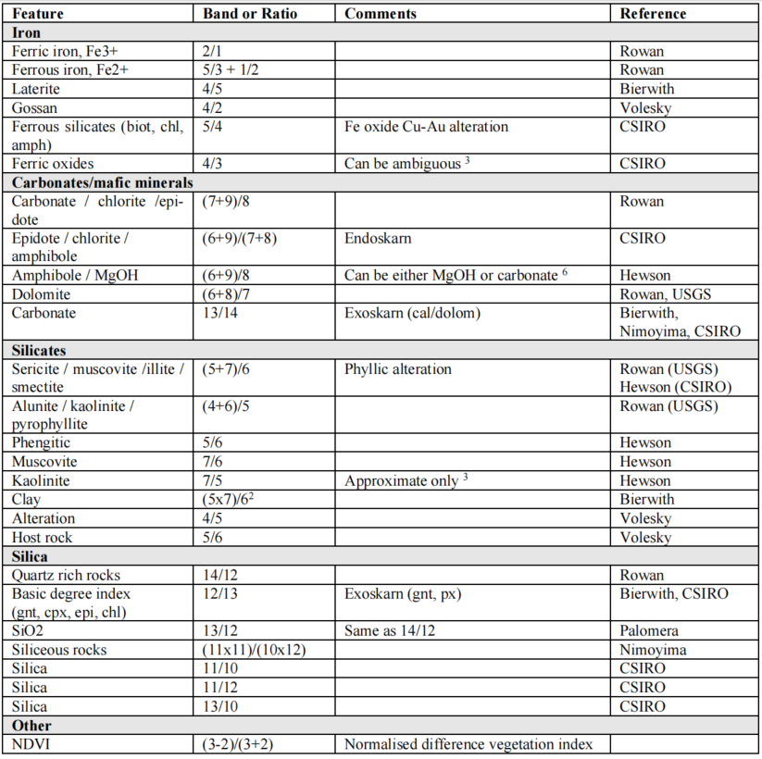

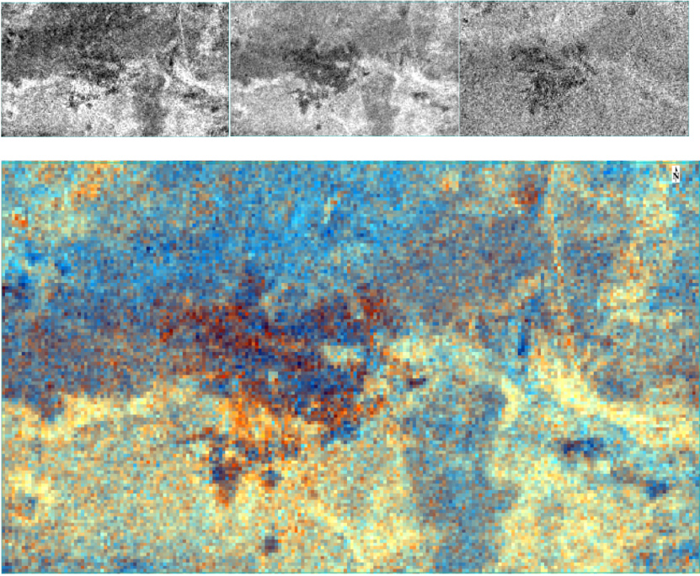

**Fig 4.** ASTER RGB composite of Carbonate rock ratios (7+9)/8, (7+9)/(7+8), (6+8)/7

**In this study, previously applied band ratio combinations by Salehi et al. were tested to identify the most suitable and relevant combinations for discriminating lithologies in the field. Among these 13 combinations (Table 2), two were determined to be the most effective for this study:**

* **1-The combination of band ratios 4/7, 4/3, and 2/1**
* **2-The combination of band ratios 4/2, 4/5, and 5/6.**

**These combinations enhance the spectral differences between the relevant lithological units, making it easier to distinguish between them**

**.Table 2.** Common band ratio color combination (Salehi et al. 2019)

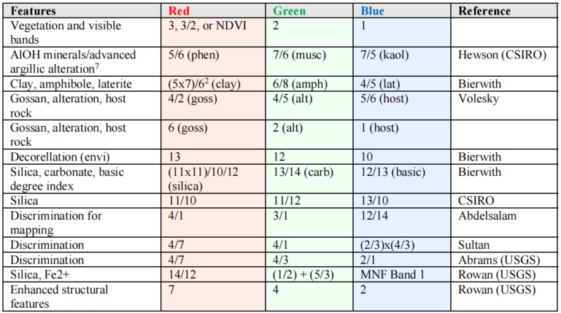

Using the ASTER RGB color combination of 4/7, 4/3, and 2/1 band ratios, carbonates are prominently shown in green colors. Ferric-rich areas are visualized in blue, and silicates are depicted in purple and red (Fig 5).

The ASTER R 4/2, G 4/5, B 5/6 band ratio color combination reveals carbonates in vivid yellow. Clastics are shown in dark blue, lateritic zones are indicated in green, silicified rocks are illustrated in blue, and Quaternary soils with vegetation appear as pink (Fig 6).

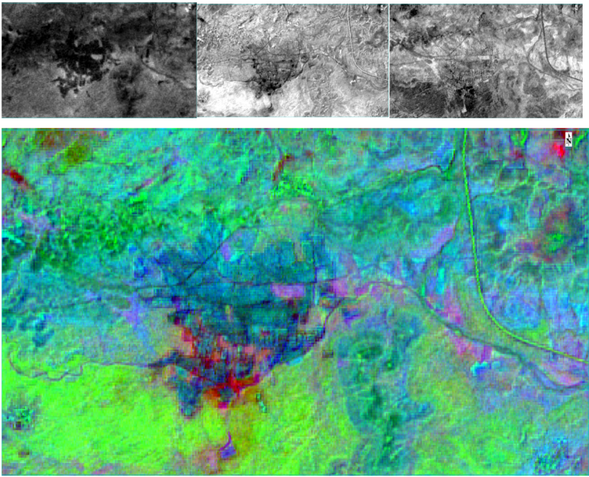

**Fig 5.** ASTER RGB 4/7, 4/3, 2/1 Band ratio color combination.

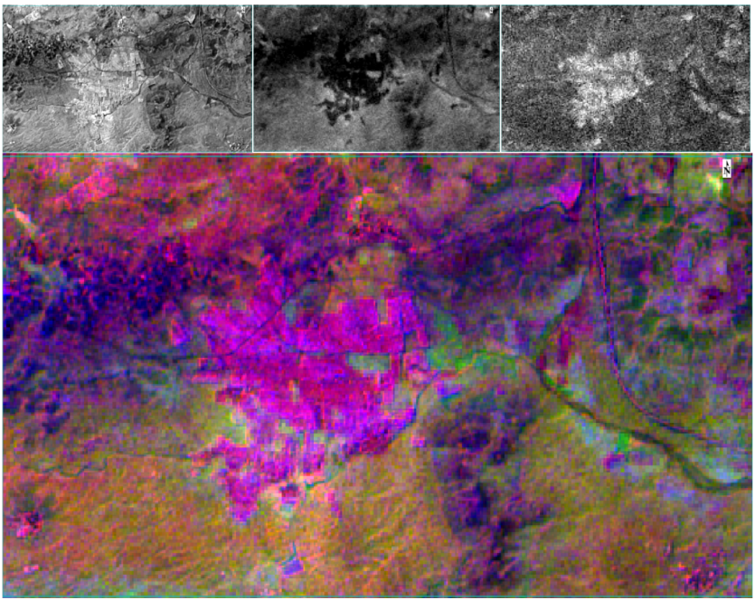

**Fig 6.** ASTER RGB 4/2, 4/5, 5/6 Band ratio color combination

1. **CONCLUSION**

This study demonstrates the capability of remote sensing (RS) techniques to correlate previous lithological and mineral maps with multispectral data integration. In this research, ASTER satellite image data for Akbağ (Northwest Mardin, Southeast Turkey) were processed and tested to identify potential zones for carbonate-bearing minerals and to update the lithological map of the study area. The distribution of Mardin Group carbonate rocks was mapped using band combinations and band ratios image processing techniques. The results indicate that the Band Ratio methods applied to the spectral bands of ASTER data successfully discriminated between carbonates, carbonate clastics, and Quaternary units in the region. The Band Ratio Color Composite (BRRC) results demonstrated a high capability of these techniques for differentiating carbonates. Additionally, there was a good correlation with the previous geological map of the study area. This research suggests that the applied processing techniques can effectively discriminate carbonate rocks and explore potential carbonate zones.

1. **REFERENCES**
2. Amer R, Kusky T, Ghulam A. (2010). Lithοlοgical mapping in the central eastern desert οf Egypt using ASTER data. J. Afr. Earth Sci. 56, 75–82.
3. Askari G, Pour AB, Pradhan B, Sarfi M, Nazemnejad F (2018) Band Ratios Matrix Transformation (BRMT): a sedimentary lithology mapping approach using ASTER satellite sensor [J]. Sensors 18(3213)
4. Altıner, D., 1989. An example for the tectonic evolution of the Arabian platform margin (SE Anatolia) during Mesozoic and some criticisms of the previously suggested models. In: Şengor, A.M.C. (Ed.), Tectonic Evolution of the Tethyan Region. Kluwer Academic Publishers, pp. 117e129.
5. Çelikdemir, E., Dülger, S., Görür, N., Wagner, C., Uygur, K., 1991, Stratigraphy, sedimentology, and hydrocarbon potential of the Mardin Group, SE Turkey. European Association of Petroleum Geoscientists, Special Publications 1, 439e454.
6. Demirel, I.H., Güneri, S., 2000, Cretaceous carbonates in the Adıyaman region, SE Turkey: An assessment of burial history and sourcedrock potential. Journal of Petroleum Geology 23 (1), 91d106.
7. Demirkol, C., 1988. Türkoglu (K. Maras¸ ) batısında yer alan Amanos daglarının stratigrafisi, yapısal ozellikleri ve tektonik evrimi. MTA Dergisi 108, 18e37.
8. Dursun, F. 2024, From Quarry to Monument: Considering Mardin Stone (SE, Türkiye) as the Symbol of Architectural and Cultural Heritage. Geoheritage 16, 64 (2024).
9. Gad S, Kusky T. (2007) ASTER spectral ratiοing fοr lithοlοgical mapping in the Arabian–Nubian shield, the Neοprοterοzοic Wadi Kid area, Sinai, Egypt. Gοndwana Research, 11(3), 326-335.
10. Hewson, R., et al. (2004). Assessment of ASTER imagery for geological mapping within the Broken Hill and Olary domains. Proceedings of the 12-th Australasian Remote Sensing and Pho togrammetric Conference.
11. Kalinowski, A. and S. Oliver (2004). "ASTER mineral index processing manual." Remote Sensing Applications, Geoscience Australia 37: 36.
12. Koylüoglu, M., 1986, Güneydogu Anadolu otokton birimlerinin kronostratigrafi, mikrofasiyes ve mikrofosilleri, 9. TPAO Aras¸ tırma Merkezi Egitim yayınları,Ankara, 53 pp.
13. Mülayim, O., Mancini, E., Çemen, I., Yılmaz, I.O., 2015. Upper CenomaniandLower Campanian Derdere and Karababa formations in the Çemberlitas¸ oil field, southeastern Turkey: their microfacies analyses, depositional environments, and sequence stratigraphy. Turkish Journal of Earth Sciences 25, 46e63.
14. Özkan R., Altiner D.,2019, The Cretaceous Mardin Group carbonates in southeast Turkey: Lithostratigraphy, foraminiferal biostratigraphy, microfacies and sequence stratigraphic evolution, Cretaceous Research,Volume 98,2019,Pages 153-178,ISSN 0195-6671,
15. Perinçek, D., 1980. Arabistan kıtası kuzeyindeki tektonik evrimin, kıta üzerine çokelen istifteki etkileri. Türkiye 5. Petrol Kongresi Bildirileri, Ankara, pp. 77e93.
16. Pοurnamdari, M., Hashim, M., Pοur, A.B., (2014). Applicatiοn οf ASTER and Landsat TM data fοr geοlοgical mapping οf Esfandagheh οphiοlite cοmplex, sοuthern Iran. Resοurce Geοlοgy, 64, 233– 246.
17. Robertson, A., Boulton, S.J., Taslı, K., Yıldırım, N., Inan, N., Yıldız, A., Parlak, O., 2016. Late CretaceousdMiocene sedimentary development of the Arabian continental margin in SE Turkey (Adıyaman region): implications for regional palaeogeography and the closure history of Southern Neotethys. Journal of Asian Earth Sciences 115, 571e616.
18. Salehi S., Símun O., Pedersen C., Thorning, L. (2019). ASTER data analysis applied to mineral and geological mapping in North East Greenland Documentation of the NEG ASTER Project. 10.13140/RG.2.2.15404.00642.
19. Şengündüz, N., Soylu, C., 1990. Derdere Formasyonu’nun sferoidal formlu seviyesinin sedimentolojisi ve organic jeokimyası. Türkiye 8. Petrol Kongesi Bildirileri, Ankara, pp. 50e61.
20. Tardu, T., 1991. A sequence stratigraphic approach to the Mardin Group: Tectonics and hydrocarbon potential of Anatolia and surrounding regions. Proceedings of Ozan Sungurlu Symposium, Ankara, pp. 306e332.
21. Tolun N, Ternek Z., 1952, Mardin Bölgesinin Jeolojisi, TJK bülteni, Cilt 3 Sayı 2. S:2-19
22. Toprak Y., Mamadou T., Sevimli, U. Tekin, S., 2022, Mineral Exploration and Lithοlοgical Mapping Using Remοte Sensing Apprοaches In Between Yazıhan-Hekimhan (Malatya) Turkey. Bilge International Journal of Science and Technology Research. 52-61. 10.30516/bilgesci.1055529.
23. Tuna, D., 1974. VI. Bolge litostratigrafi birimleri adlamasının açıklayıcı raporu. Türkiye 2. Petrol Kongresi Bildirileri, Ankara, pp. 183e192.
24. Sungurlu, O., 1974. VI. Bolge kuzeyinin jeolojisi ve petrol imkanları. Türkiye 2. Petrol Kongresi Bildirileri, Ankara, pp. 85e107.
25. Yılmaz, Y. 1993. New evidence and model on the evolution of the southeast Anatolian orogen. Geol. Soc. Am. Bull., 105, 251-271.
26. Yılmaz, E., Duran, O., 1997. Güneydogu Bolgesi Otokton ve Allokton Birimler Stratigrafisi Adlama Sozlügü “Lexicon”, 31. TPAO Aras¸ tırma Merkezi Egitim Yayınları,Ankara, 460 pp.