**A Paper on Cash Flow Statement Analysis in Bondada Engineering Limited, Hyderabad**

*Sai Durga. G, Roll No: 22481E0017, Department of Business and Management Studies, Seshadri Rao Gudlavalleru Engineering College*

**ABSTRACT**:

Cash flow analysis is a vital tool for businesses to assess their financial health and make informed decisions about their operations. In this study, we aim to delve into the abstract concept of cash flow analysis and its impact on a company's overall performance.

Cash flow analysis involves tracking the flow of cash in and out of a business over a specific period. By examining the cash receipts and expenditures, businesses can gain insights into their liquidity, solvency, and overall financial stability. This analysis is crucial for determining whether a company has enough cash on hand to meet its financial obligations, such as paying bills, payroll, and servicing debt.

One of the key aspects of cash flow analysis is determining the operating, investing, and financing activities that impact cash flow. Operating activities include revenue-generating activities such as sales, while investing activities involve buying or selling assets. Financing activities focus on how a company raises capital, such as through loans or equity financing.

By conducting a thorough cash flow analysis, businesses can identify potential cash flow bottlenecks, assess their ability to generate sufficient cash flow to cover expenses, and plan for future financial needs. This analysis can also help companies identify areas where they can improve efficiencies, reduce costs, or optimize their cash flow management practices.

Our study will explore how different industries and company sizes approach cash flow analysis, the tools and techniques they use, and the impact that cash flow analysis has on their decision-making processes. We will also examine the challenges that businesses face when conducting cash flow analysis, such as data collection and interpretation issues, and explore best practices for overcoming these challenges.

**Introduction:**

Cash flow statement is a statement which shows the sources of cash inflow and uses of cash out flow of business concern during a particular period of a time.

Cash flow statement is a financial statement that shows how changes in balance sheets and accounts and income effect in cash and cash equivalents, investing and financing activities.

Analysts are concentrated with the amount of cash that a company generates. In the long run, a company can afford to make payments to its security holders only if it produces surplus cash flow from its operations. Even profitable companies may find them selves facing cash shortage that in the extreme, can lead to bankruptcy. In the short run, cash balance may be recharged by borrowing or through the sales of assets. However, those strategies may adversely may effect company future profitability.

**Objectives of cash flow statement:**

A Cash flow statement shows inflow and outflow of cash and cash equivalents from various activities of a company during a specific period. The primary objective of cash flow statement is to provide useful information about cash flows. This information is useful in providing users of financial statements with a basis to assess the ability of the enterprise to generate cash and cash equivalents and the needs of the enterprise to utilise those cash flows. The economic decisions that are taken by users require an evaluation of the ability of an enterprise to generate cash and cash equivalents and the timing and certainty of their generation.

* To the know the liquidity position.
* To know the solvency position.
* Allows investors to understand how company’s operations making money, and hiw it is being spent.
* Show how well a company is managing its cash position and generate cash to pay off debt obligation and fund operations.

**Methodology:**

There are two types

* Direct method
* Indirect method

**Direct method:**

Direct method whereby major classes of gross cash receipts and gross cash payments are disclosed.

**Indirect method:**

Indirect method whereby net profit or loss is duly adjusted for the effects of

(1) transactions of a non-cash nature.

(2) any deferrals or accruals of past/future operating cash receipts and

(3) items of income or expenses associated with investing or financing cash flows.

It is important to mention here that under indirect method, the starting point is net profit/loss before taxation and extra ordinary items as per Statement of Profit and Loss of the enterprise. Then this amount is for non-cash items, etc., adjusted for ascertaining cash flows from operating activities.

**Treatment of Some Peculiar Items:**

**Extraordinary items:**

Extraordinary items are not the regular phenomenon, e.g., loss due to theft or earthquake or flood. Extraordinary items are non-recurring in nature and hence cash flows associated with extraordinary items should be classified and disclosed separately as arising from operating, investing or financing activities. This is done to enable users to understand their nature and effect on the present and future cash flows of an enterprise.

**Interest and Dividend:**

In case of a financial enterprise (whose main business is lending and borrowing), interest paid, interest received and dividend received are classified as operating activities while dividend paid is a financing activity. In case of a non-financial enterprise, as per AS-3, it is considered more appropriate that payment of interest and dividends are classified as financing activities whereas receipt of interest and dividends are classified as investing activities.

**Taxes on Income and Gains**

Taxes may be income tax (tax on normal profit), capital gains tax (tax on capital profits), dividend tax (tax on the amount distributed as dividend to shareholders). AS-3 requires that cash flows arising from taxes on income should be separately disclosed and should be classified as cash flows from operating activities unless they can be specifically identified with financing and investing activities. This clearly implies that:

* Tax on operating profit should be classified as operating cash flows.
* Dividend tax, i.e., tax paid on dividend should be classified as financing activity along with dividend paid.
* Capital gains tax paid on sale of fixed assets should be classified under investing activities.

**Non-cash Transactions:**

As per AS-3, investing and financing transactions that do not require the use of cash or cash equivalents should be excluded from a cash flow statement. Examples of such transactions are – acquisition of machinery by issue of equity shares or redemption of debentures by issue of equity shares. Such transactions should be disclosed elsewhere in the financial statements in a way that provide all the relevant information about these investing and financing activities. Hence, assets acquired by issue of shares are not disclosed in cash flow statement due to non-cash nature of the transaction.

**Format:**

|  |  |
| --- | --- |
| (A) Cash flows from operating activities | ****** |
| (B) Cash flows from investing activities | ****** |
| (C) Cash flows from financing activities | ****** |
| Net increase (decrease) in cash and cash  equivalents (A + B + C) | ****** |
| Add: Cash and cash equivalents at the beginning | ****** |
| = Cash and cash equivalents at the end | ****** |

Closely related to these measures of cash flow is company’s fee cash flow, which takes two forms. There is free cash flow to the firm, determined as

|  |
| --- |
| After-tax operating income |
| Add: Depreciation, amortization, and deferred taxes |
| Less: Increase in working capital |
| Less: Investment in fixed assets |

= Free cash flow to the firm

After- tax operating earnings are equal to operating earnings times the quantity(1 minus the tax rate, That is, EBIT (1-t), or equivalently EAT + tL. The increase in working capital represents an increase in the amount of current assets relative to occur liabilities and hence is short-term in nature. Investment in fixed assets is long term because it involves spending on items such as property, plant, and equipment. Thus, free cash flow to the firm is the cash generated by the company’s operations that is available to all of the company’s debt and equity holders.

Free cash flow to the equity

|  |
| --- |
| Net income |
| Add: depreciation, amortization, and deferred taxes |
| Less: increase in working capital |
| Less: investment in fixed assets |
| Less: principal repayment |
| Add: new debt issued |
| = Free cash flow to equity |
|  |

**Analysis:**

**2018-2019**

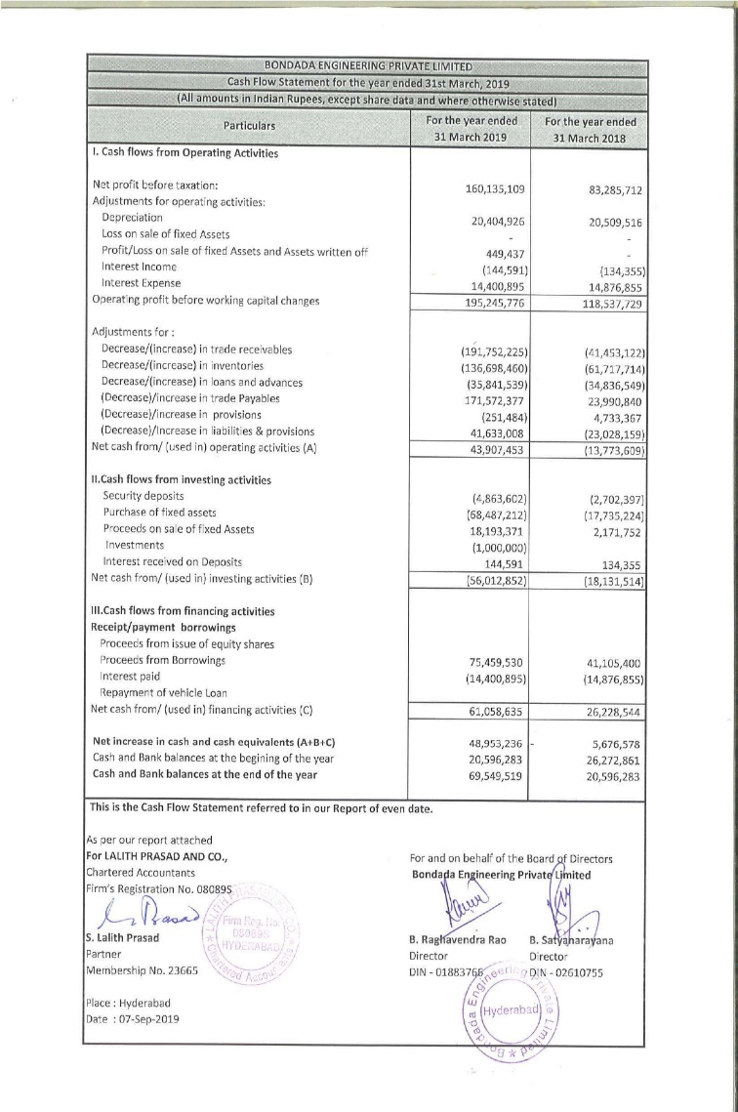

|  |  |
| --- | --- |
| **Particulars** | **For the year ended 31 march 2019** |
| **Cash from operating activities**  Net income  Depreciation  Amortization  Deferred tax and others  **Changes in working capital**  Changes in trade receivable  Changes in inventories  Changes in trade paybles  Changes in liabilities & provisions  Tax payble and others  **Total operating cash flow**  **Cash from investing actvities**  Capital expenditures  Others  **Total investing cash flow**  **Cash from financing activties**  Proceeds from issue of equity shares  Proceeds from borrowings  Interest paid  **Total financing cash flows**  **Changes in cash**  **Beginning cash**  **Ending cash**  **Free cash flow analysis**  Total operating cash flow  Total capital expenditure  **Free cash flow to the firm**  Total operating cash flow  Total investing cash flow  Total financing cash flow  Divend  **Free cash flow to the equity** | **160135109**  20404926  -  14755741  (191752225)  (136698460)  171572377  (41633008)  (36093023)  **43907453**  (68487212)  (12474360)  **(56012852)**  -  75459530  (14400895)  **61058635**  **48953236**  **20596283**  **69549519**  43907453  (68487212)  **(24579759)**  43907453  (56012852)  61058635  -  **48953236** |

**2019-2020:**

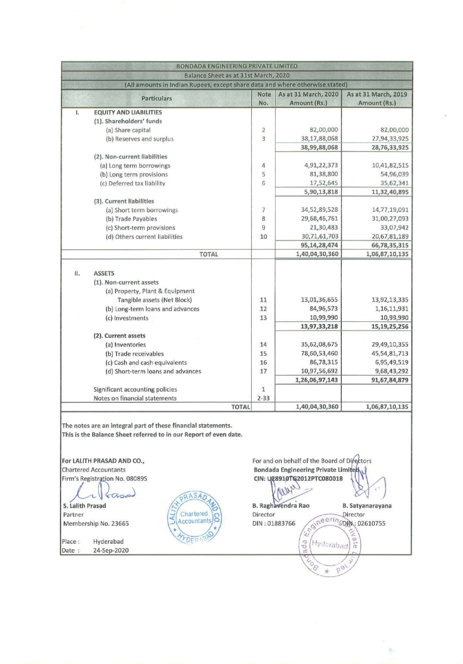

|  |  |
| --- | --- |
| **Particulars** | **For the year ended 31 march 2020** |
| **Cash from operating activities**  Net income  Depreciation  Amortization  Deferred tax and others  **Changes in working capital**  Changes in trade receivable  Changes in inventories  Changes in trade paybles  Changes in liabilities & provisions  Tax payble and others  **Total operating cash flow**  **Cash from investing actvities**  Capital expenditures  Others  **Total investing cash flow**  **Cash from financing activties**  Proceeds from issue of equity shares  Proceeds from borrowings  Interest paid  **Total financing cash flows**  **Changes in cash**  **Beginning cash**  **Ending cash**  **Free cash flow analysis**  Total operating cash flow  Total capital expenditure  **Free cash flow to the firm**  Total operating cash flow  Total investing cash flow  Total financing cash flow  Divend  **Free cash flow to the equity** | **139748327**  21613700  -  19559963  (330571746)  (61298320)  (13180332)  59999175  (10270639)  **(174399872)**  (15287392)  6672094  **(8615298)**  -  142510294  (20366329)  **122143965**  **(60871205)**  **69549519**  **8678314**  (174399872)  (15287392)  **(189687264.0)**  (174399872)  (8615298)  122143965  **-**  (60871205) |

**2020-2021**

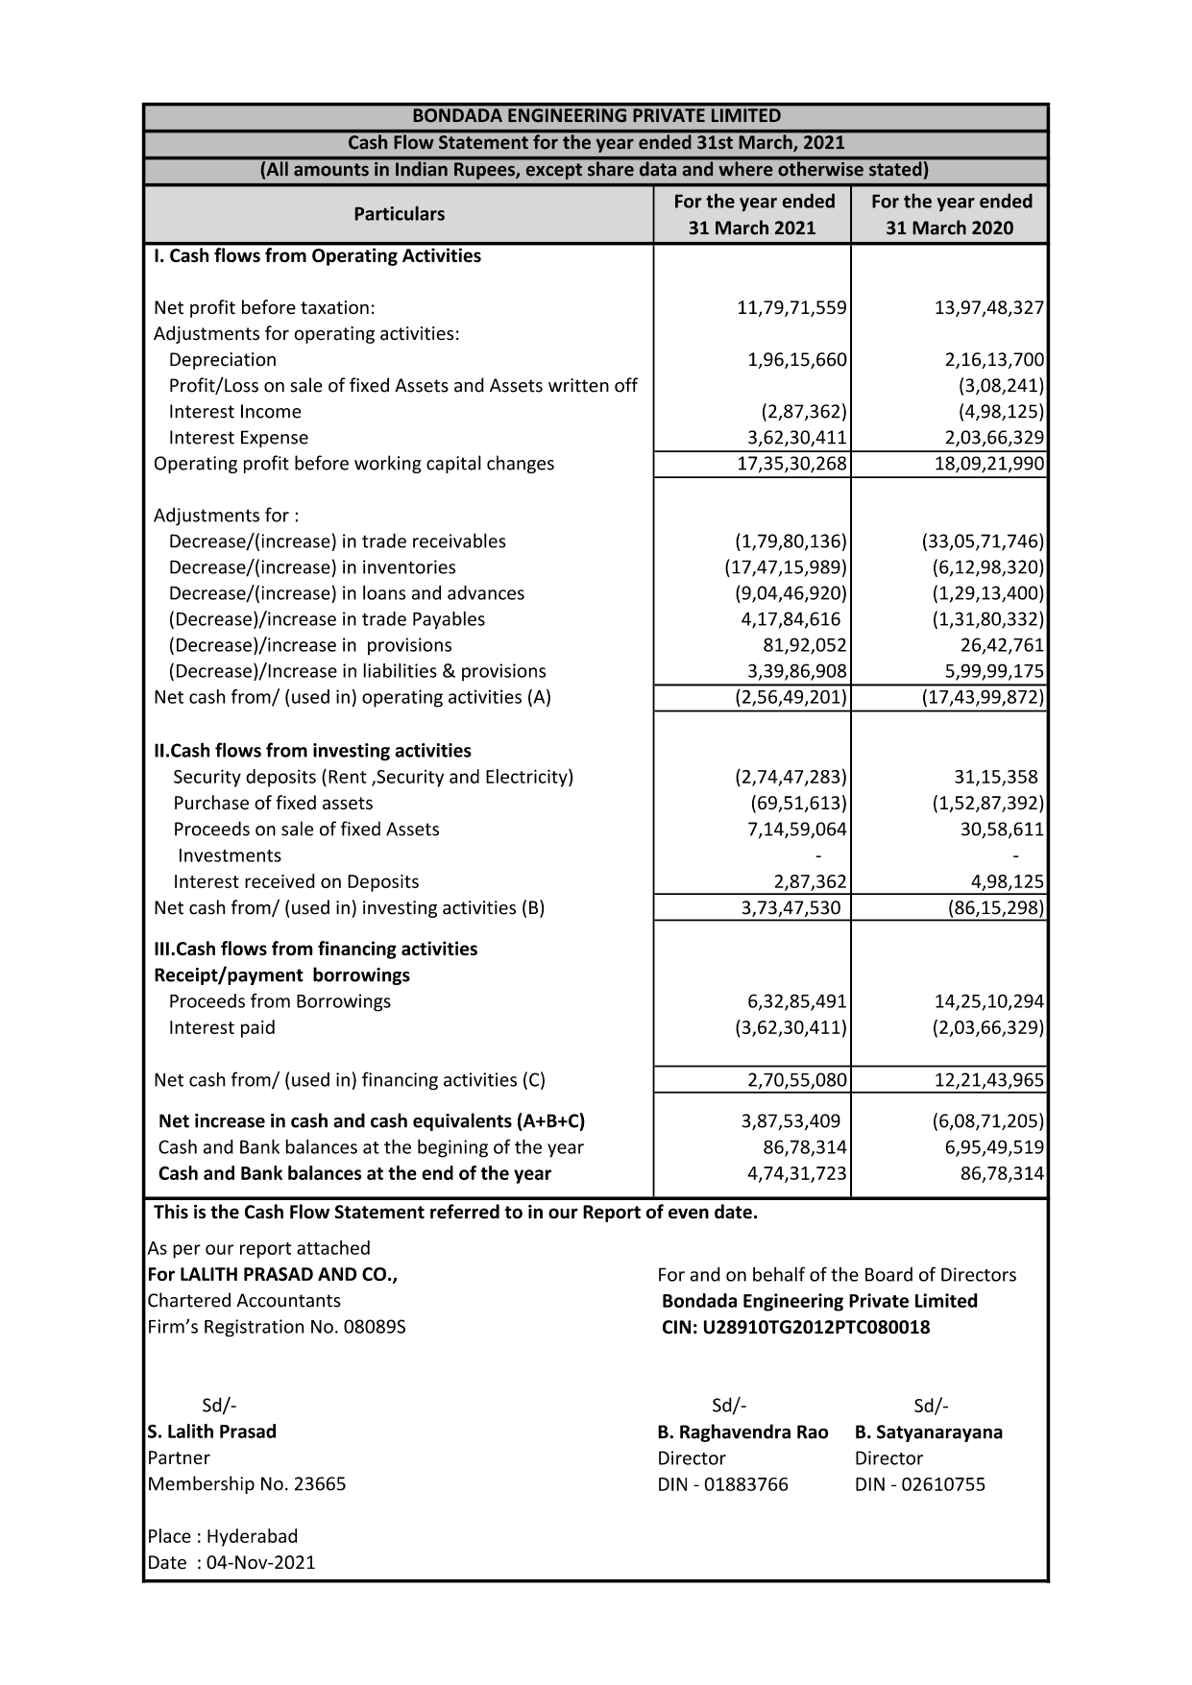

|  |  |
| --- | --- |
| **Particulars** | **For the year ended 31 march 2021** |
| **Cash from operating activities**  Net income  Depreciation  Amortization  Deferred tax and others  **Changes in working capital**  Changes in trade receivable  Changes in inventories  Changes in trade paybles  Changes in liabilities & provisions  Tax payble and others  **Total operating cash flow**  **Cash from investing actvities**  Capital expenditures  Others  **Total investing cash flow**  **Cash from financing activties**  Proceeds from issue of equity shares  Proceeds from borrowings  Interest paid  **Total financing cash flows**  **Changes in cash**  **Beginning cash**  **Ending cash**  **Free cash flow analysis**  Total operating cash flow  Total capital expenditure  **Free cash flow to the firm**  Total operating cash flow  Total investing cash flow  Total financing cash flow  Divend  **Free cash flow to the equity** | **117971559**  19615660  -  35943049  (17980136)  (174715989)  41784616  33986908  (82254868)  **(25649201)**  (6951613)  44299143  **37347530**  -  63285491  (36230411)  **27055080**  **38753409**  **8678314**  **47431723**  (25649201)  **(6951613)**  **(32600814)**  (25649201)  37347530  27055080  -  **38753409** |

**2021-2022:**

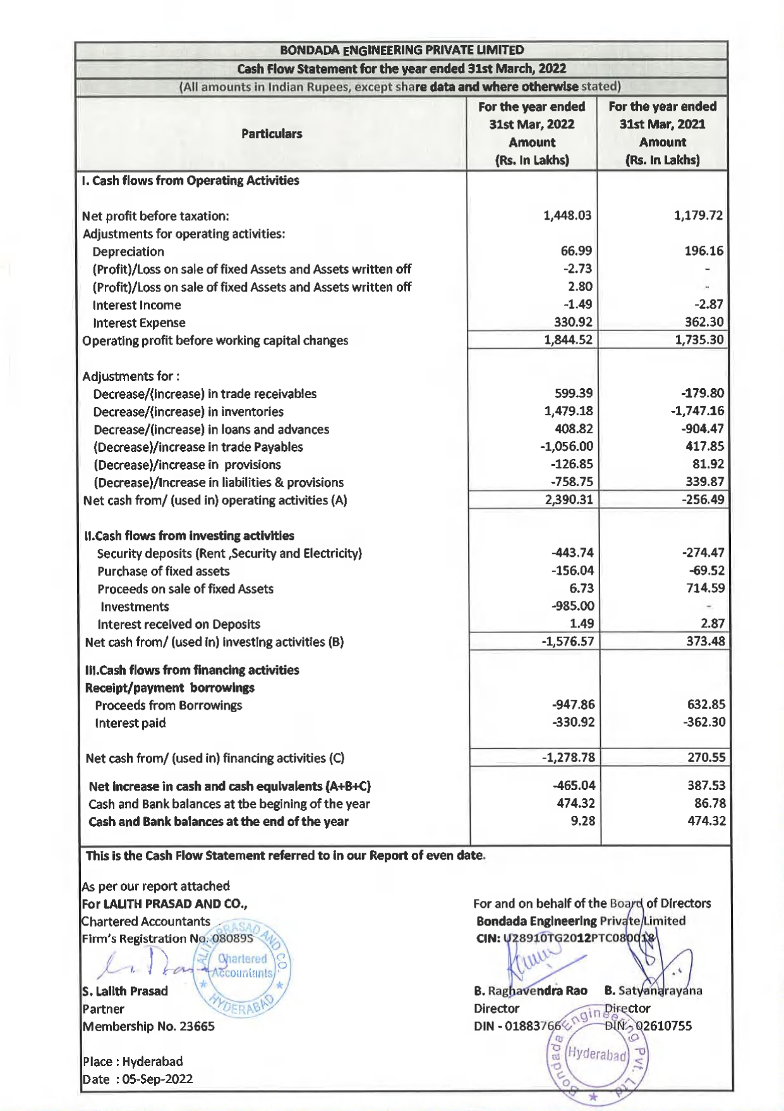

|  |  |
| --- | --- |
| **Particulars** | **For the year ended 31 march 2022** |
| **Cash from operating activities**  Net income  Depreciation  Amortization  Deferred tax and others  **Changes in working capital**  Changes in trade receivable  Changes in inventories  Changes in trade paybles  Changes in liabilities & provisions  Tax payble and others  **Total operating cash flow**  **Cash from investing actvities**  Capital expenditures  Others  **Total investing cash flow**  **Cash from financing activties**  Proceeds from issue of equity shares  Proceeds from borrowings  Interest paid  **Total financing cash flows**  **Changes in cash**  **Beginning cash**  **Ending cash**  **Free cash flow analysis**  Total operating cash flow  Total capital expenditure  **Free cash flow to the firm**  Total operating cash flow  Total investing cash flow  Total financing cash flow  Divend  **Free cash flow to the equity** | (in lakhs)  **1448.03**  66.99  -  328.580  (599.39)  1479.18  (1056)  (758.75)  (281.970)  **2390.31**  (156.04)  (1420.520)  **(1576.57)**  -  (947.86)  (330.92)  **(1278.78)**  **(465.04)**  **474.32**  **9.28**  2390.31  (156.04)  **2234.2**  2390.31  (1576.57)  (1278.78)  -  **(465.04)** |

**2022-2023:**

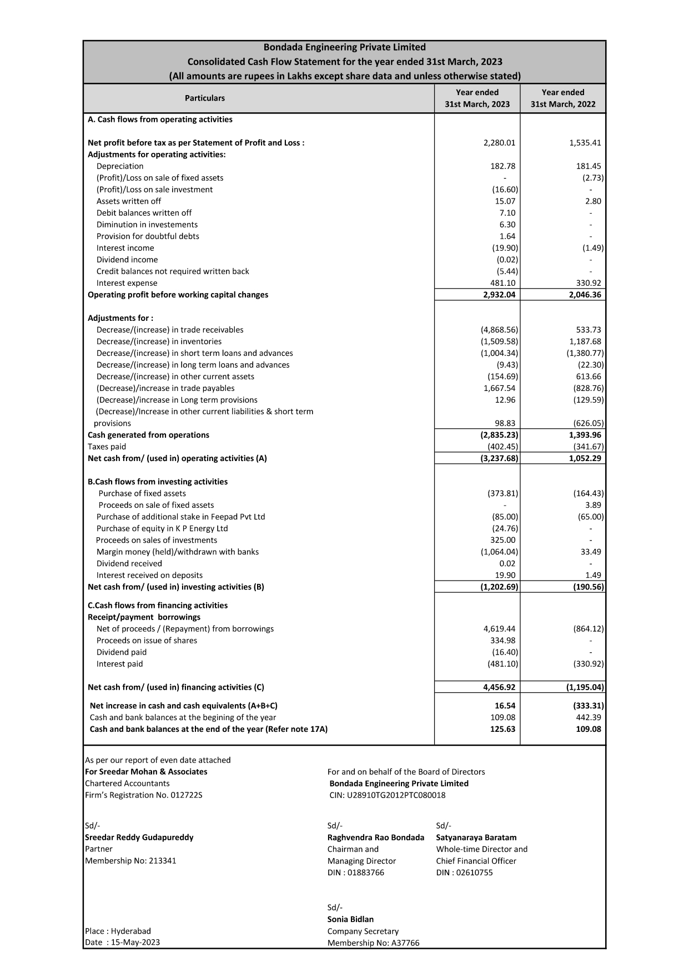

|  |  |
| --- | --- |
| **Particulars** | **For the year ended 31 march 2023** |
| **Cash from operating activities**  Net income  Depreciation  Amortization  Deferred tax and others  **Changes in working capital**  Changes in trade receivable  Changes in inventories  Changes in trade paybles  Changes in liabilities & provisions  Tax payble and others  **Total operating cash flow**  **Cash from investing actvities**  Capital expenditures  Others  **Total investing cash flow**  **Cash from financing activties**  Proceeds from issue of equity shares  Proceeds from borrowings  Interest paid  Divinded paid  **Total financing cash flows**  **Changes in cash**  **Beginning cash**  **Ending cash**  **Free cash flow analysis**  Total operating cash flow  Total capital expenditure  **Free cash flow to the firm**  Total operating cash flow  Total investing cash flow  Total financing cash flow  Divend  **Free cash flow to the equity** | **2280.01**  182.78  -  469.88  (4868.56)  (1509.58)  (1004.34)  98.83  (1557.910)  **(3237.68)**  (373.81)  (828.880)  **(1202.69)**  334.98  4619.44  (481.10)  (16.40)  **4456.92**  **16.54**  **109.08**  **125.63**  (3237.68)  (373.81)  **(2863.870)**  (3237.68)  (1202.69)  4456.92  (16.40)  **0.150** |

**Findings:**

* In 2018-2019 company invested more in capital expenditure than their income and also take loans.
* In 2019-2020 because of last year, they invest more than their income in this year their expenditure than the income and again they invest in capital expenditure without any much income. And for controlling their expenditure they again take loans.
* In2020-2021 their expenditure again increases because of their management of cash flow in the last year. But in this year, they sold their earlier fixed assets.
* In 2021-2022 in this year, they are managing their cash flow very well because their income is more than their expenditure and also invest in capital expenditure but less than operating activities this is very good sign and also they repay their borrowings also.
* In 2022-2023 their expenditure is higher than their income and also investing in capital assets and also taking borrowings because they issues IPO.

**Suggestions:**

* They have to manage their expenditure over the income.
* Investing in capital expenditure is less than the cash from operating activities.
* Controlling the borrowings to meet their expenditure.
* Maintain cash from operating activities is positive number and maintain investing activities in negative number and also financing activities also negative number.

**Bibliography:**

Books:

* How to read a cash flow statement 2nd edition by (N. Ramachandran ram Kumar kakani)
* Fundamentals of investments 3rd edition by (Gordon j. Alexander, William F. Sharpe Jeffery. Bailey

Web sites:

1 <https://bondada.net/>

2 <https://ncert.nic.in/textbook/pdf/leac206.pdf>

G.Kamal, A Study on Financial Performance using Ratios of KCP Sugars and I C Limited, Andhra Pradesh”. The International Journal of Analytical and Experimental Model Analysis. Volume XIII, Issue VIII, August/2021, pp 1356-1363, ISSN: 0886-9367.

G.Kamal, A Study on Funds Flow Statement in and Organization using Data Analysis” Journal of Education: Rabindrabharati University, Vol.: XXIII, No. : 7, 2020– 2021, pp 187-192, ISSN: 0972-7175.

G. Kamal and Kumar, T. Hemanth and Susmitha, K., Linkage of Indian Equity Market with Developed Economies Equity Markets (September 14, 2022). Available at SSRN: <https://ssrn.com/abstract=4218617> or <http://dx.doi.org/10.2139/ssrn.4218617>.

G.Kamal, Role of SHGs in Empowering Women in Marine Fishing Community, International Journal of Emerging Technologies and Innovative Research ([www.jetir.org](http://www.jetir.org/)), ISSN:2349-5162, Vol.5, Issue:9, page no. 169-173, September-2018.

J. N. V. R. Swarup Kumar, G.Kamal, A Mobile App For Age And Gender Identification Using Deep Learning Technique, International Conference on Intelligent Systems for Communication, IOT and Security, 2023, FEBRUARY 09, 2023 to FEBRUARY 11, 2023 International Conference on Intelligent Systems for Communication, IoT and Security (ICISCoIS) ,979-8-3503-3583-5/23/$31.00 ©2023 IEEE , DOI: 10.1109/ICISCOIS56541.2023.10100432 (Scopus).

TS Leelavati, S Madhavi, G Kamal, PVM Raju, K Susmitha, M Vinod, Shaik Aminabee, Revolutionizing Healthcare Delivery: Telemedicine's Influence on Access and Patient Satisfaction, International Journal of Chemical and Biochemical Sciences, Vol.: 24, No. : 5, 2023, pp 106-115, ISSN 2226-9614.

G.Kamal, Prof. T.Umamaheswara Rao, Credit Issues Encountered by Women in Marine Fishing Community in Coastal Districts of Andhra Pradesh”. The International Journal of Analytical and Experimental Modal Analysis, Volume XII, Issue X, October/2020, pp: 296:301, ISSN: 0886-9367.

Kumar K., Rao N., Kamal G., Vinod M., Leelavathi T., Sripathi M., Kumari N. (2023) The role of organizational citizenship behavior as an intervening variable in the relationship between employee engagement and gig workers’ productivity in India. *Organizational Psychology*, vol. 13, no 4, pp. 183-198.

Kumar, T. H., Kumari, Y. N., Rao, A. N., Kumari, C. L. M., Janaki, G., Lakshmi, P. A., & Krishna, J. S. S. (2022). HR Analytics as a ModeratingRole in Effective Employee Engagement and its Outcomes. *NeuroQuantology*, *20*(8), 4913.