Designing and analyzing a rocker arm using Powder Metallurgy Forging (PMF)

M.Gunasekaran¹, L.Periyannan², R.Soundarajan³

¹PG Student, Department of Mechanical Engineering, Mahendra Engineering College (Autonoumous), Namakkal, Tamilnadu, India-637503, Email Id:gunasekaran7398@gmail.com
²Assistant Professor, Department of Mechanical Engineering, Mahendra Engineering College (Autonoumous), Namakkal, Tamilnadu, India-637503, Email Id: periyannanl@gmail.com
³Assistant Professor, Department of Mechanical Engineering, Mahendra Engineering College (Autonoumous), Namakkal, Tamilnadu, India-637503

ABSTRACT: This work investigates powder metallurgy forging rocker arm part as a new approach for near-net- shape processing of titanium alloys using a coarse particle size distribution (PSD) between 90 and 250 µm. This route was utilised to takes advantage of power metallurgy forging’s (PMF’s) enclosed nature to make near-net-shape components with conventional forging equipment, making it attractive and viable even for reactive powder such as titanium. In this study, the uncompact Ti-6Al-4V ELI powder was sealed under vacuum in a stainless-steel canister and hot forged in air to produce a fully dense titanium femoral stem. After the final forging stage, the excess material in the flash region was cut, which efficiently released the canister, revealing the forged part with minimal surface contamination. The as-forged microstructure comprises coarse β grains with a martensitic structure. The subsequent annealing was able to generate a fine and homogenous lamellar microstructure with mechanical properties that respects the surgical implant standard, showing that PMF offers significant potential for forged titanium parts. Therefore, the PMF process provides a suitable alternative to produce titanium rocker arm components using basic equipment, making it more available to the Automobile industry.
KEYWORDS: Rocker Arm, Titanium, IC Engine, Cam Shafts, Powder metallurgy process

INTRODUCTION

The aim of this study is to demonstrate through ANSYS analysis that PMF (Powder Metallurgy Forging) is a viable technology for producing near-net shape (NNS) components, specifically a compound called Ti-6Al-4V ELI femoral stem implant, using closed-die forging system that complies with an element called ASTM F136-13 ( year 2021) followed standards. PMF offers advantages over FAST-forge, requiring only standard forging equipment and eliminating traditional compaction and sintering steps. This approach allows the use of coarse powders with a wide particle size distribution, including off-cuts typically discarded, thereby reducing environmental impact.
Therefore, PMF advances the strategic goal of streamlining processing steps to create cost-effective titanium rocker arm parts. This study aims to use ANSYS analysis to demonstrate PMF's viability in producing near-net shape (NNS) components, such as a compound Ti-6Al-4V ELI femoral stem implant, through closed-die forging process that meets ASTM F136-13 (year 2021) standards. Additionally, it aims to show PMF's capability to efficiently utilizes coarse powders with a wide particle size distribution (PSD), resulting in the reducing of environmental impact by repurposing typically discarded off-cut powders.
1.1 IC engine and its parts
Understanding the function of engine components is crucial for diagnosing issues when engine problems occur. This knowledge helps pinpoint which part of the engine is malfunctioning, such as the valve train. Let's delve into the purpose and role of the valve train components.
1.2 Valve Train Component Purpose
Overhead valve (OHV) engines feature a valve train with components including valve springs, rocker arms, pushrods, and lifters. In contrast, Overhead camshaft (OHC) engines utilize valve springs, rocker arms, and lifters, but differ by positioning the camshaft: on top of the cylinder head without pushrods for OHV, and beneath the head with pushrods for OHV. The primary role of these components is to facilitate the opening and closing of valves, enabling the intake of fuel through the intake valve and the expulsion of exhaust gases through the exhaust valve.
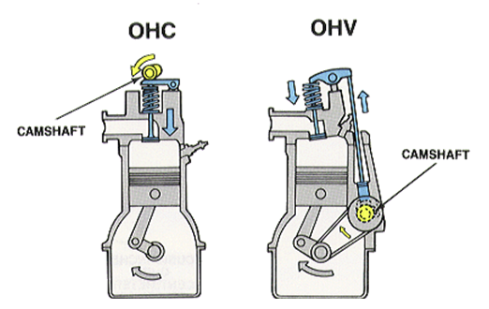
Fig. 1.1 OHC and OHV comparison diagram
1.3 Valve Train Component Functionality - OHV
In an OHV engine, the valve train process initiates with the rotation of the camshaft. As the camshaft lobe reaches its peak, the lifter moves upward, causing the pushrod to also rise. This upward motion of the pushrod applies pressure underneath the rocker arm. Balanced between the pushrod and the valve spring, the rocker arm pivots downward when pressure is applied, compressing the valve spring. This compression of the valve spring allows the exhaust valve to open, releasing exhaust gases from the cylinder.
When the highest point of the camshaft lobe returns to its initial position, the valve spring decompresses. This action closes the valve and restores all other valve train components to their original positions.
Fig. 1.2 Overhead valve
1.4 Valve Train Component Functionality - OHC
The OHC engine initiates similarly to the OHV engine. As the camshaft rotates at the top of the cylinder head, there are no pushrods involved because the camshaft directly engages with the lifters. At the highest point of the camshaft lobe, it engages with the lifters, which in turn apply pressure to the underside of the rocker arms, compressing the valve springs. Once the camshaft returns to its original starting position, the process is ready to repeat.
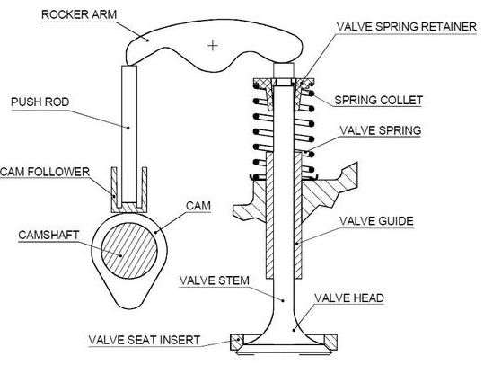
Fig. 1.3 Overhead camshaft
ROCKER ARM
A rocker arm is a pivotal lever within an engine's valve train that converts the motion from camshaft lobes into valve openings. It plays a critical role in internal combustion engines by transmitting the camshaft motion to either open intake or exhaust valves.
This action facilitates the intake of fuel and air into the combustion chamber during the intake stroke and the expulsion of exhaust gases during the exhaust stroke.
Fig 1.3 below illustrates the rocker arm within the valve train mechanism, with one end connected to the camshaft and the other end linked to the valve stem.
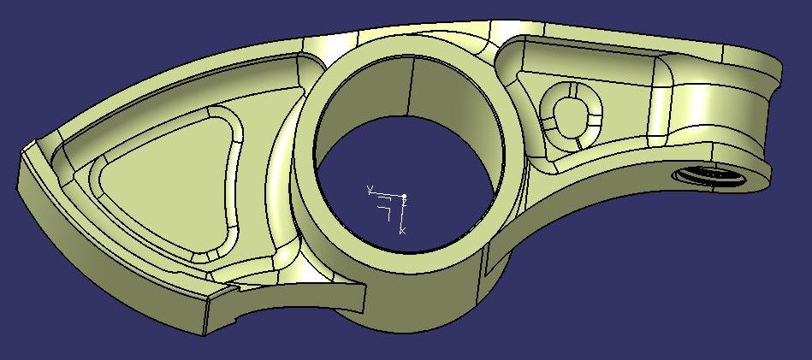
Fig. 2.1 Rocker Arm
2.2 Material
Rocker arms, like many vehicle components, are typically manufactured according to global engineering standards using high-quality alloy steels to enhance strength and longevity in engines.
In mass-produced car engines, rocker arms are commonly made from stamped steel to keep production costs low. However, at higher engine speeds (RPM), the reciprocating weight of the valve train becomes critical. To address this, aluminum rocker arms are often employed in engines designed for higher RPM operation due to their lighter weight.
In diesel truck engines, rocker arms are frequently crafted from materials like cast iron (usually ductile) or forged carbon steel. These materials are opted for their maximum durability and ability to withstand the vibrations of diesel engine operation.
Additionally, upgraded bearings are sometimes utilized at the fulcrum of rocker arms in engines that operate at high RPM to enhance performance and reliability under demanding conditions.
2.3 Understanding the role of the rocker arm in an engine.
The rocker arm transfers the camshaft motion to the intake(inlets) and exhaust valves(outlets) of the engine by directly engaging with tappets. At one end, it contacts the tappet, while the other end connects to the intake/exhaust valves. When activated by the camshaft cam, the rocker arm pivot which lowers to one side and allowing the valve to open, facilitating the inlet air and fuel into the combustion chamber.
This movement is synchronized for both intake and exhaust valves. Springs support this displacement, returning the valves to their initial position after each cycle. These springs must be robust to endure high engine speeds, maintaining consistent contact with the rocker arms throughout the operation.

MANUFACTURING METHODOLOGY
3.1 Powder metallurgy
Powder metallurgy is a economical manufacturing process which is mostly opted for its ability to achieve high quality, strength, and intricate shapes with precise accuracy, making it ideal for mass production.
The process typically consists of four primary steps:
Powder preparation
Mixing & Blending
Compacting
Sintering
Each of these steps plays a crucial role in shaping and solidifying the metal powder into the desired final product, a topic we will delve into further in this article.
Powder metallurgy has been a proven method for over a century, making it a superior choice for producing high-quality parts in various critical applications. It offers significant advantages over traditional metal forming processes like forging and casting. Due to these advantages, powder metallurgy has been acknowledged as a green technology.
Additionally, powder metallurgy enables the production of unique components that cannot be obtained through melting or traditional forming methods. A notable example is tungsten carbide (WC), which consists of tungsten carbide particles bonded with cobalt. They are extensively utilized in industries for cutting and shaping metals, with approximately 50,000 tonnes per year globally produced via powder metallurgy (PM) for various types of tools.
3.2 Powder metallurgy process
3.2.1 Powder preparation
The first step is to convert raw materials into powder form. This conversion process involves several methods such as atomization, grinding, chemical reaction, and electrolysis. These processes are used to create fine metal powders suitable for use in powder metallurgy manufacturing.
3.2.2 Mixing and blending
In the powder metallurgy process, two or more metal powders are mixed to create high-strength alloy materials tailored to specific product requirements. This mixing step is done to ensure uniform distribution of the powders, along with additives or binders (if needed). This is to enhance flow characteristics of the whole process. Lubricants may also be added during blending to facilitate the processing of the powder mixture.
3.3.3 Compacting:
This step involves compressing the above prepared powder mixture into predefined dies. Compacting aims to reduce voids or minute holes and increase the density of the product. The powder is later pressed into a mold under pressure to form a green compact. The applied pressure ranges from 80 to 1600 MPa, depending on the properties of the metal powder and binders. For softer powders, the compacting pressure ranges from about 100 to 350 MPa. For materials like steel and iron, the pressure ranges between 400 and 700 MPa.
3.3.4 Sintering process
After compressing, the green compact produced is not strong enough for use as a final product. Therefore, sintering is employed, which involves heating the green compact to an elevated temperature to achieve a permanent and strong bond. This important step in powder metallurgy enhances the overall strength of the green compact and transforms it into a properly finished product. The sintering temperature ranges from 70 to 90 percent of the melting temperature of the metal powder utilized for this process.
3.3.5 Secondary operation
After the sintering process, the resulting product is typically more porous compared to fully dense materials. The density of the product depends on factors such as compressing pressure, press capacity, sintering temperature and others such factors. In some cases, products does not require high density, allowing the sintered products to be used directly as final products. However for applications requiring high density (e.g., bearing production), secondary operations are necessary to achieve this along with high dimensional accuracy.
Common secondary operations include sizing, coining (compacting to precise dimensions), infiltration (introducing a material into the pores to enhance properties), hot forging (shaping through heat and pressure), and impregnation (filling pores with a substance for specific properties). These processes are essential for modifying the sintered product to meet stringent performance requirements in various industrial applications.
Types of powder metallurgy process:
4.1.1 Conventional powder metallurgy process
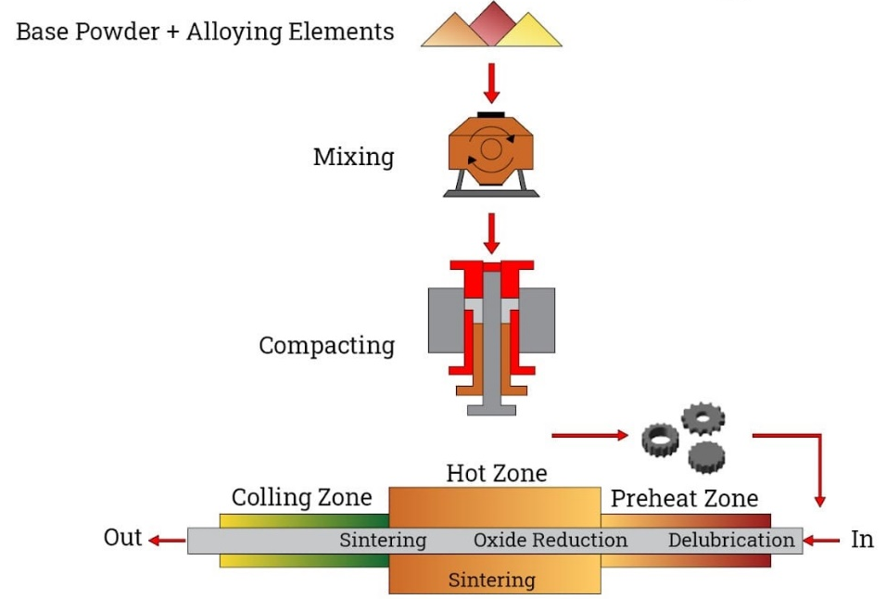
Fig. 4.1 Conventional powder metallurgy process
The above diagram shows the conventional powder metallurgy processes which involves mixing alloy powders, compacting the resulting mixture in a die and further sintering or heating in a controlled atmosphere furnace to metallurgically bond the resulting particles.
Most powder metallurgy parts weighs less than 5 lbs. (2.27 kg), although conventional PM equipment can fabricate parts weighing up to 35 lbs. (15.89 kg). Simple-shaped components like bushings and bearings are commonly produced using this method.
Modern advancements in powder metallurgy allow for the production of components with complex contours and multiple levels using sophisticated equipment, which is cost-effective and efficient.
4.1.2 Metal Injection Moulding (MIM)
Metal Injection Molding (MIM) is capable of manufacturing different shapes in large quantities using fine metal powders which typically less than 20 microns in size.
The feedstock is subsequently injected into multiple cavities of a conventional injection molding machine to form a Green component. After forming, nearly all of the binder is removed through thermal or solvent processing from the green component. The remaining or residual binder are eliminated during the sintering process. This entire process occurs in a controlled atmosphere furnace.
This method allows for the production of intricate metal parts with high precision and reproducibility, making MIM suitable for applications requiring complex geometries and consistent quality in large-scale production.
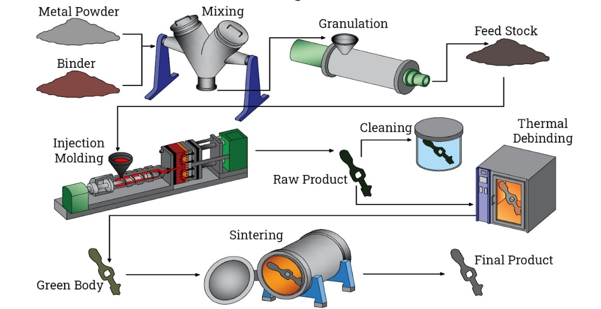
Fig. 4.2 Metal moulding process
Metal moulding process is capable of producing a wide range of shapes and configuration features. They are primarily used for relatively small parts (approximately less than 250 grams). These materials are highly complex and may require extensive finish machining.
The benefits of these metallurgical processes are their ability to achieve mechanical properties comparable to wrought materials.
They are net-shape manufacturing technologies that offer precise dimensional tolerance control. Additionally, parts produced through metal injection molding (MIM) offer nearly limitless shape and geometric feature capabilities.
This process also supports high production rates through the use of multi-cavity tooling, making it suitable for efficient mass production of intricate metal components.
4.1.3 Isostatic Pressing
This type of pressing can be conducted either in the cold or hot conditions.
Hot isostatic pressing (HIP) consolidates parts at elevated temperatures, typically above the recrystallization temperature of the material, facilitating solid-state diffusion. HIP is also effective for reducing residual porosity in sintered powder metallurgy parts, improving their density and mechanical properties.
Cold isostatic pressing (CIP) compacts green parts at ambient temperatures.
This diagram illustrates the process of cold isostatic pressing (CIP), whereas hot isostatic pressing (HIP) further enhances part consolidation and quality through high-temperature processing.
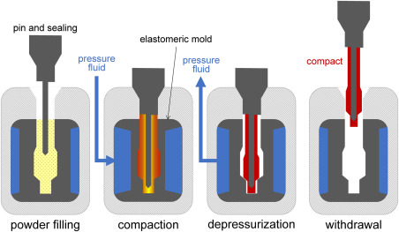
Fig. 4.3 Isostatic pressing process
Metal additive manufacturing (3D printing) represents a transformative approach to production, impacting speed-to-market and simplifying the creation of components and assemblies.
Unlike conventional subtractive manufacturing methods such as lathe machining or drilling, which remove material to form parts, Metal additive manufacturing builds components layer by layer directly from a digital model.
This process eliminates the need for molds or dies, minimizing material wastage and reducing manufacturing costs. Initially used predominantly for design and prototyping, additive manufacturing is now increasingly applied to directly produce components such as aircraft engine parts, medical implants, and jewellery.
Additive manufacturing encompasses various technologies and processes, all based on the layer-by-layer principle. This system utilizes a wide range of materials and techniques tailored to specific applications, reflecting the versatility and evolving capabilities of this manufacturing paradigm.
3.5 Advantages of powder metallurgy process
Additive manufacturing offers several advantages:
Cost-effectiveness for mass production: Eliminates the need for additional machining, reducing labor costs and material wastage.
Lower skill requirement: High level of automation reduces the need for highly skilled operators.
Unique material capabilities: Enables production of alloys which are generally difficult or impossible to produce using existing methods.
Versatile production: Capable of creating bimetallic and laminated products with ease.
High production rates: Can produce up to 500 to 1000 parts per hour, depending on the size and complexity of the parts.
Complex shapes: Easily accommodates the production of intricate and complex geometries directly from digital designs.
These advantages make additive manufacturing a compelling option for a wide range of industries seeking efficient, flexible, and innovative production solutions.
3.6 Disadvantages powder metallurgy process
- High Equipment Cost.
- Expensive for a single production.
- Intricate designs may be difficult to produce because of the less flow characteristics of metal powder.
- Completely uniform dense products are difficult to produce in this process.

MATERIALS AND METHODS
5.1 Material Selection and load calculation
The PMF (Powder Metallurgy Forging) process for femoral stem implants utilized pre-alloyed Advanced Materials plasma atomized Ti-6Al-4V (Grade 23) spherical powder.
5.2 Forming Process
The investigated Near-Net-Shape (NNS) process aimed to produce femoral stem implants using Direct Powder Forging (DPF), which involved three main steps. Initially, the process begans with preparation of the enclosed canister, followed by the primary forging of the bar.
The next steps involves forging and rolling the material in air at 1100°C to form a rectangular bar. A total deformation of 50% was applied during this phase to achieve the desired dimensions of the femoral stem implants.
After the primary forging stage, the forged rectangular bar measures 20 mm × 20 mm in cross-section and 150 mm in length. Following this, a preform is created by tapering one end of the bar and bending it to match the curvature required for the femoral stem.
Subsequently, final precision forging is conducted in a single closed-die step. To minimize friction and prevent adherence during forging, boron nitride(Chemical name-BN synthetically produced crystalline compound of boron and nitrogen) coating is applied to the die surface.
After precision forging, excess material in the flash region is trimmed at room temperature to prevent oxidation of the part and facilitate removal of the stainless-steel canister. This step efficiently releases the canister, ensuring the integrity of the forged femoral stem implants.
After the above forging and rolling step, the forged rectangular bar measures 20 mm in cross-section and 150 mm in length. The bar is tapered at one end and bent to match the curvature required for the femoral stem pre-form.
Subsequently, the final precision forging is conducted in a single closed-die step. To facilitate this process, boron nitride BN coating is applied to the die surface to reduce friction and prevent adherence.
Previous studies have shown that inter-metallic compounds can form at the canister-alloy interface during the DPF process, which may limit bonding. To address this, the forged titanium part is annealed in vacuum at 800°C for 2 hours and then furnace cooled.
Figure provides a schematic representation of the Near-Net-Shape (NNS) process employed in this study for processing titanium powder into femoral stem implants via PMF.
Figure: Schematic representation of the Near-Net-Shape (NNS) process
MODELLING AND ANALYSIS
Creo is a comprehensive product development software suite renowned for its capabilities in 3D CAD/CAM/CAE. Design engineers rely on Creo for a wide range of tasks including (i)product simulation, (ii)3D mechanical design, analysis testing, tooling creation, design communication and (iii)manufacturing applications. Creo is particularly opted for its seamless integration of parametric and direct modelling techniques, making it ideal for fulfilling various product design requirements.
6.1 3D Model of Rocker Arm
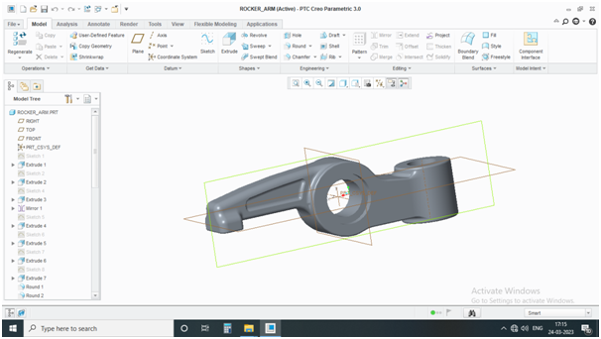
Fig.6.1 3D Model of Rocker Arm
6.2 Analysis of Rocker Arm
In engineering, stress is defined as the resistance force per unit area that a body exerts against deformation. Mathematically, stress (P) is calculated as the ratio of the internal resisting force (F) to the cross-sectional area (A) of the body, expressed as P = F/A.
Stress analysis is a critical task for engineers across disciplines such as civil, mechanical, aerospace, and others. Despite its name, stress analysis examines both stress and strain within a structure to assess its behavior under external loads.Tension.
- Compression
- Shear.
- Bending.
- Torsion.
- Fatigue.
The values of both shear stress and critical shear stress were nearly same. Thus the results concluded that pin of rocker arm is under shear stress.
6.3 Stress result for Existing Rocker arm
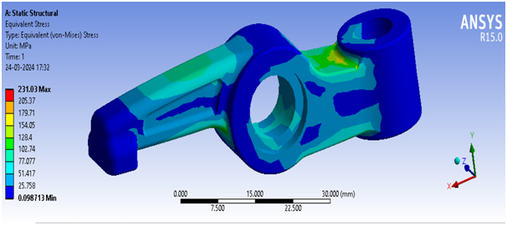
Fig. 6.4 Stress Analysis for Existing Rocker arm

6.4 Stress result for Proposed Rocker arm
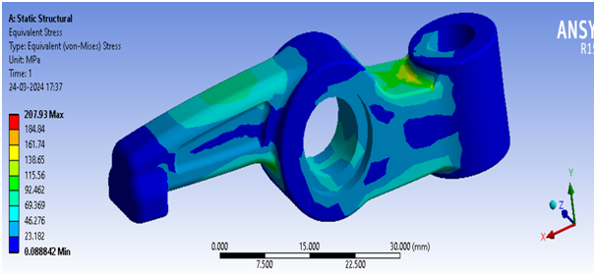
Fig. 6.5 Stress Analysis for Proposed Rocker arm
RESULTS AND DISCUSSIONS
7.1 Physical Properties
The average density of the titanium femoral stem is detailed in Table 1.
Complete densification was achieved using the DPF process. Previous research confirmed that the primary forging of the bar ingot resulted in fully dense parts, which was crucial for forging the femoral stem. As a result, the final shaping step focused solely on achieving the desired shape, producing a fully dense PM titanium femoral stem from coarse powder.
Average density of the femoral stem produces via NNS DPF process
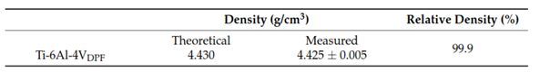
Table1
Fig. 7.3 Regular Titanium alloy Material
Powder metallurgy forging rocker arm
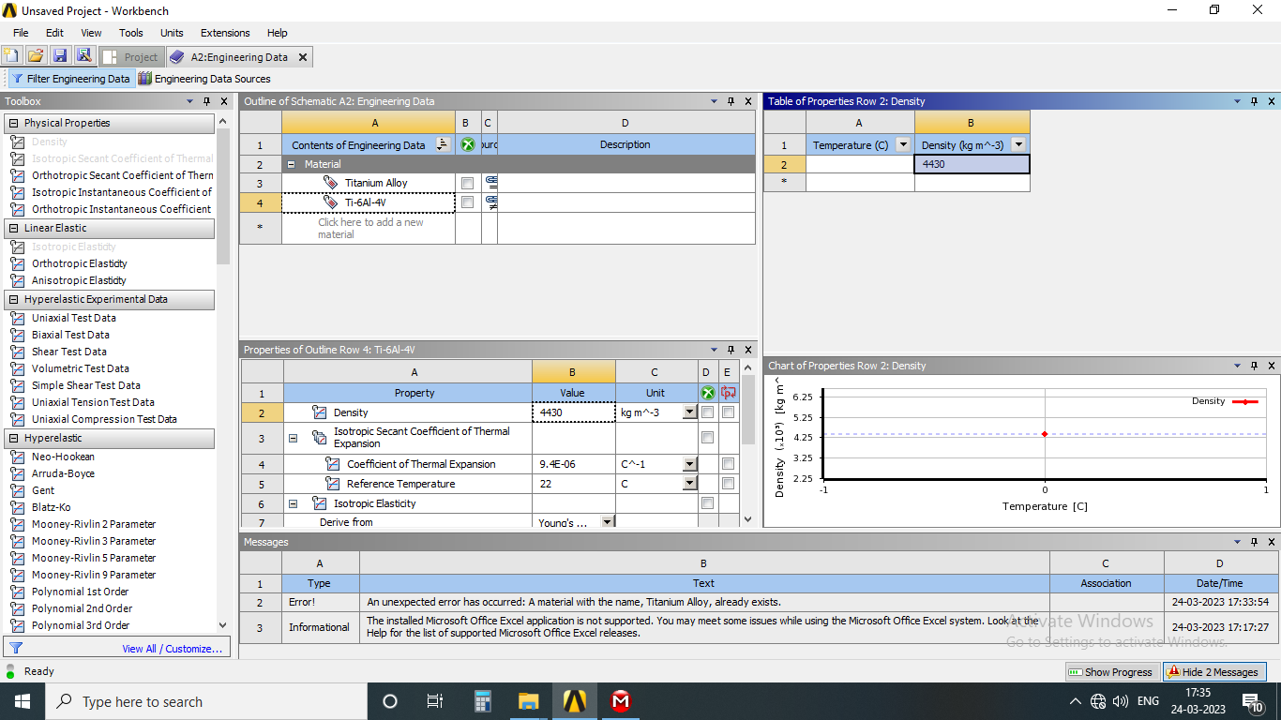
Fig. 7.4 Powder metallurgy forging rocker arm
CONCLUSION
The study assessed Direct Powder Forging (DPF) as an innovative method for static structural analysis in titanium powder processing. Using Ansys, the equivalent stress comparison between existing and new production methods was conducted. The findings suggest that conventional titanium forging parts can be utilized, enhancing accessibility to the market. Moreover, the proposed DPF method indicates potential benefits such as reducing processing steps by eliminating the need for traditional press and sinter or hot isostatic pressing (HIP) methods. This promises a more efficient and economically viable manufacturing process for titanium components.
The micro structural analysis showed that the as-forged compound Ti-6Al-4V alloy displayed a fully martensite crystal structure and coarse grain structure. There were no discernible micro structural anomalies compared to conventionally forged Ti-6Al-4V alloy, indicating favourable forging behaviour during Powder Metallurgy Forging (PMF). Subsequent annealing resulted in a fine and uniform Metallic microstructure meeting the mechanical property standards specified for biomedical Ti-6Al-4V ELI parts. Further optimization of the forging sequence, parameters, and post-forging heat treatment could potentially enhance the mechanical characteristics of Ti-6Al-4V parts by reducing shear stress within the component.
REFERENCES
- VS A.B.K Rajan, Dr. Selvakumaran Thunaipragasam, and Jaya Christiyan K.G, &quot;Numerical Analysis of
Diesel Engine Component Under Thermal Loading,&quot; International Journal of Mechanical Engineering,
vol. 7, no. 2, pp. 3271-3276, 2022.
- MS Sasikumar, S. Vinodh, and M. Saravana Kumar, &quot;Experimental and Analytical Study of Different
Fiber Reinforced Composites with Damage,&quot; International Journal of Engineering &amp; Technology, vol.
7, no. 10, pp. 207-210, 2018.
- AR Vinodh.S and Balamurugan.A, &quot;Comparative Study on the Morphology and Mechanical Properties
of Nylon 6 Nanocomposites Prepared Using Three Different Nanoclays,&quot; International Journal for
Innovative Research in Science, Engineering and …, 2018.
- S. Vinodh, R. Sasikumar, A. Rubuck, and NMM Fayas, &quot;Simulation Study and Optimization of Flight
Landing Control by Engine RPM,&quot; Simulation, vol. 3, no. 1, 2018.
- S. Vinodh, A. Bragadeesh, and P. Nishanth, &quot;An Experimental Study of Variable Compression Ratio
Engine Using Diesel Blend-A Computing Approach,&quot; International Journal of Advanced Engineering,
Management and Science, vol. 3, no. 8, 2017
- Careau, S.G.; Tougas, B.; Ulate-Kolitsky, E. Effect of direct powder forging process on the mechanical properties and microstruc- tural of Ti-6Al-4E ELI. Materials 2021, 14, 4499. [CrossRef]
- Olsson, L.R.; Lampe, V.; Fischmeister, H. Direct forging of high-alloy steel powders to bar stock. Powder Metall. 1974, 17, 347–362. [CrossRef]
- Jiang, J. Development of Direct Powder Forging Process. Ph.D. Thesis, Imperial College London, South Kensington, UK, 2017. [CrossRef]
- Manière, C.; Lee, G.; Olevsky, E.A. All-Materials-Inclusive Flash Spark Plasma Sintering. Sci. Rep. 2017, 7, 15071. [CrossRef]
- Childerhouse, T.; Jackson, M. Near net shape manufacture of titanium alloy components from powder and wire: A review of state-of-the-art process routes. Metals 2019, 9, 689. [CrossRef]
- Bai, Q.; Lin, J.; Jiang, J.; Dean, T.; Zou, J.; Tian, G. A study of direct forging process for powder superalloys. Mater. Sci. Eng. A 2015, 621, 68–75. [CrossRef]
- Wang, S.; Fang, S.; Shi, Z.; Jiang, J.; Zhou, X.; Lin, J. Direct powder forging of PM nickel-based superalloy: Densification and recrystallisation. Int. J. Adv. Manuf. Technol. 2017, 88, 2661–2670. [CrossRef]
- Calvert, E.; Wynne, B.; Weston, N.; Tudball, A.; Jackson, M. Thermomechanical processing of a high strength metastable beta titanium alloy powder, consolidated using the low-cost FAST-forge process. J. Mater. Process. Technol. 2018, 254, 158–170. [CrossRef]
- Pope, J.; Jackson, M. Fast-forge of diffusion bonded dissimilar titanium alloys: A novel hybrid processing approach for next generation near-net shape components. Metals 2019, 9, 654. [CrossRef]
- Careau, S.G.; Ulate-Kolitsky, E.; Tougas, B. In-situ alloying of Ti-5Fe titanium alloy using direct powder forging and the effect of the powder mixing method. Materialia 2022, 24, 101471. [CrossRef]
- ASTM F136-21; Standard Specification for Wrought Titanium 6Aluminium-4Vanadium ELI (Extra Low Interstitial) Alloy for Surgical Implant Applications (UNS R56401). ASTM International: West Conshohocken, PA, USA, 2018. Available online: www.astm.org (accessed on 22 July 2022).
- Dharavath, B.; Haq, A.U.; Varma, M.D.; Buddi, T.; Singh, S.K.; Naik, M.T. Comparative study of ASS 316L on formability at room temperature and super plastic region. Adv. Mater. Process. Technol. 2020, 6, 384–395. [CrossRef]
- ASTM B962-17; Standard Test Methods for Density of Compacted or Sintered Powder Metallurgy (PM) Products Using
- Archimedes’ Principle. ASTM International: West Conshohocken, PA, USA, 2018. Available online: www.astm.org (accessed on 22 July 2022).
- ASTM E2371-21a; Standard Test Method for Analysis of Titanium and Titanium Alloys by Direct Current Plasma and Induc- tively Coupled Plasma Atomic Emission Spectrometry (Performance-Based Test Methodology). ASTM International: West Conshohocken, PA, USA, 2018. Available online: www.astm.org (accessed on 22 July 2022).
- ASTM E8/E8M-21; Standard Test Methods for Tension Testing of Metallic Materials. ASTM International: West Conshohocken, PA, USA, 2016. Available online: www.astm.org (accessed on 22 July 2022).
- Bai, L.; Gong, C.; Chen, X.; Sun, Y.; Zhang, J.; Cai, L.; Zhu, S.; Xie, S.Q. Additive Manufacturing of Customized Metallic Orthopedic
- Implants: Materials, Structures, and Surface Modifications. Metals 2019, 9, 1004. [CrossRef]
- Jaber, H.; Kónya, J.; Kulcsár, K.; Kovács, T. Effects of Annealing and Solution Treatments on the Microstructure and Mechanical Properties of Ti6Al4V Manufactured by Selective Laser Melting. Materials 2022, 15, 1978. [CrossRef]
- Zhang, Z.; Qu, S.; Feng, A.; Shen, J. Achieving grain refinement and enhanced mechanical properties in Ti–6Al–4V alloy produced by multidirectional isothermal forging. Mater. Sci. Eng. A 2017, 692, 127–138. [CrossRef]
- Guo, L.; Fan, X.; Yu, G.; Yang, H. Microstructure control techniques in primary hot working of titanium alloy bars: A review. Chin.J. Aeronaut. 2016, 29, 30–40. [CrossRef]
- Semiatin, S.L. An Overview of the Thermomechanical Processing of α/β Titanium Alloys: Current Status and Future Research Opportunities. Met. Mater. Trans. A. 2020, 51, 2593–2625. [CrossRef]

