**TO IMPACT OF WATER HARVESTING ON A SMALL WATERSHED IN MALWA REGION OF MADHYA PRADESH INDIA**

**Papankusha Pandey*1**

*1M.Tech. Scholar, Department of Agricultural Engineering, S.V.N. University, Sagar, MP, India.

**ABSTRACT**

Reliable sources of fresh water are a finite resource across the world. Many countries, including India, face water scarcity due to temporal and spatial variations in precipitation, surface water pollution, and depletion of groundwater resources. In order to combat against water scarcity, the government, non-governmental organizations, researchers, and individuals have attempted to create solutions to the water scarcity problem. One solution, which has become popular throughout India is the construction of water harvestings structures (WHS), small earthen dams built to capture monsoonal runoff on ephemeral streams. Villagers believe these structures have a positive effect on groundwater levels and water availability throughout the year, although the direct effect on the local watershed is poorly understood. To better understand the impact of these structures, this work investigates the local geology, the watershed and surface water balance, and the monsoonal response of a WHS reservoir in a small watershed in Madhya Pradesh, India. Field work for this study was completed from Jan 2024 through May 2024. The accomplishments from the work are three fold. First an improved understanding of the local geology was obtained using electromagnetic induction surveys. Second, major components of the hydrologic cycle were monitored to calculate the flows for the overall water balance and the surface water balance. Finally, water levels in a WHS reservoir were monitored to allow for the reevaluation of a volume balance model proposed for management of these structures for artificially recharging groundwater. The main goal of the project is to determine the impact of water harvesting for artificial recharge and increasing water availability within the watershed. Information gathered during the geological surveys was used to develop the water balance for the watershed. From the water balance it was determined that stream flow out of the watershed is approximately 15% of the total yearly rainfall. The net transfer of surface water to the subsurface is approximately 80% of precipitation or as a flux normalized to the watershed area is 0.59m/year. The yearly change in groundwater storage is positive and wells are able to recover after two months of pumping for irrigation, indicating current groundwater practices are sustainable and not over drawing the local aquifer. After consideration of the volume balance for the WHS, it was found that from two to six times the maximum reservoir volume (6.5x104m3) is lost as groundwater recharge from the structure. If the structure is assumed to infiltrate 1.3x105m3/year, without the presence of the structure the yearly stream flow would increase by 48% if the volume of water infiltrated was assumed to be discharged as stream flow. In addition to decreasing stream flow, the upstream reservoir provides a surface water body which is present for ten months of the year, helping to decrease water scarcity in the early dry season.

**Keywords:** Aquifer; Groundwater recharge; precipitation; watershed; reservoir; infiltrate; geology.

**I. INTRODUCTION**

Water scarcity is defined by United Nations Environmental Program Global Environmental Outlook as the amount of water used for industry, agriculture, and domestic purposes divided by the total amount of renewable water available in surface water bodies and shallow aquifers. High water scarcity occurs when 40% of the total available water supplies are withdrawn (UNEP, 2000). Currently, two billion people face a high level of water scarcity, and it is predicted that by 2025 two thirds of the world’s eight billion people will face high water scarcity. One example of a country which is expected to have high water scarcity by 2025 is India. Although India has vast water resources, scarcity arises due to spatial and temporal variations of precipitation as well as poor water management (Bobba et al., 1997; Chaudary et al., 2002). The majority of rainfall across much of India occurs during the four month monsoon season, June through September. The quantity of rainfall during the monsoon is generally sufficient to meet demands. Because it comes in such a short amount of time, however, the majority of rainfall is lost as runoff (Singh and Sharama, 2002; Bobba et al., 1997). Furthermore, sustainable water management practices are not set in place, which has lead to degradation of water quantity and quality. Attempts at solutions to address the inadequate water supplies and scarcity have come in the form of aid and assistance from non-governmental organizations, local governments, researches, and individuals. Aid has been provided by land development projects, construction of retention ponds, and general education about water resources (Limaye, 2010). However, the net impact of such help is usually poorly understood (Bobba et al. 1997). Consequently, more scientific work is required to study the impacts of water harvesting, watershed restoration, and sustainable water management in order to lessen the water scarcity faced by so many. Water harvesting has been used for centuries as a way to move or store water for domestic use in the future (Lavee et al., 1997). Out of the numerous types of water harvesting, the construction of small earthen dams built on ephemeral streams to capture and store monsoonal runoff have become very popular in India (Sukhija et al., 1997; Srivastava, 2000). Water stored in these structures is then able to infiltrate and potentially recharge local aquifers instead of discharging through streams (Kumar, 2006). Although water harvesting structures (WHS) are seen as beneficial to local communities, the volume of water contributed as recharge as well as the location and accessibility of recharged water is poorly understood. Currently, there are few scientific studies which support their effectiveness.

**II. METHODOLOGY**

In order to better understand the impact of water harvesting in India, the current study focuses on a small watershed located in rural Madhya Pradesh, India (Figure 1.2). Previous investigations in the watershed were conducted in 2007 by Oblinger (2008) and the Foundation for Ecological Security (FES), a local non-governmental organization, to investigate the local geology, water balance, and model the behavior of a WHS. The goal of the current study is to further investigate the local geology, better understand the flows of the water balance, and reevaluate the model for the WHS in order to aid FES and the local village in determining the impact of water harvesting on groundwater recharge and water accessibility through surface water and groundwater sources throughout the year.

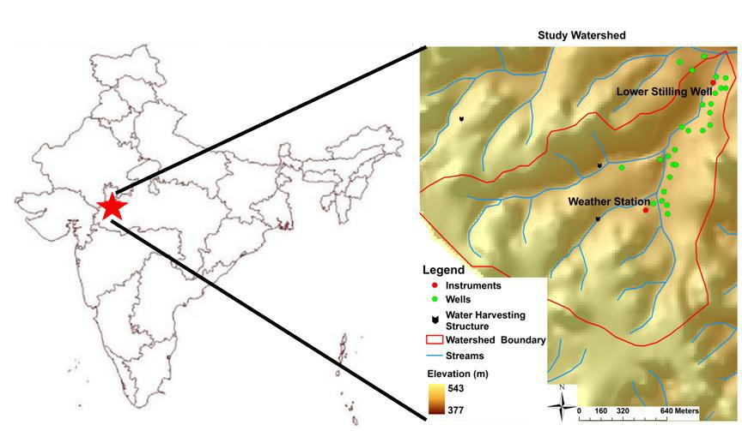

**Figure1:** Location of the study watershed in Madhya Pradesh, India.

The study watershed is located within the Deccan Basalts of central and western India. To better understand and improve on the conceptual model developed from geologic investigations in 2007, the current study uses electrical resistivity and electromagnetic induction surveys to study the stratigraphy. In addition, soil and rock samples were collected to investigate the hydrogeology. Electrical resistivity surveys performed with the Indian Institute of Technology-Bombay were used to confirm the findings from the 2007 study which characterized the thickness, type, and location of basalt flows. Electromagnetic induction surveys were used to determine the presence and extent of an upper weathered zone which may act as a surficial aquifer, and evaluate changes in the electromagnetic response through time as the monsoon season progresses. Soil and rock samples were used to determine the hydraulic conductivity and specific yield in the northeastern area of the watershed. Knowledge of the local geology, hydrogeology, and extent of the weathered zone is needed for completing the water balance for the watershed. Water balances are useful for determining net water availability for a given system (Burt, 1999). The watershed water balance is used to determine the estimated range for evapotranspiration for the watershed. Furthermore, the water balance is used to investigate the residual flow of water out of the watershed; primarily, the volume of water lost from the surficial aquifer to other reservoirs, such as leakage to a regional aquifer. A monthly surface water balance is developed to determine the net volumetric flow to the subsurface across the watershed which will help determine the overall impact of water harvesting in the watershed. After knowing the flows of the water balance, it will be possible to investigate water supplies in surface water bodies and the surficial aquifer for a given year, evaluate if current water practices in the watershed are sustainable, and determine whether or not water harvesting has a significant impact on the overall water balance. Finally, a volume balance to model the WHS as developed by Oblinger et al. (2010) is reevaluated to determine the volume of water lost from the structure as infiltration and the residence time of water in the structure. After model recalibration, the volume of infiltration from the structure is compared to the approximate volume of water which moves as the net transfer from the surface water to the groundwater system. From this comparison it is possible to determine if water harvesting is a successful method to recharge the local aquifer and ease the water scarcity faced each year. From the study it is hoped the results will continue to aid FES in assessing the impact of WHS in rural areas; furthermore, in studying the geology, availability of water, and the impact of water harvesting it is hoped villagers of the area will be able to better manage and sustain their water supplies.

**III. MODELING AND ANALYSIS**

Before developing the numerical model for the volume balance, a conceptual model for the WHS is constructed to represent the behavior of the structure. The local geology was investigated using geologic mapping, electrical resistivity surveys (Oblinger, 2008), observations in large diameter open wells, and electromagnetic induction surveys. It was found that the watershed is characterized by alternating layers of massive and columnar basalts with weathered basalt reaching a maximum thickness of 10m and small areas of alluvial material downstream of the WHS. A cross section to show the local geology is used to develop the conceptual model for the WHS.

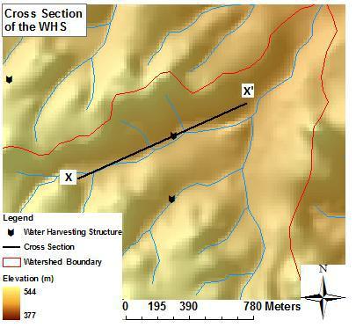

**Figure2:** Location for the cross section used to develop the conceptual model for theWHS.

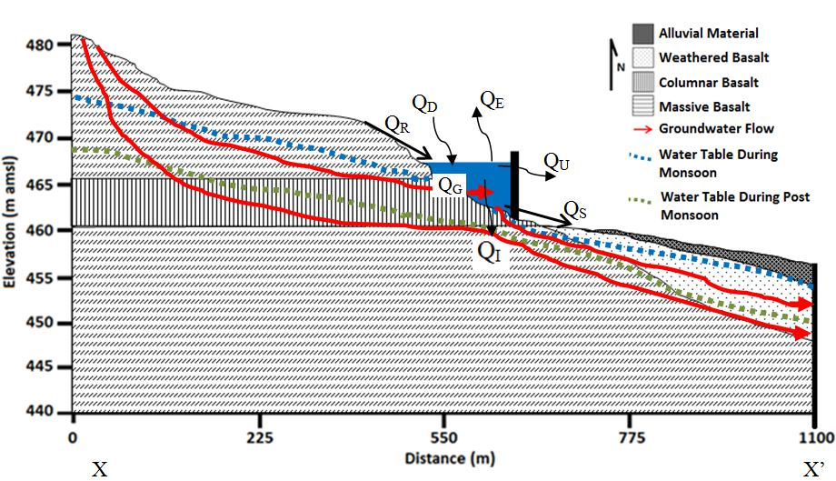

**Figure3:** Conceptual model for the WHS showing the water table for the monsoonseason and dry season, flows in and out of the structure, and groundwater flow paths. The vertical exaggeration is approximately 11.3 times and the y-axis shows the elevation above mean sea level (amsl).

Flows into the structure are groundwater (QG), runoff (Qr), and direct precipitation (Qd) and flows out of the structure are evaporation (Qe), water lost via the spillway (Qs), domestic use (QU), and infiltration (QI) (Figure 4.2). Groundwater flows into the structure at the contact between the columnar and massive basalts as well as groundwater discharged up gradient of the structure through localized springs where fractures in the massive basalts outcrop. Water is then lost as infiltration to the weathered basalts and flows down gradient. Precipitation provides water to the structure as runoff from the upland area draining into the reservoir, as well as water falling directly on the surface. During the post monsoon and dry season, rainfall is generally less than 10mm; therefore, small volumes of water are added to the structure as direct rainfall and runoff. Outflow from the WHS occurs as water to the spillway when the reservoir reaches the maximum capacity as well as direct evaporation from the surface. Domestic use includes water used by villagers and the livestock of the area. The water table during the monsoon is generally one to two meters below the ground surface downstream of the WHS, as observed in wells. It is believed groundwater flows into the structure from the columnar basalts; therefore, the water table elevation is above the surface elevation. During the post monsoon season and dry season the water table drops below the bottom elevation of the reservoir and groundwater no longer flows into the structure. With the conceptual model representing the localized geology, flows in and out of the structure, and the behavior of the water table for the monsoon and post monsoon season it is possible to develop the numerical model for the reservoir volume balance.

**IV. RESULTS AND DISCUSSION**

The model developed by Oblinger et al. (2010) is based on a simple volumetric water balance between the flows in and out, i.e., QIN and QOUT, of a reservoir:

ΔV = QIN - QOUT

Volumetric flows into the reservoir as shown in the conceptual model are contributed by groundwater discharge (QG), surface runoff (Qr), and direct rainfall (Qd). Volumetric flows out of the reservoir are a result of evaporation (Qe), infiltration losses to the subsurface (QI), the use of water by villagers and animals (Qu), and losses through a spillway (Qs) to prevent over topping of the dam. Changes in reservoir storage are given by the time derivative of the reservoir volume V(h), which is a function of the stage, h.

Volumetric flows into the reservoir as shown in the conceptual model are contributed by groundwater discharge (QG), surface runoff (Qr), and direct rainfall (Qd). Volumetric flows out of the reservoir are a result of evaporation (Qe), infiltration losses to the subsurface (QI), the use of water by villagers and animals (Qu), and losses through a spillway (Qs) to prevent over topping of the dam. Changes in reservoir storage are given by the time derivative of the reservoir volume V(h), which is a function of the stage, h.

|  |  |  |  |  |  |  |
| --- | --- | --- | --- | --- | --- | --- |
| *dV* ( *h*) |  *c* *H* |  |  *A R*  *c* ( *h*  *H* ) *A* | | | ( *h* )( *R*  *E* )  *Q*  *Q* |
|  | *G* |
| *dt* | 1 | *U* | 2 | 1*WHS* | *us* | |

This equation is discretized in time to provide an explicit solution for the volume of the reservoir:

*Vi* 1(*c*1*H G*  *AU Ri*  *c*2( *hi*  *H I* ) *AWHS* ( *hi* )( *Ri*  *Ei* ) *Qu*  *Qs* )*t* *V* (*hi* )

where V(hi+1) is the predicted reservoir volume for time step i+1, and V(hi) is the volume at the current time step.Water usage, rainfall, and evaporation, QU, Ri, and Ei, respectively, drive the model and must be known for a given study watershed. The volume of water required for human and livestock use is approximately 0.5x104m3/year (Oblinger et al., 2010), which is 8% of the maximum reservoir volume (6.5x104m3). Since not all water is taken from the WHS, the WHS is not full year round, and the flow of water required for usage is relatively small in this study compared to the other flows, it is estimated as zero for the entire period. The function AWHS(hi) is the surface area of the WHS for a given stage, hi and should be obtained directly from detailed topographic surveys or derived from geometric arguments. It is assumed that the area of the watershed upstream of the dam contributing to surface runoff (AU) can be determined from topographic data. Losses of water through the spillway (QS) are not specified directly, but rather obtained from calculated volume changes that exceed the reservoir capacity. The length of the time step used in the model is it.

**V. CONCLUSION**

A study was undertaken in a small watershed in rural Madhya Pradesh, India to determine the impact of water harvesting. Geologic investigations were carried out to better understand the stratigraphy of the watershed. Then, using the knowledge from the stratigraphy of the watershed, a water balance was developed to better understand the volumetric flows in and out of the watershed. Lastly, a volume balance for a reservoir was reevaluated to determine the impact of water harvesting in the study watershed. A study was undertaken in a small watershed in rural Madhya Pradesh, India to determine the impact of water harvesting. Geologic investigations were carried out to better understand the stratigraphy of the watershed. Then, using the knowledge from the stratigraphy of the watershed, a water balance was developed to better understand the volumetric flows in and out of the watershed. Lastly, a volume balance for a reservoir was reevaluated to determine the impact of water harvesting in the study watershed. The overall water balance was used to determine the flows in and out of the watershed, as well as determine a range for the volumetric flow of evapotranspiration (ET). Then, these flows were applied to a surface water balance to solve for the net transfer of water between the surface and subsurface. After determining the flows of the water balance, considerations were taken to determine water availability during the monsoon season and dry season. The volumetric flows of evaporation from surface water bodies and precipitation were then applied to a volume balance to reevaluate a model developed to predict the stage, residence time of water, and volume of infiltration from a water harvesting structure (WHS) in the watershed. Geologic investigations show a weathered zone is present in the lower watershed overlying the basalt bedrock described by Oblinger (2008). This surface layer thins moving southwest towards the uplands of the watershed. Electromagnetic induction surveys show at depths of investigation near 20m the electromagnetic response is low relative to the calibration location in the lower watershed, which indicates competent basalts. At shallower depths of investigation, near 7m, the electromagnetic response remains low in the uplands and hill slopes but increases in the valley of the lower watershed, indicating the presence of a weathered zone and the potential for increased water storage. The overall watershed water balance was used to develop limits on the volume of water lost from the watershed as ET as well as determining the flow of water lost as leakage from the surficial aquifer. The range for potential ET is 8.3x105m3/year to 1.5x106m3/year, or when normalized to the area of the watershed 0.32m/year to 0.59m/year. An estimate of ET using the Thornthwaite-Mather approach is approximately 1.7x106m3/year, 0.66m/year, which is higher than expected for the watershed based on the limits found from the water balance. The leakage from the watershed is negative on a yearly time scale, caused by the large flow of ET from the watershed and poor estimates of groundwater storage. The leakage flow suggests that water is entering the watershed from a deep groundwater source, which is not expected for the watershed.

**VI. REFERENCES**

[1] ANDERSON-COOK, C.M., ALLEY, M.M., ROYGARD, J.K.F., KHOSLA, R., NOBLE, R.B. and DOOLITTLE, J.A., 2002. Differentiating Soil Types Using Electromagnetic Conductivity and Crop Yield Maps. *Soil Science Society* *American Journal,* **66**(5), 1562-1570.

[2] BEDIENT, P.B. and HUBER, W.C., 2002. Hydrology and Floodplain Analysis, Upper Saddle River, NJ: Prentice-Hall Publishing.

[3] CHAUDHARY, V., JACKS, G. and GUSTAFSSON, J., 2002. An Analysis of Groundwater Vulnerability and Water Policy Reform in India. *Environmental* *Management and Health,* **13**(2), 175-193.

[4] CHANDRASEKHAR, E., 2009. Electrical Resistivity Survey Results from the Salri Watershed. Personal Communication.

[5] FARMER, D., SIVAPALAN, M. and JOTHITYANGKOON, C., 2003. Climate, Soil, and Vegetation Controls Upon the Variability of Water Balance in Temperate and Semiarid Landscapes: Downward Approach to Water Balance Analysis. *Water* *Resources Research,* **39**(2), 1035.

[6] GOVERNMENT OF INDIA, 2005, Master Plan for Artificial Recharge to Groundwater

in India, Central Groundwater Board, Ministry of Water Resources, New Delhi.

[7] KULKARNI, H., S. B. DEOLANKAR, ANIL LALWANI, V. A. LELE, 1994. Integrated Remote Sensing as an Operational Aid in Hydrogeological Studies of Deccan Basalt Aquifers. *Asian-Pacific Remote Sensing Journal,* **6**, 9-18.

[8] KUMAR, M. D., SHANTANU GHOSH, ANKIT PATEL, O. P. SINGH, R. RAVINDRANATH, 2006. Rainwater Harvesting in India: Some Critical Issues for Basin Planning and Research. *Land Use and Water Resources Research,* **6**, 1-17.