**FEASIBILITY ANALYSIS OF A STANDALONE HYBRID RENEWABLE ENERGY SYSTEM WITH SOLAR, WIND, AND HYDRO COMPONENTS**

**Samta 1, Vivek Kumar2**

1M.Tech Student, Department of Electrical Engineering, BRCM College of Engineering and Technology

2 Professor and Head, Department of Electrical Engineering, BRCM College of Engineering and Technology

**ABSTRACT**

This research paper explores the feasibility of a standalone hybrid renewable energy system (HRES) that integrates solar, wind, hydro, generator, and battery storage components. The aim is to evaluate the technical and economic viability of such a system in providing a reliable and sustainable energy supply, particularly in remote or off-grid locations. The study begins with a comprehensive background on renewable energy sources and their potential for integration into hybrid systems. It then delves into the optimal sizing and cost assessment of the HRES, considering the specific characteristics and complementarities of the included energy sources. The analysis includes resource assessment, system configuration, and economic evaluation to determine the most cost-effective and efficient design. The findings highlight the benefits and challenges of implementing a hybrid renewable energy system, offering insights into its practical application and potential for enhancing energy security and sustainability.

**Keywords:** Hybrid renewable energy system (HRES), Levelized cost of energy (LCOE), emission.

1. **INTRODUCTION**

The increasing global demand for energy, coupled with the pressing need to reduce greenhouse gas emissions and combat climate change, has driven significant interest in renewable energy sources. Among these, solar, wind, and hydro power stand out due to their abundant availability and minimal environmental impact [1-4]. However, the intermittent and variable nature of these renewable sources poses challenges for their reliable integration into standalone energy systems. This has led to the exploration and development of hybrid renewable energy systems (HRES), which combine multiple renewable energy sources to enhance overall system reliability, efficiency, and sustainability [5]. This research paper focuses on the feasibility analysis of a standalone hybrid renewable energy system incorporating solar, wind, and hydro components. The objective is to evaluate the technical, economic, and environmental viability of such a system in providing a stable and continuous energy supply, particularly in remote or off-grid locations where conventional energy infrastructure may be lacking. The integration of solar, wind, and hydro power in a hybrid system offers several advantages. Solar power provides a reliable source of energy during daylight hours, while wind power can generate electricity both day and night, depending on wind conditions [6-9]. Hydro power, particularly from small-scale or micro-hydro installations, can offer a steady and consistent energy output, compensating for the variability of solar and wind resources. By combining these three renewable sources, a hybrid system can maximize energy generation, minimize storage requirements, and ensure a more balanced and resilient energy supply. This paper begins with an overview of the current state of renewable energy technologies and their potential for integration into hybrid systems. It then outlines the methodology used for the feasibility analysis, including site selection criteria, resource assessment, system design, and economic evaluation. The results of the analysis are presented and discussed, highlighting the key factors that influence the performance and viability of the hybrid system. Finally, the paper identifies future research directions and potential improvements to enhance the feasibility and implementation of hybrid renewable energy systems. By conducting a comprehensive feasibility analysis, this research aims to contribute to the understanding and development of standalone hybrid renewable energy systems, paving the way for sustainable and resilient energy solutions in various settings.

1. **METHODOLOGY AND CONFIGURATION**

Hybrid system is increasingly recognized as a viable solution for electrifying remote rural communities where grid extension is impractical or uneconomical. In order to reduce life cycle costs and guarantee dependability, these systems frequently incorporate a variety of many HRES, including solar, wind etc., and occasionally conventional generators for backup. The location chosen for the study is Kodagu, sometimes referred to as Coorg, is a rural district in the state of Karnataka in southwest India. Madikeri Fort, located to the north of the region, features a Gothic-style cathedral with a museum on its grounds, in addition to two life-size elephant statues at its entrance [10-13]. Figure 1 to Figure 3 represent the selected location and yearly as well as hourly load profile for the chosen location [14, 15].

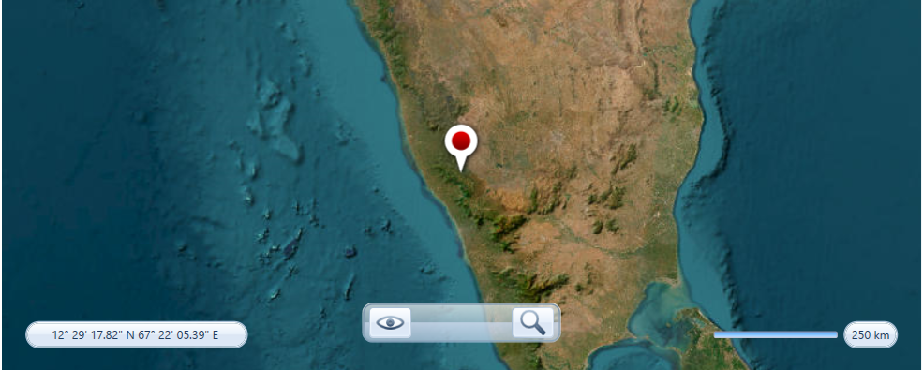

**Figure 1**: Representation of selected location of town Kodagu in Karnataka state of India

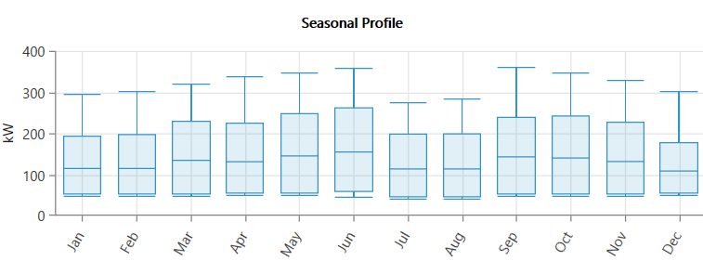

**Figure 2:** Representation of seasonal profile of the selected location for a year

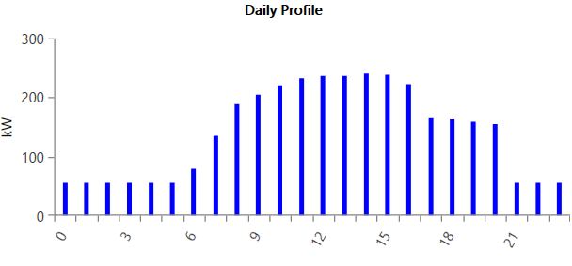

**Figure 3**: Representation of electrical load profile for 24 hours

Tables 1 and 2 present all the economic information about the electric load profile and the characteristics of the diesel generator employed in the system. Also the generator cost parameters are given in the Table 3. In the Figure 5 to Figure 8 all the economics values are mentioned that used in the study and the Table 3 to Table 7 all the parameters and resource values used in the study mentioned with all the constant values.

Table 1: Economics of electric load profile for the chosen location

|  |  |  |
| --- | --- | --- |
| Metric | Baseline | Scaled |
| Average (kWh//Day) | 3,141.3 | 3,141.3 |
| Average (kW) | 130.89 | 130.89 |
| Peak (kW) | 361.51 | 361.51 |
| Load factor | 0.36 | 0.36 |

Table 2: Economics of all the properties of diesel generator used in system

|  |  |
| --- | --- |
| **Emissions** |  |
| CO (g//L fuel) | 16.5 |
| Unburned HC (g/L fuel) | 0.72 |
| Particulates (g/L fuel) | 0.1 |
| Fuel sulfur to PM (%) | 2.2 |
| NOx (g/L fuel) | 15.5 |
|  |  |
| **Fuel Properties** |  |
| Lower heating value (MJ/kg) | 43.2 |
| Density (kg/m3) | 820 |
| Carbon content (%) | 88 |
| Sulfur Content (%) | 0.4 |

Table 3: All the input parameters for the generator input for proposed study

|  |  |
| --- | --- |
| **Generator Cost (In $/kW of capacity)** | |
| Initial Capital ($) | **500.00** |
| Replacement ($) | **500.00** |
| O&M ($/op.hour) | **0.030** |
| Fuel Price ($/L) | **1.00** |

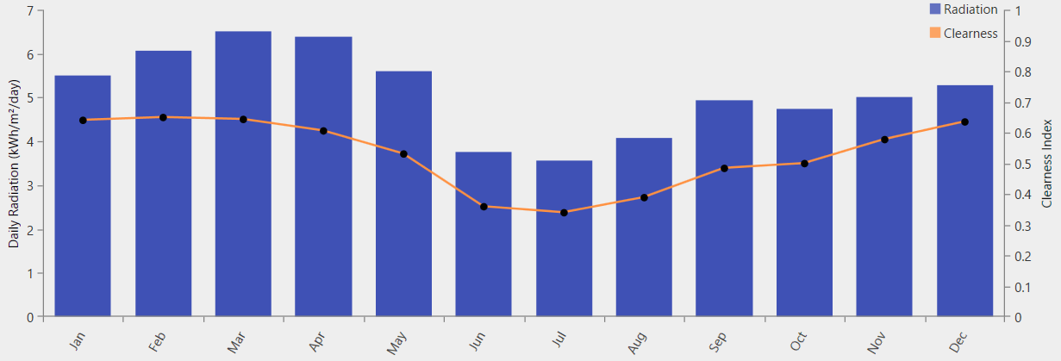

**Figure 5**: Representation for solar irradiation profile for the selected location

Table 4: Representation of solar radiations at the chosen site

|  |  |  |
| --- | --- | --- |
| **Month** | **Clearness Index** | **Daily Radiation (kWh/m2/day)** |
| January | 0.640 | 5.490 |
| February | 0.649 | 6.070 |
| March | 0.643 | 6.520 |
| April | 0.606 | 6.390 |
| May | 0.530 | 5.600 |
| June | 0.359 | 3.750 |
| July | 0.339 | 3.550 |
| August | 0.388 | 4.070 |
| September | 0.484 | 4.930 |
| October | 0.499 | 4.740 |
| November | 0.577 | 5.020 |
| December | 0.635 | 5.270 |

Table 5: Average speed of wind for the chosen site

|  |  |
| --- | --- |
| **Month** | **Average (m/s)** |
| January | 2.4500 |
| February | 2.2270 |
| March | 2.1100 |
| April | 2.1900 |
| May | 3.2900 |
| June | 5.1200 |
| July | 5.5400 |
| August | 5.0400 |
| September | 3.6200 |
| October | 2.6100 |
| November | 2.5700 |
| December | 2.8800 |

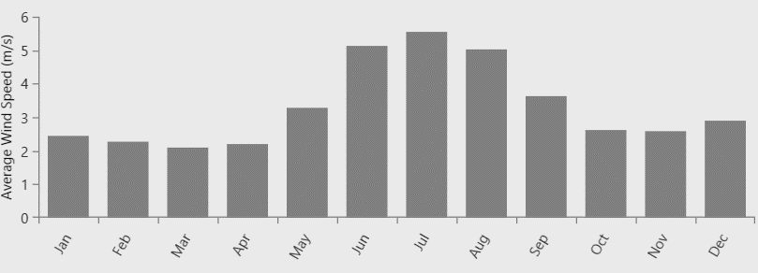

Figure 6: Average wind speed representation for the chosen location

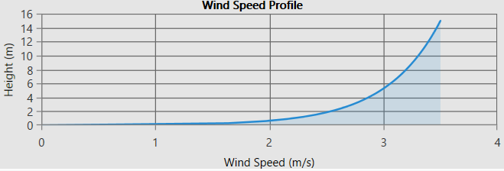

Figure 7: Representation of wind speed profile with respect to height and speed for chosen location

Table 6: Economics of the hydro power turbine for chosen location

|  |  |
| --- | --- |
| Available head (m) | 25.00 |
| Design flow rate (L/s) | 500.00 |
| Minimum flow ratio (%) | 50.00 |
| Maximum flow ratio (%) | 150.00 |
| Efficiency (%) | 80.00 |

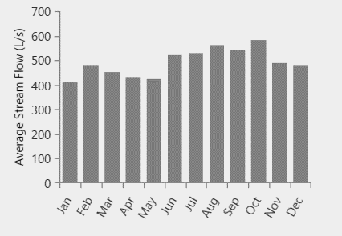

Figure 8: Representation of average water flow for the given study

Table 7: Representation of battery model with all the parameters

|  |  |
| --- | --- |
| **Idealized Battery** |  |
| Nominal Voltage (V) | 6 |
| Nominal Capacity (kWh) | 1 |
| Nominal Capacity (Ah) | 167 |
| Roundtrip efficiency (%) | 90 |
| Maximum charge current (A) | 167 |
| Maximum discharge current (A) | 500 |

1. **RESULTS AND DISCUSSIONS**

To supply dependable power, a hybrid energy system (HES) mixes conventional energy sources like diesel generators with a variety of energy sources, most commonly renewables like solar and wind. Evaluating a HES involves both technical and economic considerations, and a techno-economic analysis with sensitivity analysis is crucial for decision making.

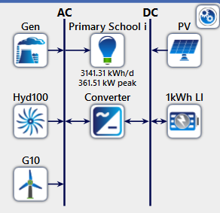

Figure 9: Representation of proposed hybrid energy system.

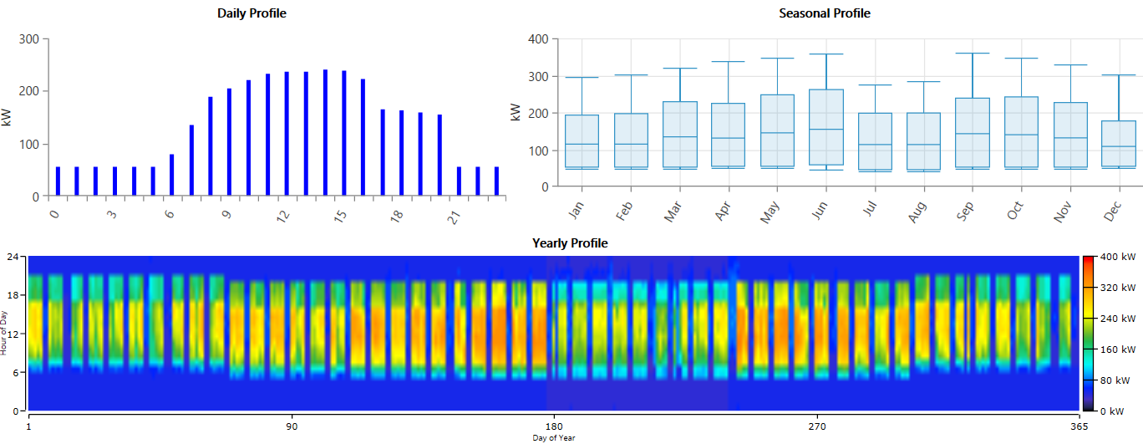

Figure 10: Load profile for the selected location with daily, seasonal and yearly load profile

The table8 provided appears to analyze various energy generation architectures and their associated costs. Here’s a detailed explanation of each column and the data it presents:

Table 8: Techno-economic feasibility analysis of hybrid energy system including solar, wind and hydro

|  |  |  |  |  |  |  |  |  |  |  |
| --- | --- | --- | --- | --- | --- | --- | --- | --- | --- | --- |
| PV (kW) | G10 | Gen (kW) | 1kWh LI | Hyd 100 (kW) | Converter (kW) | Dispatch | NPC ($) | COE ($) | Operating cost ($/yr) | Initial Capital ($) |
| 617 | 79 | 400 | 460 | 98.1 | 302 | LF | $1.51M | $0.102 | $48,433 | $8,88,740 |
| 814 |  | 400 | 511 | 98.1 | 305 | LF | $1.66M | $0.112 | $52,403 | $9,85,765 |
|  | 623 | 400 | 356 | 98.1 | 190 | CC | $2.40M | $0.162 | $1,29,413 | $7,23,121 |
| 1804 | 208 |  | 1295 | 98.1 | 296 | CC | $2.58M | $0.174 | $60,304 | $1.80M |
| 142 | 359 | 400 |  | 98.1 | 85.6 | CC | $2.95M | $0.199 | $1,90,624 | $4,80,973 |
|  | 404 | 400 |  | 98.1 |  | CC | $3.06M | $0.206 | $2,05,828 | $3,97,120 |
|  |  | 400 | 313 | 98.1 | 151 | CC | $3.26M | $0.220 | $2,22,048 | $3,92,544 |
| 275 |  | 400 |  | 98.1 | 136 | CC | $3.32M | $0.224 | $2,26,379 | $3,97,883 |
| 3546 |  |  | 1486 | 98.1 | 316 | CC | $3.74M | $0.252 | $74,986 | $2.77M |
|  |  | 400 |  | 98.1 |  | CC | $3.76M | $0.254 | $2,75,517 | $2,03,200 |

**Architecture**

PV (kW)

Represents the capacity of photovoltaic solar panels in kilowatts. Values range from 142 kW to 3,546 kW, indicating the scale of solar power integration in different setups.

G10 (kW)

Indicates the capacity of an unspecified generation source labeled "G10" in kilowatts. Values range from 79 kW to 404 kW, reflecting the variability in this component across different setups.

Gen (kW)

Represents the capacity of conventional generators in kilowatts. A constant value of 400 kW across all setups suggests a fixed conventional generation capacity.

1kWh LI

Refers to the 1-kilowatt hour Lithium-Ion battery storage capacity in kilowatts. Values range from 356 kW to 1,486 kW, indicating varying levels of energy storage capabilities.

Hyd100 (kW)

Indicates the capacity of a hydropower source labeled "Hyd100" in kilowatts. A constant value of 98.1 kW across all setups suggests a fixed hydropower capacity.

Converter (kW)

Represents the capacity of converters in kilowatts, which are used to change electricity from one form to another. Values range from 85.6 kW to 316 kW, showing differences in conversion capacity.

Dispatch

Refers to the strategy used for dispatching the generated energy. "LF" stands for Load Following, and "CC" stands for Cycle Charging, indicating the operational strategy employed.

**Cost**

NPC ($)

Stands for Net Present Cost in dollars. Values range from $1.51M to $3.76M, representing the total lifetime cost of each system discounted to present value.

COE ($) Stands for Cost of Energy in dollars per kilowatt-hour. Values range from $0.102 to $0.254, showing the cost efficiency of each setup.

Operating cost ($/yr) Indicates the annual operating cost in dollars. Values range from $48,433 to $275,517, reflecting the yearly expenditure required to run each system.

Initial capital ($) Represents the initial investment required in dollars. Values range from $203,200 to $2.77M, indicating the upfront cost to set up each system.

**Detailed Interpretation**

Solar PV Capacity (PV kW)

Systems with higher PV capacities (e.g., 3,546 kW) have higher initial capital costs but potentially lower operating costs per kilowatt-hour due to the reliance on solar energy.

Generation Sources and Battery Storage Systems with significant battery storage (e.g., 1,486 kW 1kWh LI) have varied initial capital and operating costs, depending on their dispatch strategies and other generation capacities. The presence of a consistent hydropower capacity (98.1 kW) and generator capacity (400 kW) suggests these components are baseline requirements for all systems.

Dispatch Approach

Cycle charging and Load Following (LF) approaches affect the operating cost and overall cost-efficiency of the systems. Systems using LF (e.g., with NPC $1.51M and $1.66M) generally have lower NPC and COE, indicating cost-effectiveness in some contexts compared to CC strategies.

Cost Analysis

The NPC values indicate the long-term financial commitment of each setup, with systems featuring higher initial investments generally aiming for long-term savings in operating costs. COE values provide insight into the cost per unit of energy produced, with lower COE indicating more cost-effective energy production. The variation in operating costs highlights the ongoing financial requirements, where some systems (e.g., $48,433 per year) are significantly cheaper to maintain than others (e.g., $275,517 per year). The table comprehensively presents a comparison of different energy generation architectures, focusing on their capacity, dispatch strategy, and associated costs. Systems with higher initial capital costs often aim to reduce long-term operating costs, and the choice of dispatch strategy (LF vs. CC) significantly impacts the cost dynamics. This analysis helps in identifying the most cost-effective and efficient energy generation system for different scenarios based on specific requirements and constraints.

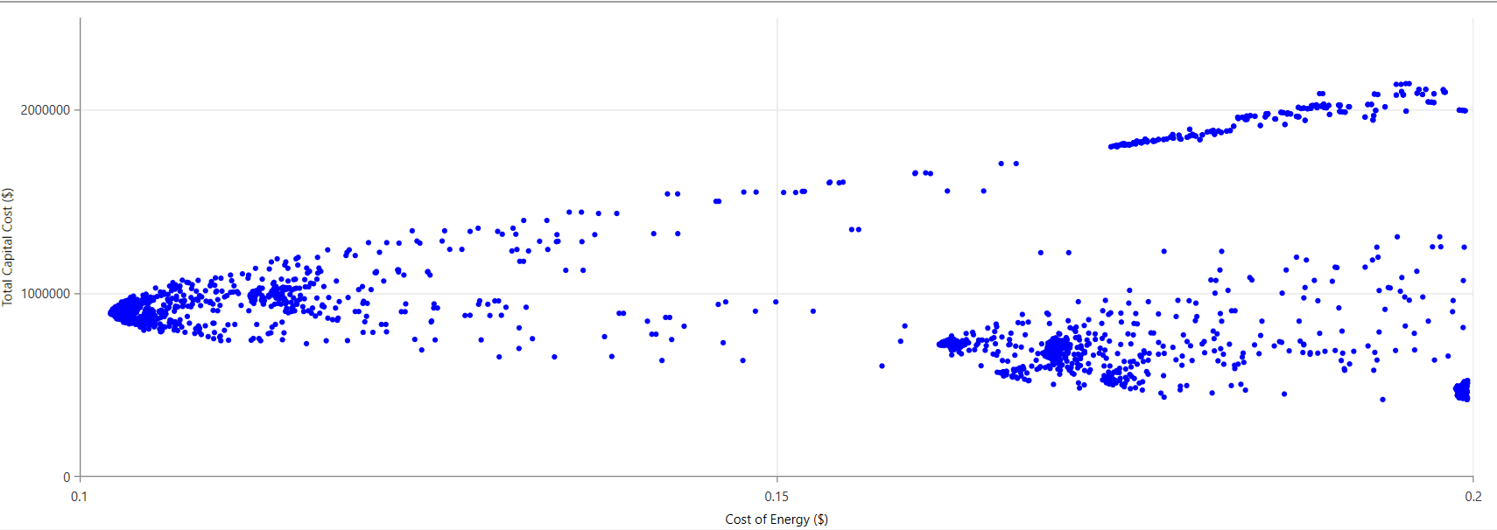

**Figure 11**: Optimization diagram for the HES at selected site

LCOE considers all the costs incurred over the lifetime of a power plant, including initial investment, operation and maintenance, and fuel costs. The U-shape could indicate that the cost of energy is relatively high at lower capital investment levels (perhaps due to high fuel costs for generators), but then decreases as the capital cost increases (potentially reflecting economies of scale for generators or the increasing contribution of renewable sources that may have lower operating costs).

.

1. **CONCLUSION**

The feasibility analysis of the standalone hybrid renewable energy system integrating solar, wind, hydro, generator, and battery storage components demonstrates significant potential for providing a reliable and sustainable energy solution in remote or off-grid locations. The optimal sizing and cost assessment reveal that a well-designed hybrid system can effectively harness the complementarities of different renewable sources, reducing reliance on fossil fuels and enhancing energy security. The inclusion of a generator and battery storage further ensures continuous power supply, addressing the intermittency issues associated with renewable energy. However, the study also identifies several challenges that need to be addressed to fully realize the potential of HRES. These include the need for advanced energy storage solutions, efficient grid integration, supportive policy frameworks, and ongoing research and development to improve system performance and reduce costs. Public awareness and acceptance, along with sustainable practices, are crucial for the successful implementation of hybrid renewable energy systems.

1. **REFERENCES**
2. Qazi, A., Hussain, F., Rahim, N., Hardaker, G., Alghazzawi, D., Shaban, K., & Haruna, K. (2019). Towards Sustainable Energy: A Systematic Review of Renewable Energy Sources, Technologies, and Public Opinions. IEEE Access, 7, 63837-63851.
3. Destouni, G., & Frank, H. (2010). Renewable Energy. AMBIO, 39, 18-21. https://doi.org/10.1007/s13280-010-0059-7.
4. Bull, S. (2001). Renewable energy today and tomorrow. Proc. IEEE, 89, 1216-1226. https://doi.org/10.1109/5.940290.
5. Koroneos, C., Spachos, T., & Moussiopoulos, N. (2003). Exergy analysis of renewable energy sources. Renewable Energy, 28, 295-310. https://doi.org/10.1016/S0960-1481 (01)00125-2.
6. Moriarty, P., & Honnery, D. (2016). Can renewable energy power the future. Energy Policy, 93, 3-7. https://doi.org/10.1016/J.ENPOL.2016.02.051.
7. E., M., Husin, H., , N., Zaki, M., & , M. (2021). A critical review of the integration of renewable energy sources with various technologies. Protection and Control of Modern Power Systems, 6, 1-18. https://doi.org/10.1186/s41601-021-00181-3.
8. Niknam, T., & Firouzi, B. (2009). A practical algorithm for distribution state estimation including renewable energy sources. Renewable Energy, 34, 2309-2316. https://doi.org/10.1016/J.RENENE.2009.03.005.
9. Parthasarathi, A. (2006). Renewable energy sources: Situation and prospects. World Affairs, 10, 112-138.
10. Panwar, N., Kaushik, S., & Kothari, S. (2011). Role of renewable energy sources in environmental protection: A review. Renewable & Sustainable Energy Reviews, 15, 1513-1524. https://doi.org/10.1016/J.RSER.2010.11.037.
11. Johansson, T., Kelly, H., Reddy, A., & Williams, R. (1993). Renewable energy: sources for fuels and electricity. . https://doi.org/10.5860/choice.31-0332.
12. Alturki, F., & Awwad, E. (2021). Sizing and Cost Minimization of Standalone Hybrid WT/PV/Biomass/Pump-Hydro Storage-Based Energy Systems. Energies, 14, 489. https://doi.org/10.3390/EN14020489.
13. Pérez-Navarro, Á, Alfonso, D., Ariza, H., Cárcel, J., Correcher, A., Escrivá-Escrivá, G., Hurtado, E., Ibáñez, F., Peñalvo, E., Roig, R., Roldán, C., Sánchez, C., Segura, I., & Vargas, C. (2016). Experimental verification of hybrid renewable systems as feasible energy sources. Renewable Energy, 86, 384-391. https://doi.org/10.1016/J.RENENE.2015.08.030.
14. Chong, W., Naghavi, M., Poh, S., Mahlia, T., & Pan, K. (2011). Techno-economic analysis of a wind–solar hybrid renewable energy system with rainwater collection feature for urban high-rise application. Applied Energy, 88, 4067-4077. https://doi.org/10.1016/J.APENERGY.2011.04.042.
15. Ma, T., Yang, H., & Lu, L. (2014). A feasibility study of a stand-alone hybrid solar–wind–battery system for a remote island. Applied Energy, 121, 149-158. https://doi.org/10.1016/J.APENERGY.2014.01.090.
16. Al-Falahi, M., Jayasinghe, S., & Enshaei, H. (2017). A review on recent size optimization methodologies for standalone solar and wind hybrid renewable energy system. Energy Conversion and Management, 143, 252-274. https://doi.org/10.1016/J.ENCONMAN.2017.04.019.
17. Fathabadi, H. (2017). Novel standalone hybrid solar/wind/fuel cell/battery power generation system. Energy, 140, 454-465. https://doi.org/10.1016/J.ENERGY.2017.08.098.
18. Kusakana, K., Munda, J., & Jimoh, A. (2009). Feasibility study of a hybrid PV-micro hydro system for rural electrification. AFRICON 2009, 1-5. https://doi.org/10.1109/AFRCON.2009.5308185.
19. Bekele, G., & Palm, B. (2010). Feasibility study for a standalone solar–wind-based hybrid energy system for application in Ethiopia. Applied Energy, 87, 487-495. https://doi.org/10.1016/J.APENERGY.2009.06.006.
20. Aziz, A. (2018). Feasibility analysis of PV/wind/battery hybrid power generation: A case study. International Journal of Renewable Energy Research. https://doi.org/10.20508/ijrer.v8i2.6949.g7356.
21. Hasan, K., Fatima, K., & mahmood, M. (2011). Feasibility of hybrid power generation over wind and solar standalone system. 2011 5th International Power Engineering and Optimization.