**Geographical Appraisal on the Conflict between humans and elephants in the Paschim Medinipur district and neighboring Region**

**Prasanta Kumar Das**

**Research Scholar, Department of Geography**

**RKDF University, Ranchi**

**Abstract.**

Anthropogenic perturbation in the form of agriculture and settlement expansion results in loss of natural forest habitat, biodiversity and fragmentation of corridors. The disproportionate sharing of forest resource and shrinkage of the sojourn ground creates food scarcity for wild animals and forces them to move to a new habitat. During this migration human-animal confict becomes a common issue in the corridors and edges in between. Such a typical situation of human-elephant conflict has been happening in the Forest of Paschim Medinipur district District, West Bengal, India. This paper aims to assess the causes and consequences arising from this elephant migration event.

**Introduction**

Unprecedented growth of human population in West Bengal is responsible for degradation and decline of forest cover from 40% a century ago to 19% in 2015 (Department of Forest 2017). Agricultural and settlement expansion results in loss and fragmentation of natural habitats as well as biodiversity loss. Human disturbance may cause animals to shift their home ranges and venture into areas, which were previously not occupied by them. Such a situation has been seen in the Forest of Paschim Medinipur district District, West Bengal, India.

In south West Bengal, Asian elephants (Elephas maximus) were abundant in the dense Sal forests of Midnapore district and adjoining areas in the early 1900s (O’ Malley 1911). However, by 1955, no resident herds of elephants were found and elephants became rare due to forest degradation (Palit 1991; Malhotra 1995). A few scattered individuals occurred in the hilly region of Ajodhya hill and Bandwan range of Purulia District (situated in the western border of the study area). In 1976 a herd of 42 elephants moved from Forest area (Fig. 1) to Purulia District and stayed there for 20 days. They caused damage to paddy and killed two people (Shahi 1980). Since the 1980s elephant migration into west Bengal became more frequent. In 1987 a herd of 50 elephants from southern Bihar moved to West Bengal after the wet season and stayed through the winter season (Sukumar 2003). Since 1988 elephants ventured into Bishnupur subdivision under Paschim Medinipur district District located in the central part of PFD after crossing Silabati River. Since 1995, the elephant herd crossed river Darkeswar and moved towards the Northern Forest Division of Paschim Medinipur district District. They extended their territory to Paschim Medinipur district North Forest Division in 1999. Around the same time another herd entered into the PFD area crossing Damodar River to Burdwan District.

There are about 3–4 herds consisting of about 15– 70 elephants that come each year into the PFD. A group of elephants now also stay throughout the year. Elephant movement into West Bengal may have been aided by the success of forestry projects in West Bengal under which large patches of degraded forest have regenerated into dense forest (Datye & Bhagwat 1995). These forest patches provide corridors for movement and shelter to elephants but are often surrounded by populated villages with paddy and water sources, leading to conflict. As a result, human-elephant conflict (HEC) has become a severe issue in the PFD area (Das Chatterjee 2016). The objectives of this study were to document human-elephant conflict, its consequences and discuss possible measures to combat the situation in the PFD.

**Research Methodology**

**Data collection**

Villages affected by HEC were identified based on the records. A questionnaire survey was conducted in the 50 most affected villages. Twenty households per village were sampled giving a total of 1000 sampled households. We enquired about livelihood patterns, movements of elephants and damages caused by them, awareness of conservation, compensation and the role of the Forest Department in mitigating the conflict.

**Results and discussion**

**Elephant movement patterns**

An increasing trend of the number of elephants entering the PFD area was seen (Fig. 3). Initially only the Forest herd came to South West Bengal but after 2010 another herd came from Mayurjharna elephant reserve area in Purulia District. The number of elephants from Forest were110 in 2012 and 35 from Mayurjharna. Depredation by the Mayurjharna elephants was more severe in comparison to the Forest herd.

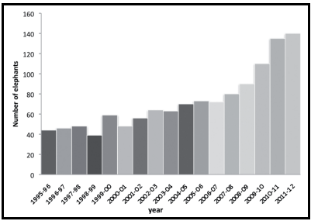

Figure 3. Number of elephants moving into PFD by year.

Along with increasing number of elephants, their duration of stay in PFD also increased (Fig. 4). Initially the elephants came just after the rainy season in late September and early October and returned to Forest in January. With time it changed to about one third of the elephants staying for two to three months at Forest and spending the remaining time in South West Bengal. This pattern was also observed by Kulandaivel (pers. comm.). By the end of the study period some elephants had become resident. In 2015 there were 6 to 12 resident elephants in PFD (Department of Forest 2015).

**Elephant’s movement pattern and habitat quality**

Elephant movement pattern in PFD is presumably determined by the availability of fodder and water in the fragmented forest patches. The surveys suggested that elephants preferred sal forests where undergrowth was high. Increased undergrowth restricts people’s movements in the forest and hence these areas are less disturbed. More undergrowth also provides ample fodder. Elephants also preferred forest patches, which are nearer to water sources.

**Socio-economic background and its relation to human-elephant conflict**

**Demographic characteristics**

About 92.6% of the population lived in a rural setting and earned their livelihood from agriculture. The economic condition of most of the people was below poverty level.

The level of education in the PFD was poor (Fig. 5) consequently they had few work opportunities

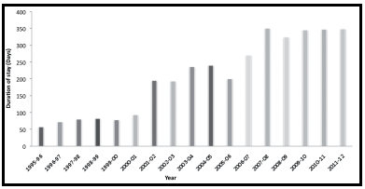

Figure 4. Duration of stay of elephants in the PFD, by year

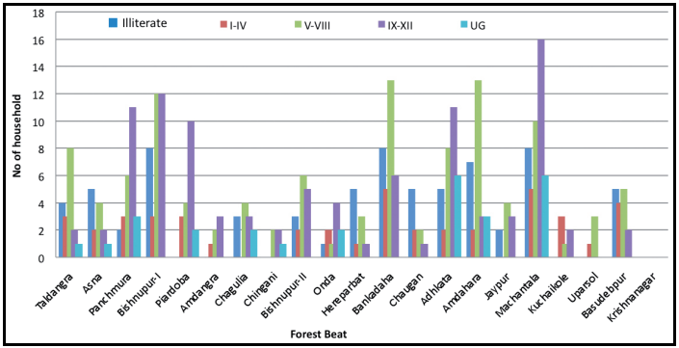

Figure 5. Educational level in PFD by Forest Beat.

and had to depend on activities like agricultural work and collection of fodder and NTFPs from nearby forest areas. Poor education level (most of them have not completed their elementary school education) may also be responsible for lack of awareness and many did not claim compensation as they were unaware of the procedure. This increased their grievances against the Forest Department.

The population density varied in different Forest Beats and was higher in villages near urban centers and in the eastern part of the study area and lower in the western part (Fig. 6).

Soil in the study area was characterized by unfertile lateritic red soil in the western part and alluvium in the eastern part. Unfertile land was a major factor for the dependence of villagers on forest resources.

**Livelihood pattern**

The main livelihood was from agriculture based activities. Livelihoods were based on cultivation or working as unskilled manual labourers. Average size of an agricultural holding was 0.16–0.64 ha, which is very small. These small holdings and home gardens were the main sources of staple food. A large portion of the population depended on the forest for their livelihood, collecting fuel wood and NTFPs such as medicinal plants, sal leaves, honey, mushrooms, barks, roots and tubers.

**Landuse pattern**

The landuse was human dominated. Agricultural land in 2006 and 2013 respectively were 36% and 35%, settlements 21% and 23%, open forest 22% and 23% and dense forest 11% and 10% of the total area (Fig. 6). Though the total area under forest cover improved due to social forestry programmes, dense forest areas decreased resulting in reduction of forest core area

**Agriculture**

Agriculture consisting of 36% of the area was the dominant land use. Most of the agricultural lands were single cropped while the north-eastern part was characterized by double cropping. Agricultural pattern was associated with movement of elephants.

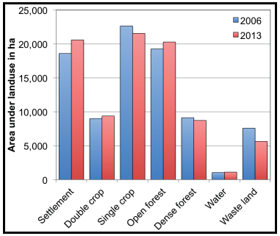

Figure 7. Landuse category extents in PFD in 2006 and 2013.

The entry route of Forest elephants to PFD during 2006–2013 remained the same but extension to the eastern part increased.

**Settlements**

The elephant habitat of PFD was surrounded by human settlements. The settlements were mainly rural with a few urban centers. In some cases settlements were situated within forest areas. Conversion of forest land into agricultural land and encroachment by settlements in the forest fringe areas were common. Elephant depredation of crops stored in granaries or houses caused property damage in addition to loss of crops (Figs. 9 & 10). Country liquor was another attraction for which elephants ventured into settlements within the forest areas.

**Elephant attacks on humans**

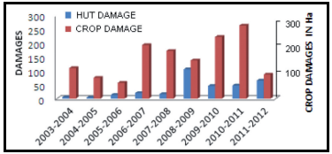Most persons killed or injured by wild animals were due to elephants. Deaths increased in the harvesting season when elephants raided crop felds. Confict was high from September to December and January to April.

Figure 8. Damage caused by elephants in PFD.injury and deaths by elephants

Most human were caused by single bulls. Deaths occurred in the villages when there were no crops in the fields. Initially there were hardly any cases of human injury and death but since 2007 the events have increased .Injuries and deaths due to elephants commonly occurred when people entered elephant habitat, encroached elephant corridors or in defending crops from elephants. Such incidents occurred mostly in the evening or at night.

**Human-elephant conflict mitigation**

Communities in the affected areas of PFD used simple and low cost techniques such as beating on drums or tin cans, free crackers, fireballs and torches to chase elephants. Firecrackers and kerosene were usually supplied by the Forest Department but was insufficient. Use of firecrackers, fireballs and torches were

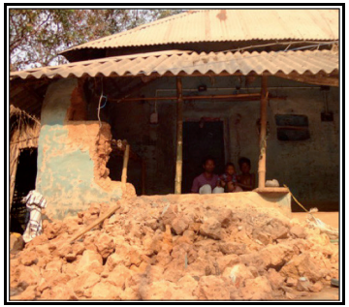

Figure10. Hut damaged by elephant.

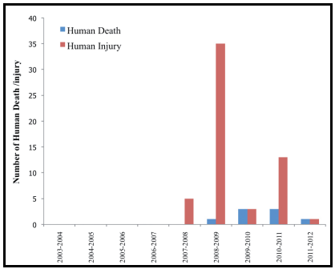

Figure 9. Death and injury caused by elephants in PFD (Source: PFD)

commoner in villages near Forest Beat or Range offices. In distant villages, throwing stones and shooting with bow and arrow was more common. Elephants injured by people became more aggressive, attacked humans and caused more damage to life and property.

In some instances the Forest Department tried to redirect the movement of elephants through use of ‘koonkie’ elephants. However in such instances, hundreds of villagers gathered in front of the route and threw stones and crackers towards the herd. As a result often the herd divided into smaller groups and the situation became uncontrollable. The lack of awareness of the people regarding elephant behaviour was one of the main hindrances in managing conflict. In some cases villagers with the help of the Forest Department constructed electric fences or trenches. The cost of constructing electric fences around the small fragmented forest patches was not cost effective. Stealing of fence material was another problem in their management. Improvement of habitat quality within the forest and awareness generation may be effective in combating the situation.

**References**

Das Chatterjee (2016) Man-Elephant Conflict. A Case Study from Forests in West Bengal, India. Springer Briefs in Environmental Science, Springer International Publishing, Switzerland.

Datye HS & Bhagwat AM (1995) Man-elephant conflict: A case study of human deaths caused by elephants in parts of central India. In: A Week With Elephants. Bombay Natural History Society, Bombay, and Oxford University Press, New Delhi, India.

Department of Forest (2017) West Bengal State Forest Report 2017. Annual administrative report of Department of Forest, Government of West Bengal.

Department of Forest (2015) State Forest Report West Bengal (2015). Annual administrative report of Department of Forest, Government of West Bengal, Directorate of Forests, Office of the Principal Chief Conservator of Forests Kolkata.

Malhotra KC (1995) Biodiversity conservation and community development in south West Bengal. In: Biodiversity Conservation Through Community Forestry. Wood H, Mellises M & Warner K (eds) Regional Community Forest Training Centre, Kesetsart University, Bangkok.

O’Malley LS (1911) Bengal District Gazetters, Midnapore, Calcutta. Administrative report of British India, The Bengal Secretariet Book Depot.

Palit S (1991) Participatory management of forest in West Bengal. Indian Forester 117: 342–348.

Shahi SP (1980) Report of the Asian Elephant Specialist Group, Central India Task Force. In: The Status of the Asian Elephant in the Indian Subcontinent. Daniel JC (ed) Asian Elephant Specialist Group, IUCN/SSC.

Sukumar R (2003) The Living Elephants: Evolutionary Ecology, Behaviour and Conservation. Oxford University Press, New York.