PERCEIVED QUALITY FACTOR INFLUENCING CONSUMER BEHAVIOR REGARDING MEDICINES FROM GENERIC MEDICAL STORE
Rohit Kumar, Research Scholar, NICE School of Business Studies, Shobhit Institute of Engineering & Technology, Deemed to be University, Meerut
Dr. Abhishek Kumar, Associate Professor, NICE School of Business Studies, Shobhit Institute of Engineering & Technology, Deemed to be University, Meerut
ABSTRACT
Generic medicines provide an affordable alternative for the treatment of chronic diseases, resulting in a higher consumption of generic medicines in rural areas. The use of generic medicines, compared to their branded counterparts, has the potential to substantially reduce out-of-pocket expenditure on drugs for patients with chronic diseases. The perceived quality and effectiveness of generic medicines can significantly influence consumer behavior towards them. Consumers may be hesitant to use generic medicines if they perceive them to be of lower quality or less effective than branded medicines. The research would help to better understand the various frameworks that have surfaced in consumer behaviour ecosystem.
Keywords: Generic Medicines, Consumer Behavior, Perceived Quality.
INTRODUCTION
Generic medicines are an essential aspect of healthcare, as they provide a cost-effective alternative to branded medicines with the same active ingredients, dosage, and efficacy. India, being a developing country, has a significant demand for generic medicines due to its affordability, and its consumption is higher in rural areas than urban areas. However, the buying behavior of consumers towards generic medicines differs significantly between rural and urban areas. Rural areas of India are characterized by limited access to healthcare facilities and a lower socio-economic status, leading to a higher preference for generic medicines. According to a study by Chuc et al. (2003), in Vietnam, which shares similarities with rural areas of India, private pharmacies were the most common source of healthcare, and the majority of consumers preferred to buy generic medicines due to their lower cost. Similarly, In India, private pharmacies are the primary source of healthcare for rural communities, and consumers are more price-sensitive, preferring generic medicines due to their affordability. Perhaps the National Pharmaceutical Policy of the country needs to incorporate the priority components established by WHO for national drug policies. At present the pharmaceutical policy does not have the relevant structures in place to ensure that the poor have access to medicines. Dichotomy between the pharmaceutical policy and the health needs of the country is a major cause of the variable and high medicine prices; Vandana Roy et al. (2012). Additionally, rural areas have a higher prevalence of chronic diseases such as diabetes and hypertension, leading to a higher demand for long-term medication. Generic medicines provide an affordable alternative for the treatment of chronic diseases, resulting in a higher consumption of generic medicines in rural areas. The use of generic medicines, compared to their branded counterparts, has the potential to substantially reduce out-of-pocket expenditure on drugs for patients with chronic diseases.
The perception and attitudes towards generic medicines among urban citizens and found that consumers had a higher perception of branded medicines' quality due to their association with multinational companies and the use of expensive marketing techniques. This perception of higher quality leads to a preference for branded medicines, even if they are more expensive than generic medicines. Additionally, consumers in urban areas have a higher disposable income, leading to a lower sensitivity towards price and a willingness to pay for perceived higher quality; Shankar et al., (2018).
The perceived quality and effectiveness of generic medicines can significantly influence consumer behavior towards them. Consumers may be hesitant to use generic medicines if they perceive them to be of lower quality or less effective than branded medicines. The research would help to better understand the various frameworks that have surfaced in consumer behaviour ecosystem. Research on consumer behaviour for buying of generic medicines is very limited in the Indian context. Factors and trends related to buying of generic medicines have not been explored. By understanding the factors that influence healthcare professionals' prescription behavior, policymakers and healthcare administrators can implement policies and guidelines that promote the usage of generic medicines.
REVIEW OF LITERATURE
Babar & Ibrahim (2000) study investigates the factors affecting the utilization of generic medicines in Malaysia, including in rural and urban areas. The study found that the main factors influencing consumer behavior were price, quality, and availability.
As indicated in the study by Federman et al. (2007), there exists a range of factors that can exert an influence on whether patients are prescribed generic medications. A pivotal role in this decision-making process is played by physicians, who not only draft prescriptions but also wield significant influence over the selection of medications.
According to Nagarajappa and Srinivasan (2019), customers displayed a significant inclination towards several key aspects when making their choices. Notably, the quality of the product, its perceived value in relation to the cost, the guidance provided by healthcare professionals, and the ease of accessing Jan Aushadhi medical stores emerged as pivotal factors that heavily influenced their decision to purchase generic medicines.
In their study, Solomon and Sundar (2019) identified and analyzed four pivotal determinants that exerted a significant influence on the level of customer satisfaction regarding the services rendered by Jan Aushadhi medical store personnel. These crucial factors encompassed accessibility, tangibility, reliability, and responsiveness. These aspects collectively contributed to shaping customers' perceptions of the quality of service offered.
Pawar et al. (2021) disclosed that there was no noteworthy distinction observed in terms of the quality and effectiveness of generic medications accessible at Jan Aushadhi medical stores in comparison to other branded medicines accessible in the broader market.
OBJECTIVE OF THE STUDY
- To evaluate the perceived quality factor influencing consumer behavior in rural and urban area of medicines from generic medical store.

RESEARCH DESIGN
The exploratory and descriptive research design has been adopted for the study. Descriptive research studies include those that make specific predictions or that describe factors and traits relating to a person, a group, or a scenario.
SAMPLING DESIGN
Population
The present research study has been conducted in Maharashtra (Pune).
Method of Sampling
In the present study, stratified random sampling has been considered so as to collect the data from respondents in NCR.
Sample size
By carefully selecting a sampling design and determining an appropriate sample size, researchers can ensure that their study produces reliable and valid results that can be generalized to the population of interest.
Sample Size= 520 Respondents
COLLECTION OF DATA
Primary Data: In the present study the primary data has been collected from the respondents from Pune region (Urban and Rural areas).
RESEARCH INSTRUMENT
For the present study, a questionnaire method has been used to obtain primary data.
Table 1: Analysis regarding the perceived quality factor influencing consumer behavior (Rural Area)
Components | Strongly Agree | Agree | Neutral | Disagree | Strongly Disagree
The medicines available at generic medical stores are of comparable quality to those from branded stores. | 66  (25.5%) | 90  (34.5%) | 43  (16.5%) | 46  (17.5%) | 15  (6%)
I believe that generic medicines provide the same therapeutic outcomes as branded medicines. | 45  (17%) | 101  (39%) | 40  (15.5%) | 55  (21%) | 19  (7.5%)
The quality of medicines is a crucial consideration for me when choosing to buy from a generic medical store. | 74  (28.5%) | 141  (54.5%) | 24  (9%) | 17  (6.5%) | 4  (1.5%)

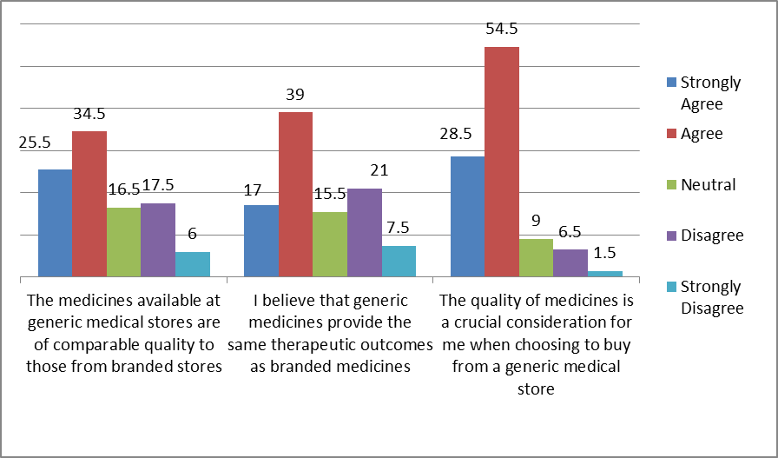
Figure 4.17: Analysis regarding the perceived quality factor influencing consumer behavior (Rural Area)
Analysis: 1. Regarding the quality of medicines available at generic medical stores, a significant proportion of rural customers, totaling 60%, either strongly agree or agree that the medicines from these stores are of comparable quality to those from branded stores. This suggests a level of confidence among rural customers in the quality of medicines offered by generic medical stores, potentially influencing their purchasing decisions.
2. Furthermore, opinions on the therapeutic outcomes of generic medicines compared to branded medicines are mixed among rural customers. While a majority, comprising 56% of respondents, either strongly agree or agree that generic medicines provide the same therapeutic outcomes, there is also a notable minority, totaling 28.5%, who disagree or strongly disagree. This indicates varying levels of confidence among rural customers regarding the therapeutic equivalence of generic medicines.
3. Moreover, the importance of quality considerations when choosing to buy from generic medical stores is notably high among rural customers. The majority, totaling 83%, either strongly agree or agree that the quality of medicines is a crucial consideration. This underscores the significance of quality perceptions in influencing purchasing decisions among rural customers, indicating that they prioritize quality assurance when selecting medicines from generic medical stores.
Table 2: Analysis regarding the perceived quality factor influencing consumer behavior (Urban Area)
Components | Strongly Agree | Agree | Neutral | Disagree | Strongly Disagree
The medicines available at generic medical stores are of comparable quality to those from branded stores. | 62  (24%) | 87  (33.5%) | 36  (14%) | 55  (21%) | 20  (7.5%)
I believe that generic medicines provide the same therapeutic outcomes as branded medicines. | 43  (16.5%) | 95  (36.5%) | 37  (14.5%) | 54  (20.5%) | 31  (12%)
The quality of medicines is a crucial consideration for me when choosing to buy from a generic medical store. | 89  (34.5%) | 132  (51%) | 20  (7.5%) | 16  (6%) | 3  (1%)

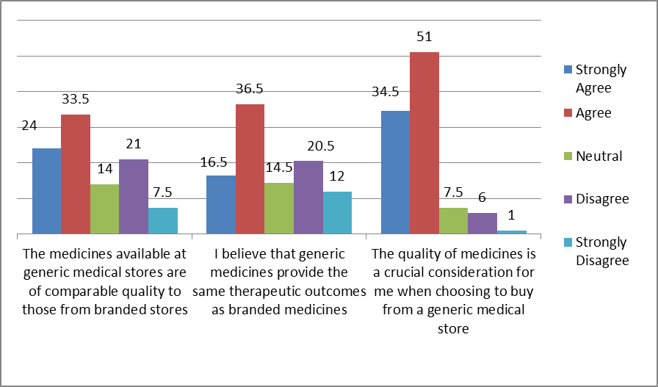
Figure 2: Analysis regarding the perceived quality factor influencing consumer behavior (Urban Area)
Analysis: 1. In terms of the quality of medicines available at generic medical stores, opinions among urban customers are somewhat divided. While a significant proportion, comprising 57.5% of respondents, either strongly agree or agree that the medicines from these stores are of comparable quality to those from branded stores, there is also a notable minority, totaling 28.5%, who disagree or strongly disagree. This suggests a degree of uncertainty or skepticism among urban customers regarding the quality of medicines offered by generic medical stores.
2. Similarly, opinions on the therapeutic outcomes of generic medicines compared to branded medicines are mixed among urban customers. While a majority, totaling 53% of respondents, either strongly agree or agree that generic medicines provide the same therapeutic outcomes, there is also a notable minority, totaling 32.5%, who disagree or strongly disagree. This indicates varying levels of confidence among urban customers regarding the therapeutic equivalence of generic medicines.
3. Moreover, the importance of quality considerations when choosing to buy from generic medical stores is notably high among urban customers. The majority, totaling 85.5%, either strongly agree or agree that the quality of medicines is a crucial consideration. This underscores the significance of quality perceptions in influencing purchasing decisions among urban customers, indicating that they prioritize quality assurance when selecting medicines from generic medical stores.
CONCLUSION
Both rural and urban customers demonstrate a significant consideration for the quality of medicines when making purchasing decisions from generic medical stores. Despite some variations in opinions regarding the comparability of generic medicines to branded ones in terms of quality and therapeutic outcomes, there is a consensus among both customer segments that the quality factor plays a crucial role in influencing their buying behavior.
REFERENCES
- Babar, Z. U. D., & Ibrahim, M. I. M. (2000). Factors affecting the utilization of generic medicines in a developing country: Evidence from Malaysia. Journal of Generic Medicines, 1(1), 11-18.
- Chuc, N. T., Larsson, M., Falkenberg, T., Do, N. T., Binh, N.T. & Tomson, G.B. (2001). Management of childhood acute respiratory infections at private pharmacies in Vietnam. Annals of Pharmacotherapy, 35(10), 1283-1288.
- Federman, A. D., Halm, E. A., & Siu, A. L. (2007). Use of generic cardiovascular medications by elderly Medicare beneficiaries receiving generalist or cardiologist care. Medical Care, 45(2), 109–115.
- Nagarajappa, M. and Srinivasan, H. (2019). Modelling Customers’ Buying Behaviour of Jan Aushadhi (Generic Medicines). Indian Journal of Pharmaceutical Education and Research, 54, 175-186.
- Pawar, A., Chainpure, M., & Dhapte-Pawar, V. (2021). Paralleling the quality and economy of levofloxacin hemihydrate and cefuroxime axetil tablets. Indian Journal of Pharmaceutical Education and Research, 55(1), 136-145.
- Roy, V., Gupta, U. & Agarwal, A.K. (2012). Cost of medicines & their affordability in private pharmacies in Delhi (India), Indian Journal of Medical Research, 136(5), 827–835.
- Shankar, P. R., Subish, P., Mishra, P., Lalit, M., & Saha, A. (2018). Buying behavior towards generic medicines among Nepalese population: A cross-sectional study. Journal of Pharmaceutical Policy and Practice, 11(1), 1-6.
- Solomon, M. C., & Sundar, C. (2019). Impact of Brand Awareness and Customer Satisfaction towards Services of Jan Aushadhi Medical Stores. International Journal of Recent Technology and Engineering (IJRTE), 8(2S4), 546–551.
- World Health Organization (2002). How to develop and implement a national drug policy WHO Policy perspectives on medicine, No.6. Geneva: WHO.

