Designing Power-Efficient Flip-Flop Integrated Circuits for Very Large-Scale Integration (VLSI)

Uditanshu S. Deshpande1, Mr. Devendra Patle2

Research Scholar1

Head of Department2

Department of Electronics & Communication Engineering12.

School of Engineering, SSUTMS, Sehore(MP)12

[uditanshudeshpande2312@gmail.com](mailto:uditanshudeshpande2312@gmail.com)1

Abstract: Over the years, advancements in Very Large Scale Integration (VLSI) technology have increased the capabilities of integrated circuits in three primary areas: area, power consumption, and latency. The challenges of the nanoscale era of very large scale integration (VLSI) low power design and the impending demands of computing need novel approaches to digital logic design that are more efficient, less power hungry, and more resistant to noise fluctuation. Modern methods like Adiabatic Logic (ADL) and Gate Diffusion Input (GDI) seek to lessen the circuit's power consumption and delay time. A fascinating new approach to constructing power-efficient digital combinational circuits is the gate diffusion input (GDI). The GDI mechanism allows for a decrease in power consumption, propagation latency, and circuit size while maintaining a logic architecture with minimal complexity. To further guarantee low power consumption and simpler clock design, another innovative approach to designing combinational and sequential logic circuits is Single Phase Quasi-Static Adiabatic Dynamic Logic (SPADL). A single pulse source is used by SPADL, the supply clock. Reduced energy dissipation occurs across active devices as a result of this strategy's limited charge transfer and current restrictions.

Keywords: Adiabatic Logic (ADL), gate diffusion input (GDI), Single Phase Quasi-Static Adiabatic Dynamic Logic (SPADL), very large scale integration (VLSI)

**Introduction**

As digital devices continue to advance, new methods have surfaced. Magnetically triggered relay switches were used in the construction of earlier digital systems. Their principal use was in the construction of elementary logic circuits. Nonetheless, systems for rail safety are still making use of them. The vacuum tube was the de facto standard up until the 1950s. The whole situation was changed when the transistor was introduced in 1947 at Bell Telephone Laboratories, after the discovery of the bipolar transistor by Schockley in 1949. Harris created a bipolar digital logic gate in 1956, and Fairchild Micro expanded their industrial logic gates into integrated-circuit design. As early as 1962, the TTL IC logic family was introduced.J. Lilienfeld, a physicist from Canada, came up with the basic concept of the MOSFET transistor—then known as an IGFET—in 1925 and patented it. In the early 1970s, MOS-based digital ICs started to thrive on their own. Surprisingly, CMOS logic gates were the first to be introduced, and this trend continued until the late 1960s. It was necessary to employ PMOS in electronic calculators for the construction of the first practical integrated circuit MOS circuits. Intel Corporation introduced the 4004 and IC 8080, the next generation of digital integrated circuits, in 1972 and 1974, respectively. A more efficient design for these microprocessors would be to use NMOS circuits rather than PMOS ones. At the same time, MOS technology made it possible to create the first high density semiconductor memory [1].

At the tail end of the 1970s, NMOS logic started to suffer from a problem that made high-density PMOS or NMOS circuitry unappealing or unworkable due to power consumption [1]. Even with cutting-edge electronics, this situation persists. Instead, strangely enough, power consumption concerns are now dominating CMOS design. Also playing a major role in the IT boom right now is CMOS technology.

Faster and smaller processing systems at lower prices are the goals of modern technology. It has accelerated the scaling of VLSI technology, which has led to an exponential rise in IC density and operating frequency. This allowed for a dramatic reduction in power consumption, which met cost and reliability targets. Problems with resilience in design have been quietly creeping up because to the persistent scaling to nanoscale scales. These problems include signal integrity, process variability, and signal defect error. The design of computer systems is also being impacted by these power consumption and quality issues.

Integrated Circuits (ICs) have shown exponential growth in both density and speed throughout the last 30 years. In accordance with Moore's law, the production of integrated circuits (ICs) involves doubling the number of transistors every two years. "Very Large Scale Integration" refers to the integration of millions of transistors, whereas "Small Scale Integration" refers to the integration of a few hundred. There is current use of the VLSI chips [1]. A simple circuit with a few gates or flip-flops was the first kind of integrated circuit. In the early days of integrated circuits, most logic functions were performed by a single transistor connected to a resistor network. In under forty years, integrated circuits (ICs) have gone through four distinct generations, with the number of transistors ranging from a few thousand to several million. The four generations of integrated circuits, denoted as SSI, MSI, LSI, and VLSI, are defined by the number of transistors used in their construction. Ultra Large Scale Integration (ULSI), the next generation, has only begun to be considered. ULSI is characterised by the incredible complexity of having more than 20 million components on a single integrated circuit chip [3].

The designers were prompted to develop a new aim for creating advanced digital circuits that minimise power consumption due to the increasing demand for sophisticated portable devices during the last decade[4][5]. In the realm of portable multimedia electronic devices, there is a great need for the creation of low power design circuits for mobile phones, laptops, desktop computers, palmtops, wireless modems, and many more. To get the most out of the gadget while keeping its power consumption low, a power supply with a cooling circuit is also required for effective heat dissipation regulation. Consequently, a new cooling device to lessen heat dissipation must be invented[6].

The main worry that hinders further development of transistors is the dissipation of power. The very large scale integration chip, which includes energy storage components such as parasitic capacitances and MOSFET devices[7]. These capacitors are charged and discharged via the resistor components employed in the circuit whenever the circuit experiences heat dissipation. This circuit's computational efficiency is determined by the heat dissipation of its transistors, which are turned on and off at certain intervals. The goal of contracting devices has reduced parasitic capacitance, which helps with power dissipation, and this could be a contentious topic[8].

One major drawback of designing digital integrated systems for signal processing and communication is their poor efficiency in low-power conditions, which has been a cause of worry for a long time. In order to reduce the power consumption of digital systems, it is necessary to optimise each layer of the design process[9]. This calls for a synpaper’ of methods including algorithm development, architectural design, circuit design, and device manufacturing in order to create a circuit with lower power consumption and higher speed. All of the current methods for manufacturing circuits—including their layout, topology, architecture, and algorithms—must be able to accommodate such optimisation. Because they minimise voltage with minimal impact on speed, controlling the threshold voltage is often considered the most significant technique. As a result, the single source of energy consumption is switching capacitance. To lower this consumption, one might moderate performance in order to avoid glitches, improve circuit design, logic design, and physical device design, and so on[10].

Maintaining consistently high-quality digital output should be designers' top priority at all times. The developed device incorporates a delay to ensure the circuit operates correctly and functionally. If necessary, the delay may subsequently be reduced. Not only does the designer or developer of the circuit take the realisation and dependability into account, but power dissipation is also a crucial factor. It's important to remember that methods for reducing power consumption don't always result in less delay[11]. There will be less circuit delay and less power consumed if the driving strengths of the gates in the circuit are increased. It is also possible to decrease latency, wasted power, and delay by decreasing the circuit's connection capacitance. Power budgeting is often great when delays are nonexistent, but power maximising without delays is easy[12].

Two mechanisms limit the waste of electricity. When designing high-performance systems, the first consideration is cooling. Quickly cycling circuits use a lot of power in a short period of time and generate a lot of heat. The integrated circuit fabrication packaging must dissipate this heat. A potential limiting factor is heat transmission, which might occur if the utility will incur higher costs due to an inability to properly use the required heat radiating devices to vent the released heat[13].

The increasing demand for portable electronics has, secondly, highlighted the need of strong, long-lasting batteries. Because they need regular charging, these convenient gadgets contribute to a limited operating duration. An benefit in extending the life of batteries is the low power performance of integrated circuits[14].

For improved circuit performance in ultra-low power applications, the two threshold operations—sub-threshold and super-threshold—increase the dynamic range of supply voltages. Scaling down the power supply lowers the chip size, leakage power, and overall circuit power consumption. By operating in a sub-threshold area with lower frequencies, sub-threshold logic may regulate temperature changes and fluctuations and improve the circuit's performance.

Power consumption and design rigidity must be taken into account at every level of the design process, according to researchers of computer systems. The choice of schemes at the circuitry level is crucial in many logic architectures as it directly affects power, operation, and durability. Dynamic logic and conventional CMOS logic won't be able to meet all of the computing needs of the future. Static complementary metal-oxide semiconductor (CMOS) and dynamic logic circuits are the two most prevalent forms of logic used in low-power, high-speed circuits. Although the static CMOS circuit is generally a durable and power-saving design, it is not very fast when used for designs that are important and large[15]. Dynamic logic is quick, but it uses a lot of power and isn't strong. The speed advantage of dynamic logic is also severely constrained because of how poorly it measures. Dynamic logic's strength and robustness in design are unappealing and have several drawbacks. Because of this, we need to enhance logic methods and schemes to make them more power efficient, faster, and noise tolerant all at once[16].

A new approach to developing low-power sequential and combinational circuits is the Gate Diffusion Input (GDI). The GDI method reduces power consumption and circuit size with a short propagation delay while maintaining a low-complexity logic architecture. Morgenshtein et al. created a Gate Diffusion Input (GDI) architecture that is more efficient, faster, and uses less power[17]. By using GDI cells, circuits with more logic functions may be constructed with reduced power consumption and greater speed. The common diffusion node of both transistors (D) is the output of GDI, which takes as inputs the common gate (G), the outer diffusion node of pMOS (P), and the outer diffusion node of nMOS (N).

A new, promising approach to achieving deep-low power that doesn't sacrifice noise immunity or driving capabilities has emerged: the adiabatic logic style. Delivering charge between circuit capacitances and a clocked source as time-changing power is the fundamental idea behind an adiabatic method[18]. The charge delivery is made to look more constrained by this design, which limits the currents and, in turn, reduces the dissipating energy across the MOS devices. It is possible for a diabatic network to achieve dissipating sub-CV2 energy per cycle in the future.

The realisation and dispersion of multiple clock phases makes adiabatic logic schemes sensitive to skews of clock and severely limits their high-frequency operations. Several of these schemes have been proposed in the last decade that require clocking by multi-level styles [8], [9], [11]-[13]. To make ADL more feasible, digital circuits that operate on a single phase clock are important, and VLSI CMOS logic circuits use this technique. There have been earlier articles on source-coupled adiabatic logic circuits [4] with and without diodes [5]. Clocks operating on single-phase electricity add another layer of complexity to the design when considering the extra voltage and current references. In addition, finding the ideal value of the clock's reference voltage makes the development of such systems very challenging [5]. However, adiabatic logic with a pass transistor [6] is only described as adiabatic logic in one phase, even though PAL requires two clocks that are dependent on each other. As a result, PALs are not really single-phase timed circuits. Also, problems with output floating and unwanted capacitance connections might impact Programmable Array Logic gates [6]. An auxiliary clock Cx and its dependency Cxb are used to ensure proper performance in a shared Clocked adiabatic logic (CAL) [7]. When turning on the clock's auxiliary nodes, this causes a significant loss of power owing to the massive capacitance, which is especially problematic for very large functional units. A new type of CMOS adiabatic logic based on one-phase clocking has been proposed, which relies on a single sinusoidal or power clock pulse supply, is easy to implement, and outperforms the adiabatic logic families that were previously proposed [4]-[12] in terms of power consumption and controllability. Intelligibility is characterised by SPADL logic, and the number of transistors and circuit complexity are both drastically reduced by qualities reproduced by static CMOS logic. Understanding Quasi-

The static logic that has been suggested significantly minimizes switching activity, which in turn decreases power consumption. The paper proposes an adiabatic logic scheme for the realisation of logic circuits based on footed GDI. In a typical case, the integrated design takes this principle into account and controls the passage of noise from the pre-charging node to the output node. This adiabatic logic circuit is more efficient at conserving energy than others. The suggested logic integrates clock-supplied single-phase adiabatic and GDI logics.This paper’ compares and contrasts the proposed technique with a comparable circuit designed using other logic systems. The flip-flop, a basic memory element in both synchronous and asynchronous sequential circuits, is universally implemented using the suggested approach. Flip-flops are fundamental building blocks in digital systems, serving as the primary storage elements in sequential circuits. As VLSI technology advances, the demand for power-efficient designs becomes crucial, especially in battery-powered and portable devices[19]. This document explores the theory and design principles behind creating power-efficient flip-flop integrated circuits in VLSI.In VLSI, the integration of millions of transistors on a single chip leads to significant power consumption challenges. Flip-flops, being ubiquitous in digital circuits for state storage, have a direct impact on the overall power efficiency of the system. The primary objectives in designing power-efficient flip-flops include minimizing dynamic power, reducing leakage power, and maintaining or improving performance.

**Types of Power Consumption in Flip-Flops**

1. **Dynamic Power Consumption**:
   * Occurs due to the charging and discharging of load capacitances during logic transitions.
   * Governed by the equation Pdynamic=αCV2fP_{dynamic} = \alpha C V^2 fPdynamic​=αCV2f, where α\alphaα is the activity factor, CCC is the capacitance, VVV is the supply voltage, and fff is the frequency of operation.
   * Reducing voltage and capacitance can significantly lower dynamic power.
2. **Leakage Power Consumption**:
   * Arises from sub-threshold leakage current, gate oxide leakage, and reverse-biased diode leakage.
   * Becomes significant as device dimensions shrink in nanoscale technologies.
   * Techniques to mitigate leakage include using high-threshold transistors, multi-threshold CMOS (MTCMOS), and power gating.

**Key Design Techniques for Power-Efficient Flip-Flops**

1. **Clock Gating**:
   * Reduces dynamic power by disabling the clock signal to flip-flops when they are not in use.
   * Helps in reducing unnecessary switching activity, thus saving power.
   * Requires careful design to avoid timing issues and clock skew.
2. **Multi-Threshold CMOS (MTCMOS)**:
   * Utilizes transistors with different threshold voltages to balance performance and leakage power.
   * High-threshold transistors are used in non-critical paths to reduce leakage, while low-threshold transistors are used in critical paths to maintain performance.
3. **Conditional Capture and Precharge Techniques**:
   * Reduce switching activity by conditionally capturing data only when there is a change in input.
   * Conditional precharge techniques precharge internal nodes only when necessary, thus reducing dynamic power.
4. **Adiabatic Logic**:
   * Recycles energy by using AC power supplies instead of DC, which can theoretically reduce energy dissipation.
   * Adiabatic flip-flops operate by gradually transferring charge, thereby reducing the energy loss during transitions.
5. **Gate Diffusion Input (GDI) Technique**:
   * Enhances power efficiency by reducing the number of transistors and switching activity.
   * GDI-based flip-flops are designed to perform various logic functions using fewer components, thus reducing dynamic and leakage power.

**Design and Analysis of Power-Efficient Flip-Flops**

**Example 1: Power-Efficient D Flip-Flop Using Clock Gating**

A common approach to designing a power-efficient D flip-flop is to incorporate clock gating. The clock gating mechanism ensures that the flip-flop only receives the clock signal when its output needs to change, thus reducing unnecessary switching.

* **Architecture**: The clock-gated D flip-flop consists of a standard D flip-flop with an additional clock gating logic circuit. The gating logic uses the enable signal to determine whether the clock should be passed to the flip-flop.
* **Advantages**: Reduces dynamic power by minimizing clock activity, leading to significant power savings in large circuits.
* **Challenges**: Introducing clock gating can complicate timing analysis and increase the risk of clock skew. Careful design and verification are required to ensure reliable operation.

**Example 2: Multi-Threshold CMOS (MTCMOS) Flip-Flop**

MTCMOS technology leverages transistors with different threshold voltages to achieve a balance between performance and leakage power.

* **Architecture**: An MTCMOS flip-flop integrates both high-threshold and low-threshold transistors. The high-threshold transistors are placed in the non-critical paths to minimize leakage, while low-threshold transistors are used in critical paths to maintain speed.
* **Advantages**: Significant reduction in leakage power without compromising performance.
* **Challenges**: Managing the trade-off between speed and leakage power can be complex, requiring precise threshold voltage selection.

Evaluating power-efficient flip-flop designs involves several key metrics:

* **Power Consumption**: Both dynamic and static power consumption are measured to assess overall efficiency.
* **Speed/Latency**: The propagation delay and setup/hold times are analyzed to ensure performance requirements are met.
* **Area**: The silicon area occupied by the flip-flop is considered, as larger areas can lead to increased cost and power.

**Simulation and Testing:**Simulating power-efficient flip-flops under various operating conditions helps in understanding their behavior and effectiveness. Tools like SPICE and CAD software are used to model and analyze the designs. Testing involves:

* **Transient Analysis**: Observing the flip-flop's response to input changes over time.
* **Power Analysis**: Measuring power consumption during different operating modes.
* **Leakage Analysis**: Evaluating leakage currents in different states.

Differentiations between five sets were performed on several logic gates. Device level circuits were constructed using 0.13 μm twin-well CMOS process technology with VTN = 0.29 and VTP=-0.3499. The circuits can be simulated at VDD = 1.3 V, Clock =100 MHz and 270 C using Predictive Technology Model Beta Version of level 49, Refer Appendix A for its model parameters and parameters descriptions in Appendix B . During simulations, the capacitance of the well and other parasitic parameters can be considered. Each set comprises a logic cell for implementation using four distinct methods: GDI, CMOS, Adiabatic, and GDI-Adiabatic. Modules are constructed for a minimum count of transistors in every approach as depicted in Table 6.1. Many circuits are realized using ratio of three to attain the top performance on power-delay. Identical switching in logic values were provided at inputs of the trial circuits for every methods. Assessed values concern to switching inputs associated to the gate of transistors, so to attain a steady differentiation. Measurements are carried out on trial circuits thus regarding for the power consumption at input and the power is not just straightway utilized from supply

**Simulation Outputs**

Simulation is performed using Symica DE. Device circuits were constructed using 0.13 μm twin-well CMOS process technology with VTN = 0.29 and VTP=-0.3499. The circuits can be simulated at VDD = 1.3 V, Clock =100 MHz and 270 C using Predictive Technology Model Beta Version of level 49.

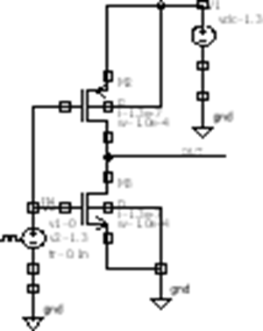

**Figure** **1:** **(a)** **Static** **CMOS** **based** **NOT**

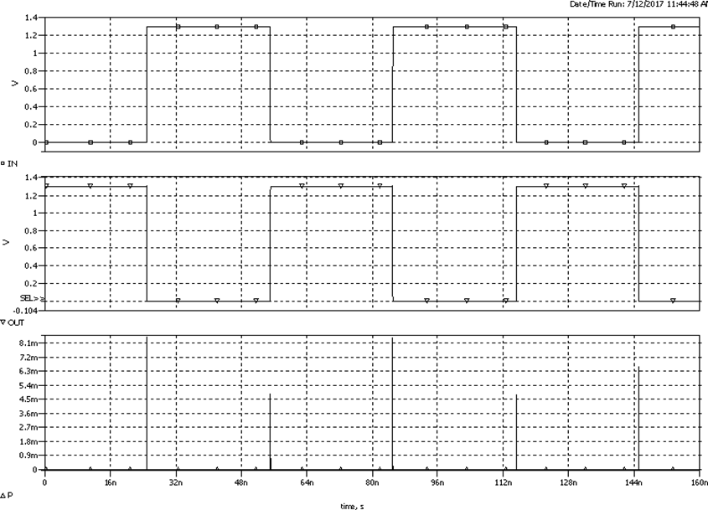

**Figure 2.(b) Simulation of static CMOS based NOT**

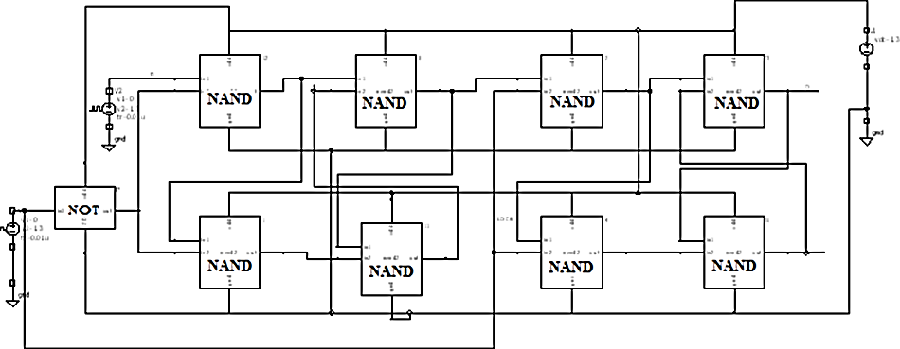

**Figure 3: (a) D Flip Flop using Static CMOS Gates**

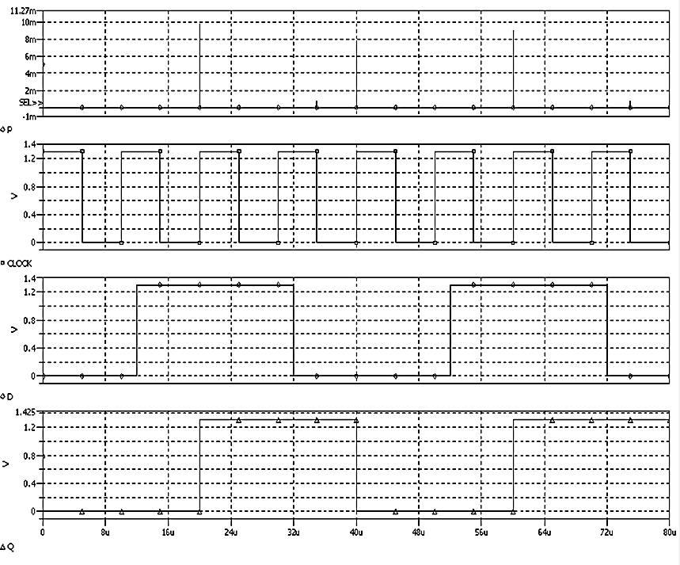

**Figure 4: (b) Simulation of D Flip Flop using static CMOS**

Conclusion: Designing power-efficient flip-flops for VLSI involves a comprehensive understanding of various power-saving techniques and their trade-offs. Clock gating, MTCMOS, conditional capture, adiabatic logic, and GDI techniques are among the most effective methods to achieve power efficiency. The ultimate goal is to minimize both dynamic and leakage power while maintaining performance and reliability. As VLSI technology continues to evolve, ongoing research and innovation in power-efficient design will remain critical to meeting the demands of modern digital systems.

**References**

1.Rabaey, J. M., Chandrakasan, A., & Nikolic, B. (2003). Digital Integrated Circuits: A Design Perspective. Prentice Hall.

2.Kawaguchi, H., & Sakurai, T. (1998). A Reduced Clock-Swing Flip-Flop (RCSFF) for 63% Power Reduction. IEEE Journal of Solid-State Circuits, 33(5), 807-811.

3.Stojanovic, V., & Oklobdzija, V. (1999). Comparative Analysis of Master-Slave Latches and Flip-Flops for High-Performance and Low-Power Systems. IEEE Journal of Solid-State Circuits, 34(4), 536-548.

4.Zhao, P., Darwish, T., & Bayoumi, M. (2004). High-Performance and Low Power Conditional Discharge Flip-Flop. IEEE Transactions on VLSI Systems, 12(5), 477-484.

5.Marković, D., Wang, C. C., Alarcon, L. P., Liu, T. T., & Rabaey, J. M. (2010). Ultralow-Power Design in Near-Threshold Region. Proceedings of the IEEE, 98(2), 237-252.

6.Chandrakasan, A., Sheng, S., & Brodersen, R. W. (1992). Low-Power CMOS Digital Design. IEEE Journal of Solid-State Circuits, 27(4), 473-484.

7.Alioto, M. (2012). Ultra-Low Power VLSI Circuit Design Demystified and Explained: A Tutorial. IEEE Transactions on Circuits and Systems I: Regular Papers, 59(1), 3-29.

8.Bellaouar, A., & Elmasry, M. (1995). Low-Power Digital VLSI Design: Circuits and Systems. Kluwer Academic Publishers.

9.Wang, J. M., Chung, S. H., & Chen, C. C. (2001). Energy Recovery Flip-Flops for Low Power Applications. IEEE Transactions on Circuits and Systems II: Express Briefs, 48(10), 1047-1050.

10.Benini, L., & De Micheli, G. (2002). Networks on Chips: A New SoC Paradigm. Computer, 35(1), 70-78.

11.Chandrakasan, A., & Brodersen, R. (1995). Minimizing Power Consumption in Digital CMOS Circuits. Proceedings of the IEEE, 83(4), 498-523.

12.Tsividis, Y., & McAndrew, C. (2011). Operation and Modeling of the MOS Transistor. Oxford University Press.

13.Roy, K., & Prasad, S. (2000). Low-Power CMOS VLSI Circuit Design. Wiley-Interscience.

14.J. M. Rabaey, A. Chandrakasan, B. Nikolic, Digital Integrated Circuits, 2nd edition, Prentice Hall, 2002. 132

15.S. M. Kang, Y. Leblebici, CMOS Digital Integrated Circuits: Analysis & Design, TATAMcGraw- Hill Publication, 3e, 2003

16. N. Weste, K. Eshraghian, Principles of CMOS VLSI Design, A systems perspective, AddisonWesley MA, 1988.

17. J. P. Uyemura, Circuit Design for CMOS VLSI. Norwell, MA: Kluwer Academic, 1992, pp. 88–129.

18.K.S. Yeo, K. Roy, Low- Voltage, Low-Power VLSI Subsystems, McGraw Hill Professional,2005.

19.K. Roy, S. Prasad, Low-Power CMOS VLSI Circuit design, Willey Interscience Publication,2000.