**Review Paper on Modeling and Optimization of WEDM Process Parameters on Machining of AISI D2 using Taguchi method**

**Gautam Kumar1, Hemendra Patle2, Puran Gour3**

1Research Scholar Master of Technology (APS) Department of Mechanical Engineering, NIIST, Bhopal

2Assistant professor, Department of Mechanical Engineering, NIIST, Bhopal (M.P.)

3Principal, NIIST, Bhopal (M.P.)

**Abstract**

Wire electric discharge machining, or WEDM, is a widely used machining technique in many sectors because it is typically employed for die-punch development and the machining of hard, brittle materials. WEDM is also used to create intricate shapes. The effectiveness of the WEDM machining process is greatly influenced by the selection of the appropriate machining parameters. Optimization is one technique used in the manufacturing sector to determine the best conditions for production, which is essential for businesses looking to manufacture high-quality goods at cheaper costs. It might be difficult to choose the ideal combination of process variables for WEDM machining in order to maximize material removal rate. This study aims to investigate the effects of process variables on performance metrics in the WEDM machining process, including wire feed, servo voltage, peak current, pulse on and off durations, and surface roughness, gap voltage, gap current, and cutting rate. In this research will be used Taguchi method for optimization on various parameters for material removal rate.

## *Keywords:* ANOVA, Inconel718, Microstructure, Selective Laser Melting, Taguchi, Porosity, Hardness

1. **Introduction**

Wire electrical discharge machining is a non-contact subtractive manufacturing process that uses an electrically charged thin wire with a dielectric fluid to cut a metal part into different shapes. The process produces small chips and precise cut lines by melting or vaporizing the material rather than cutting it. As a result, it can conveniently machine parts unsuitable for conventional machining techniques. However, the parts must be electrically conductive. Machining a part using the process involves submerging the workpiece into a dielectric fluid, securing it with a [machinist vise](https://waykenrm.com/blogs/machinist-vise/), and running the wire through it to produce sparks as it passes an electric current.

In other words, the wire carries one side of the charge, and the workpiece, which must be a conductive material, carries the other side of the charge. When the two get close, a hot electric charge jumps the gap and melts tiny pieces of the metal away.

The electric spark is the cutting tool to cut the material in the desired shape. Additionally, the wire EDM process involves deionized water to control the process and flush away tiny particles removed shown in figure 1.

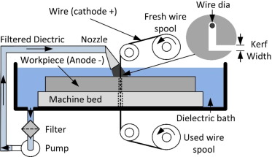

**Figure 1:** Schematic Diagram of Basic Principle of WEDM

**2. LITERATURE REVIEW**

**A.Thillaivanan et at. 2023** In this paper the complexity of electrical discharge machining process which is very difficult to determine optimal cutting parameters for improving cutting performance has been reported. Optimization of operating parameters is an important step in machining, particularly for operating unconventional machining procedure like EDM. A suitable selection of machining parameters for the electrical discharge machining process relies heavily on the operators’ technologies and experience because of their numerous and diverse range. Machining parameters tables provided by the machine tool builder cannot meet the operators’ requirements, since for unarbitrary desired machining time for a particular job, they do not provide the optimal machining conditions. An approach to determine parameters setting is proposed. Based on the Taguchi parameter design method and the analysis of variance, the significant factors affecting the machining performance such as total machining time, oversize and taper for a hole machined by EDM process, are determined. Artificial neural networks are highly flexible modelling tools with an ability to learn the mapping between input variables and output feature spaces.

**Ashish Srivastava et al. 2023** Surface finish and Metal removal rate (MRR) is one of the most prime requirements of customer and it is also a significant tool to reduce the cycle time of any machine operation as well as the overall cost of the production. In the recent years, quality of product is a essential demand of customer which turned to the fast and rapid technologies of production. This paper presents an experimental study on composite of Al2024 reinforced with SiC to investigate the effects of electric discharge machining (EDM) for three levels of each parameter such as current pulse on time and reinforcement percentage on surface finish and MRR.

**A.K.M Asif Iqbal et al. 2023** Problem statement: Electrical Discharge Machining (EDM) has grown over the last few decades from a novelty to a mainstream manufacturing process. Though, EDM process is very demanding but the mechanism of the process is complex and far from completely understood. It is difficult to establish a model that can accurately predict the performance by correlating the process parameters. The optimum processing parameters are essential to increase the production rate and decrease the machining time, since the materials, which are processed by EDM and even the process is very costly. This research establishes empirical relations regarding machining parameters and the responses in analysing the machinability of the stainless steel. Approach: The machining factors used are voltage, rotational speed of electrode and feed rate over the responses MRR, EWR and Ra. Response surface methodology was used to investigate the relationships and parametric interactions between the three controllable variables on the MRR, EWR and Ra. Central composite experimental design was used to estimate the model coefficients of the three factors. The responses were modelled using a response surface model based on experimental results. The significant coefficients were obtained by performing Analysis of Variance (ANOVA) at 95% level of significance. Results

**B. Bhattacharyya. 2022** In non-traditional machining processing, electrochemical machining (ECM) has tremendous potential on account of the versatility of its applications and it is expected that it will be successfully and commercially utilised in modern industries, although the effective utilisation of this machining technology will require the application of a system approach to solve some of the predominant machining problems. Because of various complex physico-chemical and hydrodynamic phenomena that occur in the machining gap.

**Bijaya Bijeta Nayak and Siba Sankar Mahapatra 2022**. The present work proposes an experimental investigation and optimization of various process parameters during taper cutting of deep cryo-treated [Inconel](https://www.sciencedirect.com/topics/engineering/inconel) 718 in [wire electrical discharge machining](https://www.sciencedirect.com/topics/engineering/wire-electrical-discharge-machining) process. Taguchi's [design of experiment](https://www.sciencedirect.com/topics/engineering/design-of-experiments) is used to gather information regarding the process with less number of experimental runs considering six input parameters such as part thickness, [taper angle](https://www.sciencedirect.com/topics/engineering/taper-angle), pulse duration, discharge current, wire speed and wire tension. Since traditional [Taguchi method](https://www.sciencedirect.com/topics/engineering/taguchi-method) fails to optimize multiple performance characteristics, maximum deviation theory is applied to convert multiple performance characteristics into an equivalent single performance characteristic.

**Bikash Choudhuri et al. 2022** H21 steel is one of the hot work tool steels, which exhibits superior red hardness, high mechanical strength and difficult-to-machine. Wire electrical discharge machining (WEDM) always demands high-speed and high-precision machining to fulfill productivity and accuracy of machining hard materials. Cutting speed determines the productivity of machining and the width of kerf determines the tolerance of finished product. Two methodologies viz. response surface method (RSM) and artificial neural network (ANN) are compared for their modelling, sensitivity analysis and optimization abilities. The predictability of ANN model is better than RSM which indicating the advantage of ANN in mappingthe nonlinear behavior of the system.

**Datta et al. 2021** In the present work, quadratic mathematical models have been derived to represent the process behaviour of wire electrical discharge machining (WEDM) operation. Experiments have been conducted with six process parameters: discharge current, pulse duration, pulse frequency, wire speed, wire tension and dielectric flow rate; to be varied in three different levels. This indicates utility of the grey-Taguchi technique as multi-objective optimizer in the field of wire EDM. [9]

**Deepak Rajendra Unune and Har Lal Singh Mali 2021**. The micro-wire [electric discharge machining](https://www.sciencedirect.com/topics/engineering/electric-discharge-machining) (micro-WEDM) has emerged as the popular [micromachining](https://www.sciencedirect.com/topics/engineering/micro-machining) processes for fabrication of micro-features. However, the low machining rate and poor surface finish are restricting wide applications of this process. Therefore, in this study, an attempt was made to improve machining rate of micro-WEDM with low-frequency workpiece vibration assistance. The gap voltage, capacitance, feed rate and vibrational frequency were chosen as control factors, whereas, the [material removal rate](https://www.sciencedirect.com/topics/engineering/material-removal-rate) (MRR) and kerf width were selected as [performance measures](https://www.sciencedirect.com/topics/engineering/performance-measure-psi) while fabricating [microchannels](https://www.sciencedirect.com/topics/engineering/microchannel) in [Inconel](https://www.sciencedirect.com/topics/engineering/inconel) 718.

**El-Taweel. 2021** The present study investigates the relationship of process parameters in electro-discharge of CK45 steel with novel tool electrode material such as Al–Cu–Si–TiC composite produced using powder metallurgy (P/M) technique. The central composite second-order rotatable design had been utilized to plan the experiments, and response surface methodology (RSM) was employed for developing experimental models. Analysis on machining characteristics of electrical discharge machining (EDM) die sinking was made based on the developed models. In this study, titanium carbide percent (TiC%), peak current, dielectric flushing pressure, and pulse on-time are considered as input process parameters.

[**G. Rajyalakshmi**](https://link.springer.com/article/10.1007/s00170-013-5081-z#auth-G_-Rajyalakshmi-Aff1)**&**[**P. Venkata Ramaiah**](https://link.springer.com/article/10.1007/s00170-013-5081-z#auth-P_-Venkata_Ramaiah-Aff2)**. 2020** In this paper, an effective approach, Taguchi grey relational analysis, has been applied to experimental results of wire cut electrical discharge machining (WEDM) on Inconel 825 with consideration of multiple response measures. The approach combines the orthogonal array design of experiment with grey relational analysis. The main objective of this study is to obtain improved material removal rate, surface roughness, and spark gap. Grey relational theory is adopted to determine the best process parameters that optimize the response measures. The experiment has been done by using Taguchi’s orthogonal array L36 (21 × 37). Each experiment was conducted under different conditions of input parameters.

**S.** **Gopalakannan et al. 2020**. Experiments were carried out by adopting face cantered central composite design of response surface methodology. Analysis of variance was applied to investigate the influence of process parameters and their interactions viz., pulse current, gap voltage, pulse on time and pulse off time on material removal rate (MRR), electrode wear ratio (EWR) and surface roughness (SR). The objective was to identify the significant process parameters that affect the output characteristics and to develop for MRR, EWR and SR. [13]

**J.Udaya Prakash et al. 2019** The objective of this work is to investigate the effect of parameters like gap voltage, pulse on time, pulse off time, wire feed and percentage reinforcement on the responses material removal rate as well as surface roughness while machining Aluminium alloy (A413)/flyash/boron carbide hybrid composites using Wire Electrical Discharge Machining (WEDM). Experimentation has been done on Taguchi's L27 orthogonal array under different combinations of parameters. Analysis of variance (ANOVA) has been used to determine the design parameters significantly influencing the response.

## 3. Experimental Setup and Procedure

**3.1 Work piece material**

The AISI – D2 steel will be used as a work piece material for the experiments. AISI D2 is a high carbon, high chromium tool steel alloyed with molybdenum and vanadium characterized by:

* High wear resistance
* High compressive strength
* Good through-hardening properties
* High stability in hardening
* Good resistance to tempering-back.

Table 1: Chemical composition of metal powder

|  |  |
| --- | --- |
| **Element** | **Composition (%)** |
| C | 1.40 – 1.60 |
| Mn | 0.60 |
| Si | 0.60 |
| Co | 1.00 |
| Cr | 11.00 – 13.00 |
| Mo | 0.70 – 1.20 |

**3.2 Machne tool used**

### The experiments will be carried out on a wire-cut EDM machine (Electronica Ultracut S2) of Electronica Machine Tools Ltd. (shown in figure 4.1) installed at M/s. Bhagwati Textiles (P) Ltd. Bhilwara (Raj.).

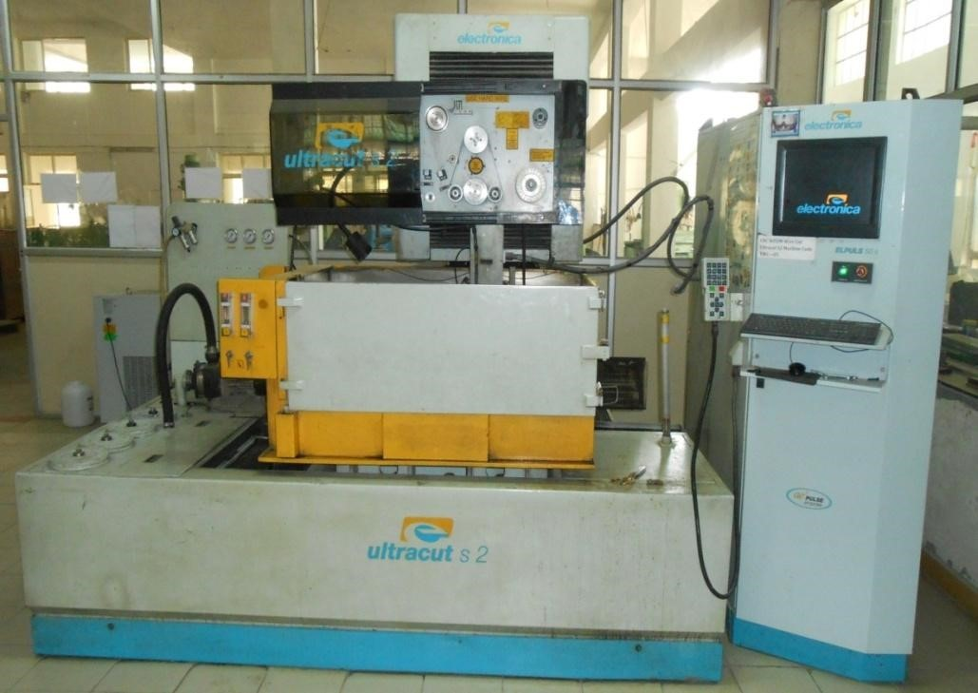

Figure 1:Electronica Ultracut S2 WEDM Machine

**3.3 Taguchi Method**

The Taguchi method (TM) is a problem-solving technique to help improve process performance, to increase efficiency and productivity. The Taguchi method is centred around reducing potential variations in a process through [design of experiments](https://checkify.com/blog/design-of-experiment/). The objective of using the methodology is to produce high-quality products with low costs to the manufacturer. Reducing variations in processes through the robust design of experiments. Taguchi developed this method for designing experiments as a way to investigate how different parameters affect process performance and a way to define how well the process is functioning. The Taguchi method is about quality control that focuses on the importance of research and development (R&D), and product design and development as a key way to reduce the occurrence of failures in the manufacturing process.

As Taguchi looked to improve product design while lowering costs, he explained that the framework can be viewed in three main components:

**Systems Design**: Focuses on the primary aspects that are necessary to produce the required product. It can include the best combination of materials and processes.

**Parameter Design**: Involves the most suitable set of rules that govern the established design elements. Defining the components in each parameter makes it easy to minimise the variation from a product. The Taguchi approach empathises this stage because it is often overlooked during industrial design practice.

**Tolerance Design**: Look at the factors that play a significant role in product quality. It then identifies tolerance limits that provide the variation required in the design

**5. CONCLUSION**

An AISI D2 will be analyzed for its machinability under WEDM operations using the Taguchi technique. The Taguchi techniques orthogonal arrays L16 will used to define the cutting parameters for the WEDM operations. The parameters selected were wire feed, servo voltage, peak current, pulse on and off durations for WEDM operation. A statistical software will be used. The influences of wire feed, servo voltage, peak current, pulse on and off durations will investigate by Taguchi. The main purpose of this study to optimize the which parameters will most affecting on the Material Removal Rate (MRR).

**Reference**

1. [1] A.Thillaivanan, P Asokan, K.N.Srinivasan, R.Saravanan, 2023, “Optimization Of Operating Parameters for EDM Process Based on the Taguchi Method and Artificial Neural Network ”, *International Journal of Engineering Science and Technology*, Vol. 2(12),pp: 6880-6888
2. Ashish Srivastava, Amit Rai Dixit, Sandeep Tiwari, 2023,” Experimental Investigation of Wire EDM Process Parameteres on Aluminium Metal Matrix Composite Al2024/SiC”, *International Journal of Advance Research and Innovation*, Volume 2-2, pp:511-515.
3. AsifIqbal, A. K. M., Khan, Ahsan Ali, 2023, “Modeling and Analysis of MRR, EWR and Surface Roughness in EDM Milling through Response Surface Methodology”, *American Journal of Engineering and Applied Sciences*, Vol.3(4), pp:611-619.
4. B. Bhattacharyya, 2022, “Investigation for controlling electrochemical machining through response surface Methodology-based approach”, *Journal of Material Processing Technology*, Vol.86, pp:200-207
5. Bijaya Bijeta, Siba Sankar Mahapatra,2022,” Optimization of WEDM process parameters using deep cryo-treated Inconel 718 as work material”, *International Journal of Engineering Science and Technology*, Vol (19), pp:161-170.
6. Bikash Choudhuri, Ruma Sen, Subrata Kumar Ghosh, S. C. Saha, 2022, “A Comparative Modeling and Multi-Objective Optimization in Wire EDM Process on H21 Tool Steel Using Intelligent Hybrid Approach”, *International Journal of Engineering and Technology (IJET)*, Vol 8- 6, pp:3102-3112.
7. Datta, Saurav, Mahapatra, SibaSankar, 2021, “Modeling, Simulation and Parametric Optimization of Wire EDM Process using Response Surface Methodology coupled with Grey-Taguchi Technique”, *International Journal of Engineering, Science and Technology*, Vol.2(5), pp:162-183.
8. Deepak Rajendra Unune, Har Lal Singh Mali, 2021,” Experimental investigation on low frequency vibration assisted micro WEDM of Inconel 718”, *International Journal of Engineering Science and Technology*.
9. El-Taweel, T. A., 2021, “Multi-response Optimization of EDM with AlCu-Si-TiC P/M Composite Electrode”, *International Journal of Engineering and Technology (IJET)*, Vol 8- 6, pp:31 -39
10. G. Rajyalakshmi,P. Venkata Ramaiah, 2020, “Multiple process parameter optimization of wire electrical discharge machining on Inconel 825 using Taguchi grey relational analysis”, *International Journal of Advanced Manufacturing Technology*, 2013/ 10.1007/s00170-013-5081.
11. Gopalakannan, S., Senthilvelan, T., Ranganathan, S., 2020, “Modeling and Optimization of EDM Process Parameters on Machining of Al 7075-B4C MMC using RSM”, *International Conference on Modeling, Optimization and Computing,* 38:685-690.