**STRENGTH PERFORMANCE OF CONCRETE MODIFIED WASTE CERAMIC TILES**

**ADEALA Adeniran Jolaade & OLAOYE Joseph Oladapo**

**Department of civil Engineering**

**The Federal Polytechnic, Ilaro, Ogun State.**

**adeala.adeniran@gmail.com**

**Abstract**

*A sizeable unit of broken ceramic tiles that were employed as finishing on a construction site are now rubbish and are usually left alone. The goal of this experiment is to replace some of the cement and coarse particles in concrete with recycled ceramic tiles. To replace cement and fine aggregates, respectively, ceramic tiles were ground into powdery and cushed-fine forms and broken into coarse form to replace coarse aggregates in proportions ranging from 0 to 30% at intervals of 5%. For each replacement (0-30%), concrete cubes with a water cement ratio (W/C) of 0.4 were cast and allowed to cure for 7, 14, and 28 days, respectively. This investigation, which was conducted in compliance with British Standard, concentrated on the compressive strength of both normal and ceramically treated concrete. In comparison to the control (25.77 N/mm2), the compressive strengths of the modified concrete (5-30%) at 28 days were 14.57/mm2, 14.27N/mm2, 13.95N/mm2, 13.56N/mm2, 13.16N/mm2, and 12..96N/mm2, respectively. It may be established that ceramic tiles in powdery and coarse forms, respectively, cannot replace the combined cement and coarse aggregates with the same percentage of substitution.*

**Keywords: Aggregate, Compressive Strength, Concrete, Ceramic tiles, Reuse**

1. **INTRODUCTION**

The second most commonly used material on the globe, after water, is concrete, which serves to shape the built environment. Additionally, it can be used as aggregate. An estimated 33 billion tons of concrete are produced worldwide each year. This equals more than 1.7 billion truckloads annually, 6.4 million truckloads daily, or more than 3.8 tons per person annually. In comparison to all other building materials combined, such as wood, steel, plastic, and aluminum, concrete is used in construction twice as often. Utilizing wastes is one of the most urgent issues of our time, which has prompted the need for specific actions to reduce waste generation. Promoting resource recovery systems (reuse, recycling, and waste-to-energy systems) as a strategy to use the resources contained in waste that would otherwise be wasted, minimizing environmental damage, is one of these actions. Pumice stone and crushed ceramic waste were employed in mortar and concrete production by Binici (2007) as partial replacements for fine aggregate. The results showed that the completed product had great resistance to chloride attack, good compressive strength, and abrasion resistance. Aruna et al. (2015) studied the replacement of coarse aggregates in tile waste-based concrete with 20mm downsizing at waste levels of 0%, 5%, 10%, 15%, 20%, and 25%. Fly ash was also used to replace some of the cement. At a replacement rate of 25%, the roof tile aggregate concrete's average maximum compressive strength was obtained. When compared to ordinary concrete, a strength loss of 10-15% is observed after 25% replacement of the aggregate from roof tiles. Modified concrete constructed from roof tiles had a fair amount of workability. For simple constructions, the modified concrete was determined to be enough. Topçu and Canbaz (2010) claim that the tile waste produced is sufficient to be used as concrete's alternative for coarse aggregate. Both the environment and business profit from the use of leftover ceramic tile. When tile aggregate is utilized, the self-weight of concrete is reduced by around 4%, increasing the cost-effectiveness of the structure. The strength of concrete is affected negatively by replacing the aggregate with tile, both in terms of compressive strength and split tensile strength. The study focused on the largest proportions of tile waste, which could be divided into smaller proportions and used to produce concrete with desirable properties.

In 2013, Ceramic tile use in concrete was looked into by Tavakoli D. et al. Instead, coarse aggregate is used in the range of 0 to 40%. Compressive strength rises by 5.13 percent with a 10% substitution, although slump, water absorption, and unit weight fall by 10%, 0.1 percent, and 2.29 percent, respectively. Spain carried out a study on the concentration of industrial ceramic waste, the recycled ceramic aggregates complied with all technical requirements set forth by current Spanish law, and the concrete was made in accordance with the Spanish concrete code.100% of coarse aggregate has been replaced with ceramic aggregate. The mechanical properties of the novel concrete and conventional concrete were compared using the right tests. Concrete properties of the ceramic ware aggregate concrete were similar to those of regular gravel concrete.

Ceramic waste from industry was explored by Parminder and Rakesh (2015) as a potential partial replacement for coarse aggregate. Three different grades of concrete have been created and put to the test. It is advised that ceramic tile aggregate be used in concrete, despite the fact that the results did not match the expectations. It was ultimately decided that the appropriate percentage of ceramic tile in M20 grade concrete is around 20%. In a study on the use of ceramic tiles in concrete published in 2016, Awoyera et al. substituted varied amounts of ceramic fine and coarse aggregates from building sites in Ota, Lagos, and Nigeria. The strength characteristics of conventional concrete are tested when ceramic cement particles are used in place of fine and coarse cement particles. Last but not least, it was asserted that cement strengthened significantly more with ceramic waste added than without. According to Rajalakshmi P et al (2016), the use of ceramic waste will be an efficient step in the improvement of concrete quality and environmental preservation. Considering that the ceramic tile industry wastes roughly 30% of its output, substituting ceramic waste for aggregates in concrete would have significant environmental benefits. They contend that compared to conventional coarse aggregate, ceramic waste aggregate is more resilient and durable. The study examined replacing 10% or more of the fine aggregate with ceramic tiles and 30%, 60%, or 100% of the coarse aggregate with ceramic tiles when using M-30 grade concrete. Regardless of the type of concrete used, the research reveals that leftover ceramic tiles can be used as a substitute for coarse and fine aggregate. Used ceramic tiles have good strength, with a maximum CFA and CCA strength of 10% and 60%, respectively Shruthi H. et al. (2016) claimed that pollution is caused by waste ceramic tile that is taken from manufacturing facilities, construction sites, and demolition sites. However, they asserted that using crushed tile in place of coarse aggregate in concrete would also be economically advantageous. In the study, M20 grade concrete was used, and ceramic tile waste was used as a substitute intended for natural coarse aggregate in concrete with 0%, 10%, 20%, and 30% substitutes. After 3, 7, and 28 days of curing, the concrete cast's compressive and split tensile strengths were evaluated. According to the findings, the best compressive strength is obtained when natural coarse aggregate is used to replace 30% of the ceramic tile aggregate. In order to partially substitute fine aggregate, Saswat and Vikas (2016) employed ceramic and demolition debris for building stiff pavement. They discovered that utilizing ceramic and demolition debris to make stiff pavement could help conserve 40% of natural fine aggregate. Additionally, it was demonstrated that the compressive strength of waste materials was enhanced when up to 20% demolition debris and 20% ceramic waste were utilized instead of concrete as a reference. Additionally, it was found through testing that 30% ceramic waste powder may replace fine aggregate in concrete without weakening the material's compressive strength. Additionally, they found that just about 1% of the split tensile strength is lost when compared to regular concrete.

The use of used ceramic tiles as a partial replacement for coarse and fine aggregate in concrete was investigated by Hemanth, K.C. et al. in 2015. In the trial, 10% and 20% of the fine and coarse aggregates were replaced with waste crushed tiles, respectively. They found that 10% of coarse material that could be replaced by cracked tiles was the appropriate proportion. The influence of ceramic waste as coarse aggregate on concrete strength qualities by Ikponmwosa and Ehikhuenmen (2017) maintained that while ceramic waste could be used for both structural and non-structural purposes, it should not be used in concrete constructions where high strength is the main consideration Reddy and Reddy (2007) claim that it has been demonstrated that ceramic scrap may replace 10% and 20% of the conventional coarse aggregates without sacrificing structural integrity.

Adeala and Omisande (2016) also discovered that all freshly treated concrete has a droop between 1mm and 2mm. After 28 days, modified concrete with 5% to 20% replacement showed compressive strengths more than 25N/mm2 compared to normal concrete with the same 1:2:4 mix design ratio. This implies that the potential for changed concrete that contains broken tiles is larger. The behavior was identical to that of conventional concrete, and the density varied between 2300 and 2500 kg/m3. According to the maritime regulation BS 6349, water absorption of modified concrete ranges from 0.89 to 3%, and should not be higher than 3% or 2% in critical situations, such as particularly severe chloride or freeze-thaw exposure.

**MATERIALS &METHODS**

The Federal Polytechnic Ilaro's rehabilitation of several building blocks provided the resources for this project, which were broken waste ceramic tiles that were salvaged (Figure 1) and further reduced into smaller, usable pieces using a hand-held hammer. Using a power milling machine, some of the broken ceramic tiles were ground up into a fine powder, as seen in (Figure 2).

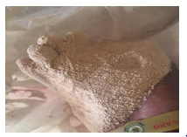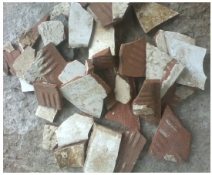 Figure 2: Crushed Fine Ceramic Tiles Figure 1: Broken Ceramic Tiles

Broken ceramic tiles passed through a 150-millimeter filter were utilized as a partial replacement for cement, while powdery ceramic tiles were passed through a 75-millimeter sieve. Cement was also purchased from a Dangote cement retail outlet in Ilaro. Coarse aggregates with a maximum size of 19mm and fine aggregates were purchased in Ilaro, Ogun State. The Federal Polytechnic Ilaro's Material Testing Laboratory provided portable water. Both coarse and aggregate sizes underwent sieve examination. For cement and coarse aggregates, respectively, powdery ceramic tiles and crushed ceramic tiles were substituted at 5%, 10%, 15%, 20%, 25%, and 30%. According to Fig. 4, a total of 72 cubes were cast at a 0.4 water cement-ratio and submerged in water for 7, 14, 21, and 28 days before being crushed. British European Standards were followed when conducting engineering testing on the specimen.

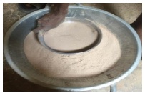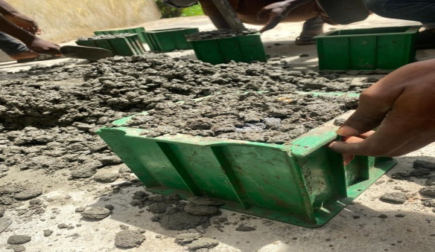

Figure 3: Powdery Ceramic Tiles during sieving Figure 4: Mixing and casting of concrete

**Table 1**: Materials batch weight in kilograms with a 0.4 water-to-cement ratio

|  |  |  |  |  |  |
| --- | --- | --- | --- | --- | --- |
| Materials | 0% | 5% | 10% | 15% | 20% 25% 30% |
| Cement | 11.00 | 10.45 | 9.90 | 9.35 | 8.80 8.25 7.70 |
| F.A | 22.00 | 20.90 | 19.80 | 18.70 | 17.60 16.50 15.40 |
| C.A | 44 | 41.8 | 39.6 | 37.4 | 35.2 33.00 30.80 |
| PCT  CFCT | 0  0 | 0.55  1.10 | 1.10  2.20 | 1.65  3.30 | 2.20 2.75 3.30  4.40 5.50 6.60 |
| CCCT | 0 | 2.20 | 4.40 | 6.60 | 8.80 11.00 13.20 |

Table 1 above shows batch weights of materials used for the research work. The percentages of the substitutes both Powdery ceramic tiles (PCT) and crushed fine and coarse ceramic tiles (CFTC) & (CCCT) were as shown.

1. **RESULTS & DISCUSSIONS**
2. **Particle Size Distribution Fine and Coarse Aggregates**

The result of the sieve analysis carried out in accordance to BS 1377 on the coarse aggregates is as depicted in Fig. 5. The Cu of the aggregates lies between 1 and 3 while the finesse moduli are between 2 and 4 for both coarse (conventional and modified) and fine aggregates as shown in fig.5 and fig.6 below.

Figure 5: Grading Curves for conventional and modified coarse Aggregates

It was observed that both conventional and modified coarse aggregates are well graded in accordance with BS 1377, 2: 1990

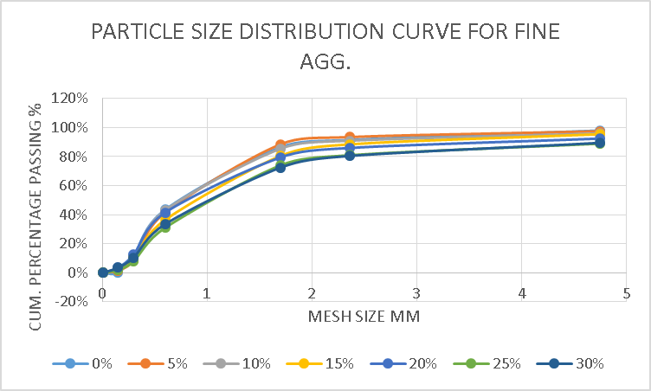

Figure 6: Grading Curve for fine Aggregates and crushed fine ceramic tiles (CFCT)

It was observed that both fine and modified fine aggregates are well graded in accordance to BS 1377,2 : 1990

1. **Specific gravity**

Specific gravity is a measure of ratio of unit weight of a substance to unit weight of standard liquid (water). The fine aggregate's specific gravity was measured in order to determine whether it could be used to make concrete.

**Table 2: Cement and modified cement specific gravities.**

|  |  |
| --- | --- |
| **% Replacement** | **Specific Gravity** |
| 0 | 2.43 |
| 5 | 2.35 |
| 10 | 2.60 |
| 15 | 2.12 |
| 20 | 2.58 |
| 25 | 2.05 |
| 30 | 3.01 |

At 0% it was observed that specific gravity was 2.43, at 5% substitute, specific gravity dropped to 2.35, on getting to 10% replacement it increased to 10%. At 15% its specific gravity reduced to 2.12 then at 20% it increased to 2.58 while at 25% it retarded to 2.05 and finally increased to 3.01 at 30% substitute.

1. **The initial and final setting times for cement paste.**

The initial and final setting time tests of a cement paste were carried out in accordance to BS 12, 1978.

**Table 3**: Setting time of cement paste

|  |  |  |
| --- | --- | --- |
| Sample composition | Time of initial setting time of cement | Time of final setting time of cemenr |
| Cement paste | 90mins | 165mins |
| 5% PCT+95% Cement paste | 145mins | 180 mins |
| 10% PCT +90% Cement paste | 157mins | 195mins |
| 15% PCT +85% Cement paste | 165mins | 262mins |
| 20% PCT +80% Cement paste | 175mins | 268mins |
| 25% PCT +75% Cement paste | 184mins | 275mins |
| 30% PCT +95% Cement paste | 202mins | 285mins |

According to BS 12 recommendations, which state that the initial and final setting times should be between 45 minutes and 10 hours, it is acceptable

1. **Workability**

Slump is a gauge of how easily freshly mixed concrete can be shaped. It is done in compliance with BS 1881-102. At 0% replacement the slump height was 4mm and decreased to 2mm and at 10% replacement it was at 5mm then later increased by difference of 1mm at 15%. It was observed that at 20% measured 4mm slump and increased to 6mm at 25% and decreased drastically to 0mm at 30% substitute.

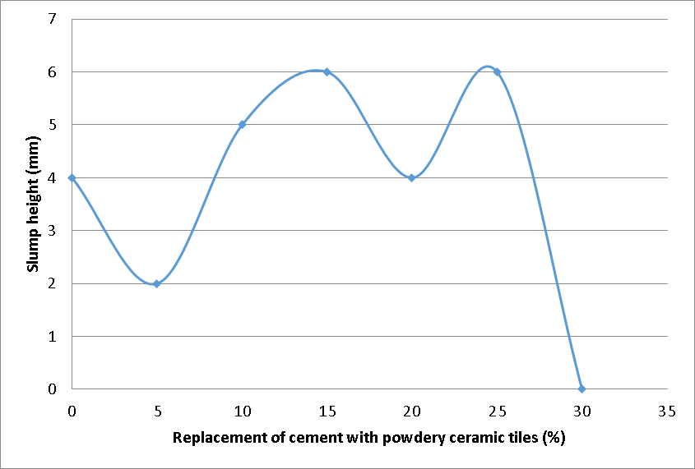

Figure 7: Concrete slump versus Ceramic Tiles replacement.

1. **Density**

Concrete density testing was done in accordance with BS 813-114.

The concrete's density was assessed and contrasted with that of normal concrete.

Density = mass/volume

Table 5: 28-day concrete's mean density

|  |  |
| --- | --- |
| Percentage replacement | Density  kg/ $m^{3}$ |
| 0 | 2347 |
| 5 | 2316 |
| 10 | 2284 |
| 15 | 2222 |
| 20 | 2185 |
| 25 | 2226 |
| 30 | 2210 |

Only 5% of replacement falls within the range of concrete's densities, which are 2300–2500 kg/m3 for conventional concrete and 2186–2316 kg/m3 for modified concrete

1. . **Water Absorption**

Water absorption is quantity of water the concrete specimen takes in after 7,14,21 and 28days. This research paper focused on 28days and it was carried out in accordance to BS813-2.

**Table 6**: Water absorption of specimen for 28days

|  |  |  |
| --- | --- | --- |
| W/C | REPLACEMENT | WATER ABSORPTION  (%) |
| 0.4 | 0% | 1.09 |
| 5% | 0.30 |
| 10% | 0.48 |
| 15% | 0.98 |
| 20% | 0.72 |
| 25% | 0.50 |
| 30% | 1.12 |

The modified concrete will likely function better in water-logged locations since it absorbs less water than ordinary concrete, according to data on water absorption. At 0%, the water absorption yields 1.09%, which falls to 0.30 at 5%, then rises to 0.48 at 10%, then rises to 0.98 at 15%, and finally, an increase of 1.12 was observed at 30%. At 0%, the water absorption yields 1.09%, which then slightly reduces to 0.72 at 20%, then rises again to 0.5 at 25%, and finally, an increase of 0.98 was noted at 15%.

1. **Compressive Strength**

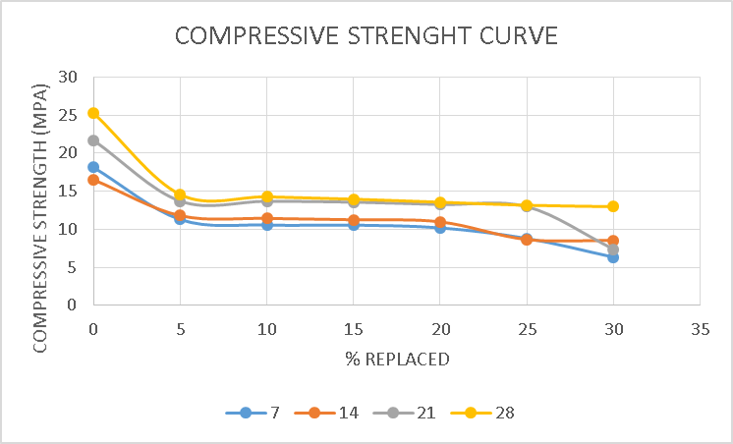

Figure 9: Compressive strength development against percentage substitution.

Compressive strength of concrete was carried out in accordance to BS 1881- 116.

The 7-day strength significantly decreased when compared to the threshold, which is unchanged concrete with a strength of 18.125 MPa. The average compressive strength of the 30% changed concrete was the lowest at 6.344 MPa, whereas that of the 5% and 10% modified concretes was 11.2823 MPa and 10.5677 MPa, respectively. All of the modified concretes' strengths exhibited a trend to deteriorate. After the modified concrete's maximum compressive strength was attained at 5% of the modified concrete, there was a continuous decline in strength up to 30%. With the exception of the 25% and 30% modified concrete, which experienced a sharp fall in compressive strength, the 14-day compressive strength displays the same pattern as the 7-day compressive strength. With the exception of the 30% modified concrete, which experiences a dramatic fall in strength, the 21-day strengths all follow the same pattern. The 28-day followed the same trend as the 7-day, but experienced a constant loss of strength. The compressive strength test reveals that due to the drastic loss in strength, modified concrete can only be utilized to create low-strength concrete, such as unreinforced plain. Concrete that has been modified cannot be used in structural elements.

Figure 9: Regression study showing the relationship between compressive strength and the 28-day replacement of cracked and powdered ceramic tiles.

The percentage replacement since = 0.504 and compressive strength have a reasonable relationship.

1. **Flexural Strength Predictive Mathematical Model**

The peak strength of changed concrete was obtained at 5% replacement, and there was a steady loss in strength up to the 30% modified concrete, according to the mathematical model of flexural strength, which showed the same trend of strength drop as the compressive strength. A mathematical assertion that connected concrete's compressive strength to its flexural strength served as the model's basis fft = 0.7fck0.5. Figure 10 displays the specimen's flexural strength.

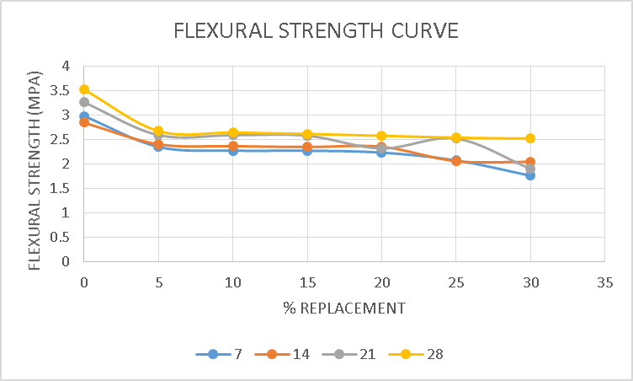

Figure 10: Mathematics Predictive model of flexural strength curve

1. **Spilt Tensile Strength Predictive Mathematical Model**

The ultimate strength of modification concrete occurred at 5% replacement, the concrete drastically reduces in strength up to the 30% modified concrete, according to the empirical relationship between compressive strength and spilt tensile strength, spilt tensile strength fst=0.56fck0.5 as shown in fig.11

Figure 11: Mathematics Predictive model of Spilt Tensile Strength curve

1. **CONCLUSION**

It was found that replacing 15% of cement and coarse aggregates, respectively, with powdered ceramic tiles and shattered ceramic tiles for a period of 28 days, can produce concrete. Additionally, it was shown that the percentage substitution of powdered ceramic tiles (PCT) and broken ceramic tiles (BCT) had a substantial correlation with compressive strength. It was also observed that the three substitutes cannot be used to produce normal weight concrete but can be used to produce light weight concrete if it is used at similar percentage replacement due to its density and compressive strength which were not between 2300 and 2500kg/m3 and 20MPa respectively.

**ACKNOWLEGDEMENT**

We valued Mr. Adeyinka's technical advice from the Concrete and Material Laboratory of the Civil Engineering Department at the Federal Polytechnic in Ilaro as well as the laboratory contributions from Adeyemi Olaoluwa Sunday, Adeyemi Adekunle Mustapha, and Usman.

**REFERENCES**

(1)Adeala A & Omisande L.A. . (2016). The Use Of Broken Ceramic As Partial Replacement Of Coarse Aggregates In Concrete. *Repositioning Nigerian Techological Education In The 21st Century* , Orita,Ilaro: ASUP,The Federal Polytechnic, Ilaro Chapter, Ogun State.10-15.

(2).Aruna D, Rajendra P, Subhash C.Y, & Katta V . (2016). Study On Usage of Potential of broken Tiles As Parial Replacement of Coarse Aggregates ceramic Waste In Concrete . *International of Journal Research In Technology and Engineering IJRTE* , 110-114.

(3).Binici, H. (2007). Effect of crushed ceramic and basaltic pumice asfine aggregates on concrete mortars properties. *Elsevier Construction and Building Materials.* , 1191-1197.

(4). BS 12. (1978). *Ordinary and Rapid hardening Portland cement.* London: British Standards Institution.

(5). BS 12. (1996*). Specification for Portland cement*. London: British Standards Institution.

(6). BS 12. (2000). *Specification for Portland cement*. London: British Standards Institution.

(7). BS 813-2. (1995). *Determination of water absorption of concrete*. London: British Standards Institution

(8). BS 1377-2. (1990). *Sieve analysis of dry sample.* London: British Standards Institution.

(9). BS 1881-102. (1983). *Methods of determination of Slump*. London: British Standards Institution.

(10). BS 1881-114 :(1983). *Methods of determination of density*. London: British Standards Institution.

(11). BS 1881- 116. (1983). *Method for Determination of Compressive Strength of Concrete*. London: British Standards Institute.

(12). BS 1881. (1986). *Methods of testing concrete*. London: British Standards Institute.

(13). BS 3148. (1980). *The requirement of water for concrete mixing*. London: British standard Institution.

(14). BS EN 197. (2000). *Specification for Portland cement*. London: British Standards Institution.

(15). Hemanth, K. A. (2015). Effect of waste ceramic tiles as partial replacement of coarse and fine aggregate of concrete. . *International Advanced Research Journal in Science, Engineering* , 13-16.

(16). Ikponmwosa, E.E.& Ehikhuenmen. (2017). The effect of ceramic waste as coarse aggregate on strength properties of concrete. *Nigerian Journal of Technology* , 691-696.

(17). Parminder S & Rakesh kumar S. (2015). Utilization Of Waste Ceramic Tiles As Coarse Aggregate In Concrete. . *Journal of Multidisciplinary Engineering Science and Technology (JMEST)* ,329 4 - 3300.

(18). Paul O. Awoyera, J. M. (2016). Characterization of ceramic waste aggregate concrete. *Housing and Building National Research Center (HBRC Journal)* .1-6.

(19). Reddy, M.V. and Reddy, C.N.V.S.(2007). An experimental study on use of Rock Flour and insulator ceramic scrap in concrete. . *Journal of Institution of Engineers, india* , 47-50.

(20). Saswat, H & Vikas, S. (2016). Comprehensive Literature review on partial replacement of fine aggregate with ceramic and demolition waste in rigid pavement. *International Journal of Innovative Research in Science Engineering and Technolgy* , 5-8.

(22). Shruti, H.G., Gowtham, P.M.E. Samreen, T. & Syed, R.P. . (2016.). Reuse of ceramic waste as aggregate in concrete. *International Research Journal of Engineering and Technology* , 13-16.

(23). Tavakoli, D., Heidari, A.& Etemadi, M. . (2011). Using tile as a pozzolan in concrete. *The Third National Conference on Concrete. tehran: Iran IJSER* .1-11.

(24). Topçu, I.B & Canbaz, M (2010). Utilization of Crushed Tile as Aggregate in Concrete. *Iranian Journal of Science Technology, Transaction B, Engineering, Vol. 31, No. B5,* , 561-565.