NPA MANAGEMENT STRATEGIES OF COMMERCIAL BANKS IN INDIA

1Purnima Sarkar

Asst.Professor- II(Finance), Amity Global Business School, Bhubaneswar

**ABSTRACT**

The Indian banking sector has been facing serious problems of raising Non- Performing Assets (NPAs). The NPAs growth has a direct impact on profitability of banks. Non- performing assets are one of the major concerns for scheduled commercial banks in India. The recommendations of Narasimham committee and Verma committee, some steps have been taken to solve the problem of old NPAs in the balance sheets of the banks. It continues to be expressed from every corner that there has rarely been any systematic evaluation of the best way of tackling the problem. There seems to be no unanimity in the proper policies to be followed in resolving this problem. NPAs reflect the performance of banks. A high level of NPAs suggests high probability of a large number of credit defaults that affect the profitability and net-worth of banks and erodes the value of the asset. NPAs affect the liquidity and profitability, in addition to posing threat on quality of asset and survival of banks. The problem of NPAs is not only affecting the banks but also the whole economy. In fact, high level of NPAs in Indian banks is nothing but a reflection of the state of health of the industry and trade. It is necessary to trim down NPAs to improve the financial health in the banking system. An attempt is made in this paper to understand NPA, the status and trend of NPAs in Indian Scheduled commercial banks, the factors contributing to NPAs, reasons for high impact of NPAs on Scheduled commercial banks in India and recovery of NPAS through various channels

**Keywords:** Non-performaing Assets,liquidity, narashimham committee

**INTRODUCTION**

The banking system in India comprises commercial and cooperative banks, of which the former accounts for more than 90 per cent of banking system’s assets. Besides a few foreign and Indian private banks, the commercial banks comprise nationalized banks (majority equity holding is with the Government), the State Bank of India (SBI) (majority equity holding being with the Reserve Bank of India) and the associate banks of SBI (majority holding being with State Bank of India). These banks, along with regional rural banks, constitute the public sector (state owned) banking system in India The banking industry has undergone a sea change after the first phase of economic liberalization in 1991 and hence credit management. Asset quality was not prime concern in Indian banking sector till 1991, but was mainly focused on performance objectives such as opening wide networks/branches, development of rural areas, priority sector lending, higher employment generation, etc. While the primary function of banks is to lend funds as loans to various sectors such as agriculture, industry, personal loans, housing loans etc., but in recent times the banks have become very cautious in extending loans. The reason being mounting nonperforming assets (NPAs) and nowadays these are one of the major concerns for banks in India. Bankers are the custodians and distributors of the liquid capital of the country. Therefore most important function of the banking system is to mobilize the savings of the people by accepting deposits from the public. The banker becomes the trustee of the surplus balances of the public. Deposit mobilization promotes the economic prosperity by controlling the money circulation and canalizing for development and productive purposes. In order to mobilize deposits, the commercial banks undertake deposit mobilization through various deposit schemes suited to the different sections of the people. The deposits along with other sources of funds namely capital, reserves and borrowings, form the sources of funds for the banks. The lending and investment activities of the bank are based on the sources of funds. The banks, in their books, have different kind of assets, such as cash in hand, balances with other banks, investment, loans and advances, fixed assets and other assets. The Non-Performing Asset (NPA) concept is restricted to loans, advances and investments. As long as an asset generates the income expected from it and does not disclose any unusual risk other than normal commercial risk, it is treated as performing asset, and when it fails to generate the expected income it becomes a “Non-Performing Asset”. In other words, a loan asset becomes a Non Performing Asset (NPA) when it ceases to generate income, i.e. interest, fees, commission or any other dues for the bank for more than 90 days. A NPA is an advance where payment of interest or repayment of installment on principal or both remains unpaid for a period of two quarters or more and if they have become ‘past due’. An amount under any of the credit facilities is to be treated as past due when it remain unpaid for 30 days beyond due date. www.ijcrt.org © 2019 IJCRT | Volume 7, Issue 4 October 2019 | ISSN: 2320-2882 IJCRT1133352 International Journal of Creative Research Thoughts (IJCRT) www.ijcrt.org 303

**LITERATURE REVIEW**

Many published articles are available in the area of non-performing assets and a large number of researchers have studied the issue of NPA in banking industry. A review of the relevant literature has been described. Kumar (2013) in his study on A Comparative study of NPA of Old Private Sector Banks and Foreign Banks has said that Non-performing Assets (NPAs) have become a nuisance and headache for the Indian banking sector for the past several years. One of the major issues challenging the performance of commercial banks in the late 90s adversely affecting was the accumulation of huge nonperforming assets (NPAs). Selvarajan & Vadivalagan (2013) in A Study on Management of NonPerforming Assets in Priority Sector reference to Indian Bank and Public Sector Banks (PSBs) find that the growth of Indian Bank’s lending to Priority sector is more than that of the Public Sector Banks as a whole. Indian Bank has slippages in controlling of NPAs in the early years of the decade. Singh (2013) in his paper entitled Recovery of NPAs in Indian commercial banks says that the origin of the problem of burgeoning NPA’s lies in the system of credit risk management by the banks. Banks are required to have adequate preventive measures in fixing pre- sanctioning appraisal responsibility and an effective post-disbursement supervision. Banks should continuously monitor loans to identify accounts that have potential to become non- performing. Gupta (2012) in her study A Comparative Study of NonPerforming Assets of SBI & Associates & Other Public Sector Banks had concluded that each bank should have its own independence credit rating agency which should evaluate the financial capacity of the borrower before credit facility and credit rating agencies should regularly evaluate the financial condition of the clients. Rai (2012) in her study on Study on performance of NPAs of Indian commercial banks find out that corporate borrowers even after defaulting continuously never had the fear of bank taking action to recover their dues. This is because there was no legal framework to safeguard the real interest of banks. Chatterjee C., Mukherjee J. and Das (2012) in their study on Management of non-performing assets - a current scenario has concluded that banks should find out the original reasons/purposes of the loan required by the borrower. Proper identification of the guarantor www.ijcrt.org © 2019 IJCRT | Volume 7, Issue 4 October 2019 | ISSN: 2320-2882 IJCRT1133352 International Journal of Creative Research Thoughts (IJCRT) www.ijcrt.org 304 should be checked by the bank including scrutiny of his/her wealth. Kaur K. and Singh B. (2011) in their study on Non-performing assets of public and private sector banks (a comparative study) studied that NPAs are considered as an important parameter to judge the performance and financial health of banks. The level of NPAs is one of the drivers of financial stability and growth of the banking sector. Prasad G.V.B. and Veena (2011) in their study on NPAs Reduction Strategies for Commercial Banks in India stated that the NPAs do not generate interest income for banks but at the same time banks are required to provide provisions for NPAs from their current profits, thus NPAs have destructive impact on the return on assets in the following ways. Chaudhary K. and Sharma M. (2011) in their research stated that An efficient management information system should be developed. The bank staff involved in sanctioning the advances should be trained about the proper documentation and charge of securities and motivated to take measures in preventing advances turning into NPA. Karunakar (2008), in his study Are non - Performing Assets Gloomy or Greedy from Indian Perspective, has highlighted problem of losses and lower profitability of Non- Performing Assets (NPA) and liability mismatch in Banks and financial sector depend on how various risks are managed in their business. The lasting solution to the problem of NPAs can be achieved only with proper credit assessment and risk management mechanism. Bhatia (2007) in his research paper explores that NPAs are considered as an important parameter to judge the performance and financial health of banks. The level of NPAs is one of the drivers of financial stability and growth of the banking sector. Kaur (2006) in her thesis titled Credit management and problem of NPAs in Public Sector Banks, suggested that for effective handling of NPAs, there is an urgent need for creating proper awareness about the adverse impact of NPAs on profitability amongst bank staff, particularly the field functionaries. Bankers should have frequent interactions and meeting with the borrowers for creating better understanding and mutual trust. Balasubramaniam C.S. (2001) highlighted the level of NPAs is high with all banks currently and the banks would be expected to bring down their NPA. This can be achieved by good credit appraisal procedures, effective internal control systems along with their efforts to improve asset quality in their balance sheets

**OBJECTIVES OF THE STUDY**

To study the status of Non-Performing Assets of Indian Scheduled Commercial Banks in India

To study the impact of NPAs on Banks.

To know the recovery of NPAS through various channels.

To make appropriate suggestions to avoid future NPAs and to manage existing NPAs in Banks.

**SCOPE OF THE STUDY**

The study has the following scope:

The study could suggest measures for the banks to avoid future NPAs & to reduce existing

The study may help the government in creating & implementing new strategies to control NPAs.

The study will help to select appropriate techniques suited to manage the NPAs and develop a time bound action plan to check the growth of NPAs.

**SOURCES OF DATA**

The data collected is mainly secondary in nature. The sources of data for this thesis include the literature published by Indian Bank and the Reserve Bank of India, various magazines, Journals, Books dealing with the current banking scenario and research papers.

**RESEARCH METHODOLOGY**

For our study, we have considered Non Performing Assets in Scheduled Commercial Banks which includes public sector banks, private sector banks and foreign banks which are listed in the Second Schedule of the Reserve Bank of India Act, 1934. The study is based on secondary data. The paper discusses the conceptual framework of NPA and it also highlights the trends, status and impact of NPA on scheduled commercial banks during the period of 14 years i.e. from 2000 to 2014. The researchers have used several reputed research journal including research paper and articles. Moreover, RBI Report on Trend and Progress of Banking in India for various years, websites and a book on banking has been referred during the study.

**POPULATION**

Banking industry is taken for the study, where aggregate data related to NPA for Public sector Banks, Private Sector Banks and Foreign Banks is used.

14 year’s Aggregate data from 2000 to 2014 was used for the study.

**Table 1 – Gross Advances and Gross NPAS of SCBs (Amount in Rupees Billion)**

|  |  |  |  |
| --- | --- | --- | --- |
| Year | Gross Advances | Gross NPAs(Amount) | Gross NPAs(Percentage) |
| 2001-02 | 6809.58 | 708.61 | 10.4 |
| 2002-03 | 7780.43 | 687.17 | 8.8 |
| 2003-04 | 9020.26 | 648.12 | 7.2 |
| 2004-05 | 11526.82 | 593.73 | 5.2 |
| 2005-06 | 15513.78 | 510.97 | 3.3 |
| 2006-07 | 20125.10 | 504.86 | 2.5 |
| 2007-08 | 25078.85 | 563.09 | 2.3 |
| 2008-09 | 30382.54 | 683.28 | 2.3 |
| 2009-10 | 35449.65 | 846.98 | 2.4 |
| 2010-11 | 40120.79 | 979.00 | 2.5 |
| 2011-12 | 46655.44 | 1370.96 | 2.9 |
| 2012-13 | 59882.79 | 1931.94 | 3.2 |
| 2013-14 | 68757.48 | 2641.95 | 3.8 |

The above table depicts the amount of Gross Advances, Gross NPA and the percentage of Gross NPA during the period of 2001-02 to 2013-14. The amount of advances of has increased from Rs. 6810 Billion in 2001-02 to Rs. 68757 Billion in 2013-14. The amount of gross NPA has increased from Rs. 708.61 billion in 2001-02 to Rs. 2642 billion in 2013-14. Similarly, NPA percentage is also showing the rising trend from 2.3 in 2007 to 3.8 in 2013.

**Table 2 – Net Advances and Net NPAS of SCBs (Amount in Rupees Billion)**

|  |  |  |  |
| --- | --- | --- | --- |
| Year | Net Advances | Net NPAs(Amount) | Net NPAs(Percentage) |
| 2001-02 | 6458.59 | 355.54 | 5.5 |
| 2002-03 | 7404.73 | 296.92 | 4.0 |
| 2003-04 | 8626.43 | 243.96 | 2.8 |
| 2004-05 | 11156.63 | 217.54 | 2.0 |
| 2005-06 | 15168.11 | 185.43 | 1.2 |
| 2006-07 | 19812.37 | 201.01 | 1.0 |
| 2007-08 | 24769.36 | 247.30 | 1.0 |
| 2008-09 | 29999.24 | 315.64 | 1.1 |
| 2009-10 | 34970.92 | 387.23 | 1.1 |
| 2010-11 | 42987.04 | 417.00 | 1.1 |
| 2011-12 | 50735.59 | 652.00 | 1.3 |
| 2012-13 | 58797.03 | 986.00 | 1.7 |
| 2013-14 | 67352.32 | 1426.57 | 2.1 |

The above table shows the amount of Net Advances, Net NPA and the percentage of Net NPA during the period of 2001-02 to 2013-14. The amount of advances has increased from Rs. 6458.59 billion in 2001-02 to 67352.32 billion in 2013-14. Further, the amount of NPA has also increased from Rs. 355.54 billion to Rs1426.57 billion during the period (2001-02 to 2013-14). The percentage of Net NPA has first declined from 5.5 in 2001-02 to 1.0 in 2007-08. Then it has increased to 2.10% in 2013-14.

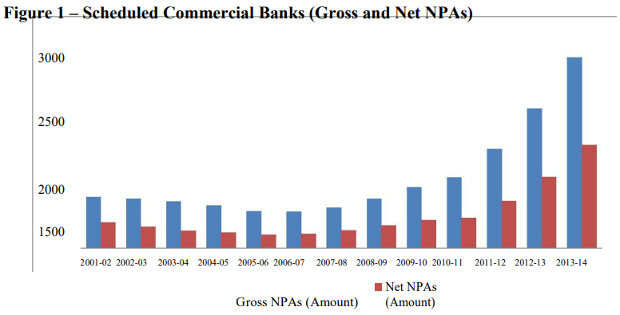

The figures from Figure 1 shows the trend of Gross NPA and Net NPA in billion for the period of 13 years starting from 2001-02 to 2013-14. The x-axis represent the years i.e. as the period of (2001-02 – 2013-14) whereas y-axis represent the amount of NPA. We can observe here that the Gross and Net amount of NPA has been showing an upward trend beginning from 2006-07 to 2013-14. Figure 2 – Gross and Net NPA (in Percentage) 12 10 Gross NPAs (Percentage) Net NPAs (Percentage) The above figure portrays the trend of Gross NPA and Net NPA in percentages for the period of 13 years i.e. from 2001-02 till 2012-14. The x-axis represents the years whereas y-axis represents the percentage of NPA. We can observe here that the Gross and Net percentage of NPA has been showing downward trend from 2001 to 2007-08 and an upward trend beginning from 2007-08 to 2013-14.

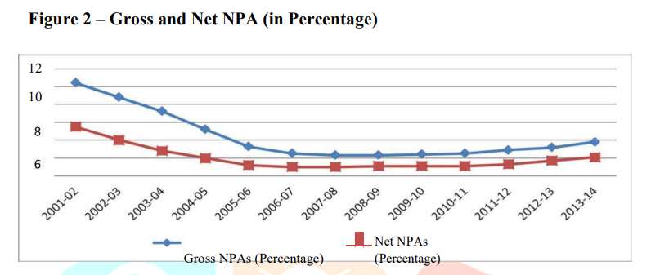

The above figure portrays the trend of Gross NPA and Net NPA in percentages for the period of 13 years i.e. from 2001-02 till 2012-14. The x-axis represents the years whereas y-axis represents the percentage of NPA. We can observe here that the Gross and Net percentage of NPA has been showing downward trend from 2001 to 2007-08 and an upward trend beginning from 2007-08 to 2013-14.

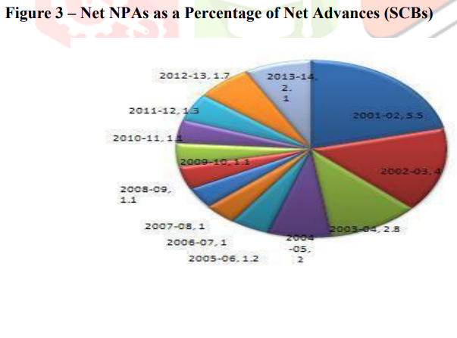

The above figure shows NPAs as a Percentage of Net Advances which was lowest 1.0 % in 2007-08 & 2008-09 and highest 5.5 % in 2001-02. It was 2.2 % in 2013-14.

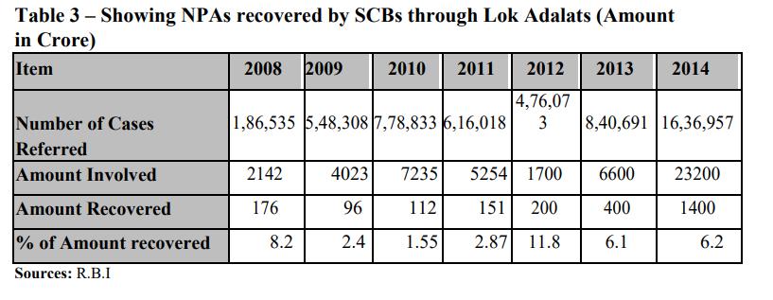

Table 3 – Showing NPAs recovered by SCBs through Lok Adalats (Amount in Crore) Item 2008 2009 2010 2011 2012 2013 2014 Number of Cases 1,86,535 5,48,308 7,78,833 6,16,018 4,76,07 3 8,40,691 16,36,957 Referred Amount Involved 2142 4023 7235 5254 1700 6600 23200 Amount Recovered 176 96 112 151 200 400 1400 % of Amount recovered 8.2 2.4 1.55 2.87 11.8 6.1 6.2 Sources: R.B.I Table 3 is showing NPAs of commercial banks recovered through Lok Adalats during the study period of 2008 to 2014. From the analysis of the table, it is clear that the number of cases referred to Lok Adalats for the recovery of NPAs of commercial banks has increased largely in 2014 as compared to 2008. However, if we look at the amount recovered by Lok Adalats during the study period, it shows a continuous decline from 2008 to 2009 and then it shows improvement from 2010 to 2014, but it is much less than the other recovery channels. These Lok Adalats are only successful in recovering 1400 crore out of 23200 crore means only 6.2% of the total amount involved in NPAs of the commercial banks. Due to its inefficiency in recovering, the amount involved in NPAs, the commercial banks resorting to others means of recovery.

**Table 4. Showing NPAs recovered by SCBs through DRTs (Amount in Crore)**

Table 4 shows NPAs of commercial banks recovered through DRTs during the study period of 2008 to 2014. From the analysis of the table, it is clear that the number of cases for the recovery of NPAs referred to DRTs is increasing through the study period and also the amount involved in these cases and the amount recovered through DRTs has increased. DRTs shows their efficiency in 2008-09 where it recovers 81.1pc of the total amount involved in NPAs and in later years also the amount recovered by DRTs is quite significant. This is the basic reason why the commercial banks are approaching DRTs for the recovery of their NPAs as compared to Lok Adalats in which the percentage of recovered amount of NPAs is very low. Though we can say that there is a slight decrease in the percentage of amount recovered by DRTs of the NPAs of commercial banks, though these are a significant recovery channel for the commercial banks.

**Table 5. Showing NPAs recovered by SCBs through SARFAESI Act (Amount in Crore)**

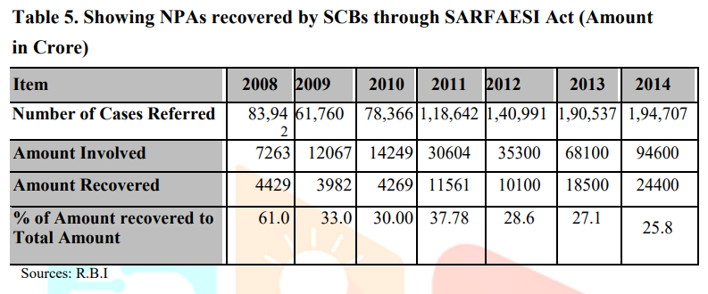

Table 5 is showing NPAs of commercial banks recovered through SARFAESI Act during the study period of 2008 to 2014. From the analysis of the table, it is clear that the number of cases referred to SARFAESI Act and the amount of NPAs involved is increased largely during the study period. This is done because of the efficiency of SARFAESI Act in recovering these NPAs of commercial banks. From the table it is clear that the SARFAESI Act is able to recover 25.8% of the amount of NPAs of the cases referred to it in the year 2014. In 2008 recovery percentage was quite higher 61.0% this act has emerged as a blessing in disguise for the commercial banks as now they are using this act largely in recovering their NPAs in order to increase their profitability.

**Figure 4 – Recovery of NPAs of SCBs through various Channels (Amount in Rs.

Figure 4 clearly showing NPAs of scheduled commercial banks recovered through various channels SARFAESI Act during the study period of 2008 to 2014. SARFAESI Act is the most effective channel of NPA recovery. Rs. 24,400 Crores were recovered through this channel in 2014.

**IMPACT OF NPA**

1. NPA affects the performance and profitability of banks. The most notable impact of NPA is change in banker’s sentiments, which may hinder credit expansion to productive purpose. Banks may incline towards more risk-free investments to avoid and reduce riskiness, which is not conducive for the growth of economy. If the level of NPAs is not controlled timely they will:
2. Reduce the earning capacity of assets and badly affect the ROI.
3. The cost of capital will go up.
4. The assets and liability mismatch will widen.
5. Higher provisioning requirement on mounting NPAs adversely affect capital adequacy ratio and banks profitability.
6. The economic value additions (EVA) by banks get upset because EVA is equal to the net operating profit minus cost of capital.
7. NPAs causes to decrease the value of share sometimes even below their book value in the capital market.

**FINDINGS**

1. Gross NPAs of scheduled commercial banks have increased from Rs. 708 Billion in 2000-01 to Rs 2642 Billion in 2012-13.
2. Net NPAs of scheduled commercial banks have increased from Rs. 355 Billion in 2000-01 to Rs. 986 Billion in 2012-13.
3. NPAs as a Percentage of Net Advances, which was lowest 1.0 % in 2007-08 & 2008-09 and highest 5.5 % in 2001-02. It was 2.2 % in 2013-14.
4. The average Percentage of Net NPAs during 2001-02 to 2013-14 was around 2.0

Number of Cases Referred to Lok Adalats was 1,86,535 in 2008 and reached to 16,36,957 in 2014

1. Number of Cases Referred to Lok Adalats was 1,86,535 in 2008 and reached to 16,36,957 in 2014.
2. Rs. 2535 crores of NPAs of SCBs recovered through Lok Adalats during 2008 to 2014 Rs. 27231 crores of NPAs of SCBs recovered through DRTs during 2008 to 2014.
3. Ineffective recovery, willful defaults and Defective lending process are the important factors, which are responsible for the rise of NPAs in banks.
4. NPAs reduce the earning capacity banks and badly affect the ROI.

**RECOMMENDATIONS FOR MANAGEMENT OF NPAS**

* RBI should revise existing credit appraisals and monitoring systems.
* Banks should improve upon and strengthen the loan recovery methods.
* Credit appraisal and post –loan monitoring are crucial steps which need to concentrate by all the public sector banks.
* There must be regular follow-up with the customers and it is the duty of banker to ensure that there is no diversion of funds. This process can be taken up at regular intervals.
* Personal visits should be made after sanction and disbursal of credit and further close monitoring of the operations of the accounts of borrowed units should be done periodically.
* Managers under credit monitoring and recovery department should have dynamism in their work. Many managers say that “we do not fear to negotiate but we do not negotiate out of fear. Such fear leads to arbitrary negotiation, which fails.
* Frequent discussions with the staff in the branch and taking their suggestions for recovery of dues.
* Assisting the borrowers in developing his/her entrepreneurial skill will not only establish a good relation between the borrowers but also help the bankers to keep a track of their funds.
* RBI may initiate actions against defaulters like, publishing names of defaulters in Newspapers, broadcasting media, which is helpful to other banks and financial institutions.
* As a part of curative measures, bankers may resort to Compromise Settlement or One Time Settlement. Lok Adalats and Debt Recovery Tribunals are other ways for the recovery of dues. It has been observed that Banks these days are highly resorting to SARFAESI Act for the management of NPA.
* If the delinquencies are due to reasons beyond the control of borrower, which are namely draughts, floods, or other natural calamities, the banker should suitably restructure the loans taking into account the genuine difficulty of the borrower

**IMITATIONS OF THE STUDY**

The study of non-performing assets of SCBs is limited to the Indian Bank and till the end of the year 2014. The basis for identifying non-performing assets is taken from the Reserve Bank of India Publications. NPAs are changing with the time. The study is done in the present environment without foreseeing future developments

**CONCLUSIONS**

Non-Performing Assets have always created a big problem for the banks in India. It is just not only problem for the banks but for the economy too. The money locked up in NPAs has a direct impact on profitability of the bank as Indian banks are highly dependent on income from interest on funds lent. This study shows that extent of NPA is comparatively very high in public sectors banks. Although various steps have been taken by government to reduce the NPAs but still a lot needs to be done to curb this problem. The NPAs level of our banks is still high as compared to the foreign banks. It is not at all possible to have zero NPAs. The bank management should speed up the recovery process. The problem of recovery is not with small borrowers but with large borrowers and a strict policy should be followed for solving this www.ijcrt.org © 2019 IJCRT | Volume 7, Issue 4 October 2019 | ISSN: 2320-2882 IJCRT1133352 International Journal of Creative Research Thoughts (IJCRT) www.ijcrt.org 313 problem. The government should also make more provisions for faster settlement of pending cases and also it should reduce the mandatory lending to priority sector as this is the major problem creating area. So the problem of NPA needs lots of serious efforts otherwise NPAs will keep killing the profitability of banks which is not good for the growing Indian economy at all.

**REFERENCES**

1.Karunakar, M., “Are non - Performing Assets Gloomy or Greedy from Indian Perspective, Research Journal of Social Sciences, 3: 4-12, 2008.

2.Taori K.J., “Problems and Issues relating to Management of Non Performing Assets of Banks in India” – The Journal of Indian Institute of Bankers– April June 2000, Volume 2, p.no – 21-24.

3. Murthy C.R.K., “Branch Level Management of Non Performing Assets: Part III – Effective Management of Civil Litigation” – Vinimaya, Vol.XXI, No.2, 2000 – 2001 p.no: 5-11.15

4.Kaveri V.S., Faculty, National Institute of Bank Management, Pune,” Prevention of NPAs– Suggested strategies” - IBA Bulletin, August 2001.

5. Rajendra Kakker. “NPA Management – Role of Asset Reconstruction Companies” – IBA Bulletin– Volume 4 – p.no: 11- 14, 2004

6.Bardia S.C., “Credit Efficiency in Banks: A Comparative Study”, The ICFAI University Press, August 2004, p.no – 60-67, 2004.