**REVIEW OF AI** B**ASED GRID CONNECTED MPPT SOLAR PHOTOVOLAIC SYSTEM**

**Laxman Kumar1 Vivek Kumar Yadav2**

*1 RKDF Institute of Science and Technology, Bhopal Electrical Engineering*

*2RKDF Institute of Science and Technology, Bhopal Electrical Engineering*

***ABSTRACT***

**The demand for power is increasing day-by-day throughout the world. The conventional power sources are reducing gradually and produce emissions of greenhouse gases to the environment. This issue can be overcome, to encourage society towards the innovative development of alternative renewable energy (RE) sources. The aim of this paper is to track MPP from the solar PV array by the proposed AI controller for irradiation changes and comparing results with PO, FL and ANN based MPPT controllers. Photovoltaic (PV) plant with grid-connected output that uses the Incremental Conductance Method and Maximum Power Point Tracking (MPPT). Due to interactions between different semiconductors and variable loads, the input source contains harmonic distortion, voltage sags and swell, and other power quality problems in the previous convolution method. Solar photo-voltaic (PV) arrays have non-linear characteristics with distinctive maximum power point (MPP) which relies on ecological conditions such as solar radiation and ambient temperature. In order to obtain continuous maximum power (MP) from PV arrays under varying ecological conditions, maximum power point tracking (MPPT) control methods are employed. MPPT is utilized to extract MP from the solar PV array, high-performance soft computing techniques can be used as an MPPT technique. Different MPPT techniques have been used to compute MPP and improved efficiency of the PV panel. AIAPO, ANN, FL and PO MPPT methods have been chosen to obtain this objective. Simulation results showing that the system in which proposed control method has been used gives better performance and reduce fluctuations of the MPP as compared to PO, FL and ANN based MPPT technique at rapid changes of irradiation. In order to fabricate a reliable and real time hybrid system, there is a massive scope of research to develop multi- input renewable energy systems.**

***Keywords: Photovoltaic, Converter, MPPT, GRID, fuzzy logic controller, artificial intelligence Network***

**I. INTRODUCTION**

This paper focuses on the modelling and simulation of Maximum Power Point algorithms to investigate tracking efficiency at different atmospheric conditions. Grid-connected output systems are made to convert as much solar energy as possible into usable electricity. Artificial intelligence, Artificial Neural Network (ANN) and the Incremental Conductance Technique method are two recommended techniques interface with DC link controller with the reference voltage in a variety of situations. The demand for power is increasing day-by-day throughout the world. The conventional power sources are reducing gradually and produce emissions of greenhouse gases to the environment. This issue can be overcome, to encourage society towards the innovative development of alternative renewable energy (RE) sources. RE sources are used in grid- connected and can be found in rural and remote areas where the public grid is not available.

A PV system converts solar energy into electrical energy by using PV effect. In a particular environment, there is only a maximum power point (MPP) due to the non-linear current voltage characteristics of PV systems. The MPP keeps changing accordingly with the solar irradiation levels and cell temperature. Moreover, the impedance mismatch between solar panel and the load may reduce the output power. In order to solve this, a DC-DC converter is used between solar panel and the battery. A maximum power tracking technique will be required to solve the impedance mismatch. This is done by ensuring that PV array operates at a single operating point where the current and voltage of the cell provides maximum power output, regardless of the variations in solar radiation In this paper, different MPPT techniques such as PO, FL, ANN and

proposed hybrid for PV system are implemented using MATLABTM / SIMULINKTM. Based on simulation results, the comparison of PO, FL, ANN and proposed hybrid MPPT method select electrical power by using semiconducting materials that display the PV impact. It is a has been carried out for finding MP track from the PV array due to variable irradiations and fixed temperature.

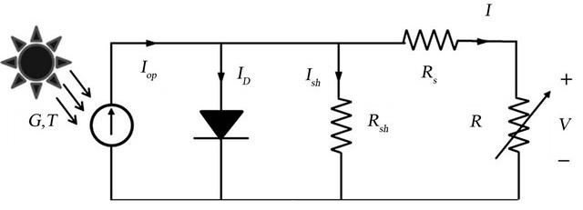

**Fig. 1** Solar Cell Equivalent Circuit

**II. MAXIMUM POWER POINT TRACKING (MPPT) CONTROLLER**

The role of the MPPT is to match panel output power with load requirements. MPPT controller ensures that a PV module’s operating point is maintained at the reference voltage that will produce maximum power for varying atmospheric conditions. The mechanism is based on the principle of impedance matching between source and load, for maximum power transfer between load and PV array at different operating points. The MPPT controller varies the ratio between voltage and current to match impedance of a solar array until the operating point provides maximum power for a given set of conditions. It also ensures a proper charging condition for the batteries and avoids any overcharging and discharging to improve the battery life.

**III. ARTIFICIAL INTELLIGENCE (AI)**

Artificial intelligence is the simulation of human intelligence processes by machines, especially computer systems. Examples of AI applications include expert systems, natural language processing (NLP), and speech recognition and machine vision. As the hype around AI has accelerated, vendors have scrambled to promote how their products and services incorporate it. Often, what they refer to as "AI" is a well-established technology such as machine learning algorithms.

No single programming language is used exclusively in AI, but Python, R, Java, C++ and Julia are all popular languages among AI developers. How does AI work? In general, AI systems work by ingesting large amounts of labeled training data, analyzing that data for correlations and patterns, and using these patterns to make predictions about future states. AI requires specialized hardware and software for writing and training machinelearning

**Maximizing Solar Energy Output with Artificial Intelligence (AI)** As of late, an evident surge in the application of solar panels in the UK for generating ecologically-aware power has been observed. The popularity that this source of power generation has garnered continues to soar as more people embrace its use and benefits. In the present day and age, capitalising on artificial intelligence (AI) to implement profound comprehension patterns is of the utmost importance. The reason for doing so lies in its ability to refine its output while simultaneously minimising expenses. The importance of optimising solar panels for energy efficiency and cost savings In the contemporary world, environmental issues are crucial, enhancing solar panel energy efficiency and reaping monetary benefits. By embarking upon this course of conduct, we can diminish our proclivity towards unreplenishable energy sources. This will enable us to curb the degree to which carbon emissions are dispersed into the environment. Optimising solar panels can lead to substantial cost savings over time, making it an economically viable solution. Using appropriate optimisation methodologies, clean and renewable energy harnessed from the sun can be produced. It is plausible to achieve this outcome by applying diversified enhancement tactics for harnessing solar power resources efficiently. Optimising solar panels can increase the efficiency Proposed Photo-Voltaic SystemProposed PV system contains the following mechanisms such as PV panel, a power boost converter, MPPT controller and resistive load. The duty cycle of the boost converter is measured using conventional and proposed MPPT algorithms. Fig. 2 shows the proposed block diagram of the PV renewable energy system. The main aim of the control system is to maximize the power generation with a variable irradiations from PV panel. Using MPPT method, it should ensure that the DC power is transformed to the load with high efficiency.

# METHODOLOGY

Mathematical Modeling Of Solar Cell In Matlab For analysis, researchers need a reliable model to forecasts the PV power generated correctly when connected in series-parallel. Applying Kirchhoff’s current law in the model shown in figure 1, the total PV current is presented in equation 1 [2].

𝐼=𝐼𝑝ℎ−𝐼𝑑−𝐼𝑠ℎ (1)

Where Iph is the photocurrent, when the PV cell is visible to incident sunlight. The photocurrent is linearly varying concerning solar irradiance at a certain temperature. Id is an anti-parallel diode current, and it produces the non-linear response on the PV cell. The current flow through the shunt resistor is represented by Ish. Substitute the expression for Ish and Id in equation 1, and the PV current is derived in equation 2 [2].

𝐼=𝐼𝑝ℎ−𝐼0(𝑒𝑞(𝑉+𝐼𝑅𝑠)𝑛𝑘𝑇−1)−𝑉+𝐼𝑅𝑠𝑅𝑝 (2)

# Where q is electron charge = 1.6×10-19; n is ideality Factor = 1.2; k is Boltzmann constant = 1.3805×10-23 J/K; Vd=V+IRs and Vt=nkTq; Io is the saturation current of the diode, the temperature of the PV cell is represented by T, Rp & Rs represents the shunt and series resistance, respectively. The photocurrent of the PV is depending on the irradiation and the cell temperature. The expression for the photocurrent is given in equation 3 [2].

𝐼𝑝ℎ=[𝐼𝑠𝑐+𝐾𝑖(𝑇−298)]×𝐼𝑟𝐼𝑟0 (3)

Where Ki is short-circuit current temperature coefficient of cell = 0.0024 and solar irradiation is represented as Ir0 = 1000 W/m2 at Standard Reference Condition. The module saturation current (I0) varies with the cell temperature, which is given by equation 4 [2]

𝐼𝑜= 𝐼[𝑇𝑇𝑟]3𝑒𝑥𝑝[𝑞×𝐸𝑔𝑛𝑘(1𝑇−1𝑇𝑟)] (4)

Where PV cell temperature is represented as Tr = 298 K or 25˚C and the band gap energy, represented by Eg, can expressed by equation 5 [3].

𝐸𝑔=𝐸𝑔0−𝛼𝑇2𝑇+𝛽=1.16−7.02×10−4[𝑇2𝑇−1108] (5)

The modules reverse saturation current (Irs) can be expressed by equation 6 [4].

𝐼𝑟𝑠=𝐼𝑠𝑐(𝑉+𝐼𝑅𝑠)𝑛𝑘𝑇−1 (6)

In order to enhance the ability of electric power generation from solar PV systems, the solar cells should be implemented in series and shunt combinations. If Np represents the cells interconnected in parallel and Ns shows the cells interconnected in series, the relationship between the output current and voltage is presented as follows [2,5]

𝐼= 𝑁𝑝×𝐼𝑝ℎ−𝑁𝑝 ×𝐼0×[𝑒𝑥𝑝(𝑉𝑁𝑠⁄+𝐼×𝑅𝑠𝑁𝑝⁄𝑛×𝑉𝑡)]−𝐼𝑠ℎ(7)

𝐼𝑠ℎ= 𝑉×𝑁𝑝𝑁𝑠+ 𝐼×𝑅𝑠⁄𝑅𝑃

cycle in the next cycle. If the increase of duty cycle produces an increase of the power, then the direction of the perturbation signal is the same as the previous cycle. Conflicting, if the perturbation duty cycle produces a decrease of the power, then the direction of perturbation signal is the opposite from the previous cycle. The increase or decrease in duty cycle is based on the perturbation (∆D) which is generated by AI system. SIMULINKTM and MATLAB function of PO MPPT controller is shown in Fig.

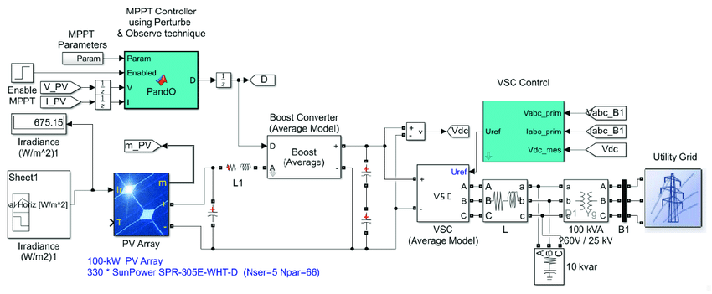

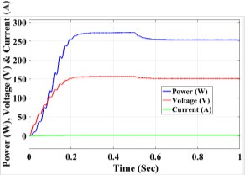**Fig. 2** SIMULINKTM and MATLAB function of PO MPPT controller

**Fig. 3** Output Power, Voltage and Current of Boost Converter with Proposed MPPT Method

A novel hybrid technique which is a combination of FL based MPPT technique and adaptive PO based MPPT technique has been employed. Since, the FL controller as described in section 4.2, with the membership functions and rule base for PV system has been employed here for the development of the subsystem as shown in A novel hybrid technique which is a combination of FL based MPPT technique and adaptive PO based MPPT technique has been employed. Since, the FL controller as described in section 4.2, with the membership functions and rule base for PV system has been employed here for the development of the subsystem as shown in

1. **CONCLUSION**

Stepwise procedure for modeling solar panel and array in MATLAB with user-friendly stimulation tool is shown in each step, which will help further modeling the solar system and I-V & P-V characteristic. The efficiency of the models is much near to the reference value and here also shows that with varying irradiation, temperature, series resistance, parallel resistance, Np and Ns and their effects on the 3 models. The incremental conductance algorithm for the MPPT method and Artificial Neural Network are evaluated in the recommended work. Such outcomes from every instance observed during testing demonstrate that Incremental conductance algorithm techniques effectively enable the practical swarm optimization algorithm in attaining MPP (Maximum Power Tracking) when photovoltaic method is undergoing Peace process, leading to a higher power extraction. To calculate, the category of failure that occurs in the PV system, the proposed algorithm of the Artificial Neural Network was used. The test data are normalized before being utilized as inputs to the input layer, where training takes place.

1. **REFERENCES**

[1]. Salmi, T., Bouzguenda, M., Gastli, A. and Masmoudi, A., 2012. Matlab/simulink based modeling of photovoltaic cell. International journal of renewable energy research, 2(2), pp.213-218.

[2]. Liu, J., Wei, X., and Huang, H. (2021). An improved grey wolf optimization algorithm and its application in path planning. IEEE Access 9, 121944–121956. doi:10.1109/

[3]. Prakash, R. and Singh, S., 2016. Designing and modelling of solar photovoltaic cell and array. IOSR Journal of Electrical and Electronics Engineering (IOSR-JEEE), 11(2), pp.35-40.

[4]. Al-Shetwi, A. Q., Hannan, M. A., JernAmmar, K. P., and Pg Abas, A. E. (2020). Power quality assessment of grid-connected PV system in compliance with the recent

integration requirements. MDPI, Electron. 9, 366.

[5]. Premkumar, M., Chandrasekaran, K. and Sowmya, R., 2020. Mathematical modelling of solar photovoltaic cell/panel/array based on the physical parameters from the manufacturer’s datasheet. International Journal of Renewable energy development, 9(1), p.7.

[6]. “PHOTOVOLTAICS REPORT “.internet: <https://www.ise.fraunhofer.de/de/downloads/pdffiles/aktuelles/photovolt> aics-report-in-englischer-sprache.pdf, October 20, 2016[Oct.23,2016].

[7]. Nguyen, X.H. and Nguyen, M.P., 2015. Mathematical modeling of photovoltaic cell/module/arrays with tags in Matlab/Simulink. Environmental Systems Research, 4, pp.1-13.

[8].Chenni, R., Makhlouf, M., Kerbache, T. and Bouzid, A., 2007. A detailed modeling method for photovoltaic cells. Energy, 32(9), pp.1724-1730.