THEORETICAL MODELING OF POST-TENSIONED NANO-CONCRETE SLAB
Vishal Sapurda Wagh¹ and Prof. Dr, B. H. Shinde²
¹PG student, Department of Civil Engineering, G.H. Raisoni University ,School of Engineering and Technology, Amravati.
²Assistant Professor, Department of Civil Engineering, G.H. Raisoni University ,School of Engineering and Technology, Amravati.

ABSTARCT: In recent times nanotechnology has given rise to new wave of material science in construction industry. Strength and durability of Post Tension slabs play major role in buildings construction, which in turn can improved by using Nano-concrete in Post Tension slabs. In this research study, an effort is made for the study of structural performance of post- tensioned concrete slabs manufactured using Nano-concrete (Post-Tensioned Nano- concrete Slab). To study structural behavior firstly the theoretical modeling of Post- Tensioned Nano-concrete slab is created by using ANSYS Workbench 19.2. By interchanging properties of concrete to Nano-concrete properties finite element analysis of Nano-concrete slabs is carried out and then comparison between ordinary PT slab and Nano- concrete PT slab is carried out for load deflection characteristics. After finite element analysis actual experimental investigation is performed to study actual behavior of Nano-concrete Post Tension slab. In this thesis Nano-concrete containing graphene (0.03% of cement) and Nano-silica (2.5% of cement) is used as material for PT slab. Post Tension slabs are tested as per IS method. From the results obtained from finite element analysis and experimental investigation, graph is plotted between load v/s deformations in slab. Results of both experimental tests as well as FEM analysis show better results in Nano-concrete PT slab than conventional PT slab. Results shows higher load carrying capacity in Nano-concrete PT slab than conventional PT slab. Also, Nano- concrete PT slab has higher yield deflection than Conventional PT Slab.
Keywords: Finite Element Modeling; Graphene; Nano-concrete; Nano-silica; Post- Tensioned Concrete slab; Post-Tensioned Nano-concrete slab.

- INTRODUCTION:

Post-tensioning was introduced in 20th century by group of excellent engineers and businessmen’s. PT that is Post-tensioning is should be considered as best innovation in industry of construction

In the last 50 years the area of post tensioning has seen an extraordinary development in construction industry. Post tensioned leading the race in the construction of the bridges of the span of 250m to 300m. They established themselves firmly in a leading position in bridge construction up to spans of the order of 250- 300m. The development in the PT elements has taken the lead in the many countries. Much of success is due to local availability of materials of concrete, development in methods of the construction of concrete elements, precast segment erection methods, improved information of the structural concrete as given in the codes of standards.
History says that Post tensioning of concrete elements starts from the late 1930s in which French scientist Freyssinet discovered that when concrete is placed under tension it increases compressive strength greatly. The system of Freyssinet includes first laid cables in the formwork at accurate places, Pour concrete around the cables, then allow concrete to set up, and stretch the wires and cut them to lock them into place. The compressive stresses in standard reinforced concrete, which consists mostly of concrete and mild steel, are borne totally by the concrete, whereas the tensile stresses are entirely borne by the steel. Because concrete is considered weak in tension, the concrete surrounding the steel reinforcement does not participate in resisting external forces/moments. It merely serves as a bonding agent. As a result, only the section of concrete above the neutral axis is effective in resisting external forces. As a result, there are a lot of hefty portions. External stresses in prestressed concrete, which is made up of concrete and high tensile steel as essential components. Because the induced pre- stress in concrete is compressive in nature, it will balance the tensile stress created by external loads in the concrete around the steel. As a result, the entire concrete structure can cooperate in resisting external forces. Prestressed concrete, according to the ACI Committee on Prestressed Concrete, is concrete in which internal stresses of such magnitude and distribution have been created that the stresses resulting from given external loadings are counteracted to a desirable degree.
For meeting challenging architectural applications of the world we must requires prestressing elements which can provide durable and easily placing concrete elements. This results in the most economical solution for the concrete application. PT slab means post tensioning slab is the slab in which tendons is provided to develop the compressive stresses to oppose the tensile forces. This technique of casting slabs results in the formation of the thinner slabs than the conventional slabs.
The compressive stresses in standard reinforced concrete, which consists mostly of concrete and mild steel, are borne totally by the concrete, whereas the tensile stresses are entirely borne by the steel. Because concrete is considered weak in tension, the concrete surrounding the steel reinforcement does not participate in resisting external forces/moments. It merely serves as a bonding agent. As a result, only the section of concrete above the neutral axis is effective in resisting external forces. As a result, there are a lot of hefty portions. Both steel and concrete are stressed before to the application of external stresses in prestressed concrete, which is made up of concrete and high tensile steel as essential components. Because the induced pre-stress in concrete is compressive in nature, it will balance the tensile stress created by external loads in the concrete around the steel. As a result, the entire concrete structure can cooperate in resisting external forces.
Nano-concrete is a concrete produced by addition of Nano-additives of size less than 500nm in conventional mix of concrete. By addition of nano-additives properties of concrete get largely altered. Since the beginning of the current century, “nanotechnology” is steadily emerging as a new industrial revolution. The significance and importance of controlling matter at the Nano-scale (10-9 m) have been realized from observing radically enhanced properties and new functionalities of traditional materials such as metals and ceramics through the application of Nano-science and nanotechnology. Hence for all practical purposes, “nanotechnology” has now been defined as capacity of working at nano level to succeed in achieving purposed structures of engineering with enhanced properties and characteristics of concrete.

OBJECTIVES OF WORK
The objective of this work is to develop theoretical modelling of post tension Nano-concrete Slab and compare the performance with conventional post tension Slab using ANSYS workbench 19.2

2. REVIEW OF LITERATURE:
Muthulingam.M and Suganya Devi et al. (1): stated that we can use post – tensioning for almost any shape of the elements with reduction in environmental impacts, time of construction, cost of construction and material of construction. Author used the strain gauges to find the strain and deformation at various places. Author stated that combination of flat as well as post tensioned slab will be more effective than conventional slab and it can be cost effective also. At regular intervals width of cracks is measured then the crack width and strain is compared. Results shows that in SFRC PT slabs, service stress limits were reached at larger demands than in RC slabs. The crack widths in SFRC PT slab is much less when desired stress reaches the service limits in the slab.
Soubhagya Ranjan Rath et al. (2): Author stated that due to tendons with prestress force PT slabs are develops ability to carry the load coming onto the slab. Tendons nullify all the dead load so only live load required to be carried. They also stated that in flat slabs building it resulted into reduced building height, easy formwork removal, and higher construction speed than conventional slabs. Author stated that combination of flat as well as post tensioned slab will be more effective than conventional slab and it can be cost effective also.
Abbas H. Mohammed et al. (3): In this paper author investigates behavior of two way slab subjected to static loads. Main objective of this research includes analytically investigating flexural behavior of concrete two way slab casted with post tensioned technique. To choose effective as well as most optimum layout of tendons one nonlinear finite element system is developed. Nonlinear finite element system also gives the no of tendons for the overall behavior of the two way nano-concrete slab. Nonlinear finite element system also gives the no of tendons for the overall behavior of the two way nano-concrete slab. The results of the experimental testing carried out on the slab specimens shows that with using post tensioned system for casting of slabs the failure load of slab were increased by 89% as compared to the failure load of the conventional two way slab.
K Bednarz1 et al. (4): In this research author gives the accurate practices that should be followed for the construction of the thinner but large span post tensioned slab of two directions. By use of the complete cross section that is full cross section of the thinnest slab higher stress storage system can be developed. But author stated that different cross sections will be beneficial for the larger span slabs. This study presents the analytical investigation of post tensioned slab multistory building and flat slab of the multistoried building of length 15m by using the software’s like ETABS and RAPT. Author did the comparative study of post tensioned and RCC flat slab in in multi-storey commercial building. This study presents the analytical investigation of post tensioned slab multistory building and flat slab of the multistoried building of length 15m by using the software’s like ETABS and RAPT. Author did the comparative study of post tensioned and RCC flat slab in in multi-storey commercial building.
Xiao-Gang Liu et al. (5): compared the stress increment of unbonded pre-stressed tendons to bonded non-prestressed reinforcement, looking at 1) bonded non-prestressed reinforcement strength and cross-sectional reinforcement ratio, 2) steel flange strength and cross-sectional area, 3) concrete cubic strength, and 4) ratio of concrete flange thickness to girder dep The span depth ratio, as well as the strength and thickness of the corrugated webs, the initial pre-stressing force and cross-sectional area of pre-stressing strands, and the initial pre-stressing force and cross-sectional area of pre-stressing strands, were all proven. An analytical model of the stress increment of unbonded pre- stressed tendons was established for the stress rise of unbonded pre-stressed tendons at the yielding load of pre-stressed concrete girders with corrugated steel webs.
Y. Ogawa et al. (6): have introduced a new notion known as the effective creep coefficient. This concept was established using an ultra-high-strength concrete strain directly measured in a pre-stressed concrete grid, as well as a shrinkage strain including molten slag fine aggregates and both a molten slag finely aggregate and roof tile crude waste aggregated shrinkage strain. The effective creep coefficient was confirmed by comparing the pre-stress loss acquired with the effective creep coefficient achieved through experiment and traditional creep test. The stress losses computed with efficient creep coefficients were better than those resulting from traditional creep coefficients.
S. Mugil and K. Mugunthan (7): evaluated the mechanical properties of nano- silica cement concrete. The addition of nano-silica to mortar has been proven to increase its compressive strength. They investigated the performance of nano-silica in reinforced beams. It's also been revealed that when the percentage of nano-silica in concrete rises, the concrete's workability and strength decline. The strength of concrete cubes was improved when beams were cast with a nominal amount of nano-silica. Finally, the beam's flexural strength was calculated, and a load vs. deflection graph was constructed to show how the strength increased and decreased.
M. Sarkisian et al. (8): In this paper author investigates behavior of two way slab subjected to static loads. Main objective of this research includes analytically investigating flexural behavior of concrete two way slab casted with post tensioned technique. To choose effective as well as most optimum layout of tendons one nonlinear finite element system is developed. Nonlinear finite element system also gives the no of tendons for the overall behavior of the two way nano-concrete slab. Nonlinear finite element system also gives the no of tendons for the overall behavior of the two way nano-concrete slab. The results of the experimental testing carried out on the slab specimens shows that with using post tensioned system for casting of slabs the failure load of slab were increased by 895 as compared to the failure load of the conventional two way slab.
Shriraj S. Malvade, P.J. Salunke (9): In this paper author studies the analysis as well as behavior of the Post tensioned flat slab during earthquake. Author also compares this behavior with the behavior of the normal flat slab. In PT slabs concrete can be kept in compression by keeping majority of prestressing tendons in the stressing condition. For analysis using SAFE software two different flat slabs of sizes 8mX8m were supported on the 4 square columns of size 400mm X 400mm is modeled in SAFE. Respective properties of slab are determined by using SAFE. The main objective of this paper is to give a review on the response and behavioral properties of Post- tensioned flat slab during earthquake and compare with normal flat slab. Results for maximum and minimum moments are calculated using SAFE.
D.Gouse Peera (10): examined and analysed a number of methods and their application to the design and the Morice-Little methodology to design pre-stressed rod elements. The effective width of the PT slab was divided into eight parts, with conventional restrictions. All deflections were associated with the average deflection and charges and deflections were studied at these nine standard positions. An example was the design of a bridge PT slab, and the results were displayed in crisp designs. Post- tensioned or prepressed precast or cast-in-situ PT slabs may be available. We may discover how the Morice-Little approach is employed through this research in the design of the PT slab.
P. D. Bhawar (11): carried out a study on the optimization of concrete PT slabs under pre-stressed conditions. In the design of the bridge system, the study was performed to lower the cost of components including steel, concrete and tendons. A programme for analysing and designing a low-cost, prestressed PT slab was designed in MATLABR2010a software. The optimtool instrument has been utilised to determine the least cost of the building. A pre-stressed PT slab example was supplied and described using the active set approach from the optimtool. To characterize the optimization problem based on AASHTO Standards, IRC 21–2000 bridge standards, design variables and limitations have been used. The proposed costs were compared to an existing project, leading to substantial cost savings and a workable design.
Surendra P. Shah (12): This research paper has been discussed the comparatively effects of adding silica fume and Nano silica to concrete and provides a better understanding of the changes in the concrete nanostructure. Nano indentation with scanning probe microscopy imaging was used to measure the local mechanical properties of cement pastes with 0 % and 15% replacement of cement with silica fume. Evidence of pozzolanic reaction is confirmed by reduction in volume of calcium hydroxide which replaced by silica fumes. Furthermore, replacing 15% cement by silica fume increased the volume fraction of the high-stiffness calcium silicate hydrate (C-S- H).
J. Chris Carroll (13): Research paper has given the idea about a different grade of strands to study the results of an experimental investigation looking at the behavior of pre-tensioned, prestressed concrete members containing (2070 MPa) Prestressing strands. Current code provisions are based on years of Experimental Research and are used with the traditional 1860 MPa Prestressing strand. Recent developments have resulted in a higher- strength strand with an ultimate tensile strength of 2070 MPa. In this research paper researcher have investigated how grade of bond effects on bond quality, transfer length, development length with experimental as well as with analytical.
Dimitar Dimov et al. (14): studied the properties of Ultrahigh Performance Nano engineered Graphene Concrete. They used high-shear liquid phase exfoliation method for addition of Graphene into concrete. Compressive strength of cubes was determined by using uniaxial compression test. Strain gauge used to measure strain. 3:point bending test was used to measure flexural strength. Results show that with addition of Graphene electrical and thermal performance was improved. They used high-shear liquid phase exfoliation method for addition of Graphene into concrete. By mixing water, based graphene dispersions in concrete cubes are casted to find strength and durability. In addition, water permeability decreased by nearly 400% compared to normal concrete
Mohan Raj and Sugila Devi (15): Authors carried out experimental investigation of Nano-concrete containing m sand and nano-silica. In this experiment, cement replace by various percentage of silica to find influence of Nano-silica on concrete. Test results obtained indicates that by using Nano silica more than optimum percentage will reduce the workability of the concrete mix by absorption of water from the concrete mix. Test results also shows that for M20 grade concrete optimum content of Nano-silica should be 3% because for 3% it shows highest tensile, compressive strength.
Chen et al. (16): This paper evaluates shrinkage properties and mechanical behavior of concrete containing graphene. Sample specimens were casted by addition of graphene oxide in various percentages. The results indicate that GO were increase compressive strength by 4.04–12.65%, 3.8–7.38%, and 3.92–10.97% at age of 28 days, flexural strength increase by 5.02–21.51%, 4.25–13.06% at the age of 3 days, and elasticity modulus of concrete increase by 6.07–27.45%. It was also found that GO can also enhance the shrinkage strain of concrete mix.
Mani and Nandini Devi (17): This paper discusses the behavior of concrete containing Nano Silica, CNT and Nano Titanium Dioxide of size smaller than 500nm. The tests conducted on cubes, cylinders and prism shows increase in compressive, split tensile and flexural strength. They carried out test for various % of silica and reported that 3% in optimum for Nano silica. Results also show that resistance to permeability and corrosion is higher for concrete containing Nano-Silica than ordinary concrete. There is reduction in workability of concrete by increase in percentage of silica fume. From results it is concluded that durability and corrosion resistance of concrete improved by mixing of Nano-silica.
H. O. Shin et al. (18): In this paper, author studies the changes in properties of sleepers by using various fibers as reinforcement. The fibers used for reinforcement are steel fibers and blast furnace slag. Results of tests conducted indicate 56% replacement of slag as optimum percentage as at 56% replacement mix shows optimum results than other mixes. The mix of concrete with replacement of slag as 56% also shows lesser emission of carbon dioxide than the other mix. Results also indicates that when steel and GGBFS is mixed combine the properties resulted will be better than that of mix containing GGBFS only.
Mohammad Reza et al. (19): In this paper, author discusses the effect of combined Nano silica and micro silica on Sulphate resistance of Portland cement mortars. In mortars the replacement of cement by micro silica or Nano-silica should be by 3%. To study behavior of Sulphate attack author submerged the mortar in 5% Sulphate solution for 1.5 years. There is reduction in workability of concrete by increase in percentage of silica fume. From results it is concluded that durability and corrosion resistance of concrete improved by mixing of Nano-silica. The most of the results shows that use of both Micro and Nano silica in 3% gives the best results.strength, compressive strength and flexural strength are increased.

- METHODOLOGY

- POST TENSIONED SLAB
- Introduction to Post-Tensioned Slab
Post-tensioned (PT) slabs are typically flat slabs, band beam and slabs or ribbed slabs. PT slabs offer the thinnest slab type, as concrete is worked to its strengths, mostly being kept in compression. Longer spans can be achieved due to prestress, which can also be used to counteract deflections.
Post-tensioned slabs use high-strength tensioned steel strands to compress the slabs, keeping the majority of the concrete in compression. This gives a very efficient structure which minimises material usages and decreases the economic span range when compared to reinforced concrete.
Post-tensioning is a method of reinforcing (strengthening) concrete or other materials with high-strength steel strands or bars, typically referred to as tendons. Post-tensioning applications include office and apartment buildings, parking structures, slabs-on-ground, bridges, sports stadiums, rock and soil anchors, and water-tanks. In many cases, post-tensioning allows construction, which would otherwise be impossible due to either site constraints or architectural requirements. Although post-tensioning systems require specialized knowledge and expertise to manufacture, fabricate, assemble and install, the concept is easy to explain. Imagine a series of wooden blocks with holes drilled through them, into which a rubber band is threaded like a necklace. If one holds the ends of the rubber band loosely, the blocks will sag. Post-tensioning is demonstrated by placing wing nuts on either end of the rubber band and winding the rubber band so that the blocks are held tightly together. (Pushing them together is the same as putting them under compression.) If one holds the ends of the screws after winding, the blocks will remain straight or will only sag slightly. The tightened rubber band is comparable to a post-tensioning tendon, which has been stretched by hydraulic jacks and is held in place by wedge-type anchoring devices.
- Prestressed concrete
Post-tensioned concrete is a construction technique where high-strength steel strands (tendons) are tensioned after the concrete has hardene. While concrete is strong in compression, it is weak in tension. Steel is strong under forces of tension, so combining the two elements results in the creation of very strong concrete components. Post-tensioning can help create innovative concrete components that are thinner, longer, and stronger than ever before.
Many of today’s “high-performance” concrete structures, including many landmark bridges and buildings, employ some type of prestressing. Parking garages, high-rise residential towers, and many other kinds of structures also employ post-tensioning techniques.
- Benefits of Prestressed concrete
To fully appreciate the benefits of post-tensioning in building, bridge and slab-on-grade construction, it is helpful to know a little bit about concrete. Concrete is very strong in compression but weak in tension, (i.e. it will crack when forces act to pull it apart). In conventional concrete construction, if a load (i.e. the cars in a parking garage) is applied to a slab or beam, the slab or beam will tend to deflect or sag. This deflection will cause the bottom of the beam to elongate slightly; even a slight elongation is enough to cause tensile forces and cracking. Steel reinforcing bars (“rebar”) are typically embedded in the concrete as tensile reinforcement. Rebar is what is called “passive”reinforcement however; it does not carry any force until the concrete has already deflected enough to crack. Post-tensioning on the other hand is considered “active” reinforcing. Because it is prestressed, the steel is effective as reinforcement even though the concrete may not be cracked. Post-tensioned structures can be designed to have minimal deflection and cracking, even under full load.
- Application of Prestressed concrete
In building construction, post-tensioning allows longer clear spans, thinner slabs, fewer beams and more slender, dramatic elements. Thinner slabs mean less concrete is required; in addition it means a lower overall building height for the same floor-to-floor height. Post-tensioning allows a significant reduction in building weight versus a conventional concrete building with the same number of floors. This reduces the foundation load and can be a major advantage in seismic areas. A lower building height can also translate to considerable savings in mechanical systems and façade costs. There are post-tensioning applications in almost all facets of constructions. In areas where there are expansive clays or soils with low bearing capacity, post-tensioned slabson-ground and mat foundations reduce problems with cracking and differential settlement. Post-tensioning is the system of choice for parking structures since it allows a high degree of flexibility in the column layout, span lengths and ramp configurations. In stadiums, post-tensioning allows long clear spans and very creative architecture. Posttensioning permits extremely long-spans bridges to be constructed without the use of temporary intermediate supports. This minimizes the impact on the environment and avoids disruption to water or road traffic below. Posttensioning also allows bridges to be built to very demanding geometry requirements, including complex curves, variable superelevation and significant grade changes. Post-tensioned rock and soil anchors are used in tunneling, slope stabilization and as tie-backs for excavations. Post-tensioning is also the preferred reinforcing system when it comes to construction of water tight structures such as water-tanks.
- Merits of Post Tension slab
Post-tensioned concrete slabs in buildings provide various benefits over reinforced concrete slabs & other structural systems toward both single and multi-level structures. Described below, some of the advantages of the slabs :-
- Longer Spans: Longer spans are utilized to lessen the number of columns. It leads to bigger, column free floor areas which significantly enhance the adaptability of application for the structure as well as leads to greater rental returns.
- Entire structural cost: The complete cost of materials, labor and formwork which are essential to build up a floor is decreased for spans higher than 7 meters and consequently leads to huge cost savings.
- Minimized floor to floor height: Thinner slabs are utilized for the similar imposed loads. The decreased section depths facilitate least building height together with consequent savings in facade costs. As a substitute, toward bigger buildings, it facilitates more floors to be developed inside the original building envelope.
- Deflection Free Slabs: Unwanted deflections under service loads are virtually removed.
- Water-resistant slabs: Post-tensioned slabs are designed to remain free from cracks and as a result water-resistant slabs should be formed with proper design, detailing and construction. The selection of concrete mix and curing method together with standard workmanship are also very important.
- Early formwork stripping: The earlier stripping of formwork and curtailed backpropping requirements facilitate rapid construction cycles as well as fast reprocessing of formwork.
- Materials Handling: The decreased material quantities in concrete and reinforcement significantly offer benefit to on-site carnage requirements. The stability of post-tensioning strand is roughly 4 times that of traditional reinforcement. So, the whole weight of reinforcing material is considerably minimized.Column and footing design: The decreased floor dead loads are applied to create cost-effective design of the reinforcement concrete columns and footings. In multi-storied buildings, decreased column sizes may raise the floor net rentable area.

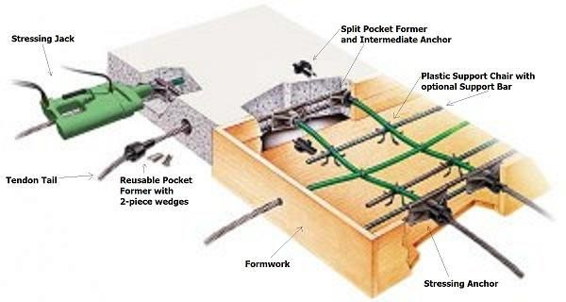
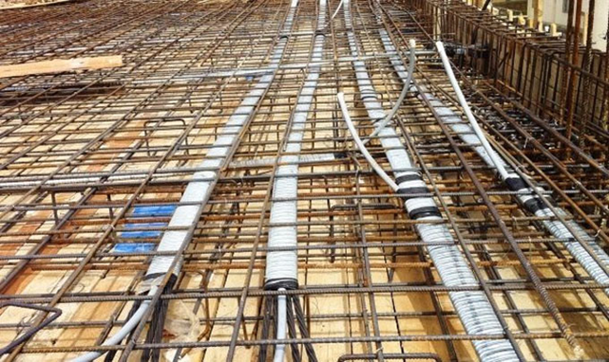
Fig- Typical Details of Post Tension Slab

COMPONENTS OF POST TENSIONING SLAB
- Ducts
Ducts are used in bonded and external post-tensioning to provide a void that permits the installation and stressing of strands after the concrete has been placed and hardened. Typically, ducts are filled with protective material after stressing to ensure that water and contaminants do not collect in the duct.
Standard Size : 50x20mm, 70x20mm, 90x20mm, other sizes can be custom-made
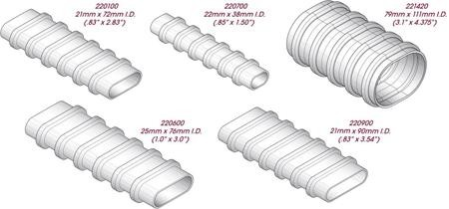
Fig- Duct Types
- Tendon:-
A tendon is a steel element such as a wire, cable, bar, rod, or strand used to impart prestress to concrete when the element is tensioned.
The basic element of a post-tensioning system is called a tendon. A post-tensioning tendon is made up of one or more pieces of prestressing steel, coated with a protective coating, and housed inside a duct or sheathing. A tendon has anchors on each end to transmit the forces into the structure.
Tendons in prestressed concrete are nothing but steel cable or wires. They provide strength to the prestressed concrete. You may witness these cables in the beam or a column. Depending on the tensile stresses, prestressed concrete can have one or a group of wires inserted in it.
Post tensioning tendons are usually made of strands 0.6'' (15.2mm) diameter. System is also available for 0.62'' (15.7mm) and 0.5'' (12.7mm).
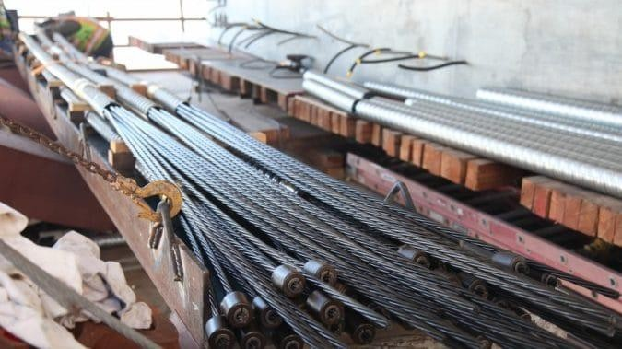
Fig- Tendons
- Anchors
An anchor is a steel element either cast into concrete or post-installed into a hardened concrete member and used to transmit loads to the concrete. Cast-in anchors include headed bolds, hooked bolts (J- or L-bolt), and headed studs.
The purpose of prestressing an anchor is to create an elastic tension in the free section of the steel anchor tendon with the aid of suitable stressing equipment; in this way, the tendon section exerts a predetermined force on the anchored structure.
- in prestressed concrete, to lock the stressed tendon in position so that it will retain its stressed condition;
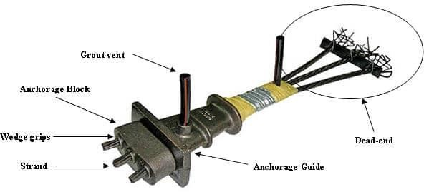
(2) in precast-concrete construction, to attach the precast units to the building frame; (3) in slabs-on-grade or walls, to fasten to rock or adjacent structures to prevent movement of the structure.

INTRODUCTION TO NANO-CONCRETE
Nano-concrete is a concrete produced by addition of Nano-additives of size less than 500nm in conventional mix of concrete. By addition of nano-additives properties of concrete get largely altered.
Since the beginning of the current century, “nanotechnology” is steadily emerging as a new industrial revolution. The significance and importance of controlling matter at the Nano-scale (10-9 m) have been realized from observing radically enhanced properties and new functionalities of traditional materials such as metals and ceramics through the application of Nano-science and nanotechnology. Hence for all practical purposes, “nanotechnology” has now been defined as capacity of working at nano level to succeed in achieving purposed structures of engineering with enhanced properties and characteristics of concrete.
- Nano-Additives:
In this research we are going to use Graphene and Nano silica as Nano additives. Previous studies show that addition of Graphene 0.03% and Nano silica 2.5% gives optimum results. Addition of Graphene and Nano silica improves the compressive strength as well as tensile strength of concrete. It also increases the young modulus of concrete. Nano concrete reduces transmission length in Prestress concrete. Effective Prestress value is more for conventional concrete. Combination of Graphene and Nano- silica improves the compressive strength as well as tensile strength of concrete significantly by 24 % and 34% respectively. New mix design concrete containing only Graphene as well as combination of Graphene and Nano-silica increases the young’s modulus of concrete The new mix design concrete (Graphene + nano silica) reduces the transmission length in Prestress concrete Effective Prestress value is more in The new mix design concrete (Graphene + Nano silica ) as compared to conventional concrete.
- Nano silica:
Laboratory experiments show that Nano silica particles can be obtained by sol-gel process from the hydrolysis of tetra ethoxy silane in ethanol using ammonia as catalyst.
There are several producers and suppliers of Nano silica in the market. It may be observed that the properties lie in a fairly narrow range and the particle size is generally lower than what is often synthesized in the laboratories. The availability of Nano silica additives in liquid suspension form facilitates their use in the mortar and concrete mixes but some studies have revealed that the problem of uniform dispersion of particles is not fully avoided and they are likely to form weak zones in concrete.
Further, the problem of workability due to reduced fluidity has been observed. Notwithstanding such observations, there have been some claims that the Nano silica addition did not adversely affect the paste microstructure.
Characteristics | Value
1. Density | 2.7
2. PH | 3.7:4.7
3. SiO2 Content | >99.8% by wt.

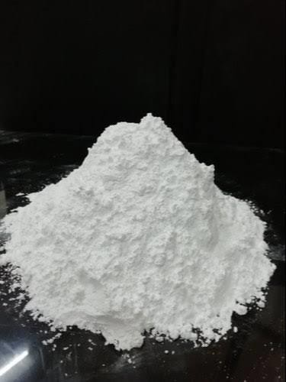
Table - Characteristics of Nano silica

Fig- Nano Silica
- Graphene:
Graphene has a very thinner layer of carbon; hence it has very high surface area, greater modulus of elasticity, higher thermal as well as electrical conductivity. Such characteristic of graphene makes graphene major nano-additives for the applications in the concrete structures.
Graphene had a single carbon layer which is organized in lattice in shape of hexagon Graphene is considered as primary material for allotropes of the carbon.
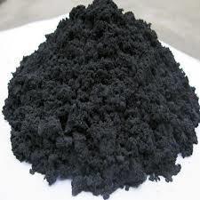
Figure - Graphene
Graphene Nano particles are the extraction of carbon, which improves the strength of concrete, but graphene material does not mix properly with concrete directly, before adding it to concrete have to dissolve with water with the help of SDL.
Characteristics | Value
Specific gravity | 1.90
Test | Test less
odor | Oder less
Color | Black

Table - Characteristics of Graphene

- THEORETICAL MODELING OF POST-TENSIONED NANO- CONCRETE SLAB
- Modelling:
For theoretical modeling of PT slab first solid model is developed for concrete and Nano-concrete material properties. Then support loading and boundary conditions were applied on PT slab as per IS code. Then results for deformation were obtained.
- Section:
The PT slab designed as per IS 1343. The size of the PT slabs is 1000mm x 1000mm x 200mm. Likewise two kinds of solid shape examples are ready. The grade of concrete and nano concrete is kept same; M45.
- Material Properties:
- Concrete:
For experiment we are going to use M45 grade concrete. Hence properties of M45 grade concrete are required to enter in model. Properties to be entered are shown in Table shows properties of concrete entered in PT slab modal.
Properties | Conventional PT Slab | Nano-concrete PT Slab
Young’s Modulus of  Elasticity | 33541.01 MPa | 38681.39 MPa
Poisson’s Ratio | 0.18 | 0.17
Thermal Expansion  Coefficient | 1.2x10-5 | 1.2x10-5
Ultimate Compressive  Strength | 45 N/mm2 | 60.75 N/mm2
Ultimate Tensile Strength | 4.69 N/mm2 | 5.455 N/mm2

Table - Material Properties for Concrete and Nano-concrete

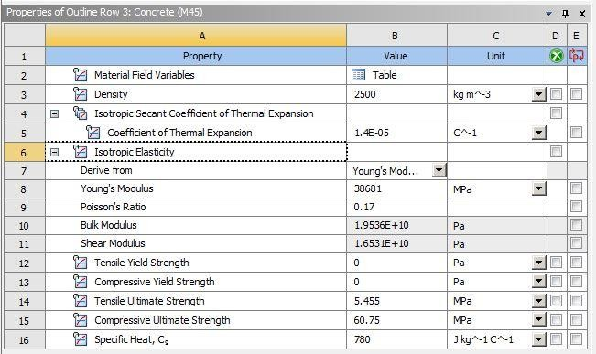

Figure - Nano-concrete Material Properties
- Prestressing Tendons:
Properties to be entered are shown in below Table, Above Figure shows various properties of tendons entered in validation model. Total prestress force applied in 188 kN. Total of 4 no Tendons provided which are 12.7 mm diameter each.
Properties | Value
Young’s Modulus of Elasticity Poisson’s  Ratio | 195000 MPa
Poisson’s Ratio | 0.3
Yield Tensile Strength | 1640 MPa
Ultimate Tensile Strength | 1860 MPa
Density | 78.5 kN/m3
Table : Material Properties for Prestressing Tendons

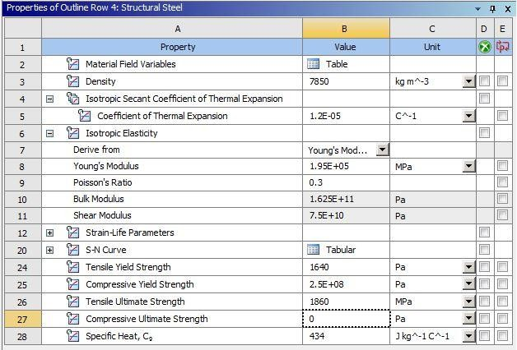

Figure : Prestressing Tendons Material Properties

- Post-Tensioned Slab Geometry:
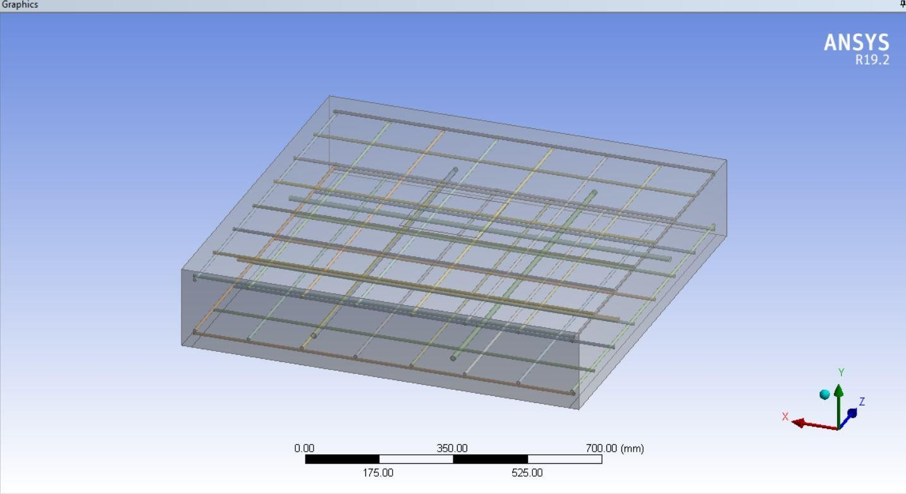
For modeling of PT slab first solid model of slab is developed in solid works software and then it is imported in ANSYS Workbench 19.2 to achieve better accuracy in geometry of PT slab 3-D model. Figure shows 3-D geometrical model of the slab obtained in the ANSYS Workbench 19.2.

Figure : 3-D Geometrical Model of PT slab
As per design the PT slab two-way slab is provided with total 4 no of tendons. Each tendon has 7 ply wires. Diameter of each wire is 12.7 mm.
- Meshing:\
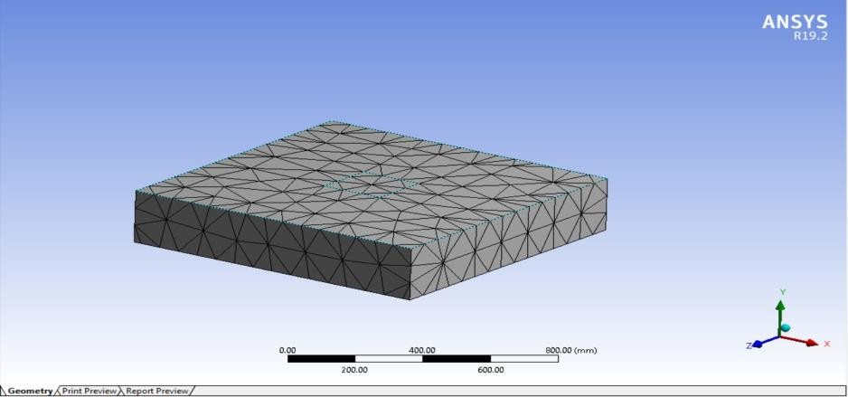
Body sizing, automatic method, sweep meshing and Edge sizing was used for meshing of 3D PT slab. Total node is 655454 and element is 156267. Figure 3.8.5 shows meshing generated on the concrete face. As PT slab has regular geometry uniform mesh is generated on face of concrete as shown in figure.
Figure : Concrete Face Meshing
- Loading Conditions & Support Conditions:
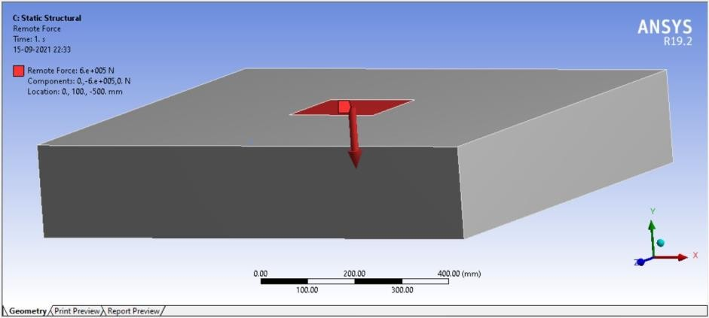
The support conditions were provided for nano-concrete PT slab and for conventional PT slab are same as experimental investigations, simple supports. Single point load is applied for the area of about 100mm x100mm over the top portion of the slab.

Figure : Support & loading condition
The load values are applied at a range of 0KN to 400KN and deflections were calculated at an interval of 25KN; and investigation was passed out. The pictorial representation of consequences is publicized in below figures.
- METHOD OF TEST :
EXPERIMENTAL STUDY
- Material Properties:
- Properties of cement:
OPC 53 cement is used for casting of cubes as well as slab. Cement used was confirmed to IS-12269. It does not contain any lumps. Following table shows the properties of the cement.
Characteristics | Value | Requirements as per IS:12269
1. Specific Gravity | 3.14 | -
2. Consistency | 30% | Not Specified
3. Initial Setting Time | 130 minutes | More than 30 minutes
4. Final Setting Time | 270 minutes | Less than 600 minutes

Table : Properties of Cement
- Properties Coarse Aggregate:
Coarse aggregate gives strength to the concrete. They are produced by crushing and disintegration of the parent rocks. For casting of slab and casting of cubes coarse aggregates of nominal size of 10mm and 20mm is used. Before casting coarse aggregate were tested as per IS 383.
Characteristics | Value
Specific gravity | 2.76

Table : Coarse aggregate properties
- Properties fine aggregate:
Crushed sand obtained is used as fine aggregate. Crushed sand passing 4.75 mm is used as fine aggregate.
Characteristics | Value
Type | Crushed
Specific gravity | 2.65
Maximum size | 4.75

Table : Fine Aggregate Properties.
- Properties Super Plasticizer:
Commercially available Super plasticizer Fosrock, based on Sulphonated naphthalene polymers is used for casting. Fosrock is a water reducing admixture. Which increase workability of concrete by reducing water content by 30 %
Characteristics | Value
Specific gravity | 1.20
Dosage | 0.7-1.2% of cement (1.2% is taken)

Table : Super plasticizer properties
- Quality of Water:
Water used for casting is required to be fresh, clear, clean, and it is free from oils, alkalis, acids. For casting purpose local available water is used.

- Concrete Mix Design (M45):
The method of selection of appropriate ingredients of the concrete and calculating their absolute quantities for required strength of the concrete with the objective that cost should be low is called as concrete mix design. For the experimental study mix design used is based on the Indian Standard 10262-2019. For casting of Cubes and casting of sleepers M45 grade concrete is required.
Ingredients | Conventional mix  (M45 grade) | Mix Containing Nano silica & Graphene
Cement (^{𝑘𝑔})  𝑚3 | 415 | 415
Fine Aggregate (^{𝑘𝑔})  𝑚3 | 643 | 643
Coarse Aggregate (^{𝑘𝑔}))  𝑚3 | 1225 | 1225
Super plasticizer (^{𝑘𝑔}))  𝑚3 | 4.98 | 4.98
w/c ratio | 0.37 | 0.37
Graphene (0.03% of cement) (^{𝑘𝑔})  𝑚3 | - | 0.12
Nano silica (2.5% of cement) (^{𝑘𝑔})  𝑚3 | - | 10.37
Water (^{𝑘𝑔})  𝑚3 | 154 | 154

Table : Mix Design for Conventional concrete and Nano Concrete

- CUBE TEST
Cube test not only determine strength of concrete at compression but also checks whether design is correct or not.
- Casting of Cubes:
For Compressive Strength ;
In this dissertation cubical mold of 15cm as length, width and height is used to cast the cubes. 3 cubes of conventional mix and 3 cubes of nonconcrete mix is casted. Design mix of concrete is first poured in molds and kept for 24 hours. After exactly 24 hours cubes are removed from molds and kept in water for curing of 28 days. During casting
cubes it should be ensured that top surface is smooth as well as even. If top surface is not smooth or even then use cement paste to make it even and smooth.
Figure below shows casting of cubes at site. Figure below shows filling of the moulds using concrete. After filing the concrete compaction is required to fill the voids and removing the gaps in concrete. The compaction is done by using vibration method.
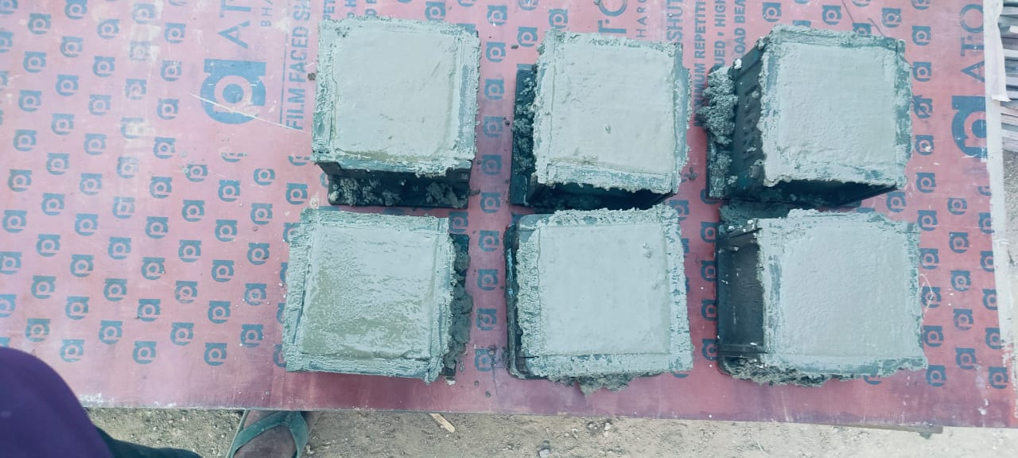
Figure : Cubical Moulds filled with Concrete
- For Shear Strength ;
In this dissertation cubical mold of 150 mm*150 mm* 150 mm as length, width and height is used but this mold insert the wooden block at any one corner and this wooden block sizes of 60 mm*60 mm*150 mm, length, width, height respectively to cast the cubes. 3 cubes of conventional mix and 3 cubes of nano-concrete mix is casted. Design mix of concrete is first poured in molds and kept for 24 hours. After exactly 24 hours cubes are removed from molds and kept in water for curing of 28 days.
During casting cubes it should be ensured that top surface is smooth as well as even. If top surface is not smooth or even then use cement paste to make it even and smooth.
Figure below shows casting of cubes at site. Figure below shows filling of the moulds using concrete. After filing the concrete compaction is required to fill the voids and removing the gaps in concrete. The compaction is done by using vibration method. The figure below shows photo taken during compaction of the cubes.

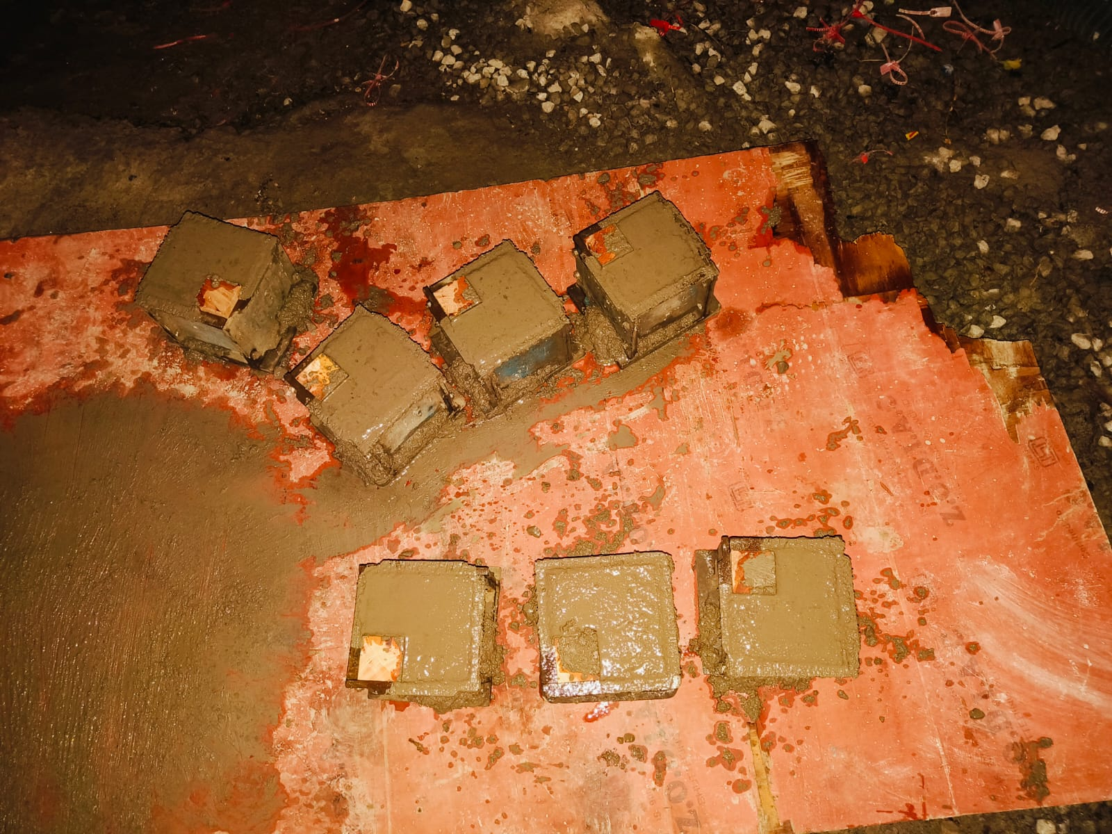
Figure : Cubical Moulds filled with Concrete
Curing of cubes
Water used for curing is required to be fresh, clear, clean, and it is free from oils, alkalis, acids. For casting purpose local available water is used. The temperature of water used for curing should be tested at every 7 day. Temperature of water should not be less than 25⁰C and should not be higher than 29⁰C. Figure below shows water curing of the concrete.

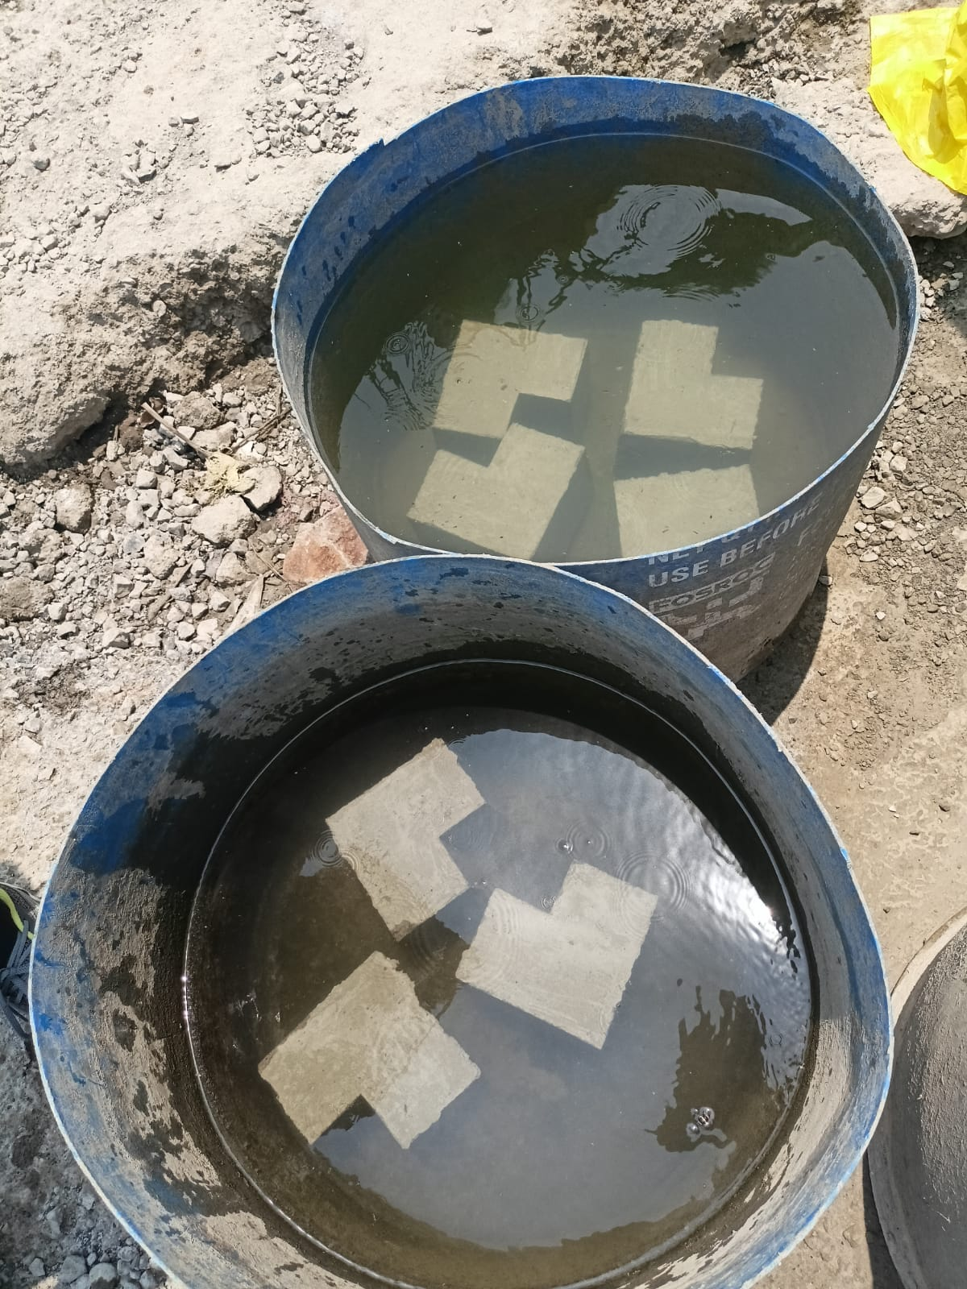
Figure : Curing of Cubes
Testing of Cubes
After 28 days of casting, cubes are removed from water and made the surface of cubes dry. Surface dried cubes are tested by using compression testing machine. In CTM load applied at speed of 1.35 kN/cm². Figure 3.24 shows diagram of the CTM.
Compressive strength and Shear Strength calculated by dividing failure load by surface area of specimen.
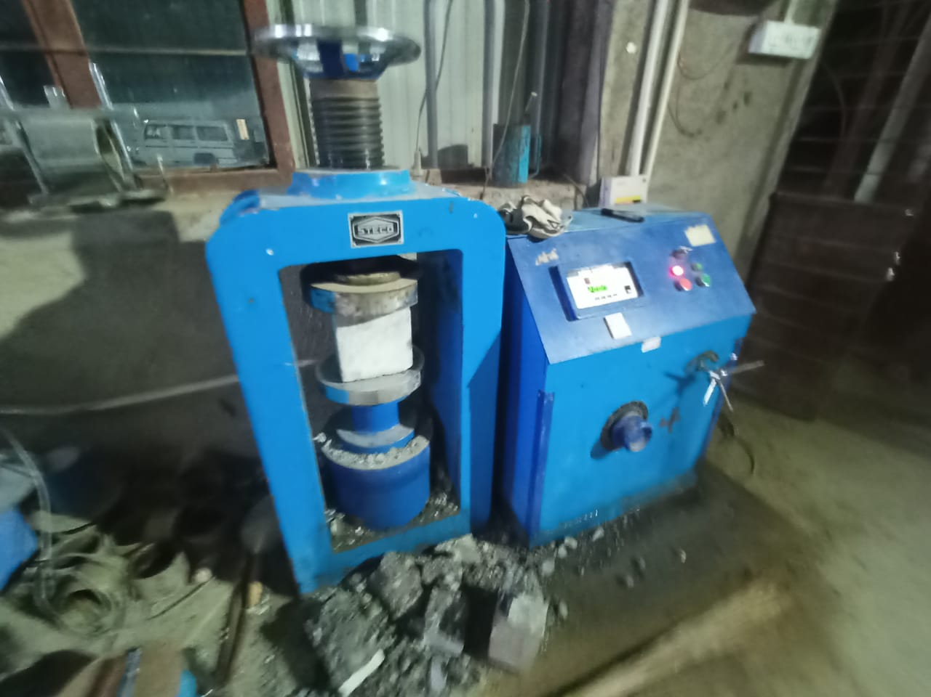
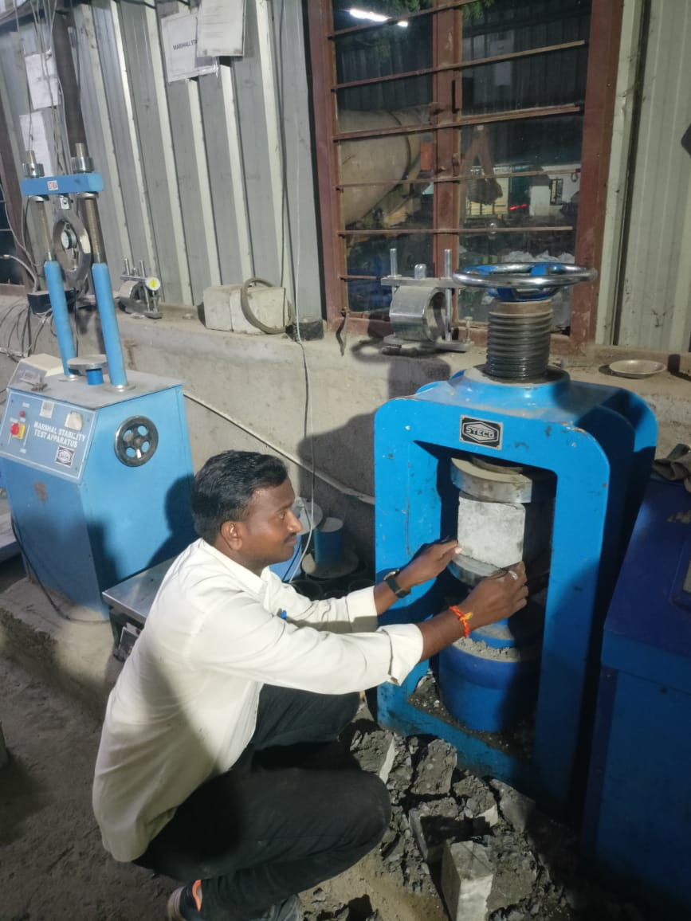
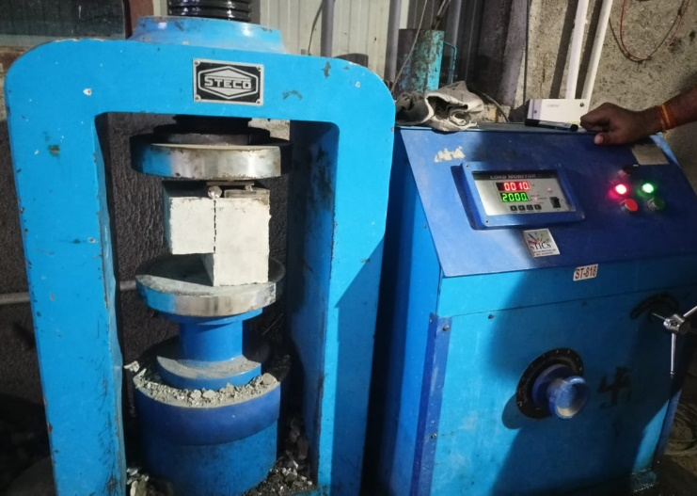
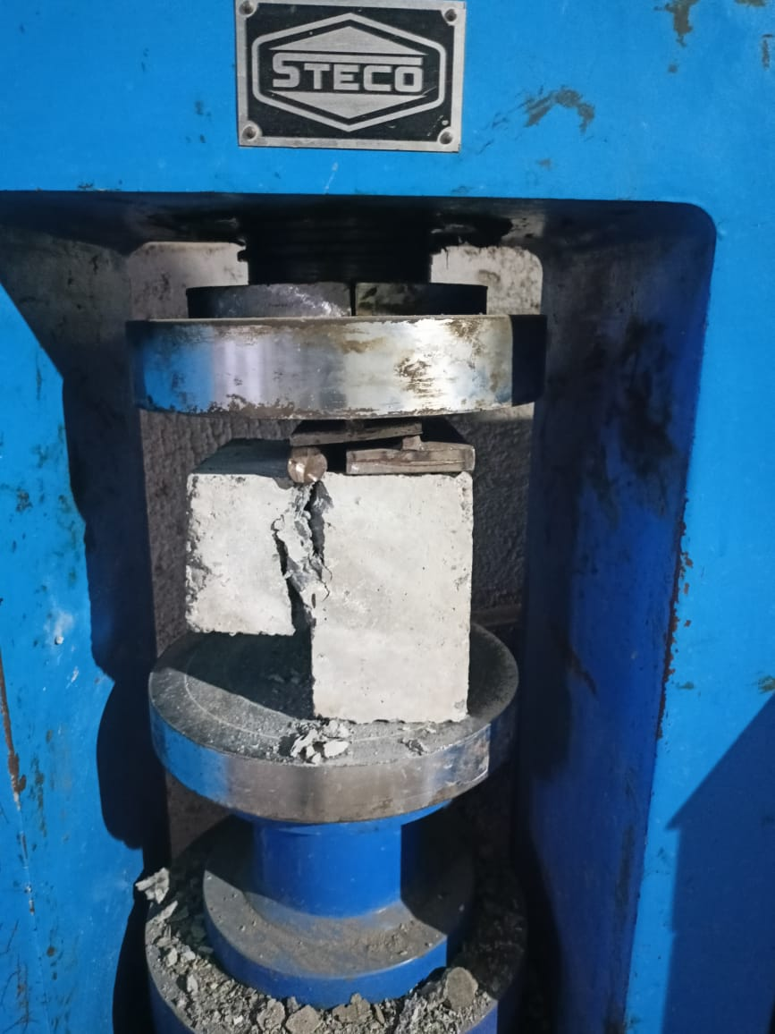

Figure : Testing of Cubes

- MANUFACTURING OF SLAB SPECIMEN
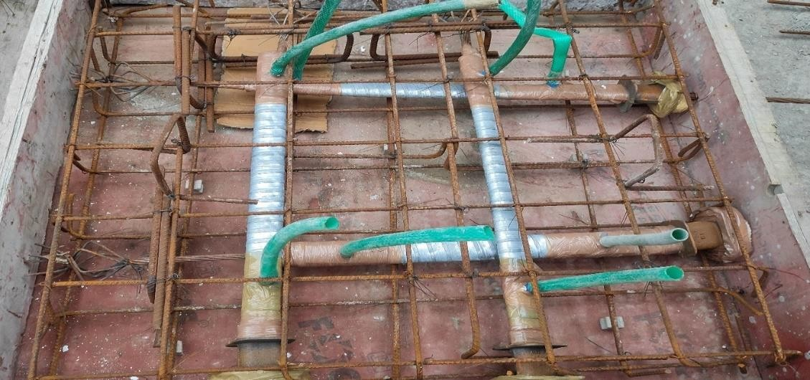
Test examples were planned of two sorts of slabs, one of the kind were a PT ordinary concrete reinforced substantial section and different PT slab with nano concrete. The size of the two slabs is 1000mm x 1000mm x 200mm. The test arrangement was created to assess the static conduct of both the sections. Likewise two kinds of solid shape examples are ready. The grade of concrete and nano concrete is kept same; M45.

Figure : Reinforcement for PT slab
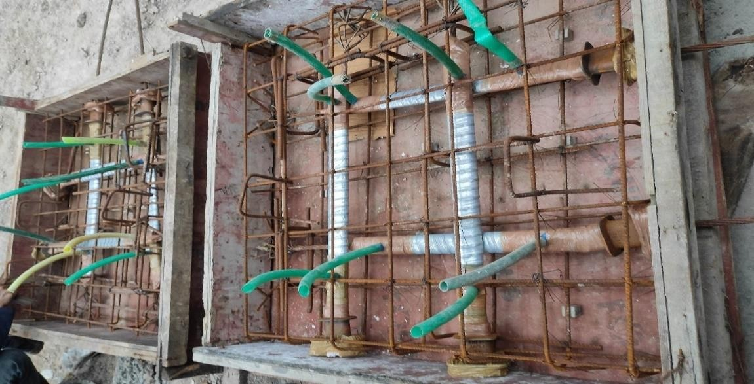
The installation of post-tensioning tendons in the concrete and stressing it requires skilled labour and a personnel who are certified in doing the tensioning works. With the help of skilled labour completed formwork as per design and tendons are laid down along with the conventional rebars. The position of laying of the tendons is decided by the design. These tendons are encased in steel ducts so that they do not come in contact with the water in concrete. Fixing the block out to casting and wrapping it with OPP tape. After that marking of tendon in both live and dead end.

Figure : Prepared formwork for conventional slab
Normally regular cement is utilized for the projecting of conventional PT slab in any case, here nano substantial material is utilized by utilizing nano-graphene and nano- silica material. Physically compacted cement of M45 grade is utilized for ordinary section and M45 grade of nano-concrete is utilized for nano-concrete section. Graphene is needed to blend in water with the assistance of SDL. Graphene and nano silica were taken as 0.03% and 2.5% of concrete substance separately. High RPM blender was utilized for blending of graphene with water at the hour of projecting.
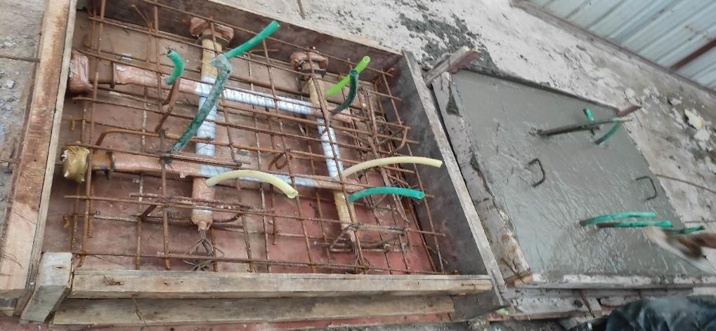
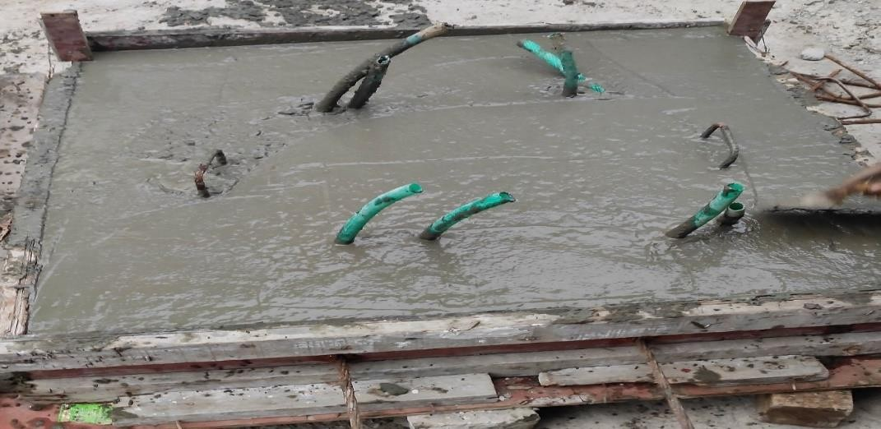
Figure : Prepared conventional concrete PT slab

Figure : Prepared Nano-concrete concrete PT slab
Procedure For Slab Test
The slab was merely supported at different sides. Specimens were tested in test frame by applying single point load over the top bit of section. Freight is smeared with the assistance of pressure driven knave with the limit of most extreme stacking 500KN. At center, dial gauge is kept for deformation measurement of deflected slab specimen.

- RESULTS
- Results of Static Stress Analysis:
Theoretical modeling of PT slab developed by using ANSYS Workbench 19.2 gives total deformation of PT slab as shown in figure 8.1 and 8.2 for static load of 400 KN on slab. From figure we can see that total deformation for conventional PT slab is 5.47 mm and for Nano-concrete PT slab is 4.52. So we can conclude that by using Nano- concrete deformation of PT slab get decreased. Figures also shows max deformation is at center.
Following Table 4.1 shows results for load v/s total deformation at center of PT slab. From this table load V/s deformation graph is plotted. From the results we can see that post-tensioned nano-concrete slab has 17% less deformation than conventional concrete post-tensioned slab i.e., by using Nano-concrete total deformation is reduced by 17%.
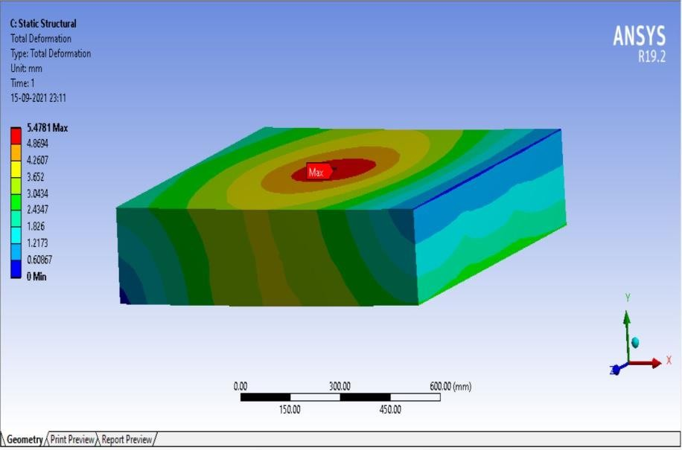
Figure : Total Deformation in Conventional Concrete PT slab
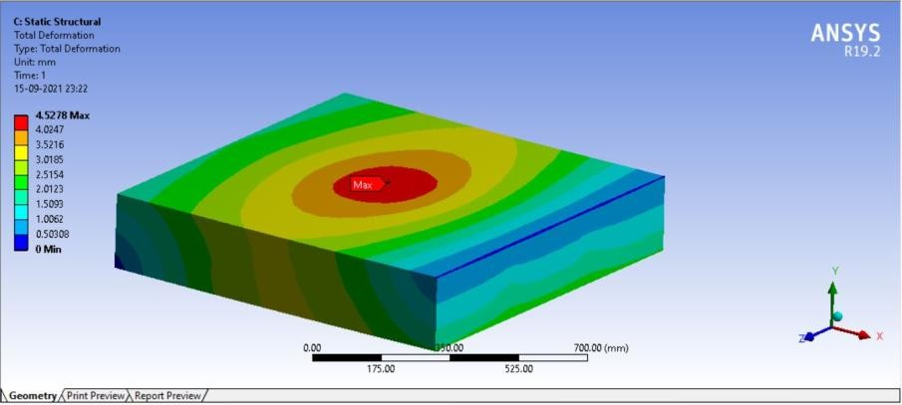
Figure : Total Deformation in Nano-concrete PT slab

Table : Results of Theoretical Modeling
Load (KN) | Total Deformation (mm)
Load (KN) | Conventional PT Slab | Nano-concrete PT Slab
0 | 0 | 0
50 | 0.68476 | 0.5659
100 | 1.3695 | 1.1319
150 | 2.0546 | 1.6979
200 | 2.7390 | 2.2639
250 | 3.4238 | 2.8298
300 | 4.1085 | 3.3958
350 | 4.7933 | 3.9618
400 | 5.4781 | 4.5278

450

400

350

300

250

200

150

100

50

0
0
1
2
3
Deflection(mm)
4
5
6
Conventional PT Slab
Nano-concrete PT Slab

Figure : Load v/s Deflection Graph of Theoretical Model
Load(KN)

Table : Results of Experimental Modeling
Load (KN) | Total Deformation (mm)
 | Conventional PT Slab | Nano-concrete PT Slab
0 | 0 | 0
50 | 0.5 | 0.40
100 | 1.20 | 0.80
150 | 1.60 | 1.10
200 | 1.95 | 1.60
250 | 2.40 | 2.10
300 | 3.15 | 2.75
310 | 3.80 | 3.15
350 | - | 3.70
375 | - | 3.90

400

350

300

250

200

150

100

50

0
0
0.5
1
1.5
2
2.5
3
3.5
4
4.5
Deflection(mm)
Nano-concrete PT Slab
Conventional PT Slab

Figure : Load v/s Deflection Graph of Experimental Model

Results of Cube Test:
- Compressive Strength
gives results of cube test carried out using CTM after 28 days. From results we can conclude that using graphene and Nano-silica in optimum percentage compressive strength of concrete increased by 24.76 %.
Table : Compressive strength of conventional concrete cubes
Specimen | Weight  ( gms ) | Density  (gm/cc) | Failure Load (kN) | Area  (𝒎𝒎^{𝟐})  (150*150) | Compressive Strength @ 28 days  (𝑵⁄𝒎𝒎^{𝟐}) | Average Strength (𝑵⁄𝒎𝒎^{𝟐})
1. | 8760 | 2.59 | 1085 | 22500 | 48.25 | 48.21
2. | 8810 | 2.61 | 1111 | 22500 | 49.38 | 48.21
3. | 8720 | 2.58 | 1057 | 22500 | 47.01 | 48.21

Table : Compressive strength of nano-concrete cubes
Specimen | Weight  ( gms ) | Density  (gm/cc) | Failure Load (kN) | Area  (𝒎𝒎^{𝟐})  (150*150) | Compressive Strength @ 28 days  (𝑵⁄𝒎𝒎^{𝟐}) | Average Strength (𝑵⁄𝒎𝒎^{𝟐})
1. | 8870 | 2.62 | 1348 | 22500 | 59.93 | 60.16
2. | 8805 | 2.60 | 1413 | 22500 | 62.8 | 60.16
3. | 8762 | 2.58 | 1299 | 22500 | 57.77 | 60.16

Table : Change in compressive strength
Specimen | Compressive Strength @ 28 days  (𝑵⁄𝒎𝒎^{𝟐}) |  | % Increase | Average Strength  % Increase
Specimen | Conventional  concrete | Nano-concrete | % Increase | Average Strength  % Increase
1. | 48.25 | 59.93 | 24.21 | 24.76
2. | 49.38 | 62.80 | 27.18 | 24.76
3. | 47.01 | 57.77 | 22.88 | 24.76

- Shear Strength :-
gives results of cube test carried out using CTM after 28 days. From results we can conclude that using graphene and Nano-silica in optimum percentage Shear strength of concrete increased by 26.47.

Table : Shear strength of conventional concrete cubes
Specimen | Weight  ( gms ) | Density  (gm/cc) | Failure Shear Load (KN) | Area  (𝒎𝒎^{𝟐})  (150*90) | Shear Strength @ 28 days  (𝑵⁄𝒎𝒎^{𝟐}) | Average Shear Strength (𝑵⁄𝒎𝒎^{𝟐})
1. | 7300 | 2.85 | 75 | 13500 | 5.56 | 5.31
2. | 7435 | 2.89 | 68 | 13500 | 5.04 | 5.31
3. | 7380 | 2.87 | 72 | 13500 | 5.33 | 5.31

Table : Shear strength of nano-concrete cubes
Specimen | Weight  ( gms ) | Density  (gm/cc) | Failure Shear Load (KN) | Area  (𝒎𝒎^{𝟐})  (150*90) | Shear Strength @ 28 days  (𝑵⁄𝒎𝒎^{𝟐}) | Average Shear Strength (𝑵⁄𝒎𝒎^{𝟐})
1. | 7290 | 2.84 | 94 | 13500 | 6.96 | 6.71
2. | 7403 | 2.88 | 87 | 13500 | 6.44 | 6.71
3. | 7330 | 2.85 | 91 | 13500 | 6.74 | 6.71

Table : Changes in Shear strength
Specimen | Shear Strength @ 28 days  (𝑵⁄𝒎𝒎^{𝟐}) |  | % Increase | Average Shear  Strength  % Increase
Specimen | Conventional  concrete | Nano-concrete | % Increase | Average Shear  Strength  % Increase
1. | 5.56 | 6.96 | 25.18 | 26.47
2. | 5.04 | 6.44 | 27.78 | 26.47
3. | 5.33 | 6.74 | 26.45 | 26.47

- CONCLUSION
Conclusion
In this research new attempt of use of Nano-concrete for the PT slab is made. Finite element analysis and experimental testing were performed to determine the probability of use of Nano-concrete for the PT slab as material. From the results come from the testing and analysis following conclusions were made.
Compression test results show that the compressive strength of concrete is increased by around 24.76 % when graphene and nano silica is added to it.
Shear Strenght test results show that the shear strength of concrete is increased by around 26.47 % when graphene and nano silica is added to it.
Finite Element modal results show that the deflection in nano-concrete is decreased by around 17% for same load in analytical study
The load carrying capacity of post-tensioned nano-concrete slab is increased by 25 % with almost same deflection as that of post-tensioned conventional concrete slab.

Future Scope
In present dissertation work an effort is made for knowledge, analyze, and design the novel Post-tensioned Nano-concrete Slab by experimental as well as finite element analysis study. This experimental as well as analytical program solely designed to determine the properties of novel Post-tensioned Nano-concrete Slab for static load conditions as per IS standard specifications. In addition, the comparison is to be done of performance of conventional concrete PT slab and Post-tensioned Nano concrete slab with more precision by the help of Indian Standards code.

- REFERENCES
- Muthulingam.M., and Suganya Devi.,(2020), “Analytical Study of Fiber Reinforced Post Tensioned Slab.” International Journal of Engineering Research & Technology (IJERT),Vol.9.
- Soubhagya Ranjan Rath., Susanta Kumar Sethy., and Mukesh Kumar Dubey.,(2019), “Review Paper on Post-Tensioned Flat Slab with Drop Panels and Its Comparison with Conventional Slab.” International Journal of Research in Advent Technology, Vol.7, No.4.
- Abbas H. Mohammed., Khattab S. Abdul-Razzaq., Taha K. Mohammedali., Dia Eddin Nassani b., Ali K. Hussein.,(2018), “Finite Element Modeling of Post- Tensioned Two-Way Concrete Slabs under Flexural Loading.” Civil Engineering Journal.
- Arvind Jayalakshmi Satyanarayanan., Helen Santhi Mariadhas., and Prabu Dhanapalan., (2018), “Safety and Economy in the Design of Reinforced and Post- tensioned Slab Systems Using IS, BS, and ACI Standards.”
- K Bednarz.,(2018), “Analysis of the effectiveness of various cross-sections in large-span post-tensioned ceilings.” IOP Conf. Series: Materials Science and Engineering 324 (2018) 012045 doi:10.1088/1757-899X/324/1/012045
- Jnanesh Reddy R K., and Pradeep A R.,(2017), “Comparative Study of Post Tensioned and RCC Flat Slab in Multi-Storey Commercial Building.” International Research Journal of Engineering and Technology (IRJET), Volume: 04 Issue: 06 | June -2017.
- Rafal Szydlowski., and Barbara Labuzek., (2017) “Post-Tensioned Concrete Long-Span Slabs in Projects of Modern Building Construction.” IOP Conf. Series: Materials Science and Engineering 245 (2017) 022065 doi:10.1088/1757- 899X/245/2/022065.
- M. Sarkisian, P.E., E. Long,; A. Beghini,; R. Garai,; D. Shook, P.E., M.ASCE5 ;
  - Diaz,; and R. Henoch, 2017), “New Methods in Efficient PostTensioned Slab Design Using Topology Optimization.”
- Shriraj S. Malvade., and P.J. Salunke., (2017), “Analysis of Post-Tensioned Flat Slab by using SAFE.”, International Journal of Scientific Engineering and Applied Science (IJSEAS) – Volume-3, Issue-3.
- Min Sook Kim and Young Hak Lee., (2016), “Flexural Behavior of Posttensioned Flat Plates Depending on Tendon Layout.” Advances in Materials Science and Engineering, Volume 2016, Article ID 2651435, 11 pages http://dx.doi.org/10.1155/2016/2651435.
- Shriraj S. Malvade., (2016), “A Review on Seismic Assessment of PostTensioned Flat Slab.” IJSTE - International Journal of Science Technology & Engineering | Volume 2 | Issue 12.
- Pinho Ramos., Válter J.G. Lúcio., and Duarte M.V. Faria., (2014), “The effect of the vertical component of prestress forces on the punching strength of flat slabs.”, Navyashree K., and Sahana T.S.,(2014), ” International Journal of Research in Engineering and Technology, Volume: 03 Issue: 08.
- Boskey Vishal Bahoria., and Dhananjay K. Parbat., (2013), “Analysis and Design of RCC and Post-tensioned Flat Slabs Considering Seismic Effect.” IACSIT International Journal of Engineering and Technology, Vol. 5, No. 1, February 2013.
- Vakas K. Rahman., and Prof. A. R. Mundhada., (2013), “Comparative Study of RCC and Prestressed Concrete Flat Slabs.” International Journal of Modern Engineering Research (IJMER) ,Vol. 3, Issue. 3, May.-June.
- Andrea E. Shear., James P. Donnelly., and Matthew E. Lewis., (2011), “Tendon Failure Investigation and Drying in a Two-Way Unbonded PostTensioned Roof Slab.” Structures Congress 2011 ASCE 2011, Page no 1759 to 1770.
- R. P. Apostolska., G. S. Necevska-Cvetanovska., J. P.Cvetanovska., and N. Mircic., (2008), “SEISMIC PERFORMANCE OF FLAT-SLAB BUILDING STRUCTURAL SYSTEMS.” The 14 th World Conference on Earthquake Engineering October 12-17, 2008, Beijing, China.
- U. Prawatwong., C.H. Tandian., and P. Warnitchai., (2008), “SEISMIC PERFORMANCE OF POST–TENSIONED INTERIOR SLAB-COLUMN CONNECTIONS WITH AND WITHOUT DROP PANEL.” The 14 th World Conference on Earthquake Engineering October 12-17, 2008, Beijing, China.
- Stephen L. Kajewski., (2005), “Multilevel Formwork Load Distribution with Posttensioned Slabs.” JOURNAL OF CONSTRUCTION ENGINEERING AND MANAGEMENT © ASCE / FEBRUARY 2005 / 203.
- Virote Boonyapinyo., Pennung Warnitchai., and Nuttawut Intaboot., (2004), “Seismic capacity evaluation of post-tensioned concrete slab-column frame buildings by pushover analysis.” Songklanakarin J. Sci. Technol. Vol.28 No.5 Sep. - Oct. 2006.
- Paul N. Roschke., and Masamichi Inoue., (1991), “EFFECTS OF BANDED POST-TENSIONING IN PRESTRESSED CONCRETE FLAT SLAB.” J. Struct. Eng. 1991.117:563-583., Page no 563 to 583.
- Mohan Raj.B1., and Sugila Devi.G., (2019), “EXPERIMENTAL INVESTIGATION ON NANO CONCRETE WITH NANO SILICA AND M-SAND.” International Research Journal of Engineering and Technology (IRJET) Volume: 06 Issue: 03 | Mar 2019.
- Mani. M., and Dr. G. Nandini Devi., (2017), “STUDY ON BEHAVIOUR OF NANO CONCRETE.” International Journal of Emerging Trends & Technology in Computer Science (IJETTCS) Volume 6, Issue 5, September- October 2017.
- Abdullah Keyvani., (2007), “Huge opportunities for industry of nanofibrous concrete technology.” IJNN,Vol.3, No.1, December 200

