Smart Traffic Automation using Spike Speed Brakers

**Anurag Patil1, Akash Kute2, Payal Yadav3, Avinash Mhaske4**

*1234 Dept. of Electronics & Telecommunication, Shreeyash Pratishtan’s Shreeyash College of Engg. & Technology, Chh. Sambhaji Nagar, Maharashtra, India*

**Abstract –** *The Smart Traffic Automation project introduces a groundbreaking strategy to tackle the challenges faced by modern traffic management systems. Driven by the increasing problems of traffic congestion and safety concerns, this project integrates spike speed breakers with traffic signals. The objectives are to optimize traffic flow, enhance safety, and alleviate congestion through an innovative decision-making framework. Utilizing cutting-edge sensors and control systems, the methodology focuses on creating a responsive and efficient smart traffic automation system. Key features include real-time adjustment to traffic signal conditions and an emergency shutdown mechanism. The project's significance lies in its potential to transform urban traffic management, providing a scalable and adaptable solution. The findings offer valuable insights into the effectiveness of spike speed breakers in enhancing overall traffic control.*

*Keywords: Smart Traffic Automation, Spike Speed Breakers, Traffic Management, Decision making System, Safety, Congestion Reduction.*

# INTRODUCTION

Speed breakers, also referred to as speed bumps, are elevated sections of the roadway designed to reduce vehicle speed as they traverse over them. They are commonly deployed to deter speeding in areas like residential neighborhoods or near schools, where pedestrians and other vulnerable road users are present. Regular encounters with speed breakers can have psychological impacts on individuals, negatively affecting their work, education, and personal life. Frequent traffic congestion results in wasted fuel and time, leading to increased stress and frustration due to delays in professional activities. The continuous honking of horns contributes to noise pollution. To address these issues, we have developed a study on the Smart Traffic Management System, which uses centrally-controlled traffic signals and sensors to regulate traffic flow across the area. For monitoring purposes, CCTV cameras are installed to observe vehicle movement on the road. With the aid of CCTV cameras, image processing is effectively carried out, providing detailed information about the number of vehicles on the road. [1]

# OBJECTIVES

* The main purpose of the spike speed brakers is, controlling the flow of Traffic and preventing accidents.
* The main objective of spike speed brakers is to manage and reduce excessive speeding in designated road areas.
* To prevent unnecessary accidents and protect our citizens.
* Work zone barriers are utilized to shield traffic from hazards.
* To reduce the time consumption.
* To reduce human load.

1. **LITERATURE SURVEY**

A thorough literature review was conducted on advanced traffic management systems, focusing on control methodologies such as SCAT and SCOT, the integration of Raspberry Pi technology, and the application of micro-simulation software like TRANSYT and VISSIM. In Cambridge Kingdom Town, the implementation of a sophisticated smart traffic management system revolves around three core components: traffic lights, queue detectors, and a centralized control system [5]. These detectors continuously gather real-time traffic flow data, which is meticulously analyzed using a comprehensive model to determine optimal adjustments to traffic signal timings.

The system employs Arrival Flow Management strategies, where traffic lights positioned at key intersections on major arterials and radial roads serve as pivotal management points. Developed through extensive research and refinement, this advanced software solution has been successfully deployed across various European cities, including Cambridge, with a primary focus on enhancing the efficiency of bus transit networks [6]. Traditionally, traffic management relied heavily on fixed-time and vehicle-actuated signal systems. However, modern approaches now emphasize adaptive traffic signal controllers utilizing a variety of algorithms designed to minimize traffic delays and optimize flow dynamics.

The integration of TRANSYT software facilitates the optimization of fixed-time signal configurations, while VISSIM micro-simulation software validates and refines these models, thereby supporting the development of adaptive signal control frameworks. Microsimulation studies consistently demonstrate that adaptive signal management significantly reduces delays compared to traditional fixed-time systems, underscoring its effectiveness in dynamically responding to varying traffic conditions [7]. This approach addresses critical deficiencies in outdated traffic management systems, which often result in inefficiencies and delays due to static signal schedules that do not adjust in real-time to traffic fluctuations.

The proposed smart traffic system ensures responsive adjustments of traffic light timings based on current traffic density and conditions, leveraging advanced sensors and image processing technologies integrated via Raspberry Pi platforms. Collected data is seamlessly transmitted to cloud-based servers for continuous monitoring of traffic patterns and predictive analysis of future traffic densities, ensuring operational continuity and resilience against localized system failures.

Moreover, Advanced Traffic Management Systems (ATMS) have emerged as pivotal solutions for mitigating urban traffic congestion. These systems integrate comprehensive traffic studies encompassing volume analysis, spot speed assessments, and qualitative roadside interviews to enhance intersection capacity and improve overall Level of Service (LOS) [8]. Beyond enhancing traffic safety and mobility, ATMS initiatives also drive systemic efficiencies and contribute to environmental sustainability efforts on urban highways and within smart city frameworks [9].

# EXISTING SYSTEM

This approach is entirely centered on making traffic lights fully adaptive through the use of a wireless sensor network [2]. According to this concept, traffic lights transition between red and green states based on traffic load, prioritizing traffic flow over fixed time intervals as shown in fig. 1.

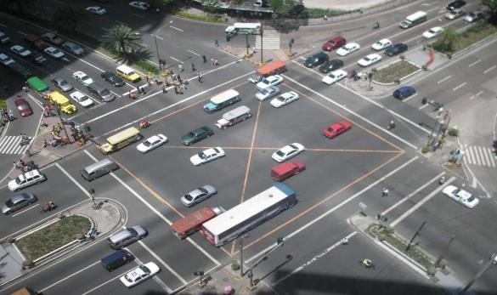

**Fig -1**: Traffic loaded intersection

This method does not give priority to vehicles at intersections, which can result in delays for emergency vehicles waiting for their turn to cross. As a result, rescue teams may be delayed in reaching their destinations, potentially leading to greater damage. Therefore, enhancements are necessary to introduce changes that prioritize the passage of emergency vehicles [3].

# WSITMN - Wireless Sensor and RFID Tag Integrated Traffic Monitoring Network

This approach does not prioritize vehicles at intersections, potentially causing delays for emergency vehicles that must wait for the intersection to clear. Consequently, rescue teams may be hindered in reaching their destinations promptly, which could lead to increased damage. Therefore, improvements are needed to implement changes that ensure the prioritization of emergency vehicles [3].The Government has approved a National Road Safety Policy is shown in figure 2.

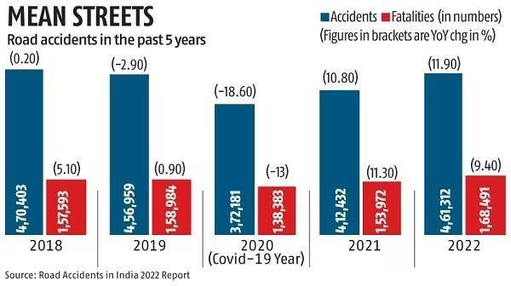

**Fig -2**: Road fatalities in India

This policy outlines several measures, including promoting awareness, establishing a road safety information database, encouraging the development of safer road infrastructure, implementing intelligent transport systems, and enforcing safety laws [5].

# PROPOSED SYSTEM

The microcontroller serves as the core component of the control system. The consequence block can be tailored according to specific needs, with the converter block obtaining its supply directly from the source via a filter circuit.

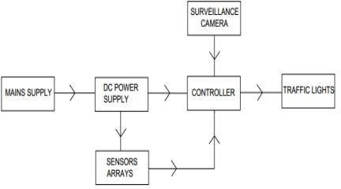

**Fig -3**: Block diagram

The transmitter generates an AC frequency, which is then applied to the antenna. When energized by this AC, the antenna emits radio waves. Besides broadcasting, transmitters are crucial components of many electronic devices that communicate via radio, including two-way radios in aircraft and spacecraft, cell phones, Wi-Fi and Bluetooth-enabled devices, ships, garage door openers, radar systems, and navigational beacons. The term "transmitter" is often used specifically to describe equipment used for broadcasting.

# Tyre Killer

The blocking segment will feature spikes positioned at a 60° angle and constructed from tempered steel. The spacing between the spikes, measured from their centers, should range from 100 mm to 200 mm, as illustrated in Figure 4 [6].

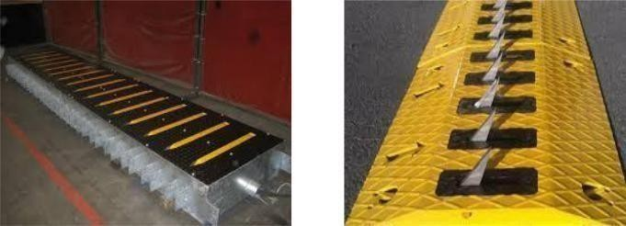

**Fig -4**: Tyre killer

# Speed Brakers

While speed breakers or bumps effectively reduce vehicle speeds, their use is sometimes controversial due to potential drawbacks. They can increase traffic noise, damage vehicles when driven over at high speeds, and slow down emergency vehicles [7]. Poorly designed speed bumps, especially those that are too high or have a steep angle (often found in private car parks [citation needed]), can be disruptive to drivers and challenging for vehicles with low ground clearance, even at low speeds. This motion is illustrated in Figure 5.

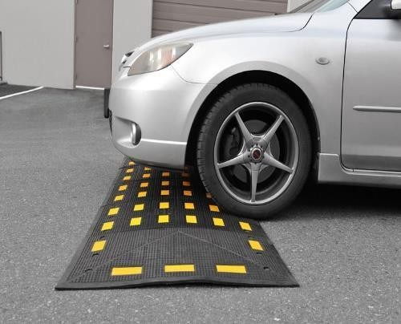

**Fig -5:** Speed Brakers

# APPLICATION

1. **Adaptive Speed Control:**

Spike speed breakers integrated into smart traffic systems dynamically control vehicle speeds based on real-time traffic conditions and signal changes. They serve as a physical deterrent to excessive speeding, reducing the need for traditional enforcement methods and minimizing accidents caused by high-speed vehicles. By adjusting the spike activation in real-time, the system ensures that vehicles slow down appropriately as traffic conditions change, improving overall road safety and efficiency.

1. **Emergency Vehicle Priority:** One of the critical applications of smart traffic automation is prioritizing emergency vehicles. The system can deactivate spike speed breakers when an emergency vehicle is detected approaching an intersection, allowing them to pass through unhindered. This prioritization ensures rapid response times for emergency services, reducing potential delays caused by conventional traffic management systems and enhancing public safety.
2. **Enhanced Traffic Flow Management:** Spike speed breakers can be integrated with adaptive traffic signal controllers to smooth out traffic flow at intersections and key points on the road network. By coordinating the activation of spikes with traffic light cycles and real-time traffic data, the system can reduce congestion, prevent bottlenecks, and enhance the throughput of vehicles, leading to more efficient use of road infrastructure.
3. **Pedestrian Safety Improvements:** In areas with high pedestrian activity, such as school zones and shopping districts, smart spike speed breakers can enhance safety by ensuring vehicles reduce speed near pedestrian crossings. The system can be programmed to activate spikes in response to pedestrian presence, detected through sensors or cameras, providing a physical and visual cue for drivers to slow down and yielding safer conditions for pedestrians.
4. **Integration with Smart City Initiatives:** As part of broader smart city initiatives, spike speed breakers can contribute to the overall smart infrastructure by integrating with other intelligent transportation systems (ITS). They can work in conjunction with smart traffic lights, automated enforcement systems, and connected vehicle technologies to create a cohesive network that enhances urban mobility, reduces emissions, and improves the quality of life for city residents.
5. **Data Collection and Analytics:** The deployment of smart spike speed breakers provides valuable data on vehicle speeds, traffic patterns, and driver behavior. This data can be analyzed to inform traffic planning and infrastructure development. Additionally, real-time analytics can be used to adjust traffic management strategies dynamically, ensuring that the system adapts to changing conditions and maintains optimal traffic flow.
6. **Reduction of Noise and Environmental Pollution:** By ensuring that vehicles maintain consistent speeds and avoid abrupt braking and acceleration, spike speed breakers help reduce traffic noise and lower emissions. This contributes to a quieter and cleaner environment, particularly in urban areas where traffic-related pollution is a significant concern.

# 7. ADVANTAGES

**1. Enhanced Traffic Safety:** Smart traffic automation with spike speed breakers improves road safety by reducing vehicle speeds, especially in high-risk areas like intersections, pedestrian crossings, and school zones. This system acts as a deterrent to speeding, leading to fewer accidents and lower severity of collisions. Studies have shown that lower vehicle speeds significantly decrease the likelihood and severity of crashes, particularly for vulnerable road users like pedestrians and cyclists.

**2. Prioritization of Emergency Vehicles:** One of the key benefits is the ability to prioritize emergency vehicles. The system deactivates spike speed breakers for approaching emergency vehicles, ensuring they pass through intersections without delay. This rapid clearance helps emergency responders reach their destinations faster, potentially saving lives and reducing property damage during critical situations.

**3. Improved Traffic Flow and Congestion Reduction:** Spike speed breakers integrated with adaptive traffic signals help manage traffic flow more efficiently. By dynamically adjusting the activation of spikes based on real-time traffic data, the system minimizes congestion and prevents bottlenecks. This leads to smoother traffic flow, reduced travel times, and increased road capacity. Studies indicate that adaptive traffic systems can reduce delays by up to 20-40% compared to fixed-time systems.

**4. Environmental Benefits:** Maintaining consistent vehicle speeds with smart spike speed breakers reduces fuel consumption and emissions. Vehicles that travel at steady speeds emit less CO2 and other pollutants compared to those frequently accelerating and decelerating. This contributes to a cleaner urban environment and supports efforts to reduce the carbon footprint of transportation.

8. **DISADVANTAGES**

**1. Potential for Increased Maintenance Costs:** The installation of spike speed breakers introduces additional maintenance requirements compared to traditional traffic control measures. The spikes and associated electronic control systems can be subject to wear and tear, requiring regular inspections, repairs, and replacements to ensure proper functioning. Over time, this can lead to increased operational and maintenance expenses.

**2. Impact on Emergency Vehicles:** Although systems are designed to deactivate spike speed breakers for emergency vehicles, any malfunction or delay in response could potentially hinder the passage of these vehicles. In cases where the system fails to deactivate spikes promptly, emergency responders could face delays, impacting their ability to reach incidents quickly and efficiently.

**3. Discomfort and Potential Damage to Vehicles:** Even with smart control, spike speed breakers can cause discomfort to vehicle occupants and potential damage to vehicles, especially if spikes are not deactivated in time or if drivers are unaware of their presence. Vehicles with low ground clearance or softer suspension systems might experience more significant impacts when traversing spike speed breakers, leading to possible damage.

**4. High Initial Implementation Costs:** The installation of smart spike speed breakers involves substantial initial costs, including hardware (spikes, sensors, control units), software (traffic management algorithms), and infrastructure modifications. For many municipalities, especially those with limited budgets, these high upfront expenses can be a significant barrier to adoption.

# 9. COMPARISON ANALYSIS

**9.1 POWER SUPPLY**

**Previous System**: Utilized a general 9V power supply without specific regulation details, which might lead to instability or inefficiency. Potential safety hazards due to unregulated power supply, such as overheating or short circuits.

**Proposed System:** Includes a converter block that transforms AC to regulated DC, ensuring a stable and efficient power supply.

Enhanced safety features with regulated DC output, reducing the risk of overheating, short circuits, and electrical failures.

# 9.2 SENSOR TYPE

**Previous System:** Possibly used only for basic motion detection, with limited functionality in low visibility conditions [8].

**Proposed System:** Employs advanced infrared sensors to detect vehicles even in low visibility conditions (e.g., at night or in adverse weather), enhancing overall system reliability.

# 9.3 OUTPUT

**Previous System:** Likely had limited integration with traffic signals, possibly only sending basic alerts or not interfacing with traffic signals at all.

**Proposed System:** Actively communicates with traffic signals, providing real-time data on vehicle speeds and traffic conditions. This enables dynamic adjustment of traffic light timing to optimize traffic flow and reduce congestion.

# 9.4 MAIN COMPONENT

**Previous System:** May not have utilized a diffusor motor or might have employed a basic motor system for spike control without advanced features.

**Proposed System:** Incorporates a high- precision diffusor motor to control the deployment and retraction of spike speed breakers. This motor ensures smooth and reliable operation, enhancing the system's responsiveness and safety.

# 10. CONCLUSION

The implementation of a smart traffic automation system, integrating spike speed breakers, presents a transformative approach to modernizing urban traffic management. Through the adoption of advanced technologies, such as adaptive signal control, spike speed breakers, and real- time data analytics, the

The deployment of a smart traffic automation system that integrates spike speed breakers represents a groundbreaking approach to modernizing urban traffic management. By leveraging advanced technologies like adaptive signal control, spike speed breakers, and real-time data analytics, the system aims to optimize traffic flow, enhance safety, and promote sustainable urban transportation [9]. The robust hardware and software infrastructure, complemented by a user-friendly interface, forms the backbone of a reliable and efficient traffic management framework.

# 11. FUTURE SCOPE

In the future, the system could integrate with smart traffic lights to synchronize speed control with traffic signal changes, thereby optimizing traffic flow and reducing congestion [10]. Additional functionalities could include the recognition and prioritization of emergency vehicles, ensuring their unimpeded passage. Reintegrating Vehicle-to-Infrastructure (V2I) technology would allow vehicles to communicate directly with the spike speed breaker system, enabling precise speed control and early warnings to navigate without triggering the spike speed breakers [11]. By implementing advanced data analytics and machine learning algorithms, the system's capability to predict traffic patterns and dynamically adjust speed control measures based on real-time data could be significantly enhanced.

# REFERENCES

1. Derawi, Mohammad & Dalveren, Yaser & Alaya Cheikh, Faouzi. (2020). Internet-of-Things- Based Smart Transportation Systems for Safer Roads. 10.1109/WF-IoT48130.2020.9221208.

Dasari Vishal, H. Saliq Afaque, Harsh Bhardawaj,

T. K. Ramesh, “IoT- Driven Road Safety System”,

in ICEECCOT- 2017.

[2] Rijurekha Sen, Bhaskaran Raman, Intelligent Transport Systems for Indian Cities.

[3] Piotr Burnos, Janusz Gajda, Piotr Piwowar, Ryszard Sroka,Marek Stencel,TadeuszZeglen,Measurements of Road Traffic Parameters Using Inductive Loops and Piezoelectric Sensors,Metrology and Measurement Systems, 14(2), pp 187–203, 2007.

[4] Ashish Jain, Manisha Mittal, Harish Verma, and Amrita rai, Traffic Density Measurement based On-road Traffic Control using Ultrasonic Sensors and GSM Technology in Proc. of International Conference on Emerging Trends in Engineering and Technology

[5] Chandrasekhar.M, Saikrishna.C, Chakradhar.B, phaneendra kumar.p, sasanka.c,Traffic Control Using Digital Image Processing, International Journal of Advanced Electrical and Electronics Engineering ISSN 2278-8948, 2, May 2013

[9] Gustav Nilsson, Giacomo Como, On Generalized Proportional Allocation Policies for Traffic Signal Control, International Federation of Automatic Control, 50(1) (2017), pp 9643–9648]

1. Shweta S. Malekar, Yokesh Bhute, “A review: Implementation of Advance Adaptive Traffic Light Control system using DIP and Embedded”, in IJRITCC, volume 5, Issue 2,ISSN:23218169,February 2017.
2. Harshini Vijinetha H, Dr. K R Nataraj, “IoT Based Intelligent Traffic Control system”, in IJRASET, V Dasari vishal, H. Volume 5,issue 5,May 2017,ISSN:2321-9653.
3. Oladimeji, Damilola & Gupta, Khushi & Kose, Nuri Alperen & Gundogan, Kubra & Ge, Linqiang & Liang, Fan. (2023). Smart Transportation: An Overview of Technologies and Applications. Sensors. 23. 3880. 10.3390/s23083880.
4. Amirgholy, Mahyar & Nourinejad, Mehdi. (2020). Optimal traffic control at smart intersections: Automated network fundamental diagram. Transportation Research Part B Methodological. 10.1016/j.trb.2019.10.001.
5. Gadawe, Noor & Qaddoori, Sahar. (2019). Design and implementation of smart traffic light controller using VHDL language. International Journal of Engineering & Technology. 8. 596. 10.14419/ijet.v8i4.29478.
6. Qaddoori, Sahar & Gadawe, Noor. (2020). Real- Time Traffic Light Controller System based on FPGA and Arduino. 10.4108/eai.28-6- 2020.2297938.
7. Ribeiro, M. & Borges, T. & Henriques, P. & Cunha, A. & Silva, J. & Sa´, I. & Leite, A. & Gonçalves, B. & Lourenço, R. & Silva, P. & Meneses, G.. (2023). Remote Traffic Light System to Support Traffic Light Maintenance. 10.1007/978-3-031-30514- 6_17.
8. Tawalbeh L. A., Mehmood R., Benkhlifa E. and Song

H. 2016 Mobile Cloud Computing Model and Big Data Analysis for Healthcare Applications IEEE 6Access 4 6171-6180

1. Lin B., Guo W., Xiong N., Chen G., Vasilakos A. V. and Zhang H. A Pretreatment Workflow Scheduling Approach for Big Data Applications in Multicloud Environments IEEE Transactions on Network and Service Management 13 581-594 Sept. 2016
2. Makati intersection.jpg Wikimedia Commons contributors Wikimedia Commons 10 September 2022 07:16 UTC 3 June 2024 08:26 UTC

https://commons.wikimedia.org/w/index.php? Makati_intersection.jpg&oldid 687747090

687747090.