Smart Traffic Automation using Spike Speed Brakers

**Anurag Patil1, Akash Kute2, Payal Yadav3, Avinash Mhaske4**

*1234 Dept. of Electronics & Telecommunication, Shreeyash Pratishtan’s Shreeyash College of Engg. & Technology, Chh. Sambhaji Nagar, Maharashtra, India*

**Abstract –** *The Smart Traffic Automation project introduces a groundbreaking strategy to tackle the challenges faced by modern traffic management systems. Driven by the increasing problems of traffic congestion and safety concerns, this project integrates spike speed breakers with traffic signals. The objectives are to optimize traffic flow, enhance safety, and alleviate congestion through an innovative decision-making framework. Utilizing cutting-edge sensors and control systems, the methodology focuses on creating a responsive and efficient smart traffic automation system. Key features include real-time adjustment to traffic signal conditions and an emergency shutdown mechanism. The project's significance lies in its potential to transform urban traffic management, providing a scalable and adaptable solution. The findings offer valuable insights into the effectiveness of spike speed breakers in enhancing overall traffic control.*

*Keywords: Smart Traffic Automation, Spike Speed Breakers, Traffic Management, Decision making System, Safety, Congestion Reduction.*

# INTRODUCTION

Speed breakers, also referred to as speed bumps, are elevated sections of the roadway designed to reduce vehicle speed as they traverse over them. They are commonly deployed to deter speeding in areas like residential neighborhoods or near schools, where pedestrians and other vulnerable road users are present. Regular encounters with speed breakers can have psychological impacts on individuals, negatively affecting their work, education, and personal life. Frequent traffic congestion results in wasted fuel and time, leading to increased stress and frustration due to delays in professional activities. The continuous honking of horns contributes to noise pollution. To address these issues, we have developed a study on the Smart Traffic Management System, which uses centrally-controlled traffic signals and sensors to regulate traffic flow across the area. For monitoring purposes, CCTV cameras are installed to observe vehicle movement on the road. With the aid of CCTV cameras, image processing is effectively carried out, providing detailed information about the number of vehicles on the road. [1]

# OBJECTIVES

* The main purpose of the spike speed brakers is, controlling the flow of Traffic and preventing accidents.
* The main objective of spike speed brakers is to manage and reduce excessive speeding in designated road areas.
* To prevent unnecessary accidents and protect our citizens.
* Work zone barriers are utilized to shield traffic from hazards.
* To reduce the time consumption.
* To reduce human load.

# EXISTING SYSTEM

This approach is entirely centered on making traffic lights fully adaptive through the use of a wireless sensor network [2]. According to this concept, traffic lights transition between red and green states based on traffic load, prioritizing traffic flow over fixed time intervals as shown in fig. 1.

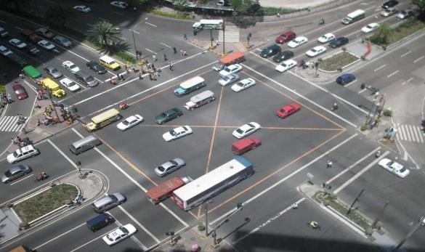

**Fig -1**: Traffic loaded intersection

This method does not give priority to vehicles at intersections, which can result in delays for emergency vehicles waiting for their turn to cross. As a result, rescue teams may be delayed in reaching their destinations, potentially leading to greater damage. Therefore, enhancements are necessary to introduce changes that prioritize the passage of emergency vehicles [3].

# WSITMN - Wireless Sensor and RFID Tag Integrated Traffic Monitoring Network

This approach does not prioritize vehicles at intersections, potentially causing delays for emergency vehicles that must wait for the intersection to clear. Consequently, rescue teams may be hindered in reaching their destinations promptly, which could lead to increased damage. Therefore, improvements are needed to implement changes that ensure the prioritization of emergency vehicles [3].The Government has approved a National Road Safety Policy is shown in figure 2.

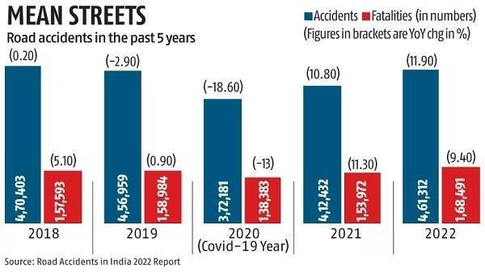

**Fig -2**: Road fatalities in India

This policy outlines several measures, including promoting awareness, establishing a road safety information database, encouraging the development of safer road infrastructure, implementing intelligent transport systems, and enforcing safety laws [5].

# PROPOSED SYSTEM

The microcontroller serves as the core component of the control system. The consequence block can be tailored according to specific needs, with the converter block obtaining its supply directly from the source via a filter circuit.

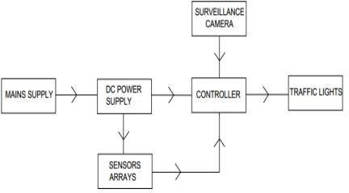

**Fig -3**: Block diagram

The transmitter generates an AC frequency, which is then applied to the antenna. When energized by this AC, the antenna emits radio waves. Besides broadcasting, transmitters are crucial components of many electronic devices that communicate via radio, including two-way radios in aircraft and spacecraft, cell phones, Wi-Fi and Bluetooth-enabled devices, ships, garage door openers, radar systems, and navigational beacons. The term "transmitter" is often used specifically to describe equipment used for broadcasting.

# Tyre Killer

The blocking segment will feature spikes positioned at a 60° angle and constructed from tempered steel. The spacing between the spikes, measured from their centers, should range from 100 mm to 200 mm, as illustrated in Figure 4 [6].

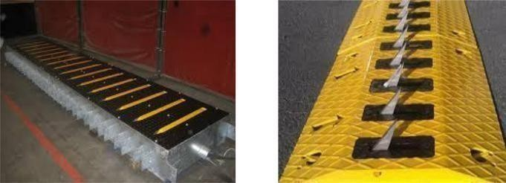

**Fig -4**: Tyre killer

# Speed Brakers

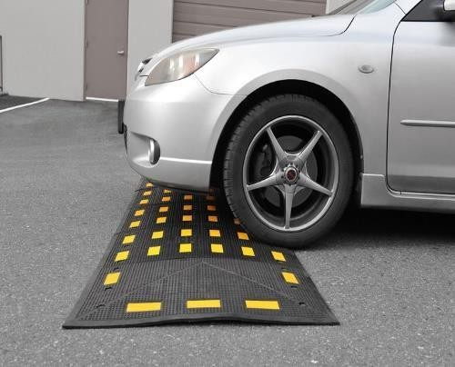While speed breakers or bumps effectively reduce vehicle speeds, their use is sometimes controversial due to potential drawbacks. They can increase traffic noise, damage vehicles when driven over at high speeds, and slow down emergency vehicles [7]. Poorly designed speed bumps, especially those that are too high or have a steep angle (often found in private car parks [citation needed]), can be disruptive to drivers and challenging for vehicles with low ground clearance, even at low speeds. This motion is illustrated in Figure 5.

**Fig -5:** Speed Brakers

# EXPERIMENTAL SETUP

Utilizing Arduino in our system enables us to interpret analog or digital input signals from various sensors and translate them into actions such as activating motors, controlling LEDs, connecting to the cloud, and performing other tasks.

The hardware outputs of our proposed system are presented through an LCD display. Figure 6 illustrates the hardware module of our system, comprising components such as power supply, Arduino board, infrared sensor, radar sensor, servo motor, speed bumps, road blocker, tire killer, and LCD display. The functionality of the system is primarily managed by Arduino, with the infrared sensor employed for detecting emergency vehicles. The results are shown on the LCD display.

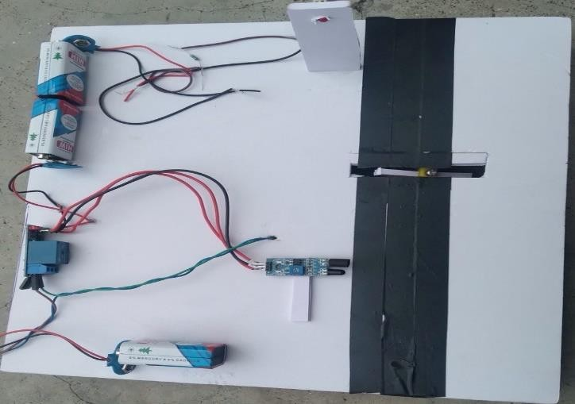

**Fig -6**: Hardware module of the proposed system

# OUTPUT ANALYSIS

In this section proposed system, the output is shown in the figure below. As mentioned previously, the spikes get activated while traffic light becomes red and get down when it becomes green.

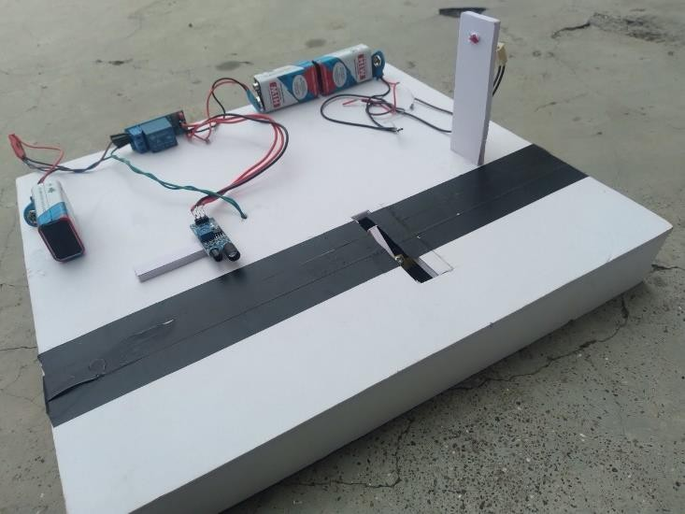

**Fig -7:** Position of speed bumps & vehicles

# ADVANTAGES

* Improved traffic flow
* Enhanced safety
* Reduced traffic jams and congestion

# COMPARISON ANALYSIS

* 1. **POWER SUPPLY**

**Previous System**: Utilized a general 9V power supply without specific regulation details, which might lead to instability or inefficiency. Potential safety hazards due to unregulated power supply, such as overheating or short circuits.

**Proposed System**: Includes a converter block that transforms AC to regulated DC, ensuring a stable and efficient power supply.

Enhanced safety features with regulated DC output, reducing the risk of overheating, short circuits, and electrical failures.

# SENSOR TYPE

**Previous System:** Possibly used only for basic motion detection, with limited functionality in low visibility conditions [8].

**Proposed System:** Employs advanced infrared sensors to detect vehicles even in low visibility conditions (e.g., at night or in adverse weather), enhancing overall system reliability.

# OUTPUT

**Previous System:** Likely had limited integration with traffic signals, possibly only sending basic alerts or not interfacing with traffic signals at all.

**Proposed System:** Actively communicates with traffic signals, providing real-time data on vehicle speeds and traffic conditions. This enables dynamic adjustment of traffic light timing to optimize traffic flow and reduce congestion.

# MAIN COMPONENT

**Previous System:** May not have utilized a diffusor motor or might have employed a basic motor system for spike control without advanced features.

**Proposed System:** Incorporates a high- precision diffusor motor to control the deployment and retraction of spike speed breakers. This motor ensures smooth and reliable operation, enhancing the system's responsiveness and safety.

# CONCLUSION

The implementation of a smart traffic automation system, integrating spike speed breakers, presents a transformative approach to modernizing urban traffic management. Through the adoption of advanced technologies, such as adaptive signal control, spike speed breakers, and real- time data analytics, the

The deployment of a smart traffic automation system that integrates spike speed breakers represents a groundbreaking approach to modernizing urban traffic management. By leveraging advanced technologies like adaptive signal control, spike speed breakers, and real-time data analytics, the system aims to optimize traffic flow, enhance safety, and promote sustainable urban transportation [9]. The robust hardware and software infrastructure, complemented by a user-friendly interface, forms the backbone of a reliable and efficient traffic management framework.

# FUTURE SCOPE

In the future, the system could integrate with smart traffic lights to synchronize speed control with traffic signal changes, thereby optimizing traffic flow and reducing congestion [10]. Additional functionalities could include the recognition and prioritization of emergency vehicles, ensuring their unimpeded passage. Reintegrating Vehicle-to-Infrastructure (V2I) technology would allow vehicles to communicate directly with the spike speed breaker system, enabling precise speed control and early warnings to navigate without triggering the spike speed breakers [11]. By implementing advanced data analytics and machine learning algorithms, the system's capability to predict traffic patterns and dynamically adjust speed control measures based on real-time data could be significantly enhanced.

# REFERENCES

1. Derawi, Mohammad & Dalveren, Yaser & Alaya Cheikh, Faouzi. (2020). Internet-of-Things- Based Smart Transportation Systems for Safer Roads. 10.1109/WF-IoT48130.2020.9221208.

Dasari Vishal, H. Saliq Afaque, Harsh Bhardawaj,

T. K. Ramesh, “IoT- Driven Road Safety System”,

in ICEECCOT- 2017.

1. Shweta S. Malekar, Yokesh Bhute, “A review: Implementation of Advance Adaptive Traffic Light Control system using DIP and Embedded”, in IJRITCC, volume 5, Issue 2,ISSN:23218169,February 2017.
2. Harshini Vijinetha H, Dr. K R Nataraj, “IoT Based Intelligent Traffic Control system”, in IJRASET, V Dasari vishal, H. Volume 5,issue 5,May 2017,ISSN:2321-9653.
3. Oladimeji, Damilola & Gupta, Khushi & Kose, Nuri Alperen & Gundogan, Kubra & Ge, Linqiang & Liang, Fan. (2023). Smart Transportation: An Overview of Technologies and Applications. Sensors. 23. 3880. 10.3390/s23083880.
4. Amirgholy, Mahyar & Nourinejad, Mehdi. (2020). Optimal traffic control at smart intersections: Automated network fundamental diagram. Transportation Research Part B Methodological. 10.1016/j.trb.2019.10.001.
5. Gadawe, Noor & Qaddoori, Sahar. (2019). Design and implementation of smart traffic light controller using VHDL language. International Journal of Engineering & Technology. 8. 596. 10.14419/ijet.v8i4.29478.
6. Qaddoori, Sahar & Gadawe, Noor. (2020). Real- Time Traffic Light Controller System based on FPGA and Arduino. 10.4108/eai.28-6- 2020.2297938.
7. Ribeiro, M. & Borges, T. & Henriques, P. & Cunha, A. & Silva, J. & Sa´, I. & Leite, A. & Gonçalves, B. & Lourenço, R. & Silva, P. & Meneses, G.. (2023). Remote Traffic Light System to Support Traffic Light Maintenance. 10.1007/978-3-031-30514- 6_17.
8. Tawalbeh L. A., Mehmood R., Benkhlifa E. and Song

H. 2016 Mobile Cloud Computing Model and Big Data Analysis for Healthcare Applications IEEE 6Access 4 6171-6180

1. Lin B., Guo W., Xiong N., Chen G., Vasilakos A. V. and Zhang H. A Pretreatment Workflow Scheduling Approach for Big Data Applications in Multicloud Environments IEEE Transactions on Network and Service Management 13 581-594 Sept. 2016
2. Makati intersection.jpg Wikimedia Commons contributors Wikimedia Commons 10 September 2022 07:16 UTC 3 June 2024 08:26 UTC

https://commons.wikimedia.org/w/index.php? Makati_intersection.jpg&oldid 687747090

687747090.