A RESEARCH ON PREPARATION AND EVLUATION OF HERBAL

FACE PACK

AUTHORS: 1)MISS POOJA SANDIP NIDHANE

2) MISS LOHALE RENUKA FAKIRA

AFFLIATION: PRINCIPAL ASHVIN COLLEGE OF PHARMACY

MANCHI,HILL

ASSISTANT PROFESSOR AND HOD OF QUALITY

ASSURANCE MISS MAGAR MAM

**Introduction**

Since from ancient period of time, People are aware of the use of plants for the healthy, Glowing and beautiful skin cosmetics are products used clean, Beautify and promote attractive to appearance cosmetics are commercially available products that are used to improve the appearance of the skin by action of cleansing. Beautifying, Promoting Attractiveness. From the ancient time, Different herbs are used for Cleaning, Beautifying and to manage them face skin is the major part of the body, Which indicates the health of an individual skin of the face is the major part of the body, Which is a mirror, Reflecting the health of an individual a balanced nutrition containing amino acids, Lipids and carbohydrates are required for the skin keep it clear glossy and healthy. Herbal face packs are helps to reduce wrinkles, pimples, acne and dark circles. Also increase the fairness and smoothness of skin. It also helps someone to boost their confidence. Ayurveda is the most useful and successful means for achieving this purpose. (6)

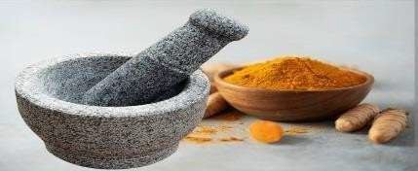

* **Herbal Skin care Face Pack:**

The face packs which are mentioned in ayurveda help to reduce dead skin, reduce signs of aging,skin tanning, protect from Sun and gives cooling effect on skin. Herbal face packs increase the fairness and smoothness of skin.

The maximum benefits of herbal face packs by using them. According to our skin type. These face packs increase skin glow and are best ayurveda treatment to increase fairness. Face packs are one of the oldest and beautiful methods of cleansing skin.

There are various kinds of face Packs described in ayurveda which have Nourishing, Healing, Cleaning, Astringent and Antiseptic properties. We can prepare face pack in home with basic integrant found in house and kitchen.

Herbal face pack are cheaper and have no side effects for getting fair skin naturally. From the ancient era people are using herbs for cleaning ,Beautifying and too manage them.

since the prehistoric times, people have the knowledge about the uses of plants for the crucial role needed for maintaining healthy skin. cosmetics are the products used mainly for Cleaning, Beautifying and promote attractive appearance.

Facial skin is a major part of the body, Which indicates the health of an individual. In ayurveda, The herbal pack/paste is called as “Mukha Lepa” generally use in facial therapy. This herbal pack/paste smeared on face to treat Acne, Pimple, Scars, Marks, and Pigments .The main advantage of using herbal cosmetic is that it is pure and does not have any side effects on the human body.

Men have rough skin and when they don’t take sufficient care, Then the skin turns dark due too very exposure to the sun, other pollutants etc.

In this project we have formulated home made face pack to whiten, lighten and brighten the skin naturally for men and women. This face pack has natural skin lightening property and can be easily prepared At home.(3)

**Benefits of Herbal Skin Care Face Pack:**

1. Nourishes the skin. Fruit face packs supply essential nutrients to skin.

2. Helps to reduce, acne, pimple, scars and marks depending on its herbal ingredients.

3. Face packs usually remove dead cells of skin.

4. These face masks provide a soothing and relaxing effect on skin.

5. They help to restore the lost shine and glow of skin in short span of time.

6. Regular use of natural face masks bring glow to skin, improve skin texture and

Complexion.

7. The harmful effects of pollution and harsh climates can be effectively combated with Judicial use of face pack.

8. They help to prevent premature aging of skin.

9. Formation of wrinkles, fine lines and sagging of skin can be effectively controlled by

using natural face packs.

10. Natural face packs make the skin look young and healthy.

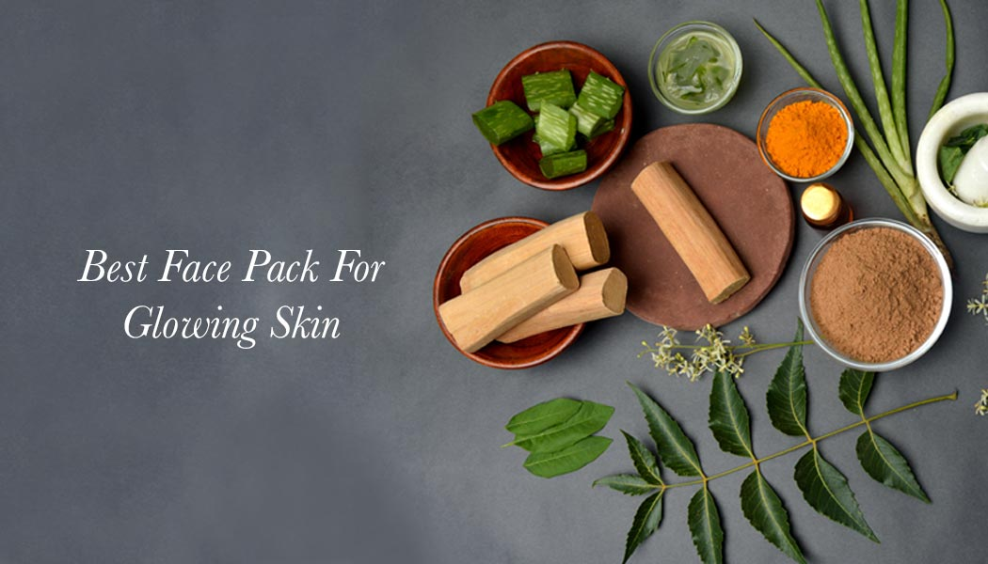

* **Precautions to be Taken While Applying Face Packs:**

• Select the face packs according your skin type.

• The face pack should not be left on face, or than 15-20 minutes. Keeping for very

long times may result in formation of wrinkles, sagging of skin and enlargement of

open pores.

• Avoid applying face pack near “eye zone”. The skin around eye is very delicate.

• Applying face pack in a week. Don’t try to peel or straiten the dried face packs.

This may harm underlying skin.

• Spray water on face before removing dried face pack. After removing the mask roll

an ice cube on facial skin which helps to use open pores and tightens skin

**Ideal Properties of Face Pack :**

• It should be non- irritating and non-toxic.

• It should be stable both physically and chemically.

• It should be free from gritty particles.

• It should have pleasant odour.

• They should be capable of producing significant cleansing of the skin.

• They should produce a sensation of tightening of the skin after application.

• They should form a smooth paste. (13 )

**LITERATURE OF REVIEW :**

1. **DW Maske AO, Pandhare M, Ashwin**. Formulation and evaluation of herbal face pack for glowing skin. International Journal of Advances in Pharmaceuticsm.

2. **Wäldchen J, Mäder P.** Plant species identification using computer vision techniques: A systematic literature review. Archives of Computational Methodsin Engineering, studies the plant species identification.

3**. Pal SK, Shukla Y**. Herbal medicine: current status and the future. Asian pacific journal of cancer prevention. Studies about the introduction of herbal drugs and current status.

4. **Yadav R, Yadav N**. Preparation and evaluation of herbal face pack. International Journal of Recent Scientific Research, study about the preparation and evaluation of herbal face pack.

5. International journal of creative research thoughts (IJCRT) A review on herbal face pack.**Mr.Rutik p.ankushe,Mr. Abhijeet a.Paear,Miss Manisha K.Pakhare**

6 Jain A, Patil Formulation and evaluation of poly-herbal face pack, evaluation parameters of herbal face pack.

7. **Neware PR, Rahangdale RS, Patle OD, Suryavanshi MM, Donode PS, Sirsat NS**. Formulation and evaluation of herbal face pack for ACNE-prone skin and dull skin. precautions to be taken while applying the face pack and ideal properties of herbal face pack.

8.world journal of pharmaceutical research on formulation and evaluation of herbal facial scrub containing sunflower seeds and other natural ingredients. **Dr.Shweta P.Ghode,Vibhavari M.Chatur,Dr.Prashant D.Ghode**

9. International journal of advances in pharmaceutics of formulation and evaluation of herbal face pack for glowing.**Avinash O.Maske,Manisha Pandhare**

**Aim and Objectives:**

**Aim:** To Formulate and Evaluate A cosmetic preparation of poly herbal face pack made from herbal ingredients.

**Objectives:**

➢ To formulate a face pack with flax seed it was used as Anti-infalmmatory.

➢ To formulate and develop safe, effective, and stable face pack

➢ To formulate and evaluate having acceptable properties.

➢ To improve patient /Customer compliance.

➢ To help prevent acne, clear oiliness.

➢ To perform stability studies of the formulation as per ICH guidelines.

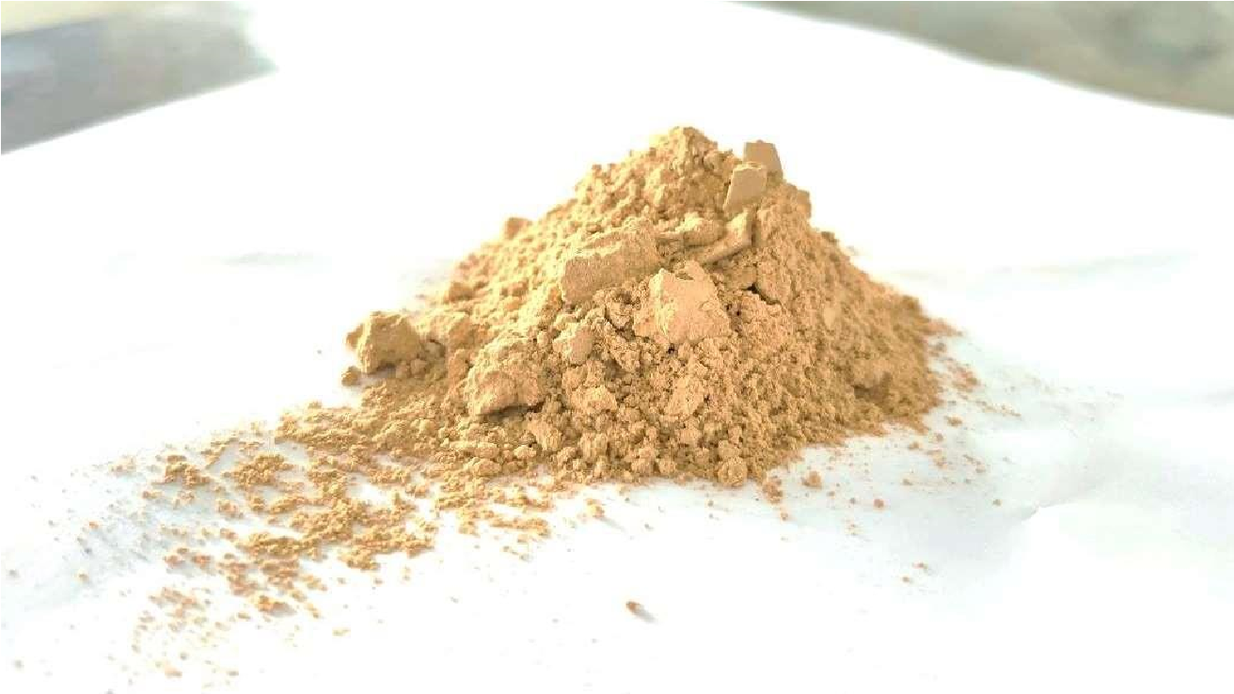

Fig no 1 - Formulation of herbal face pack

* **PLAN OF WORK :**

Collection and identification of different plant materials

Preparation of powder of dry crude drugs

Sieving of powder

Formulation of face pack by mixing all ingredients

Evaluation tests of Face pack

Experimental result and discussion

Conclusion

**Plant materials**

The plant selected for preparation for herbal face pack are Sunflower Seeds, Ashwagandhaa, Basil Seeds, Rice Flour, Sandal Wood, Cinnamon Powder, Turmeric.

### 1 . TURMERIC :

**Botanical Name :** *Curcuma Longa*

**Family :** Zingiberaceae

**Genus :** Curcum

**Chemical constituents**:1.vanilylidene acetone

2.zingiberaceae

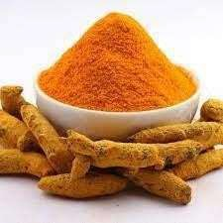 3.piper

Fig No 2 Turmeric

Turmeric has anti-inflammatory and anti-allergic activity. It is best blood purifier and helps in wound healing. It possess best blood purification action so it is used in all disease with blood impurities origin. Delays the signs of aging like wrinkles. It is a very good anti inflammatory and anti-allergic Agent .(7)

### 2. SANDAL WOOD :

**Botanical Name :** *Pterocarpus Santalinus*

**Family :** Fabaceae

**Genus:** Pterocarpus santalinus

# Chemical constituents: 1. Alpha santol

# 2. Beeta santol

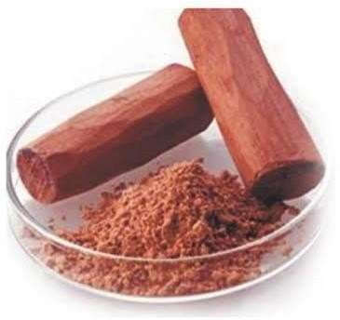

Fig No 3 Sandal wood

There are many advantages of using red sandalwood on the skin. It nourishes our skin and keeps it healthy, fair and glowing. Red sandalwood is also considered as a savior for dull, lifeless skin. It is one of the best natural Sandalwood has an anti-tanning and anti-aging property. It also helps skin in many ways like toning effect, emollient, antibacterial properties, cooling astringent property, soothing and healing property.(6)

**3 . ASHWAGANDHA :**

**BotanicalName**: *Withaniasomnifera*

**Biological source:** ashwagandha is derived from the root of Withania somnifera Plant .

**Family**: solanaceae

**Genus**: withaania

# Chemical constituents : 1.Alkaloids

# 2.steriods

# 3. lactones

# 

**Fig No 4 Ashwagandha**

Ashwagandha encourages the production of natural oils that the skin needs. It helps in the reduction of acne, while keeping the skin soothed, clarified, and replenished. It is known to possess anti-ageing properties which keep the elasticity of the skin intact .It also contains anti-inflammatory and anti-arthritic property. (6)

# 4.BASIL SEEDS :

# Botanical Name: *ocimum basilicum*

# Family: *Lamiaceae*

# Genus: ocimum L

# Chemical constituents: 1.stearic acid

# 2. Oleic acid

# 3.palmitic acid

# 4. Linoleic acid

# 5. Alpha-linoleic acid

# 6. Carpic acid

# 

# Fig No -5 Basil Seeds

# It is believed to possess several health benefits, such as aiding digestion ,promoting weight loss, reliving constipations, improving skin health,and providing a cooling effect on the body.additonally,basil seeds are rich in fibre ,antioxidants, minerals like iron ,essential fatty acids.(5)

**5.SUNFLOWER SEEDS**

**Botanical name-** *Helianthus annuus*

**Family-**Helianthus

**Genus-**asteraceae (compositae)

**Chemical constituents:** 1.cholrine

2.betaine

3. lignans

4. phenolic acid

5. arginine

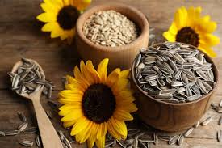

Fig No -6 Sunflower Seeds

Sunflower seed oil has been studied for its protective effect on biophysical properties of skin in humans. DNA. They contain copper, which helps to produce the melanin that gives your skin its unique pigment. Sunflower seeds are an excellent source of vitamin E and a very good source of copper and vitamin B1. In addition, sunflower seeds are a good source manganese, selenium, phosphorus, magnesium, vitamin B6, folate and niacin.(11)

**6.RICE FLOUR:**

**Botanical name:** *oryza sativa*

**Family:** *poaceae*

**Genus:** oryza

**Chemical constituents:** 1. Carbohydrate

2. starch

3. amylose

4. amylopectin

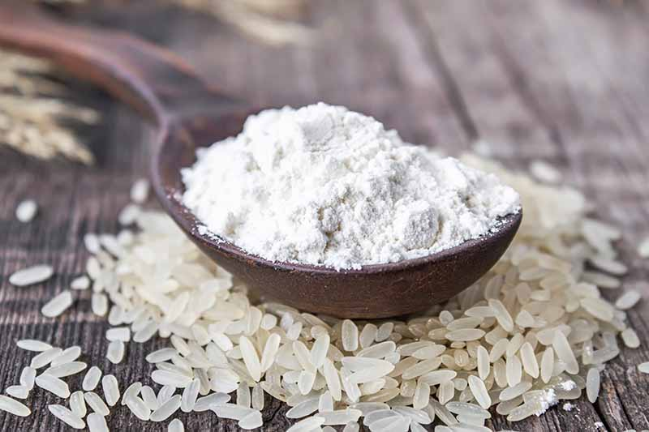

Fig No -7 Rice flour

Rice flour can be applied to cure some forms of skin ailments. In Indian subcontinent, rice water is duly prescribed by Ayurvedic practitioners as in undigested form. It aids the growth of useful bacteria for normal bowel movements an effective ointment to cool off inflamed skin surfaces .(9, 10)

**7.Cinnamon Powder :**

**Botanical name:** *cinnamomum verum*

**Biological source:** It is derived from the inner dark of shoots of copied trees of cinnamomum zeylanicum nees.

**Family *:*** *lauraceae*

**Genus:** cinnamomum zeylanicum

**Chemical constituents:** 1.cinnamaldehyde,

2. Eugenol

3. linalool

4.p-cymene

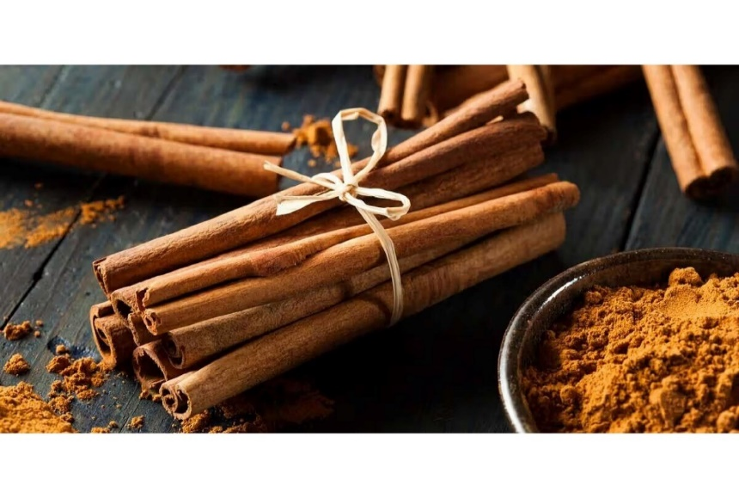

# Fig No -8 Cinnamon Powder

Cinnamon powder comes from the bark of tropical, every green

trees.health benefits of cinnamon acts as anti-bacterial ,anti-viral and anti-fungal,loaded with antioxidants ,reduces inflammation.it may improve insulin sensitivity.It may be beneficial for the aging skin.(10)

# Formulation ( Table No 1 )

|  |  |  |  |
| --- | --- | --- | --- |
| Sr.no | Ingredients | Quantity(100 gm) | uses |
| 1. | Turmeric | 10gm | Anti- allergic |
| 2. | Sunflower seeds | 50gm | Protective agent |
| 3. | Ashwagandha powder | 10gm | Anti-bacterial agent |
| 4. | Basil seeds | 2.5gm | Cooling effect |
| 5. | Rice flour | 12.5gm | Anti-inflammatory |
| 6. | Sandal wood powder | 10gm | Antiseptic |
| 7. | Cinnamon powder | 5gm | Anti -ageing |

# Formulation Table No :2

# Three formulation prepared labeled as formulation- F1, F2 ,F3, of polyherbal facepack. In 3 formulation we used same ingredients only differ in quantity.

# 

|  |  |  |  |  |  |
| --- | --- | --- | --- | --- | --- |
| **Ingredients** | **F1(g)** | **F2(g)** | **F3(g)** | **Category** | **Images** |
| **Sunflower seed powder** | 5 | 5 | 5 | Sun protective |  |
| **Ashwangandha powder** | 1 | 1.10 | 1 | Reduce dead skin |  |
| **Sandal wood powder** | 1 | 1 | 1 | Antiseptic and Reduce skin condition |  |
| **Turmeric** | 1 | 1 | 1 | Antiinflamatory Activity , Antiallergic Activity | **Organic Turmeric Powder, Ground Turmeric, Organic Haldi Powder, ऑर्गेनिक  हल्दी का पाउडर, ऑर्गेनिक टर्मरिक पाउडर - M/s. Meera Industries, Phulabani |  ID: 22096515397** |
| **Basil Seeds** | 0.25 | 0.15 | 0.50 | Providing Cooling Effect On The Skin |  |
| **Rice Flour** | 1.25 | 1.25 | 1 | Sun Tanning | Comida Corn Starch Powder, 300 g : Amazon.in: Grocery & Gourmet Foods |
| **Cinnamon Powder** | 0.5 | 0.5 | 0.5 | Reduce signs of Ageing |  |

**Microscopy Test (Table No 3 ) :**

|  |  |  |
| --- | --- | --- |
| F1 |  | **DIL. HCl TEST**  **Calcium oxalate crystals** |
|  |  | **IODINE TEST**  **Starch Grains** |
|  |  | **RUTHENIUM RED TEST**  **Mucilage** |

|  |  |  |
| --- | --- | --- |
| F2 |  | **DIL. HCl TEST**  **Calcium oxalate crystals** |
|  |  | **IODINE TEST**  **Starch Grains** |
|  |  | **RUTHENIUM RED TEST**  **Mucilage** |

|  |  |  |
| --- | --- | --- |
| F3 |  | **DIL. HCl TEST**  **Calcium oxalate crystals** |
|  |  | **IODINE TEST**  **Starch Grains** |
|  |  | **RUTHENIUM RED TEST**  **Mucilage** |

## 

## Fig no-9 microscopy test

## PROCEDURE : (2)

* All The Required Herbal Powders For The Face Pack Preparation Were Accurately Weighed Individually By Using Digital Balance.
* The accurate quantity ingredients were weighed and ground into fine powder by using sieve #120.
* Then the all ingredients were mixed geometrically by serial dilution method for uniform mixing.
* Then the prepared face pack was packed into a self-sealable polyethylene bag, labelled, and used for further studies.

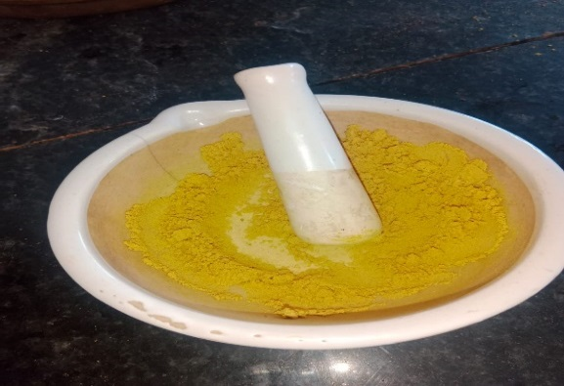

Fig no-10 prepared face pa

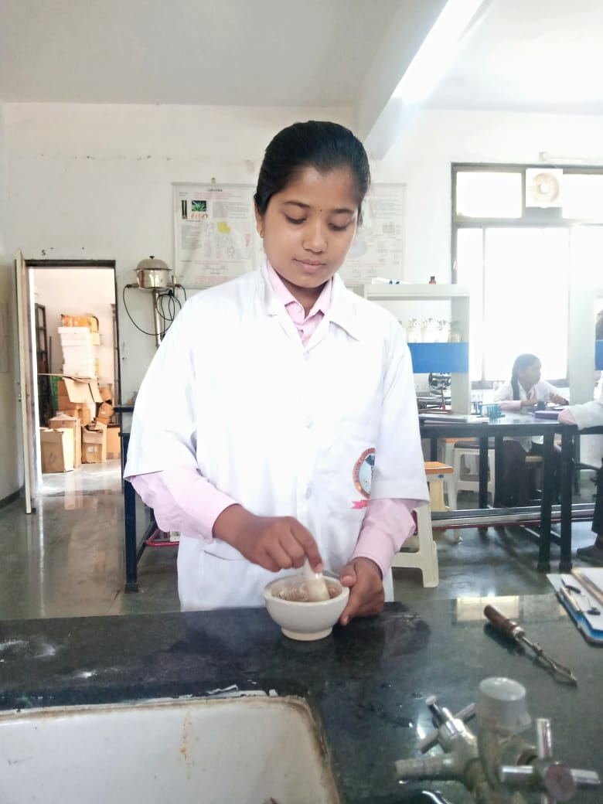

Fig.No.11Triturating

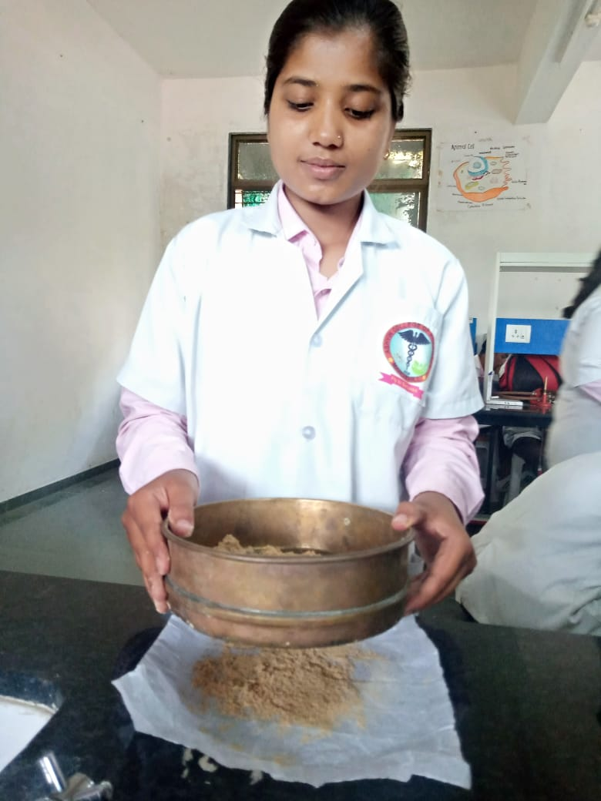

Fig.No.12 Sieving

**Procedure for Apply of Herbal Face Pack :(1)**



Washing

And Then Wash The Face With Cold Water.

The Acne And Blemishes Spots. Kept As It Is For

Complete Drying For 30

To 40 Min

C O

V E

R

Add Water Or Rose Water

To Mix It Well And Apply Over The Facial Skin.

Addition

Take Prepared Face Pack

Powder In A Bowl As Per The Requirement ,

**Evaluation Parameter for Herbal face pack:(8)**

**1. Organoleptic Evaluation:**

The organoleptic parameters include its nature, color, odor, feel and consistency which were evaluated manually for its physical properties.

**2. Evaluation of Flow properties:**

* **Tapped density :** Tapped volume was measure with tapping for 100 timeson flat table top surface.

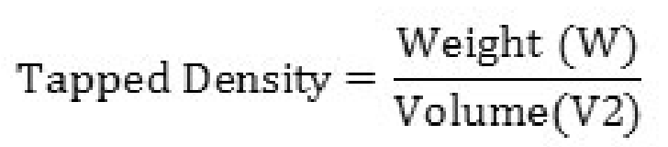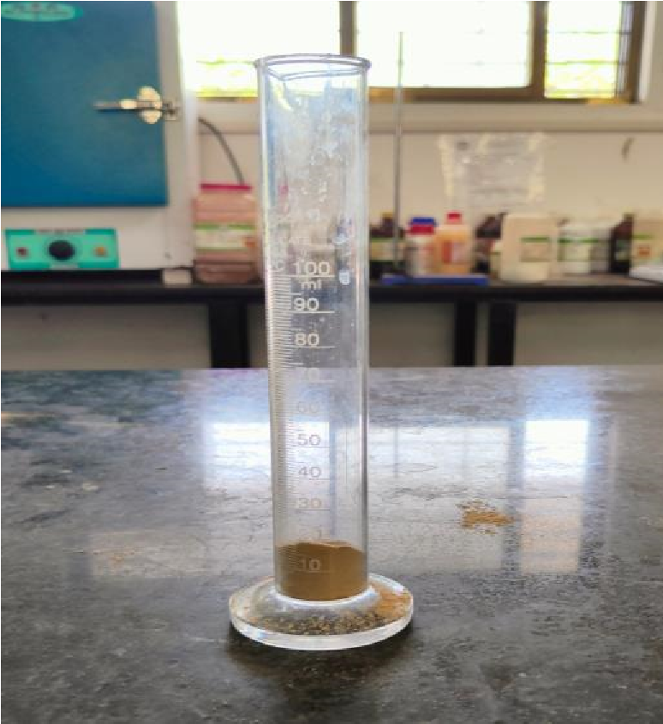

Fig No 13 Tapped Density

* **Bulk density:**
* Bulk density: Bulk volume was measured after manually tapping thecylinder two times on a flat table top surface.

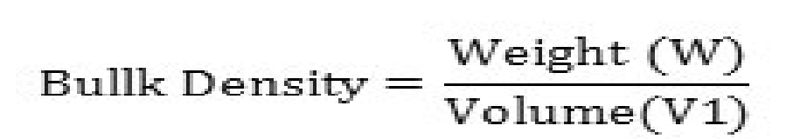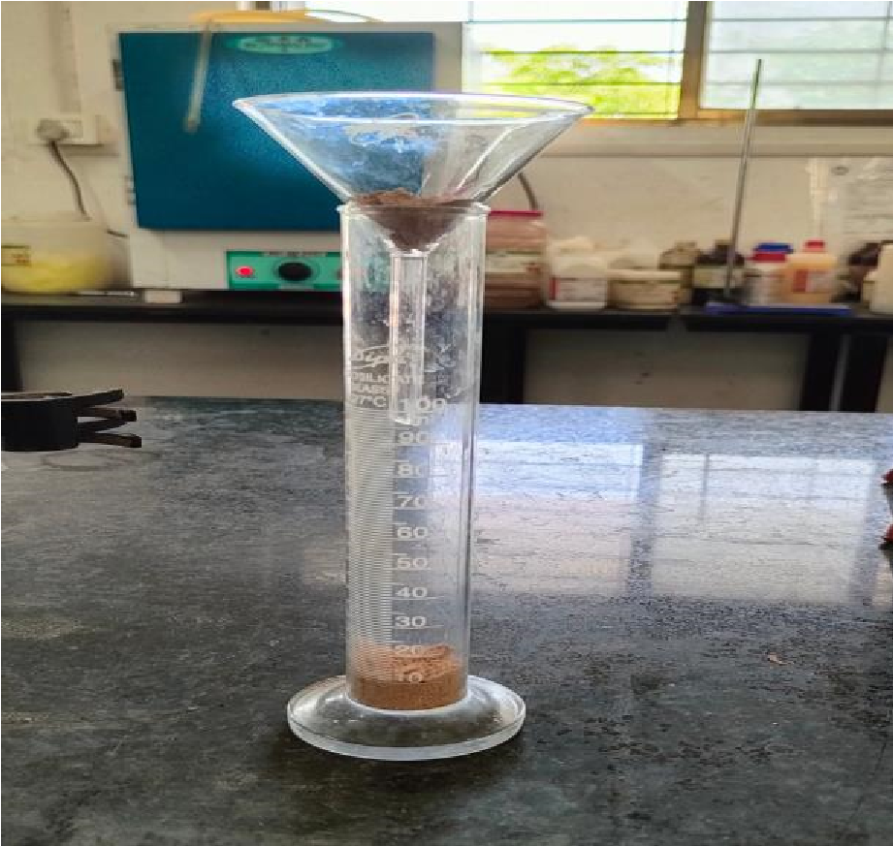

Fig.No.14 Bulk Density

* **Angle of repose:**

The flow properties of Powders were studied by measuring Angle of Repose. It was determined by funnel method. Heightof granules forming cone (h) and Radius of the base circle ® was measured. The angle of repose was calculated as follows:

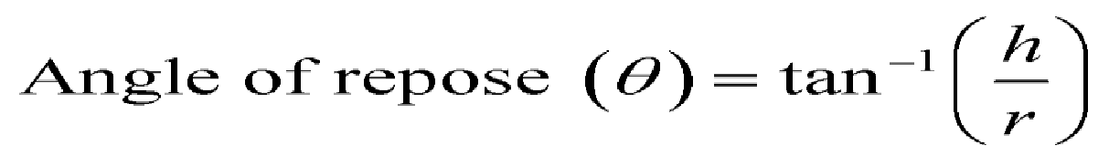

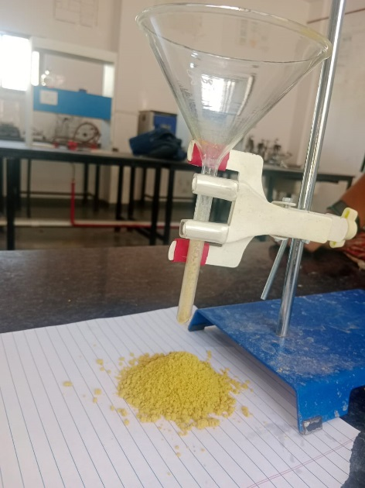

Fig. No. 15 Angle Of Repose

* **Hausner’s ratio :**

. : It is indicative of flow properties. It is derived property from bulk and tapped density. Lower the Hausner ratio is indicating better flow whereas higher ratio indicates poor flow of granules. It is calculatedby the following formula

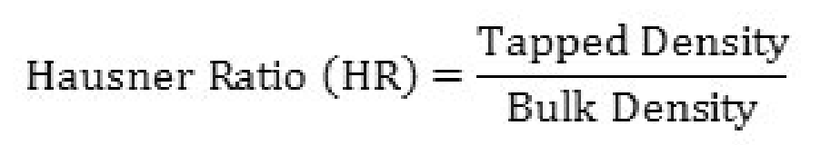

* **Carr’s index**

Carr’s Index: The bulk and tapped densities were used to calculate Carr’s Compressibility index to provide measure of the flow properties and compressibility of powder.

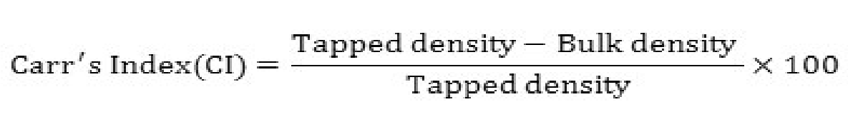

* **pH**: pH of the prepared herbal Face Pack was evaluated by using digital pH meter.

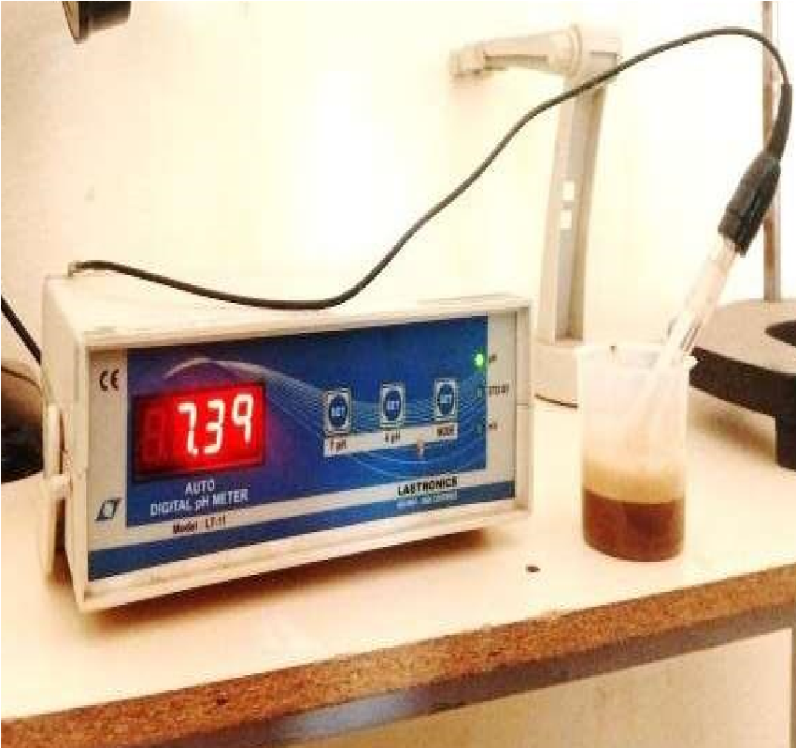

Fig .16 PH Meter

**3. Irritancy Test:**

A definite quantity of prepared face packs was applied to the specified area and time was noted. Irritation, Redness, Swelling.

Fig 17.

Irritancy test

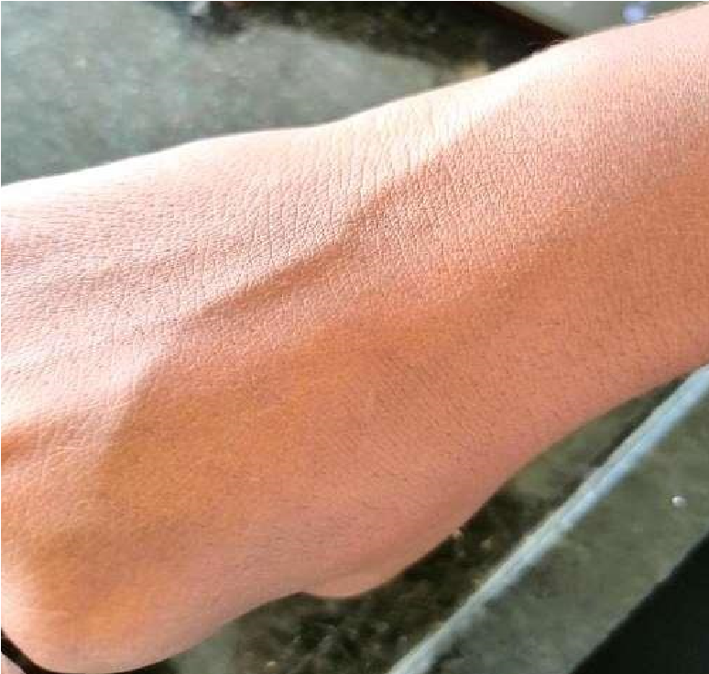

**Organoleptic Evaluation ( Table No 4)**

Organoleptic properties of formulation (F1, F2, F3)

|  |  |  |  |  |
| --- | --- | --- | --- | --- |
| **Sr. No.** | **Parameters** | **F1** | **F2** | **F3** |
| **1** | **Appearance** | powder  (Free flowing | powder  (Free flowing) | powder  (Free flowing) |
| **2** | **Colour** | slight brown | creamish brown | slight creamish |
| **3** | **Odour** | slight | slight | slight |
| **4** | **Texture** | fine | fine | fine |
| **5**  **5** | **Smoothness** | Smooth | Smooth | Smooth |

#### Physico-Chemical Evaluation: (Table No 5)

Physical parameters and Physiochemical evaluations of formulation

(F1, F2, F3)

|  |  |  |  |  |  |
| --- | --- | --- | --- | --- | --- |
| **Sr. No.** | **Parameters** | **Observations** | | | |
| **F1** | **F2** | **F3** |  |
| **1** | **Particle Size (mm)** | 32-33mm | 32-34mm | 33-35mm |  |
| **2** | **Ash content** | 11.5 % | 24.5% | 22.5% |  |
| **2** | **pH** | 6.1 | 6.3 | 5.9 |  |
| **3** | **Loss on drying** | 0.14% | 0.16% | 0.09% |  |
| **4** | **Tapped density** | 0.5 gm | 0.5gm | 0.5gm |  |
| **5** | **Bulk density** | 0.46 | 0.49 | 0.47 |  |
| **6** | **Angle of repose** | 37 (fair) | 36 (fair) | 35 (fair) |  |
|  |  |  |  |  |  |

**Irritancy Test : ( Table No 6)**

**Irritancy Test of formulation (F1, F2, F3)**

|  |  |  |  |  |  |  |
| --- | --- | --- | --- | --- | --- | --- |
| **Sr. No.** | **Evalations** | **Observations** | | | | **Irritancy** |
| **F1** | **F2** | **F3** |  | |
| **1** | **Irritant** | NIL | NIL | NIL | No irritation | |
| **2** | **Erythema** | NIL | NIL | NIL | No irritation | |
| **3** | **Edema** | NIL | NIL | NIL | No irritation | |

**Result and Discussion:**

The results of evaluation are displayed in Table 4,5,6 for organoleptic and physicochemical and general powder evaluation. The study of appearance, color, odour, texture, smoothness, ash values, pH and loss on drying of was performed for formulation (F1, F2, F3). The appearance for all formulation was free flowing, odour was slight, and texture was fine and smooth. The loss on drying value for F1 was found to be 0.14%, for F2 was found to be 0.16%, for F3 was found to be 0.09% . The formulation (F1, F2, F3) was evaluated for particle size, angle of repose, bulk density and tapped density before being formulated. Values of particle size, angle of repose, bulk density and tapped density obtained for F1, F2, F3 (32- 33mm), (32-34), (33-34) respectively. THE ph of F1,F2, F3 (6.1) , (6.3),( 5.9). The powder had passable flow property which is suitable for a face pack. And it’s easily washable with water. Formulation F3 showed better zone of inhibition as compared to other formulations, so we selected F3 formulation as our optimized batch.

# CONCLUSION

Natural remedies are more acceptable in the belief that they are safer with fewer side effects than the synthetic ones.

Herbal formulations have growing demand in the world market. herbal face packs are used too , stimulate blood circulation, Rejuvenate the muscles and help to maintain the elasticity of the skin and remove dirt from skin pores.It is a very good attempt to establish the herbal face pack containing different powder of plants. Thus in the present work, we found good properties for the face packs and further optimization studies are required on this study to find the useful benefits of face packs on human use as cosmetic product.

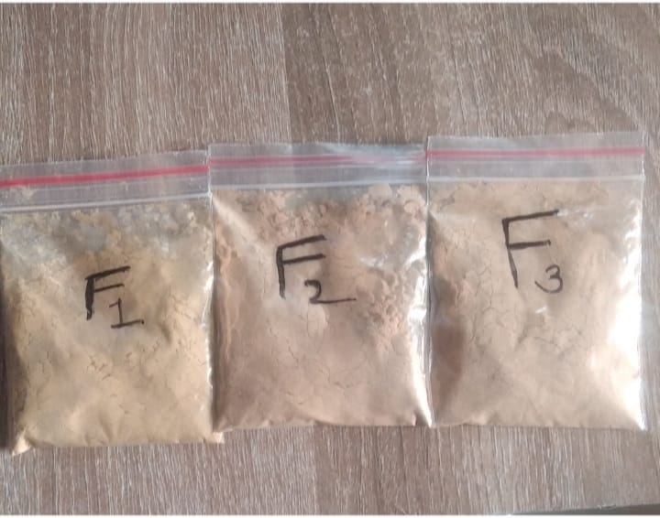

Fig no 18:packed face pack

# REFERANCE

1. **Rani, S. R. and Hiremanth**, Text book of Industrial pharmacy, Drug delivery systems & Cosmetics & Herbal.
2. Development of Cosmetic Mask Formulations. Rev Bras Cienc. Farm 40(10):159-161.
3. **Banchhor, M., Ashawat, M.S., , Saraf, S. and Saraf, S. (**2009). Herbal Cosmetics: Trends in Skin Care Formulation. Phcog Rev 3(5):
4. **Yadav N, Yadav R.** Preparation and evaluation of herbal face pack. International Journal of Recent Scientific4334-7.
5. **Jain A, Patil S.** Formulation and evaluation of poly- herbal Face pack.
6. International journal of creative research thoughts( ICJRT) A review literature on herbal face pack.
7. curcumin A review of its effect on human healthi susan hewlings douglas salman.
8. A pratical book of physical pharmaceutics ll ,**Dr Ashok A. Hajare (nirali publication)** page no-1.8 to 1.10
9. **Umadevi M,pushpa R, Sampathkumar KP , Bhowmik** D. Rice-traditional medicinal plant in India .journal of pharmacognosy and phytochemistry .2012 May 1

10. International journal of advances in pharmaceutics ,

Formulation and Evaluation of herbal face pack for glowing

skin.

1. . world journal of pharmaceutical research ,Formulation and Evaluation of facial scrub containing sunflower seeds and other natural ingredients.
2. . **Rieger M M. Harry’s cosmeticology**.In Chapter 23,Face Body and hair mask and scrubs, 8th edition vol I new York:chemical publishing Co,Inc,2009;471-483
3. **. Neware PR, Rahangdale RS, Patle OD, Suryavanshi MM, Donode PS, Sirsat NS.** Formulation and Evaluation of Herbal Face Pack for ACNE-Prone Skin and Dull Skin.

**Errata** **:** ________________________________________________________________________________________________________________________________________________________________________________________________________________________________________________________________________________________________________________________________________________________________________________________________________________________________________________________________________________________________________________________________________________________________________________________________________________________________________________________________________________________________________________________________________________________________________________________________________________________________________________________________________________________________________________________________________________________________________________________________________________________________________________________________________________________________________________________________________________________________________________________________________________________________________________________________________________________________________________________________________________________________________________________________________________________________________________________________________________________________________________