BACTERIOLOGICAL ANALYSIS OF TREATED AND UNTREATED WATER IN AGBA-DAM AND

USMAN, AISHA UMI

ASSITANT LECTURER

MICROBIOLOGY

CUSTECH, OSARA, NIGERIA.

*Abstract:* Bacteriological analysis of water samples collected frorn Agba darn and Agbadam treatment plant were investigated and compared. The total bacteria counts and total coliform counts were determined. the total bacteria count ranged between 0.1

and 2x10 CFU/ml while the total coliform count ranged from 21-48/10Ornl MPN index. Physicochemical parameters like temperature, pH, free residual chlorine and total hardness were also determined. The temperature range of the water samples was

within 26.5 and 29.0C. The pH range for the water samples was within 6.76 and 7.39. A total of Ten bacteria species were isolated and identified, these include, Bacillus sp., Proteus sp., Klebsiella sp., Enteorbacter aerogenes, Staphylococcus aureus, Pseudomonas aeruginosa, Acinetobacter sp., Citrobacter sp., *Escherichia coli* and Flavobacterium sp. Similar bacteria species were isolated from the raw water and the treated water samples. The isolation of E. coli from the treated water indicates faecal contamination. The isolation of *E.coli* from both water samples (the treated and untreated) indicates a poorly treated water.

*________________________________________________________________________________________________________*

**INTRODUCTION**

Water is the most common liquid on earth, it is vital for all life forms (Hasen and Clegg. 2004). It is used in our every day life for cooking, washing, quenching thirst and it is also used industrial processes. However, water is increasingly becoming unavailable

for human use. Life is basically water i.e. both animals and man are made up mainly of water. About Two- Third of the weight of an adult human consists of water. And about Two- Third of this is located within cells, while the remaining third consists of extracellular water. Water ensures the smooth running of our biological system, it enables chemical reactions to occur within the body, and it also helps in excretion process, in regulating body temperature and in the transporting chemicals between cells and the external environment (Hansen and Clegg, 2004). Water makes up 70% of the earth surface, of the total resource of water, 97% is in oceans and is too salty to be used for drinking, irrigation or in industry. The majority of the remaining 3% is frozen in ice caps and glaciers or is buried too deeply underground to be utilized. The exploitable volume therefore, is only 0.0003% of the total, though it is replenished by the hydrological cycle (Mason, 2002). Not only is fresh water essential to life but it is also a relatively scarce resource, and it is likely to become more so with impacts of global warming and population growth (Mason, 2002). Many fresh water resources are contaminated through human activities. More than 0% of the world's population doesn't have access to safe drinking water and a greater proportion still doesn't have even basic sanitation (Mason, 2002). In 2000, it was estimated that in excess of 1 billion persons still lacked access to improved drinking water sources (WHO, 2006). Most of these are the rural and urban poor living in developing countries. Each day 25,000 children die from their everyday use of water, 4 million of those death are simply from diarrhea. It is not only children that suffer, it was estimated that at one time half of the inhabitants of developing countries were ill with diseases caused by dirty water and poor sanitation. Some 80% of all illness and one-third of all deaths are due (Lean et.al., 1990). Until the last 200 years or so, the deterioration of water courses by organic pollutant wasn't a serious problem because relatively small human population lived in scattered communities the natural self-purification properties of rivers could cope with the waste dumped into them, waste pollution became a problem with industrialization, coupled with rapid acceleration in population growth. The greater majority of evident water related problems are the result of microbial(bacteriological, viral, protozoan) contaminant. ln general terms, the greatest risks are ingestion of water that is contaminated with human and animal faeces (WHO, 2006). Pathogens transmitted through drìnking water lead to severe and sometimes life-threatening disease like cholera, infectious hepatitis and disease caused by Shigella spp and *E. coli* 0l57 (WHO, 2006). In other to safe guard public health; guidelines for drinking water safety were made. Safe drinking water as described by the guideline doesn't represent any significant health risk to health overtime of consumption including different sensitivity that may occur between life stages, safe drinking water is suitable for all usual domestic purposes including personal hygiene (WHO, 2006). Portable water is defined as water that is free from disease producing microorganisms and chemical substances deleterious to health (Ihekoronye and Ngoddy, 1985). Conformation with microbiological standard is of special interest because of the capacity of water to spread diseases within a large population. Although the standards vary from place to place, the objective anywhere is to reduce the possibility of spreading water borne diseases to the barest minimum, in addition to being pleasant to drinking which implies that it must be wholesome and palatable in all respects (Edema *et al.,* 2001). In other to monitor the safety of water, the use of indicator organisms was adopted. Indicator organisms are used as index of possible water contamination by human pathogens (Prescott *et al.,* 2007). Water intended for human consumption should contain no indicator Organism (WHO, 2006). Accordingly, the treatment of water for drinking involves stages where the microbes are removed or destroyed before the water gets into homes (Fawole and Osho, 2007). The physical process for water treatment involves abstraction, preliminary storage, treatment, sedimentation, filtration etc.

This purification process removes or inactivates disease causing bacteria and indicator organisms (coliforms) (Prescott *et al.,* 2007). Coliforms in treated water supplies suggest inadequate treatment, post treatment contamination or excessive nutrients; coliform test can therefore be an indicator of both treatment efficiency and of the integrity of the distribution system (WH0, 1997). Regrowth of thermotolerant coliform organism in the distribution systems is unlikely unless bacterial nutrients are present, unsuitable materials are in contact with the water, the temperature is above 13'C and there is no free residual chlorine (WHO, 1997).

**RESEARCH METHODOLOGY**

**Sample collection**

Sterilized sampling bottles were used to collect the sample for the collection of water from a tap located in the treatment plant at Agba dam, the tap was disinfected using 70% alcohol and the tap was allowed to run for a while before collection into sampling bottles. For the collection of the untreated water (surface water), the sampling bottles were immersed into the water with the aid of a rope and an attached weight (WHO, 1997). The collection of the surface water was done at different sites (points) in the dam.

**Determination of the physicochemical properties**

**Determination of temperature**

The temperature reading of the samples were taken immediately after sample collection, a thermometer was dipped into the samples and allowed to stay for 3-5 minutes, the reading was taken after the mercury had become stable and thereafter recorded.

**Determination of pH**

The pH reading was taken immediately the samples were brought to the laboratory. It was done using a glass electrode pH meter,

the pH reading was carried out by dipping the glass electrode pH meter into the water samples, the readings were then recorded.

**Determination of Free Residual Chlorine (FRC)**

The free residual chlorine was determined for the treated water by titration as described below:

100ml of the water sample was poured into a 250ml conical flask and 2ml of 5% potassium chromate (KCr) was added, it serve as the indicator. The water sample was then titrated against 0.1n silver nitrate (AgNO3) solution with continuous shaking until a pink colour appeared. The titre value of AgNO3, in the burrette was then recorded. The concentration of the FRC is calculated using the formula: mML-1 of chlorine(Cr) = Titre value x Factor of AgNO,

Concentration of FRC = mML -1x molar mass

(mg/l) 1000

**Determination of Total Hardness**

100ml of the water sample was measured and poured into a 250ml conical flask. Five (5) drops of Ammonium hydroxide (NH4OH) was added, Three (3) drops of the indicator erichrome black was added and it was titrated against 0.1N EDTA. The titre was recorded. Hard water gives a pink coloration after titration while a soft water gives a green coloration.

**Preparation of Culture Media**

MacConkey agar was used for the enumeration of total coliform and Eosin Methylene Blue (EMB) which is a differential medium for the isolation of *E. coli*. MacConkey broth was used for the enumeration of coliforms in the water sample. Each of the medium was prepared according to manufacturer’s instruction.

**Enumeration of total bacterial count**

The standard pour plate method of Fawole and Oso (2007). was used for the enumeration of the total bacterial count, a general purpose media was used for the culture of the bacteria. Serial dilutions of the samples were made- the dilution factor for the treated water and raw water samples was 10-3. After serial dilution the petri dishes was swirled to allow its content mix properly and also to allow even distribution of the microbial colonies. The plates were left to stand so that the agar Can solidify, after solidification the plates were inverted and kept in the incubator at 37°C for 48hours. After 24 hours the plates were examined for colony formation and after 48 hours the colonies on each plate was counted and recorded in CFU/ml.

**Test for Coliform**

**Most Probable Number**

The process involves pipetting 0.lml and 1ml of MacConkey broth into sterile MacCartney bottles containing inverted durham tubes, this is for the single strength broth, for the double strength broth 1Oml of MacConkey broth was pippeted into MacCartney

bottles containng inverted durham tubes. 10ml each of the water samples were then pipetted into respective MacCartney bottles. The durham tubes were inserted carefully so as to prevent trapped air bubbles which may give a false test result. The bottles were then incubated at 37°C for 48hrs. After which, the results were read. A positive result is indicated by a change in color of the broth from pink to orange and also the presence of gas bubbles in the durham tube. The number of positive results was recorded and the most probable number (MPN) per 100ml for the water samples was obtained by comparison with the MPN table (WHO, 1997).

**Isolation of indicator organism**

Freshly prepared EMB agar was poured aseptically into Petri dishes and allowed to solidify. After which, 1ml each of the water samples were pipetted on to the agar surface and it was then streaked. It was then incubated at 37'C for 48hrs. Afler 48hrs. the plates were then observed; the indicator organism (*E.coli*) presence is characterized by the presence of greenish-metallic sheen on the agar surface (Prescott et al., 2007).

**Characterization and identification of bacterial isolates**

The growth of distinct bacterial colonies was counted and the morphology of the various colonies recorded. Pure cultures obtained were transferred to agar slants. These were used for various biochemical tests to determine the idenetities of the various isolates. The organisms were identified using bergys manual.

**IV. RESULTS AND DISCUSSION**

The water samples were collected from Agba dam and Agba dam treatnent plant within Ilorin metropolis.

**Physicochemical analysis**

As shown in Table 2 the temperature ranged from 26.5 and 29.0C, the pH range for the water samples was between 6.82-7.39. total hardness ranged from 0.33-0.41 and the free residual chlorine ranged from 0.2-2.0mg/l.

**Microbiological analysis**

Tables 1 below showed the average total bacterial count, the total bacteria counts ranged from 0.6 x 103 cfu/ml – 2.0 x 103 cfu/ml. Table 3 showed the result for the Most Probable Number (MPN).

**Isolates identification**

Table 4 shows the microorganisms isolated and identified from the water samples.

**Table 1 : Total bacteria count**

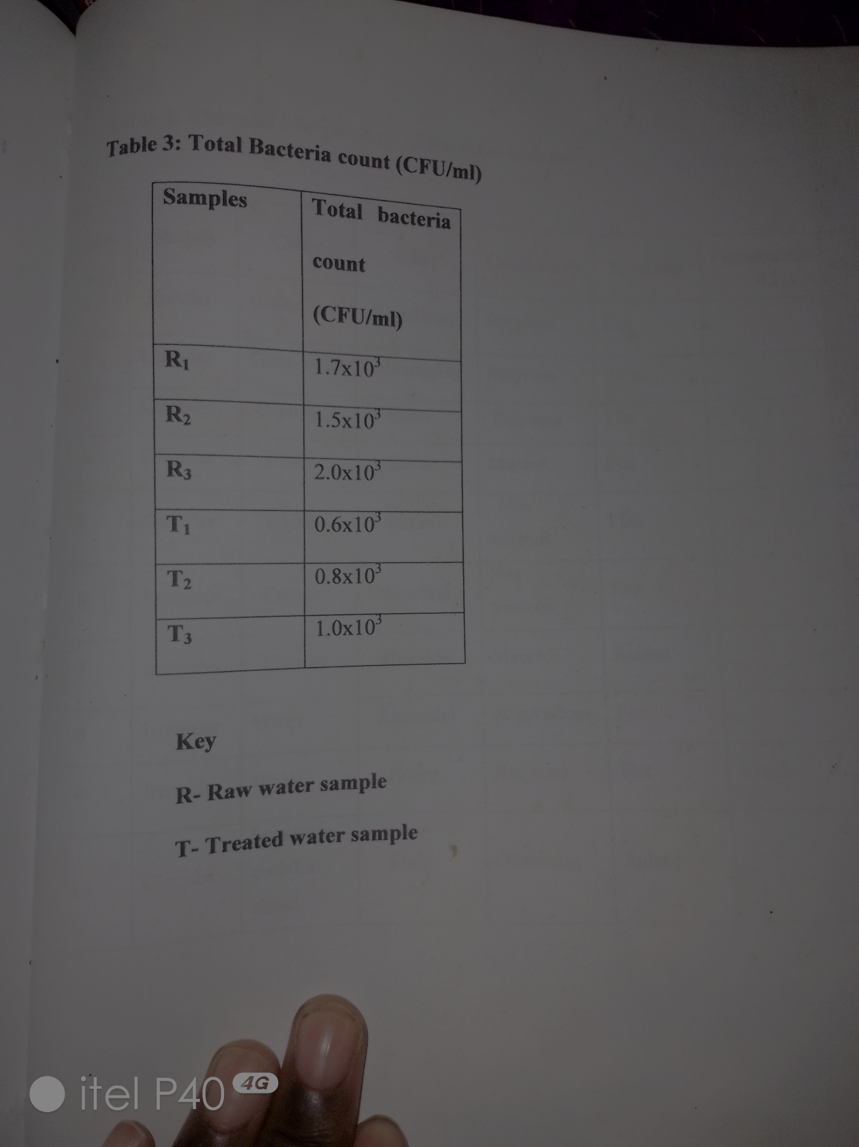

Table : Physicochemical properties of water samples

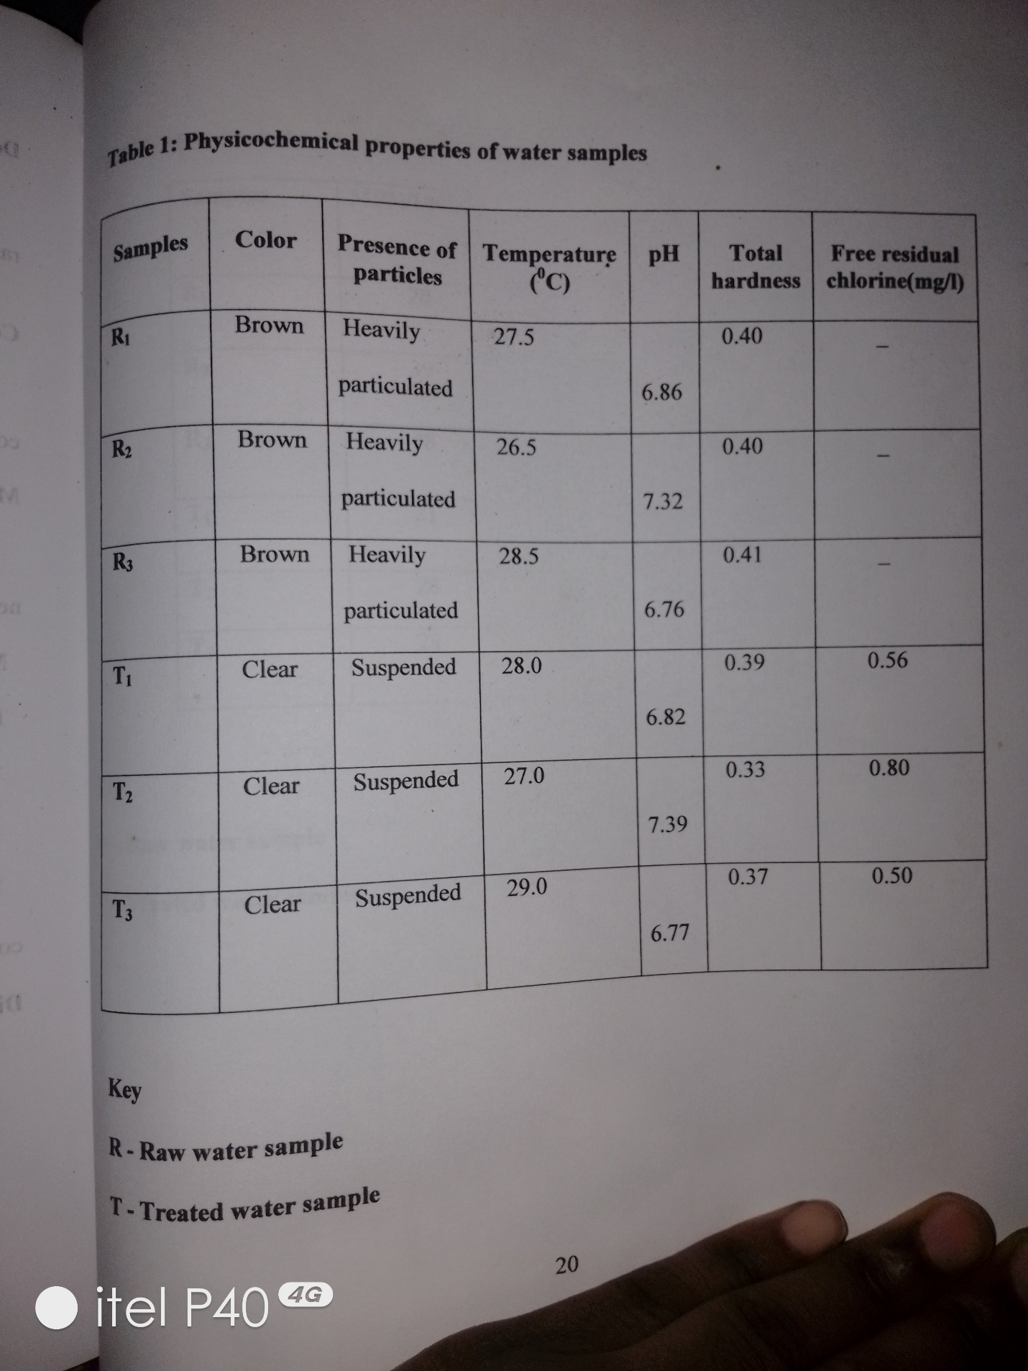

Table : Most probable number per 100ml

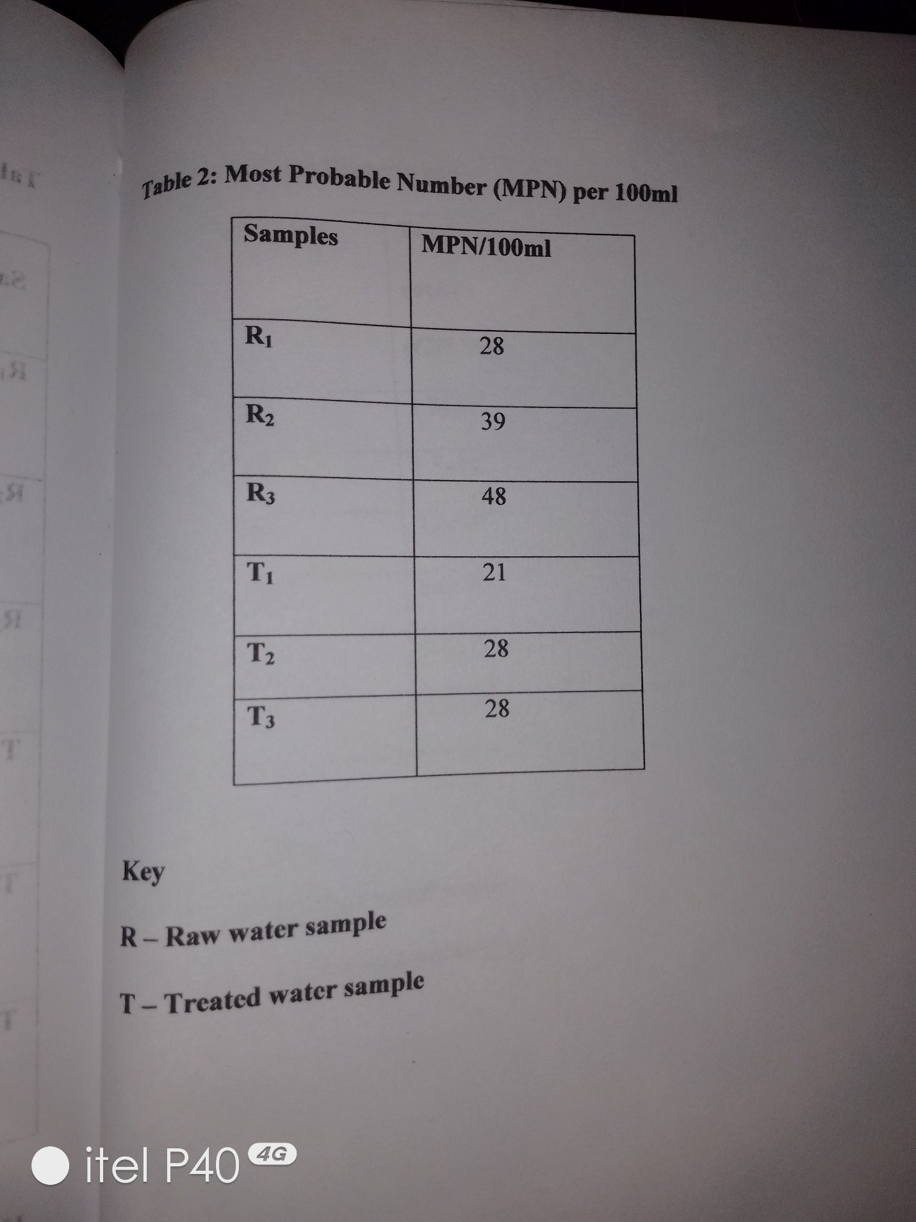

Table : Distribution of bacteria isolates in water samples

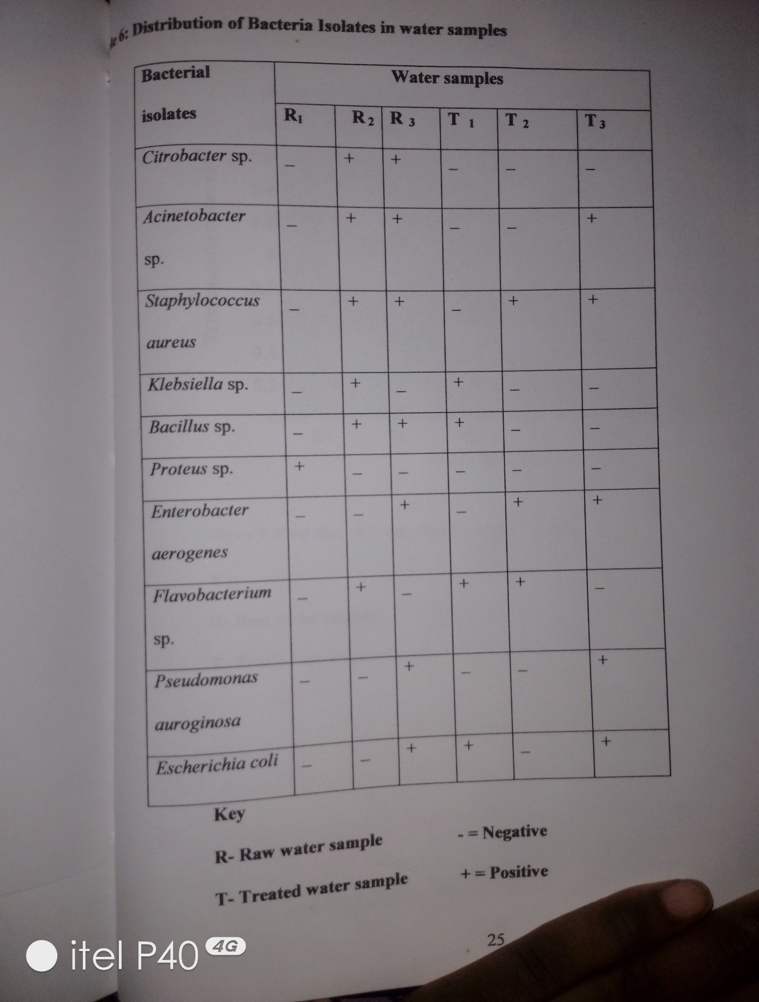

The results of the physicochemical parameters reveal that the pH range for the samples ranged from 6 to 8, this pH range favours the optimum growth of most bacteria grow best at or near pH of 7 (Prescott *et al.,* 2007). The temperature affects directly or indirectly a wide variety of chemical, physical parameters; narnely microbial growth, disinfection efficiency, dissipation of isinfectants residual (Donlan *et al.,* 1994). The temperature for the water samples ranged from 26.5-29.0°C. Mesophiles have a growth range of 5-40°C, but proliferate more at temperature greater than 20C (Fransolet *et al.,* 1985) present. Since, water is very important and vital for our daily life, analysis of its microbial content is important in revealing the dangers that may be posed by the microorganisms animal or human origin (Okonko *et al.,* 2008). The raw water (untreated water) sample had the highest total bacteria count highest coliform count as shown in (Table 2). This may be due to the high temperature of the water body. The presence of the indicator organism in this water sample, generally may be contaminated with faeces either of animal or human origin. This result compares favourably with the report of Banwo (2006) which indicates that the presence of bushes and shrubs makes likely possible that smaller mammals may have been coming around the water to drink water, thereby passing out faeces into the water. The presence of significant amount of suspended particles may also contribute to the presence of microorganism in the treated water sample and may reduce the treatment efficiency since; these particles may serve as shield for the organisms or even a growth source. The free residual chlorine for the treated water was within the normal range of 0.2-2.0mg/l as shown in (Table 1). The isolation of *E. coli* (indicator organism) provides conclusive evidence of fecal pollution which shouldn't be present in drinking water (WHO, 2002). The total coliform count for the treated water per 100ml as shown in (Table 2) is higher than the recommended standard for water, which is less than 2 MPN/100ml (FAO, 1997).The detection of these coliform bacteria in the treated water may be associated with the following factors; filtration, temperature, disinfectant type, disinfectant level, corrosion control, and operational characteristics (Lechevallier, 1996). Some of the bacteria isolated from the treated water sample such as Klebsiella sp., Acinetobacter sp., Enterobacter aerogenes, *Pseudomonas aeroginosa*, is in line with the works of Reasoner *et al.,* (1989) who observed the presence of wide variety of opportunistic pathogens such as Pseudomonas sp, Acinetobacter, Enterobacter aerogenes and the presence of bacteria in the treated water after regrowth. Although no clear pathogen was isolated, this opportunistic pathogen, may pose serious health problems in otherwise healthy individuals. Bacillus sp can cause bacteriamia *Pseudomonas aeroginosa* can cause urinary tract infection (Prescott *et al.* 2007). Some strains of *Escherichia coli* can cause gastroenteritis and urinary tract infections (Stainer *et al.,* 1987). Acinetobacter sp can cause urinary tract infection, pneumonia, bacteriamia, Secondary meningitis and wound infections (WHO, 2006).

**Conclusion**

The presence of the indicator organism in the treated water sample is of great concern, as it might be an indicator of the presence of more pathogenic organism, which may cause severe life-threatening disease. It is therefore important that water should be treated more efficiently to reduce the risk of water borne disease and also outbreaks. As a way of reducing the risk of water borne disease, treatment plants should be properly cleaned and sanitized, this is because colonized treatment plant would increase the microbial load and precipitate treatment failure, and also particles should be reduced to the barest minimum because it may protect microorganisms and lead to inefficiency in the treatment process. Finally, all levels of the society from the consumer to politicians must be educated to the necessity of improving water quality as a major step in improving the quality of life and health.

# **References**

1] Allen, J. M., Ldberg, CS, and Donald, JR (0004), Heterotrophie plnte count bncterin What is their significance in driking water? Iuternational Jornal of Food Microbolology. 92: 265-274.

2] Banwo, k.(2006). Nutrient load and pollution study of sone selected stations alongOgunpa River in Ibadan, Nigerin.M.Sc. I Dissertation, University of Jbadan, Ibadan, Nigeria. p. 107.

3] Donlan, R. M. Pipes, W. O. and Votte, T. L. (1994), Biofilm formation on cast iron substrate in water distraction system, Water Resource,28: 1497-1503,

4] Fdema, M.O,Omemu, A.M and Fapetu, O.M. (2001), Microbiology and Physiocochemical analysis of different water sources of drinking water in Abeokuta. Nigeria. Nigeria Journal of Microbiology 15(1): 57-61.

5] Fawole,O.M. and Oso, B.A.(2007), Laboratory Manual of Microbiology. Spectrum Books LTD, Ibadan. pp 15- 33.

6] Food and Agriculture Organization (FAO), (1997). Annual Report on Food Quality Control. 1:11-13.

7[ Fransolet, G., Villers, G, and Masschelein, W.J. (1985). Influence of Temperature on Bacteria Development in waftrs. Ozone Science. 7:205-227.

8] Hansen, W.D. and Clegg, J. (1979). Cell Amociated Water. Academic Press .p7.

9] Holdgate, M.W. (1979). A perspectve of Environmental Pollution. Cambridge University hekoonye, A.L. and Ngoody, P.O.(1985). Integrated Food Sciences and Technology for ihe roppies. Maemillian Press London, Oxford. pp.95-195. tean, C, Hinrichsen,D, and Markham, A.(1990).4tlas of the Emvironment. Hutchison London. pp. 36-40.

10] Lechevallier, M.W. (1996). Full Scale Studies of Factors related to Coliform growth in Drinking Water. Applied Environmental Microbiology. 65: 2201-221 1.

11] Manson, C. (2002). Biology of Freshwater Pollution. Fourth Edition, Prentice Hall. Ppl- 93

12] Okonko, I. 0.. Adejoye, O.D, Ogunnubi, T.A, Fajobi, E.A and Shittu,0.B.(2008). Microbiological and Physicochemical Analysis of Different water Samples Used for Domestic Purposes in Abeokuta and Ojota, Lagos state, Nigeria. African.Journal ofBiotechnology.7:617-618.

13] Prescott,L.M. and Harley, J.P. (2002). Laboratory Exercise in Microbiology. MeGraw Hill Companies Inc. pp. 230-301. Prescott, L.M., Harley, J.P. and Kleins, D.A.(2007). Microbiology. Seventh Edition. MeGraw Hill Companies Inc. pp 899-1053.

14] Reasoner, D.J, Blannon, J.C and Geldreich, E.E.(1989). Non photosynthetic pigmented Bacteria in portable treatment water and distribution system. Applied Environmental Microbiology. 55:912-921.

15] Ronald, M.A. (2004). Hand Book of Microbiology Media. Third Edition. pp.629-876.

16] Stainer, R.Y, Ingrtam, J. L., Wheels, M. L. and Painter, P.R. (1987). Bacterial General Microbiology Fifteen Edition Prentice-Hall, New Jersey. pp. , 447448.

17] Tebutt, T. (1983). I Principles of Quality Control. Pergarmon, England. p25.

18] World Health Organization (1997). Guidelines for Drinking Water Quality Vol 3. Surveillance and Control of community Supplies. pp.80-140

18] World Health Organization (2006). Guidelines for Drinking Water Ouality. Vol 1.Recommnendation. pp.120-234.