OPTIMIZATION OF COOLING TOWER PERFORMANCE ANALYSIS: A REVIEW
Ms. Vidhi Chandan¹ and Prof. Vishal Sapate²
¹PG student, Department of Civil Engineering, G.H. Raisoni University ,School of Engineering and Technology, Amravati.
²Assistant Professor, Department of Civil Engineering, G.H. Raisoni University ,School of Engineering and Technology, Amravati.

ABSTRACT:
Cooling towers are devices that convert hot water into cold water through direct air contact, utilizing the temperature difference between the air inside and outside the tower. Among the various types of cooling towers, the natural draft cooling tower is widely utilized. The hyperbolic shape of cooling towers is typically preferred due to its strength, stability, and the large available area at the base resulting from the shape. Given their critical role in nuclear and chemical plants, continuous assessment of cooling towers' stability under self-weight and lateral loads, such as wind and earthquake loads, is imperative. Therefore, cooling towers are analyzed for wind loads, with assumptions of fixity at the shell base. Wind loads on these structures are calculated in the form of pressures using circumferentially distributed design wind pressure coefficients according to the IS:11504-1985 code, alongside design wind pressures at different levels as per the IS:875 (Part 3) - 1987 code. Despite their small shell thickness, these towers stand out due to their sheer size and sensitivity to horizontal loads.
Keywords: cooling tower, stress, forces and loads

- INTRODUCTION:
A cooling tower is a tall cylindrical concrete structure utilized for cooling water or condensing steam generated by industrial processes. It functions as a heat rejection device by extracting waste heat and dissipating it into the atmosphere through the cooling of a water stream to a lower temperature. Typically, cooling towers come in two main shapes: hyperboloid (or hyperbolic) and rectangular. Hyperboloid cooling towers are usually taller, ranging from 130 to 200 meters in height and approximately 100 meters in diameter, while rectangular cooling towers are shorter, around 40 meters tall and 80 meters long. Constructed primarily of concrete and rebar, the choice of foundation for each cooling tower, whether individual foundations, ring foundations, or piling, depends on the prevailing ground conditions. Cooling towers find applications in various industries, including oil refineries, petrochemical plants, chemical plants, thermal power stations, and HVAC systems for cooling buildings. Ensuring the safety of hyperbolic cooling towers is vital for the continuous operation of power plants, with seismic considerations often influencing the design process depending on the site's earthquake risk.
Natural Draught cooling towers are effective measures for cooling thermal power plants by minimizing water usage and avoiding thermal pollution of natural water bodies, thereby balancing environmental factors, investments, and operating costs with demands for reliable energy supply. The cooling load, determined by the amount of heat needing extraction from a given process or peak comfort cooling demand, dictates the necessary size of the cooling tower to reject this heat to the atmosphere. These towers utilize evaporation to reject heat, wherein warm recirculating water is sent to the tower. Here, a portion of the water evaporates into the air passing through the tower, causing the air to absorb heat and lower the temperature of the remaining water. This process significantly cools the water stream, which collects in the tower basin and can be pumped back into the system to extract more heat, allowing for repeated water usage to meet cooling demands. The heat that can be rejected from water to air depends directly on the relative humidity of the air, with lower relative humidity enabling greater water absorption through evaporation.
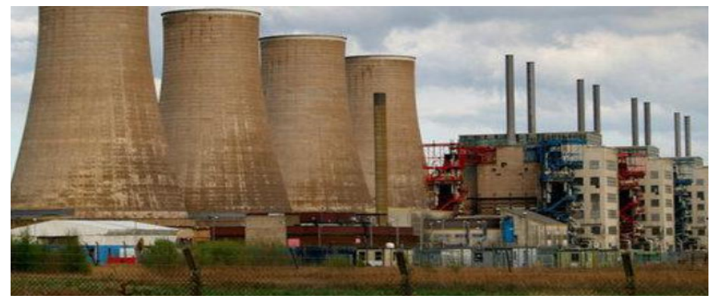
Figure No.1: Group of Natural draught cooling towers

- REVIEW OF LITERATURE:
The response of cooling towers is influenced by both vertical and circumferential wind distribution. The ultimate load-bearing capacity of the cooling tower shell is determined to be 1.925 times the design wind pressure corresponding to a wind velocity of 40.2 m/s (90 mph). Nonlinear behavior initiates with the formation of horizontal tension cracks at the windward meridian, occurring at 43% height of the cooling tower shell. Seismic analysis using enforced seismic design requirements of NDCT may utilize free vibration analysis techniques. The stress state within the cooling tower ranges from tension to compression. Wind vibration coefficients increase initially with height, then decrease, peaking at the top section (Parth.R.Chhaya et al 2014).

This paper focuses on thermal analysis of cooling towers, using Bellary Thermal Power Station (BTPS) cooling towers as a case study. Analysis is conducted using Staad. ProV8i software, assuming top-end freedom and base fixity. Material properties considered are Young’s modulus of 2.1 MPa, Poisson Ratio of 0.15, and RCC density of 25 kN/m3. Results include displacement in X, Y, Z directions, and maximum principal stress. Graphical plots depict the variation in displacement and maximum principal stress with thickness. Heat loss rate is influenced by atmospheric parameters like air temperature, water temperature, relative humidity, and heat loss rate. Thermal loading leads to increased displacement in X and Z directions with decreasing thickness and height, while displacement in Y direction increases with increasing thickness and height (Priya Kulkarni et al, 2015).
The study focuses on modal analysis of hyperbolic cooling towers, utilizing two existing towers from Bellary Thermal Power Station (BTPS) as case studies. ANSYS Software is employed for Finite Element Analysis (FEA), with boundary conditions set as top end free and bottom end fixed. Material properties of the cooling tower, such as Young’s Modulus (31 GPa), Poisson’s Ratio (0.15), and density of Reinforced Cement Concrete (RCC) (25 kN/m3), are considered. Analysis is conducted using 8-noded SHELL 93 elements to determine natural frequencies, maximum deflection, maximum principal stress and strain, and maximum Von Mises stress and strains. Graphical plots are generated to illustrate variations in maximum principal stress versus thickness, and maximum deflection versus thickness (Sachin Kulkarni et al, 2014).

Analysis results indicate that displacement, support reactions, support moments, stresses, and bending moments due to seismic loading on hyperbolic cooling towers are continuous functions of geometry parameters such as top diameter, throat diameter, and height. The seismic zone plays a significant role in the analysis. The study suggests that a tower with a thickness of 300 mm, throat diameter of 64 m, and height of 150 m is efficient, but if height extension is required, it should not exceed 159 m (as observed from actual work), with 170 m height considered critical. For seismic zones IV and V, the resultant nodal displacement decreases as the height and throat diameter of the structure increase. Cooling towers with a throat diameter of 64 m exhibit higher displacements compared to those with a 70 m throat diameter for thicknesses of 300 mm and 400 mm, respectively (Iqbal Hafeez Khan et al, 2015).

Overall, the analysis concludes that nodal displacement increases by 30% with increasing tower height, while it can be reduced by around 20-25% by increasing plate thickness. Mass participation exceeding 75% is obtained for all dominant modes. Plate stress variation is minimal (5%) with height and plate thickness increase. Additionally, the Critical Quelling Control (CQC) shear increases by around 35% with tower height and plate thickness increase. Considering cost effectiveness, the optimum height, plate thickness, and throat diameter are suggested as 250 m, 300 mm, and 60 m, respectively (Pujaa Venkataiah et al, 2016).
The analysis reveals that maximum displacement, support reactions, support moments, stresses, and bending moments in plates due to seismic loading, wind loading, and dead load (i.e., its self-weight) on a hyperbolic cooling tower are continuous functions of its geometry (top diameter, throat diameter, and height). The earthquake zone significantly influences the analysis. Consequently, it is observed that a thickness of 300 mm, a throat diameter of 60 m, and a height of 250 m are more efficient compared to other configurations. However, if height extension is necessary, it should not exceed 159 m (based on actual work), with 170 m being considered critical (Akash Goyal et al., 2017).

Ensuring the safety of hyperbolic cooling towers is vital for the continuous operations of a power plant. Site-specific factors such as wind and earthquake forces may govern the tower's design. A comparison of different analysis methods reveals that the structure's behavior under El-Centro earthquake using nonlinear dynamic time history analysis exhibits higher nodal drift compared to other methods. Percentage variations between different analysis methods are noted: 30% between El-Centro earthquake and response spectrum, 63% between response spectrum and time history, and 73% between El-Centro earthquake and time history. It is concluded that time history analysis predicts structural responses more accurately than equivalent static and response spectrum methods since it incorporates P-Δ effects and material and geometric nonlinearity, reflecting real structural behavior (Athira C R et al., 2016).

- CONCLUSIONS
The safety of hyperbolic cooling towers is important to the continuous operation of a power plant. Therefore the analysis is required to know maximum displacement, support reactions, support moments, stresses and bending moments in plates due to seismic loading, wind loading and dead load i.e. its self weight on a hyperbolic cooling tower is continuous function of geometry

- REFERENCES
1. Parth.R.Chhaya, Nizam.M.Mistry andAnuj.K.Chandiwala, “A Review On Effect Of Wind Loading On Natural Draught Hyperbolic Cooling Tower”, International Journal of Advance Engineering and Research Development, Volume 1, Issue 12, December -2014.
2. Priya Kulkarni and S. K. Kulkarni, “Thermal Effect on RCC Hyperbolic Cooling Tower”, International Journal of Innovative Research in Science, Engineering and Technology, Vol. 4, Issue 9, September 2015.
3. Sachin Kulkarni and Prof A.V. Kulkarni, “Modal Analysis Of Reinforced Concrete Cooling Towers”, International Journal of Advance Engineering and Research Development, Volume 1, Issue 12, December -2014.
4. Iqbal Hafeez Khan, Rakesh Patel and Aslam Hussain, “Parametric Analysis Of Hyperbolic Cooling Tower Under Seismic Loads Through Staad.Pro”, International Research Journal of Engineering and Technology (IRJET), Volume: 02 Issue: 09 | Dec-2015.
5. Pujaa Venkataiah and , P. Prakash, “Seismic Analysis and Design of a Hyperbolic Cooling Tower”, International journal of scientific engineering and technology research, Vol.05,Issue.12, May-2016, Pages:2413-2415.
6. Akash Goyal, A N Shankar and S K Sethy, “Parametric Analysis of Hyperbolic Cooling Tower under Seismic Loads, Wind Loads and Dead Load through Staad. Pro”, International Journal of Engineering Research & Science (IJOER), Vol-3, Issue-8, August- 2017.
7. Athira C R, Rahul K R, Reshma R Sivan, Seethu vijayan and Nithin V Sabu, “Linear and Nonlinear Performance Evaluation and Design of Cooling Tower at Dahej”, IOSR Journal of Mechanical and Civil Engineering (IOSR -JMCE), International Conference on Emerging Trends in Engineering & Management.
8. R. Purusothaman, “Planning, Designing And Analysing Of Cooling Tower”, International Journal of Advanced Research in Civil,Structural,Environmental and Infrastructure Engineering and Developing, Volume: 3, Issue: 1,Special Issue: 1 ,Mar,2018.
9. Dr. S. N. Tande and Snehal S. Chougule, “Linear and Nonlinear Behaviour of R. C. Cooling Tower under Earthquake Loading”, International Journal of Latest Trends in Engineering and Technology, 2(4), 2013, 370-379.
10. Shailesh S. Angalekar and Dr. A. B. Kulkarni, “Analysis of Natural Draught Hyperbolic Cooling Towers by Finite Element Method Using Equivalent Plate Concept”, International Journal of Research and Applications, 1(2), 144-148

