Revitalizing Tresses: A Comprehensive Review of Herbal Hair Serum
ABSTRACT:
Demand of Cosmetic in market increase day to day life & many People use regularly. Humans use various cosmetics to enhance beauty and elegance to look young and charming. Cosmetics thus play a vital role in human life. s serum moisture the skin and stimulate the growth of new hair more as compare to old. Hair is one of the primary parts of the body which acts as a protective appendage. Herbal cosmetics are mostly use because less negative effect & give more safe loss Problem find the ways to increase have development & prevent have loss.
In the mammalian system, the hair follicle is known to be the most significant organ that determines appearance, gender distinction, gives violent temperature protection, and plays a part in tone-defence. Soapnuts, also known as Reetha, have been used to make natural hair care cosmetics. This plants fruits contains saponin, which makes your hair healthy and dirt free. Neem Oil helps in preventing split-ends and reduces itchiness and inflammation that's caused by tangling of hair. Rosemary oil helps to strengthen hair structure by improving scalp health and enhancing hair's tensile bond and elasticity. Almond oil would help prevent split ends and dryness, and would thus help you have longer and shinier growth.
Vitamin E is also useful in treating dry and damaged hair, provides hydration to the scalp and henna is useful for shine and colouring to hair. Triethanolamine is use as an emulsifying agent and pH balancer, it is often chosen to promote healthy hair growth and cleanliness Rose Water is a mild astringent which may help to reduce oiliness and dandruff and it is a component of perfume.

Keywords – cosmetics ,hair , serum, moisturising, scalp , rosemary .

INTRODUCTION_{[1,2]}

In recent years, the pursuit of luscious, healthy locks has led many individuals to explore natural alternatives for hair care. Amidst this trend, herbal hair serums have emerged as promising solutions, offering a blend of botanical extracts and potent nutrients to nourish and rejuvenate hair from root to tip. Unlike conventional hair products laden with synthetic chemicals, herbal hair serums harness the power of nature's bounty, incorporating ingredients renowned for their therapeutic properties. From revitalizing scalp health to promoting hair growth and restoring shine, these serums embody a holistic approach to hair care, aligning with the growing demand for clean, eco-friendly beauty solutions.
This review endeavors to delve into the efficacy, safety, and user experience of various herbal hair serums available in the market today. By analyzing ingredient compositions, exploring scientific research, and aggregating consumer feedback, we aim to provide readers with an informed perspective on the potential benefits and limitations of incorporating herbal hair serums into their beauty regimen.
Throughout this exploration, we will assess key factors such as formulation transparency, sustainability practices, and tangible results to empower readers in making well-informed choices for their hair care needs. As the demand for natural beauty solutions continues to soar, understanding the nuances of herbal hair serums becomes paramount in navigating the vast landscape of hair care products.

Objective _{[2,23]}
The objectives of herbal hair serums typically include:

Nourishment: Herbal hair serums aim to provide essential nutrients and hydration to the hair follicles, scalp, and hair strands. This nourishment helps improve the overall health and appearance of the hair, making it softer, smoother, and more manageable.

Strengthening: Herbal hair serums often contain ingredients that strengthen the hair shaft and reduce breakage. By fortifying the hair strands, these serums help prevent split ends and promote stronger, healthier hair growth over time

Repair and Restoration: Many herbal hair serums are formulated to repair damage caused by heat styling, chemical treatments, and environmental factors. These serums may contain ingredients that help restore moisture, elasticity, and shine to damaged or dull hair.

Scalp Health: Herbal hair serums can also benefit the scalp by soothing irritation, reducing inflammation, and promoting a balanced scalp environment. This can help alleviate symptoms of dandruff, itching, and dryness, creating a healthier foundation for hair growth

Promotion of Hair Growth: Some herbal hair serums are specifically designed to stimulate hair growth and combat hair loss. These serums may contain ingredients that improve blood circulation to the scalp, nourish the hair follicles, and encourage the growth of new hair strands.

Protection: Herbal hair serums often include antioxidants and UV filters to protect the hair and scalp from environmental damage, such as UV radiation, pollution, and free radicals. This protection helps maintain the health and integrity of the hair, preventing premature aging and damage

Highlights _{[2,3,27]}
- Hair serum is the styling product that coats the surface of the hair known as hair serum.
- It is basically a hair care product in liquid form, its consistency thicker than water.
- Hair serum is not just meant for hair styling. multiple hair concerns like dry hair, dull hair, and
- unmanageable hair .
- There are different types of hair serums for different hair goals. Depending on the products ingredients a hair serum may minimizes frizz, make shiny and straightens the hair.
- intended to be used on wet hair. Suitable types of hairs for using hair serum: Straight, Wavy, Curly.
Benefits _{[4,5,12,27]}

- Natural Ingredients: Herbal hair serums typically contain natural ingredients such as botanical extracts, essential oils, and vitamins. These ingredients are often gentler on the scalp and hair compared to synthetic chemicals, reducing the risk of irritation or adverse reactions.

- Nourishment and Hydration: Herbal hair serums are formulated to nourish and hydrate the hair follicles and scalp. Ingredients like aloe vera help moisturize the hair, making it softer, smoother, and more manageable.

- Strengthening and Repair: Many herbal hair serums contain ingredients known for their strengthening and repairing properties.

- Stimulated Hair Growth: Certain herbal ingredients are believed to promote hair growth by stimulating blood circulation to the scalp and nourishing the hair follicles. Ingredients like , rosemary oil rose water ,reetha may help encourage healthy hair growth and reduce hair loss

- Antioxidant Protection: Herbal hair serums often contain antioxidants that help protect the hair and scalp from environmental damage, such as UV radiation and pollution. Antioxidant-rich ingredients like vitamin E can help prevent oxidative stress and keep the hair looking healthy and vibrant.

- Soothing Scalp Benefits: Many herbal ingredients have soothing and anti-inflammatory properties that can help calm an irritated or itchy scalp.

- Eco-Friendly and Sustainable: Herbal hair serums are often produced using sustainable practices and biodegradable ingredients, making them more environmentally friendly than some conventional hair care products. Additionally, many herbal hair serums come in recyclable packaging, further reducing their environmental impact.
Side effects _{[6,8]}
- Excessive and frequent application can cause the hair to become dry and unhealthy.
- Using the serum on the scalp may cause irritation
- Avoid applying scalp cream since it could cause oiliness or inflammation.
- Some potential side effects of herbal hair serums may include allergic reactions, scalp irritation, or hair damage if the ingredients are not suitable for your specific hair type or if you have sensitivities to certain botanicals.
- Always perform a patch test before using a new product and consult with a dermatologist or healthcare professional if you experience any adverse reactions.
HERBAL INGREDIENTS _{[11-16]}
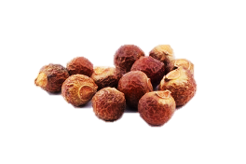
- REETHA

- SYNONYM- Indian soapberry, washnut, ritha
- BIOLOGICAL NAME- Sapindus mukorossi
- FAMILY - Sapindaceae
- USES – used as Surfactant , Cleanser, antidandruff
- Henna
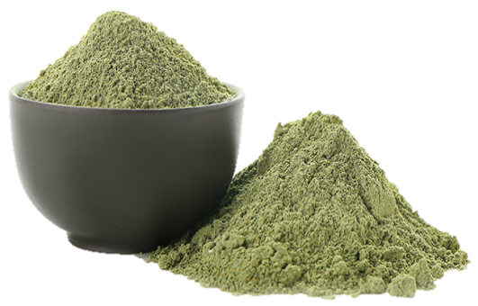

- SYNONYM- henna, mehendi
- BIOLOGICAL NAME- Law Sonia inermis
- FAMILY- Lythraceae
- USES- as dye for skin, hair
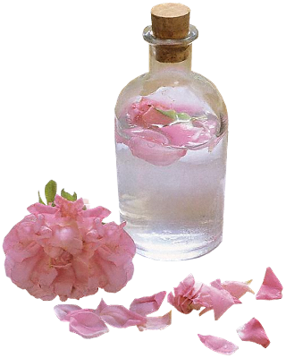
3. Rose water

Rosewater is used as an emollient, and sometimes used in cosmetics such as cold creams, toners and face wash. Also as a perfume and moisturizer. Rose Water is have a mild astringent property which help to reduce oiliness and dandruff. It has anti-inflammatory properties, which may make it beneficial for scalp conditions .women with curly hair swear by rose water's ability to calm down frizz and add improve shine. It’s also component of perfume.
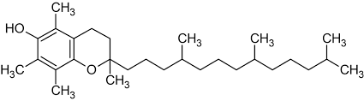
4. Vitamin E
C₂₉H₅₀O₂

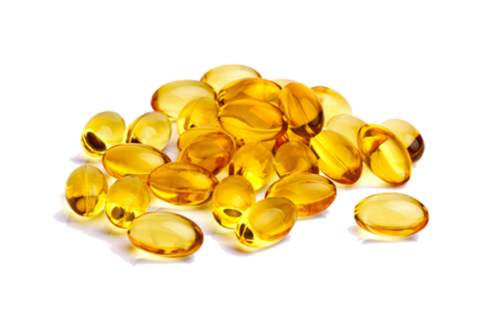

Vitamin E is a generic name used for class of eight chemicals, comprising derivatives of tocopherol and tocotrienol. Tocopherols and tocotrienols are found in naturally occurring vitamin E in alpha, beta, gamma, and delta isomers according to methyl and hydroxyl substitutions in their phenolic rings.
The chromanol double ring in vitamin E has a hydrophobic side chain to permeate membranes and a hydroxyl group to lower free radicals.
Vitamin E oil minimizes breakage, traps moisture, and shields hair from damage. Because vitamin E contains naturally occurring antioxidants that may promote hair growth, it may help support a healthy crown and hair. Antioxidants and vitamins can minimise the amount of free radicals and oxidative stress that cause the hair follicle cells deterioration
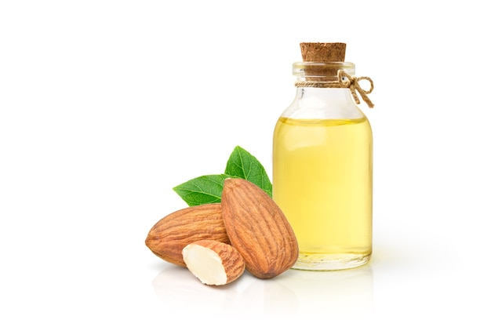
5. Almond oil

- Synonym: Jordan almond
- Biological name: Prunus amygdalus
- Family: prunus
- Uses: Promotes hair growth ,Scalp health and Hair softening
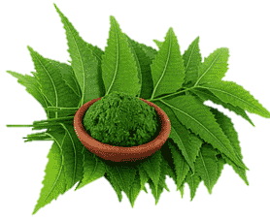
6. Neem:

- Synonym
- Biological name: Azadirachta indica
- Family: Meliaceae
- Uses:
- Insecticide
- Fungicide
- Used in shampoos for treating dandruff and in soaps or creams for skin conditions
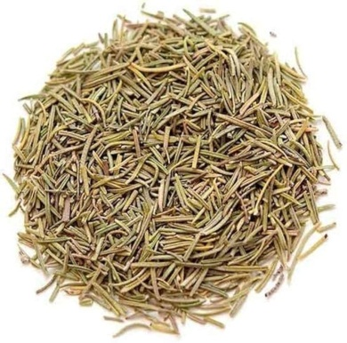
7. Rosemary:

Synonym : Gulmehendi
Biological name: Salvia rosmarinus
Family: Lamiaceae
Uses: Rosemary is believed to promote hair growth by improving blood circulation to the scalp, potentially encouraging the growth of stronger and healthier hair.
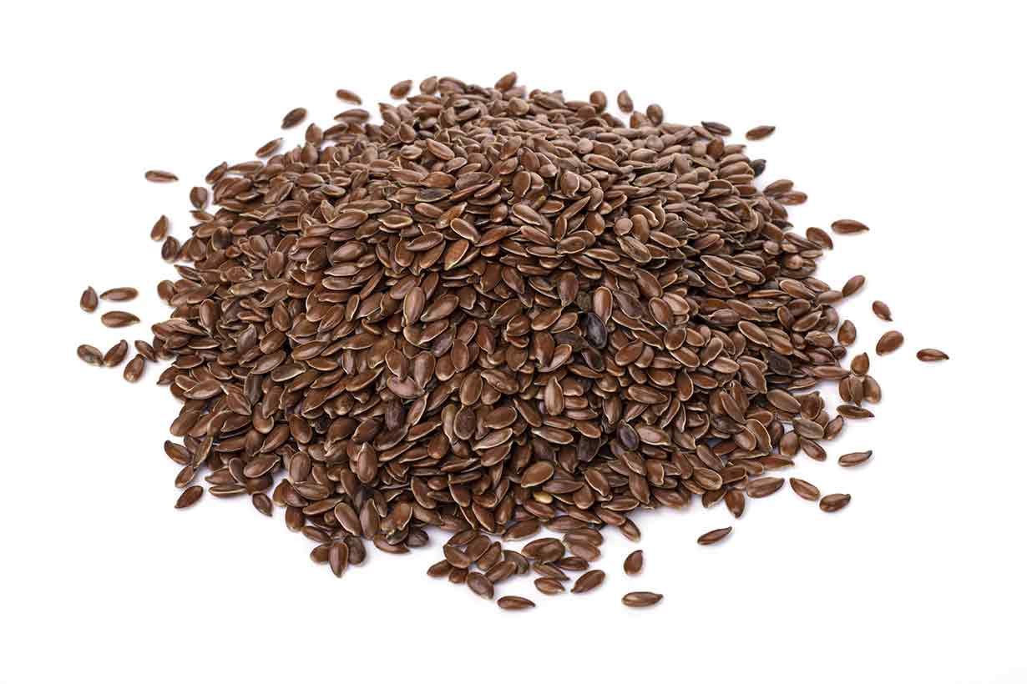
8. Flaxseed

- Synonym - linseed
- Biological name- Linum usitatissimum (Linn.)
- Family- Linaceae
- Uses: improve scalp condition, strengthen the hair shaft, and enhance shine and manageability.
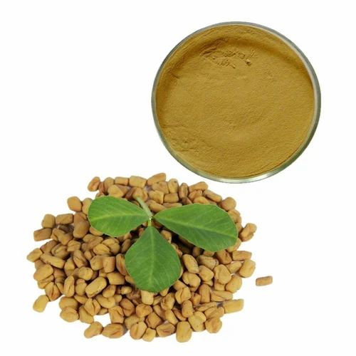
9. Fenugreek

- Synonym – Methi
- Biological name-Trigonella forum
- Family- Fabaceae
- Uses: Fenugreek seeds are rich in protein, and nicotinic acid content, renowned for their capacity to fight hair fall and dandruff
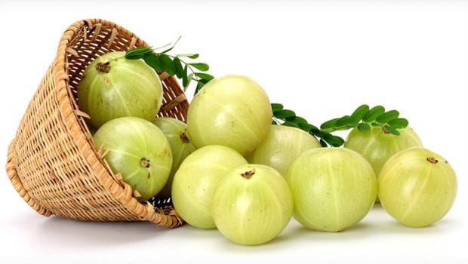
10. Amla powder

• Synonym: amla, Indian goose berry
• Biological Name: Phyllanthus emblica linn
• Family: phyllanthaceae
- Uses
It used for nourishing the scalp
Strengthens hair and root
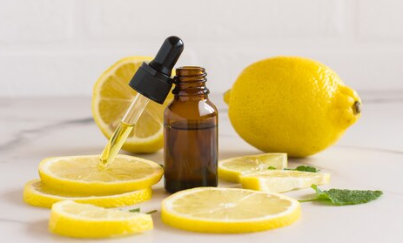
11. Citrous Oil

• Synonym: bitter orange peel, Seville orange
• Biological Name: citrus aurantium Linn
• Family: Rutaceae
- Uses : Protect the hair from UV rays and Help to reduce dandruff and relive from itchy scalp

EVALUATION PARAMETERS _{[17,18,19,20]}
Following are the general parameters for evaluation of herbal serum
- General Appearance Test:Color: Evaluate the color of the serum.Odor: Assess the scent of the serum.Texture: Examine the consistency and feel of the serum

- pH Test: Determine the pH of the serum to ensure it aligns with the ideal pH range for hair care products, which is between 4.5 and 7.

- Stability Test: Store the hair serum for a minimum of 7 days to assess its stability. After this period, recheck the pH and viscosity, comparing the results with initial data. Consistency in values indicates formulation stability

- Microbial Test: After 7 days, observe the serum for microbial contamination, particularly fungal growth, after 24 hours

- Viscosity Measurement: Utilize a viscometer to determine the viscosity of the serum.

- Homogeneity Test: Apply a clean, dry slide with the serum and cover it with a glass cover. Examine the appearance under light for any coarse particles

- Homogeneity Assessment: Visually inspect the herbal hair serum for uniformity, ensuring the absence of lumps, flocculates, or aggregates.\

- Spreadability Assessment : Spreadability was evaluated using a parallel plate method commonly employed for semi-solid preparations. One gram of hair serum was placed between two horizontal plates measuring 20x20 cm, with the upper plate weighing 125 g. After 1 minute, the spread diameter was measured. Spreadability (S) was calculated using the formula:
S = ML/T,
where M represents the weight in the pan (attached to the upper slide),
L denotes the distance moved by the glass slide,
T signifies the time (in seconds) taken to completely separate the slides.

- Skin Sensitivity Test (Draize Skin Test)
The Draize skin test was conducted as an initial examination to detect any potential allergic reactions caused by the hair serum. The back was shaved on both the right and left sides and divided into 6 regions, each measuring 4x4 cm in a rectangular shape with a 1.5 cm distance between squares. Each square was numbered from 1 to 6. Observations were recorded before hair serum application and after shaving.
- Sterility Test
Sterility testing involved loading sterile discs with 1% hair serum and incubating them for 24 hours at 32°C on nutrient agar to ensure sterility..
- Emolliency Determination
Emolliency, slipperiness, and the amount of residue left after the application of a fixed amount of serum were assessed

CONCLUSION
In conclusion, after reviewing various herbal hair serums, it's evident that these products offer promising benefits such as nourishing the scalp, promoting hair growth, and improving overall hair health. The blend of botanical extracts not only addresses specific hair concerns but also contributes to overall scalp health. Carefully selected herbs work synergistically to nourish the hair from root to tip, providing essential nutrients and moisture. Reetha, Fenugreek (methi), Rosemary, amla, citrus etc provides beneficial nutrition to hairs for smooth shiny and dandruff free hairs. However, it's essential to choose a serum that aligns with your specific hair needs and preferences. It’s important to conduct thorough research, read reviews, and consider consulting with a dermatologist to review possible side effects. By incorporating a high-quality herbal hair serum on hair care routine, potentially achieve healthier, more vibrant hair. We must trust in the potency of nature for a truly enriching hair care journey.

REFERENCE
- Patni P., Varghese D., Balekar N. and Jain D.K. Formulation and evaluation of herbal hair oil For alopecia management. Planta Indica. 2(3): 27-30, 2006
- Adirajan N., Ravikumar T., SShanmugasunda Ram N. and Babu M. In vivo and in vitro evaluation of hair growth potential of Hibiscus rosa-Sinensis Linn. J Ethanpharm. 88: 235-239, 2003
- Purwal, L., Gupta, S. B. N. and Pande, M.S. Development and Evaluation of Herbal Formulations for hair growth, E- Journal of Chemistry, Vol-5, NO-1, 34-38, 2008.
- Gloor M, Fitchtler C.The basic of protein chemistry, J. Cosmetology, 3, p.193-194, 1973.
- Rathi V., Rathi J.C., Tamizharasi S. and Pathak A.K. Plants used for hair growth promotion: A Review. Phcog Rev. 2(3): 165-167, 2008
- Price VH. Treatment of hair loss. N Eng. J Med. 1999; 341(13):964–973. Doi: 10.1056/NEJM199909233411307
- Sinclair R. Male pattern androgenetic alopecia. BMJ. 1998; 317 (7162):865–869. Doi:10.1136/bmj.317.7162.865
- Orasan MS, Roman II, Coneac A, Muresan A, Orasan RI. Hair loss and regeneration performed on animal models. Clujul Med. 2016; 89 (3):327.
- Rogers NE, Avram MR. Medical treatments for male and female Pattern hair loss. J Am Acad Dermatol. 2008; 59(4):547–566.
- Complementary A. Or Integrative Health: What’s in a Name? NCCIH. National Center for Complementary and Integrative Health NCCIH; 2016.
- Hosking A-M, Juhasz M, Mesinkovska NA. Complementary and Alternative treatments for alopecia: a comprehensive review. Skin Appendage Disorders. 2019; 5(2):72–89. Doi: 10.1159/00049203
- Soleymani T, Shapiro J. The Infatuation with Biotin Supplementation: is There Truth behind Its Rising Popularity? A Comparative Analysis of Clinical Efficacy versus Social
- Dawber R, Rundegren J. Hypertrichosis in females applying minoxidil Topical solution and in normal controls. J Eur Acad Dermatol Venereol. 2003; 17(3):271–275. Doi:10.1046/j.1468-3083.2003.00621.x
- Upadhyay, A. & Singh, D. K. (2012). "Pharmacological effects of Sapindus mukorossi". Revista do Instituto de Medicina Tropical de São Paulo. 54 (5): 273–280. Doi: 10.1590/s0036-46652012000500007. PMID 22983291.
- Kirsten Nunez, November 2020, Hair Serum Benefits and How to Use,https://www.healthline.com/health/how-to-use- serum-for-hair.
- Sneha Kalra, March 2020, Hair care: Advantages, disadvantages and everything you need to know about HairSerums,https://www.pinkvilla.com/fashion/beauty/hair-care-advantages-disadvantages
- Aruna V, Amruthavalli GV, Gayathri R. Hair root activation by anagen grow- an herbal hair growth serum. Dermatol & Cosmet 2019; 1(3): 56-9.
- Reddy TUK, Sindhu G, Rajesh S, Aruna B, Rani KSS. Preparation and evaluation ofherbal hair oil. Indo Am. j. pharm. Sci 2017; 4(06): 1540-6.
- Shah RR, Mohite SA, Patel NR. Preparation and evaluation ofpolyherbal hair oil- an effective cosmetic. Asian J Pharm Res 2018; 8(1): 36-8.[http://dx.doi.org/10.5958/2231-5691.2018.00007.2]
- Sumangala BK, Kalpana P, Aishwarya T, Krithika G. Evaluation ofherbal formulations on fungal pathogens of plants: A case study. ActaScientific Agriculture 2019; 3: 122-4. [http://dx.doi.org/10.31080/ASAG.2019.03.0734
- Viswanad V, Aleykutty NA, Jayakar B, Zacharia SM, Thomas L.Development and evaluation of antimicrobial herbal formulationscontaining the methanolic extract of Samadera indica for skindiseases. J Adv Pharm Technol Res 2012; 3(2): 106-11.[http://dx.doi.org/10.4103/2231-4040.97285] [PMID: 22837958]
- Department of Medical Sciences. Thai Herbal Pharmacopoeia 2019. Nonthaburi Province: Department of Medical Sciences; 2019. Royal Thai Government Gazette. Herbal Products Enactment, Bangkok; 2019 1. Joey E Lai Cheong, John A McGrath (2009) Structure and function of skin, hair and nails. Medicine 37(5): 223-226
- Sakuldach M, Phakdeekul W, Kedthongma Comparisons Health Literacy to the Performance of Volunteers in Elderly Care, Pad Subdistrict Municipality, Kham Ta Kla District, Sakon Nakhon Province. Test EngManagt. 2020; 83:16398-16400.
- Anusha R, Akhila N, Nikhitha J,Harish K, Shaikh AR, Sony Y et al. Formulation and evaluation of herbal hair serum-a review. Int J Basic Clin Pharmacol 2023; 12: 759-65.
- Gholop C, Dhale P, Badhekar A, Shinde PM, Datkhile S. Review on Formulation and Evaluation of Herbal Hair serum. IJARSCT. 2022 ;(2):222-5
- Wijaya WH, Mun'im A, Djajadisastra J. Effectivenesstest of fenugreek seed (Trigonella foenum-graecum I.)Extract hair tonic in hair growth activity. Int J CurrRes. 2013;5(11):3453-60
- Ruchi Tiwari,Gaurav Tiwari1, Ajeet Yadav and Vadivelan Ramachandran, Development and Evaluation of Herbal Hair Serum: A traditional way to Improve Hair Quality, research article, The Open Dermatology Journal,2021,52-58
- Shivshankar jaganath shinde, Kute.C.G..,and Dr.Prachi Udapurkar, Formulation and Evaluation of Herbal Hair Serum, 3 IJCRT | Volume 11, Issue 6 June 2023, ISSN: 2320-2882
- Shah RR, Mohite SA, Patel NR. Preparation and evaluation of polyherbal hair oil- aneffective cosmetic. Asian J Pharm Res 2018; 8(1): 36-8.34.Cross Ref Gautam S, Dwivedi S, Dubey K, Joshi H. Formulation and evaluation of herbal hair oil. Int J Chem Sci 2012; 10(1):349-53
- Pawar Shankar ,Shinde Pallavi .M. ,Datkhile Sachin .V. ,Review on Formulation and Evaluation of Herbal Hair Serum, International Journal of Research in Engineering and Science (IJRES), ISSN (Online): 2320-9364 Volume 10 Issue 11 , November 2022 ǁ PP. 13-16

