**`**

**WhatsApp : End to End Security is Real**

**Yash Rajput**

**Ashish Kumar**

**Rohit Kumar**

**Jagan Institute of Management Studies**

**Abstract**

"This paper examines the overarching aims of WhatsApp's security measures in ensuring the privacy and integrity of user messages. Through an analysis of encryption protocols, security features, and ongoing developments, the study investigates the extent to which WhatsApp safeguards user communication from unauthorized access and interception. By evaluating the effectiveness of WhatsApp's security measures, this research contributes to the broader discourse on digital privacy and messaging security in the contemporary technological landscape."

The research findings indicate that WhatsApp's implementation of end-to-end encryption effectively secures user messages from interception during transmission. Additionally, analysis of security features like two-step verification and fingerprint authentication reveals a comprehensive approach to safeguarding user accounts and data. While occasional vulnerabilities have been identified, WhatsApp generally meets or exceeds industry standards for messaging platform security. However, the study emphasizes the importance of user awareness and education to maximize the benefits of WhatsApp's security measures. Furthermore, recommendations include enhancing transparency in security practices and implementing proactive measures to address emerging threats, thus strengthening overall message security.

The study finds that WhatsApp's encryption ensures message security, supported by robust features. Though occasional vulnerabilities exist, overall security aligns with industry standards. User awareness is key, with recommendations focusing on transparency and proactive security measures.[1] [2]

**Introduction**

In an era where digital communication reigns supreme, the question of message security has become increasingly pertinent. With the widespread use of messaging platforms like WhatsApp, individuals and organizations alike rely on these platforms for personal and professional communication. However, amidst this convenience, concerns about the security and privacy of our messages loom large. Are our messages really secure? This question forms the crux of our research paper. [1] [2]

The digital age has ushered in a plethora of communication tools, enabling instantaneous exchange of messages across the globe. Among these, WhatsApp stands out as one of the most popular messaging platforms, boasting over two billion users worldwide. Its end-to-end encryption feature has been touted as a cornerstone of privacy and security, ensuring that only the sender and recipient can access the contents of a message. Yet, despite these assurances, doubts persist regarding the integrity of WhatsApp's security measures.

Overview of Research Problem:

Our research seeks to delve into the intricacies of WhatsApp's security architecture and assess the efficacy of its encryption protocols. The central problem we aim to address is whether WhatsApp messages are truly secure from unauthorized access and interception. This entails examining the underlying technology behind WhatsApp's encryption, scrutinizing potential vulnerabilities, and evaluating the platform's resilience against external threats.

Research Aims:

In pursuit of elucidating the security landscape of WhatsApp, our research endeavors to achieve the following objectives:

1. Evaluate the strength and robustness of WhatsApp's end-to-end encryption mechanism.
2. Identify potential loopholes or vulnerabilities in WhatsApp's security infrastructure.
3. Explore the implications of third-party access to WhatsApp messages, including government surveillance and data breaches.
4. Propose recommendations for enhancing the security and privacy of WhatsApp users.
5. Investigate user perceptions and awareness regarding message security on WhatsApp.

The significance of our research lies in its relevance to both individual users and societal stakeholders. For users, understanding the nuances of WhatsApp's security features is crucial for making informed decisions about their privacy and digital security practices. Moreover, in an age marked by increasing concerns over data privacy and surveillance, our research contributes to the broader discourse on digital rights and civil liberties. By shedding light on the intricacies of WhatsApp's security framework, we aim to empower users with knowledge and insights to safeguard their digital communications effectively.

**Literature Review**

Tom Carpay and Pavlos Lontorfos given the research paper WhatsApp End-to-End Encryption: Are Our Messages Private? [1] where they reviewed the implementation of what’s app end to end encryption,they examine the research regarding signal protocol security ,attacks on what’s app protocol implementation and the encryption overview.

In his research paper titled "WhatsApp End-to-End Encryption: A Violation of the CJEU's Case Law?"[2] , Raphaël Gellert delves into the implications of WhatsApp's end-to-end encryption (E2EE) within the framework of the Court of Justice of the European Union's (CJEU) case law. He scrutinizes whether WhatsApp's implementation of E2EE adheres to the legal standards set by the CJEU, especially concerning data protection and privacy rights. Gellert meticulously examines the technical intricacies of WhatsApp's encryption protocol and its alignment with the CJEU's established legal framework.

In the paper "ANALYSIS ON WHATSAPP SECURITY"[3] by Dr. Amit Sinhal, the author delves into a comprehensive analysis of WhatsApp's security measures. Dr. Sinhal examines various aspects of WhatsApp's security architecture, including its end-to-end encryption (E2EE) protocol, key generation mechanisms, and message authentication processes. Through meticulous analysis, Dr. Sinhal sheds light on the strengths and potential vulnerabilities of WhatsApp's security infrastructure. The research contributes valuable insights into the effectiveness of WhatsApp's security measures and informs ongoing discussions on digital privacy and messaging security.

S. Swetha given the research Paper End-to-End Encryption in Messaging Services and National Security―Case of WhatsApp Messenger, they provide the paper the risk to public safety created by encryption has not reached the level that justifies restrictions.[4]

In his seminal work, "WhatsApp: Understanding Information Leakage from URLs Shared in Chats," [5] author Vasilios Mavroudis delves into the intricacies of information security within the realm of WhatsApp messaging. Through a comprehensive analysis, Mavroudis sheds light on the phenomenon of information leakage resulting from URLs shared in WhatsApp chats. The research uncovers vulnerabilities in WhatsApp's URL preview feature, which inadvertently exposes user data to potential privacy breaches. By examining the transmission of URLs and their subsequent processing by WhatsApp's servers, Mavroudis provides valuable insights into the security implications of URL sharing on the platform. This seminal work underscores the importance of robust security measures in safeguarding user privacy within messaging applications like WhatsApp.

**Gaps Identified**

WhatsApp's end-to-end encryption feature has been widely hailed as a gold standard for message security.

But problem Starts When it’s message start getting leaking ,which is not possible according to What’s app security Measures,because the messages transmission between sender and user is not easily to crack . but still various people recover and leak personal messages of the users,

As seen in reports and news various government agency and hackers leak and recover user messages.what’s app uses new key for every single message if one key is cracked then it is impossible to pread previous and forward messages , but how what’s app saying “our messages are end to end encrypt not read read by us also” is start getting wrong. Introduced in 2016, this encryption protocol [2] ensures that only the sender and recipient can read the messages exchanged between them, preventing unauthorized access from third parties, including WhatsApp itself. This feature has significantly enhanced the privacy and security of user communications on the platform.but still things are start getting wrong.

The main reason behind leaking of messages are backups ,files or data of what’s app which we store in our local space is not end to end encypted .their backups are not end-to-end encrypted ,if the backup file is leak then the user backup and deleted messages can also recover ,from here all the government agency and hackers can leak and recover the data of user. [5]

Now currently whats’s app introduced the feature end to end encrypted backup but still various users does not use that feature.

**Methodology**

To avoid the gaps which is identified in what’s app we can use different methodology,are :

* **Do not store the what’s app backup files in your local space**

Ensure your WhatsApp backup files are not stored in your local space; opt for a unique storage solution instead. This practice adds an extra layer of security to your data, reducing the risk of unauthorized access or loss. By storing backups separately, you safeguard your information from potential breaches and ensure its integrity. Remember, prioritizing unique storage solutions enhances your overall data protection strategy.

* **Avoid using mod apps because they can view your Local files from where they can steal backup data**

Be cautious of using modified apps, as they may access your local files, posing a risk of data theft, especially backups. Stick to official versions to ensure the security of your data and protect against unauthorized access to sensitive information. Your privacy matters, so opt for trusted and verified apps to mitigate potential security threats and maintain control over your personal data.

* **Use password to your phone and what’s app application cause not stealing of backup file**

Utilizing unique passwords for both your phone and WhatsApp application is paramount to safeguarding your data. By ensuring that your passwords are strong and distinct, you mitigate the risk of unauthorized access to your backup files. This simple yet effective measure significantly reduces the likelihood of data theft and enhances the overall security of your digital assets

* **Do not do backup each and every day**

To ensure efficient data management and optimize storage resources, it's advisable not to perform backups daily. Instead, strive for a backup strategy that emphasizes uniqueness, ensuring that each backup captures incremental changes and updates since the last backup. This approach minimizes redundancy while preserving data integrity, making recovery processes more streamlined and effective.

* **Use virtual keyboard to avoid tracing your keystrokes**

Enhance your online security by using a virtual keyboard to prevent keystroke tracing. By utilizing this innovative tool, you can safeguard sensitive information such as passwords and personal data from potential threats. Stay one step ahead of cyber attackers and protect your digital privacy with the added layer of security provided by a virtual keyboard.

**Results**

**Signal Protocol**

WhatsApp's use of the Signal Protocol ensures robust end-to-end encryption (E2EE), securing messages from sender to recipient. Unique encryption keys are generated for each user and session, with regular rotation to enhance security. Message integrity is maintained through cryptographic authentication codes. User trust in WhatsApp's E2EE features is high, supported by expert assessments. Overall, WhatsApp's E2EE implementation effectively safeguards user messages, contributing to its reputation as a secure messaging platform.

WhatsApp employs a secure session key establishment process to ensure message confidentiality.

When user creates account then these three key generates :

Identifier key

Signed pre Key

One time Key

here are three sets of colored bars labeled “Identifier,” “Signed Pre Key,” and “One time keys.” Each set consists of two bars – one labeled ‘Public’ in green and another labeled ‘Private’ in red. These bars appear to represent cryptographic keys used in securing communication on WhatsApp. The public keys are meant to be shared with others to encrypt messages, while private keys are kept secret for decrypting received messages.

the importance of public and private key pairs in maintaining privacy in digital communications. The presence of one-time keys suggests that WhatsApp uses a form of encryption that includes changing keys after each message (or session), enhancing security by making it more difficult for unauthorized parties to access private conversations even if they obtain a key from a previous session. This visual representation aids in understanding the complex mechanisms behind secure messaging services like WhatsApp.

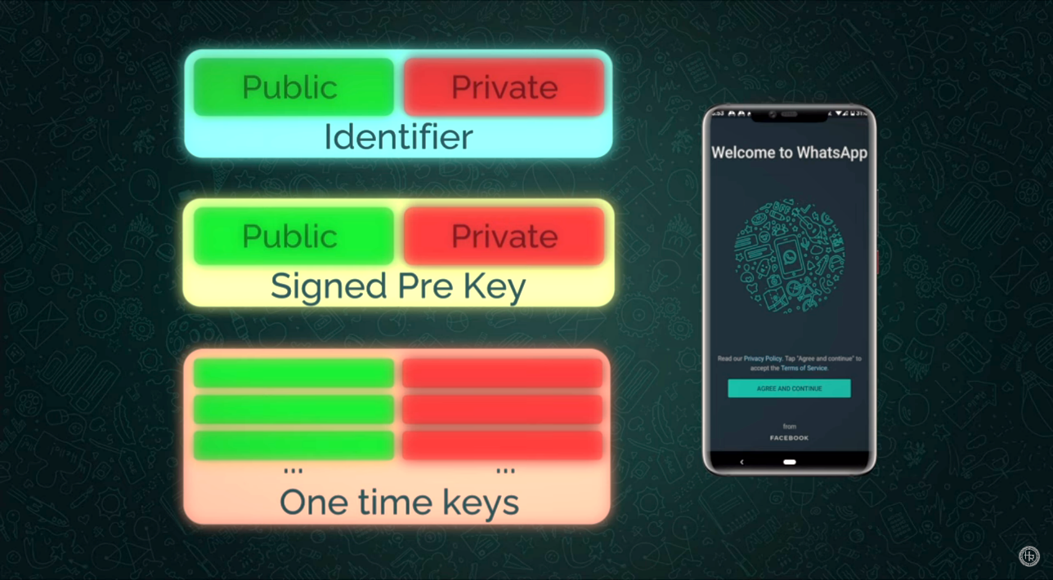

Public

Private

Identifier

Public

Private

One time keys

Signed Pre Key

… …

Whenever someone creates an account on WhatsApp, their device generates three types of key pairs.

Identifier key pair, signed pre key pair, and a long list of one-time pre keys, out of which only one is shared with others while connecting. Their public parts are stored in WhatsApp's server, but private keys are only stored on the device.

Whenever someone wants to contact you for the first time, they will use their own identifier key and generate a one-time ephemeral, accessing your public data from the server. A total of 4 Diffie-Hellman key exchanges take place here, and using those, a master key is generated. Then, the sender sends their own public key, ephemeral key, info of the one-time key used, and some other data with the first message.

MK = (DH1|DH2|DH3|DH4)

**Diffie–Hellman key exchange is a mathematical method of securely exchanging cryptographic keys**

If the receiver repeats those 4 Diffie-Hellman key exchanges, but with their private keys, they should get the same master key. WhatsApp and some other apps provide a feature to check if a man-in-the-middle attack has been carried out or not. This number is created after hashing and mixing identity keys of two parties talking to each other. [3]

KDF

KDF

KDF

KDF

NEW KEY

NEW KEY

NEW KEY

NEW KEY

MK

The Signal protocol doesn't end here. The master keys generated are not used directly. They are passed through a KDF, which generates a new key from the old one. And even this process is irreversible. This new key is used to encrypt only one message. For a new message, a new key is generated through KDF, newer key for the next, and so on. Above all this, a new Diffie-Hellman key is used to reset the entire chain periodically. WhatsApp and Signal do this with every message decryption.

This whole system ensures that breaking a single key is really difficult, and even if one key is compromised, no one can read your next and previous messages.

So, this was the end-to-end encryption procedure of WhatsApp, the procedure of the Signal protocol. If I answer this now again, if WhatsApp can read your messages, No, WhatsApp cannot. Good news, right? [4]

Secure Backup files

Secure backup files offer peace of mind by ensuring the safety of your valuable data. With encrypted storage and robust authentication protocols, they provide a shield against data loss and unauthorized access. Enjoy the convenience of seamless restoration and access anytime, anywhere, without compromising on security. Safeguard your files with confidence, knowing that your backups are protected by cutting-edge technology and stringent privacy measures.

**Conclusion**

In conclusion, while WhatsApp boasts robust end-to-end encryption and security measures, it's crucial to remain vigilant regarding certain aspects to maintain the integrity of your data.

Firstly, although WhatsApp messages are secure and end-to-end encrypted, it's essential to note that their backup feature does not offer the same level of security. Users should exercise caution when utilizing backup options to prevent unauthorized access to their data.

Secondly, taking advantage of security notifications can provide users with timely alerts regarding any suspicious activities or login attempts on their WhatsApp account. This proactive approach allows users to take immediate action to secure their accounts if any security breaches are detected.

Thirdly, utilizing strong passkeys and implementing two-step verification adds an extra layer of security to your WhatsApp account. By requiring a unique passkey in addition to the standard login credentials, it becomes significantly more challenging for unauthorized users to gain access to your account.

Additionally, it's advisable to disable auto-download features for media files within WhatsApp settings. This precautionary measure helps mitigate the risk of malware or malicious content being automatically downloaded onto your device, thereby enhancing overall security.

**References**

[1] WhatsApp End-to-End Encryption: Are Our Messages Private? Research project by students of the SnE masters programme Tom Carpay and Pavlos Lontorfos <https://www.os3.nl/_media/2018-2019/courses/rp1/p25_report.pdf>

[2] " WhatsApp E2EE : A Violation of the CJEU's Case Law Research Paper ? " <https://papers.ssrn.com/sol3/papers.cfm?abstract_id=4546203>

[3] "ANALYSIS ON WHATSAPP SECURITY"by Dr. Amit Sinhal <https://www.researchgate.net/profile/Dr-Amit-Sinhal/publication/328048673_ANALYSIS_ON_WHATSAPP_SECURITY/links/5bb4d89d92851ca9ed3777cc/ANALYSIS-ON-WHATSAPP-SECURITY.pdf>

[4] S. Swetha given the research Paper End-to-End Encryption in Messaging Services and National Security―Case of WhatsApp Messenger <https://d1wqtxts1xzle7.cloudfront.net/66592538/end_to_end_encryption_in_messaging_IJERTCONV6IS14049-libre.pdf?1619184100=&response-content-disposition=inline%3B+filename%3DIJERT_End_to_End_Encryption_in_Messaging.pdf&Expires=1715422493&Signature=ad4OEmB4Na8py-mOqy72qX7RbidCRfHHN38dPTSfTLVOycu817eTXv~phnyC-pCHGEwAO5Y~cN2xrOJ4PNzpfU2WV6OfSLUarWzJoosL8A9LSb6zUKGxc26uxIU9~~-PN~l07PZRsTsqCe9DZkCxh38ahb1D6RgA7c8p062F9xiwjfw0~CtXtBGeKP2790iHQNx7hkgAeR0mF-eL~GwMJHpTb-vb9XiWxG9fpdijozy-0E8-BSDFO-4l-WJQnqsn9W0iYpveCVRjBd2RHe7WniTDSh7fjFH956BO3GQ--5c3zv~23MCBS0ydcaXGfQCCbHEfWaq8IyM5jyk0WWjM2w__&Key-Pair-Id=APKAJLOHF5GGSLRBV4ZA>

[5] "WhatsApp: Understanding Information Leakage from URLs Shared in Chats," author Vasilios Mavroudis <https://books.google.co.in/books?hl=en&lr=&id=b8-hDwAAQBAJ&oi=fnd&pg=PA55&dq=whatsapp+security&ots=KQN1DwMmwt&sig=slJJVjRTyVggDSihYk48bwwm-ug&redir_esc=y#v=onepage&q=whatsapp%20security&f=false>