A Study of Fire Effect on the Concrete Building Compressive Strength Using Non-Destructive Test (NDT) : A Case Study
Norrizah Binti Abd Wahab¹, Zuraini Binti Din², Siti Salwa Binti Mohamad Noor³
^{1,2,3}Civil Engineering Department,Politeknik Sultan Haji Ahmad Shah,Pahang, Malaysia.

The effects of fire are visually noticeable in terms of architectural damage. Structural damage is difficult to identify unless by performing tests. Visually, the reduction in concrete strength can be seen through a change in the pink or red colour of the concrete which is used as an indicator. However, usually it cannot be seen by visual observation alone and it is necessary to carry out on-site tests or location sampling for laboratory tests. Therefore, it is necessary to appoint an experienced engineer to inspect the burning building before the owner occupies the building. A study was conducted to determine the compressive strength of concrete using non-destructive testing. The objective of the study was achieved by using the Rebound Hammer test method to obtain the compressive strength value of the concrete structure of the burning building. The result of the average reading of the compressive strength value obtained is 19.08 N/mm2. The results of this study show that the compressive strength of concrete is less than 20 N/mm2 indicating a weak concrete layer. Studies show that there is a reduction in the compressive strength of concrete because of fire. The study suggests that the community should be made aware that every building that has suffered a fire needs to undergo forensic testing before the renovation process for the sake of building safety.
Keywords: compressive strength, non-destructive testing, rebound hammer
- INTRODUCTION
Fires in buildings every year are listed in the statistics of the Ministry of Local Government Development. Referring to KPKT statistics in 2021, there were 4538 building fires in Malaysia. Visually, the reduction in concrete strength can be seen through a change in the pink or red colour of the concrete which is used as an indicator. The effects of fire are visually noticeable in terms of architectural damage. Structural damage is difficult to identify unless by performing tests on the building structure. The strength of the building structure is the most important aspect to ensure the building is safe to occupy. Study shows that, exposure for 2 hours to 800 C temperature degree make concrete lose about 60% of its strength, that ratio is very dangerous and may cause structure failure for the buildings (Alaa Aly Elsayd, 2019). Concrete strength is also affected by fire characteristics, such as: rate of heating, maximum temperature level, exposure duration, and rate of cooling (Zhang, 2001).
Building is essential because they support the function of various human activities, such social, as economic and housing activities. Most of burnt building recorded by the KPKT, has the potential to be reused based on the low percentage of damage to the building. Most building owners do not want to incur additional costs to repair due to the high-cost rate. However, this can be overcome by studying the structure of the building. Among the tests that can be done is Non-Destructive Testing (NDT). The purpose of this test is to determine the mechanical properties of the structure without destroying the building. The compressive strength of the structure is tested using the Rebound Hammer test method. This paper aims to develop health assessment framework by integrating non-destructive testing techniques along with microstructural analysis for Reinforced Concrete (RC) building subjected to fire.

- CASE STUDY
This study was conducted in the cafeteria block in the student dormitory area of Kamsis Al-Ghazali, Polytechnic of Sultan Haji Ahmad Shah, Kuantan Pahang Malaysia which has been on fire for the past 8 years. This fire has caused the roof structure made of wood to be completely damaged. The main structure of the building made of concrete is still intact. This study is very important to see if this building is safe to occupy. The study was carried out to determine structural feasibility. This study is also expected to help the polytechnic management to optimize the cost of expenses to repair the building again. If the results of the study show that the building is safe to occupy, it can save time to repair the building instead of building a new building structure. Overall, this study can also contribute something beneficial for the development of civil engineering technology in particular and other engineering fields in general.

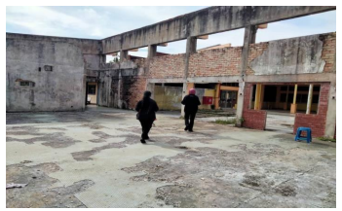
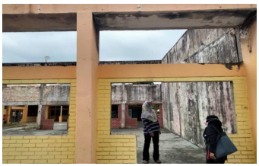

Figure 1: The Exterior of Building Figure 2: The Interior of Building

- LITERITURE REVIEW
During a fire, the building structure will be exposed to high temperatures which will produce fire loading on the building so that it can destroy the entire building structure (Muhammad & Siaw, 2000). According to Lau, (2019) concrete and steel are the two main materials of structural construction that will experience deterioration of mechanical properties under high temperatures even though the physical condition is good after a fire. The fire temperature depends on the type of fuel and in the temperature range of 600ºC and 1000ºC is expected to occur in a fire situation (Lau, 2019).

According to Ida Bagus, (2016), burning concrete will experience hardening on the surface exposed to fire with the results of the Rebound Hammer test obtained there is a difference of 30% to 60% reduction from the actual concrete strength. According to Kamarudin, (1995), at uniform hot temperatures between 600ºC and 800ºC, the compressive strength of concrete drops to a minimum level. The compressive strength increases by about 10% of the original strength at room temperature when the temperature reaches 150ºC. The compressive strength of concrete decreases to a lower level at a temperature of 400 ºC to 500 ºC which is only 75%-88% of the original strength depending on the type of stones used. Meanwhile, the compressive strength was found to decrease to 40% of the original strength if the sample was allowed to cool to room temperature.

The compressive strength of concrete decreases dramatically when exposed to a temperature of 1000℃ in the first hour of heating which is approximately 80% of the original strength (Muhammad & Siaw, 2000). According to Muhammad & Siaw, (2000) again, the compressive strength is reduced from 35% to 50% at a temperature of 600℃ and at a temperature of 400℃, the compressive strength is reduced by 15% of the original compressive strength. An increase in temperature will affect the change in the properties of concrete. The thermal conductivity of concrete decreases by 25% at temperatures up to 800℃ depending on the reduction in moisture content of concrete (Reed and Ruth, 1995) in (Muhammad & Siaw, 2000).

This study will be conducted using a Non-Destructive Testing (NDT) tool. A study in the field was conducted to measure the compressive strength of the concrete of the pole structure that had experienced a fire using the Rebound Hammer tool. According to Malek Jedidi, (2020) the use of Rebound Hammer only allows the estimation of concrete strength or its uniformity to be measured. The concrete surface strength test with Rebound Hammer carried out is in reference to BS 1881: Part 202:1986. The results of the tests performed will determine the strength of the building's structural concrete, check the uniformity of the concrete, and determine areas of lower concrete quality. At the same time can determine the safety of the building. Figure 3 shows the Rebound Hammer tool used to test the compressive strength of concrete structures.

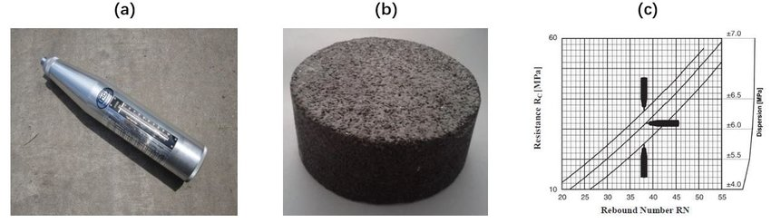

Figure 3: The Exterior of Building

- METHODOLOGY
The study was carried out starting with collecting secondary data and conducting interviews with the polytechnic management. Site visit is carried out to determine the location of the test and the number of tests that need to be carried out. Data collecting from test are analysis using statistics.

The selected testing column must be smooth, clean and dry. from foreign objects so that the data obtained is correct. Allowable tested location not to exceed 300×300 mm in one area. Usually, data collection on structural samples is carried out using the grid method (Muftah & Mohd Syahrul Hisyam, 2012). The grid lines are drawn at 30mm and the overlapping lines are used as test points as in Figure 4 below. The Rebound Hammer tool is placed on the concrete and pressed at an angle of 90 degrees on the concrete surface. The button is pressed to hold the elastic spring inside. Then the reading of the Rebound number, R is taken from the indicator on the Rebound Hammer tool.

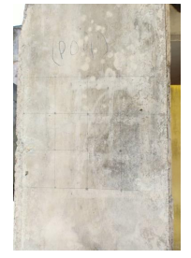

Figure 4 : Grid Lines on Column Structures

The standard procedure for determining the rebound number is to refer to ASTM C805, JGJ/T 23-201. A total of 5 – 12 strokes are repeated, and the average rebound number is obtained before referring to the calibration curve graph that has been provided on the rocking hammer tool. The calibration curve graph is referred to read the estimated compression strength on the concrete surface. The data obtained is recorded and repeated until all points are completed. The study was carried out on four column samples with 12 readings taken for each column. The data obtained is recorded and analysed to get a score of whether it is good or failed.

- RESULT AND DISCUSSION
Rebound number readings are taken from the tested column and interpreted into concrete strength and then analysed. The concrete compressive strength data obtained from the Rebound Hammer test as in the Table 1 below.

Table 1: Rebound Hammer Reading (Compressive Strength N/mm²)
Tested Column |  | Column 1 | Column 2 | Column 3 |  | Column 4
Test | Point | Compressive Strength (N/mm²) | Compressive  Strength (N/mm²) | Compressive  Strength (N/mm²) |  | Compressive  Strength (N/mm²)
Rebound Hammer Position |  | Horizontal | Horizontal | Horizontal |  | Horizontal
Test  Result | 1 | 18 | 18 | 22 |  | 20
 | 2 | 16 | 20 | 16 |  | 22
 | 3 | 20 | 22 | 20 |  | 16
 | 4 | 18 | 20 | 20 |  | 20
 | 5 | 20 | 18 | 20 |  | 18
 | 6 | 20 | 20 | 20 |  | 20
 | 7 | 18 | 20 | 18 |  | 20
 | 8 | 20 | 18 | 20 |  | 18
 | 9 | 18 | 22 | 18 |  | 20
 | 10 | 18 | 18 | 16 |  | 18
 | 11 | 16 | 18 | 20 |  | 22
 | 12 | 20 | 20 | 18 |  | 18
Total |  | 222 | 234 | 228 |  | 232
Average |  | 18.5 | 19.5 | 19 |  | 19.3
Final Compressive |  | <20 | <20 | <20 |  | <20
Quality of Concrete |  | Poor Concrete | Poor Concrete |  | Poor Concrete |  | Poor Concrete

From Table 1 shows the average value of compression strength for Column 1 - Column 4 is between 18.5 - 19.5 N/mm². According to Standard (2016) as shown in Table 2, the compressive strength value is categorized as a poor concrete quality which is <20 N/mm2.

Table 2: Rebound Number (Compressive Strength N/mm²) and Concrete Quality
Average Rebound Number | Quality of Concrete
>40 | Very good hard layer
30 to 40 | Good layer
20 to 30 | Fair
<20 | Poor concrete
0 | Delaminated
Source: Malaysian Standard (2016)

The results of the study prove that a building or structure that is on fire will experience a decrease in compressive strength. At uniform hot temperatures between 600ºC and 800ºC, the compressive strength of concrete drops to a minimum level (Kamaruddin, 1995). Figure 4 shows the relationship between rebound number and concrete compressive strength. The value of concrete compressive strength is proportional to the increase in rebound number.

From Table 2, a low rebound number will indicate that the concrete surface is weak. A high rebound number will show that the concrete is hard and strong. From the test can be concluded that the quality of the structural concrete of the Kamsis Al-Ghazali cafeteria block, is categorized as a weak concrete.
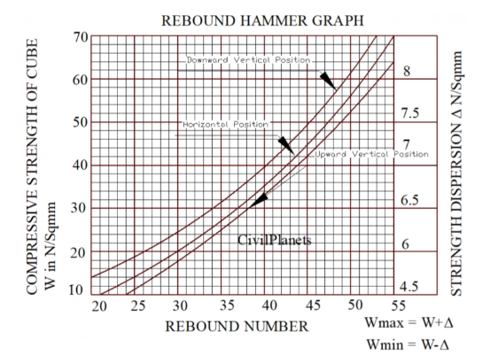

Source: Malaysian Standard (2016)
Figure 5: Hammer Rebound Graph

Figure 5 shows the relationship between rebound number and concrete compressive strength. The value of concrete compressive strength is proportional to the increase in rebound number.

A low rebound number will indicate that the concrete surface is weak. A high rebound number will show that the concrete is hard and strong. As a result, the quality of the structural concrete of the Kamsis Al-Ghazali cafeteria block, Sultan Haji Ahmad Shah Polytechnic is categorized as a weak concrete

- CONCLUSION AND RECOMMENDATIONS
It can be concluded that can be made from the tests carried out for the building's column structure using the Rebound Hammer non-destructive testing method is to find out the strength of the building's concrete. Data results using the Rebound Hammer tool show that the concrete layer of the column is weak. This is because all four randomly selected column structures have a strength value of less than 20 N/mm2, which has been referenced from the Rebound Hammer graph. From the result, can be concluded that the building is not safe to occupy. This study can help the Polytechnic top management to expediate to repair the cafeteria building because the area is highly in need.

It is recommended that other Non-Destructive Testing studies be conducted to obtain more accurate results. For example, testing using the Ultrasonic Pulse Velocity tool can determine the quality of concrete. Structural cracking studies can also be used to determine the effects of burning buildings. To study the deeper structure of cooperation between forensic JKR can help get more accurate results.

- REFERENCES
[1] T. Mohana Priya, Dr. M. Punithavalli & Dr. R. Rajesh Kanna, Machine Learning Algorithm for Development of
Enhanced Support Vector Machine Technique to Predict Stress, Global Journal of Computer Science and
Technology: C Software & Data Engineering, Volume 20, Issue 2, No. 2020, pp 12-20

[2] Alaa Aly Elsayd, Islam Nabil Fathy (2019) “Experimental Study of Fire Effects on Compressive Strength of Normal
Strength Concrete Supported With Nanomaterials Additives”, IOSR Journal of Engineering (IOSRJEN) Vol. 09, Issue 2
pp 17-26.

[3] Zhang, B.; Bicanic, N.; Pearce, C.J.; Balabanic, G.; Purkiss, J.A. Discussion on: Residual fracture properties of normal
and high strength concrete subject to elevated temperature. Mag. Concr. Res. 2001, 53, 221–224.
[GoogleScholar][CrossRef]

[4] BS 1881-202:(1986) Testing Concrete Part 202: Recommendations for Surface Hardness Testing by Rebound

Hammer.BSI.

[5] Ida Bagus Rai Widiarsa (2016). Kajian Struktur Bangunan Restoran La Sicilia Pasca Kebakaran. Laboratorium Struktur
dan Bahan Jurusan Teknik Sipil, Universitas Udayana.

[6] Kamaruddin Mohd. Yusof (1995). Pengenalan Kekuatan dan Ketahanlasakan Konkrit. Dewan Bahasa dan Pusta
Kementerian Pendidikan Malaysia.

[7] Kementerian Kesejahteraan Bandar, Perumahan dan Kerajaan Tempatan (2021). Statistik Kebakaran Mengikut Jenis
Bangunan, 2021.

[8] Lau Yeo Sin (2019). Selamatkah untuk menduduki Bangunan yang Pernah Terbakar. IPM Professional Services. Capaian
https://ipm.my/Articles

[9] Malek Jedidi (2020). Evaluation of the Quality of Concrete Structures by the Rebound Hammer Method. Cur Trends
Civil & Struct Eng. 5(5): 2020. CTCSE.MS.ID.000621. DOI: 10.33552/CTCSE.2020.05.000621.

[10] Mohammad Bin Ismail, Siaw Wai San (2000). Kesan Kebakaran ke atas Kekuatan Mampatan Konkrit, Jurnal of Civil
Engineering, vol. no.12,2000.

[11] Reed Brantley. L And Ruth T Brantley (1995)."Building Materials TechnologyStructural Performance & Environmental
Impact." R.R. Donnelley & Son Company.

[12] Standard Malaysia (2016). MS EN12504-2:2013, Testing Concrete in Structures-Part 2: Non-Destructive Testing-
Determination of Rebound Number (Second Revision). Medium. https://mysol.jsm.gov.my.

[13] Malhotra, H.L. (1956) “The effect of high-temperature on compressive strength “, magazine of concrete research, 8(3)
pp.85 – 94.

