**INVESTIGATING THE QUALITY OF SERVICE AT RECEIVER END DUE TO MULTIPATH FADING ON SIGNAL STRENGTH**

**Ikemsinachi Chikeziri Osuagwu, Chris A. Nwabueze, Chidiebere N. Muoghalu**

Department of Electrical and Electronic Engineering, Chukwuemeka Odumegwu Ojukwu University, Uli, Anambra, Nigeria

**ABSTRACT**

In multipath propagation channels, fading is a common a common phenomenon which occurs due to variation in signal characteristics and therefore results in poor received signal quality. This effect is usually considered as poor Quality of Service (QoS) at the receiver end by the user because signal strength is reduced, signal to noise ratio (SNR) quality drops, among other factors to measure QoS. In this paper, an experimental study was conducted on effect of multipath fading in Eastern part of Nigeria considering a geographical area due to its economic and strategic importance and natural vegetation. The experimental result indicated that the characterisation and then average signal strength of receiver for the first and second experiment conducted were -93.925dBm and -93.075dBm respectively. The overall average signal strength received was determined using the mean of the two experiments and it was -93.5125dBm. The implication of the result dBm showed that the performance of the 4G communication setup used for the characterization was able to achieve an average signal strength of -93.512, which according to the Nigerian Communications Commission (NCC) standard for quality of service can be classified as poor (for signal strength of range $≤$-85 to 95 dB). Further research is being carried out to improve QoS in this area using an intelligent technique.

**Keywords:** Fading, Multipath propagation, Quality of Service, Signal to noise ratio, Nigerian Communications Commission

1. **INTRODUCTION**

Wireless communication is a process of transmitting or receiving information via electromagnetic waves. This process is facilitated by various Information and Telecommunication Technology Infrastructures (ITTI) such as the transmitter, receiver, base stations, etc which operate using various telecommunication principles to carry data from one point to another. During this process, the transmitter sends the message to the receiver via the antenna which uses radio waves to transmit the signal to the receiver, however this antenna transmits this signal via multiple channels of which the direct channel to the receiver is called the line of sight (LOS) [1].

Other channel which equally carry the signal experiences various characteristics such as refraction, reflection, scattering among others due to the surrounding objects which stands as obstacle to the direct LOS to the channel such as tall buildings, mountains, ceiling, ground, water, etc. this results in variation in the time of arrival of the various carrier signal, variation in amplitudes, signal strength, and causes fading of the signal at the receiver end [2.3].

Fading is a process which occurs in multipath propagation channels were the variation in the signal characteristics results in poor Quality of Service (QoS) such as signal strength, signal to noise ratio, among other QoS indicators and has remained a major challenge [4]. One of the major causes of this fading is destructive interference. This occurs when the multipath signal which lags in time, and strength collides with the LOS signal at the same amplitude but cancel each other in opposite direction, thus resulting to deep fading [5] and has remained a very big problem over the years, with urgent need for solution.

Over time, many research solutions have been presented to solve the problem of fading in multipath propagation and are classified as diversity, equalization and channel coding techniques respectively [6]. The diversity technique employed multiple antennas to improve the quality of service at the receiver end. In this way, signal can be transmitted using various real channels to reduce the impact of fading [7]. The equalization technique on the other hand used ensures the compensation of the average range of delay characteristics and channel amplitude [8]. However all these techniques have their pros and cons, for instance, the use of diversity technique is cost intensive as it requires more antennas; the use of coding do not consider the dynamics of the receiver (i.e receiver which continuous changes motion) and hence not very reliable.

This paper is designed to investigate the impact of multipath on received signal strength considering variation in distance of the receiver position from the transmitter in a particular geographic location in South Eastern Nigeria.

1. **OVERVIEW OF MULTIPATH SIGNAL**

Multipath propagation is frequently one of the limiting factors for determining accurate outdoor and indoor localization. It causes interference of the direct line of sight (LOS) signal with reflected signals from objects such as buildings, ground, trees, and other obstacles. The destructive interference of the LOS and these reflected signals can create frequency dependent signal loss called multipath fading [9].

Indoors, multipath fading is common and makes it difficult to accurately estimate the LOS path length needed for accurate localization. There are different indoor positioning technologies such as Radio-Frequency Identification (RFID), Ultra-Wideband (UWB), Zigbee, Wireless Local Area Network (WLAN), Continuous-Wave Frequency-Modulated (FMCW) radar, etc. that use conventional measurement methods like Received Signal Strength (RSS), Time Of Arrival (TOA), Time Difference Of Arrival (TDOA), Angle Of Arrival (AOA), and carrier signal Phase Of Arrival (POA). The AOA and RSS methods are highly vulnerable to multipath effects and cause significant position errors [10].

To extract ranging information, one needs to determine the LOS time-delay to the ns-level in real time while subject to significant multipath interference. Bandwidth is the easiest leverage one has against rejecting or characterizing multipath. Rejection of some multipath echoes, multipath induced position errors can be devastating to narrow band location systems. Therefore, in narrow band systems, multipath compensation is an important step in accurate ranging of the distance from a beacon carried by an emergency first responder, for example. Different multipath compensation schemes have been proposed and implemented over the years to tackle the effect of multipath propagation for accurate location [11]. An illustration of multipath effect in communication system is shown in Figure 1.

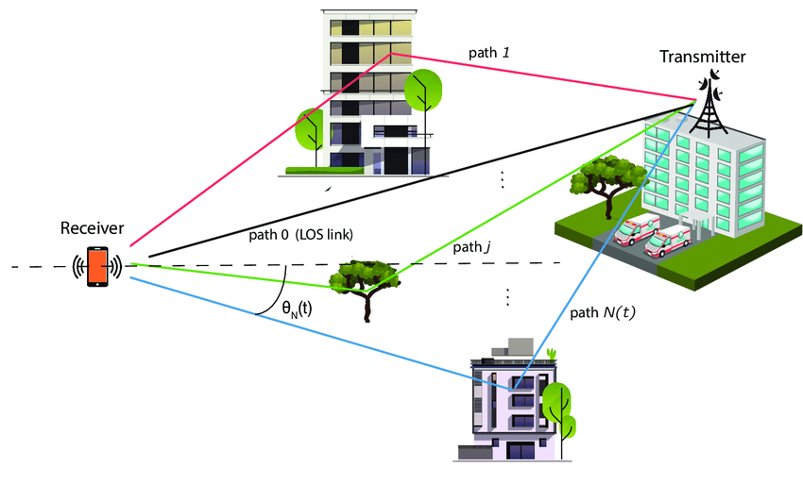

**Figure 1:** Multipath communication process [11]

1. **METHOD**

**3.1 Case Study Area Description**

The case study area is the Milliken Hills, located at Coal Camp, Enugu State, Nigeria. The area located at Google coordinates of Latitude 6.451369 and Longitude 7.4721296. This community is surrounded by hills and mountains which has continuously remained a barrier to quality of communication service to the subscribers. The area constitutes road network which connected Enugu state to the neighboring Anambra State, which are all located between the hills. The area due to the importance of the road network has remained one of the busiest places in Enugu state due to the massive number of people trooping in and out of the state via the road network. The pictorial presentation of the case study area is shown in Figure 2. The performance standard for evaluation is presented in Table 1 according to NCC

**Table 1.** Sample Comparison

|  |  |  |
| --- | --- | --- |
| SN. | Signal Strength range (dBm) | Signal strength indicator |
| 1 | $≤$-60 to 0 | Very good |
| 2 | $≤$-75 to -60 | Good |
| 3 | $≤$-75 to -85 | Fair |
| 4 | $≤$-85 to 95 | Poor |
| 5 | $≤$-95 to 125 | Very poor |

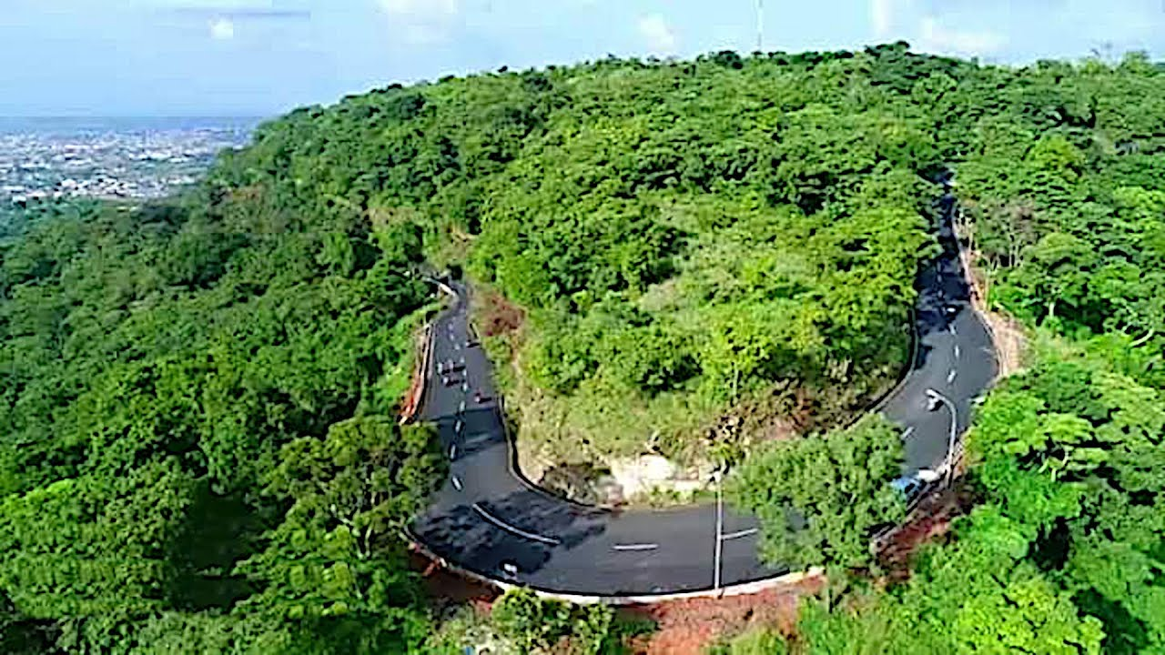

**Figure 2:** Picture of the road network at Milliken hills, Enugu (Source: Google, Images)

**3.2 Data Collection**

The data collection was done driving with the test-bed around the area and taking the measurement. The total area coverage during the drive test is 417,07003m2, while the total drive test distance covered is 4km. The QoS performance of the transmitter and receiver were measured after ever 100meter driver. The map of the drive test area was presented in Figure 3, while the data collected and all results were reported in the chapter four of this work.

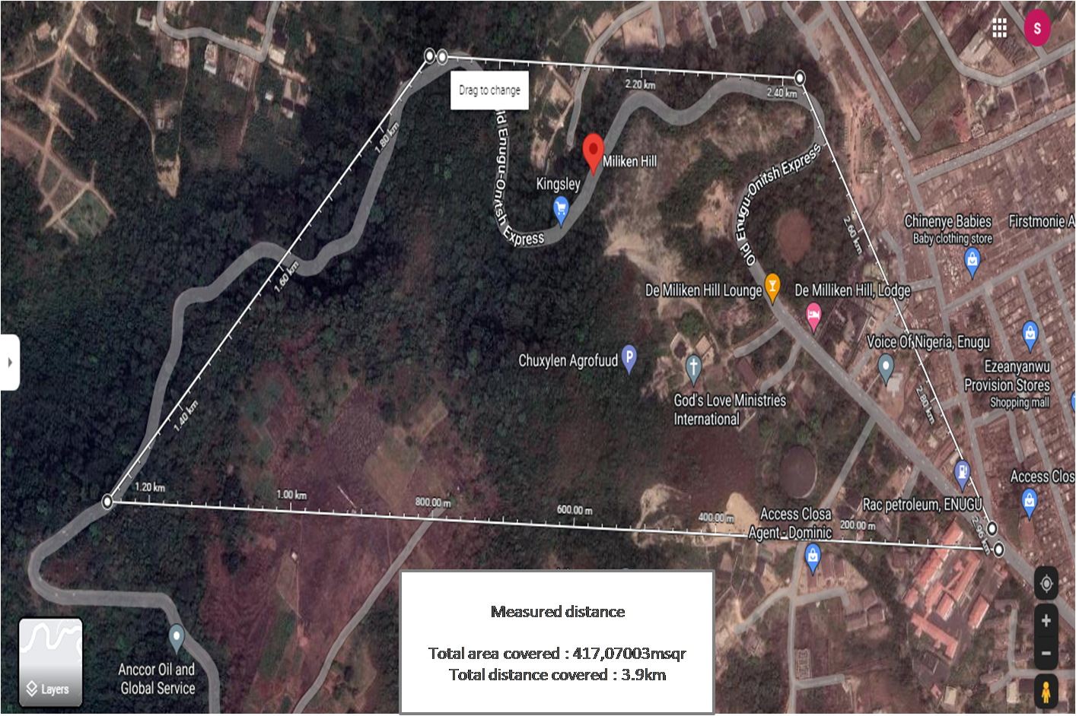

**Figure 3:** Map of the drive test area during the characterization (Source: Google Map)

**3.3 Model of the Multipath Propagation**

The model of ideal receiver power without obstructions of any form in an urban area can be represented by:

$R_{t}= h_{o}p(t-t_{o})$ (1)

where the transmitted power of the transmitter is $p(t)$; wireless link channel is $h_{o}(t-t_{o})$; the receive signal is attenuated by a factor of $h_{o}$ and delay time is $t_{o}$. In the case of multipath propagation, the receiver signal in (1) is received from multiple channels at varying time and distance and attenuation and it is given by:

$R_{t}= \sum_{n=0}^{N}{h_{o}p(t-t_{n})}$ (2)

where n is the number of channels used for the signal transmission. In the case where multipath channels varies with time due to the behavior of the receiver or the dynamic nature of obstacle at the propagation path, the receiver signal is presented as

$R_{t}= \sum_{n=0}^{N}{h_{n}^{t}p(t-t_{n}^{(t)})}$ (3)

where the channel characteristics such as attenuated factor ($h_{n}$) and delay time is ($t_{n}$) can vary with time depending on the obstacles along the path of propagation.

1. **RESULTS AND ISCUSSION**

The result of the characterisation presented the signal strength collected from the spectrum analyzer used to measure the quality of service at the receiver end due to the impact of multipath fading. The result was recorded for two separate experiments and the average was used for the analysis. The data collected during characterization was presented in the Table 2.

**Table 2.**Result of characterisation

|  |  |  |  |
| --- | --- | --- | --- |
| Distance (meters) | Receiver signal strength (dBm) | Receiver signal strength (dBm) | Average Receiver signal strength (dBm) |
| 100 | -92 | -94 | -93.0 |
| 200 | -89 | -87 | -88.0 |
| 300 | -89 | -89 | -89.0 |
| 400 | -95 | -93 | -94.0 |
| 500 | -90 | -92 | -91.0 |
| 600 | -95 | -93 | -94.0 |
| 700 | -95 | -92 | -93.5 |
| 800 | -87 | -86 | -86.5 |
| 900 | -97 | -95 | -96.0 |
| 1000 | -88 | -88 | -88.0 |
| 1100 | -98 | -97 | -97.5 |
| 1200 | -88 | -87 | -87.5 |
| 1300 | -98 | -95 | -96.5 |
| 1400 | -89 | -87 | -88.0 |
| 1500 | -92 | -91 | -91.5 |
| 1600 | -87 | -85 | -86.0 |
| 1700 | -89 | -86 | -87.5 |
| 1800 | -105 | -104 | -104.5 |
| 1900 | -105 | -104 | -104.5 |
| 2000 | -103 | -104 | -103.5 |
| 2100 | -103 | -102 | -102.5 |
| 2200 | -100 | -101 | -100.5 |
| 2300 | -94 | -95 | -94.5 |
| 2400 | -93 | -94 | -93.5 |
| 2500 | -87 | -86 | -86.5 |
| 2600 | -97 | -98 | -97.5 |
| 2700 | -88 | -87 | -87.5 |
| 2800 | -98 | -96 | -97.0 |
| 2900 | -99 | -98 | -98.5 |
| 3000 | -101 | -99 | -100 |
| 3100 | -99 | -95 | -97.0 |
| 3200 | -92 | -95 | -93.5 |
| 3300 | -87 | -85 | -86.0 |
| 3400 | -89 | -86 | -87.5 |
| 3500 | -95 | -98 | -96.5 |
| 3600 | -94 | -96 | -95.0 |
| 3700 | -87 | -88 | -87.5 |
| 3800 | -97 | -94 | -95.5 |
| 3900 | -88 | -87 | -87.5 |
| 4000 | -98 | -94 | -96.5 |
| Average | -93.925 | -93.075 | -93.5125 |

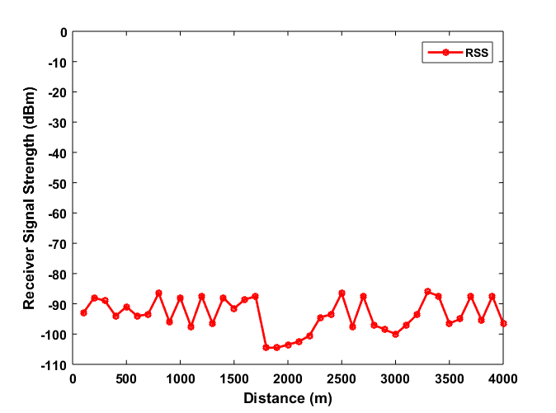

**Figure 4:** Graph of the characterization performance at varying distance

Table 2 presented the result of the characterization and then average signal strength receiver for the first and second experiment conducted were -93.925dBm and -93.075dBm respectively. The overall average signal strength received was determined using the mean of the two experiments is -93.5125dBm. The implication of the result showed that the performance of the 4G communication setup used for the characterization was able to achieve an average signal strength of -93.512, which according to NCC standard for quality of service can be classified as poor. The reason for this poor performance was due to the impact of multipath which was induced as a result of the vegetation terrain along the characterization environment which hence affected the quality of service. The result was also examined using graphically analysis as in Figure 4.

As shown in Figure 4, presented the performance of the characterization graphical analysis and it was observed that the signal strength varies as the transmitter changes position. Also it was observed that in some area the signal strength is fair in some area; this was because at that position, the vegetation was less and hence interfere less with the multipath channel than when compared in certain area where the vegetation was very much and totally affected quality of service

1. **CONCLUSION**

Multipath fading is well reported effect that impact on received signal quality due to attenuation of transmitted signals as they encounter obstacles before reaching final destination. This paper was specifically designed to study the effect of multipath fading on a geographical area in Eastern region of Nigeria due to the uniqueness of its topography. The investigation showed that the Milliken-hills though characterized by many beauty of nature such as mountains, hills as the name implied, valleys, rivers, rain forest among others, it has remained so sad that these natural offerings have affected quality of communication in the area, due to fading on signal channels and this has remained a very big problem.

**REFERENCES**

1. Uko, M. C.; Ekpo, S. C.; Ukommi, U.; Kharel, R. (2017), “Shadowing Effect On Macro-Femto Heterogeneous Network For Cell-Edge Users” Applied Computational Electromagnetics (ACES), 31st International Review Of Progress In Applied Computational Electromagnetics year: Pages: 1 – 2
2. Roozbech Hanzehyan, Reza Dianat, and Najmeh Shirazi (2012), ‘Variable Step-Size Blind Equalization Based on Modified Constant Modulus Algorithm’, International Journal of Machine Learning and Computing, vol.2, No.1, pp30-34
3. John G. Proakis, Masoud Salehi, Gerhard Bauch (2004); ‘Contemporary Communication Systems Using MaTLab and Simulink’, Second Edition, CENGAGE Learning.
4. Zhang J., C. Pan, F. Pei, G. Liu, and X. Cheng, (2014) “Three-dimensional fading channel models”: a survey of elevation angle research, IEEE Commun. Mag., vol. 52, no. 6, pp. 218226.
5. Watteyne T, A. Mehta, and K. Pister, (2009) “Reliability Through Frequency Diversity: Why Channel Hopping Makes Sense,” in 6th ACM PEWASUN, Tenerife, Canary Islands, Spain, 26.
6. Pister K. and Doherty L., (2008) “TSMP: Time Synchronized Mesh Protocol,” in Parallel and Distributed Computing and Systems (PDCS), Orlando, Florida, USA, 16-18.
7. Ortiz J. and Culler D., (2008) “Exploring Diversity: Evaluating the Cost of Frequency Diversity in Communication and Routing,” in SenSys. Raleigh, NC, USA: ACM, 5-7.
8. Akaneme S.A, and Onoh G. N. (2015) “ Algorithms For Evaluating Adaptive Equalization In Wireless Communication Systems” European Journal of Engineering and Technology; Vol 3; No 2; 2015; ISSN 2056-5860
9. Bhargavi D. K. and Vijaya rakash A. M. (2015) “A Novel Handover Algorithm for LTE Based MacroFemto Heterogeneous Networks” International Journal of VLSI Design & Communication Systems (VLSICS) Vol.6, No.4.
10. Syed A. Jafar, Gerard J. Foschini and Andrea J. Goldsmith (2004) ”Exploring Optimal Multicellular Multiple Antenna Systems” EURASIP Journal on Applied Signal Processing 2004:5, 591– 604
11. Abst R. (2004), “Relay-Based Deployment Concepts for Wireless and Mobile Broadband Radio ” IEEE Communication Magazine, Vol. 42, Pp. 80–89.