Analysis of multi-storey buildings with hybrid shear wall- steel bracing structural system
Shubham Bhalchandra Ajmire¹ and Dr. B. H. Shinde²
¹PG student, Department of Civil Engineering, G.H. Raisoni University ,School of Engineering and Technology, Amravati.
²Assistant Professor, Department of Civil Engineering, G.H. Raisoni University ,School of Engineering and Technology, Amravati.

ABSTARCT: This study investigates the seismic performance of hybrid steel buildings utilizing a combination of concrete shear walls and steel bracings as lateral force resisting systems. Focusing on seismic Zone-V, which represents regions with the highest seismic activity, the analysis examines the displacement, reactions, and plate stresses experienced by the structural models subjected to earthquake loading. Results indicate that structures in Zone-V exhibit maximum displacement and reactions, highlighting the significant impact of seismic forces in these regions. Moreover, plate stresses escalate with the severity of the seismic zone, underscoring the heightened demands on building components. Despite these challenges, the hybrid shear wall and bracing system demonstrate remarkable effectiveness in mitigating seismic forces, ensuring structural resilience and stability during earthquakes. This research underscores the importance of selecting appropriate structural systems tailored to seismic hazards, particularly in high seismic zones, and highlights the efficacy of hybrid systems in enhancing seismic performance
Keywords: shear walls, bracing systems, multistorey buildings, lateral forces, structural stability
- INTRODUCTION:
Multi-storey buildings are integral components of urban landscapes, catering to the increasing demands for residential, commercial, and institutional spaces. As population densities rise and land availability diminishes in urban areas, the construction of tall buildings becomes imperative to optimize land use efficiently. However, the structural design and engineering of such buildings present unique challenges, particularly in ensuring structural integrity, stability, and resilience against various loads, including gravity loads, lateral loads, and environmental forces such as wind and seismic events.
Among the key considerations in the design of multi-storey buildings is the selection of an appropriate structural system capable of withstanding these loads while maintaining performance and safety standards. Traditional structural systems, such as reinforced concrete (RC) shear walls or steel moment frames, have been extensively used in tall building construction, each with its advantages and limitations.
In recent years, there has been a growing interest in hybrid structural systems that combine the benefits of different materials and construction techniques to optimize performance and efficiency. One such hybrid system gaining prominence is the combination of shear walls and steel bracing elements. This system offers the advantages of enhanced lateral stiffness and strength provided by shear walls, along with the ductility and energy dissipation capabilities offered by steel bracing systems.
This introduction sets the stage for the analysis of multi-storey buildings utilizing a hybrid shear wall-steel bracing structural system. The following sections will delve into the structural behavior, design considerations, and performance evaluation of this hybrid system, aiming to provide insights into its effectiveness and suitability for tall building construction in various environmental and loading conditions. Through a comprehensive examination of this hybrid structural system, this study seeks to contribute to the advancement of innovative solutions for safe and resilient multi-storey building design.
2. REVIEW OF LITERATURE:
Thejaswini R.M. et al [1] found that in the modelling, material is considered as an isotropic material. The 3d building model generated in is shown in STADD Pro. A simplified probabilistic risk analysis (PRA) procedure is presented for the seismic reliability of G+7 storey RCC building by considering effect of with and without floating column in the modelling.
Thomsen IV, J. H. et al [2] observed that the moment about X and moment about Z are compared by equivalent static analysis method. The above building models are generated using the software STAAD Pro 8Vi and are analyzed using equivalent static method.
Vijay Kumara Gowada et al [3] found that in this paper modern construction technology, floating column is becoming a typical feature for multistory buildings in urban India. Such practices are highly undesirable in buildings built in seismically active areas. Due to this floating column the moments in columns, storey drifts, storey shears and other factors tends to increase which leads to strength reduction in structures.
Nanduri, PMB Raj Kiran, et al [4] found that this study emphasizes about recognizing the presence of floating column in multistoried buildings and how to reduce the risk factor of earthquake effects by strengthening the floating columns building with Bracings. In this present study four models are used namely, 'Model 1 (G+9 Normal RC Building)', 'Model 2 (G+9 RC Floating column Building)', 'Model 3 (G+9 RC Floating column Building with Bracings at corner)', 'Model 4 (G+9 RC Floating column Building with Bracings at centre)'.
Chung, Kwangryang, et al [5] observed that seismic analysis is carried out on all four models using Equivalent static method and Response spectrum method in two zones (III, V) respectively. Comparison of results Storey shears, Storey Drifts, Maximum Displacement, Time period and Base shear for all four models are executed. As the Model 4 throw in better results compared to other Models, its performance is reviewed using pushover analysis and the performance levels are discussed by comparing Model 4 with Model 3. This seismic assessment is executed using ETABS software as per the code book IS:1893-2002.

3. METHODOLOGY
Following models in STAAD-PRO carried out:
- G-4 Steel Building (without shear wall / bracings)
- G-4- Steel Building EQ-2
- G-4- Steel Building EQ-3
- G-4- Steel Building EQ-4
- G-4- Steel Building EQ-5
- G-5 Steel Building (without shear wall / bracings)
- G-5- Steel Building EQ-2
- G-5- Steel Building EQ-3
- G-5- Steel Building EQ-4
- G-5- Steel Building EQ-5
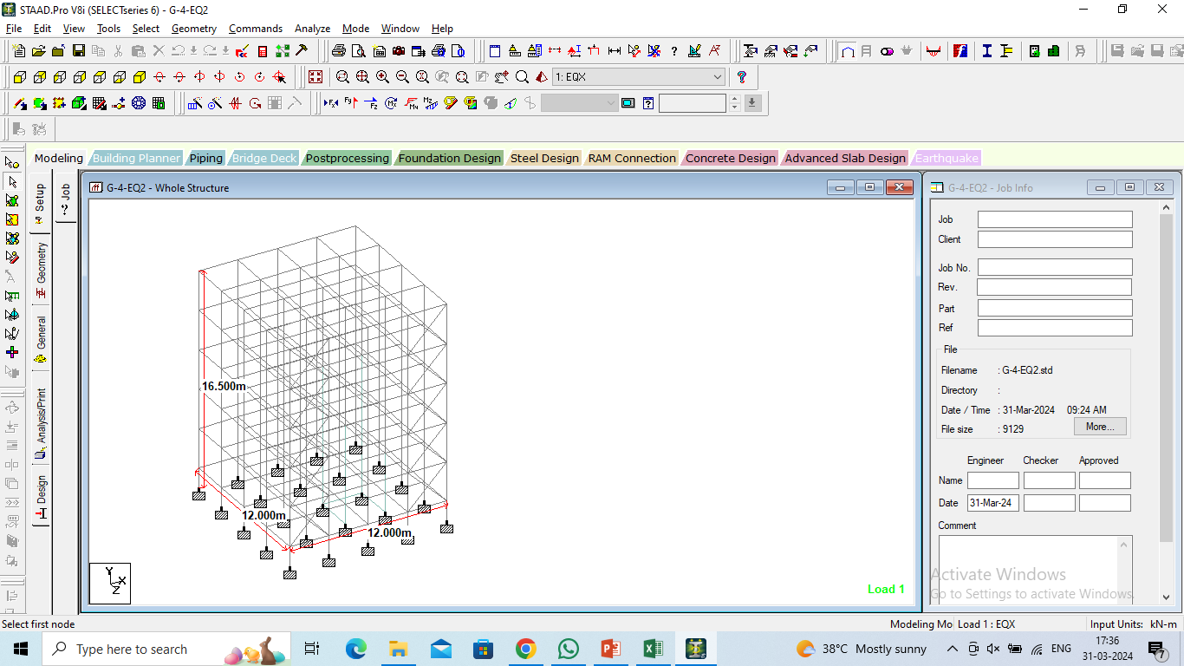
Fig.1 : Geometry of G-4 Steel building

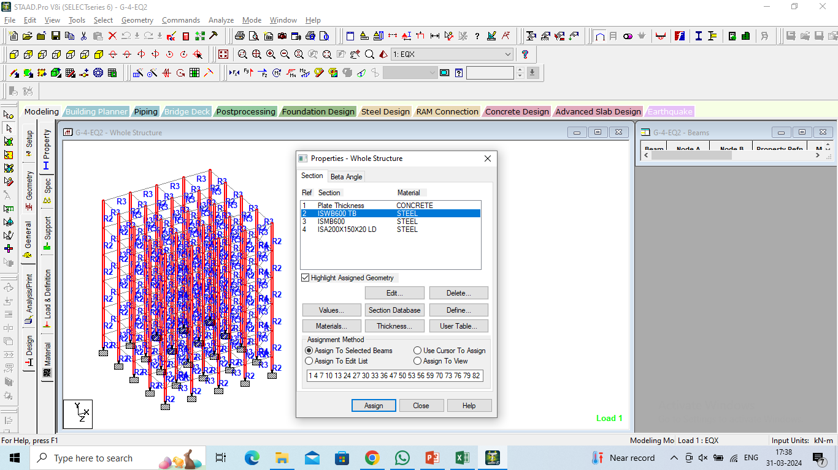
Fig.2 : Properties Assigned to the steel building

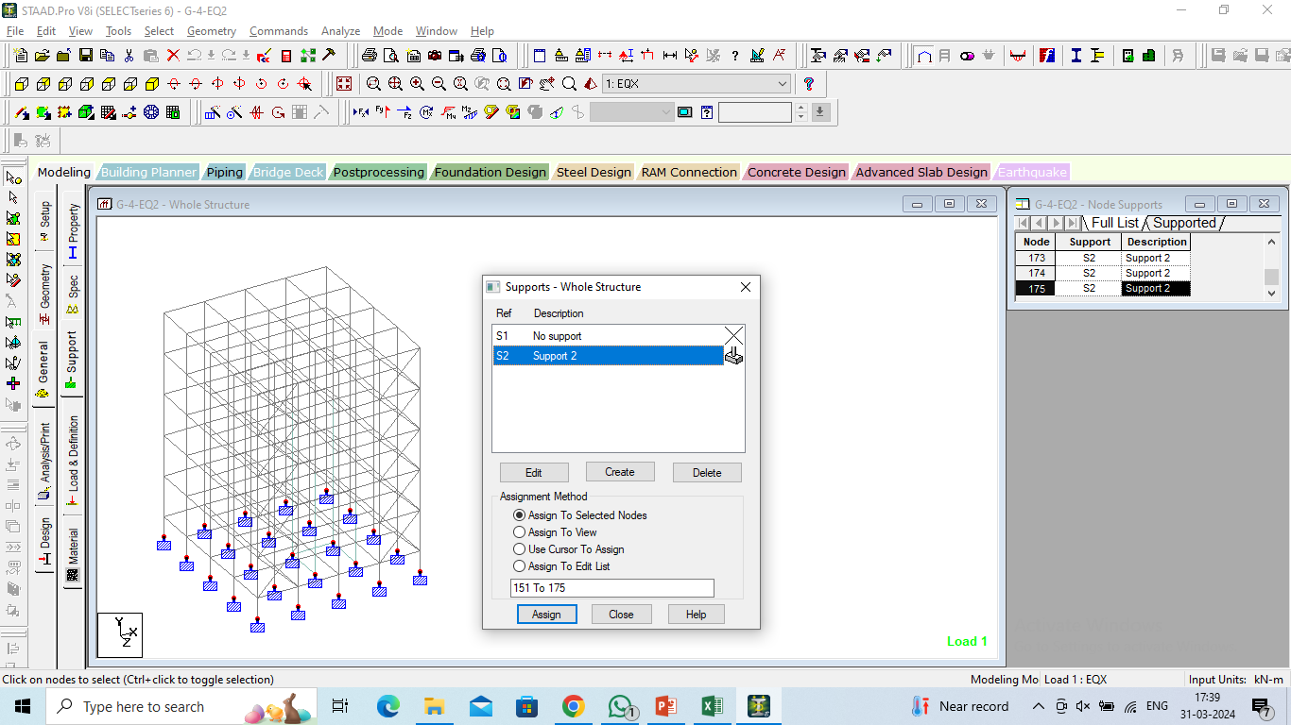
Fig.3 : Supports Assigned to the steel building

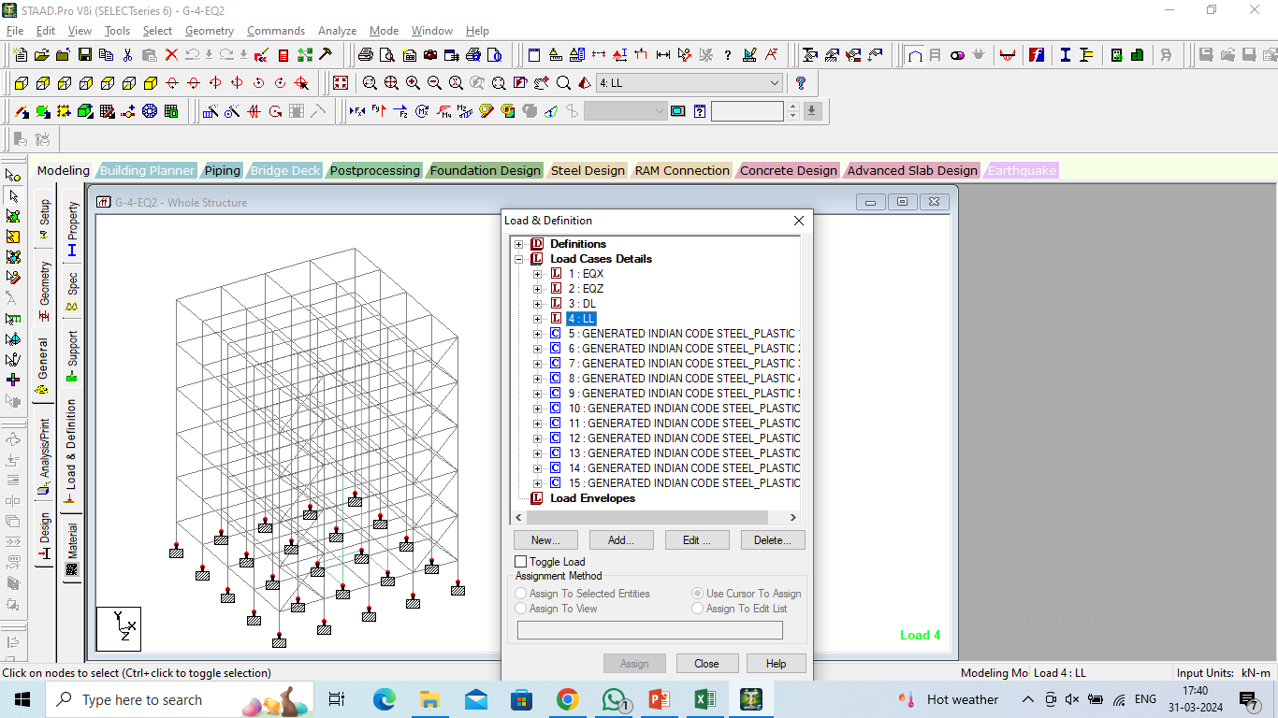
Fig.4: Load Assigned to the steel building

4. RESULTS
Following results are obtained in the STTAD-PRO software
Fig.5 : Displacement for all the models

Fig.6 : Reactions for all the models

Fig.7 : Plate Stresses for all the models

Fig.8 : Principal Stresses for all the models

5. CONCLUSIONS
This excerpt appears to discuss the seismic performance of different structural systems, particularly concrete shear walls and steel bracings, in hybrid steel buildings subjected to earthquake loading, with a specific focus on seismic Zone-V.

1. Hybrid Structural System:
- The term "hybrid" suggests that the building employs a combination of concrete shear walls and steel bracings as its primary lateral force resisting system. This approach is common in seismic design, as it combines the strengths of both materials to enhance overall structural performance.
2. Displacement and Reactions:
- The statement indicates that the maximum displacement and reactions occur in models located in seismic Zone-V. Seismic Zone-V typically represents regions with the highest level of seismic activity and therefore experiences the most significant ground motion during earthquakes. Consequently, structures in Zone-V are subjected to larger displacements and higher forces, leading to increased reactions at the supports.
3. Plate Stresses:
- The observation that plate stresses increase as the seismic zone becomes more severe is consistent with the behavior expected in earthquake-prone regions. Higher seismic forces experienced in Zone-V lead to increased demands on building components, including floor plates. This results in higher stress levels within the plates, which can affect their performance and may necessitate design modifications or reinforcement.
4. Effectiveness of Hybrid System:
- The conclusion that the hybrid shear wall and bracing system are effective in counteracting seismic forces suggests that the chosen structural configuration successfully mitigates the effects of seismic loading. Hybrid systems leverage the strengths of both concrete and steel elements to provide robust resistance against lateral forces, ensuring the structural integrity and stability of the building during earthquakes.
Overall, this excerpt highlights the importance of selecting appropriate structural systems and designs to withstand the challenges posed by seismic activity, particularly in high seismic zones like Zone-V. It underscores the effectiveness of hybrid structural systems in enhancing seismic resilience and reducing the vulnerability of buildings to earthquake-induced damage.

REFERENCES:
- T. Vellaichamy, Preetha. "Effect of outrigger systems for tall buildings." Materials Today: Proceedings (2022)..
- Thomsen Amoussou, Cossi Prosper Dagbo, Honggang Lei, Yahia Halabi, and Wael Alhaddad. "Performance-based seismic design methodology for tall buildings with outrigger and ladder systems." In Structures, vol. 34, pp. 2288-2307. Elsevier, 2021..
- V. Wei, Zhen, Q. I. U. Yi-kun, Y. A. N. G. Qing-shun, and Z. H. A. N. G. Wan-kai. "Energy dissipation performance of outrigger in tall buildings." 工程力学 38, no. 2 (2021): 36-43..
- Nanduri, PMB Raj Kiran, B. Suresh, and MD Ihtesham Hussain. "Optimum position of outrigger system for high-rise reinforced concrete buildings under wind and earthquake loadings." American Journal of Engineering Research 2, no. 8 (2013): 76-89.
- Chung, Kwangryang, and Wonil Sunu. "Outrigger systems for tall buildings in Korea." International Journal of High-Rise Buildings 4, no. 3 (2015): 209-217.
- Sha, Marabi, B., S. C. Alih, and I. Faridmehr. "Evaluation of the Efficiency of Single-Outrigger Structural Systems in Tall Buildings." In IOP Conference Series: Earth and Environmental Science, vol. 682, no. 1, p. 012010. IOP Publishing, 2021.
- Mulla, Abdul Karim, and B. N. Srinivas. "A study on outrigger system in a tall RC structure with steel bracing." International Journal of Engineering Research and 4 (2015).
- Kian, Po Seng. "The use of outrigger and belt truss system for high-rise concrete buildings." Civil Engineering Dimension 3, no. 1 (2001): 36-41.
- Gadkari, Ajinkya Prashant, and N. G. Gore. "Review on behaviour of outrigger structural system in high-rise building." International Journal of Engineering Development and Research 4 (2016): 2065-2073.
- Laccone, Francesco, Alberto Casali, Marco Sodano, and Maurizio Froli. "Morphogenesis of a bundled tall building: Biomimetic, structural, and wind‐energy design of a multi‐core‐outrigger system combined with diagrid." The Structural Design of Tall and Special Buildings 30, no. 6 (2021): e1839.
- Sharma, S., & Tiwary, A. K. (2021). Analysis of multi-story buildings with hybrid shear wall: steel bracing structural system. Innovative Infrastructure Solutions, 6, 1-12.
- Dharanya, A., Gayathri, S., & Deepika, M. (2017). Comparison Study of Shear Wall and Bracings under Seismic Loading in Multi-Storey Residential Building. International Journal of ChemTech Research, 10(8), 417-424.
- Azad, M. S., & Abd Gani, S. H. (2016). Comparative study of seismic analysis of multistory buildings with shear walls and bracing systems. International Journal of Advanced Structures and Geotechnical Engineering (IJASGE), 5(03), 72-77.
- Atif, M., Vairagade, L., & Nair, V. (2015). Comparative Study on Seismic Analysis of Multistorey Building Stiffened With Bracing and Shear Wall. International Research Journal of Engineering and Technology (IRJET), 2(05), 1158-1170.
- Sreeram, K. V. G. M., Singh, R. P., & KUMAR, S. S. B. S. (2017). Effective location of shear walls and bracings for multistoried building. International Research Journal of Engineering and Technology. www. irjet. net.
- Islam, M. R., Chakraborty, S., & Kim, D. (2022). Effects of Material Nonlinearity on Seismic Responses of Multistoried Buildings with Shear Walls and Bracing Systems. ARCHITECTURAL RESEARCH, 24(3), 75-84.
- Soni, P., Tamrakar, P. L., & Kumhar, V. (2016). Structural analysis of multistory building of different shear walls location and heights. International Journal of Engineering Trends and Technology (IJETT), 32(1), 50-57.
- Pujari, A., & Doshi, T. D. (2022). Seismic Analysis of Multi-Storey Irregular Building, Including Effect of Shear Wall and Bracing System. IUP Journal of Structural Engineering, 15(1).

