INTERNET OF THINGS



Empowering Smart Cities: Exploring the Role of IoT in Urban Transformation

**CHAITANYA LABHE & MAYUR PATIL**

ABSTRACT:

The integration of Internet of Things (IoT) technology within urban settings has emerged as a transformative force, exerting a profound influence across diverse sectors such as transportation, utilities, public safety, and sustainable urban development. Within transportation, IoT facilitates real-time traffic monitoring, enhances the efficiency of public transit systems, and simplifies parking processes, all of which contribute to mitigating congestion and improving the overall commuter experience. In utilities management, IoT-enabled solutions like smart grids, meters, and waste management systems optimize resource allocation, fostering sustainability by minimizing waste and maximizing efficiency. Public safety also stands to benefit significantly from IoT innovations, with smart surveillance and emergency response systems bolstering law enforcement capabilities and aiding in disaster management scenarios. Furthermore, IoT plays a crucial role in public health monitoring, enabling the tracking of air quality and disease spread to facilitate timely interventions and mitigate health risks. The concept of sustainable urban development is further advanced through IoT technologies, which allow for the optimization of energy consumption, transportation networks, water management systems, waste disposal processes, and environmental monitoring. This holistic approach to urban management not only enhances efficiency but also elevates the overall quality of life for residents. Despite the immense potential of IoT, its widespread implementation encounters various challenges, including concerns related to security, technological limitations, infrastructural barriers, and socioeconomic disparities. However, ongoing advancements in IoT, such as the integration of 5G connectivity, artificial intelligence, sensor technology, urban digital twins, and blockchain solutions, hold promise for overcoming these obstacles and ushering in an era of smarter, more sustainable, and inclusive cities.

INTRODUCTION:

The integration of Internet of Things (IoT) technology represents a paradigm shift in urban development, offering transformative possibilities for creating smarter and more sustainable cities. This paper explores the multifaceted role of IoT in empowering smart cities, covering various aspects of urban development and highlighting its potential to address pressing challenges while driving innovation and efficiency. Beginning with a focus on enhancing urban infrastructure, IoT applications in transportation and utilities stand out as critical areas of impact. In transportation, IoT facilitates real-time monitoring of traffic conditions through sensors and cameras, enabling effective traffic management and congestion reduction.[3] Furthermore, IoT enhances public transport systems by providing real-time data on vehicle locations and passenger counts, thereby improving fleet management and passenger experience. Predictive maintenance of vehicles and infrastructure ensures safety and minimizes downtime, while environmental monitoring aids in identifying pollution hotspots and implementing targeted interventions. Additionally, smart parking solutions streamline parking processes, reducing congestion and emissions, while intelligent lighting and crosswalks enhance the rider experience for cyclists and pedestrians. In utilities management, IoT-enabled smart grids optimize electricity production, distribution, and consumption, leading to enhanced energy efficiency, cost reduction, and reliability. Water management benefits from IoT-enabled smart meters detecting leaks and ensuring water quality, crucial for addressing water scarcity[4]. Smart waste management systems utilize IoT sensors to monitor waste levels, optimizing collection routes and schedules, thereby reducing fuel consumption and emissions. Moving on to the domain of public safety, IoT innovations play a pivotal role in enhancing security and emergency response systems. Smart surveillance systems leverage IoT-enabled cameras and facial recognition technology to detect suspicious activities in real-time, aiding law enforcement efforts. Additionally, IoT facilitates emergency response systems by equipping first responders with connected devices for health monitoring and optimizing dispatch systems for quicker response times. Disaster management benefits from IoT sensor networks, providing early warnings for natural disasters and enabling real-time information sharing among agencies. Furthermore, IoT contributes to public health by monitoring air quality and tracking disease spread through data analysis, enabling timely interventions to prevent respiratory illnesses and contain outbreaks. Despite its transformative potential, IoT implementation in urban development poses significant challenges. Security and privacy concerns, technological limitations, infrastructural constraints, and socioeconomic inequalities are among the key hurdles to overcome. Robust regulatory frameworks, standardized protocols, and inclusive decision-making processes are essential to mitigate risks and ensure equitable access to IoT benefits. Drawing insights from successful IoT implementations in global cities like Seoul, Amsterdam, and New York City, this paper underscores the importance of collaboration, innovation, and strategic planning in harnessing the full potential of IoT for urban transformation. Looking ahead, future trends and innovations in urban IoT, including advancements in 5G technology, AI integration, sensor technology, blockchain for security, edge computing, inclusive deployment strategies, public health monitoring, and regulatory frameworks, promise to further accelerate the transition towards smarter, more sustainable cities. By leveraging the power of IoT, cities can optimize resource utilization, improve service delivery, enhance quality of life, and foster resilient and inclusive urban communities for generations to come.[23]

ENHANCING URBAN INFRASTRUCTURE THROUGH IOT:

In transportation, IoT offers innovative solutions to enhance efficiency, safety, and sustainability. Real-time monitoring of traffic conditions through sensors and cameras enables effective traffic management, reducing congestion and optimizing signal timings.[3] Moreover, IoT facilitates improvements in public transport systems by providing real-time data on vehicle locations and passenger counts, enhancing fleet management and passenger experience. Predictive maintenance of vehicles and infrastructure ensures safety and minimizes downtime, while environmental monitoring aids in identifying pollution hotspots and implementing targeted interventions. Smart parking solutions streamline parking processes, reducing congestion and emissions, while enhanced rider experience is achieved through intelligent lighting and crosswalks for cyclists and pedestrians.

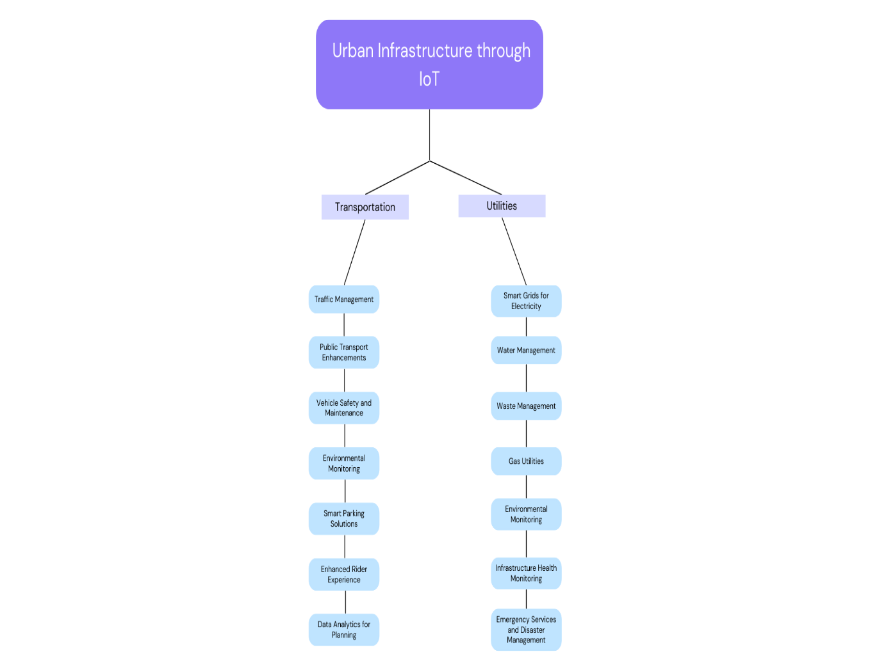

Additionally, data analytics derived from IoT devices inform urban planning decisions, optimizing infrastructure improvements[7]. In the domain of utilities, IoT revolutionizes the management of resources such as electricity, water, and waste. Smart grids powered by IoT technology optimize electricity production, distribution, and consumption, leading to enhanced energy efficiency, cost reduction, and reliability. Water management benefits from IoT-enabled smart meters detecting leaks and ensuring water quality, crucial for addressing water scarcity. Smart waste management systems utilize IoT sensors to monitor waste levels, optimizing collection routes and schedules, thereby reducing fuel consumption and emissions. IoT also enhances gas utility operations by detecting pipeline anomalies and monitoring gas usage with precision. Environmental monitoring through IoT devices informs policies and improves urban quality of life, while infrastructure health monitoring prevents accidents through timely maintenance. In Indian smart cities[1], IoT infrastructure addresses key urban challenges across various sectors. Real-time traffic monitoring aids in congestion reduction, while smart waste management systems improve efficiency and encourage waste segregation. IoT-enabled water management solutions detect leaks and ensure efficient resource utilization, vital in water-scarce regions. Smart grids manage energy consumption effectively and integrate renewable sources into the grid, promoting sustainability.[4] Public safety is enhanced through connected surveillance and emergency response systems, while governance becomes more interactive and responsive with IoT-enabled civic engagement platforms, integrating citizen feedback into city management processes.[25]

PUBLIC SAFETY INNOVATIONS POWERED BY IOT:

**Public Safety Innovations:**

Smart surveillance systems leverage IoT-enabled cameras and facial recognition technology to detect suspicious activities in real-time, aiding law enforcement efforts. Additionally, IoT facilitates emergency response systems by equipping first responders with connected devices for health monitoring and optimizing dispatch systems for quicker response times. Disaster management benefits from IoT sensor networks, providing early warnings for natural disasters and enabling real-time information sharing among agencies.

**Public Health Monitoring:**

IoT contributes to public health by monitoring air quality and tracking disease spread through data analysis, enabling timely interventions to prevent respiratory illnesses and contain outbreaks.

**Infrastructure Safety and Traffic Management:**

Infrastructure safety is enhanced through IoT-enabled structural health monitoring and smart lighting systems, while traffic management benefits from connected traffic lights and future possibilities of vehicle-to-infrastructure communication, improving road safety and efficiency.

**Challenges and Considerations:**

Despite its benefits, IoT implementation in healthcare faces challenges such as data security, technology interoperability, and ensuring equitable access to advanced healthcare technologies for all patients. These challenges must be addressed to fully realize the potential of IoT in transforming healthcare delivery.

SUSTAINABLE URBAN DEVELOPMENT THROUGH IOT:

Sustainable urban development through IoT involves leveraging interconnected devices and sensors to enhance the efficiency of urban systems and elevate the quality of life within cities. Firstly, IoT facilitates smart energy management by optimizing resource usage in buildings and residences, thereby reducing energy consumption[6]. Additionally, smart grids can efficiently handle electrical loads and incorporate renewable energy sources, contributing to sustainable energy practices. Secondly, IoT plays a crucial role in refining transportation systems. Through sensors, it enables the optimization of traffic flow, minimizes congestion, and lowers emissions by adjusting traffic signals and furnishing real-time data to public transit systems and drivers.[3] Furthermore, IoT enhances water management by promptly detecting leaks and monitoring water quality, thus promoting conservation efforts and efficient management practices. Moreover, waste management benefits from IoT integration through sensors monitoring waste levels in bins, which aids in optimizing collection routes and schedules, thereby improving efficiency. Environmental monitoring is another key aspect where IoT devices come into play, allowing for the real-time tracking of air and noise pollution levels. This data facilitates the implementation of strategies to enhance environmental conditions within urban areas. In terms of infrastructure maintenance, IoT sensors monitor the structural health of buildings and infrastructure, predicting maintenance requirements to prevent failures and prolong their lifespan[6]. Lastly, IoT data contributes to more effective urban planning and management, enabling cities to adapt dynamically to changes in population and urbanization trends.[13]

CHALLENGES IN IOT IMPLEMETATION:

The integration of IoT into urban transformation brings forth significant challenges, particularly in terms of security and privacy. One major concern is data privacy, as IoT devices collect vast amounts of personal information, raising fears of unauthorized access and privacy infringement. Additionally, the vulnerability of IoT devices to cyberattacks poses risks to critical infrastructure, highlighting the importance of robust data security measures. The potential for constant surveillance through IoT devices raises ethical questions regarding privacy and data access, further complicating the implementation process. As cities expand their use of IoT, scalability becomes a pressing issue, with the challenge of maintaining robust security measures across a growing network of devices. Moreover, the lack of standardization across IoT devices and systems leads to inconsistent security protocols, underscoring the need for uniform regulations to safeguard data and ensure reliable operations. Furthermore, ensuring consistent software updates and maintenance across diverse devices poses logistical challenges, as does the risk of widespread network disruption due to breaches in interconnected IoT systems.

In addition to security and privacy concerns, technological and infrastructural limitations pose significant obstacles to the effective implementation of IoT in urban development. Urban areas may face challenges such as unreliable network connectivity, particularly in areas with signal interference or dead zones, hindering the functionality of IoT devices. Moreover, the scalability of infrastructure to accommodate the increasing number of IoT devices and data generated presents a considerable challenge. Integrating IoT technologies with existing legacy systems is complex and costly, requiring substantial investment and resources. Ensuring a sustainable power supply for IoT devices, especially in remote or inaccessible locations, remains a significant challenge, as does managing and securely storing the vast amounts of data generated by IoT devices. Ongoing maintenance of IoT devices, particularly those embedded in critical infrastructure, requires considerable resources and attention. Interoperability issues arising from the lack of standardization among IoT devices and systems further complicate the implementation process, as does the substantial initial investment required for setting up IoT infrastructure.

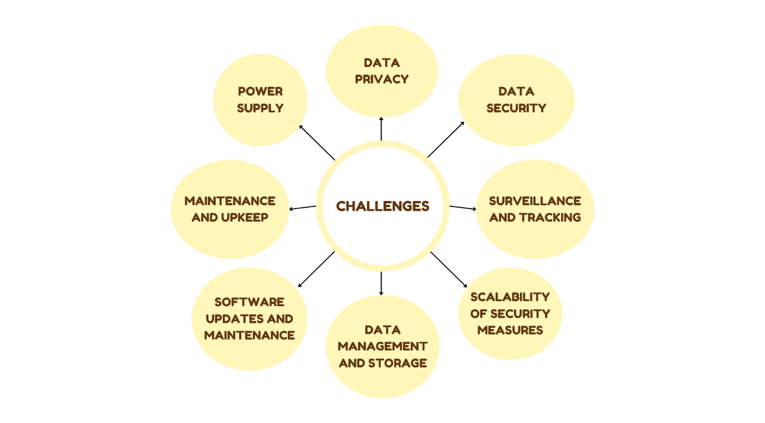

Furthermore, the deployment of IoT technologies in urban development underscores significant challenges related to economic and social inequality. The digital divide, stemming from disparities in internet access and technological literacy, exacerbates existing inequalities between different socioeconomic groups. Moreover, the cost barriers associated with IoT devices and infrastructure limit access to the benefits of IoT for lower-income communities, perpetuating inequality. Automation of tasks by IoT technologies may lead to job displacement, particularly in vulnerable sectors, further widening the gap between different segments of society[8][12]. Additionally, concerns about surveillance and privacy infringement through IoT technologies disproportionately affect marginalized communities, raising questions about data ethics and equity. Gentrification resulting from IoT-driven urban improvements may contribute to the displacement of lower-income residents, exacerbating social inequality. Shifts in funding towards IoT initiatives may divert resources from essential public services, impacting disadvantaged communities' access to education, healthcare, and transportation. Inclusive decision-making processes that consider the needs and concerns of all population segments are crucial to address the social and economic implications of IoT implementation[24]. Moreover, ensuring cybersecurity measures that are accessible and effective for all communities is essential to mitigate risks and protect vulnerable populations from cyber threats.

CASE STUDIES: IOT SUCCESS STORIES IN GLOBAL CITIES

**Seoul, South Korea:**

In Seoul, South Korea IoT innovations have transformed multiple aspects of city life. Smart traffic systems dynamically adjust signals based on real-time data, easing congestion and improving commute times. Additionally, IoT-based waste management optimizes collection routes, enhancing cleanliness and reducing costs. IoT also bolsters public safety through advanced monitoring and emergency response systems. Moreover, Seoul employs IoT for energy efficiency projects and environmental monitoring, offering real-time data to citizens for informed decision-making. Furthermore, the city integrates IoT in healthcare, enabling remote monitoring and timely interventions for patients.[20]

**Amsterdam, Netherlands:**

Amsterdam, Netherlands has embraced IoT to improve urban functionality and sustainability. Smart lighting systems and parking solutions enhance energy efficiency and reduce congestion, while water management initiatives leverage IoT for efficient resource utilization and flood prevention. Amsterdam also implements smart waste management and environmental monitoring systems, complemented by smart grids for energy management. Furthermore, IoT supports urban farming projects and healthcare innovations, contributing to residents' well-being and environmental goals.[17]

**New York City, USA:**

In New York City, USA, IoT technologies optimize waste management, traffic flow, and air quality monitoring. Smart waste management systems reduce overflow and emissions, while IoT devices enhance traffic management and public transit reliability. Continuous air quality monitoring informs public health decisions, complementing efforts to improve energy efficiency through smart building solutions. IoT strengthens public safety with connected cameras and sensors, aiding emergency response efforts. Moreover, the city employs IoT in water management and healthcare, including pandemic response measures and urban farming initiatives.[16]

FUTURE TRENDS AND INNOVATIONS:

In the realm of urban development, the integration of IoT technology is poised to revolutionize city landscapes, fostering smarter and more sustainable environments. Several key trends and innovations are set to shape this evolution: Firstly, the advent of 5G and its subsequent advancements will vastly enhance IoT capabilities within urban areas. With its unparalleled speed and reduced latency, 5G will enable seamless connectivity among a plethora of devices, facilitating real-time operations such as autonomous vehicles and more responsive city services. Secondly, the merging of artificial intelligence with IoT will play a pivotal role in deciphering the immense volumes of data generated by urban IoT devices[14]. AI integration promises predictive maintenance of city infrastructure, refined traffic management, optimized energy consumption, and personalized public services. Moreover, ongoing advancements in sensor technology will bolster the efficiency and affordability of IoT devices. These next-generation sensors, boasting precision, energy efficiency, and expanded environmental detection capabilities, will revolutionize urban environment monitoring and management[22]. Furthermore, the emergence of urban digital twins will become increasingly prevalent in city planning endeavors. These virtual replicas of physical environments allow for the simulation and prediction of real-world scenarios, enabling city planners to refine solutions in a virtual realm before implementing them. In the realm of urban mobility, IoT will continue to drive transformation through initiatives like smart traffic management systems, connected public transit, and support for electric and autonomous vehicles. This encompasses innovations such as smart parking solutions, traffic flow optimization, and real-time route planning. Additionally, blockchain technology holds promise for enhancing the security and transparency of IoT networks. By securing data transactions and enabling transparent operations, blockchain can help mitigate privacy and security concerns associated with IoT in urban settings[13]. Edge computing is set to streamline data processing by handling information closer to its source, thereby reducing latency, bandwidth usage, and central data center loads. Furthermore, there will be a heightened focus on inclusive and equitable deployment of technology, ensuring that IoT solutions cater to the needs of all community members, including marginalized groups. Moreover, IoT devices will increasingly play a role in monitoring environmental conditions that impact public health, such as air quality and water safety, aiding in citizen alerts and informed decision-making during health crises. Lastly, as IoT becomes ingrained in urban infrastructure, expect the development of robust regulatory and ethical frameworks to address concerns regarding data privacy, security, and societal impacts.

RESEARCH SUMMARY:

The research explores the multifaceted role of IoT in empowering smart cities and facilitating urban transformation. It delves into various aspects of urban infrastructure enhancement through IoT implementation, emphasizing its impact on transportation, utilities, and public safety. In transportation, IoT solutions offer real-time monitoring of traffic conditions, enhancing efficiency and safety while reducing congestion through optimized signal timings and smart traffic management systems. Additionally, IoT facilitates improvements in public transport systems, predictive maintenance, environmental monitoring, and smart parking solutions, all contributing to a more sustainable and efficient urban mobility landscape. In the domain of utilities, IoT revolutionizes resource management by optimizing electricity, water, and waste management systems. Smart grids and meters, coupled with IoT-enabled sensors, ensure efficient energy consumption, water conservation, and optimized waste collection routes, thereby promoting sustainability and cost reduction. Furthermore, the research highlights the pivotal role of IoT in public safety innovations, including smart surveillance systems, emergency response mechanisms, and disaster management, leveraging real-time data for enhanced situational awareness and effective response strategies. Moreover, it addresses the challenges and considerations associated with IoT implementation, particularly focusing on security, privacy, technological limitations, and socioeconomic disparities. Despite its transformative potential, the integration of IoT into urban development poses significant challenges, including data privacy concerns, infrastructure scalability issues, and economic inequality. The research also presents case studies from global cities such as Seoul, Amsterdam, and New York City, showcasing successful IoT implementations across various urban sectors. Lastly, it outlines future trends and innovations in urban IoT, including advancements in 5G technology, AI integration, sensor technology, blockchain for security, edge computing, inclusive technology deployment, and regulatory frameworks, all poised to shape the future of smart cities towards sustainability, inclusivity, and resilience.

CONCLUSION:

In conclusion, the integration of IoT technology holds immense potential for empowering smart cities and driving urban transformation. Through interconnected devices and sensors, IoT facilitates enhancements across various sectors, from transportation and utilities to public safety and sustainable urban development. By leveraging real-time data and predictive analytics, cities can optimize resource usage, improve infrastructure efficiency, and elevate the quality of life for residents. In transportation, IoT enables real-time monitoring of traffic conditions, enhances public transport systems, and streamlines parking processes, contributing to reduced congestion and emissions. Moreover, in utilities management, IoT revolutionizes energy, water, and waste management practices, leading to enhanced efficiency, cost reduction, and sustainability. Additionally, IoT-driven innovations in public safety, healthcare monitoring, and infrastructure management enhance urban resilience and safety. However, the integration of IoT into urban development presents significant challenges, particularly in terms of security, privacy, technological limitations, and social equity. Addressing these challenges requires robust data security measures, standardized protocols, and inclusive decision-making processes that consider the needs and concerns of all population segments. Moreover, as cities embrace IoT initiatives, there is a pressing need for regulatory frameworks and ethical guidelines to safeguard data privacy, security, and mitigate potential societal impacts. Looking ahead, future trends and innovations in IoT, such as advancements in 5G technology, AI integration, sensor technology, and edge computing, will further drive urban evolution towards smarter and more sustainable environments. By prioritizing inclusive and equitable deployment of technology and fostering collaboration between stakeholders, cities can harness the full potential of IoT to address urban challenges and create more resilient, livable, and prosperous communities.

References:

1. Praharaj, S., Han, J. H., & Hawken, S. (2018). Urban innovation through policy integration: Critical perspectives from 100 smart cities mission in India. City, culture and society, 12, 35-43.
2. Nesti, G. (2020). Defining and assessing the transformational nature of smart city governance: Insights from four European cases. International Review of Administrative Sciences, 86(1), 20-37.
3. T. Jaiswal, M. Pandey and P. Tripathi, "Review On IoT Enabled Smart Cities in India," 2020 First International Conference on Power, Control and Computing Technologies (ICPC2T), Raipur, India, 2020, pp. 289-294, doi: 10.1109/ICPC2T48082.2020.9071519. keywords: {Smart cities;Intelligent sensors;Temperature sensors;Internet of Things;Government;IoT;Smart City;challenges;Applications;Smart Home},
4. <https://youtu.be/obiCtZfrN2g?si=AqWPSGf-PwvzqGD9>
5. <https://timesofindia.indiatimes.com/blogs/voices/the-future-is-iot-a-guide-to-the-transformation-to-smart-cities/> (January 13, 2023, 2:00 PM IST Pranesh Chaudhary in Voices, India, TOI)
6. <https://appinventiv.com/blog/role-of-iot-in-smart-cities-applications/#:~:text=Unveiling%20the%20Benefits%20of%20IoT%20in%20Smart%20Cities,IoT(Internet%20of&text=It%20streamlines%20services%2C%20enhancing%20residents,a%20smarter%2C%20more%20connected%20community>. (Sudeep Srivastava, March 29, 2024)
7. <https://www.smartsight.in/industry-insights/smart-cities-and-the-role-of-iot-in-urban-planning/>
8. ref S. K. Vishwakarma, P. Upadhyaya, B. Kumari and A. K. Mishra, "Smart Energy Efficient Home Automation System Using IoT," 2019 4th International Conference on Internet of Things: Smart Innovation and Usages (IoT-SIU), Ghaziabad, India, 2019, pp. 1-4, doi: 10.1109/IoT-SIU.2019.8777607.
9. <https://prakashinfotech.com/applications-of-iot-transforming-smart-cities> [Yuvraj Raulji Published on:March 28, 2024]
10. Indicators for Sustainable Cities. Available online: https://ec.europa.eu/environment/integration/ research/newsalert/pdf/indicators_for_sustainable_cities_IR12_en.pdf (accessed on 10 July 2020).
11. <https://smartcity.eletsonline.com/iot-to-play-a-crucial-role-in-developing-indian-smart-cities/> [By Elets News Network -April 8, 2024]
12. <https://www.researchgate.net/publication/377737939_A_Smart_IoT-Based_Home_Automation_System_for_Controlling_and_Monitoring_Home_Appliances> keywords: {Internet of Things;Smart homes;Home appliances;Google;Automation;Home Automation;Relay;Node MCU (ESP8266);IFTTT;Adafruit;Internet of Things (IoT);Google Assistant;Voice Control;Smartphone}
13. <https://www.researchgate.net/publication/379691146_Empowering_Smart_Cities_with_AI_and_RPA_Strategies_for_Intelligent_Urban_Management_and_Sustainable_Development>
14. Rao, S.K.; Prasad, R. Impact of 5G technologies on smart city implementation. Wirel. Pers. Commun. 2018, 100, 161–176.
15. Farooqi, N.; Gutub, A.; Khozium, M.O. Smart community challenges: Enabling IoT/M2M technology case study. Life Sci. J. 2019, 16, 11–17
16. P. Wilson, ‘‘State of smart cities in UK and beyond,’’ IET Smart Cities, vol. 1, no. 1, pp. 19–22, Jun. 2019.
17. Cisco. (2014). Amsterdam Uses Ioe-Driven Capabilities To Cut Energy Usage, Improve Electric Grid’S Reliability, And More. [Online]. Available: https://www.cisco.com/c/dam/m/en_us/ ioe/public_sector/p
18. N. Mohamed, J. Al-Jaroodi, I. Jawhar, S. Lazarova-Molnar, and S. Mahmoud, ‘‘SmartCityWare: A service-oriented middleware for cloud and fog enabled smart city services,’’ IEEE Access, vol. 5, pp. 17576–17588, 2017.
19. Boori MS, Choudhary K, Paringer R, Kupriyanov A (2021) Spatiotemporal ecological vulnerability analysis with statistical correlation based on satellite remote sensing in Samara. Russ J Environ Manag 285:112138. <https://doi.org/10.1016/J.JENVMAN.2021.112138>
20. Dadhich AP, Goyal R, Dadhich PN (2018) Assessment of spatio-temporal variations in air quality of Jaipur city, Rajasthan, India. Egypt J Remote Sens Space Sci 21(2):173–181. <https://doi.org/10.1016/J.EJRS.2017.04.002>
21. Azim Premji, Chairman Wipro Ltd, (2017, February 04), Smart cities are more talk than action. Retrieved from <http://www.economictimes.indiatimes.com>.
22. Shamsuddin, S., & Srinivasan, S. (2020). Just Smart or Just and Smart Cities? Assessing the Literature on Housing and Information and Communication Technology. Housing Policy Debate, 1-24.
23. Rai, S., Deshpande, M., & Thakur, G. (2020). People Centric Smart Cities. In E3S Web of Conferences (Vol. 170, p. 05003). EDP Sciences.
24. AIF, Poverty in India, Azad India Foundation, Kishanganj, India. available: <http://www.azadindia.org/social-issues/poverty-in-india.html>
25. J. Belissent, WEBINAR: The Core Of A Smart City Must Be Smart Governance,CIOS, Forrester, 2011. available: <https://www.forrester.com/The+Core+Of+A+Smart+City+Must+Be+Smart+Governance/-/EWEB7738>