**Formulation and Evaluation of Microspongial Gel of Calendula Officinalis for Wound Healing Property**

Sagar Jadkar *, Avantika Bandagi 1 , Aakanksha Chavan 2 ,Sharaddha Thakre3,Vaishnavi Gadade4

1,2,3,4Department of Pharmaceutics, Lokmangal Collage of Pharmacy, Wadala, Solapur, Affiliated to Dr. Babasaheb Amedkar Technological University, Lonere Raigad, Maharashtra.

**Abstract**

*Calendula Officinalis* is a natural herbal remedy also known as pot marigold or marigold. It has several important phytoconstituents with a wide range of applications and multiple activities. These constituents include lipids, steroids, flavonoids, saponins, carotenoids, and all parts of the plant, including the flowers and leaves, have therapeutic activity. The Soxhlet technique can be used to obtain the extract of flowers. Additionally, it can be made in a variety of dosage forms such as cream, powder, gel, etc. and utilised to a range of purposes. Particulate drug delivery systems made of porous material are called microsponges. These are tiny, spherical particles that resemble sponges and have a broad porous surface. They may also increase stability by altering the drug release pattern while causing fewer negative effects. Drugs can be inserted into microsponges, which are then transformed into dosage forms, such as gel. This type of microspongial gel is utilised for wound healing, which is particularly common in people with diabetes mellitus. Thus, the primary goal of this article is to make a microspongial gel that contains *calendula officinalis* and is intended to be used for wound healing.

*Keywords : Calendula Officinalis, Microsponges, Quasio Emulsion Solvent Diffusion , Soxhlat , Microspongial gel*

1. **Introduction**-

Pharmaceutical scientists have encountered many difficulties, one of which has been controlling the pace at which active drugs are delivered to a specific location within the human body. These conditions are satisfied by the microsponges delivery mechanism. Porous microspheres with several interconnected gaps ranging in particle size from 5 to 300 µm are known as microsponges. Numerous active ingredients can be entrapped by these microsponges.(1) The vehicle contains microspheres, which have an average diameter of 25 µm and function as tiny sponges to hold the active medicine until it is applied to the skin's surface, at which point it releases. For prolonged drug retention, the microspores in the spheres have a pore length of 10 feet and a total pore density of about 1 ml per gm.(2) For therapy to be effective, it becomes necessary to supply a high concentration of active components or to maximise the amount of time an active ingredient is in contact with the skin's surface or epidermis while avoiding penetration of the ingredient inside the skin. Porous microsponges filled with active ingredients are the preferred option when mixed into gels, creams, lotions, and powders. The Quasio-Emulsion solvent diffusion method (3) is used to prepare microsponges, which are then mixed into the gel for topical administration. The active component is taken to be *Calendula officinalis* methanoic extract.

1. **Introduction of wound healing :**

Skin wounds are caused by the integrity of the epidermal layer breaking down. A wound is any tissue damage that results in a loss of function and anatomical integrity. Skin healing is essentially what wound healing entails. After an epidermal layer injury, wound healing starts right away and may take years. The highly ordered cellular, humoral, and molecular systems are part of this dynamic process. Inflammation, proliferation, and remodelling are the three overlapping stages of wound healing Any interference results in unusual wound healing. Sometimes, primary and secondary healing are used to categorise wound healing. Primary healing is the simple healing of a well-approximated, non-infected wound. The best illustration of primary healing is a surgical wound. The secondary healing stage starts if an infection, dehiscence, hypoxia, or immunological dysfunction interferes with the wound's ability to heal. Granulation tissue forms during secondary healing, and this new tissue is covered in epithelium. These kinds of wounds are more prone to infections and inadequate recovery.

1. **Pathophysiology**

Wound healing has four overlapping phases which are Bleeding, inflammation, proliferation, and remodelling

**1)Haemostasis or Bleeding:**

Haemostasis is the initial stage of the wound healing process that involves stopping bleeding. It is crucial for preventing excessive blood loss and initiating the repair process. Here's how it generally works: Vascular Spasm: Immediately after injury, blood vessels constrict to reduce blood flow to the damaged area. This constriction helps minimize blood loss.Platelet Plug Formation: Platelets, tiny cell fragments in the blood, adhere to the site of injury and aggregate together to form a temporary plug. This plug helps further reduce blood loss.Coagulation: Coagulation, or blood clotting, reinforces the platelet plug with a meshwork of fibrin threads. Fibrin is a protein that stabilizes the clot and prevents further bleeding.

These processes together form hemostasis, which lays the groundwork for the subsequent phases of wound healing: inflammation, proliferation, and maturation. Proper hemostasis is essential for successful wound repair and is typically followed by inflammation to clean the wound and begin tissue repair.

**2) Inflammation:**

Inflammation and hemostasis are present during this stage. When the skin is injured, clotting cascades are triggered right away, temporarily plugging the wound site with a fibrin blood clot. Meanwhile, the injured area experiences 5-to 10-minute vasoconstriction. These transient responses shield the wound and stop more bleeding. Additionally, this fibrin plug creates a transient matrix that acts as a scaffold for subsequent healing processes, including the migration of endothelial cells, fibroblasts, leukocytes, and keratinocytes, as well as a source of growth factors.

Following this transient vasoconstriction response, vasodilatation takes place, leading to localised hyperaemia and oedema. Collision-exposed sub-endothelium, tissue factor, and platelet aggregation promote platelet degranulation and aggregation. Inflammation is initiated and hemostasis is completed by the secreted chemotactic and growth factors. Within the first 24 hours of the injury, neutrophils are drawn to the location and remain for two to five days. They start the process of phagocytosis, which macrophages subsequently carry out.

Reactive oxygen species (ROS) and proteases are released by these phagocytic cells to eradicate nearby microorganisms and debride necrotic tissues. Additionally, by producing a large number of pro-inflammatory cytokines, neutrophils enhance the inflammatory response and serve as a chemoattractant for other cells. Macrophages show up three days after the wound. In a similar vein, they secrete a multitude of growth factors, chemokines, and cytokines that encourage cell division and the production of extracellular matrix (ECM) components.

**3)Proliferation:**

The creation of granulation tissue and the repair of the vascular network define the subsequent proliferative phase. This stage lasts for days or weeks and begins from three to ten days following the injury. This phase is characterised by the involvement of multiple cytokines and growth factors, including the transforming growth factor-beta family (TGF-beta, comprising TGF-beta1, TGF-beta2, and TGF-beta3), the interleukin (IL) family, and angiogenesis factors.In this phase, fibroblasts and endothelial cells are the predominant proliferating cells. An adequate supply of blood is necessary for cell growth to occur. As a result, an angiogenic response starts at the same time.

Local hypoxia, platelet-derived growth factor (PDGF), fibroblast growth factor-basic (bFGF), vascular endothelial growth factor (VEGF), and the serine protease thrombin are the primary stimulants of this reaction. Angiogenesis and Vasculogenesis are the two ways by which new vessels are formed. Angiogenesis is the "sprouting" process by which resident endothelial cells of the nearby mature vascular network give rise to neo-vessels that develop into the avascular location. In contrast, progenitor stem cells develop and create new arteries during the de novo process of vasculogenesis, which occurs without the cells "sprouting" from an established vascular network. Endothelial progenitor cells (EPC) are progenitor stem cells that are commonly seen in the bone marrow.

EPC recruitment into the circulation starts following the injury. The activation of EPC is aided by VEGF, NO, and matrix metalloproteinases (MMP), particularly MMP-9. Likewise, the primary homing signal that directs EPCs to congregate in ischemia-affected tissues is stromal derived factor 1-alpha (SDF1-alpha). Eventually, a new vascular network that facilitates gas and metabolite exchange as well as nutrition delivery is created. Antiangiogenic drugs like bevacizumab have the potential to disrupt this stage and result in the development of chronic wounds. However, epithelization also starts during wounds and is induced by several growth hormones and inflammatory cytokines.

Epithelization is facilitated by local keratinocytes located at the wound's edge as well as epithelial stem cells found in the hair follicle and apocrine gland bulbs.Once stem cells differentiate into keratinocytes, the latter start to move around the wound edge until they come into direct contact with one another. The migration is stopped by the nearby keratinocytes' prevention of contact. Granulation tissue development is the final stage of the proliferation phase. Fibroblasts move to the location of the wound and multiply . Next, they start creating a temporary matrix made of fibronectin, glycosaminoglycans, and type III collagen. Fibroblasts, granulocytes, macrophages, capillaries, and loosely arranged collagen bundles make up the granulation tissue. Also, because angiogenesis is still ongoing, this new, traditional red tissue is extremely vascular.

**4)Remodelling:**

The final stage of wound healing, known as remodelling, lasts for up to a year and starts on day 21. The new tissue's synthesis and breakdown must be precisely balanced throughout this phase and must be rigorously maintained. Any disturbance results in the development of a chronic wound. The granulation tissue production stops and the wound begins to mature during the remodelling phase. ECM components that are subjected to specific changes to create a more robust and well-organized ECM. Stronger collagen type 1 takes the role of collagen type III.The wound's tensile strength steadily rises. At least four to five weeks are needed for the synthesis of collagen. But, compared to collagen found in healthy skin, the collagen in a wounded area will never be as organised. It is significant to remember that the hydroxylases need oxygen and vitamin C to synthesise collagen. Thus, wound strength may be impacted by hypoxia and vitamin C insufficiency. Matrix remodelling enzymes, in particular matrix remodelling proteins (MMPs), have important roles in cellular migration, proliferation, and angiogenesis as well as in the remodelling of the local matrix microenvironment. Apoptosis occurs in the remaining cells from the earlier phase.

Furthermore, wound contraction starts. Fibroblasts are stimulated to develop into myofibroblasts by TGF-beta1. Myofibroblasts contribute to wound contraction in addition to synthesising major extracellular matrix (ECM) components like glycoproteins, proteoglycans, and collagen types I through VI. Myofibroblasts are interestingly similar to smooth muscle cells. They may produce significant contractile forces and traction across the wound site, and they express alpha-smooth muscle actin. This contraction allows the wound to close by drawing the margins together. Following complete epithelization of the wound, myofibroblasts die. Therefore, fibrosis and the creation of scars may result from prolonged or excessive myofibroblast activity. One important factor in the development of a mature, largely acellular wound is the fibroblastic cells' apoptosis. Nevertheless, little is known about the apoptotic mechanisms underlying wound healing.

At last, angiogenic reactions stop, and blood flow decreases. acute metabolism at the margins of the wounds. These procedures offer complete healing of damaged tissue areas and reinstatement of the wound's mechanical strength. Scar formation results from the healing of wounds. It is well recognised that inflammation and scarring are connected. There are some flaws in this scar tissue. For example, the strength of a wound never reaches the level of the normal skin. Wound strength will be only about 80% at three months and later. Similarly, following a serious injury, subepidermal appendages like sweat glands or hair follicles would not repair. Furthermore, this scar tissue—which is necessary for the strong adhesion of the epidermis to the dermis—lacks rete pegs.[27]

*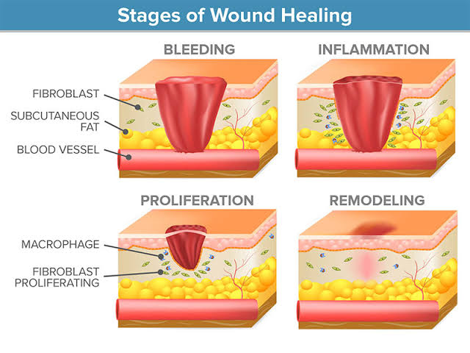Fig .1 Phases Of Wound Healing*

1. **Aim of Work­:**

To Formulate and Evaluate the Microspongial Gel of Calendula officinalis for Wound Healing Property is the main aim of this article .

* **Need of the Study :**

• Researching *Calendula officinalis*, or marigold, is beneficial for learning about its therapeutic qualities, its uses in skincare products, and ecological importance as a herbal medicine.

• Its potential in cosmetics and herbal medicine, as well as its anti-inflammatory, antibacterial, and wound-healing qualities, can all be investigated through research.

• Studying microsponges formulations can lead to the creation of innovative drug delivery systems with controlled release features, increased stability, and targeted delivery. Additionally, studies can study their usage in cosmetics for enhancing skin penetration of active substances. Developing new drug delivery systems with targeted delivery, improved stability, and controlled release characteristics can result from studying microsponges formulations. Additionally, studies can study their usage in cosmetics for enhancing skin penetration of active substances.

• Research on microsponges in gel formulation for wound healing is crucial for a number of reasons, including improved wound dressing that promotes cell proliferation and tissue regeneration, increased biocompatibility and safety, and fewer adverse effects.

All things considered, research on microspongial gels for wound healing may result in the creation of novel and potent treatments that encourage quicker and more efficient wound healing.

* **Objectives of Work :**

The objectives of formulating and evaluating microspongial gel for wound healing properties can include:

* Formulation Optimisation: To maximise the effectiveness of wound healing, formulate an optimal formulation of microspongial gel by choosing the right polymers, cross-linking agents, and therapeutic agents.
* Controlled Drug Release: To ensure a longer therapeutic effect at the wound site, study the release kinetics of therapeutic drugs from the microspongial gel in order to produce sustained and controlled release profiles.
* Biocompatibility Assessment: To guarantee safety and compatibility with wound tissues, assess the biocompatibility of the microspongial gel formulation using in vitro and in vivo tests.
* Wound Healing Efficacy: Using in vitro and in vivo wound models, evaluate the microsponge gel formulation's ability to promote wound healing by taking into account variables including collagen deposition, wound closure rate, and epithelialization.

1. **Plant Profile**
2. **Plant Description -**

*Calendula officinalis* is a short-lived scented herbaceous perennial, Growing to 80cm (31in) tall, with sparsely branching lax or erect Stems. The leaves are oblong-lance. The tubular, hermaphrodite disc florets are usually more intensely orange in colour, measuring 5–17 cm (2–7 in), hairy on both sides, and having entire or occasionally waved or weakly toothed margins. The yellow inflorescences have a 4–7 cm diameter, thick capitulum, or flower head. Surrounded by two rows of hairy bracts; in the wild plant they have A single ring of ray florets surrounding the central disc florets-yellow Colour than the female, tridentate, peripheral ray florets. The Flowers may appear all year long if conditions are favourable. The Fruit is a curved, thorny achene.(4)The cultivation of the Calendula is primarily evident in the Southern Europe And it is badly survive in the Sunny season and not survive in the hot Season it is well survive and flourish in the cold season

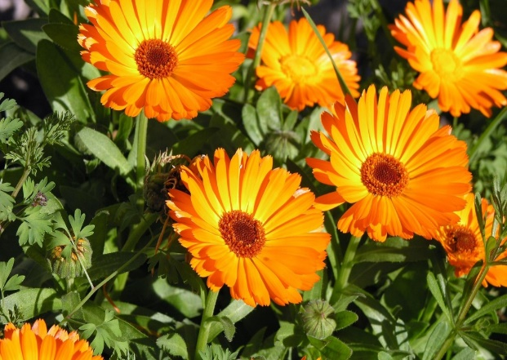

**

*Fig . no. 2 Calendula officinalis flower*

* **Common names -**

Pot marigold , Bride of the Sun, bull flower, butterwort Calendula, field Marigold, garden marigold, goldbloom, holligold, Mara villa, Mary bud, Marigold, Ringelblumen(Ger). In old English calendula was known as “golds”, and was associated first with the Virgin Mary and then with Queen Mary; hence “Mary’s gold.(5)

* **Organoleptic Chatecter**-

The odour of *Calendula officinalis is* faint and aromatic. The taste of *Calendula officinalis* is bitter.

* **Botanical name**- *Calendula officinalis* .
* **Botanical Family** – Asteraceae

1. **Botanical Classification -** (6)

|  |  |
| --- | --- |
| Kingdom | *Plantae* |
| Sub kingdom | *Tracheobionta* |
| Division | *Magnoliophytes* |
| Class | *Magnoliopsida* |
| Sub class | *Asteridae* |
| Order | *Asterales* |
| Family | *Asteraceae* |
| Tribe | *Calenduleae* |
| Genus | *Calendula* |
| Species | *C.officinalis* |

1. **Herbal Medicinal uses-** (7)

* Healing of minor wounds, burns, and abrasions: In the past, topical Calendula officinalis was used to treat these conditions; however, few clinical trials have been carried out to evaluate its safety and effectiveness for these applications.
* Ulcerations of the veins
* Antihypertensive medications; radiation dermatitis in breast cancer patients
* Sleep aids
* Sedative
* Lipid-lowering drugs; calendula enhances the action of insulin in hypoglycemia.
* **Excipient Profile –**

1. **Polyvinyl Alcohol**
   * 1. **Synonym-**Gelvatol, vinol
     2. **Description -**is a water-soluble synthetic polymer. It has the idealized formula [CH2CH(OH)]n. It is used in papermaking, textile warp sizing, as a thickener and emulsion stabilizer in polyvinyl acetate.It is colourless (white) and odorless**.**
     3. **M.W -** between 26,300 and 30,000
     4. **Molecular Formula-** CH2CH(OH)]n
     5. **IUPAC**- butan-2-ol
     6. **Solubility-** water soluble
     7. **Storage-** Keep polyvinyl alcohol in sealed containers to prevent moisture absorption**.**

*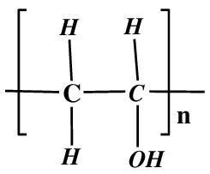Fig no. 3 Polyvinyl Alcohol*

**2) Dichloromethane**

1. **Synonym** - methylene chloride
2. **Description**- is an organochlorine compound with the formula CH2Cl2. This colourless, volatile liquid with a chloroform-like, sweet odour is widely used as a solvent. Although it is not miscible with water, it is slightly polar, and miscible with many organic solvents.
3. **M.W** - 84.93 g/mol
4. **M.Formula**- CH2Cl2
5. **IUPAC Name**- methylene chloride.
6. **Solubility**- not miscible with water, it is slightly polar, and miscible with many organic solvents
7. 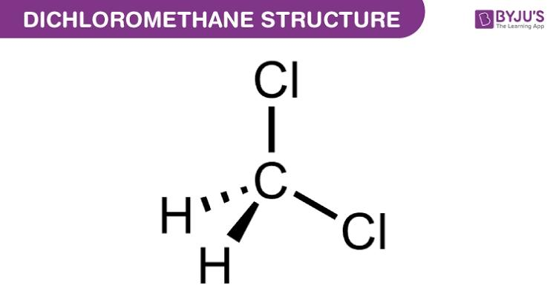**Storage** - should be stored in a cool, dry area in tightly closed, labelled containers.

*Fig no. 4 Dichloromethane*

**3) Cellulose**

1. **Synonym** - cellulosic, polyose.
2. **Description**- Cellulose is an odorless, white powdery fibers. Density: 1.5 g/cm3. The biopolymer composing the cell wall of vegetable tissues. Prepared by treating cotton with an organic solvent to de-wax it and removing pectic acids by extration with a solution of sodium hydroxide.
3. **M.W -** 162.1406 g/mol
4. **M. Formula** - (C₆H₁₀O₅)n
5. **IUPAC name**-(6S)-2-(hydroxymethyl)-6-[(3S)-4,5,6-trihydroxy-2-(hydroxymethyl)oxan-3-yl]oxyoxane-3,4,5-triol
6. **Solubility**- insoluble in water but can be dissolved in strong acidic or alkaline condition**.**
7. 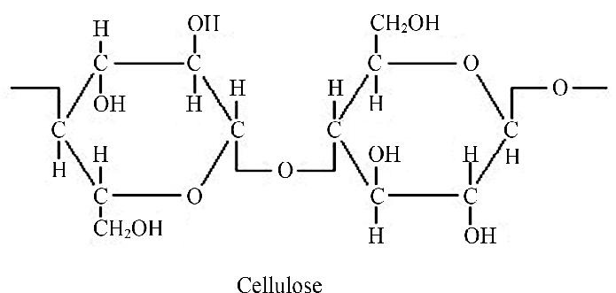**Storage-** well ventilated to prevent the build up of acidic gasses that drive the autocatalytic degradation reactions of cellulosic films.

*Fig no. 5 Cellulose*

**4) Carbopol 934-**

1. **Synonym** - Synthases M – 3V,Unopol 934.
2. **Description**- is a white powder, cross-linked polyacrylic acid polymer. It exhibits short flow properties and a creamy sensory profile.
3. **M.W** - 102.13 g/mol.
4. **M.Formula**- C 5H10 O 2
5. **IUPAC Name**- Poly(acrylic acid-co-poly(alkenyl polyether))
6. **Solubility-** soluble in water
7. 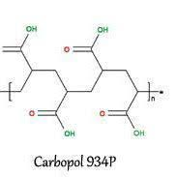**Storage** -Store in a well-ventilated place. Keep container tightly closed.

*Fig no. 6 Carbapol 934*

**5) Methyl Paraben-**

1. **Synonym** - Methyl Hydroxy Benzoate
2. **Description**- one of the parabens, is a preservative .
3. **M.W -** 152.149 g·mol−1
4. **M. Formula**- C8H8O3
5. **IUPAC Name**- Methyl4-hydroxybenzoate
6. **Solubility**- freely soluble in most oils, waxes, fatty alcohols, but have relatively low solubility in water.
7. 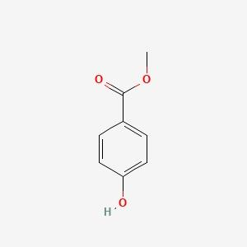**Storage**- Store in a dry, cool and well-ventilated place.

*Fig no. 7 Methyl Paraben*

**6. Propyl Paraben-**

1. **Synonym** - 4-hydroxybenzoic acid propyl ester.
2. **Description**- is the n-propyl ester of p-hydroxybenzoic acid. It occurs as a natural substance found in many plants and some insects. Additionally, it can be manufactured synthetically for use in cosmetics, pharmaceuticals, and foods.
3. **M.W** - 180.2 g/mol
4. **M.Formula**- C10H12O3
5. **IUPAC name**- Propyl4-hydroxybenzoate
6. **Solubility**- very slightly soluble in water, but freely soluble in alcohol and ether.
7. 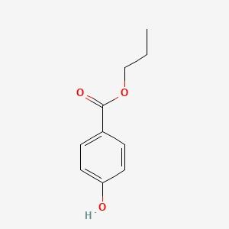**Storage**- Store in a dry, cool and well -ventilated place .

*Fig no. 8 Propyl Paraben*

**7) Propylene glycol**

1. **Synonym-** 1,2-dihydroxypropane
2. **Description** - is a viscous, colourless liquid, which is nearly odourless but possesses a faintly sweet taste. Its chemical formula is CH3CH(OH)CH2OH. As it contains two alcohol groups, it is classed as a diol. It is miscible with a broad range of solvents, including water, acetone, and chloroform.
3. **M.W** - 76.09 g/mol
4. **M. formula** - C3H8O2
5. **IUPAC Name**- propane-1,2-diol
6. **Solubility**- completely soluble in water.

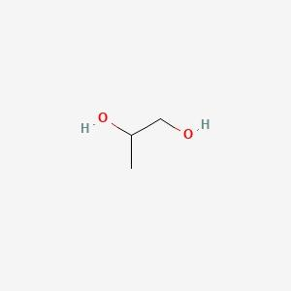

*Fig no. 9 Propylene Glycol*

1. **Triethaloamine**
2. **Synonym**: Triethylamine
3. **Description**: Triethaloamine is a colorless liquid with a strong, ammonia-like odor. It is Commonly used as a base in organic synthesis and as a catalyst in chemical reactions.
4. **Molecular Formula**:C6H15NO3
5. **Molecular Weight**: Approximately 101.19 g/mol
6. **IUPAC Name**: N,N-Diethylethanamine
7. **Solubility**: Soluble in water, ethanol, and ether
8. **Storage**: Store in a cool, dry, and well-ventilated area away from sources of ignition and Incompatible substances.

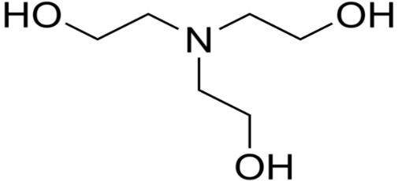

*Fig no. 10 Triethanolamine*

1. **Materials and Methods**

* **Materials and Equipments :**

The raw materials like collection of plants , excipients and chemicals required for the present work were procured from different sources. Following materials were used for Formulation and Evaluation of Microspongial Gel from Methanolic extract of *Calendula officinalis* flowers for Wound healing Activity.

*Table no. 1 List of Excipients*

|  |  |  |
| --- | --- | --- |
| **Sr. No.** | **Excipients** | **Manufacturer** |
|  | Polyvinyl Alcohol | Aarti Scientific Company |
|  | Cellulose | Vishal chem |
|  | Dichloromethane | Aarti Scientific Company |
|  | Carbapol 934 | Aarti Distributors |
|  | Methyl Paraben | Vishal chem |
|  | Propyl Paraben | Aarti Scientific Company |
|  | Propylene Glycol | Aarti Scientific Company |

*Table no.2 List of Equipments*

|  |  |  |
| --- | --- | --- |
| **Sr. no.** | **Equipments** | **Suppliers** |
| 1. | Ultrasonicator | Electrolab Pvt. Ltd |
| 2. | Magnetic Stirrer | Electrolab Pvt. Ltd |
| 3. | Homogenizer | Electrolab Pvt. Ltd |
| 4. | IR Spectrophotometer | BRUKER |
| 5. | Hot Air Oven | BRUKER |
| 6. | Electronic Balance | WENSAR |

1. **Collection of Plant Material** –

For the next step, dried *Calendula officinalis*, often known as pot marigold, flowers were purchased from a nearby vendor and finely grind into a powder.

1. **Methods**

* **Extraction Process**-

The dried flowers of *Calendula officinalis*, sometimes known as pot marigold, were bought from a nearby seller and ground into a fine powder in preparation for the extraction process. Calendula officinalis can be extracted using the Soxhlet procedure. To begin, the soxhlat can be assembled. Next, 20 mg of finely graded powder are weighed. Finally, the medication is placed into Soxhlet. The methanol was added as a solvent for the extraction procedure after the filter paper was formed into a pouch and placed within the condenser. Additionally, to stop the solvent from evaporating, position the cotton at the top of the condenser. Same procedure can be repeated three times, meaning that the drug's pure form will be achieved following the completion of three cycles of the soxlate. Subsequently, the undiluted extract is gathered and refined using Whattmen filter paper before being transferred into a petri dish and allowed to air dry, causing the alcohol to evaporate. The phytoconstituents that were extracted using the aforementioned method include amino acids, steroids, tannis, saponins, and flavonoids.

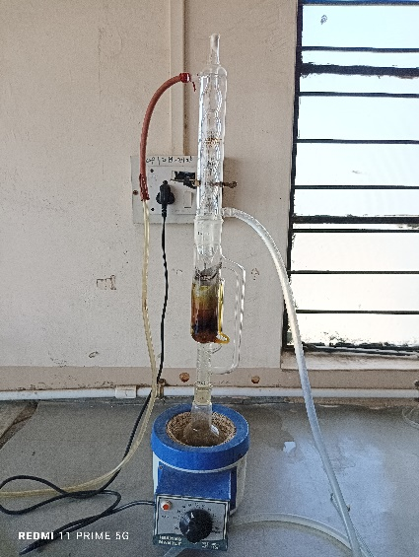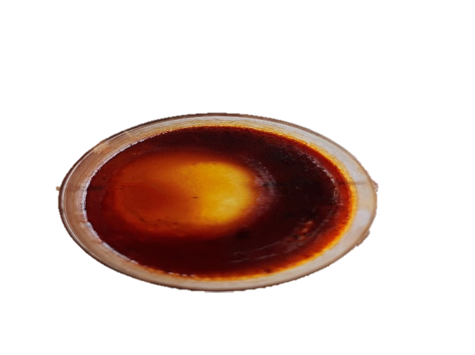 *Fig.no 11 Extraction of Calendula Officinalis*

* **Qualitative and Quantitative Analysis :**

1. **Qualitative Tests**
2. **Chemical tests for the Flavonoid’s**-
   * 1. **Alkaline reagent test**.

To 2 ml of extract, two to three drops of sodium hydroxide were added. At first, it had a really dark golden colour. However, if a few drops of diluted HCL were added, it gradually lost colour, indicating the presence of flavonoids.

* + 1. **Shinod’s test**.

1 ml of extract was mixed with ten drops of diluted HCL and a piece of magnesium; the resultant rich pink hue indicated the presence of flavonoids.

1. **Chemical test for the tannis** –
   * 1. **Ferric chloride test**:

1 ml of extract was mixed with 2 ml of 5% neutral ferric chloride solution; the dark blue colouring indicates the presence of tannins and phenolic compounds.

* + 1. **Lead tetra acetic acid test**:

After adding 0.5 mL of extract to one ml of lead tetra acetate solution, a precipitate formed, indicating the presence of tannins and phenolic chemicals. (18)

1. **Chemical test for Saponnis-**
   * 1. **Wet foam test**:

After diluting the test solution with water and vigorously shaking it for one to two minutes, a stable foamy lather formed on top of the sample's test tube.

* + 1. **Dry foam test**:

After shaking 0.5 gm of the plant's crude powder in a test tube with 5 ml of distilled water and heating it in a water bath, the stable, persistent froth was combined with 3 drops of olive oil and forcefully shaken. Emulsion development is a sign that saponins are present. (19)

1. **Chemical test for triterpenoids (26)**
   * 1. **Foam test**: After diluting 1 ml of extract with 5 ml of distilled water, the mixture is forcefully shaken in a test tube for a minute. When a stable foam forms above the liquid level in the test tube, triterpenes glycosides, also known as saponins, are present.
     2. **Colour reaction**:

1 drop of 10% CuSO4 and 1 ml of concentrated H2SO4 were added to roughly 2 ml of extract; the mixture was then gently heated. Triterpenoids are present when blue-green coloration appears.

1. **Introduction of Microsponges**

Modern times have seen a number of technological advancements in innovative drug delivery systems that provide the drug's target-specific actions as well as its beneficial therapeutic effects. Because of this, numerous scientists are researched. In order to provide the highest Therapeutic index and the length of the actions, we proposed another unique drug delivery technology that we named microsponges. Originally, microsponges were created for topical drug administration. Micro sponges were active agent-loaded macro porous beads, usually with a diameter of 10–25 microns. Micro sponges consist of porous microspheres with embedded, linked voids ranging in size from 5 to 300 µm. These are spherical, homogeneous polymer particles.(8) prosthetic microsponges. prolonged and consistent medicine release. It enhances the compliance of the patient by minimising The irritation. Formulations containing microsponges are thermal, Physically, and chemically stable. By absorbing them, they lessen greasiness and oiliness on the skin.(9)

A microsponges delivery system is a polymeric system made up of porous microspheres that can entrap and release substances into the skin over an extended period of time. It is a strongly cross-linked microsphere. Extended release, decreased discomfort, increased tolerance, and enhanced thermal, physical, and chemical stability are all features of this delivery technology. Achieving the appropriate drug concentration in blood or tissue that is therapeutically efficacious and non-toxic for an extended period of time is the primary objective of any drug delivery system (10) Microsponges are made utilising the quasi-emulsion solvent diffusion process.

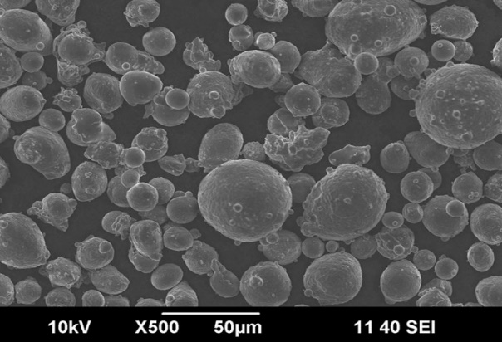

*Fig no.12 microscopic view of calendula officinalis Microsponges*

1. **History-**

Won created the microsponges technique in 1987, and Advanced Polymer Systems, Inc. was granted the original patents. This company created numerous variations of the technology and used them for pharmaceutical, over-the-counter, and cosmetic items.(11)

1. **Characteristics-**

* When there is no increase in viscosity, monomers and polymers are inert.• Water-impermeable or marginally soluble.
* Use no more than 10-12% w/w microsponges to prevent aesthetic issues.
* Temperature, pH, and diffusion all influenced the rate of release.
* Mass without desiccation
* Prolonged release
* enhanced elegance of the product. (12)

1. **Applications**-
2. *Drug distribution Systems*: Targeted and regulated drug distribution is achieved by the use of microsponges as carriers. Improved stability, extended release kinetics, and fewer adverse effects are just a few benefits they provide.(13)
3. *Cosmetic Formulations*: To improve product stability and efficacy through controlled release of active ingredients, cosmetics employ microsponges.(14)
4. *Wound Healing*: Because of its high porosity and biocompatibility, microsponges are being investigated for tissue engineering and wound dressings.(15)
5. *Food business*: To improve the stability and regulated release of flavours, vitamins, and other useful components, the food business uses microsponges to encapsulate them.
6. *Agriculture*: The controlled release of agrochemicals, such as fertilisers and pesticides, using microsponges is being investigated as a way to increase their effectiveness while lowering environmental impact.
7. *Textiles:* They are used in textiles for a number of purposes, such as moisture control, antimicrobial treatments, and the regulated release of scents or insect repellents.
8. *Biomedical imaging*: Contrast enhancement in computed tomography and magnetic resonance imaging (MRI) is achieved by using microsponges functionalized with imaging agents.
9. **Formulation of Microsponges**

Depending on the physico-chemical characteristics of the drug to be loaded, there are two ways to load drugs into microsponges: a one-step approach and a two-step process. The creation of microsponges is done in two ways.-

1. Liquid-Liquid suspension polymerization method
2. Quasi- emulsion solvent diffusion method :-

* **Quasi- emulsion solvent diffusion method**

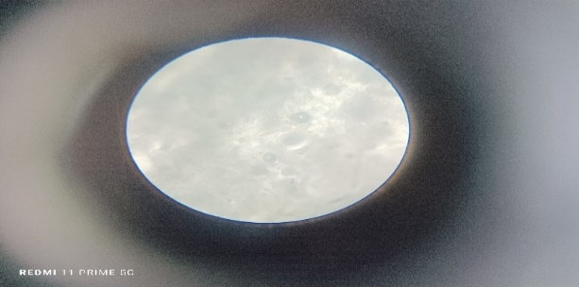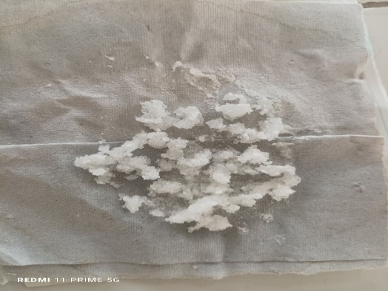 A two-step procedure is employed when the medication is susceptible to the conditions of polymerization. Using the various polymer quantities, microsponges were created via a quasi-emulsion solvent diffusion method. The internal phase of that contained cellulose, specifically ethyl cellulose, which was utilised as a polymer, and the external phase contained 50 ml of distilled

*Fig no.13 Formulation and microscopic view of Microsponges*

water and 0.5 mg of polyvinyl alcohol [PVA]. in an effort to promote the Plasticity. Calendula Officinalis can then be added to a solution and dissolved at 35 degrees Celsius using ultrasonication. Initially, the External phase was added to the Internal phase, which was initially prepared at 60°C. Once the mixture was emulsified, it was constantly swirled For two hours. The mixture was then filtered in order to extract the microsponges. The product was cleaned and dried for 24 hours at 40°C in a hoover oven [20, 21].

*Table no. 3 - Formulation Table of Microsponges*

|  |  |  |  |  |  |  |
| --- | --- | --- | --- | --- | --- | --- |
| **Sr.** | **Ingredient** | **F1** | **F2** | **F3** | **F4** | **F5** |
| 1 | Drug[Calendula officinalis] | 0.8gm | 0.7 gm | 0.5 gm | 0.7 gm | 1.2 gm |
| 2 | Cellulose | 0.8 gm | 0.7 gm | 0.5 gm | 0.7 gm | 1.2 gm |
| 3 | Polyvinyl Alcohol | 0.5 gm | 0.5 gm | 0.5 gm | 0.5 gm | 0.5 gm |
| 4 | Dichloromethane | 10ml | 10ml | 15 ml | 10ml | 10ml |
| 5 | Distilled Water | 40 ml | 45 ml | 50 ml | 50 ml | 48 ml |

1. **Evaluation of Microsponges** :-
2. **Preformulation Study-**

The purpose of the Preformulation parameters is to identify the freezing point, excipients, and chemical science qualities that will affect the formulation style, manufacturing process, pharmacokinetics, and biopharmaceutical properties. Organoleptic properties, such as the drug's chemical state, taste, odour, and colour, are investigated in order to determine drug identity and drug-chemical compound compatibility.(22)

1. **Drug Content** –

The drug content was determined by using phosphate buffer (pH 7.4) with the help of UV- spectrophotometer by dissolving the formulation in phosphate buffer for 24 hrs and then the sample was taken and analysed in UV- spectrophotometer. With this evaluation parameter of Microsponge it was revealed that the formulation F3 have the Drug content greater and after that the drug content is decreasing with increase in content of polymer due to improper carrying of drug by the polymer.(28)

1. **Dissolution tests**

Using a modified basket made of 5μm stainless steel mesh, a dissolving apparatus can be used to study the dissolution release rate of microsponges. In order to ensure sink conditions, the dissolution medium is chosen while taking the solubility of the actives into account. The samples from the dissolution medium were examined using an appropriate analytical technique at different times.(23)

1. **Gel**

Gel is a semi solid formulation that has a pair of Components which is liquid phase in rich. It has a Character the continuous structure show like solid Properties. After the application of gel the liquids are Drying by the evaporation and, gels of drug are covering The skin. Gels are as compare to the creams and other ointments Give better drug release. These are highly bio-Compatible that’s why minimum risk of adverse reaction And inflammation. The dermatological use of gels has many property as thixotropic, easily remove, non-Greasy, desirable spreadable, non-staining, emollients, Compatible with the many excipients. Topical drug Delivery systems are applying as directly on the body Surface as external part by spraying, rubbing, spreading. The topical rout of administration is very common and It is use as treatment of skin disorder and local effects. Gels are often topically applied as emollients, or as Occlusive dressing and also as protective for the local And systemic medication. Gels are defined as significant Extent dilute cross linked system that is in the steady State no flow. Spreadability was then calculated using

The following formula: S = M × L/T .

Conventional topical dose formulations, including lotions, creams, ointments, and powders, have raised questions about drug administration through the skin and diffusion or release from the vehicle. Because they are quickly removed from the skin and release the medication from their base in an ineffective manner, creams and lotions frequently have low bioavailability. Non-hydrophilic ointments are greasy, oleaginous, and inconvenient for patients. Medicated powders intended for topical administration also have a brief skin residence period. Gels are semisolid systems in which a three-dimensional network of interlocking particles restricts the dispersion medium's motion.(16)

With the use of gel, the drug delivery system can readily lengthen the residence period and boost the rate of absorption, a phenomenon known as bioavailability. Gels have the advantages of being consistently non-greasy, simple to use, and improved patient compliance. Therefore, the gel can be made by utilising Carbolpol 934 as the polymer and adding drug-containing microsponges to the gel's base. The resulting microspongial gel is then employed for topical treatments. As a result, the formulation offered the benefits of both gel for quickly healing diabetic wounds and microsponges, which extended medication release because of their entrapped form in porous structure.(17)

1. **Formulation of Microspongial Gel**

Gel was created using drug extract microspongial at 0.8 , 1.0, 1.2 mg concentrations. In another beaker, carbapol 934 was uniformly dissolved in distilled water and left to soak for a whole day while being constantly swirled. In a different beaker, propyl paraben was dissolved in distilled water. This solution was supplemented with the microspongial drug extract and carefully triturated. The extract and propyl paraben mixture was then well combined with the carbapol mixture. After adding propylene glycol, the mixture was homogenised for 10 minutes to thoroughly combine all of the constituents, and the pH was adjusted to 6.8 to 7.

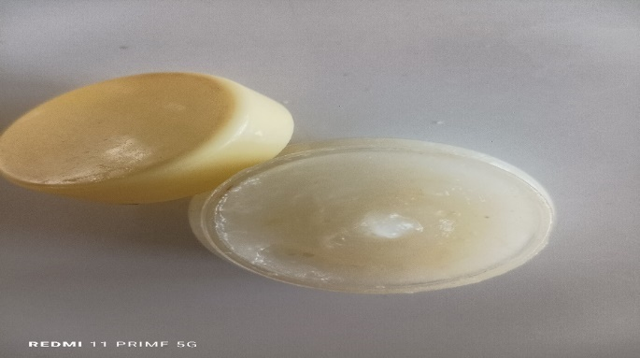

*Fig no. 14 Microspongial Gel Formulation*

*Table no.4 : Formulation of Microspongial Gel*

|  |  |  |  |  |  |
| --- | --- | --- | --- | --- | --- |
| **Sr. No.** | **Ingredients** | **F1** | **F2** | **F3** | **F4** |
| 1) | Microsponges loaded drug | 0.8 mg | 0.8 mg | 1.0 mg | 1.2 mg |
| 2) | Carbapol 934 | 0.2 mg | 0.3 mg | 0.3 mg | 0.5 mg |
| 3) | Propylene glycol | 5 ml | 4 ml | 6 ml | 2 ml |
| 4) | Methyl Paraben | 0.2 mg | 0.2 mg | 0.18 mg | 0.20 mg |
| 5) | Propyl Paraben | 0.18 mg | 0.18 mg | 0.20 mg | 0.20 mg |
| 6) | Triethnolamine | 1 ml | 2 ml | 3 ml | 1ml |
| 7) | Dis. Water | 20 ml | 20 ml | 25 ml | 25 ml |

1. **Result and Discussion –**

* **Solubility Studies of Calendula officinalis in Different Solvents**

Solubility of calendula officinalis in different solvents was determined and tabulated in

Table no. 5

|  |  |  |
| --- | --- | --- |
| **Sr.No.** | **Solvents** | **Solubility** |
| 1 | Distilled Water | Very Slightly Soluble |
| 2 | Ethanol | Soluble |
| 3 | Methanol | Soluble |
| 4 | Chloroform | Slightly Soluble |
| 5 | Phosphate buffer 7.4 | Sparingly Soluble |

* **Determination of Phytochemical Constituents present in the Methanolic extract of Calendula officinalis**

In this study, Methanolic extract subjected to Qualitative chemical analysis for various phytochemical constituents like Flavonoids, tannins, saponins, Triterpenoids. Table no. 6 shows test performed for the identification of phytochemical constituents.

|  |  |  |  |  |
| --- | --- | --- | --- | --- |
| **Sr. No.** | **Phytochemical constituents** | **Test Performed** | **Observation** | **Inference** |
| 1 | Flavonoids | Alkaline reagent test  Shinoda Test | Colourless  Pink Colour | Present  Present |
| 2 | Tannins | Ferric Chloride test  Lead tetracetic test | Dark Blue  Ppt formed | Present  Present |
| 3 | Saponins | Wet foam test  Dry foam test | Foamy lather on top of the tube  Emulsion development | Present  Present |
| 4 | Triterpenoids | Foam test  Colour reaction | Foam developed  Blue green colouration | Present  Present |

1. **Quantitative Analysis** :-

* **FTIR Spectroscopic Analysis-**

1. **FTIR Analysis of Methanolic extract of Calendula officinalis Flower-**

The % transmittance was used to, identify the phytoconstituents present in the drug i.e., the presence of flavonoid, tannins, saponins, triterpenoids in the Calendula officinalis that shows the wound healing activity. Infrared spectroscopic studies are crucial and beneficial in the determination of the purity of chemical compounds. The binary blends, individual drug and Additives were scanned in the region of 4000-400 cm-1 with a resolution of 4cm-1.

The % transmittance was plotted on the y-axis and the wavenumber on x-axis. The prominent peaks of various groups are C-H stretching at 2925 cm-1, C=O stretching at 1719 cm-1, C-O stretching at 1070 cm-1, OH stretching at 3383 cm-1.

All the characteristic of Calendula officinalis were present in the spectra at the respective wavelength. We observed that all the characteristic peaks of the functional groups were as the similarly with the standard.

*Table no. 7 FTIR Spectra of Methanolic Extract of Calendula officinalis*

|  |  |  |
| --- | --- | --- |
| **Functional Group** | **Wavenumber in cm-1** | **Functional Group Bond** |
| Alkane | 2925 cm-1 | C-H |
| Ketone | 1719 cm -1 | C=O |
| Carbonyl Group | 1070 cm-1 | C-O |
| Alcohol | 3383 cm-1 | O-H |

*Fig no.14 FTIR Spectra of Methanolic Extract of Calendula officinalis*

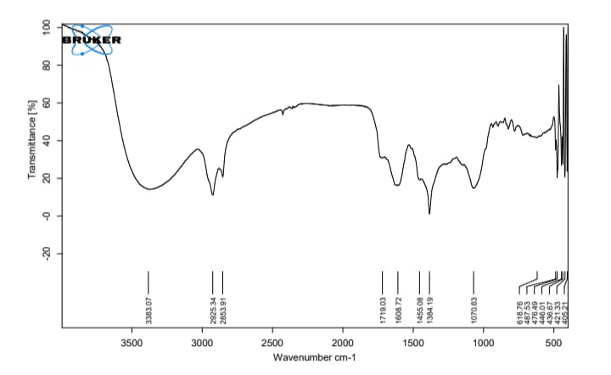

1. **Drug- Excipient Profile**

The Excipient compatibility studies were performed by using Fourier Transform Infrared Spectroscopy. The FTIR Spectra showed the prominent peaks of various bonds between the groups in the microspongial chemical structure. The prominent peaks of various groups are C-H stretching at 2920 cm-1,C=O stretching at 1631 cm-1, C-O stretching at 1059 cm-1, OH stretching at 3346 cm-1.

All the characteristics peaks of Microsponges were present in all spectra at the respective wavelength when compared with standard frequencies of functional groups. This confirmed that there was no chemical interaction between the microsponges and other excipients or confirmed that the Microsponges is present and unchanged form in the physical mixture of excipients.

*Table no. 8 - FTIR spectra of Calendula officinalis with excipients*

|  |  |  |
| --- | --- | --- |
| **Functional Group** | **Wavenumber cm-1** | **Functional Group Bond** |
| Alkane | 2920 cm-1 | C-H |
| Ketone | 1631 cm-1 | C=O |
| Carbonyl Group | 1059 cm-1 | C-O |
| Alcohol | 3346 cm-1 | O-H |

*Fig no.15- FTIR spectra of Calendula officinalis with excipients*

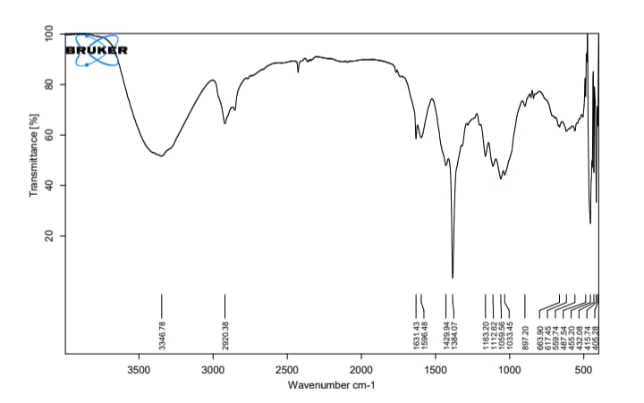

1. **Evaluation of microspongial gel**
2. **Visual inspection**

The colour, texture, and appearance of the microsponges' produced gel formulation were examined visually.

1. **pH measurement**

The gel formulation's pH was measured with a digital pH metre. After dissolving one gm of gel in 100 ml of distilled water, it was kept for two hours. There was a pH measurement of the formulation. The produced gel PH is nearly suitable with body pH 7 to Avoid inflammation.

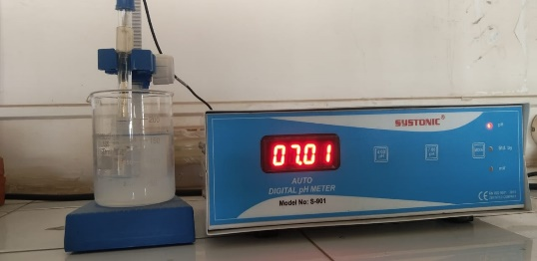

*Fig no. 14 pH measurement*

1. **Spreadability studies**

Good spreadability is one of the requirements for a gel to satisfy the ideal attributes. The phrase is used to describe the area that gel readily spreads when applied to the skin or other afflicted part. The spreading value of a formulation also affects its medicinal efficacy. Spreadability is measured in terms of the number of seconds it takes for two slides to separate from gel that is positioned between them when a specific stress is applied. Shorter time is taken to improve spreadability by separating two slides.(25)

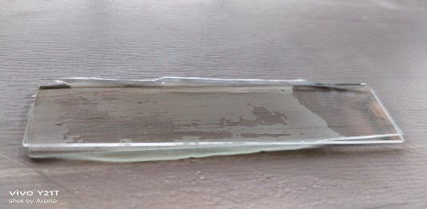

*Fig no. 15 Spreadability studies*

1. **Viscosity measurement**

The viscosity of the different gel formulations was evaluated using A Brookfield viscometer with spindle no. 4 at 100 rpm at temperature 25˚C. The viscosity of the improved formulation was obtained as Such without dilution using Brookfield Viscometer (Model-LVDV-E). More viscosity in the prepared microspongial gel allows for easier application to the skin's surface and improved absorption capacity.[24]

1. **Homogeneity**

The prepared gel were shows the homogenous nature.

1. **Stability**

Stability of gel base and formulation was examined range of storage conditions and analyse the physical characteristics such as appearance, colour, odour are stable in nature(30 days)

1. **Conclusion :-**

The study found that Calendula officinalis flower extract effectively heals wounds. Calendula extract promotes speedier wound healing by enhancing connective tissue synthesis, particularly collagen. C. officinalis is a plant with diverse phytochemicals and pharmacological properties, making it a promising source for novel medications. Many reports and analytical investigations demonstrate that calendula officinalis has effective antifungal, anti-inflammatory, and wound healing properties while being non-toxic. Microsponges are promising materials for wound healing due to their distinct characteristics. These tiny sponge-like structures can absorb and distribute therapeutic materials, such as medications or growth hormones, straight to the wound. They deliver a regulated release of these substances, which promotes tissue regeneration and speeds up the healing process. Furthermore, their porous structure allows for gas exchange and maintains a moist environment, which is beneficial to wound healing. Microsponges have enormous potential for improving wound healing.

The gel formulation a moist environment that promotes wound healing, whereas the microsponges help to transfer therapeutic substances to the wound site. The microsponges also serve to manage the release of these drugs, resulting in a more continuous and effective treatment. Overall, microspongial gel is a potential way to enhancing wound healing outcomes.

1. **References-**
2. N.H. Aloorkar, A.S. Kulkarni, D.J. Ingale, and R.A. Patil, Microsponges as Innovative Drug Delivery Systems, International Journal of Pharmaceutical Sciences and Nanotechnology, Volume 5 Issue 1 April – June 2012.
3. Saroj Kumar Pradhan, MICROSPONGES AS THE VERSATILE TOOL FOR DRUG DELIVERY SYSTEM, IJRPC 2011, 1(2), ISSN: 2231278.
4. Ashlesha P. Pandit,Saurabh A. Patel, Vandana P.Bhanushali,Vinit S. Kulkarni, and Vrushali D. Kakad, Nebivolol-Loaded Microsponge Gel for Healing of Diabetic Wound, AAPS Pharm SciTech (# 2016)DOI: 10.1208/s12249-016-0574-3.
5. Vrish Dhwaj Ashwlayan, Amrish Kumar, Mansi Verma, Vipin Kumar Garg, Therapeutic Potential of Calendula Officinalis, Pharmacy & Pharmacology, International Journal, Volume 6 Issue 2 – 2018. India Correspondence: Vrish Dhwaj Ashwlayan, Departmen of Pharmaceutical Technology, Meerut Institute ofEngineering And Technology, India, Email [vrish.ashwlayan@miet.ac.in](mailto:vrish.ashwlayan@miet.ac.in) Received: January20, 2018 | Published: April 20, 2018
6. Kathi J. Kemper, MD, MPH Longwood Herbal Task Force: [http://www.mcp.edu/herbal/default.htm Revised July 1](http://www.mcp.edu/herbal/default.htm%20Revised%20July%201), 1999
7. AR Mullaicharam, Nirmala Amaresh, and Hemalatha Balasubramanian, Phytochemistry and Pleiotropic Pharmacological Properties of Calendula Officinalis – A Review, RRJPP | Volume 2 | Issue 4 | October – December, 2014.
8. Bhargab Deka, Bedanta Bhattacharjee, Anshul Shakya, Abu Md Ashif Ikbal, Chayanika Goswami, & Santa Sarma. (2021). Mechanism of Action of Wound Healing Activity of Calendula Officinalis: A Comprehensive Review. Pharmaceutical and Biosciences Journal, 9(1), 28-44. <https://doi.org/10.20510/ukjpb/9/i1/1609684673>
9. Pawan Singh Rawat, Archana Dhyani, A brief review of Microsponges: An update, The Pharma Innovation Journal 2017; 6(5): 1134-139.9
10. Gautam Singhvi , Prachi Manchanda, Microsponge: An Emerging drug delivery strategy, Wileyonlinelibrary.com/journal/ddr, Drug Dev Res.2018;1–9.
11. Kapoor et al , A review ON MICROSPONGE DRUG DELIVERY SYSTEM journal of Drug Delivery & Therapeutics; 2014, 4(5),29-35.
12. Pandey Poornima, Jain Vikas. A review: microsponges Drug Delivery system, International Journal of Biopharmaceutics. 2013; 4(3):225-230.
13. Patil S, Shital, Dandekar Vaishali. Microsponge drug Delivery System: an overview, European Journal of Pharmaceutical and Medical Research. 2016; 3(8):212-221.
14. Dandagi P.M., Mastiholimath V.S., Gadad A.P. Microsponges as Innovative Drug Delivery Systems: A Review. Curr. Drug Deliv. 2008;5(4):243–250.
15. Jain V., Singh R., Mittal A., Jain A. Microsponges: A Novel Strategy For Drug Delivery System in Topical Formulation. J. Drug Deliv. Ther. 2019;9(5):955–962.
16. Pawar H.V., Boateng J.S. Interpenetrating polymer network Based nanosponges for delivery of Poorly soluble drugs: Part II—application as wound healing and anti-Inflammatory agents. Eur. J. Pharm. Sci. 2012;47(1):121–132.
17. VISHAL YADAV, PRAKASH JADHAV, SHAILAJA DOMBE*, ANJALI BODHE, PRANALI SALUNKHE. Arvind Gavali College of Pharmacy, Jaitapur, Satara 415004, India Email: [shailajadombe@rediffmail.com](mailto:shailajadombe@rediffmail.com)
18. Ashlesha P. Pandit,1,3 Saurabh A. Patel,1 Vandana P. Bhanushali,1 Vinit S. Kulkarni,1 and Vrushali D. Kakad.
19. Nagaraju KANCHERLA Anusha DHAKSHINAMOOTHI K CHITRA and Ravi Babu KOMARAM, Preliminary Analysis of Phytoconstituents and Evaluation of Anthelminthic Property of Cayratia auriculata (In Vitro), Maedica (Bucur). 2019 Dec; 14(4): 350–356. Doi: 10.26574/maedica.2019.14.4.350.
20. Maher Mohamed Abed El Aziz, Aziza Said Ashour, Al Sadek Gomha Melad, A review on saponins from Medicinal plants: chemistry, isolation, and determination. Nanomed Res. 2019;8(1):6‒12.
21. The microsponges delivery system of benzoyl peroxide: Preparation, characterization and Release studies M. Jelvehgari a , M.R. Siahi-Shadbad a , S. Azarmi a , Gary P. Martin b , Ali Nokhodchi.[international journal of pharmaceutics]
22. journal of global pharma technology Microsponges as novel topical drug delivery system Pratik B.N ,GOTHI G.D.
23. Kshatriya Pravin Jamnadas1, Shinde Jitendra V. , Chavan Rajshree S . As Review on Microsponge Gel as Topical Drug Delivery System. Journal of Drug Delivery and Therapeutics.
24. Shubhrajit Mantry, Arnab Bagchi, Sujit Das, Sudip Das. MICROSPONGE AS A NOVEL STRATERGY OF DRUG DELIVERY SYSTEM. Mantry et.al / UJPSR / 1 (1), 2015, 32-38 Department of Pharmaceutics e ISSN: 2454-3764 Print ISSN: 2454-375.
25. Pankaj Singh Khanka , Kashif Hussain . Formulation and Evaluation of Antifungal Microsponge Loaded Gel. International Journal of Research in Engineering, Science and Management Volume-2, Issue-12, December-2019.
26. Diksha D Ghorpade , Dr. Atram SC2 . Formulation and evaluation Of microsponges loaded topical gel for treatment of acne vulgaris. Drug Development & Research, 4 (15) 2023: 001-0010
27. Mariia Shanaida1 , Antonina Pryshlyak2 , Olena Golembiovska3 ,Determination of Triterpenoids in Some Lamiaceae Species, Research J. Pharm. and Tech 2018; 11(7): 3113-3118. DOI: 10.5958/0974-360X.2018.00571.
28. Ozgok Kangal MK, Regan JP. Wound Healing. [Updated 2023 May 1]. In: StatPearls [Internet]. Treasure Island (FL): StatPearls Publishing; 2024 Jan-. Available from: <https://www.ncbi.nlm.nih.gov/books/NBK535406/>
29. Hamid Hussain, Archana Dhyani, Divya Juyal, Abhishek Bahuguna, Formulation and evaluation of gel-loaded microsponges of Diclofenac sodium for topical delivery, The Pharma Innovation Journal 2014; 3(10): 58-63.