## OPTIMIZATION AND DEVELOPMENT OF BORE WELL PUMP LIFTING MECHANISM

## Sandeep Kumar1, Arun kumar 2, Deepak saini3, Naushad ali4

1*Asst Prof. Department of Mechanical Engineering, MIT Moradabad. UP-244001*

*2,3 & 4UG Student, Department of Mechanical Engineering, MIT Moradabad. UP-244001*

[sandeep.sun.varshney@gmail.com,](mailto:sandeep.sun.varshney@gmail.com,%20) arunchauhan64821@gmail.com

**Abstract:** Today borewell machines became very important role in achieving the Fresh water resources above the ground are very less. So, we are mostly dependent on the underground water and many fuel resources are also present in ground like oil so we have contract good and more efficient borewell machines. This research has solutions of the problem of layer soil blocking the output bike from the ground. Our project is the solution of this problem .A Borewell machine is a specialized piece of equipment used to drill deep into the ground to extract water, oil, or other resources.

**Keywords:**DTH (Down-the-Hole), Tubewell Drilling Machine.

# Introduction

Now a day's borewell machines play a important role in our life. Borewell has revolutionized the concept of water accessibility with the launch of the borewell in India. Water shortages and accessibility are major problems for irrigation, manufacturing, and domestic households; borewell has become a one-stop solution. Different machine for specific problems and area. Boring machines are essential in various industries, including Agriculture, Domestic water supply for homes.

Borewells play a crucial role in agricultural irrigation. Farmers use borewell water to provide a consistent supply for their crops, enhancing productivity. To create a borewell, a drilling machine is used to dig a well or borehole. Water Extraction: The borewell allows extraction of water for various purposes, including domestic, agricultural, and industrial use.

This Boring machine is specially designed for to Separate the layer of soil from the pipe. To prevent the cementing of layer of the soil. In the water pipe, with the time. That makes your boring more efficient and long lasting. This machine bore the hole larger than the diameter of pipe which sucks the water from the ground. Due to the large diameter of borehole then pipes, the soils do not enter in the water resource and do not form a layer in the pipe so that the pump do not damage. So, you do not need to construct layer of cement and Concrete around the motor in the boring. So, your construction and maintenance cost per year came down.

# Components Used

**MOTOR: -** A 3-phase AC motor of power rating of 2 H.P are used in this module to rotate drilling pipe by a pulley belt it rotates the such low rpm of 28 but it generates sufficient torque to penetrate the soil and bore the ground Specification and recommendation of motor: -A motor should be water proof A motor should have high torque your motor have a good power rating that make your machine efficient.

**Pulley Belt: -** V shape Pulley belt is use in this module to transfer power to the drill. this pulley is strong wears good amount of load. Specification and recommendation: - Pulley belt should be strong and large amount of load. It very according to your drilling surface. Pulley should have less friction and tight from both side.

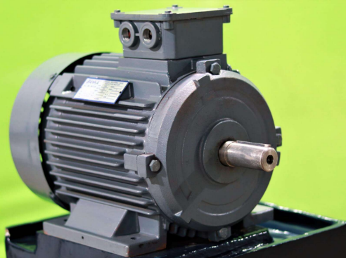

**Figure 1-Motor**

**Driller Bit: -** Drill bit is a very important component of this project. This drill bit is specially for bore greater diameter than the pipe to solve the problem of layer formation. Drill Bit is made up of cast iron. Cast iron is a strong and durable material commonly used in construction, engineering, and manufacturing.

|  |  |  |
| --- | --- | --- |
| Name of component | Quantity | Rating |
| Motor | 1 | 2 HP |
| Base/Platform | 1 |  |
| Trigger | 1 |  |
| Pulley belt | 1 |  |
| Handle/ Grip | 1 |  |
| Forward/ Reverse switch | 1 |  |
| Depth stop | 1 |  |

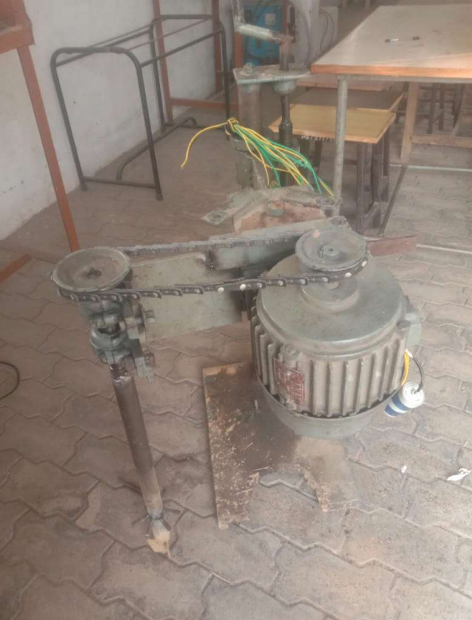

**3. Results-**

we have tested it on the ground by Attach the boring blade on the nose of the drill to get large diameter. soil up to 10 inches depth and the Diameter of the borehole was 15 cm. the machine work completely fine. Soil was 5 cm away from drill in the circular shape. We done three test the details are shown below.

**Fig. 2 Model of borewell machine**

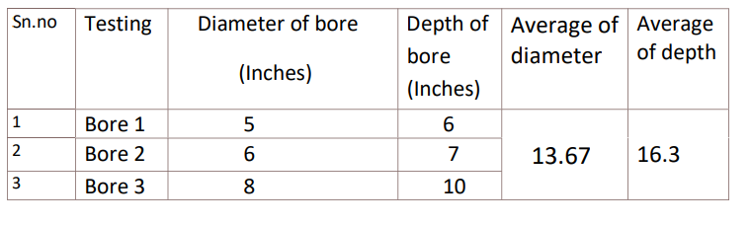

The boring machine working quite well. The average diameter of the bore is 13.67 inches The average debt deal by the bore machine is 16.3 Inches

# Conclusions

This borewell machine can bore the greater diameter hole than the pipe, which solved the problem of layering of soil. We do not need to construct layer of cement and Concrete around the motor in the boring. Which reduce the cost and increase the life of the bore. So, the machine saves the reconstruction Cost, energy, time and maintenance cost.

# References

i. Puttapaka Nagaraju, Ch. Ashok Kumar, “Modeling and Analysis of 2-Stage Reduction Gear Box”, IJMETMR- International

Journal and Magazine of Engineering Technology, Management and Research | Vol. 01, Issue, 12, 2014.

ii. Mayur N. Adhude, Dr. Sharad S. Chaudhari., “An Overview of Bore Well Motor Pump Installation and Lifting Machine”,

IJSRD - International Journal for Scientific Research & Development | Vol. 03, Issue 08, 2015.

iii. Avishek Mishra, Prabhat K. Singh, Md. Shahrukh Haque, Ghanshyam Kurre, Sandeep Rathor, Mr. Chova R. Sahu, “Study of

Convertible Wheel Drives Using Chain Sprocket”, IJARIIE-International Journal of Advance Research and Innovative Ideas

Education | Vol. 02, Issue 02, 2016.

iv. Bhandari V.B, “Design of Machine Elements”, McGraw Hill Education (India) Private Limited (Fourth Edition).

v. PSG college of Technology, “Design Data Book”, Kalaikathir Achchagam

# 