# ABSTRACT:

The advantages of oral dosage form that are responsible for its popularity are its ease of Administration, patient compliance and stability of formulation.

The most popular oral dosage Forms being’s tablets and capsules, but one important drawback of the dosage forms however Is the difficulty to swallow especially when a dosage form is developed for pediatric and Geriatric patient.

The modern scientific and technological advancement in the pharmaceutical Field had created bank of interest in reconstitutable oral suspension dosage form in the recent year. The reconstituted system is the formulation of choice when the drug stability is a major Concern. Reconstitutable oral systems show the adequate chemical stability of the drug during Shelf life and also reduce the weight of the final product.

Dry syrup form of the drug is also useful in case of bioavailability as it has high bioavailability rather than tablets and capsules as it disintegrates in water outside of the oral cavity and directly the suspension is gone through the gastrointestinal tract.

So, the suspension easily absorbs in the GIT.

**Keywords**: Dry Syrup, Patient Compliance, Antibiotic, Amoxicillin, Stability, Sedimentation Volume, Reconstituted Dry Syrup.

**INTRODUCTION:**

Many antibiotic materials are unstable when maintained in solution for an appreciable length of time, and therefore, from a stability standpoint, Insoluble forms of the drug substances in aqueous suspensions or as dry. Powder for reconstitution are attractive to manufacturers.(1) Since Decades among all the pharmaceutical products available, oral drug Delivery has gained a higher scope and popularityand has been widely Employed for the systemicdelivery of drugs. The positive aspect Regarding the oral dosage form which created its high levelof acceptance Was its ease of administration, patient compliance and stability of Formulation .(2)The antibacterial oral suspensions include preparations of antibiotics substances , sulfonamides , other anti-infective agents , or combinations of these The antibiotic oral suspension, including those prepared by reconstitution, provide a convenient way to Administer dosages to infants and children and to adult patients who Prefer liquid preparations to solid ones. Although studies have Demonstrated that the dry oral suspension after constitution in a liquid Is stable for 24 h after preparation, reconstituted solution remains stable When stored in the refrigerator for the labelled period, usually 7 to 14 d, Depending on the preparation. This is a sufficient period for the patient to complete the regimen usually prescribed. However, in case the Medication remains after the patient completes the course of therapy, The patient should be instructed to discard the remaining portion, which Would be unfit for use at the later time.(3) Oral administration is the most popular route due to ease of ingestion, pain avoidance, versatility and most importantly, patient compliance. The intraoral route is the most preferred due to its convenience and rapid onset of action. Intraoral dosage forms have evolved as an alternative to conventional tablets, capsules and liquid preparations.(4)

Amoxicillin is a broad-spectrum, pharmacologically active beta-lactam antibiotic effective against. Gram-positive and Gram-negative bacteria. It is a widely used antibiotic in human and veterinary medicine for the treatment and prevention of respiratory, gastrointestinal, urinary and skin infections due to its pharmacological and pharmacokinetic propAmoxicillin trihydrate is resistant to gastric acid. Peak plasma concentration of amoxicillin trihydrate of 5 microgram/ ml has been observed in 1 to 2 hours after oral dose of 250 mg, with detectable amount present up to 8 hours. About 20% of amoxicillin trihydrate is bound to plasma protein in the circulation and plasma half-lives of 1 to 1.5 hours have been reported. The half-life may be longer in neonates and elderly, in renal failure half-life may be 7 to 20 hours. It is metabolized to a limited extent to penicillin acid which is excreted in the urine. Amoxicillin trihydrate is slightly soluble in water (3430 mg/L water) and in alcohol, practically insoluble in ether and fatty oils. It dissolves in dilute acids and dilute alkali hydroxides. Based on the above physicochemical and biopharmaceutical properties, amoxicillin trihydrate was selected as a drug candidate. retires.

The most common reason for the formulation of suspensions for reconstitution is the inadequate chemical stability of the drug in an aqueous vehicle. In such cases, dissolution or even suspension of the drug results in a very short shelf life. For example, reconstituted suspensions of penicillin have a maximum shelf life of 14 d. The manufactured dry mixture, however, has a shelf life of at least 2 y. Another reason for the formulating suspensions for reconstitution is

to avoid the physical stability problems often encountered in conventional suspensions. These problems include possible increased drug solubility due to pH changes from chemical degradation, incompatibility of ingredients, viscosity changes, conversion of polymorphic form and crystal growth and caking. Formulation for reconstitution reduces the weight of the final product because the aqueous vehicle is absent and consequently, transportation expenses may be reduced. The dry mixture may be shipped without regard to seasonal temperatures because its physical stability is less susceptible to temperature extremes as compared with conventional suspensions.

Amoxicillin is a penicillin antibiotic. It is used to treat bacterial infections, such as chest infections (including pneumonia) and dental abscesses. It can also be used together with other antibiotics and medicines to treat stomach ulcers.

**Cough:**

The another name for “Cough” is “tosses”, the voluntary or involuntary act which clears the throat and breathing passage of foreign particles, microbes, irritants, fluids and mucus is nothing but cough It is the rapid expulsion

of air from lungs. When we have blockage or irritation in the throat or upper air passage, the brain thinks a foreign element is there in body and it inform body immediately to cough to expel out foreign element out of our body. The

cough reflex consists of the 3 phases which are an inhalation, a forced exhalation against a closed glottis, and a violent release of air from the lungs following opening of the glottis, and followed by a distinctive sound .

It is symptom related to most respiratory problems such as asthma, viral infections, lung cancer, tuberculosis, pulmonary embolus The repetition of coughing produces inflammation and discomfort, which result in more coughing in individual Respiratory tract infections are mostly common in children; some of them are self-limiting and the risk of complication may be very small.

**1) Allergies or sinusitis:**

It can cause a prolong cough including an itchy throat, runny nose, watery eyes, sore

throat, or rash. Allergy tests are done to find out which allergens cause the problem and doctor advice how to avoid those allergens.

**2) Asthma:**

Asthma can be very difficult to diagnose in children as symptoms may vary from every child to child. While wheezing cough, that get worse at night is one of the many signs. The other cough occurs with increased in physical activities like playing, exercise, etc. Treatment for asthma is dependent upon what is actual cause.

**3) Infection:**

Cold, flu, and croup this leads to a prolong cough for children. Colds cause mild to moderate hacking cough while the flu a sometimes cause severe, dry cough and croup has a “barking” cough mostly occurs at night with noisy breathing.(7)

Pneumonia:

The study has found that babies infected with „superbugs‟ in birth facilities within 72 hours of being born, thousands of Indian babies are dying due to an „alarming degree‟ of drug resistance. The researcher found that nearly 26% of babies with sepsis died, as multi drug resistance made

the ailment untreatable. Estimates also indicate that 56,524 babies die each year from resistance to first line antibiotics. Study result highlighted the big threat to efforts aimed at containing infant mortality rates. Antibiotic resistance is a global public health threat, but nowhere is it as stark as in India. The crude infectious disease mortality rate in India today is 416.75 per 100,000 persons, twice the rate in the U.S. (200) when antibiotics were introduced. In India almost 100% of the healthy population carries bacteria that are resistance to ampicillin, ciprofloxacin, trimethoprim, nalidixic acid and chloramphenicol.(12)

**1.1 Dry Syrups**:

“Dry pharmaceutical syrup may be defined as a Finely divided insoluble particle ranging from0.5-5 μ, which Is to be distributed in a suitable vehicle”.

Dry syrups are the solid dosage form that can be reconstituted by the addition of water to administer by the oral route. Mostly antibiotics, some moisture sensitive Drugs are available in the form of dry syrup and pediatric.(7)

Many preparations like Amoxicillin trihydrate, Erythromycin Ethyl succinate, Dicloxacillin sodium etc. are available as dry powder mixtures of granules intended to be suspended in water in another vehicle before oral administration. The reconstituted system is the formulation of choice when drug stability is a major c .The dry mix for oral Suspension contains the drug, colorants, flavors, sweeteners, stabilizing agents, suspending agentsand preserving agents That may be needed to enhance the stability of the formulation.

Dry syrups are dry mixtures containing the and appropriate suspending and dispersing agents must be diluted and stirred with a specific amount of vehicle, most often purified water.

Stability is defined as the ability of a substance or drug product to remain within specifications and to maintain its identity, strength, quality and purity throughout the test or until expiration.

Dry Syrup Manufacturers in India – We must first understand what dry syrups are important and what exactly they are. Dry syrups are powder-based syrups. It requires water to reconstitute it. Most importantly it is mainly used for pediatric use. The dry syrups are also very easy to carry. Are you looking for Dry Syrup Manufacturers In India then read the following article.

The drugs that are prepared as a dry suspension are mainly antibiotics. Also, it is known that dry syrups are very suitable for children and even for old aged people. Many pharmaceutical companies have been manufacturing top-quality dry syrups. Listed below are some top pharmaceutical firms that can help you with the pharma product or pharma franchise company. Dry Syrup Manufacturers in India – We must first understand what dry syrups are important and what exactly they are. Dry syrups are powder-based syrups. It requires water to reconstitute it. Most importantly it is mainly used for pediatric use. The dry syrups are also very easy to carry. Are you looking for Dry Syrup Manufacturers In India.

The drugs that are prepared as a dry suspension are mainly antibiotics. Also, it is known that dry syrups are very suitable for children and even for old aged people. Many pharmaceutical companies have been manufacturing top-quality dry syrups. Listed below are some top pharmaceutical firms that can help you with the pharma product or pharma franchise company.

A reconstitubal suspension can Offer several advantages such as maintenance of the chemical Stability of the active compounds until reconstitution at the Start oftreatment. The same suspension can be easily Administered to childrenof different ages by adjusting the Volume to swallow Dry syrups are oral pharmaceutical formulations particularly suitedfor use in pediatric medicine. As with other oral pharmaceutical formulations, the palatability of a dry syrup cans havea profound impact on therapeutic outcome (7). If the bitterness of an active pharmaceutical ingredient causes poor palatability, drug efficacy may be reduced due to non-compliance. The exploration of factors influencing the palatability of dry. syrups may therefore lead to improvements in their pharmaceutical formulation (7) The same suspension can be easily administered to people of different ages by adjusting the volume to be swallowed. The dry ones are oral pharmaceutical formulations particularly suitable for use in pediatric medicine.

As with other oral pharmaceutical formulations, the palatability of a syrup can have a profound impact on therapeutic outcomes. If the bitterness of an active pharmaceutical ingredient results in poor effectiveness of the drug may be reduced due to the rules. Exploring the factors influencing

.the palatability of dry syrups could lead to improvements in their pharmaceutical formulation.(8)

The reconstituted system is the formulation of choice when drug stability is a major concern

The medications are supplied in dry form because the product can be stored for a long time in dry form but becomes unstable and deteriorates in solution within a relatively short time.

Such solutions would have a “ shelf life”. For example, a reconstituted suspension of penicillin has a maximum shelf life of 14 days. The dry mixture produced, however, has a lifespan of at least 2 years. Augmentin dry powder has a shelf life of 24 months when is stored at a temperature below 25°C. edits reconstituted powder has a shelf life of days when stored between 2°C and 8°C.(9) Another reason to prescribe antibiotics in dry syrup form to infants and young children is to prevent children from swallowing tablets or capsules.unavailability of certain antibiotics in the form of tablets. and the discomfort, expense and risk associated with antibiotics.(2) It would be expected that the process of reconstituting medications from powder to liquid form would cause more errors than dosing ready-to-use liquid medications. Errors may occur regarding the reconstitution process, volume and temperature of the reconstituted liquid, shelf life of the drug, storage conditions and accuracy.(5)

stability studies have demonstrated that the dry suspension after constitution in a liquid is stable during preparation; The reconstituted solution remains stable when stored for the period indicated, generally 7 to 14 depending on the Ph. however, if the medicine remains after the patient has completed the treatment, the patient should be asked to discard the remaining portion, which would be unsuitable for further use depths is a sufficient period for the patient to follow the usually prescribed diet ration.(10)

The semantic differential (SD) method developed by Osgood etal (7)Is amethod used to quantify image.In a previous study, we have used the SD method in human taste testing studies to evaluate the palatability of total enteral nutrients . In the present study, the SD method was used to explore the factors influencing the palatability of 20 dry syrups currently marketed in Japanand commonly used in pediatric medicine. The use of the artificial taste sensor for pharmaceutical purposes is an innovation which has reduced dependence on human gustatory sensation testing. The bitterness of active pharmaceutical ingredients in oral pharmaceutical formulations has previously been evaluated using the artificial taste sensor or “electronic tongue”(10) There are several types of sensors which have different components of lipids and plasticizers and are sensitive to different materials: C00 is sensitive to acidic bitter materials such as diclo fenac sodium, a non-steroidal antiinflammatory drug ; AE1 is sensitive to astringent materials such as tannic acid; AC0 and AN0 are set basic materials such as solifenacin succinate or amlodipine baseplate and BT0 is sensitive to hydrochloride salts, including quinine hydrochloride(11) The bitterness of an active pharmaceutical ingredient in oral pharmaceutical formulations mixed with various foods or beverages has also been evaluated using a taste sensor.(11)

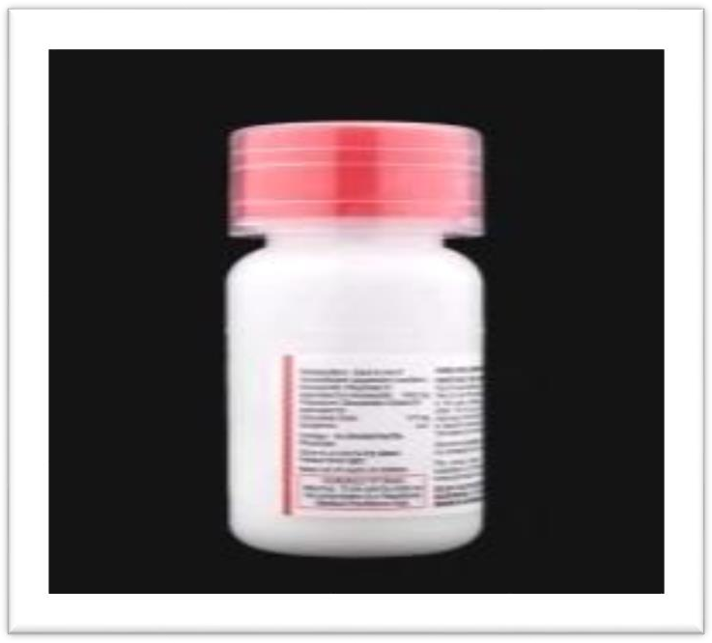Fig. no.1 Dry Syrup

**Suspension:**

A Pharmaceutical suspension is a coarse dispersion in which internal phase is dispersed uniformly throughout the external phase. The internal phase consisting of In soluble solid particles having a specific range of size which is maintained uniformly throughout the suspending vehicle with the help of single or combination of suspending agent.

The external phase (suspending medium) is usually aqueous in some case, may be an organic or oily liquid for non-oral use.(7)

# Reasons for formulation of such suspensions: (17)

Reconstitute suspension is formulated due many reasons such as for patient which have difficulty in swallowing, drug stability etc. Some reasons are discussed below.

1. The main reason for the formulation of suspensions for reconstitution is inadequate chemical stability of the drug in an aqueous vehicle.
2. Another reason for the formulating suspensions for reconstitution is to avoid the physical stability problems. These problems include possible increased drug solubility due to pH changes from chemical degradation, incompatibility of ingredients, viscosity changes, conversion of polymorphic form and crystal growth and caking.
3. Formulation for reconstitution reduces the weight of the final product because the aqueous vehicle is absent and consequently, transportation expenses may be reduced.
4. Suspension for reconstitution is convenient dosage form for large doses .
5. Safe and compliant for pediatric and geriatric patient.
6. Suitable for insoluble or poorly soluble API.

# Major application - pediatric therapy: taste masking.(18)

Oral Route of administration is the route of choice for administration of medicines in children. The only hurdle for dosage form designing for pediatric patients is the patient’s acceptance of the dosage form. Pediatric Patients tend to become uncooperative during the administration of oral medication; the most common reason being the taste of the oral formulation administered among the children. Most of the drugs administered as granules for oral suspension under pediatric therapy are Antibiotics, which when administered orally as another dosage form have a bitter taste making it unpleasant for Children to consume the medication.

**LITERATURE REVIEW**

1. Taste masking and development of palatable dosage forms of bitter drugs constitutes the objective of many a research project in the field of pharmaceutical technology. Taste is an important factor in the development of dosage form. The problem of bitter and obnoxious taste of drug in pediatric patient can create a bad psychological effect on mind. The purpose of this research was to mask the intensely bitter taste of Ciprofloxacin is a broad-spectrum antibiotic. It is extremelybitter taste resulting in poor patient’s compliance. The aim of present work was to prepare drug resin complex (DRC) using ion exchange resin (Kyron T114) for taste masking and formulate oral reconstituable dry syrup. Formulated ciprofloxacin reconstituable dry syrup has acceptable Drug Dissolution properties. In evaluating period of 7 days no significant change was observed in pH, sedimentation volume, specific gravity and drug content. From the results it concluded that effective taste masking of ciprofloxacin was achieve using Kyron T114 and successfully evaluated in reconstituable dry syrup.(19)

2. Hydroxyurea (HU) is the drug of choice for the management of sickle cell disease but the available dosage form exists as a 500 mg capsule, which is not appropriate for pediatrics whose dosing requirements are 20mg/kg. The current practice of compounding is prone to dose errors and contamination. Also, shortage of compounding laboratories in hospitals in the developing countries is a major issue. This study aimed at investigating the stability of HU in aqueous solution followed by formulation and evaluation of its dry syrup. Stability of HU aqueous solution was investigated and subsequently dry syrups formulated. They were evaluated for flow ability, assay, dissolution, moisture content, rheology and pH. The formulated dry syrups complied with the United States Pharmacopeia (USP) specifications for stability, angle of repose (24-25°), assay (90-110%), dissolution (more than 85% in the first 30 minutes), shear thinning and pH (7.3). HU dry syrup was successfully developed, optimized and found to comply with USP specifications.(20)

3. The development of a capillary zone electrophoresis method with head-column field-amplified sampl stacking injection for the determination of formoterol (FMTR) in a low dosage dry syrup form was described. To obtain the highest sensitivity, the sample solution was prepared by high content of organic solvent with the presence of a small amount of H+ (60-100 micro) and the capillary inlet end was dipped in water before electro injection. This method was fully validated in terms of repeatability (RSDs for migration time, peak area of FMTR and peak area ratio between FMTR and I.S. at 1 micro g/ml of FMTR was 0.76, 1.10 and 0.55% respectively), reproducibility (RSDs from different capillaries, an alytes, days and instruments were 1.52%, 1.04%, 1.16% and 1.93% respectively), linearity (y = 0.827x - 0.085, r = 0.9993 (n = 6) over the range of 0.25-2.0 microg/ml), limits of quantitation, ruggedness and robustness. The method was applied to the determination of the drug in commercial dry syrup preparation (recovery was 100.9%, RSD = 1.5%, n = 5) and proved to be fast and reliable for the quantitation analysis of FMTR in the pharmaceutical form.( 21)

4. Taste is an important factor in the development of dosage form. The problem of bitter and obnoxious taste of drug in pediatric patient can create a bad psychological effect on mind. The purpose of this research was to mask the intensely bitter taste of Linezolid using ion exchange resin and to formulate the dry syrup of the taste masked drug. When suspension is swallowed the bitter taste of the drug may not be felt as ion exchange resin does not release the drug at salivary pH. When it comes in contact with acidic environment of stomach, the complex will be broken down releasing the drug which may then absorbed. Batch method was used for formation of drug resin complex. Various ion exchange resin like different grade of Kyron and indium 214 were

used for masking the bitter taste. Optimization of drug loading was carried out. Indian 214 was selected as an optimized resin with 84.47 % drug loading. Dry syrup was made using suspending agent likegellan gum, guar gum and CMC and evaluated for various parameters like color, odor, taste, viscosity, sedimentation volume, redispersibility, % drug content, drug release. By evaluating all the parameter, the batch formulation contained guar gum 3 % was the best one amongst all the other formulations .(22)

5. Many patients with bronchiectasis suffer from two or more exacerbations per year. However, there are no approved therapies to reduce or delay exacerbations in this patient population. Ciprofloxacin Dry powder inhalation is in development as a long-term, intermittent therapy to reduce exacerbations in patients with noncystic fibrosis (CF) bronchiectasis and evidence of respiratory pathogens. Ciprofloxacin DPI combines drug substance, dry powder manufacturing technology, and an efficient, pocket-sized, dry powder inhaler to deliver an effective antibiotic directly to the site of infection, with minimal systemic exposure and treatment burden.

Here we review the drug substance and particle engineering (PulmoSphere™) technology used, and key physical properties of Ciprofloxacin Inhalation Powder, including deposition, delivered dose uniformity, consistency, and stability. Design features of the T-326 Inhaler are described in relation to lung targeting, safety and tolerability of inhalation powders, as well as treatment burden and adherence. If approved, Ciprofloxacin DPI may provide a valuable treatmen toption for those with frequent exacerbations and respiratory pathogens.(23)

7.Oral paediatric suspensions of antibiotics are mainly available as dry powders for reconstitution. Most of reconstituted antibiotic suspension is to be kept refrigerated in order to get the optimal therapeutic action from the drug. However, many patients do not keep to it to specified storage conditions for many reasons. Like no refrigeration and irregular power supply that may result in various degree of degradation of reconstituted antibiotics. Pharmacists are therefore challenged how to counsel patients when there is no refrigeration or erratic power supply. Inappropriate use of antibiotics leads to economically and clinically preventable negative consequences including unnecessary adverse effects, increase mortality and morbidity from treatment failure, wasting healthcare resources, and increase the emergency of bacterial resistance.Improper storage condition leads to physical instability, chemical instability, reduction in potency, or it may also leads to serious adverse effect on the patient’s health .(24)

7. Dry syrup form of the drug is also useful in case of bioavailability as it has high bioavailabilityrather than tablets and capsules as it disintegrates in water outside of the oral cavity and directly the suspension is gone through the gastrointestinal tract. These are dry mixtures containing the drug and suitable suspending and dispersing agents to be diluted and agitated with a specific quantity of vehicle, most often purified water. Drugs that are instable if maintained for extended periods in the presence of aqueous vehicle (e.g., many antibiotic drugs) are frequently supplied as dry powder mixtures for reconstitution at the time of dispensing. This type of preparation is designated in the USP by atitle “for Oral Suspension”. There constituted system is the formulation of choice when the drug stability is a major concern. After reconstitution, these systems have a short but acceptable life if stored at refrigerator temperatures. Reconstitutable oral systems show the adequate chemical stability of the drug during shelf life, avoids the physical stability problem srelated to solubility, pH and incompatibilities with other ingredients and also reduce the weight of the final product because the aqueous vehicle is absent and consequently the transportation expenses may be reduced. (25)

8. The purpose of this study was to assess the bitterness intensity and pH of the solutions of clarithromycin dry syrup (CAM-DS), carbocisteine preparation (CC), and the concomitant use of both drugs. We conducted 6 types of human gustatory sensation tests with 6 healthy male volunteers. As a result, there was almost no difference in the bitterness intensity of CAM-DS between the branded (the latest and former preparations) and the generic formulations. The bitterness intensity of CAM-DS (the latest and former preparations of the branded as well as the generic formulations) was almost equally enhanced by mixing it with either the branded CC-DS or the branded and the generic carbocisteine granule (CC-Gr). On this occasion, the enhancing the bitterness of the branded CAM-DS (latest and former preparation) was nearly avoided safely by dosage form's changing CC-DS or CC-Gr to the branded CC-Sy. However, unlike the branded CC-Sy, some generic CC-Sy failed to suppress the bitterness. Furthermore, it was proven that some generic CAM-DS were shown to exhibit bitterness when mixed with even branded CC-Sy. In conclusion, it should be noted that the extent of bitterness of the mixture of CAM-DS and CC highly varies among the generic formulations. (26)

9.The clinical efficacy was examined for the newly developed oral cephem antibiotic, cefpodoxime proxetil dry syrup, in the treatment of various acute infections in the field of pediatrics. dry syrup was administered at 10 mg/kg/day in 3-divided doses to 535 children at 21 institutions, including Tottori University Hospital and its related hospitals. The efficacy rate of this drug was determined to be 80.8%. Among isolates, Staphylococcus aureus and Streptococcussp. were highly susceptible to the drug, whereas Haemophilus influenzae showed

relatively poor susceptibility. Side effects were observed in 2.80% of all of the patients, and abnormal laboratory findings were detected in 1.87%. The low incident of side effects demonstrated its high safety, and this drug was considered to be very useful for such pediatric infections as acute tonsillitis, acute pharyngitis and acute bronchitis (27).

MATERIALS AND METHODS

Materials:

1) Amoxicillin Teihydrateate

2) Potassium Clavulanate

3) Guar Gum

4) Dextrose

5) Calcium Carbonate

6) Starch

7) Venilla

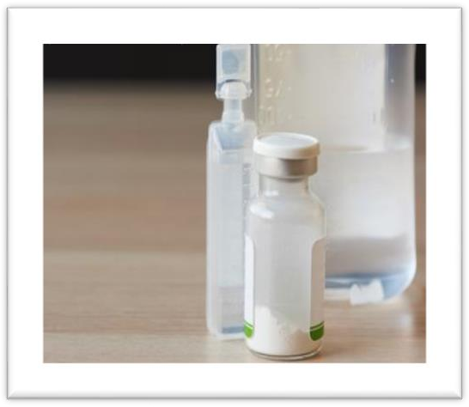Fig.no.2 Ampoules bottle

**1. Amoxicillin Trihydrateate**:

Amoxicillin is a penicillin antibiotic. It is used to treat bacterial infections, such as chest infections (including pneumonia) and dental abscesses. It can also be used together with other antibiotics and medicines to treat stomach ulcers.

**Uses:**

Amoxicillin is used to treat a wide variety of bacterial infections. This medication is a penicillin- type antibiotic. It works by stopping the growth of bacteria.This antibiotic treats only bacterial infections. It will not work for viral infections (such as common cold, flu). Using any antibiotic when it is not needed can cause it to not work for future infections. Amoxicillin is also used with other medications to treat stomach/intestinal ulcers caused by the bacteria H. pylori and to prevent the ulcers from returning.

**Amoxicillin Is FDA Approved To Treat :**

• Bacterial Pharyngitis

• Bronchitis

• Tonsillits

• Pneumonia

• Bacterial Rhinosinusitis

# Clavulanate potassium:

clavulanic acid is a combination penicillin-type antibiotic used to treat a wide variety of bacterial infections. It works by stopping the growth of bacteria.This antibiotic treats only bacterial infections. It will not work for viral infections (such as common cold, flu). Using any antibiotic when it is not needed can cause it to not work for future infections.

very serious allergic reaction to this drug is rare. However, get medical help right away if you notice any symptoms of a serious allergic reaction, including: fever that doesn't go away, new or worsening lymph node swelling, rash, itching/swelling (especially of the face/tongue/throat), severe dizziness, trouble breathing.

# Side Effects:

1. Severe stomach pain,
2. Diarrhea that is watery or bloody
3. Pale or yellowed skin
4. Dark colored urine
5. Fever
6. Confusion or weakness
7. Loss of appetite
8. Upper stomach pain
9. Little or no urination
10. Easy bruising or bleeding**.**

# 3.Guar gum :

Commonly used thickening and stabilizing agent in various pharmaceutical formulations, including dry syrups. Here are some key roles of guar gum in dry syrup preparations:

1. **Thickening agent**: Guar gum helps to increase the viscosity of the syrup, giving it a smooth and uniform consistency. This aids in suspending the active ingredients evenly throughout the formulation and prevents settling.
2. **Stabilizer**: Guar gum acts as a stabilizer by preventing the separation of ingredients in the dry syrup powder. It helps maintain the homogeneity and uniform dispersion of the components, ensuring consistent dosing.
3. **Improves flow properties**: Guar gum can improve the flow properties of the powder, making it easier to handle and dispense. It helps prevent clumping and caking, resulting in a more user- friendly product.
4. **Enhances texture**: Guar gum contributes to the overall texture of the dry syrup powder, providing a pleasant mouthfeel when reconstituted with water. It can help improve the overall palatability of the formulation.
5. **Binding agent:** Guar gum can act as a binding agent, helping to hold the ingredients together in the dry syrup powder. This is important for ensuring the stability and integrity of the formulation during storage and handling.

# Side Effect:

1. Gastrointestinal Issues
2. Allergic Reactions
3. Potential Interaction with Medications
4. Impact on Nutrient Absorption
5. Esophageal or Intestinal Obstruction
6. Avoidance in Certain Populations

# Dextrose:

**Uses:**

Dextrose,also known as glucose, is a simple sugar commonly used in various applications. It is often used as an energy source, a sweetener, or a stabilizer in food products. In the medical field, dextrose is used in intravenous solutions for patients requiring quick energy, and in the laboratory, it serves as a carbon source for microorganisms in culture media. Dextrose is derived from natural sources like corn or wheat and is considered safe for consumption

**5. Calcium** **Carbonat :**

Calcium carbonate can serve several purposes due to its properties and benefits. Here are some common uses of calcium carbonate in dry syrup preparations:

**Buffering Agent**: Calcium carbonate can be used as a buffering agent in dry syrup formulations to help maintain the desired pH level of the solution. By stabilizing the pH, it ensures that the medication remains effective and stable for a longer period.

**Antacid:** Calcium carbonate is often included in dry syrups for its antacid properties. It helps neutralize excess stomach acid and provide relief from conditions like heartburn, indigestion, and acid reflux.

**Calcium Supplement**: Since calcium carbonate is a good source of calcium, it can be added to dry syrups as a calcium supplement. This is particularly beneficial for individuals who may have calcium deficiencies and need to increase their daily intake of this essential mineral.

**Taste Masking Agent:** The mild chalky taste of calcium carbonate can also help mask bitter or unpleasant flavors of certain medications in dry syrup formulations. This can improve the overall palatability of the syrup and enhance patient compliance.

nce the stability, flow properties, and physical characteristics of the dry syrup formulation. It may also contribute to the overall structural integrity and appearance of the product.

These are some of the key roles that calcium carbonate can play in dry syrup preparations, contributing to the efficacy, stability, and overall quality of the medication. Manufacturers may incorporate calcium carbonate into dry syrup formulations based on the specific requirements and desired outcomes of the product.

**5. Starch**

1) Binder: Starch can act as a binder to hold the ingredients of the dry syrup together, ensuring that the powder remains cohesive and does not separate or clump during storage or transportation.

2) Disintegrant: Starch can help promote the disintegration of the dry syrup in liquid when it is reconstituted, allowing for quick and uniform mixing to form a suspension for administration.

**6. Vanilla:**

Vanilla is a popular flavoring agent that is often used in dry syrup formulations to improve the taste and palatability of the medication. In addition to masking the unpleasant taste of certain active ingredients, vanilla can also enhance the overall sensory experience of taking a medication, especially for individuals who may have difficulty swallowing pills or find the taste of some medications unappealing.

The use of vanilla in dry syrups can help make the medication more pleasant to take, leading to better adherence to the prescribed treatment regimen. It can also help reduce the likelihood of adverse reactions such as nausea or vomiting that may be triggered by an unpleasant taste.

**The equipment used is mixers.(28)**

1. Dry mixer

2. Paddle mixer

3. Vertical screw mixer

4. Double cone mixer

5. V blender

**Processing the dry mixture:**

Drug resin complexes (DRC) were prepared by using batch process. Accurately weighed amountof Kyron T 114 dispersed in a beaker containing deionized water and allowed to swell for 45 minutes. Swelled resin slurry was filtered on what man filter paper. Then it was washed with deionized water. Drug resin complex (DRC) was prepared, by placing acid activated resin in a beaker containing deionized water. Accurately weighed amount of Ciprofloxacin was added slowly to the resin slurry and stirred for 3hours in magnetic stirrer. During stirring, pH of

The drugresin slurry was measured frequently and adjusts to 6.5 by using 0.1 M KOH. After three hours of stirring, the DRC was separated from dispersion by filtration and washed with deionized water. DRC was dried at 55°C until it was dry. The dried mass was powdered and sieved through 40- mesh sieve. Complex was evaluated for drug loading efficiency.

**The equipment used is mixers.(28)**

1. Dry mixer

2. Paddle mixer

3. Vertical screw mixer

4. Double cone mixer

5. V blender

**Processing the dry mixture**:

Drug resin complexes (DRC) were prepared by using batch process. Accurately weighed amountof Kyron T 114 dispersed in a beaker containing deionized water and allowed to swell for 45 minutes. Swelled resin slurry was filtered on what man filter paper. Then it was washed with deionized water. Drug resin complex (DRC) was prepared, by placing acid activated resin in a beaker containing deionized water. Accurately weighed amount of Ciprofloxacin was added slowly to the resin slurry and stirred for 3hours in magnetic stirrer. During stirring, pH of

The drugresin slurry was measured frequently and adjusts to 6.5 by using 0.1 M KOH. After three hours of stirring, the DRC was separated from dispersion by filtration and washed with deionized water. DRC was dried at 55°C until it was dry. The dried mass was powdered and sieved through 40- mesh sieve. Complex was evaluated for drug loading efficiency.

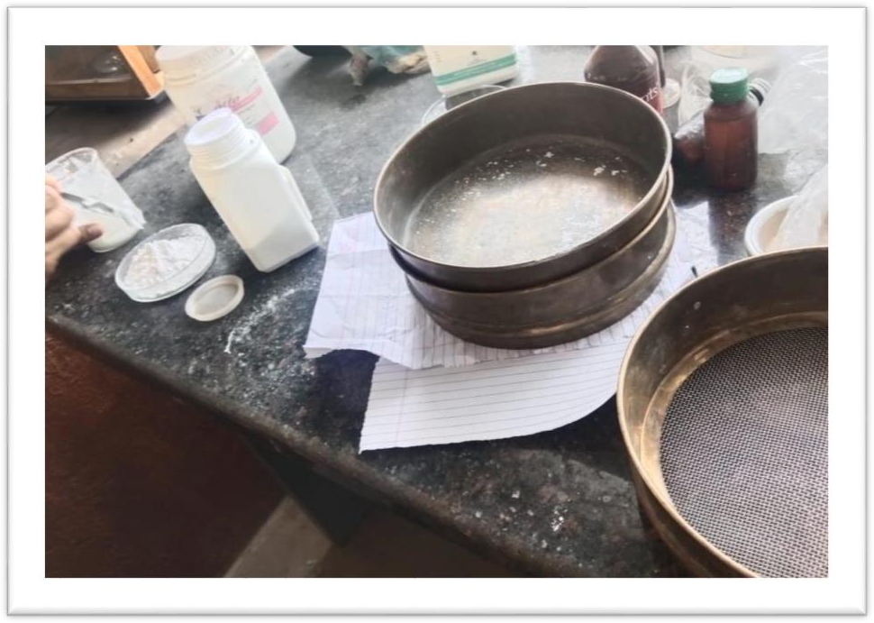Fig.no.3 seving method

**Formulation Table:**

Table.no 2 Formulation Table

|  |  |  |  |  |  |
| --- | --- | --- | --- | --- | --- |
| SR.  NO. | Ingredints | F1 | F2 | F3 | F4 |
| 1 | Amoxicillin  Trihydrateate | 4gm | 4.3gm | 4.5gm | 4.3gm |
| 2 | Potassium  Clavlanate | 0.678gm | 0.675gm | 0.674gm | 0.672gm |
| 3 | Guar Gum | 0.018gm | 0.019gm | 0.015gm | 0.014gm |
| 4 | Dextrose | 0.075gm | 0.076gm | 0.074gm | 0.071gm |
| 5 | Starch | 0.15gm | 0.18gm | 0.16gm | 0.15gm |
| 6 | Calcium  Carbonate | 1gm | 2gm | 1.5gm | 1.2gm |
| 7 | Venilla | q.s | q.s | q.s | q.s |

**Powder blends**:

Powder blends, sometimes called powder mixtures are prepared by mixing the excipients of the dry mixture in powder form. Excipients present in small quantities may require atwo-stage mixing operation. Such excipients

can be mixed with a portion of a major excipient to aid in their dispersion. For example, milled sucrose provides a large surface area for the adsorption of the small quantities of flavor oils. The second stage comprises the mixing of the remaining excipients. The selection of the appropriate mixer involves several considerations, the most significant of which is that the mixer should rapidly and reliably produce a homogenous mixture.

**Combination product**:

Powdered and granulated excipients can be combined to overcome some disadvantages of granulated products. Less energy and equipment for granulation may be required if the majority of the diluents can be added after granulation. Also, heat sensitive excipients such as flavors can be added after drying of granulation to avoid exposure to elevated temperatures. The general method is first to granulate some of the excipients, then blend the remaining excipients with the dried granules before filling the container. The presence of the diluents helps to improve flow and reduces both segregation and dust formation.

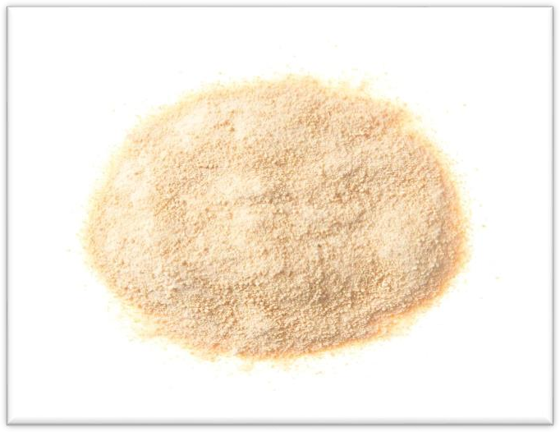Fig.no.4.Dry Granulation

# Processing the dry mixture Use efficient mixing:

* Determine an adequate duration of mixing time.
* Avoid accumulation of heat and moisture during mixing.
* Limit temperature/humidity variations. A general rule is 700 C at<40% relative humidity.
* The finished batch should be protected from moisture. Store in lined containers with silicadesiccant bags.
* The sample for batch uniformity. Test at the top, middle and bottom levels of the dry mixture.

# Condition for manufacturing Dry Syrup:

For manufacturing of dry syrup following conditions should Bemaintained.

* Relative humidity: Not more than 60%.
* Temperature: Below 25°C
* All relevant materials are removed.
* Equipment is cleaned
* Balanced is calibrate

# Method of preparation of dry mixture:(29)

Mostly antibiotics are available in dry syrup form. Dry syrup is manufactured in three methods.

1. Direct Mixing,
2. Dry Granulation (Slugging)
3. Wet Granulation (wet massing)

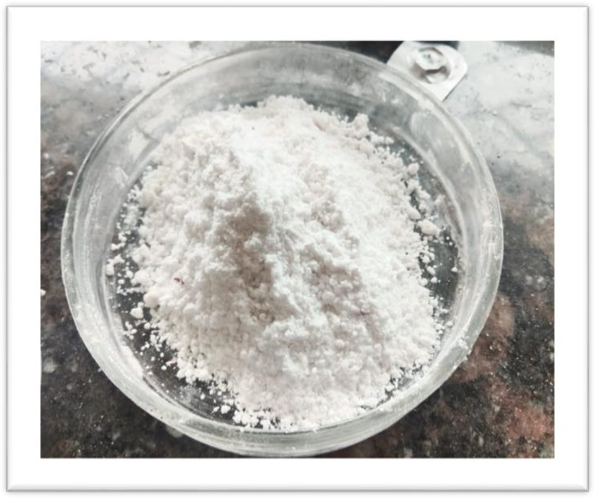Fig. no.5 Dry Mixing

**Dry mixture :(1,15,30**)

• Powder blends

• Granulated products

• Combination products

**Powder blends:**

Powder blends, sometimes called powder mixtures are prepared by mixing the excipients of the dry mixture in powder form. Excipients present in small quantities may require a two stage mixing operation. Such excipients can be mixed with a portion of a major

excipient to aid in their dispersion. For example, milled sucrose provides a large surface area for the adsorption of the small quantities of flavor oils. The second stage comprises the mixing of the remaining excipients. The selection of the appropriate mixer involves several

considerations, the most significant of which is that the mixer should rapidly and reliably produce a homogenous mixture.

**Combination product:**

Powdered and granulated excipients can be combined to overcome some disadvantages of granulated products. Less energy and equipment for granulation may be required if the majority of the diluents can be added after granulation. Also, heat sensitive

excipients such as flavours can be added after drying of the granulation to avoid exposure to elevated temperatures. The general method is first to granulate some of the excipients, then

blend the remaining excipients with the dried granules before filling the container. The presence of the diluents helps to improve flow and reduces both segregation and dust formation.

**Preparation of Dry Syrup:**

Bactericidal antimicrobials, such as amoxicillin, often are most effective in a “time-dependent” manner rather than a “concentration-dependent” manner. Time-dependent refers to the time that serum concentrations exceed the minimum-inhibitor-concentration (MIC) for the microorganism. Therefore, they are often dosed more frequently, rather than the concentration-dependent drugs, which can be dosed, for example, daily. The more “around-the-clock” dosing provides minor variation in peak and trough serum concentrations. Amoxicillin is an oral antimicrobial; whereas, ampicillin (which is structurally similar) can be given orally, intravenously, or intramuscularly. Amoxicillin comes in immediate-release or extended-release tablets. It also comes in a chewable tablet or a suspension. It may be mixed (after thoroughly shaking) and administered with formula, milk, water, fruit juice, ginger ale, or other cold drinks if given in suspension. The administration should take place immediately after mixing. Patients should not crush Extended- release tablets, and the administration should be within 1 hour after finishing a meal. Amoxicillin is sometimes preferred over penicillin in children

**Excipients used: (15,30)**

Number of excipients should be minimum as more the number of excipients in the formulation, the greater is the possibility of problems, for example, the chances of compatibility Problems are increased as more excipients are used. More Processing is required to incorporate more excipients. For Reducing the number of excipients use

an excipient that Performs more than one function. E.g., Sucrose can be used as a Diluents, sweetener and suspending agent. All excipients should disperse rapidly on reconstitution. This Criterion eliminates several suspending agents.

Granule disintegrant:

It results in prevention of the particle Aggregation.

Granule binder:

It helps to reduce the settling of particles in Suspensions.

It is also used as a stabilizer forsuspensions. Eg. High molecular weight povidone.

**Suspending agents:**

Suspending agents should be easily dispersed during Reconstitution. These rules out several common suspending Agents because many require hydration, elevated temperatures or high shear mixing for adequate dispersion. Some of the Suspending agents that are recommended for use are Acacia, Carboxy methylcellulose sodium, Iota Carrageenan, Microcrystalline cellulose with Carboxy methylcellulose sodium, Silicon dioxide,

Sodium Starch glycolate, Tragacanth,n Xanthan gum. Xanthan gum is a common suspending agent in suspensions for reconstitution. Its solution viscosity is practically Independent of pH and temperature.

**Sweeteners:(15,30)**

Sweeteners can mask the unfavorable taste and enhance Patient acceptance in the pediatric population that uses this Product. The sweetener is a significant component of Suspensions for reconstitution. Drugs frequently have a bitter Taste and suspending agents, particularly clays, may have a Bland taste. e.g., Sucrose can perform both functions of sweetener and Suspending agent, and serve as a diluent in the dry mixture.

Saccharin may become restricted by the Food and Drug Administration because of its carcinogenic potential. Others Include Mannitol, Dextrose, Aspartame, Saccharin Sod. Sucrose can perform both functions of sweetener and suspending agent and can serve as a diluentin the dry mixture. Aspartame has fair acid stability but poor heat stability. Saccharin may becomerestricted by the Food and Drug Administration because of its carcinogenic potential.(3)

**Wetting agents:**

Many drugs in suspension are hydrophobic; they repel water and are not easily wetted. Must select the appropriate wetting Agent for optimum dispersion of the drug at the lowest Effective concentrations excess wetting agent can produce Foaming and impart an unpleasant taste. Eg. Polysorbate 80, Sodium lauryl sulfate. Polysorbate 80 is a common wetting agent. It is nonionic and is chemically compatible with both cationic and anionic excipients and drugs. It is used in concentrations lesser than or equal to 0.1%.Another common wetting. agent is Sodium lauryl sulfate. This agent is anionic and may be incompatible with cationic drugs.(27)

**Other excipients**:

The other excipients include buffers, preservatives, flavors and Colors. Buffers are used to maintain the optimal pH for all excipients. Suspension pH is often adjusted to ensure that the drug Remains in soluble. Eg. Sodium citrate Preservatives are required in most suspensions because the Suspending agents and sweetener are good media for growth of microorganisms. e.g.,Sorbic acid. Sucrose in sufficient Concentrations (60%w/w) can aid in the prevention of Microbial growth. Other common preservatives used are Sodium benzoate and Sodium propionate. Flavors enhance patient acceptability of product. Both natural and artificial flavors are used. Additional flavors used include Raspberry, pineapple etc. In some cases, refrigeration after Reconstitution is required for the stability of the flavoring Agent rather than for the stability of the drug. Colorant sare intended to provide a more aesthetic appearance to the final suspension. Anticaking agents such as amorphous silica gelhave many Functions in suspensions for reconstitution. A common Problem in dry mixtures is poor powder flow and caking. This is often caused by powder agglomeration due to moisture Uptake (28)

**Result And Discussion** :

Dry Syrup is an antibacterial medication that consists of antibiotics.Dry syrups are the solid dosage form that can be reconstituted by the addition of water to administer by the oral route. Mostly antibiotics, some moisture sensitive and pediatric Drugs are available in the form of dry syrup Dry syrup is a common pharmaceutical dosage form used to deliver medications in a palatable and easily administrable form, particularly for pediatric patients who may have difficulty swallowing tablets or capsules. The formulation of dry syrup typically involves incorporating the active pharmaceutical ingredient into a powder mixture along with other excipients such as sweeteners, flavoring agents, and flow aids. the result and discussion section of a study evaluating a dry syrup formulation, researchers typically present the key findings related to the physical characteristics, pharmaceutical properties, stability, and bioavailability of the product. This can include information on factors such as the uniformity of drug content, particle size distribution, moisture content, reconstitution properties, flow ablity, and the shelf-life of the formulation.

Additionally, the discussion may cover comparisons with existing products or formulations, implications of the results for clinical use, challenges encountered during the development process, potential areas for further research or optimization, and overall conclusions regarding the efficacy and feasibility of the dry syrup formulation for its intended purpose. Overall, the result and discussion section of a dry syrup study aims to provide a comprehensive analysis of the formulation's performance and characteristics, highlighting its potential benefits and limitations to guide future development and application in the pharmaceutical field.

# Table.No.Evaluation Test

|  |  |  |  |  |  |
| --- | --- | --- | --- | --- | --- |
| Sr.No | Evaluation Parameter Test | F1 | F2 | F3 | F4 |
| 1. | PH | 6.4 | 6.5 | 6.7 | 6.9 |
| 2. | Colour | Pale Yellow | Pale Yellow | Pale Yellow | Peale Yellow |
| 3. | Odour | Venilla | Venilla | Venilla | Venilla |
| 4. | Taste | Sweet | sweet | sweet | sweet |
| 5. | Dissoluation Test | 30 min | 25min | 20min | 15min |

**PACKAGING AND STORAGE:**

Dry powder for reconstitution packaged in wide mouth Container or in sachet in case of unit dosing.

* The dry powders for reconstitution should be packaged in Wide mouth container having sufficient air
* space above the liquid.
* The dry powders should be stored in tight container Protected from freezing, excessive heat and light.
* The label should contain the direction stating: “Shake Before Use” to ensure uniform distribution of solid
* Particles and thereby to obtain uniform and proper Dosage.
* The dry powders should be stored at room temperature.
* After reconstitution the suspension should be stored in the Refrigerator (freezing should beavoided to prevent Aggregation)
* For single dosage packing, sachets are used made up of 4 Layers of aluminum foil.

# Labelling:

1. That the contents are meant for preparation of an oral liquid.
2. The directions for preparing the oral liquid including nature and quantity of liquid to be used.
3. The conditions under which the reconstituted solution should be Stored.
4. The period during which the constituted oral liquid may be Expected to remain satisfactory for use when
5. prepared and stored in Accordance with manufacturer’s recommendations
6. The strength in terms of active ingredients in a suitable dose Volume of reconstituted preparation.

# CONCLUSION:

The aim of this present investigation was to develop taste masked Linezolid pediatric dry syrup. Ion exchange resin technique was selected to mask the bitter taste of Linezolidas complexation with ion exchange resin is a simple and cost-effective technique. Several ion exchange resins like kyron T104, kyron T- 134, kyron T-154, T-314 and indion 214 were used to mask the taste.

Complexation of Linezolid and resin was done by

stirring them together for6-8 hours on magnetic stirrer. Taste masked dry syrup of Linezolid was prepared using in dion 214as Linezolid had a maximum binding efficiency with indion 214 about

84. 47 %. So it was selected as a resior final taste masked dry syrup. The resinate were evaluated for different parameters liketaste evaluation,

micromeritic properties and % drug content. It was concluded that the taste was completely masked and acceptable for pediatric patients. The taste masked syrup was prepared using three different suspending agents

namely gellan gum, guar gum and CMC. The final formulation contained three different concentrations of each suspending agents. Then it was evaluated for different parameters like colour, odour, % drug content, flow properties, sedimentation volume, pH, redispersibility, viscosity and in- vitro drug release. From the results it was concluded that the formulation with suspending agent guar gum with 3 % concentration showed highest sedimentation volume and better redispersibility which were very important parameter when once have to deal with suspension. The other parameters were also showed better results for the same suspending agent. So it was selected as an optimized suspendingagent amongst three. Even after studying the stability study of 18 days the results of parameters were matched with the initial once.

# Referance :

1.Howard CA. Introduction of pharmaceutical dosage forms; Lea and Febiger, Philadelphia; 1981. p. 139-66.

2 .Ofner CM, Schnaare RL, Schwartz JB. Reconstitutable oral suspension”. Lieberman HA, Rieger MM, Banker GS.Pharmaceutical dosage forms and disperse system; Vol. 2. 2nd Edition. (New York: Marcel dekkar Inc) NJ; 1984. p. 243-59.

1. Lieberman HA, Rieger MM, Banker GS. Pharmaceutical dosage forms and disperse system. Vol. 2. 2nd Edition. (New York: Marcel dekkar Inc.); 1994. p. 149-77.
2. Peace N, Olubukola O, et al. Stability of reconstituted amoxicillin clavulanate potassium under simulated in-home storage conditions. J. Applied Pharm. Sci., 2012; 2(1): 28–31.
3. Patel M, Patel KR, Patel MR, Patel NM. Formulation and Evaluation of Microemulsion Based Gel of Ketoconazole International Journal of Universal Pharmacy and Bio Sciences, 2014;3(2):93-111.
4. Singh VK, Mishra VK, Maurya JK. Formulation and evaluation of cephalexin monohydrate Re-constitutional oral suspension with piperine and their antibacterial activity. World Journal of Pharmaceutical Research, 2014; 3(5):821-831.
5. Kumar RS, Yagnesh TNS. Pharmaceutical Suspensions: Patient Compliance Oral Dosage Forms. World Journal of Pharmacy and Pharmaceutical Sciences, 2016; 7(12):1471-1537.
6. Ecanow B.etalii. Newer aspects of suspension theory. Amer. Perfum. Cosmet, 1969;84(11):27-30.
7. Ratnaparkhi MP, Gupta Jyoti P. Sustained release oral drug delivery system-an overview. International Journal of Pharma Research & Review, Mar 2013; 2(3):11-21.
8. Peace N, Olubukola O, et al. Stability of reconstituted amoxicillin clavulanate potassium under simulated in-home storage conditions. J. Applied Pharm. Sci., 2012; 2(1): 28–31.
9. Anabousi H.I. phD Thesis. Problems Associated with Reconstitution, Administration, and Storage of Antibiotic Suspensions for Pediatrics in Nablus City-Palestine. An-Najah National University, 2013.
10. The Hindu Article. Babies fall victim to antibiotic resistance, 2016. [http://www.thehindu.com/news/national/Babies-fall-victim-to-antibiotic](http://www.thehindu.com/news/national/Babies-fall-victim-to-antibiotic%20resistance/article14983731.ece) [resistance/article14983731.ece.](http://www.thehindu.com/news/national/Babies-fall-victim-to-antibiotic%20resistance/article14983731.ece)
11. Mali RR, Goel V, Gupta S. Novel study in sustained release drug delivery system: A Review. Int. J. Pharm. Med. Res. 2015;3(2):204-215.
12. Kundu S, Patil AV, Srinivasan G, Borkar N. Controlled Release Suspension: A Review. International Journal of Pharmaceutical Innovations.

2011; 2(4):1-18.

1. Bardeskar C, Geeverghese R.Reconstitutable Oral Suspensions (Dry Syrups): An Overview. World Journal of Pharmaceutical Research. 2014; 4(3):462-484.
2. Damor SR, Jethara SI, Patel MS, Patel MR. A Review On Dual Release Oral Reconstitutable Suspension. World Journal of Pharmaceutical Research. 2015; 4(3):592-613
3. Bhandare P,Yadav A. A Review on “Dry Syrups For Paediatrics”. Int J Curr Pharm Res, 2015;9(1):25-31.
4. Yoshida, M., Haraguchi, T. and Uchida, T. (2014) Bitterness Evaluation of Acidic Pharmaceutical Substances (NSAIDs) Using a Taste Sensor. Chemical and Pharmaceutical Bulletin, 62, 1252-1258.
5. Uchida, T., Yoshida, M., Hazekawa, M., Haraguchi, T., Fruno, H., Teraoka, M. and Ikezaki, H.(2013)Evaluation of Palatability of 10 Commercial Amlodipine Orally Disintegrating Tablets by Gustatory Sensation Testing, OD- Mate as a New Disintegration Apparatus and the Artificial Taste Sensor. The Journal of Pharmacy and Pharmacology, 65, 1312-1320. [https://doi.org/10.1111/jphp.12101.](https://doi.org/10.1111/jphp.12101)
6. Kobayashi, Y., Habara, M., Ikezazki, H., Chen, R., Naito, Y. and Toko, K. (2010) Advanced Taste Sensors Based on Artificial Lipids with Global Selectivity to Basic Taste Qualities and High Correlation to Sensory Scores.

21.Sensors, 10, 3411-3443.https://doi.org/10.3390/s100403411.

1. Haraguchi, T., Miyazaki, A., Yoshida, M. and Uchida, T. (2013) Bitterness Evaluation of Intactand Crushed Vesicare Orally Disintegrating Tablets Using Taste Sensors. The Journal of Pharmacy and Pharmacology, 65, 980-987. [https://doi.org/10.1111/jphp.12078.](https://doi.org/10.1111/jphp.12078)
2. Dr. Sangeeta Asija1*, Bhavana Salunke2, Dr. Rajesh Asija3, Mr. Anil Kumar Goyal4, Mr. Jitendra Kum.2017.
3. Wu, X., Onitake, H., Haraguchi, T., Tahara, Y., Yatabe, R., Yoshida, M., Uchida, T., Ikezaki
4. H. and Toko, K. (2016) Quantitative Prediction of Bitterness Masking Effect of High-Potency Sweeteners Using Taste Sensor. Sensors and Actuators B: Chemical,

235, 11-17. <https://doi.org/10.1016/j.snb.2016.05.009>.

1. Yoshimatsu, J., Toko, K., Tahara, Y., Ishida, M., Habara, M., Ikezaki, H., Kojima, H., Ikegami,S., Yoshida, M.and Uchida, T. (2020) Development of Taste Sensor to Detect Non- Charged BitterSubstances. Sensors, 20, 3455. 1https://doi.org/10.3390/s20123455.
2. Haraguchi, T., Uchida, T., Hazekawa, M., Yoshida, M., Nakashima, M., Sanda, H., Hase,

T. and Tomoda, Y.(2016) Ability of Food/Drink to Reduce the Bitterness Intensity of Topiramate as Determined by Taste Sensor Analysis. Chemical and Pharmaceutical Bulletin, 64, 14-20. <https://doi.org/10.1248/cpb.c15-00474>.

1. Pavane M, Shirsat M, Dhobale A, Joshi D, Dhembre G, Ingale P. Formulation,

Development and Evaluation of Oral Reconstitutable Dry Syrup. Indo American Journal of Pharmaceutical Sciences. 2018; 5(1):483-491.

1. Pavane M, Shirsat M, Dhobale A, Joshi D, Dhembre G, Ingale P. Formulation,

Development and Evaluation of Oral Reconstitutable Dry Syrup. Indo American Journal of Pharmaceutical Sciences. 2018; 5(1):483-491

1. Parmar Pratik, MR Patel, KR Patel, NM Patel. “A review on taste masking pediatric dry syrup”. Intrnational J Univers Pharm Bio Sci 2013;2:2319-8141.