**A Review On: Nanoparticals Used In Treatment Of Cervical Cancer**

Ms. Takale Akanksha Machhindra\*1 , Mr. Wamane Vikas B.\*2

\*1 Student, Pratibhatai Pawar College Of Pharmacy, Shrirampur

\*2 Asst. Professor, Pratibhatai Pawar College Of Pharmacy, Shrirampur

Corresponding author: Ms. Takale Akanksha Machhindra

**Abstract:**

Globally, cervical cancer is the primary cause of fatalities from gynecological tumors. Because of severe side effects and medication resistance, traditional methods including surgery and chemoradiotherapy have limited uses. Immune checkpoint inhibitors (ICIs) are becoming more and more popular, yet their clinical response rates are not very high. Effective treatment plans for patients with metastatic or recurring cervical cancer are currently lacking. Nanomaterials such as liposomes, dendrimers, and polymers are now regarded as promising delivery vehicles because of their advantages in terms of increased biocompatibility, decreased toxicity, and tumor-specific administration. In this study, we examine the uses of nanoparticles in the treatment of cervical cancer, medicine delivery, and genome-editing based on CRISPR.

**Introduction:**

One of the most deadliest yet preventable cancer with an annual incidence of over 450,000 cases worldwide, cervical cancer is a common disease and the third leading cause of cancer-related deaths in women. The high death rate might result from the majority of cervical cancer cases being detected at an advanced stage . The majority of cervical cancer cases are diagnosed at an advanced stage, which may account for the high death rate. For instance, over 70% of cervical cancer cases that are diagnosed in developing nations are either locally invasive or metastatic. Surgical excision is an effective treatment for early-stage cervical cancers, with a 5-year survival rate exceeding 90% 3. However, the 5-year survival rate for metastatic cervical cancers is only approximately 50%. Therefore, in order to raise the survival rate, active efforts must be made to improve cervical cancer diagnosis and treatment (1).

In india cervical cancer is one of leading causes of cancer mortality among women 30 to 69 years of age accounting for 17% of all cancer deaths India has population of around 365.71 million women >15 year age who are at high risk of developing cervical cancer current estimates revealed 132,000 new diagnosed cases and 74,000 deaths annually in india during year 2007 survey, accounting for nearly ⅓ rd of global cervical cancer deaths (2).

**2.Cervical cancer**

Cells that begin to grow in the cervix can develop into cervical cancer. The lower portion of theuterus that joins the vagina is called the cervix. The human papillomavirus, or HPV, is responsible for most cervical cancers and comes in different strains. A common infection spread through intercourse is HPV. The immune system of the body usually stops HPV from causing harm when it is exposed. But in a tiny minority of cases, the virus lives for years. This plays a part in the process by which some cervical cells develop into cancerous cellsSurgery to remove the cancer is frequently used as the initial treatment for cervical cancer. Medication to destroy the cancer cells may be one of the additional treatments**.**Chemotherapy and medications for targeted therapy are possible options. Strong energy beam radiation therapy is another option. Radiation therapy is occasionally combined with low-dose chemotherapy(3).

** Fig no 2. Women reproductive system .**

**Symptoms :**

Cervical cancer may not show any symptoms at first. Cervical cancer may exhibit the following symptoms and indicators as it progresses:

Bleeding From The Vagina After Having Sex, In Between Periods, Or Following Menopause Menstrual Bleeding That Is Heavier And Lasts Longer Than Usual.

Vaginal Discharge That Is Bloody, Watery, Smells Bad, And May Be Heavy Pain In The Pelvis Or During Sexual Activity(4)

**Causes:**

The development of DNA alterations in healthy cervix cells is the first step toward cervical cancer. The instructions that inform a cell what to do are encoded in its DNA. The alterations instruct the cells to proliferate rapidly. When healthy cells would naturally perish as a part of their life cycle, the cells survive.

There are too many cells as a result. The cells may aggregate into a mass known as a tumor. Healthy bodily tissue can be invaded by the cells and destroyed. The cells may eventually separate and disperse to other areas of the body. HPV is the primary cause of most cervical malignancies. A frequent virus that is spread through intercourse is HPV.

Most people never have any issues with the infection. Usually, it disappears on its own. However, in certain cases, the virus can alter cells in a way that could result in cancer(5)

Cervical cancer is categorized into different types depending on the specific cell where the cancer originates. The primary classifications of cervical cancer include:

1. Squamous cell carcinoma: This form of cervical cancer initiates in the thin and flat cells known as squamous cells. These cells form a lining on the outer surface of the cervix. The majority of cervical cancers fall under the category of squamous cell carcinomas.
2. Adenocarcinoma is a form of cervical cancer that originates in the gland cells that are shaped like columns and line the cervical canal.(6)

Cervical exfoliative cytology was developed to detect cervical intraepithelial neoplasia, which can be treated to prevent the development of cervical cancer. This was made possible by the realization that cervical neoplasia starts as an intraepithelial change and typically takes many years to develop into an invasive disease. Since high-risk HPV infection was found to be the cause of cervical cancer and prophylactic vaccination was developed in the 1990s, a more global approach to prevention through prophylactic vaccination is now possible. One way to think of prevention is through vaccination as primary and screening as secondary.

Given HPV's critical role in the development of cervical cancer, screening with HPV testing can lead to a more precise risk-based strategy (7).

**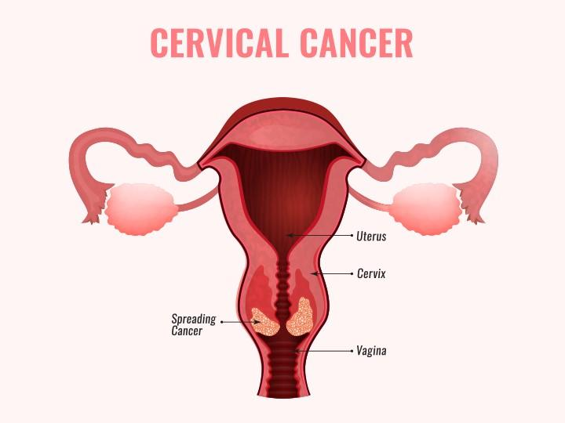**

**Fig no.3 cervical cancer female reproductive system**

### Risk factors:

### Sexually transmitted infections (STI)

### Reproductive and sexual factors

### Nutritional factors

### Behavioral factors

### Inflammatory diseases

**1.Sexually transmitted infections (STI):**

**HPV :**

partners for sexual relations Cervical cancer has also been connected to factors related to sexual behavior. According to one study, persons who have several sexual partners are more likely to get cervical cancer . In addition, numerous studies have revealed that women who have several sexual partners are more likely to contract HPV and develop cervical cancer . According to the meta-analysis, people who have several sexual partners are significantly more likely to develop cervical disorders, including non-malignant cervical disease and cervical cancer, than people who have fewer partners . Even after accounting for the presence of HPV infection, a significant risk factor for cervical cancer, the link persisted.

**Human immunodeficiency virus (HIV):**

Women living with HIV are more susceptible to infection from high-risk HPV strains A higher rate of persistent HPV infection with several oncogene viruses, more abnormal Papanicolau (Pap) smears, and a higher risk of CIN and invasive cervix carcinoma were suggested by the results of investigations on the link between HIV and cervical cancer . HIV-positive women are more likely to contract HPV at a young age (13–18 years old) and have a higher chance of developing cervical cancer. HIV positive patients with cervical cancer receive their diagnosis earlier (15–49 years old) compared to women who are not infected

**2. Reproductive and sexual factors:**

**sexual partners**:

Cervical cancer has also been connected to factors related to sexual behavior. According to one study, persons who have several sexual partners are more likely to get cervical cancer . In addition, numerous studies have revealed that women who have several sexual partners are more likely to contract HPV and develop cervical cancer .more likely to develop cervical disorders, including non-malignant cervical disease and cervical cancer, than people who have fewer partners.

**Oral contraceptive (OC) pills:**

for oral contraception (OC) It is well known that OC tablets increase the risk of cervical cancer. According to an international joint epidemiological study on cervical cancer, the longer a someone had used OC, the higher their relative risk became. According to reports, using OC for five years or longer can double your risk of developing cancer (36). Furthermore, if women who tested positive for HPV DNA used oral contraceptives for five years or longer, their chance of developing cervical cancer increased by three times, according to a multi-center case-control research (8)

**3.Nutritional factors:**

**Vitamin A:**

They came to the conclusion that since vitamin A deficiency is linked to a 10% lower chance of HPV infection, it may help prevent HPV infection by creating oxidative stress, which inhibits the function of cell repair and causes cell damage.

**Vitamin D :**

In order to allow regular bone mineralization, vitamin D maintains sufficient levels of calcium and phosphate in the blood and facilitates calcium absorption in the small intestine. For osteoblasts and osteoclasts to build and repair bones, vitamin D is also required. In addition, vitamin D regulates immunological, neuromuscular, and cell proliferation in addition to reducing inflammation. In order to facilitate regular bone mineralization, vitamin D increases the absorption of calcium in the small intestine and keeps serum calcium and phosphate concentrations appropriate.

**VitaminC:**

Ascorbic acid, another name for vitamin C, serves a number of vital roles in the preservation and protection of cell health, including promoting the healing of wounds and preserving the health of skin, blood vessels, bones, and cartilage [42]. A lack of vitamin C can cause scurvy.

**VitaminE:**

Tocopherol, often known as vitamin E, is a fat-soluble antioxidant that prevents reactive oxygen species (ROS) from being produced when fat oxidizes. Researchers are looking into the possibility that vitamin E could help stop or postpone the development of chronic illnesses linked to free radicals Additionally, it has been shown that vitamin E shields cells against mutagenesis and oxidative DNA damage, which delays the growth of various malignancies.(8)

**4.Behavioral factors:**

smoking or inhaling smoke from others. Cervical cancer is more common in people who smoke or are exposed to secondhand smoke. The more a person smokes or is around secondhand smoke, the higher the risk.

### 5.Inflammatory diseases:

### Cervicitis is a female genital tract inflammation characterized by purulent endocervical exudate and/or cervical friability. may be asymptomatic or manifest as discharge or irregular bleeding. Cervicitis is frequently caused by the sexually transmitted Neisseria gonorrhoeae and CIt hlamydia trachomatis, but it can also be caused by other sexually or non-sexually transmitted infectious agents, or it can develop from non-infectious causes. Pelvic inflammatory disease (PID) is a more serious infection of the upper female genital tract that can be caused by N. gonorrhoeae or C. trachomatis, but it is frequently polymicrobial. PID is usually an ascending infection from vaginal or cervical bacteria, but it can occasionally be the result of transperitoneal spread of bacteria, such as in the case of a ruptured (9)

**6.TREATMENTS FOR CERVICAL CANCER:**

* Treatment options for cervical cancer relapse after initial treatment are available. These choices are contingent upon a number of variables, including the patient's general health status, the extent of recurrence, and the cancer stage.
* Immunotherapy medications: Immune checkpoint inhibitors, such nivolumab and pembrolizumab (Trusted Source), have demonstrated potential in the treatment of recurrent cervical cancer, either in isolation or in conjunction with chemotherapy.

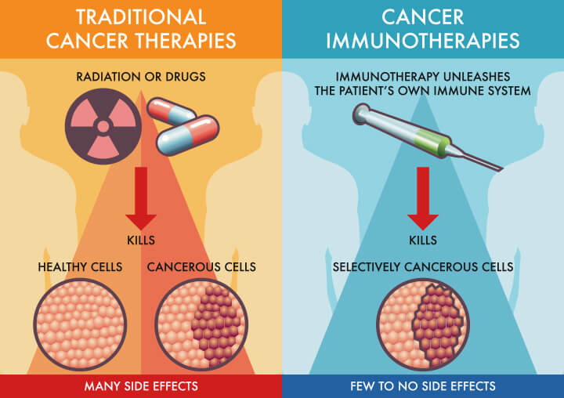

Fig no.4 chemotherapy and immunotherapy

* Chemotherapy with radiation therapy: For patients with recurring pelvic cancer, doctors may suggest chemotherapy in addition to radiation therapy from Trusted Source. Drugs used in chemotherapy may include topotecan, paclitaxel, and cisplatin.
* Pelvic exenteration: A pelvic exenteration may be necessary for those who cannot receive radiation therapy, according to Trusted Source. In this extreme surgical operation, the patient's uterus, vagina, cervix, and surrounding lymph nodes are removed, along with any organs that are impacted, like the bladder or rectum.

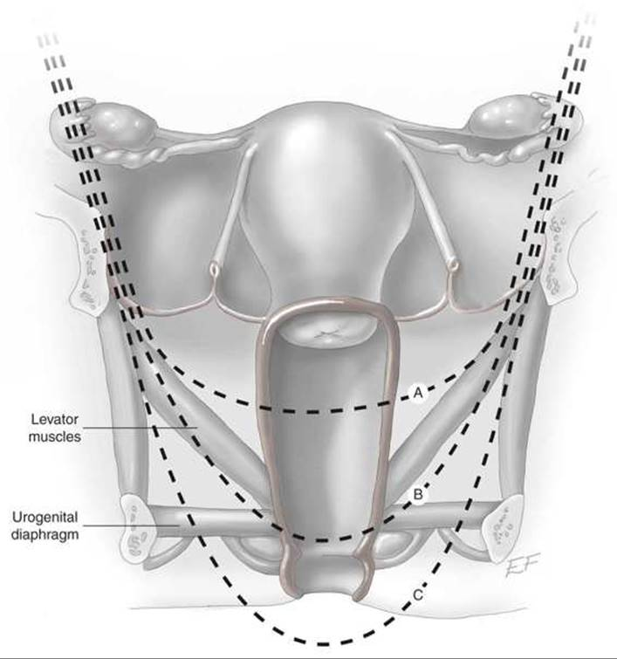

Fig no5.Diagram of pelvic exenteration

* Radical hysterectomy: For patients who have already received radiation therapy and experience minor recurrences in the cervix or uterus, doctors may recommend a radical hysterectomy(10).

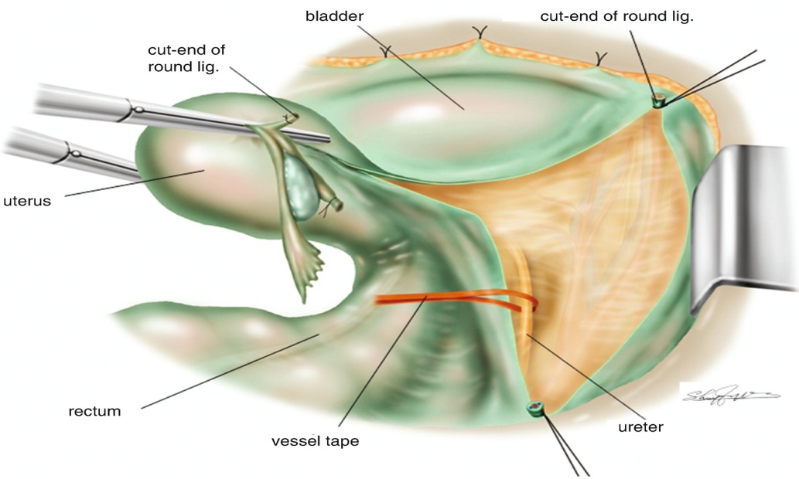

Fig no5. Radical Hysterectomy

**7**. **Prevention and vaccine:**

Asymptomatic female screening is not commonly performed in India. Thus, vaccination against HPV is a promising approach to the prevention of cervical cancer. Cervarix and Gardasil, the two HPV vaccinations, work equally well to prevent recurrent HPV 16 and 18 infections . Primary prophylaxis against HPV types 16 and 18 is provided via HPV vaccine. Vaccination against Cervarix and, more recently, Gardasil has shown promise in the immunoprevention of cervical cancer, but its distribution to developing countries has been unequal. Even in countries where the vaccine is readily available, vaccination uptake has faced a number of challenges

**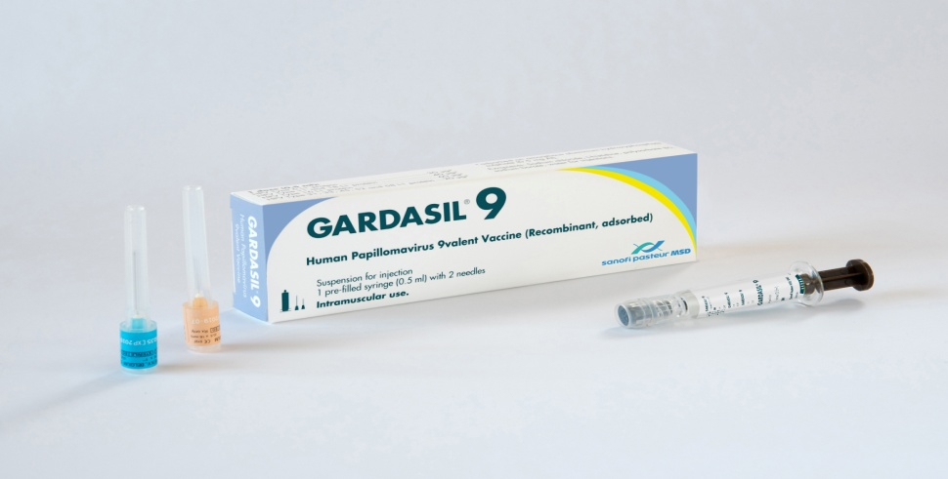**

Figno. Gardasil9 vaccine

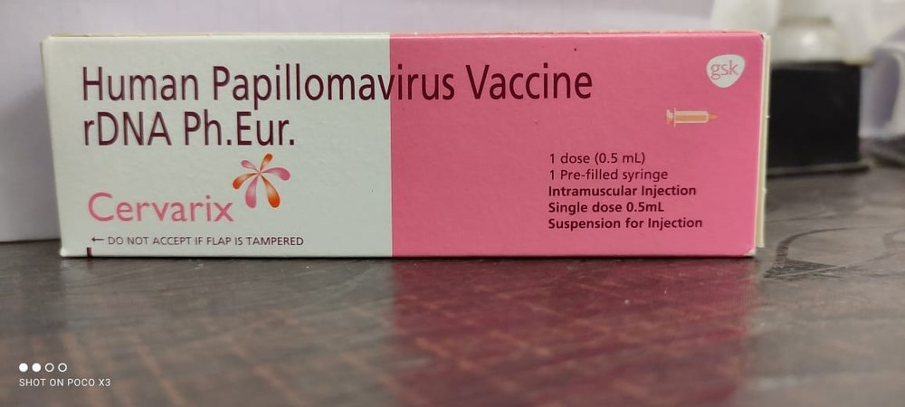

Figno.6 ceravix vaccine

* Schedule and Dosage of Vaccines : The initial dosage needs to be administered between the ages of 9 and 12, and it needs to be finished before 26. It is possible to deliver the HPV vaccine in addition to the hepatitis B and tetanus, diphtheria, and pertussis (Tdap) immunizations (11).
* SAGE recommends modifying the following HPV dose schedules: For girls aged 9 to 14, one or two doses are recommended; for young women aged 15 to 21, one or two doses; and for women over 21, two doses spaced six months apart. Immunocompromised individuals, particularly those infected with HIV, ought to receive three doses if at all possible; if not, they ought to receive at least two [22]. The initial dosage needs to be administered between the ages of 9 and 12, and it needs to be finished before 26. The HPV vaccination can be given in addition to the hepatitis B and tetanus, diphtheria, and pertussis (Tdap) vaccines .These vaccinations guard against HPV types 6/11/16/18/31/33/45/52/58 infection(12)

**8. The Mechanism of Vaccine Action**

Since HPV only infects humans, it is challenging to understand how the nonavalent HPV vaccination functions. Nonetheless, it is believed that the humoral response is the reason the immunization has effect. The L1 virus-like particles (VLP) of the carcinogenic protein subunit (CPS) component of HPV types 6, 11, 16, 18, 31, 33, 45, 52, and 58 are used to make nonavalent HPV vaccines. The inactive HPV L1 virus-like particles (VLPs) in the vaccine produce antibodies that neutralize various HPV strains and initiate a strong humoral immune response that guards against diseases and dysplastic lesions caused by HPV, according to 2016 immunogenicity research. The same study found that the nonavalent HPV vaccine produced antibody titers that were 10-100 times higher than those caused by naturally occurring HPV(13).

An external file that holds a picture, illustration, etc.
Object name is gr1_lrg.jpg

Figno.7Mechanism of action of vaccines.

**9. Nanoparticals:**

A nanoparticle, or ultrafine particle, is a particle of matter with a dimension of one to one hundred nanometers (nm). Due to their minuscule size and massive surface area, nanoparticles often display unique size-dependent properties. When a particle's size gets closer to the nanoscale and its characteristic length scale is lower than or equal to the de Broglie wavelength or the wavelength of light, the periodic boundary conditions of the crystalline particle are eliminated . As a result, a great deal of the physical properties of nanoparticles are different from those of bulk materials, which opens up a variety of new applications for themWhen used in medication delivery systems, nanoparticles provide a number of benefits over traditional cervical cancer treatment. Because they are smaller than 1000 nm, they can evade the phagocytes' quick clearance and enter the bloodstream for a longer period of time. Furthermore, they can readily penetrate tissues or cells to go to specific organs like the spleen, liver, or cervix. Their biodegradability, pH, and heat sensitivity of their architectures give them controlled-release properties that enable the delivery of drugs or molecules (14).

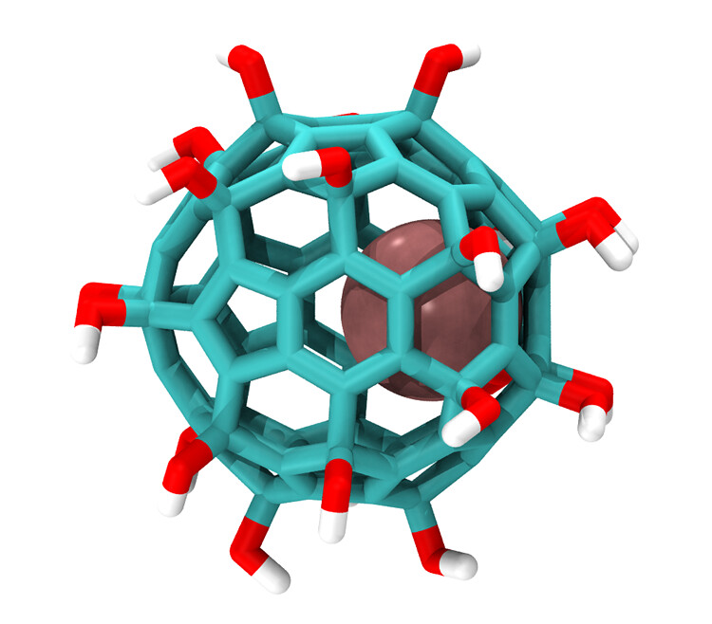  
 figno.8 structure of nanoparticals.

**Lipid-Based Nanocarriers :**

Lipid nanocarriers improve medication solubility, encapsulation, and delivery, increasing chemotherapeutic absorption. They are often made from phospholipids, triglycerides, or cholesterol. Other organic nanoparticles include liposomes, solid lipid nanoparticles (SLN), and nanostructured lipid carriers (NLC), in addition to lipid nanocarriers. Since Alec Bangham discovered liposomes in 1960, they have undoubtedly been the subject of the greatest research of all the nanoparticles. The ability of liposomes to transport hydrophilic and hydrophobic medications, such as immune cytokines, chemotherapeutic particles, and phytochemicals, to cancer cells is one of their key advantages. Their effective application in cervical cancer has been demonstrated by recent trials when paired with paclitaxel, interleukin 2 (IL-2), curcumin, and cisplatin (lipoplatin). Nanoparticles that are loaded with liposomes improve the stability, bioavailability, and absorption of drugs by tumor cells (15).

Solid lipid nanoparticles have the advantage of increasing medication solubility while lowering medicinal dosage. Additionally, the lipid matrix of SLNs improves drug stability by securing chemically unstable components and facilitating their adhesion and integration into malignant cells. However, SLN exhibits a lower drug loading volume and a quicker drug ejection through its depositing. Colloidal drug carrier systems are excellent options for drug delivery because they are nanostructured lipid carriers made of a mixture of liquid and solid lipids. They shield vulnerable active ingredients, increase the bioavailability of poorly soluble chemicals, and facilitate the medication's targeted distribution used in both mouse cervical carcinoma and HeLa cells (16).

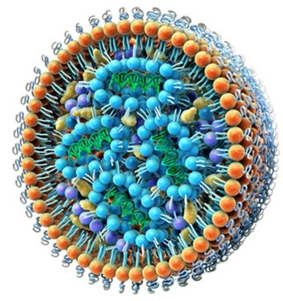

Fig no.9 lipid based nanocarrier

### Polymeric and Dendrimeric Nanoparticles:

Polymeric nanoparticles are biocompatible structures with excellent preservation for controlled release, penetration, and destruction by chemicals or enzymes inside malignant cells. They have the ability to load specific targets with antibodies, DNA, or RNA, enabling specific interactions . The medication delivery is easier to manage since it may be easily guided by the rate at which nanopolymers degrade. Once the agent supply is exhausted, the breakdown products are non-toxic, and the absorbable components metabolize without the need for surgical removal . When used in both in vitro and in vivo cervical cancer treatments, several derivatives of poly(lactide-co-glycolide) (PGLA) loaded with docetaxel demonstrated good delivery control and sustainability as well as a better efficiency of cellular uptake and antitumor potential (17).

When mixed with nanoparticles of polymers. Dendrimers are multifunctional due to their structure, which allows antigen molecules to be presented and fastened to their extremities. demonstrate that dendrimers loaded with doxorubicin and adorned with IL-6 antibodies exhibit increased cellular incorporation and a reduction in IC50. Furthermore, in HeLa cervical cancer cells, it has a higher cytotoxicity and increases the rates of drug loading and discharge as well as arginyl-glycyl-aspartic acid (RGD) peptide conjugation(18).

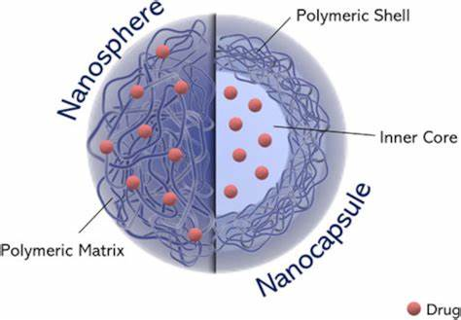

Figno. 10 Diagram of polymeric and Dendrimeric nanoparticle

**Carbon-Based Nanoparticles** :

Carbon-based nanotubes have been broadly examined since 1990 and are alluring nanoparticles in expanding the pharmacological profile of different conclusion and helpful specialists. These days, they separate into single-walled carbon nanotubes (SWCNT) and multiple-walled carbon nanotubes (MWCNT), each with diverse characteristics. They brought awesome commitment in imaging and sedate conveyance, due to their warm, mechanical, and electrical highlights . The photothermic treatment of strong tumors utilizing SWCNT improved by near-infrared light (NIR) decide a noninvasive cell passing, without harmful side impact. The proficiency of SWCNT and MWCNT was demonstrated within the treatment and early conclusion of cervical cancer, but indeed in the event that they are exceptionally promising, there are still a few issues with respect to harmfulness and biocompatibility due to the need of selectivity for these medications (19) .



Figno.carbon nanoparticles

### 

### Metallic Nanoparticles (MNP) :

The amalgamation of MNP (gold, silver, press oxide, and silica) is accomplished by chemical and physical strategies. Compared to other nanoparticles, gold and silver nanocarriers have a specific include, called the surface plasmon reverberation (SPR), which makes the cellular surface usefulness more flexible and biocompatible. There are still questions with respect to their poisonous quality related to the ionized or the particulate structure. Two components were proposed, the transcytosis and paracellular transport, but the in vivo carriage and the assimilation handle are still hazy . Be that as it may, gold nanoparticle- (AuNP-) stacked gallic corrosive (GA) moderates down tumor cells multiplication by causing cellular apoptosis in CaSki or HeLa cell societies, compared to free GA. Shockingly, a tall dosage of AuNPs-GA (150 μM) complex did not influence the typical cervical cells, compared to the GA gather. Subsequently, the think about uncovered that indeed on the off chance that AuNPs-GA productivity is lesser than GA alone, no cellular poisonous quality was detailed within the ordinary cervical cells bunch when AuNPs-GA was connected . Another think about appears that AuNP-conjugated doxorubicin presents a better anticancer movement in human cervical cancer cells, compared to free drugs . The AuNP conjugation with bioactive atoms diminishes in general harmfulness and increments mitochondria focusing on in cancer cells. Phloroglucinol conjugated with AuNPs decides apoptosis in HeLa cancer cells by expanding the penetrability of the mitochondrial film . Another think about appeared that in case stacked with Podophyllum hexandrum plant extricate, the AuNPs decide DNA impedance and cellular cycle piece at G2/M stage in HeLa cells(20) .

Bionanotechnology through green union is more secure and less costly. The photosynthesized Catharanthus roseus (CR) AuNPs upgrade mitochondrial-mediated apoptotic signaling pathway through receptive oxygen species (ROS), causing tall poisonous quality in HeLa cell societies . Silver nanoparticles (AgNPs) have an broad utilize within the wellbeing care industry due to their specific highlights, being an anti-inflammatory, antibacterial, antiviral, antiangiogenic, or anticancer item. In the event that silver is utilized in moo amounts, it causes no harm in creature cells, compared to expanded poisonous quality against microbes or cancerous cells. In cervical cancer treatment, few ponders are accessible for AgNPs gotten by chemical amalgamation like bright radiation, photochemical lessening, laser removal, or aerosol technologies . Rather like within the case of AuNPs, green amalgamation of AgNPs is generally utilized due to ecofriendly generation. Yuan et al. detailed that AgNPs conjugated with camptothecin (CPT) appeared cell multiplication hindrance and improved cytotoxicity and apoptosis, through changed instruments such as raising the levels of oxidative stretch markers and quickening numerous proapoptotic quality expression . Changed therapeutic plants with antioxidant properties such as Flute player longum and Cleistanthus collinus have been utilized for AgNP union, appearing favorable reactions in anticancer treatment (21).

Press oxide nanoparticles have been broadly considered due to their astonishing capacity of combining sedate conveyance frameworks, imaging, and treatment characteristics. The impact of supermagnetic DMSO@ γ-Fe₂O₃, combined with chemotherapy operator carmustine on cervical cancer beneath a variable attractive field appeared an expanded harmful impact, improved by nanomagnetic liquid thermotherapy utilized on cervical cells. Superparamagnetic press oxide nanoparticles (SPIONs) are extraordinary for their noninvasive conclusion and helpful utilize but there's still a gradually advance into clinical application(22) .

Mesoporous silica nanoparticles (MSNs) show awesome highlights such as tunable extent, tall stack volume, morphology, soundness, and essentially plausibility to adjust inner and outside surfaces of the NP and this make them exceptionally alluring for the cervical cancer determination, treatment, and promising in cancer theragnostics . Utilizing MSNs, Franco et al. appeared expanded cellular link-up and nanomaterial exchange among safe cells and increase of interaction between MSNs and macrophages to arrange an resistant reaction in cervical cancer(23) .

Selenium nanoparticles (Se NP) have shown potential in treating cervical cancer, with their ability to inhibit migration and invasion activity contributing to an antimetastatic effect. Rajkumar et al. conducted an analysis on the anticancer properties of Se NP synthesized from Pseudomonas stutzeri (MH191156), highlighting its effectiveness against cervical cancer cells in terms of antitumor and antiangiogenic characteristics. Additionally, other researchers have demonstrated its efficacy in cervical cancer by utilizing it as a drug delivery system in combination with doxorubicin, or by employing targeted siRNA delivery to silence Derlin1 and enhance the anticancer effect (24).

When the cooper oxide nanoparticles were tested against various cancer cells, including human cervical (HeLa cells), breast (MCF-7 cells), lung (A549 cells), and epithelioma (Hep-2 cells), they showed remarkable cytotoxicity results. Due to their photocatalytic activity, zinc oxide nanoparticles have been effectively employed in the cosmetics industry; however, in vitro human squamous cell carcinoma, it has been demonstrated that their combination with paclitaxel and cisplatin causes selective cancerous cell death. By changing the size and surface activity of the cell and boosting the production of reactive oxygen species (ROS), barium carbonate, like AuNP, is used in the green synthesis of NP and can cause tumor cell apoptosis. A nanomagnetic material with strong paramagnetism and a magnetic response is used to create magnetic nanoparticles (25).

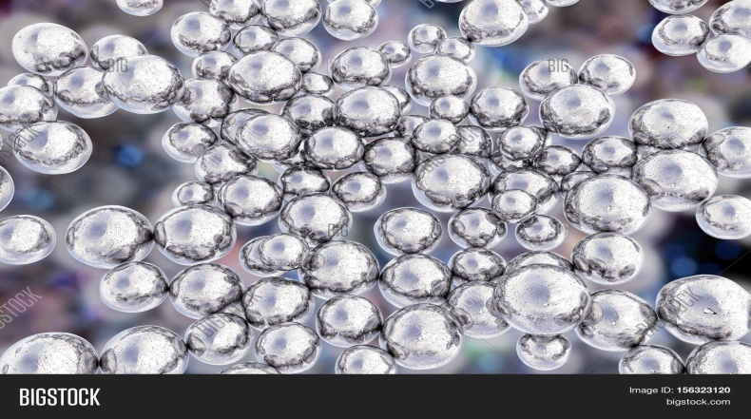

Fig no.Metallic Nanoparticle

### Inorganic Nanoparticles:

The cooper oxide nanoparticles uncovered astounding cytotoxicity comes about when they were tried against distinctive cancer cells like human cervical (HeLa cells), breast (MCF-7 cells), lung (A549 cells), and epithelioma (Hep-2 cells)(26). In spite of the fact that zinc oxide nanoparticles have been effectively utilized within the beauty care products industry due to their photocatalytic activity, it was appeared that in the event that utilized among paclitaxel and cisplatin decide particular cancerous cell passing in vitro human squamous cell carcinoma . Barium carbonate like AuNP is utilized through the green amalgamation of NP and can produce tumor cell apoptosis, by influencing the measure and surface movement of the cell and expanding the generation of receptive oxygen species (ROS)(27). Attractive nanoparticles are made of a nanomagnetic fabric which has attractive reaction and tall paramagnetism. The attractive nanoparticles that are as a rule utilized are magnetite and maghemite(28). Due to their properties, they can be put beneath a attractive field in arrange to convey a focused on sedate or as a attractive reverberation imaging differentiate operator (29).

**Protein and Polysaccharide Nanocarriers :**

Proteins are common biomolecules heightening utilized in nanotechnology with single or different capacities. In arrange to extend the focusing on handle, the protein nanocarrier is harmed by chemical change and after that it is conjugated with the targeting ligand, which is able amplify the precise conveyance toward cells or tissues(30). Egg whites may be a multifunctional protein that contains a few hydrophobic pockets, which ease the interface between the sedate and amphiphilic or hydrophobic particles. Li et al. utilized in a stage 2 consider nanoparticle albumin-bound paclitaxel (nab-paclixatel) and nedaplatin (NDP) for patients with progressed, repetitive, and metastatic cervical cancer with great action and mediocre comes about, . Alberts et al. appeared comparable comes about in a stage 2 trial, utilizing albumin-bound nab-paclitaxel within the treatment for repetitive and metastatic cervical cancer(31) .

Gelatin nanoparticles (GNP) have a huge appropriateness to target harmed tissue such as cancer, tuberculosis, vasospasm, or HIV(32) . The polysaccharides are much the same as proteins, being composed of monosaccharides clusters associated by O-glicosidic bonds. They are invaluable since they are exceptionally flexible and have particular qualities. Due to their comparable structure with extracellular lattice they can bypass different immunological responses, making them appropriate candidates for sedate conveyance frameworks(33) . Still, the polysaccharides can effortlessly crumble (oxidation handle) in the event that dissolving temperature is utilized for their accomplishment. In addition, highlights such as water solvency put limits on a few applications regions(34) .

**Future Perspective**:

With respect to the hypothetical models of controlled sedate discharge, in expansion to the classical ones, which conjure dissemination conditions by Fickian, and non-Fickian forms, a unused course of demonstrate is based on the portrayal of medicate discharge forms by persistent and undefined bends (multifractals bends)(35). As the utilize of such bends infers the property of self-similarity in any discharge focuses of the framework (i.e., the portion reflects the total, the total reflects the portion, i.e.,the holographic guideline), it takes after that medicate conveyance components can be absorbed to holographic usage of discharge elements. Taking after this, the lesson of holographic component of controlled medicate discharge it may be proposed(36) .

 For a profound understanding of wonders, which happened within the human life form, in cases with human papilloma infection contamination, we chosen to analyze by comparison of two tests (HPV 16 and control) on the micronic scale. Besides, after this accomplishment of getting the nanoscale optical imaging of the tests on 20 μm through the improved darkfield hyperspectral microscopy, we realized a unearthly examination(37) . The elucidation of the gotten spectral profile appeared that there's a clear contrast between the two tests(38). Hence, the chart comparing to the control test is characterized by a diminishing nondifferential bend that appears an exponential diminish. In differentiate, the chart comparing to the HPV test is spoken to by an expanding nondifferential bend appearing a immersion level(39). In expansion, for any of the nondifferential bends displayed over, fractal measurements can be calculated, as well as their succulence and lacunarity (40).

An external file that holds a picture, illustration, etc.
Object name is JIR2022-1636908.004.jpg

Fig no.Enhanced dark field hyperspectral microscopy-control cervical tissue versus HPV 16 cervical tissue.

This opportunity presents more insights into the fundamental directions in artificial intelligence that may serve as a first step toward considerably faster identification and diagnosis of HPV infection in patients than would be possible with Pap smear or DNA HPV tests. The accuracy of this new method will be at least the same(41).

The size, structure, and a few specific chemical and biophysical characteristics all support the effectiveness of nanoparticles. Furthermore, a drug's unique biochemical and biophysical properties play a major role in creating the ideal nanoparticle-drug delivery combination. Additional adjustments to the size, form, surface characteristic, and aqueous solubility of nanoparticles may improve their bioavailability and bioactivity. Despite the rapid advancements in nanotechnology today, there are still some questions about the usefulness of nanoagents in real-world applications. There are several unanswered concerns about their toxicity, safety, and efficient control(42). There have lately been attempts to conjugate nanoparticles with natural molecules via the green chemistry pathway due to the potentially hazardous effects that nanoparticles may have in normal cells. Numerous investigations revealed that biosynthetic methods using bionanotechnology lessen the toxicity dilemma(43). .

**Conclusion:**

The development of innovative therapeutic approaches for cervical cancer that are tailored to tumor types and have minimal side effects is urgently needed. While liposomes, polymers, dendrimers, and inorganic materials have demonstrated great potential for clinical transformation as nanocarrier-based drug administration, it is nearly impossible for a single type of nanoparticle to address all the challenges, such as dose-dependent toxicities, drug biocompatibility, and controlled release during in vivo drug delivery. In order to effectively administer anti-cancer medications that precisely target the apoptotic pathway of cervical cancer and suppress cell proliferation or cause cell killing, it may be worthwhile to design the most appropriate multifunctional materials. Given the critical role that radiation plays in the treatment of cervical cancer, it makes therapeutic sense to develop a radiosensitizer based on nanoparticles in conjunction with HPV.

**Reference :**

1.Jiezhong Chen, Wenyi Gu, Lei Yang, Chen Chen, Renfu Shao, Kewei Xu, Zhi Ping Xu, Nanotechnology in the management of cervical cancer, Reviews in Medical Virology , Volume 25, Issue S1.

2.WHO/ICO Information Centre on HPV and Cervical Cancer (HPV information Centre). summary report on HPV and Cervical cancer statistics in india 2007.

3.P. Medina-Alarcón a 1, Aline R. Voltan b, Bruno Fonseca-Santos c 1, IsabelaJacob Moro c, Felipe de Oliveira Souza a, Marlus Chorilli c, Christiane Pienna Soares a, André Gonzaga dos Santos d, Maria J.S. Mendes-Giannini a, Ana M. Fusco-Almeida A Highlights in Nanocarriers for the treatment against cervical cancerMaterials Science and Engineering: C Volume 801 November 2017

4.Cervical cancer therapies: Current challenges and future perspective Carly A. Burmeister,a,1 Saif F. Khan,a,1 Georgia Schäfer,b,c,d Nomonde Mbatani,g,h Tracey Adams,g,h,i Jennifer Moodley,e,f,g and Sharon Principle

5. Carly A. Burmeister,a,1 Saif F. Khan,a,1 Georgia Schäfer,b,c,d NomondeMbatani,g,h Tracey Adams,g,h,i Jennifer Moodley,e,f,g and Sharon PrincipleJAMA Cervical cancer therapies: Current challenges and future perspective . 2023;330(6):547-558.

6.Paul A Cohen, MD Prof Anjua Jhingran, MDProf Ana Oaknin, MDProf Lynette Denny, PhD Cervical cancer Published:January 12, 2019

7. S.D. Balasubramaniam,V.Balakrishnan,C.E.Oon and G.kaur, "key molecular events in cervical cancer development,"Medicina, vol.55,no. 7,p.384,2019

8. .[Shaokai Zhang](https://pubmed.ncbi.nlm.nih.gov/?term=Zhang%20S%5BAuthor%5D),1 [Huifang Xu](https://pubmed.ncbi.nlm.nih.gov/?term=Xu%20H%5BAuthor%5D),1 [Luyao Zhang](https://pubmed.ncbi.nlm.nih.gov/?term=Zhang%20L%5BAuthor%5D),1 and [Youlin Qiao](https://pubmed.ncbi.nlm.nih.gov/?term=Qiao%20Y%5BAuthor%5D)1,2 Cervical cancer: Epidemiology, risk factors and screening, Chinese Journal of Cancer Research 2020 Dec 31; 32(6): 720–728.

9.[Ayumi Ono](https://pubmed.ncbi.nlm.nih.gov/?term=Ono%20A%5BAuthor%5D), [Masafumi Koshiyama](https://pubmed.ncbi.nlm.nih.gov/?term=Koshiyama%20M%5BAuthor%5D)\* [Miwa Nakagawa](https://pubmed.ncbi.nlm.nih.gov/?term=Nakagawa%20M%5BAuthor%5D), [Yumiko Watanabe](https://pubmed.ncbi.nlm.nih.gov/?term=Watanabe%20Y%5BAuthor%5D), [Eri Ikuta](https://pubmed.ncbi.nlm.nih.gov/?term=Ikuta%20E%5BAuthor%5D),[Keiko Seki](https://pubmed.ncbi.nlm.nih.gov/?term=Seki%20K%5BAuthor%5D), and [Makiko Oowaki](https://pubmed.ncbi.nlm.nih.gov/?term=Oowaki%20M%5BAuthor%5D)1The Preventive Effect of Dietary Antioxidants on Cervical Cancer Development 2020 Nov; 56(11): 604.

10. Paul A Cohen, MDProf Anjua Jhingran, MDProf Ana Oaknin, MD, Prof Lynette Denny, PhD Cervical cancer Published:January 12, 2019

11. Rebecca B. Perkins, MD, MSc1; Nicolas Wentzensen, MD, PhD, MS2; Richard S. Guido, MD3,4; et alMark Schiffman, MD, MPH2 A ReviewCervical Cancer Screening

JAMA. 2023;330(6):547-558.

12. Zhang, W., Liu, Y., Zhou, X., Zhao, R., & Wang, H. B. (2020). Applications of CRISPR‐Cas9 in gynecological cancer research. *Clinical Genetics*, 97(6), 827–834.

13.  Gallego LS, Dominguez A, Parmar M. Treasure Island (FL): StatPearls Publishing; 2022. Human Papilloma Virus Vaccine.

14. Gupta S., Gupta M. K. Possible role of nanocarriers in drug delivery against cervical cancer. Nano Reviews & Experiments*.*2017;**8**(1, article 1335567) doi: 10.1080/20022727.2017.1335567.

15.  Nakisige C., Schwartz M., Ndira A.O. Cervical cancer screening and treatment in Uganda. *Gynecol. Oncol. Rep.*2017;20:37–40. doi: 10.1016/j.gore.2017.01.009.

16. Olorunfemi G, Ndlovu N, Masukume G, et al Temporal trends in the epidemiology of cervical cancer in South Africa (1994-2012) *Int J Cancer.*2018;143:2238–49. doi: 10.1002/ijc.31610.

17. Kreiter, S., Selmi, A., Diken, M., Sebastian, M., Osterloh, P., Schild, H., … Sahin, U. (2007). Increased antigen presentation efficiency by coupling antigens to MHC class I trafficking signals. *Journal of Immunology*, 180, 309–318.

18. Liu Z, Tabakman S, Welsher K, Dai H. Carbon nanotubes in biology and medicine: in vitro and in vivo detection, imaging and drug delivery. *Nano Research* 2009; 2: 85–120.

19. Alberts DS, Blessing JA, Landrum LM, *et al*. Phase II trial of nab-paclitaxel in the treatment of recurrent or persistent advanced cervix cancer: a gynecologic oncology group study. *Gynecologic Oncology* 2012; **127**: 451–455.

20. Habibi, N., Quevedo, D. F., Gregory, J. V., & Lahann, J. (2020). Emerging methods in therapeutics using multifunctional nanoparticles. Wiley Interdisciplinary Reviews. Nanomedicine and Nanobiotechnology, 12(4), e1625.

21. Zheng, T., Wang, W. T., Wu, F., Zhang, M., Shen, J., & Sun, Y. (2019). Zwitterionic polymer‐gated au@TiO 2 Core‐Shell nanoparticles for imaging‐guided combined cancer therapy. *Theranostics*, 9(17), 5035–5048.

22. Smerkova, K., Dolezelikova, K., Bozdechova, L., Heger, Z., Zurek, L., & Adam, V. (2019). Nanomaterials with active targeting as advanced antimicrobials. *Wiley Interdisciplinary Reviews. Nanomedicine and Nanobiotechnology*, 12(5), e1636.

23. Sharma, S., Deep, A., & Sharma, A. K. (2020). Current treatment for cervical cancer: An update. *Anti‐Cancer Agents in Medicinal Chemistry*, 20, 1–12.

24.Sica, A., & Massarotti, M. (2017). Myeloid suppressor cells in cancer and autoimmunity. *Journal of Autoimmunity*, 85, 117–125.

25. Liu, Y. C., Wu, L., Tong, R. Z., Yang, F. Y., Yin, L. M., Li, M. Q., … Lu, Y. (2019). PD‐1/PD‐L1 inhibitors in cervical cancer. *Frontiers in Pharmacology*, 1(10), 65. 10.3389/fphar.2019.00065

26. Liao, J. H., Zheng, H. Z., Hu, R., Cao, J., Wei, X., Li, D., … Yin, Y. H. (2018). Hyaluronan based tumor‐targeting and pH‐responsive Shell cross‐linkable nanoparticles for the controlled release of doxorubicin. Journal of Biomedical Nanotechnology, 14, 496–509.

27. Hengge, U. R., & Ruzicka, T. (2004). Topical immunomodulation in dermatology: Potential of toll‐like receptor agonists. *Dermatologic Surgery*, 30(8), 1101–1112. 10.1111/j.1524-4725.2004.30335.

28.Pathak, K., & Akhtar, N. (2018). Nanocarriers for the effective treatment of cervical cancer: Research advancements and patent analysis. *Recent Patents on Drug Delivery & Formulation*, 12, 93–109.

29.Shanei, A., & Zadeh, H. A. (2019). Investigating the Sonodynamic Radiosensitivity effect of Gold nanoparticles on HeLa cervical cancer cells. *Journal of Korean Medical Science*, 34(37), e243.

30. Smerkova, K., Dolezelikova, K., Bozdechova, L., Heger, Z., Zurek, L., & Adam, V. (2019). Nanomaterials with active targeting as advanced antimicrobials. *Wiley Interdisciplinary Reviews. Nanomedicine and Nanobiotechnology*, 12(5), e1636.

31. Palantavida S, Guz NV, Woodworth C, Sokolov I. Ultrabright fluorescent mesoporous silica nanoparticles for prescreening of cervical cancer. *Nanomedicine: Nanotechnology, Biology and Medicine* 2013; **9**: 1255–1262.

32. Zheng, T., Wang, W. T., Wu, F., Zhang, M., Shen, J., & Sun, Y. (2019). Zwitterionic polymer-gated au@TiO 2 Core-Shell nanoparticles for imaging-guided combined cancer therapy. *Theranostics*, **9**(17), 5035–5048.

33. Wang M, Peng P, Chen Z, Deng X. Nanoparticle delivery of active traditional chinese medicine ingredients: A new strategy for the treatment of liver cancer. *Curr Pharm Biotechnol* (2023) 24:1630–44. doi: 10.2174/1389201024666230313151316

34. Rasouli E, Shahnavaz Z, Basirun WJ, Rezayi M, Avan A, Ghayour-Mobarhan M, et al. Advancements in electrochemical DNA sensor for detection of human papilloma virus - a review. *Analytical Biochem* (2018) 556:136–44. doi: 10.1016/j.ab.2018.07.002

35. Bakrania A, Zheng G, Bhat M. Nanomedicine in hepatocellular carcinoma: A new frontier in targeted cancer treatment. *Pharmaceutics* (2021) 14. doi: 10.3390/pharmaceutics14010041

36. Forouzanfar MH, Foreman KJ, Delossantos AM, *et al*. Breast and cervical cancer in 187 countries between 1980 and 2010: a systematic analysis. *The Lancet* 2011; **378**: 1461–1484.

37. Palantavida S, Guz NV, Sokolov I. Functionalized ultrabright fluorescent mesoporous silica nanoparticles. *Particle & Particle Systems Characterization* 2013; **30**: 804–811.

38. Kratz F. Albumin as a drug carrier: design of prodrugs, drug conjugates and nanoparticles. *Journal of Controlled Release* 2008; **132**: 171–183.

39.Jenkins D. Diagnosing human papillomaviruses: recent advances. *Current Opinion in Infectious Diseases* 2001; **14**: 53–62.

40. Foldvari M, Kumar P. Recent progress in the application of nanotechnology for prevention and treatment of human papillomavirus infection. *Therapeutic Delivery* 2012; **3**: 1005–1017.

41. Bazak R, Houri M, El Achy S, Kamel S, Refaat T. Cancer active targeting by nanoparticles: A comprehensive review of literature. *J Cancer Res Clin Oncol* (2015) 141:769–84. doi: 10.1007/s00432-014-1767-3

42. Pita R, Ehmann F, Papaluca M. Nanomedicines in the EU—regulatory overview. *AAPS J.*2016;18:1576–1582. doi: 10.1208/s12248-016-9967-1.

43. Chen J, Huang L, Lai H. Methotrexateloaded PEGylated chitosan nanoparticles: synthesis, characterization, and in vitro and in vivo antitumoral activity. *Mol Pharm.*2014;11:2213–2223. doi: 10.1021/mp400269z.