**MULTI-TARGET DRUG DESIGN FOR COMPLEX DISEASES**

### **Mr. Anmol Vidhyadhar Shinde, Mr. Sandip V. Jadhav, Dr. Vijaysinh U. Sable**

**Dr. Rani M. Mhetre**

**Author, Assistant Professor, Associate Professor, Associate Professor**

**Department of Pharmacology, Lokmangal College of Pharmacy, Wadala, Solapur, Maharashtra, India.**

### **Abstract**

Drug discovery and design have evolved significantly to address the increasing global burden of complex diseases. Traditional approaches focused on highly selective chemical entities targeting single biological entities. While this strategy has led to significant therapeutic advancements, particularly for diseases such as malaria, diabetes, and certain cancers, it has limitations in treating multifactorial diseases due to issues like drug resistance and limited efficacy. Polypharmacology, the study of drug design with an emphasis on molecules with several targets or pathways, has emerged as a result. This study explores the rationale and benefits of transitioning from medication design focused on a single target to drug design that targets multiple targets simultaneously. When looking at the new molecular entities (NMEs) that the FDA approved from 2015 to 2017, it's clear that multi-target drugs are ruling the roost, particularly in areas like anti-neoplastic, neurological system, and anti-infective remedies. Improved efficacy and lower resistance relative to single-target therapy are demonstrated by multi-target medications for viral infections, schizophrenia were conducted neurological illnesses, and many malignancies. Despite the promise of multi-target drugs, their rational design poses significant challenges, including target selection, achieving balanced activity, and avoiding off-target effects. The review concludes that while multi-target strategies offer substantial potential, especially for complex diseases, ongoing research is needed to refine these approaches and maximize their therapeutic benefits.

**Keywords:** Polypharmacology, Multi-target drug design, Drug discovery, FDA-approved NMEs, Therapeutic efficacy.

**Introduction**

The ever-increasing rates of morbidity and mortality worldwide due to the so-called incurable diseases have made drug research and design more dynamic than ever before. In the past, researchers have relied on designing very discerning chemical units to target a single organic entity that was thought to be the main actor in a particular pathology in order to find new therapeutic medications (1). The goal of this method was to make medication candidates more drug-like while avoiding any unwanted side effects, according to researchers. But for complicated disorders in particular, very targeted therapy medicines that aim at individual molecular targets have failed to produce the desired results. Drug resistance has been on the rise, and highly selective treatment agents are a contributing factor.

Without a doubt, the present level of therapeutic evolution can be traced back to the long history of the single-target medication strategy, which has yielded innumerable achievements for the pharmaceutical industry and disease treatment. Traditional treatments for malaria, for instance, have included the use of medications like artemisinin and chloroquine. However, while insulin remains the gold standard for treating type-1 diabetes, a number of oral hypoglycemic medications are used to control type-2 diabetes. Of the many cancer medications available, carboplatin, adriamycin, and fluorouracil stand out. A reevaluation of drug design methodologies was necessary, however, because single-target medicines have limited effectiveness in treating multifactorial disorders (2). These diseases' aetiology depends on a complex interplay of biochemical events and several bioreceptors. Within this framework, medicinal chemists have been on the lookout for new resources to help speed up, improve, and otherwise streamline the process of designing and screening potential new drugs in recent years.

Polypharmacology is a new therapeutic approach that has recently gained popularity in the quest for more effective clinical procedures due to the ineffectiveness of certain treatments based on single medications. The study and practice of developing and administering pharmaceuticals with the ability to modulate numerous molecular targets or biochemical pathways is known as polypharmacology. This strategy aims to target several targets simultaneously and can take many forms, such as drug associations, drug combinations, or even a single drug with numerous ligands. Treatment for HIV/AIDS, some cancers, TB, and hypertension are all possible examples of conditions that could benefit from combination therapy (3). The unique pharmacokinetics, solubility, toxicity, bioavailability, and expenses of combination therapy, along with its inefficiency and negative consequences from drug-drug interactions, have prompted the development of new approaches to drug discovery. Single medications that simultaneously recognise more than one molecular target are now being considered as part of the most recent strategy. The most recent approach that promotes the integration of many structural components into a single framework is molecular recognition by several bioreceptors, which act concurrently in various targets connected to biochemical networks that are accountable for the pathophysiology of multifactorial disorders.

**Creating medications with several targets for difficult conditions**

**The shift in drug design paradigm from single-target to multi-target**

In order to prevent side effects caused by accidentally targeting other biological targets ("off-targets"), traditional medication design has focused on selectively directing a particular biological entity, typically a protein. Because of the inherent risk of unwanted side effects, the idea of medications interacting with numerous targets has long been regarded as undesirable. Such single-target medications are insufficient to attain a therapeutic impact, however, as the complexity of the present incurable diseases has plainly shown (4). At the same time, we know that compounds that hit multiple targets may, in theory, have a safer profile than ones that only hit one target.

Based on this mounting data, the idea of multi-target therapies has gone from an emerging paradigm when initially proposed in the early 2000s to one of the most talked-about subjects in drug development in 2017. Indeed, these ideas have piqued the curiosity of the pharmaceutical and academic drug discovery communities throughout the years, leading to the availability of a multitude of multi-target medications.

**Research on NMEs that were approved by the FDA between 2015 and 2017**

Following a comparable study by (5), we conducted an analysis of the US Food and Drug Administration (FDA)-approved NMEs from 2015–2017 (status September 2017). This serves as clear evidence of the successful translation of multi-target drugs into the clinic. Small molecules, therapeutic combinations, biologics, and diagnostics were the four NME categories into which the 101 newly authorised NMEs on FDA.gov fell over this three-year period. Further analysis of the small molecules has allowed for the subdivison of these medications into those with a single target and those with many targets. This categorization was made possible by consulting the DrugBank database, which contains details on authorised drugs. It shows that 31 percent of the new NMEs are biotech pharmaceuticals, which include proteins, peptides, and monoclonal antibodies. This proportion is almost equal to 34 percent of the drugs that target a specific organ or tissue. This is in keeping with the current trend in the pharmaceutical industry towards the development of biologics, which are based on the idea of individualised medicine.

Hierarchy of approved NMEs from 2015–2017 (as of September 2017), broken down by NME class

Small molecules, whether multi-targeted or single-targeted, nonetheless play a role, even if the number of accepted biologics has grown in recent years. Despite the fact that multi-target medications continue to grow in number (21% vs. 16% in previous years), the number of small molecules with a single target remains higher (34%). By expanding our perspective and thinking about polypharmacology in general, we may add up the 21% of medications with multiple targets and the 10% of therapeutic combinations that have recently been approved. Thus, the overall number (31%) gets close to the percentage of medications with a single target (34%). This strongly supports the allure of polypharmacological methods, particularly in specific therapeutic domains as anti-neoplastic, anti-infective, and nervous system agents.

**Drugs that target many targets for complicated disorders**

Daclatasvir is an anti-infective that was developed to target a specific viral protein related in HCV replication, specifically the nonstructural 5A (NS5A) phosphoprotein. It was one of the last non-interferon based medications to be licenced (2015) for the treatment of hepatitis C virus (HCV) (6). Because drug-resistance is already a well-established problem, multiple combination treatments have been licenced since January 2016, despite the high effectiveness. The archetypal polypharmacology concept, which informed the development of each of these combinations, states that by acting on two distinct HCV replication sites simultaneously, antiviral efficacy may be increased relative to that of individual medications and resistance can be decreased.

(i)Elbasvir with grazoprevir, an NS3/4A protease inhibitor;

(ii) Sofosbuvir with velpatasvir, an NS5A inhibitor; and

(iii) The fixed-dose mixture of glecaprevir and pibrentasvir, two NS5A inhibitors and an NS3/4A protease inhibitor, respectively, are examples of such combinations.

The use of polypharmacology in the nervous system has resulted in the approval of four medications that target multiple targets. More and more multi-target medications for the handling of schizophrenia and main depressive disorders have been produced in recent years. One of the primary approaches to treating schizophrenia involves blocking the receptors for serotonin 5-HT2A, dopamine D2, and α1-adrenergic chemical (7). To improve antipsychotic efficacy or reduce undesirable effects, effects at these broad targets are being considered. In 2015, the first-generation antipsychotic, aripiprazole, was out to the market. It was the first serotonin-dopamine activity modulator (SDAM) to be developed. Its development began with these ideas in mind, using the arylpiperazine substructure as a good scaffold to achieve a perfect balance between the 5-HT1A, D2, and 5-HT2A receptor actions. Negative side effects, likely caused by long-term engagement with post-synaptic D2 receptors, were also observed. Brexpiprazole, a new partial agonist for D2 and 5-HT1A receptors, was first licenced in October 2015. Compared to aripiprazole, it has fewer intrinsic activity at D2 receptors but more stable activities at 5-HT1A, 5-HT2A, and α1B receptor subtypes.

Because of the intricacy, multivariate character, and uncertain etiopathogenesis of neurodegenerative illnesses, the polypharmacological approach appears especially promising in this area. One drug with a multi-target profile was rasagiline, which was licenced in 2006 for the treatment of neurodegenerative disorders. Safinamide, a multi-target medication, is the first novel chemical entity to be licenced for the treatment of neurodegeneration in more than ten years. The unique multi-target profile of safinamide led to its approval in March 2017 as an adjunctive treatment for PD, while it was first designed as an anticonvulsant agent (8). Its effects on motor symptoms are mainly due to its dopaminergic effects, such as selective and reversible MAO-B and dopamine reuptake inhibition. However, it also has non-dopaminergic properties, such as blocking voltage-dependent Ca2+ and Na+ channels and inhibiting glutamate release, which are believed to provide neuroprotectant and neurorescue effects.

In addition to neurodegenerative diseases and schizophrenia, polypharmacological approaches could be useful in cancer, a condition in which multiple abnormal proteins and pathways work together to start tumour growth and to promote its advancement. Redundancies and complexity in biological processes might cause compensation and resistance to targeted treatments, just as in the aforementioned disorders (9). Of the several classes of polypharmacological treatments for cancer, the two most common were multi-kinase inhibitors and pan-inhibitors of histone deacetylases (HDACs). Among the first category is lenvatinib, an inhibitor of reversible multi-tyrosine kinase receptors. A number of receptors have their activity regulated by it. These include SCFR, VEGFR beta, RET, FGFR 1-3, and PDGFR beta. All of these receptors play a role in cancer progression, tumour growth, and pathogenic angiogenesis. Approval for the treatment of radioiodine-refractory thyroid malignancies was based on its broad action profile. The irreversible mechanism of action of another newly licenced multi-tyrosine kinase inhibitor, neratinib, is responsible for its anticancer effect. This is due to the fact that it targets EGFR and HER2, two receptors that are abundantly expressed in various carcinomas. The construction of such a dual-inhibitor harbouring a Michael acceptor warhead was conducted, captivating benefit of the in height sequence commonality shared by HER-2 and EGFR. This molecule was optimised with the use of computational simulations to ensure that its warhead interacts with Cys 773 of EGFR and the similar Cys 805 of HER-2.

There is another family of multi-kinase inhibitors that has been extensively researched: dual inhibitors of cyclin-dependent kinase (CDK) 6 and 4. Over a mixture of chemical screening and optimisation, we discovered that inhibitors with exceptional selectivity for CDK 4/6 can be obtained by modifying the C2-position. This finding was achieved by repurposing the pyrido[2,3-d]pyrimidin-7-one scaffold, which had been utilised to block several kinases before their toxicity led to its discontinuation. During this time, the FDA has allowed the use of ribociclib, palbociclib, and abemaciclib as breast cancer therapy (10). It was in April 2017 that the popular multi-kinases inhibitor midostaurin was authorised for the treatment of newly diagnosed adult patients with acute myeloid leukaemia who had a exact FLT3 gene mutation. It is a pan-kinase inhibitor that is derived semi-synthetically from staurosporine. Many tyrosine kinases, notably PKC alpha, KIT, VEGFR2, PDGFR, and both wild-type and mutant FLT3, can have their activity suppressed by it, according to research.

In February 2015, the FDA authorised panobinostat, a pan-HDAC inhibitor based on cinnamic hydroxamate, for the action of multiple myeloma when utilised in conjunction with a proteasome inhibitor, bortezomib, and dexamethasone. This approval is relevant to the current discussion surrounding epigenetic polypharmacology (11). Through the nonselective inhibition of both classes (I and II) of HDAC enzymes, the cell cycle halt and/or apoptosis of cancer cells were brought about by enhanced acetylation of histone proteins. Efficacy as a single treatment in multiple myeloma patients is limited because of its broad activity profile against histone deacetylases (HDACs), which rely on zinc chelation for activity. Nevertheless, it has shown synergistic effects when combined with other medications that attack distinct nodes in the tumour network. Taken together, these findings support the idea that the network disruption strategy could be an effective weapon in the battle against cancer.

**Improving rational drug design for multiple targets: new challenges**

These results suggest that the moment has come to broaden the use of polypharmacology and multi-target medicines to other medical fields. But there's still a long way to go until we can figure out how to rationally build them, from selecting targets to discovering tiny molecules. One problem with multi-target medications and therapy combinations is that it can be difficult to pick the correct mix of targets for the condition of interest, even though there are many helpful resources available online (12). Adverse event profiling, pathway-target-drug-disease linkages, and target-disease associations must be well-understood. It is also important to consider the potential for additive or synergistic effects when choosing targets to modulate. It is important to note that targets on the same pathway can only produce additive effects, while targets on functionally complementary pathways can only produce synergism. Because of this, a superior safety profile compared to single-target medicines is anticipated, and in both instances, the effect is achieved at lower dosages.

Concerning the second issue, while the earliest medications were found by chance, modern multi-target compounds are made by rational design, usually by merging two different chemical structures into one, beginning with compounds that have the desired activity towards the targets of interest (13). Therefore, it is common practice to combine the pharmacophores of selective molecules—whether they are recognised medications or drug candidates—to produce multi-target compounds. The degree of overlap between the beginning frameworks determines whether pharmacophores with similar scaffolds, typically ring systems, can be fused or merged. On the other hand, pharmacophores can be linked with cleavable or non-cleavable linkers if they contain structure elements that are specific to each target; nevertheless, this approach frequently results in compounds that lack drug-like qualities. The chemical tractability, target specificity, and accessibility of starting frameworks are the usual determinants of the production of multi-target molecules. Beyond that, each framework must maintain its capacity to interact with its unique target in order for the multi-target compounds to function properly (14). When the targets are distantly related or completely unrelated (i.e., from different protein families), it becomes even more difficult to take into account the structure-activity relationships that regulate the interaction between the starting molecules and their specific targets.

Important factors to consider include achieving a constant amount of modulation for all targets and "designing out" unfavourable interactions with any unwanted targets (off-target). The importance of the latter factor is magnified when there are shared functional domains and/or binding regions within target families, or when developing multi-target medicines for targets within the same family, such as multi-kinases inhibitors. A major obstacle in rationally designing multi-target drugs is selecting the appropriate target combination, delivering balance activity towards them, omitting activity at the unwanted target(s), and keeping drug-like properties.

**Treatment for cancer**

Cancer kills more people than tuberculosis, AIDS, diabetes, and malaria put together, according to reports from (15). Over the years, cancer has surpassed all other chronic diseases in terms of mortality, taking the lives of millions of people every year across the globe. Just in the US alone, cancer killed one million people in 2018, with the continent of Africa reporting the second-highest number of cases. Fluorouracil, carboplatin, and adriamycin are the three most used cancer medications. Treatment of cancer, like other complicated diseases, looked to benefit from the introduction of combination therapy rather than monotherapy. Scientists in the 1960s pondered whether the method of treating tuberculosis with a mix of antibiotics to decrease the likelihood of resistance could be used to the treatment of cancer as well. This inquiry led to the development of combination chemotherapy as a cancer treatment option.35 Thanks to this method, diseases like acute lymphocytic leukaemia and Hodgkin's lymphoma, which were before nearly always deadly, are now treatable. Countless additional malignancies have since benefited from combined chemotherapy.

As early as the 1970s, researchers discovered that combination chemotherapy was superior than both individual medications and "sequential chemotherapy," the practice of administering chemotherapy drugs in a specific order rather than all at once. This improved outcomes for patients with lung cancer. Chemotherapy has only been incorporated into a novel form of immunotherapy known as checkpoint inhibition therapy during the past ten years. Important immune system regulators that, when activated, dampen the immunological response to an immunologic stimulation are the focus of the treatment (16). In order to prevent cancer cells from signalling T-cells, checkpoint inhibitors obstruct their receptors. It appears that immunotherapy medications are sometimes enhanced by the addition of chemotherapy treatments. Depending on the patient's condition and kind of cancer, combination chemotherapy or single-drug chemotherapy may be the best course of action at this time. Although chemotherapy can initially be effective against many malignancies, resistance can develop over time. Researchers have lately adopted the multi-target approach technique for designing and discovering more powerful and effective anticancer medications, despite the fact that lack of selectivity was previously thought to be a major hurdle in this field.

Anticancer medications with multi-target capabilities include lapatinib and duvelisib. Duvelisib is a new orally administered dual inhibitor of PI3K-ά and γ. Results from clinical trials of duvelisib in patients with advanced hematologic cancers are promising. A novel strategy for cancer treatment is the creation of hybrid compounds that target many sites simultaneously. The difficulty in killing cancer cells with a single target has led to the proposal of hybrid compounds having several targets as more potent and effective anticancer medications. When it comes to cancer treatments, hybrid compounds are a godsend. Unlike individual drugs, they overcome issues like low solubility, adverse effects, and multidrug resistance.

**The Potential of Natural Products as a Multi-Targeting Therapy for Tuberculosis**

Many of the traditional uses of medicinal herbs for the action of lung disorders like tuberculosis remain unclear. In addition, there has been a lack of direct testing of the majority of plant species or chemicals against tuberculosis essential proteins or protein biomarkers that contribute to tuberculosis latency. New anti-TB medications could be developed using this information. There is a large variety of chemical structures found in medicinal plants, and these compounds exhibit varying degrees of efficacy against Mycobacterium TB. It is recommended to combine the present first-line medications with plant-derived compounds that have been found to have minimal poisonousness and high action against M. tuberculosis species (17). The last ten years have seen the approval of twenty-five medications derived from natural ingredients, with another thirty-one pharmaceuticals in various stages of clinical studies. There have been several reports in the last 10 years of plant extracts with strong anti-MDR-TB properties. These include fragrant ginger, roselle, celebes pepper, and banana leaves, among others.

Some antitubercular medicines have multi-target capabilities. For instance, SQ109 and its derivatives have been found to suppress the production of cell wall biosynthesis-related transporter proteins (MmpL3 and MmpL11) as well as menaquinone biosynthesis-related proteins (MenA and MenG). In addition, Li and colleagues (2014) proved that SQ109 compounds inhibited a variety of Gram-negative and Gram-positive bacteria, fungi, and parasites, with M. tuberculosis and P. falciparum.

**Trends in Antidiabetic Drugs Discovery**

The complicated metabolic disease diabetes mellitus, which is defined by chronic hyperglycemia, is quickly becoming an epidemic and a main public health concern about the world. The numerous crippling symptoms of diabetes are caused by persistent hyperglycemia, which is noticed in diabetic people. The vast majority of instances of diabetes are type 2, which is defined by cellular insulin resistance and is the greatest predominant form of the disease. A world free of diabetes and obesity is within reach if we all work together by 2025. After There has been tremendous advancement in the creation of antihyperglycemic medications for the management of diabetes throughout the years (18). Part of the reason for this advancement could be the ever-increasing knowledge of the disease's nature. Multiple biochemical mechanisms work together to cause diabetes, rather than just one or two proteins or pathways. Problems with insulin secretion, disruptions to the insulin signalling system in the primary organs that insulin targets, and, finally, disruptions to glucose and lipid metabolism are all aspects of this condition. The complexity of diabetes means that there is no one cure for the disease.

**Current Antidiabetic Therapy**

Insulin injection has long been the gold standard for diabetes therapy due to the emphasis on glycemic control. There is a substantial risk of hypoglycemia and weight gain connected with insulin therapy, despite its effectiveness. Type 2 diabetes (T2D), which is often marked by insulin resistance, is becoming more widespread, and as a result, many oral hypoglycemic medications were manufactured. There were insulin sensitizers, secretagogues, and α-glucosidase inhibitors. The former group of drugs did not directly affect insulin action but did decrease glucose intestine absorption.

Sodium-glucose co-transporter-2 (SGLT2) and Dipeptidyl peptidase-IV (DPP-IV) inhibitors are two additional single-target antidiabetic medications that have gained approval for the treatment of type 2 diabetes in the past few years (19). Incretions lose their insulinotropic activity because DPP-IV breaks them down and renders them inactive. Unlike other antidiabetic medications, SGLT-2 inhibitors improve glucose excretion in the urine by blocking the renal SGLT-2 protein, which is responsible for 80-90% of glucose reabsorption.

A number of combination therapies have been developed and used in the ongoing battle against diabetes, following the introduction of new antidiabetic medications like SGLT2 inhibitors and DPP-IV. Among these, you can find combination therapies that involve two drugs, three drugs, or even four drugs, such as metformin and sulfonylurea or metformin and an inhibitor of dipeptidyl peptidase IV (DPP-IV). There has been a lot of success in developing new treatments to manage diabetes, but the existing antidiabetic medications have some drawbacks when used alone or in combination. This highlights the need for more innovative drugs to effectively stop diabetes and its complications. Given the complexity of diabetes, it is possible that the most effective strategy for combating the condition will be the identification and development of multi-target treatment regimens, as opposed to single-target therapies.

**Neurodegenerative Diseases**

Because of their shared multiple modes of action, neurodegenerative disorders pose a number of challenges to the medical community. Present neurodegenerative illnesses include Parkinson's disease (PD), Alzheimer's disease (AD), Huntington’s disease (HD), and amyotrophic lateral sclerosis (ALS). Protein unfolding and aggregation, oxidative stress, mitochondrial dysfunction, metallic dishomatosis, and phosphorylation impairment are all interrelated clinical symptoms and mechanisms of action of these diseases. More and more research is focusing on the idea of multitarget directed ligands (MTDL) as a means to manage the various targets that contribute to disease pathogenesis (20).

For instance, triazinones (Figure 1) were characterised as multitarget molecules by (Ramsay et al., 2018) and may serve as a foundational building block for future lead medicines targeting Alzheimer's disease. The study concluded that triazinones had the ability to modify both the BACE-1 and GSK-3B enzymes at the same time, with IC50 values for BACE-1 ranging from 18-0.01 μM and for GSK-3B from 14-0.78 μM. They discovered that the compounds, particularly compound 3, developed dual-target profiles due to their robust interactions with both enzymes examined in the molecular docking investigation.

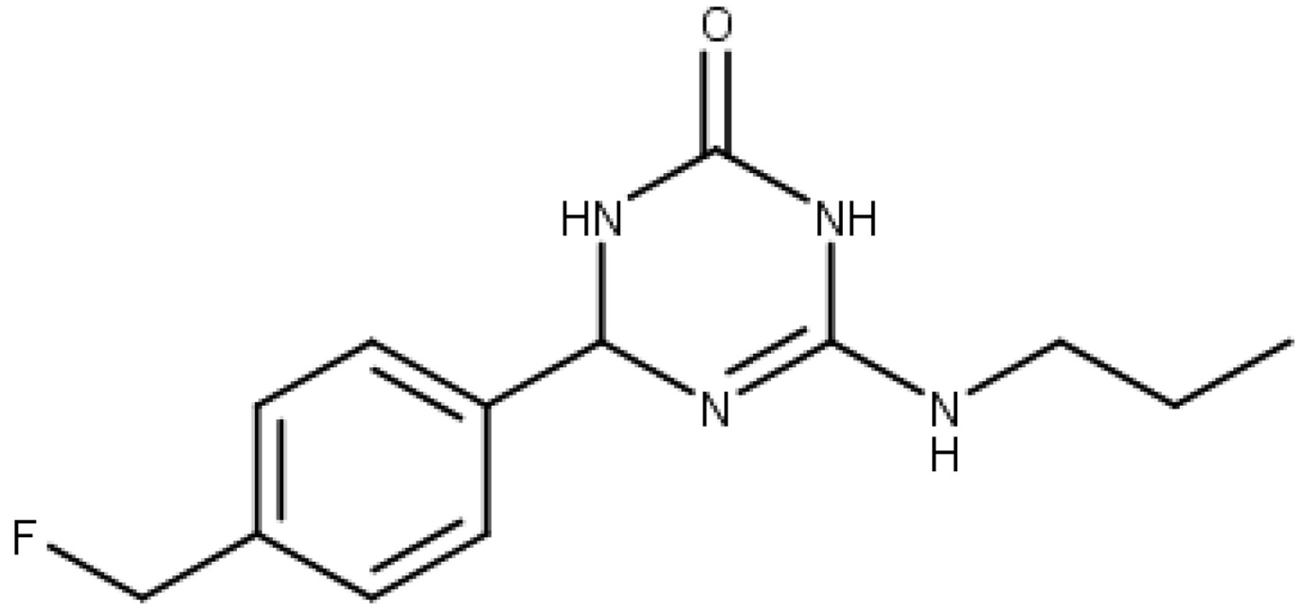

(21) used computational modelling to examine the protein dysregulation associated with Alzheimer's disease. They discovered that 2-aminotiazoles (Figure 2) are effective inhibitors of PARP-1 and BACE-1, and their predictive capabilities lay the groundwork for the design and optimisation of new, highly effective inhibitors of these enzymes.

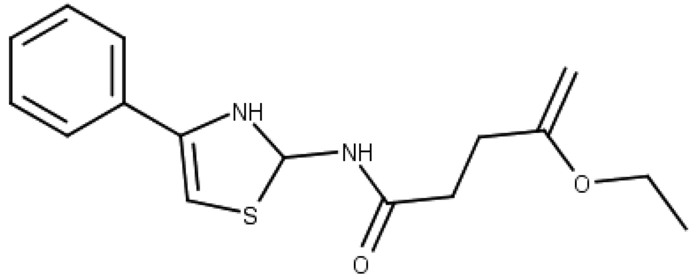

Figure 3 from another study shows that 67 indole-hybrid molecules were developed. After screening, 13 of these hybrids were sent to molecular docking studies with the enzymes LOX-5, PLA2, COX-2, and cholinesterase B and A. Consequently, they found that three hybrid compounds interacted strongly with the research targets, outperforming reference medications in terms of energy values.

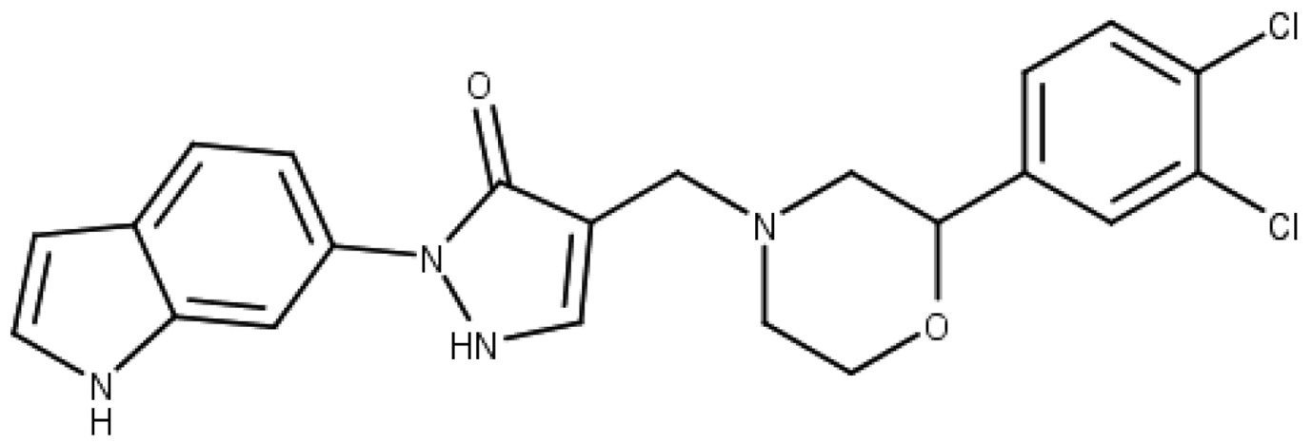

## AIDS

The pharmaceutical sector has taken an interest in studying the human immunodeficiency virus (HIV-1), leading to acquired immunodeficiency syndrome (AIDS), due to the advent of drug-resistant strains and the growing incidence of infections. Antiretroviral drugs with specific targets are no longer recommended for clinical use since drug-resistant strains have emerged. Combining antiretrovirals that target different viral targets allows for more effective viral growth inhibition. Using a regression model that accounts for protease, integrase, and reverse transcriptase activity, (22) conducted a multitarget quantitative structure-activity relationship (QSAR) investigation on HIV-1. The significance of this study is determined by the fact that, unlike most medications used in therapy, we have shown a method for efficiently identifying and designing inhibitors that link to numerous targets. This is significant because most pharmaceuticals only block one target. Founded on multi-task learning, the multi-target QSAR model trained using 3 sets of target data with varying proportions of the total data (10%, 30%, 50%, 70%, and 90%). Affinity prediction made use of such a model. The results show that multitarget QSARs are better than single-target ones. This is because multi-task learning synergy can be more clearly observed in small datasets, and when label data on individual tasks is insufficient, the synergy among tasks can be utilised. The authors draw the conclusion that a multi-task learning paradigm augmented with multitarget virtual screening can speed up the process of finding potential HIV-1 inhibitor leads while also decreasing the resources needed to acquire drugs for AIDS therapy efficacy and activity evaluations. (23) created two mt-QSAR models using a diverse set of compounds. The models took into account a cut-off value for inhibitory action for each protein in the study, which included C-C chemokine receptor types 2, 5, C-X-C chemokine receptor types 2, and 4 as well as retroviral reverse transcriptase, aspartyl protease, and retroviral integrase. Using fragments-based descriptors, the first model employed a linear discriminant analysis, the top model produced 16 descriptors (Equation 1). In order to create the second model, we turned to artificial neural networks. The top model produced RBF profiles 11: 11-293-1: 1.

### **Future Perspectives and Conclusion**

Advanced computational methods, systems biology, and artificial intelligence are being used in multi-target drug design to predict and evaluate target combinations. Researchers are focusing on big data and AI to uncover new polypharmacological profiles and increase drug-like properties. Network pharmacology and personalised medicine should improve multi-target medication specificity and efficacy. These methods will handle patient differences and disease complexity. Multi-target drugs may change treatment for complex disorders like cancer, neurological, and cardiovascular. These drugs may reduce drug resistance and negative effects of high-dose single-target treatments by impacting many biological pathways simultaneously, resulting in more effective and synergistic therapy. Changing to complete therapy methods that produce greater and longer-lasting clinical responses may improve patient outcomes and quality of life. Modern pharmacology's multi-target drug design development and relevance are reviewed. FDA-approved new molecular entities show a growing polypharmacology trend. The urge to treat varied diseases drives this development. Multi-target drugs improve efficacy and reduce negative effects. The continuing integration of cutting-edge technology and transdisciplinary methodologies into drug research will enable more effective and customised therapies. This analysis shows how multi-target approaches can transform healthcare by overcoming single-target medicine limitations.

**Reference**

1. Ramsay, R. R., Popovic-Nikolic, M. R., Nikolic, K., Uliassi, E., & Bolognesi, M. L. (2018). A perspective on multi-target drug discovery and design for complex diseases. *Clinical and translational medicine*, *7*, 1-14.
2. Makhoba, X. H., Viegas Jr, C., Mosa, R. A., Viegas, F. P., & Pooe, O. J. (2020). Potential impact of the multi-target drug approach in the treatment of some complex diseases. *Drug design, development and therapy*, 3235-3249.
3. Zięba, A., Stępnicki, P., Matosiuk, D., & Kaczor, A. A. (2022). What are the challenges with multi-targeted drug design for complex diseases?. *Expert Opinion on Drug Discovery*, *17*(7), 673-683.
4. Yang, T., Sui, X., Yu, B., Shen, Y., & Cong, H. (2020). Recent advances in the rational drug design based on multi-target ligands. *Current Medicinal Chemistry*, *27*(28), 4720-4740.
5. Tian, S., Huang, Z., Meng, Q., & Liu, Z. (2021). Multi-target drug design of anti-alzheimer’s disease based on tacrine. *Mini Reviews in Medicinal Chemistry*, *21*(15), 2039-2064.
6. Wang, T., Liu, X. H., Guan, J., Ge, S., Wu, M. B., Lin, J. P., & Yang, L. R. (2019). Advancement of multi-target drug discoveries and promising applications in the field of Alzheimer's disease. *European Journal of Medicinal Chemistry*, *169*, 200-223.
7. Apaydın, S., & Török, M. (2019). Sulfonamide derivatives as multi-target agents for complex diseases. *Bioorganic & medicinal chemistry letters*, *29*(16), 2042-2050.
8. Gupta, N., Pandya, P., & Verma, S. (2019). Computational predictions for multi-target drug design. *Multi-target drug design using chem-bioinformatic approaches*, 27-50.
9. Alcaro, S., Bolognesi, M. L., García-Sosa, A. T., & Rapposelli, S. (2019). Multi-target-directed ligands (MTDL) as challenging research tools in drug discovery: From design to pharmacological evaluation. *Frontiers in chemistry*, *7*, 71.
10. Benek, O., Korabecny, J., & Soukup, O. (2020). A perspective on multi-target drugs for Alzheimer’s disease. *Trends in pharmacological sciences*, *41*(7), 434-445.
11. Kumar, A., Tiwari, A., & Sharma, A. (2018). Changing paradigm from one target one ligand towards multi-target directed ligand design for key drug targets of Alzheimer disease: an important role of in silico methods in multi-target directed ligands design. *Current Neuropharmacology*, *16*(6), 726-739.
12. Plazas, E., & Muñoz, D. R. (2022). Natural isoquinoline alkaloids: Pharmacological features and multi-target potential for complex diseases. *Pharmacological Research*, *177*, 106126.
13. Stępnicki, P., Kondej, M., Koszła, O., Żuk, J., & Kaczor, A. A. (2021). Multi-targeted drug design strategies for the treatment of schizophrenia. *Expert opinion on drug discovery*, *16*(1), 101-114.
14. Zhang, P., Xu, S., Zhu, Z., & Xu, J. (2019). Multi-target design strategies for the improved treatment of Alzheimer's disease. *European journal of medicinal chemistry*, *176*, 228-247.
15. de Freitas Silva, M., Dias, K. S., Gontijo, V. S., Ortiz, C. J. C., & Viegas Jr, C. (2018). Multi-target directed drugs as a modern approach for drug design towards Alzheimer's disease: an update. *Current Medicinal Chemistry*, *25*(29), 3491-3525.
16. Ambure, P., & Roy, K. (2017). CADD modeling of multi-target drugs against Alzheimer's disease. *Current Drug Targets*, *18*(5), 522-533.
17. Abdolmaleki, A., B Ghasemi, J., & Ghasemi, F. (2017). Computer aided drug design for multi-target drug design: SAR/QSAR, molecular docking and pharmacophore methods. *Current drug targets*, *18*(5), 556-575.
18. González, J. F., Alcántara, A. R., Doadrio, A. L., & Sánchez-Montero, J. M. (2019). Developments with multi-target drugs for Alzheimer’s disease: An overview of the current discovery approaches. *Expert opinion on drug discovery*, *14*(9), 879-891.
19. Abdolmaleki, A., Shiri, F., & Ghasemi, J. B. (2019). Computational multi-target drug design. *Multi-target drug design using chem-bioinformatic approaches*, 51-90.
20. Ivasiv, V., Albertini, C., Gonçalves, A. E., Rossi, M., & Bolognesi, M. L. (2019). Molecular hybridization as a tool for designing multitarget drug candidates for complex diseases. *Current Topics in Medicinal Chemistry*, *19*(19), 1694-1711.
21. Makhoba, X. H., Viegas Jr, C., Mosa, R. A., Viegas, F. P., & Pooe, O. J. (2020). Potential impact of the multi-target drug approach in the treatment of some complex diseases. *Drug design, development and therapy*, 3235-3249.
22. Zięba, A., Stępnicki, P., Matosiuk, D., & Kaczor, A. A. (2022). What are the challenges with multi-targeted drug design for complex diseases?. *Expert Opinion on Drug Discovery*, *17*(7), 673-683.