**ONLINE LIBRARY MANAGEMENT SYSTEM**

**Ruchi P Jain *1, Hemanth C*2, Ms. Keerthana H R*3**

*1*2Student, Department of BCA, BMS College of Commerce and Management, Bangalore, Karnataka, India

*3Assistant Professor, Department of BCA, BMS College of Commerce and Management, Bangalore, Karnataka, India

1. **ABSTRACT**

Library may be an assortment of sources of data and similar resources, created accessible to an outlined community for reference or borrowing. Therefore, the method of handling a library manually is incredibly hard and clumsy. As regards to the present purpose of read, the processed system for handling the activities of library management provides a comprehensive thanks to reduce physical labor, to cut back complexness of the manual system and shortly. This project work aims to style and implement a processed library management system.

The aim of the work is to develop the Management data system (MIS) to modify the record keeping of Publishers, Books, Members and Book issue with a read to reinforce the choice creating of the functionaries. Web-based interfaces let users—including customers and librarians—to connect with the system and perform operations including searching for goods, verifying their availability, making reservations, and handling borrowing transactions. A strong database for holding bibliographic data, user profiles with borrowing rights, and administrative tools that let librarians keep an eye on inventory, check circulation, and create reports are all common aspects of this work.

**Keywords:** digital library, integrated library system, web-based library, automated library system, library software, electronic book management.

1. **INTRODUCTION**

Online Library Management System is an application which refers to library systems which are generally small or medium in size. It is used by librarian to manage the library using a computerized system where he/she can add new books, add new students, delete books, delete students, issue books, view complete book details etc. Books and student maintenance modules are also included in this system which would keep track of the students using the library and also a detailed description about the books a library contains. With this computerized system there will be no loss of book record or student record which generally happens when a non- computerized system is used.

All these modules are able to help librarian to manage the library with more convenience and in a more efficient way as compared to library systems which are not computerized. Online Library Management Systems represent a significant leap towards modernizing library services. They not only enhance operational efficiency but also transform the library into a versatile, accessible, and user-friendly space. As libraries continue to adapt to the evolving needs of their patrons, Online Library Management System will remain a cornerstone of their digital strategy, providing a platform for innovation and growth in the ever-changing landscape of information management**.**

1. **LITERATURE REVIEW**

The library is thought to be the brain of any institute, in fact, several institutes perceive the importance of the library to the expansion of the institute and their esteemed users that we flatly call the students. An integrated library system additionally called a library management system (Adamson et al., 2008) is an enterprise resource coming up with a system for a library, accustomed track things in hand, orders created, bills paid, and users who have borrowed. The Library Management System is known as a Library Management software system for the observance and dominance of the transactions in a very library (Ashutosh and Ashish., 2012). Library Management System supports the required demand of the library like the acquisition, cataloging, circulation, and alternative sections.

Since the arrival of the computer in recent age, there are completely different ways of keeping records within the library. Records are kept within the library on shelves and every shelf is labeled in alphabetical or numerical order, within which the classes of books available are organized on a completely different position on the shelves and similarly are recorded on the library manuscript and once any book is to be documented the manuscript is being referred to, to know the position of a much-needed book by the person who requested for the book.

1. **SCOPE**

A number of essential features are included in the suggested library management system to effectively oversee library operations. Students may sign up, make accounts, and log in to access their profiles and library services. It also has strong user management features. To efficiently monitor the system and manage user accounts, administrators and librarians are additionally equipped with specific registration and login functions. Book management features facilitate the cataloging of new books by providing information on the title, author, and category, and they also allow for necessary changes and removals. Users may search for books using a variety of parameters thanks to a thorough search tool. Book issuance and return automated procedures keep track of transactions, schedule due dates, and smoothly update availability statuses. Student book reservations and a notice board with updates and vital notifications are examples of interaction elements.

1. **REQUIREMENT ANALYSIS**

**Processor:** Multi-core processor (e.g., Intel Core i5 and above)

**Memory (RAM):** Minimum 1GB RAM

**Storage:** SSD storage for faster data access and improved performance

**Network:** Stable internet connection

**Operating System:** Windows (Windows 10 or Server editions)

**Text Editor**: Visual Studio Code

**Frontend Technologies:** HTML, CSS, JS

**Backend Technologies:** PHP

**Database:** MYSQL

1. **MODULES DESCRIPTION**

**ADMIN LOGIN:**

The Admin Dashboard offers a comprehensive array of features designed to manage every aspect of the library system efficiently. Administrators have the ability to add, update, or delete categories, authors, and books, ensuring the library's catalog remains current and well-organized. They can seamlessly issue new books to students and update records when books are returned, facilitating smooth transaction management.

The dashboard includes a convenient search function that allows administrators to locate student records quickly using their unique student ID. Detailed student information can be accessed directly from the dashboard, providing insights into borrowing history and other pertinent details. Furthermore, administrators can maintain security by changing their own passwords as needed, ensuring access control and data integrity within the system. This comprehensive suite of functionalities empowers administrators to effectively oversee library operations and deliver excellent service to users.

**USER (STUDENT) LOGIN:**

User plays a major role, user can log into the system, they are required to enter the user id and the password before they are allowed to enter the dashboard. The user id and password will be verified and if it is invalid the user cannot enter the system. The user id is provided once they register themselves, the system performs authorization process which decides what user level can access to. The user has to logout of the system once they are finished using the system.

All the users can register themselves; the system will verify the details and will also be able to delete the information if the information entered by the user is wrong or invalid. Once the student logs in he/she can view their own dashboard. The student has the access to update their profile. They can view their issues books and also the date and time when they are supposed to return the borrowed book. Students can view what and how many books are available in the library. Students can change their passwords and also retrieve the password if they have forgotten it.

1. **SYSTEM REPRESENTATION**

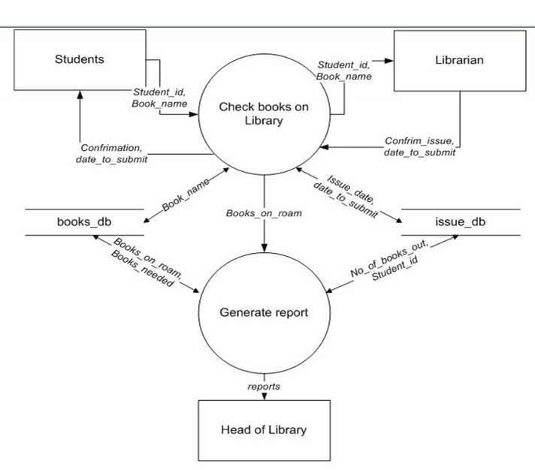

**CONTEXT FLOW DIAGRAM**

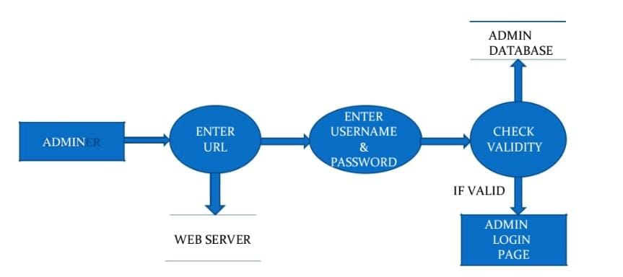

**DATA FLOW DIAGRAM OF ADMIN LOGIN**

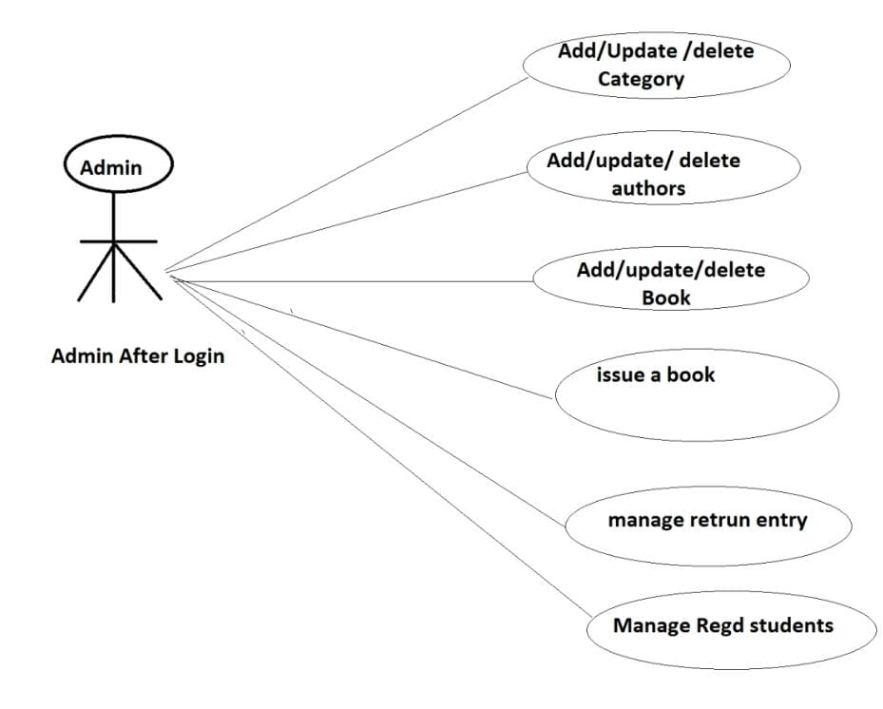

**DATA FLOW DIAGRAM OF ADMIN**

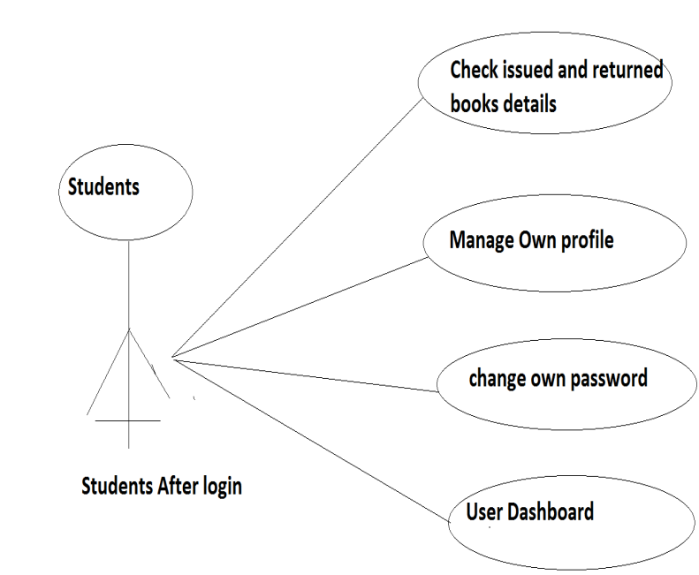

**DATA FLOW DIAGRAM OF STUDENT**

1. **RESULTS**

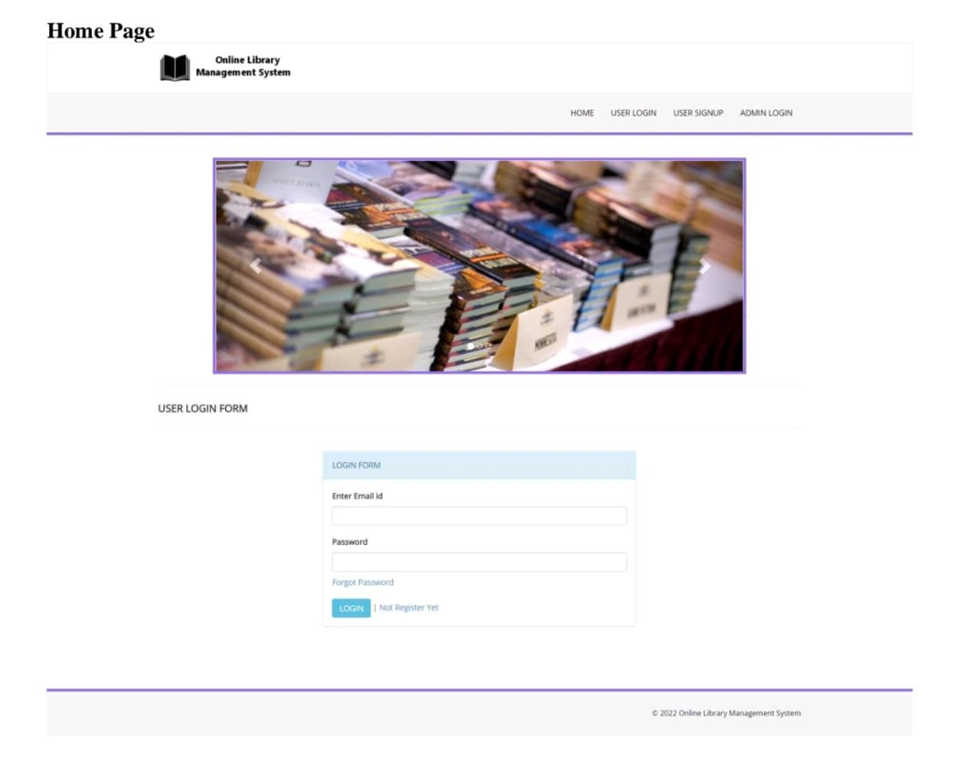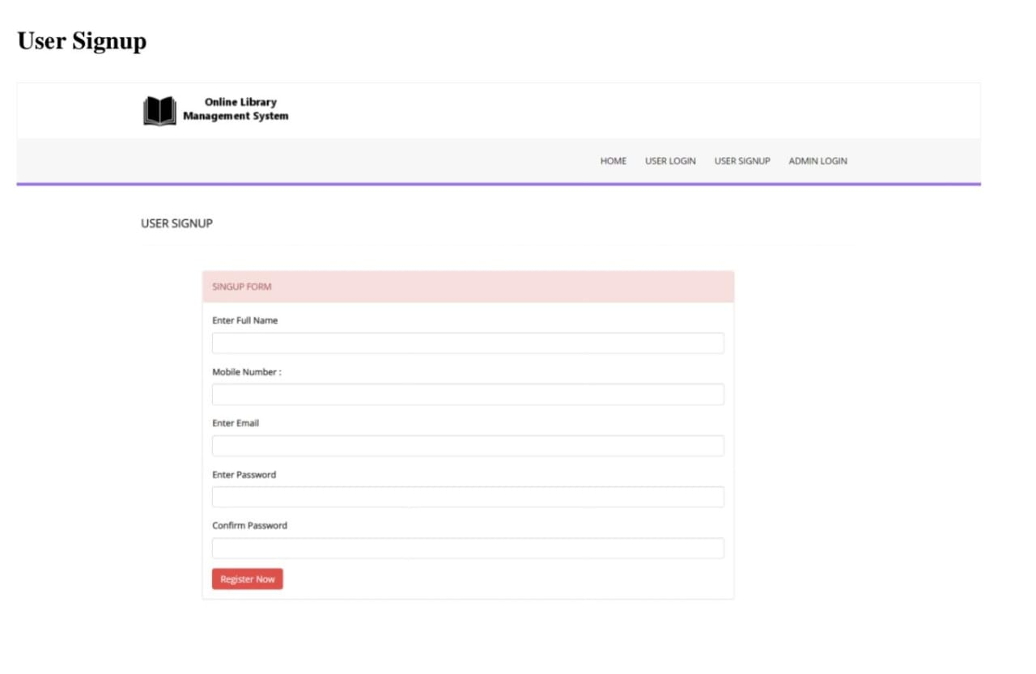

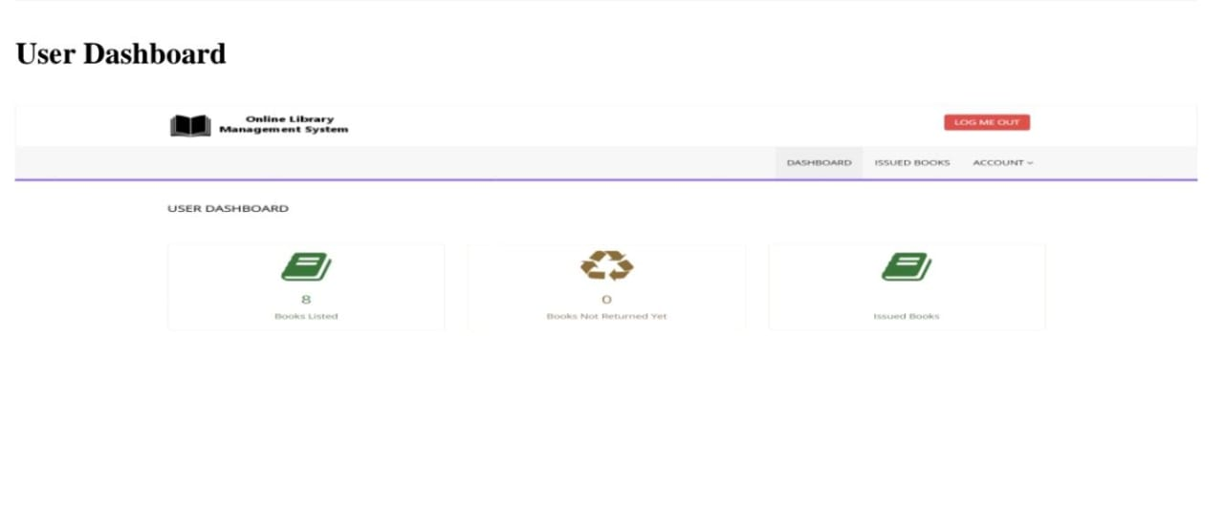

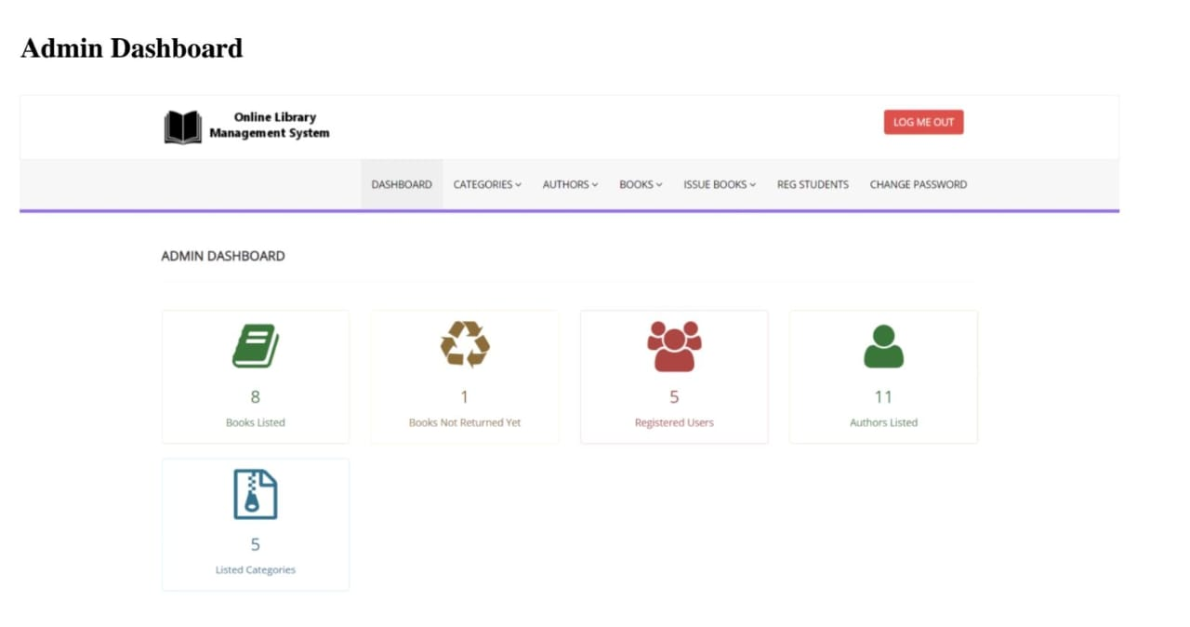

1. **CONCLUSION**

In conclusion, the evolution and implementation of an online Library Management System (LMS) represent a transformative leap in modern library operations. By leveraging digital technologies, LMS enhances accessibility, efficiency, and user engagement within library services. The system's intuitive interfaces, personalized features, and integration with emerging technologies such as AI and data analytics underscore its adaptability to evolving user preferences and technological advancements. Furthermore, the LMS's role in fostering community interaction, supporting educational initiatives, and facilitating global access to knowledge underscores its pivotal importance in the digital age.

1. **REFERENCES**

[1] <https://www.jetir.org/view?paper=JETIRDU06021>

[2] <https://ijarsct.co.in/Paper5952.pdf>

[3] <https://iopscience.iop.org/article/10.1088/1742-6596/1575/1/012053/pdf>

[4] [multiresearch.net/cms/publications/CFP13462019.pdf](https://www.multiresearch.net/cms/publications/CFP13462019.pdf)

[5] [Library Management System (ijraset.com)](https://www.ijraset.com/research-paper/library-management-system)