**Application of Human-Computer Interaction Technology in OBE-Based Medical Education**

**Katherine Ning LI**

Dept. Anatomy , Institute of Sports Science, Xi’an Physical Education University, China

**Abstract:**

This study explores the potential and effectiveness of applying Human-Computer Interaction (HCI) technology in Outcome-Based Education (OBE) models within medical education. As medical education reform progresses, the OBE model is gaining increasing attention, and the rapid development of HCI technology offers new approaches and tools for its implementation. This paper first reviews the current practice of OBE in medical education, analyzing the challenges and opportunities it faces. On this basis, it proposes a model integrating HCI technology into OBE in medical education. The model includes critical components such as Virtual Reality (VR) simulation training, intelligent feedback systems, and collaborative learning platforms to enhance learning outcomes, improve practical skills, and cultivate clinical thinking. The results show that HCI technology has deeply integrated technology and educational concepts, providing students with personalized, immersive learning experiences. Based on this, the paper proposes several recommendations for promoting the application of HCI technology in OBE-based medical education, including strengthening infrastructure construction, developing adaptive teaching content, and training teachers' technical skills. This study provides new ideas and practical guidance for the innovative development of medical education, which is of great significance for improving the quality of medical education.

**Keywords**: Human-Computer Interaction Technology, Medical Education, Outcome-Based Education, Application Model, Case Analysis

1. INTRODUCTION

Medical education is facing unprecedented challenges and opportunities. With the rapid development of medical technology and the increasing demand for high-quality healthcare services, traditional medical education models can no longer meet the needs of modern medical practice. As an emerging educational concept, outcome-based education (OBE) emphasizes learning outcomes and provides new ideas for medical education reform. At the same time, the rapid advancement of human-computer interaction (HCI) technology has brought revolutionary changes to medical education. This study explores how HCI technology can be applied in the OBE framework to improve teaching effectiveness, enhance students' practical abilities, and foster innovative thinking. By constructing an innovative application model and conducting case analysis, this study will provide valuable insights and practical guidance for the future development of medical education.

2. OBE PRACTICE IN MEDICAL EDUCATION

Outcome-based education (OBE) has become a significant trend in the global medical education application. The OBE model emphasizes outcome-oriented learning, focusing on the knowledge, skills, and attitudes students should possess upon completing their studies. In medical education, this concept's practice is mainly reflected in the reforms of curriculum design, teaching methods, and assessment systems.

In curriculum design, medical schools are gradually shifting from a traditional subject-oriented approach to a competency-oriented approach, constructing curricula around the core competencies required of physicians. For example, the Association of American Medical Colleges (AAMC) proposed the 13 Core Entrustable Professional Activities (EPAs) ,These competencies serve as reference standards for many medical schools' curriculum reforms. This competency-based curriculum design closely integrates learning content with clinical practice. It promotes interdisciplinary integration, such as organically combining introductory medical and clinical medical courses to cultivate students' overall medical thinking. Additionally, many medical schools have introduced early clinical exposure arrangements, allowing students to engage with patients and the medical environment from their studies to enhance motivation and professional identity.

In terms of teaching methods, the practice of the OBE concept has driven the widespread adoption of student-centered teaching models. Traditional lecture-based teaching is gradually supplemented or replaced by interactive teaching methods such as Problem-Based Learning (PBL), Team-Based Learning (TBL), and case discussions. These methods emphasize students' active participation and critical thinking development, aligning more closely with adult learning theories and medical practice needs. For example, clinical skills training has gained more attention, with the extensive application of Objective Structured Clinical Examinations (OSCE) not only as an assessment tool but also as a crucial learning method. The range of simulation teaching applications continues to expand, from simple model training to high-fidelity human simulators and the introduction of Virtual Reality (VR) and Augmented Reality (AR) technologies, providing students with safe, repeatable practice environments. These innovative teaching methods improve learning efficiency and develop students' clinical thinking, communication skills, and teamwork abilities, all emphasized as essential learning outcomes in OBE.

Assessment system reform is one of the most challenging aspects of OBE practice in medical education. Traditional knowledge-oriented, single-mode assessments gradually transition to diversified, process-oriented, formative evaluations. Workplace-Based Assessment (WBA) has become a crucial means of evaluating clinical skills and professionalism, such as Mini Clinical Evaluation Exercise (Mini-CEX) and Direct Observation of Procedural Skills (DOPS). These assessment methods comprehensively evaluate students' abilities in natural clinical settings, aligning more closely with OBE concepts. At the same time, student self-assessment and peer assessment are included in the evaluation system, cultivating students' reflective abilities and lifelong learning habits. Notably, many medical schools have begun adopting Programmatic Assessment, organically combining multiple assessment methods and collecting evidence of students' competency development through continuous, low-stakes assessments to form comprehensive, personalized learning portfolios. For example, the assessment reform implemented by Maastricht University Medical School in the Netherlands is a typical example of Programmatic Assessment. Additionally, tracking the performance of graduates in clinical work has become increasingly important, as has using feedback to improve educational programs and forming a continuous improvement cycle for educational quality. This outcome-based assessment system ensures that students achieve the expected learning outcomes and provides a basis for continuous improvement of educational programs.

3. APPLICATION MODEL OF HCI TECHNOLOGY IN OBE-BASED MEDICAL EDUCATION

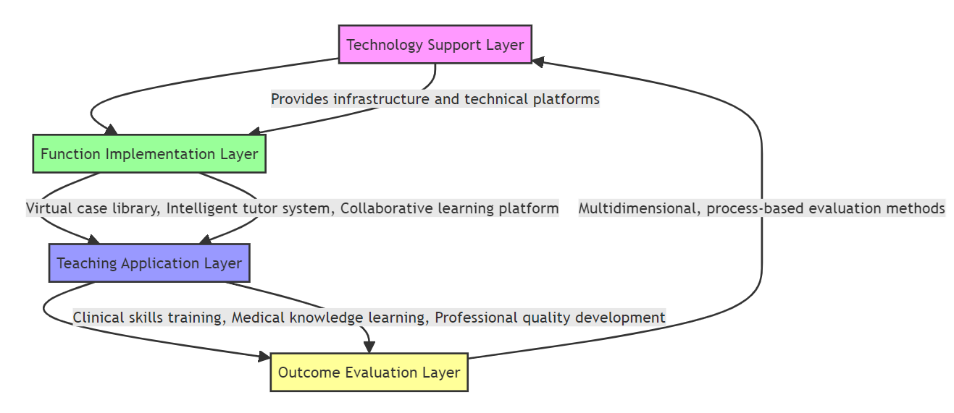

Fig.1 Model of HCI

3.1 Model Framework （Fig.1）

The basic framework of the model includes four interrelated levels: the technical support level, the functional implementation level, the teaching application level, and the outcome evaluation level. The technical support level provides the infrastructure and technical platform; the functional implementation level includes functional modules such as a virtual case library, intelligent tutor system, and collaborative learning platform; the teaching application level encompasses specific application scenarios like clinical skills training, medical knowledge learning, and professionalism cultivation; the outcome evaluation level uses multi-dimensional, process-oriented evaluation methods to monitor and assess learning outcomes in real-time. This hierarchical structure ensures the systematic and operable nature of the model, effectively supporting the practice of OBE concepts in medical education.

3.2 Detailed Description of Model Components

The functional implementation level is the core of the model. The virtual case library utilizes VR technology to create highly realistic clinical scenarios, supporting immersive learning for students. Based on AI technology, the intelligent tutor system provides personalized guidance and feedback according to students' learning performance. The collaborative learning platform uses augmented reality (AR) technology to support remote collaboration and real-time interaction.

The teaching application level applies these functional modules to specific teaching scenarios, such as using VR technology for surgical simulation training, employing AI-assisted diagnostic systems to develop clinical decision-making skills, and using AR technology to aid anatomy learning.

The outcome evaluation level employs diverse evaluation methods, including skills assessments in VR environments, AI-driven knowledge graph analysis, and extensive data-based learning behavior analysis, to comprehensively evaluate learning outcomes.

4. CASE STUDY: APPLICATION OF HCI AND OBE THEORY IN HEALTH MANAGEMENT EDUCATION

4.1 Background Introduction

The School of Exercise and Health Sciences innovated its educational model for the rehabilitation therapy major. With an increasingly complex healthcare system and evolving public health challenges, traditional teaching methods were insufficient to meet the demand for well-rounded rehabilitation therapists. The school decided to integrate Human-Computer Interaction (HCI) technology and adopt Outcome-Based Education (OBE) principles to cultivate professionals capable of using data analysis, preventive medicine, and health promotion strategies to improve population health.

4.2 Application of OBE Concepts

* Defining Learning Outcomes: Based on industry demands and international standards, clear learning outcomes were defined, including data analysis abilities, health policy formulation, project management, and communication coordination. Students are expected to design and implement community-based health promotion projects and evaluate their effectiveness.
* Curriculum Design: The curriculum was restructured to ensure that each course directly corresponds to specific learning outcomes. Interdisciplinary courses were introduced, such as "Health Informatics" and "Public Health Big Data Analysis."
* Teaching Strategies: Interactive teaching methods were adopted, such as case-based teaching and project-based learning. Practical sessions, including virtual health management system operations and field research, were increased.

4.3 Integration of HCI Technology

* Health Management Simulation System: A VR-based health management simulation system was developed to simulate communities or organizations of different scales. Students can conduct population health assessments, formulate intervention measures, and allocate resources in a virtual environment.
* Data Visualization Platform: An interactive data visualization platform was created using AR technology. Students can intuitively analyze and manipulate complex health data through AR glasses or tablets.
* AI-Assisted Decision-Making System: An AI-driven health management decision support system was developed to simulate real-world complex situations. Students can input various parameters, and the system provides possible outcomes and recommendations, enhancing their decision-making skills.
* Remote Collaboration Platform: A cloud-based remote collaboration platform was established to support virtual team projects. Students can collaborate with peers from other institutions or organizations to solve cross-regional health management problems.

4.4 Evaluation Methods

* Comprehensive Project Evaluation: Students must complete a comprehensive health management project, from problem identification to solution implementation and evaluation. The simulation system collects decision-making data throughout the project for a thorough evaluation.
* Continuous Assessment: The AI system tracks students' performance in the virtual environment, generating learning progress reports. Regular online quizzes and case analyses are conducted to assess the application of theoretical knowledge.
* 360-Degree Feedback: Feedback is collected from teachers, peers, simulated patients, and community members during internships and project collaborations. Electronic evaluation tools collect and analyze feedback data in real-time.

5. CONCLUSIONS AND RECOMMENDATIONS

It demonstrated the innovative application of HCI technology and OBE concepts in health management education. By combining advanced technology with educational theories, students' professional abilities and practical skills are enhanced, and their capability to tackle complex health management challenges is developed. This educational model provides new ideas and methods for training health management professionals who can adapt to the future needs of the healthcare system. Plans include introducing more real-time data and real-world cases to enhance the authenticity of the simulation system further. Additionally, exploring the expansion of this educational model to other public health-related fields, such as epidemiology and health policy, is recommended.

6. REFERENCES

1. Encandela JA, Shaull L, Jayas A, et al. Entrustable professional activities as a training and assessment framework in undergraduate medical education: A case study of a multi-institutional pilot. Med Educ Online. 2023;28(1):2175405.
2. Bray MJ, Bradley EB, Martindale JR, Gusic ME. Implementing Systematic Faculty Development to Support an EPA-Based Program of Assessment: Strategies, Outcomes, and Lessons Learned. Teach Learn Med. 2021;33(4):434-444.
3. Aqib A, Fareez F, Assadpour E, et al. Development of a Novel Web-Based Tool to Enhance Clinical Skills in Medical Education. JMIR Med Educ. 2024;10:e47438.
4. Dagher T, Oyler J, Press VG, et al. Development and Implementation of an Experiential Longitudinal Health Systems Science Thread Into an Existing Medical School Curriculum. Acad Med. Published online June 12, 2024. doi:10.1097/ACM.0000000000005784
5. Sadati L, Edalattalab F, Hajati N, et al. OSABSS: An authentic examination for assessing basic surgical skills in surgical residents. Surg Open Sci. 2024;19:217-222.
6. Liu P, Dong X, Liu F, Fu H. Effects of virtual reality OSCE on nursing students' education: a study protocol for systematic review and meta-analysis. BMJ Open. 2024;14(5):e082847.
7. Braund H, Dalgarno N, O'Dell R, Taylor DR. Making assessment a team sport: a qualitative study of facilitated group feedback in internal medicine residency. Can Med Educ J. 2024;15(2):14-26.
8. Alruqi I, Al-Nasser S, Agha S. Family Medicine Resident Experience Toward Workplace-Based Assessment Form in Improving Clinical Teaching: An Exploratory Qualitative Study. Adv Med Educ Pract. 2024;15:37-46.
9. Shuford A, Carney PA, Ketterer B, et al. An Analysis of Workplace-Based Assessments for Core Entrustable Professional Activities for Entering Residency: Does Type of Clinical Assessor Influence Level of Supervision Ratings?. Acad Med. Published online March 18, 2024. doi:10.1097/ACM.000000000000569.