A Review: HPLC Method Development and Validation

Abstract :

Chromatography is typically used in chemical analysis, even though it is primarily a separation technique. The incredibly flexible method known as high-performance liquid chromatography (HPLC) uses a column filled with micrometer-sized particles to separate analytes. Reversed-phase chromatography is currently the most often utilised HPLC separation method. This can be attributed to the reversed-phase method's ease of use, adaptability, and broad applicability, as it can manage molecules with varying molecular masses and polarities.The methods and problems associated with developing and validating HPLC methods are covered in this article. HPLC is the dominant separation technique in modern pharmaceutical and biomedical analysis because it results in highly efficient separations and in most cases provides high detection sensitivity. Most of the drugs in multi component dosage forms can be analyzed by HPLC method because of the several advantages like rapidity, specificity, accuracy, precision and ease of automation in this method.

Keywords: HPLC, Method development, Optimization, Validation

1. INTRODUCTION

Many analytical techniques are used to analyse drug samples in bulk, pharmaceutical formulations, and biological fluids. Analytical chemistry is frequently defined as the branch of chemistry responsible for characterising the composition of matter, both qualitatively and quantitatively [1–2]. Chromatography is an analytical method that can be used to separate and purify inorganic and organic compounds. Additionally, it is highly helpful for isomerizationthe separation of closely related compounds and fractionation of complex mixtures.

The relatively new technology of chromatography was first invented in Warsaw in 1906 by a Botanist named M Tswett.

This method essentially relies on variations in the speed at which mixture constituents pass through a porous media (the stationary phase) when subjected to a solvent or gas. now a commonly used analytical chemistry instrument. Because it may be applied to a wider range of mobile and stationary phases and is not restricted to volatile and thermally stable samples, High Performance Liquid Chromatography is a more flexible method than gas chromatography.[4]

The technique of HPLC has following features.

1. High resolution
2. Small diameter, Stainless steel, Glass column
3. Rapid analysis
4. Relatively higher mobile phase pressure
5. Controlled flow rate of mobile phase

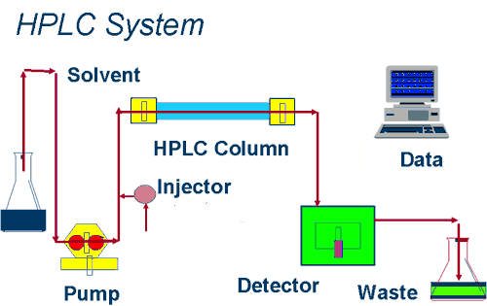

**Fig .1 Flow Diagram of HPLC**

**Development of analytical methods** -  
  
In situations where conclusive approaches are lacking, novel methodologies are being developed to assess the innovative product. New strategies are developed to decrease the value other than time in order to analyse the presence of either pharmacopoeial or non-pharmacopoeial products with higher strength and precision. Through trial runs, these approaches have been refined and found to be reliable. Alternative strategies are developed and implemented to replace the current process with comparable laboratory data, taking into account all available advantages and disadvantages.

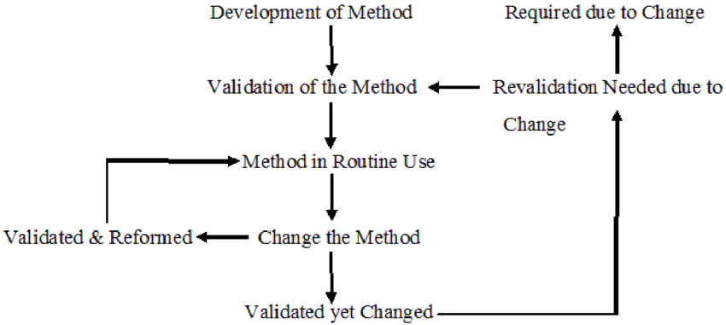

**Fig 2 . Life cycle of the analytical method**

**Principle** -

The idea is to inject a sample solution into a porous material column (the stationary phase) and then pump a liquid (the mobile phase) through the column at high pressure. The basis for sample separation is the variation in migration rates through the column resulting from the sample's partitioning into the stationary and mobile phases. Elution occurs at different times based on how various components behave during partitioning. [5]

**METHOD DEVELOPMENT**

Analytical methods development and validation has important roles in the analysis such as discovery, development, and manufacture of pharmaceutical products. The product containing one or more drug called combination product. responsible for the development and validation of analytical methods. The official test methods that result from these processes are used by quality control laboratories to ensure the identity, purity, potency, and performance of drug products[6].

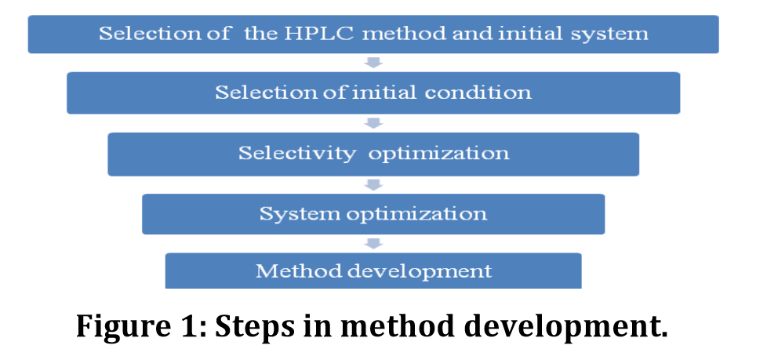

**Sample collection and preparation:**

The living media that contain the analyte are typically blood, plasma, urine, serum, etc. Blood is typically drawn from human volunteers or subjects by vein puncture with a hypodermic syringe up to 5-7 ml. The venous blood is withdrawn into tubes with an anticoagulant, usually ethylenediaminetetraacetic acid; heparin is used. Plasma is obtained by centrifugation at 4000 rpm for 15 minutes; approximately 30–50% of the volume is collected. The goal of sample preparation is to clean up the sample before analysis. Materials in biological samples that can affect the chromatographic column or the detector include endogenous macromolecules, proteins, salts, small molecules, and metabolic byproducts. solvent suitable for instillation into the chromatographic system. General methods for sample preparation such as liquid/liquid extraction, solid-phase extraction (SPE) and protein[7,8]

**BIOANALYTICAL METHOD-**

Some of the following bioanalytical method:

* Extraction method
* Protein precipitation
* Chromatography method
* Ligand binding assay (LBA)

**Extraction method**

**Liquid-liquid extraction** - It is based on the principles of difference solubility and partitioning equilibrium of analyte molecules between aqueous (the sample) and the organic phases. Liquid-liquid extraction generally involves the extraction of a substance from one liquid phase to additional liquid phase [9]. Nowadays liquid extraction replaced with advanced and improved methods like liquid phase micro extraction and supported membrane extraction, single drop liquid phase micro extraction [10].

**SPE** - SPE is choosy method for sample preparation where the analyte is bound onto a solid support, interferences are washed off and the analyte is selectively eluted. No. of choices of sorbents, SPE is a very powerful technique. Solid phase includes four steps; conditioning, sample loading, washing and elution are shown in Fig. 1.

1. Conditioning –

The column is triggered with an organic solvent that acts as a wetting agent on the packing material and solvates the functional groups of the sorbent. Water or aqueous buffer is added to activate the column for proper adsorption mechanisms.

1. Sample loading-

After adjustment of pH, the sample is entering on the column by gravity feed, pumping or aspirating by vacuum.

1. Washing - Interferences from the matrix are removed while retaining the analyte.
2. Elution

Distribution of analyte - sorbent interactions by suitable solvent, removing as little of the remaining interferences as possible.[11] Generally, sorbents used in SPE consists of 40μm diameter silica gel with around 60 A0pore diameters. To this silica gel, functional groups are chemically bonded. The most commonly used format is a syringe barrel that contains a 20μm frit at the bottom of the syringe with the sorbent material and another frit on top, referred to as packed columns. Extractions disks are place in syringe

barrels. These disks consist of 8-12 μm particles of packing

material fixed into an inert matrix[12,13].

**HPLCsystem** -  
Main components of a typical HPLC system include the following:

**Solvent reservoirs:** Place enough HPLC solvents there to keep the system running continuously. may have unique filters and an online degassing system installed to protect the solvent from outside influences.

**Pump:** This ensures that the mobile phase flows through the system continuously and steadily. The majority of contemporary pumps enable the carefully regulated mixing of various solvents from various reservoirs.

**Injector:** Before the mobile phase enters the column, the analytes mixture can be introduced (injected) into the stream. The majority of modern injectors are autosamplers, which enable programmed injections of various volumes of samples that are extracted from the vials in the autosampler tray.

**Column:** The HPLC system's column is its central component and is what actually separates the analytes in the mixture. The interface with a large surface area formed by the mobile phase and stationary phase coming into contact is called a column. The majority of recent advances in chromatography have been focused on creating several strategies to improve this interfacial contact. his touch between the faces.

**Detector** - A detector is a tool used in pharmaceutical analysis that records certain physical and occasionally chemical aspects of the column effluent continuously. The most used type of detector is UV (ultraviolet), which enables continuous registration of the UV absorbance at a

selected wavelength or over a span of wavelengths (diode array detection). Appearance of the analyte in the detector flow-cell causes the change of the absorbance. If the analyte absorbs greater than the background (mobile phase), a positive signal is obtained.

**Steps for developing a method-**

The following are some of the stages that go into developing an analytical method:

Characterization of the standard and analyte -

• All of the information that is currently available about the analyte's structure and physical and chemical characteristics, such as its solubility and optical isomerism, is gathered.

• When 100% purity is obtained, the standard analyte is equal. It is necessary to make the necessary arrangements for freezer, desiccator, and refrigerator use for proper storage.

• When measuring several portions in the sample matrix, the number of elements is appropriately observed, providing the information, and the accessibility of standards is computed.

• However, methods such as high-performance liquid chromatography, gas chromatography, and UV-visible, FTIR, and atomic absorption.

**Literature survey and previous methods:**

All relevant literature is examined for the drug's manufacturing, solubility, physical and chemical properties, and applicable analytical techniques using references to pertinent books, journals, publications from the American Society for Testing and Materials (ASTM), the Association of Official Agricultural Chemists (AOAC), and the United States Pharmacopeia/National Formulary (USP/NF). It is also very convenient to search Chemical Abstracts Service's automated computerised literature

**Technique requirement**: To build up the analytical fig. of advantage, such as linearity, selectivity, specificity, range, accuracy, precision, LOD, LOQ, etc., an analytical methodology requirement is necessary .

**Selecting the method-**• The methodology is developing since it is being adjusted as needed by using the information gathered from the literature. Occasionally, it is necessary to obtain extra equipment in order to develop, modify, duplicate, and validate current analyte and test protocols. • In the event that no previous suitable methods exist for examining the analyte under investigation .

**Appropriate instrumentation and preliminary studies**: An appropriate set of instruments examines the installation qualification (IQ), operation qualification (OQ), and performance qualification (PQ) of instruments relevant to research standard methodology .

**Optimisation:** A trial-and-error method is used initially, after a set of conditions are differentiated and one parameter is changed at a time. This job is required to be completed based on a scientific organised technique plan that appropriately covers all required points and documents any dead ends .

**Correct recording of analytical figures of merit:** The actual calculated analytical figures of advantage, which include LOD, LOQ, cost, linearity, evaluation time, sample planning, etc., are also documented [2].

**Assessment of the generated method using the real specimen:** The specimen solution must elicit a precise and comprehensive identification of the medication's peak interest apart from all other matrix components [2].

**CONCLUSION-**  
This article explains validation, its various forms, the reasons it's important, how to create a method, and how to execute the validation process to show that the methodology works as intended. With the use of specific pharmacological examples, all validation parameters—including linearity, LOQ, LOD, range, specificity, robustness, ruggedness, and system suitability—are fully described. In the pharmaceutical industry, validation is an essential technique that ensures quality is included into the processes that support drug development and production.. Some of the method and how is validation carried out were described in different situations encountered in the study sample analysis has been reported in this article. These various essential development and validation characteristics

**REFERENCES**

1. David Harvey. Textbook of Modern analytical Chemistry. DePauw University, 1st ed., 2000: 2.

2. Azim Md. Sabir, Mitra Moloy and Bhasin P. Arminder S. HPLC method development and validation: A review. Int. Res. J. Pharm., 2013; 4(4): 39-46.

3. Guredeep R. Chatwal and Shyam K. Anand. Textbook of instrumental methods of chemical analysis. 2007: 2.567.

4. Vibha Gupta. Development and validation of HPLC method – A review. Int. Res J Pharm. App Sci., 2012; 2(4): 17-25

5. Patel RM, Patel PM, Patel NM, Stability Indicating HPLC Method Development- A Review, Int Res J Pharmacy, 2011; 2(5): 7987.

6.http://shodhganga.inflibnet.ac.in/bitstream/ 10603/8513/9/09_chapter%202.pdf

7. Kallner A. Quality specifications based on the uncertainty of measurement. Scand J Clin Lab Invest 1999;59(7):513-6.

8. Rao KR, Kumar KS. Bioanalytical method validation-A quality assurance auditor view point. J Pharm Sci Res 2009;1(3):1-10

9. Lang JR, Bolton S. A comprehensive method validation strategy for bioanalytical applications in the pharmaceutical industry--1. Experimental considerations. J Pharm Biomed Anal 1991;9(5):357-61.

10. Causon R. Validation of chromatographic methods in biomedical analysis. Viewpoint and discussion. J Chromatogr B Biomed Sci Appl 1997;689(1):175-80.

11. Shah VP. The history of bioanalytical method validation and regulation: Evolution of a guidance document on bioanalytical method validation. AAPS J 2007;9(1):43-7.

12. Buick AR, Doig MV, Jeal SC, Land GS, McDowall RD. Method validation in the bioanalytical laboratory. J Pharm Biomed Anal 1990;8(8-12):629-37.

13. Tiwari G, Tiwari R. Bioanalytical method validation: An updated review. Pharm Methods 2010;1(1):25-38