A BRIEF ARTICLE OF ASTHMA

**AUTHOR: - (1) Gautam Ankita Vinod**

1. **Nandre Rutuja Parmeshwar**
2. **Pimpale Ashwini Balu**
3. **Pimpale Shivani Balu**
4. **Shaikh Saniya Tajmahammad**
5. **Gaikwad Saurabh Dilip**
6. **Dr. Salve Megha T.**

**College:- Shivajirao Pawar College of Pharmacy, Pachegaon Ahmednagar – 413725**

# Introduction :-

Asthma is a disease affecting the airways that carry air to and from lungs. People who suffer from this chronic condition (long lasting or recurrent) are said to be asthmatic. The inside walls of an asthmatic’s airways are swollen or inflamed. This swelling or inflammation makes the airways extremely sensitive to irritations and increases the susceptibility to an allergic reaction. As inflammation causes the airway to become narrower, less air can pass through them, both to and from the lungs. Symptoms of the narrowing include wheezing (a whistling sound while breathing), chest tightness, breathing problems and coughing. Asthmatics usually experience these symptoms most frequently during the night and the early morning. According to recent estimates, asthma affects 300 million people in the world and more than 22 million in the United States. Although people of all ages suffer from the disease, it most often starts in childhood, currently affecting 6 million children in the US. Asthma kills about 255,000 people worldwide every 3-4 year. A condition

in which a person’s airways become inflamed, narrow and swell and produce extra mucus, which makes it difficult to breathe. Asthma can be minor or it can interfere with daily activities. In some cases, it may lead to a life-threatening attack. Asthma may cause difficulty breathing, chest pain, cough and wheezing. The symptoms may sometimes flare up. Asthma can usually be managed with rescue inhalers to treat symptoms (Salbutamol) and controller inhalers that prevent symptoms (Steroids). Severe cases may require longer-acting inhalers that keep the airways open (Formoterol, Salmeterol, Tiotropium), as well as inhalant steroids.

# During Asthma Attack The Following Changes Takes Place :-

1. The muscles around the airways tighten up, narrowing the airway.
2. Less air is able to flow through the airway.
3. Inflammation of the airways increases, further narrowing the airway.
4. More mucus is produced in the airways, undermining the flow of air even more.

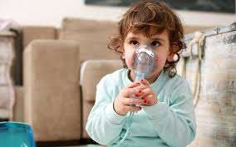

In some asthma attacks, the airways are blocked such that oxygen fails to enter the lungs. This also prevents oxygen from entering the blood stream and travelling to the body’s vital organs. Asthma attacks of this type can be fatal and the patient may require hospitalization. At the same time carbon dioxide deposition in the lungs leads to carbon dioxide poisoning.

# Classification Of Asthma :-

* **Types Of Asthma :-**

# Child-Onset Asthma:-

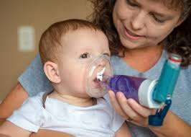

Asthma that begins during childhood is called child-onset asthma. This type of asthma happens because a child becomes sensitized to common allergens in the environment (most likely due to genetic reasons). The child is atopic (a genetically determined state of hypersensitivity to environmental allergens). Allergens are any substances that the body will treat as a foreign body, triggering an immune response. These vary widely between individuals and often include animal proteins, fungi, pollen, house dust, mites and some kind of dust. The airway cells are sensitive to particular materials making an asthmatic response more likely if the child is exposed to a certain amount of an allergen.

# Adult-Onset Asthma:-

This term is used when a person develops asthma after reaching 20 years of age. Adult-Onset asthma affects women more than men and it also much less common than child-onset asthma. It can also be triggered by some allergic material or an allergy. It is estimated that up to perhaps

50% of adult-onset asthma are linked to allergies. However, a substantial proportion of adult-onset asthma does not seem to be triggered by exposure to allergens; this is called non-allergic adult-onset asthma. This non-allergic type of adult-onset asthma is also known as intrinsic asthma. Exposure to a particle or chemical in certain plastics, metals, medications or wood dust can also be a cause of adult-onset asthma.

# Exercise-Induced Asthma:-

Coughing, wheezing or feeling out of breath during or after exercise is called as exercise-induced asthma. Level of fitness also matters a lot. A person who is unfit and runs fast for 10 minutes is going to be out of breath asthma. As with other types of asthma, a person with exercise-induced asthma will experience difficulty in getting air in and out of the lungs because of inflammation of the bronchial tubes (airways) and extra mucus.

# Cough-Induced Asthma:-

Cough-Induced asthma is one of the most difficult asthma to diagnose. The doctor has to eliminate other possibilities, such as chronic bronchitis, post nasal drip due to high fever or sinus disease. In this case the coughing can occur alone, without other asthma-type symptoms being present. The coughing can happen at any time of day or night. If it happens at night it can disrupt sleep.

# Occupational Asthma:-

This type of asthma is triggered by something in the patient’s place of work. Factors such as chemicals, vapors, gases, smoke, dust, fumes or other particles can trigger asthma. It can also be cause by a virus (flu), molds, animal products, pollen, humidity and temperature. Another trigger may be stress. Nocturnal asthma occurs between midnight and 8am. It is triggered by allergens in the home such as dust and per or it can cause by sinus conditions. Nocturnal or night-time asthma may occur without any day-time symptoms recognized by the patient. The patient may have wheezing or short breath when lying down and may not notice these symptoms until awoken by them in the middle of the night (usually between 2 – 4am). Nocturnal asthma may occur only once in a while or frequently during the week. However, when there are no day-time symptoms to suggest asthma is an underlying cause of the night-time cough, this type of asthma will be more difficult to recognize (usually

delaying proper therapy). The causes of this phenomenon are unknown, although many possibilities are under investigation.

# Steroid-Resistant Asthma (Severe Asthma):-

While the majority of patients response to regular inhaled glucocorticoid (Steroid) therapy, some are steroid resistant. Airway inflammation and immune activation play an important role in chronic asthma. Current guidelines of asthma therapy have therefore focused on the use of anti-inflammatory therapy, particularly inhaled glucocorticoid (GCs). By reducing airway inflammation and immune activation, glucocorticoids are used to treat asthma. However, patients with steroids resistant asthma have higher levels of immune activation than do patients with steroid sensitive (SS) asthma.

# Allergies :-

Common sources of indoor allergens include animal proteins (mostly cat and dog allergens), dust mites, cockroaches and fungi. It is possible that the push towards energy-efficient homes has increased exposure to these causes of asthma. Allergic reactions triggered by antibodies in the blood often lead to the airway inflammation that is associated with asthma.

# Tobacco smoke :-

Tobacco smoke has been linked to a higher risk of asthma as well as higher risk of death due to asthma, wheezing and respiratory infections. In addition, children of mothers who smoke and other people exposed to second-hand smoke have a higher risk of asthma prevalence. Adolescent smoking has also been associated with increases in asthma risk.

# Environmental factors :-

Allergic reactions and asthma symptoms are often the result of indoor air pollution from mold or noxious fumes from household cleaners and paints. Other indoor environmental factors associated with asthma include nitrogen oxide from gas stoves. In fact. People who cook with gas are more likely to have symptoms such as wheezing, breathlessness, asthma attacks and high fever.



Pollution, sulfur dioxide, nitrogen oxide, ozone, cold temperatures and high humidity have all been shown to trigger asthma in some individuals. Weather changes have also been known to stimulate asthma attacks. Cold air can lead to airway congestion, bronchoconstriction (airway constriction), secretions and decreased mucociliary clearance (another type of airway inefficiency). In some populations, humidity causes breathing difficulties as well.

# Obesity :-

1. Overweight adults – Those with a body mass index (BMI) between 25 and 30 are 38% more likely to have asthma compared to adults who are not overweight.
2. Obese adults – Those with a BMI of 30 or greater – have twice the risk of asthma. According to some researchers, the risk may be greater for no allergic asthma than allergic asthma.

# Stress :-

People who undergo stress have higher asthma rates. Part of this may be explained by increases in asthma-related behaviors such as smoking that are encouraged by stress. However, recent research has suggested that the immune system is modified by stress as well.

# Genes :-

It is possible that some 100 genes are linked to asthma also plays roles in managing the immune system and inflammation. There have not,

however been consistent results from genetic studies across populations so further investigations are required to figure out the complex interactions that cause asthma. 3 filfths of all asthma cases are hereditary. The centres for Disease Control (USA) say that having a parent with asthma increases a person’s risk by 3 to 6 times. Genetics may also be interacting with environmental factors. For example, exposure to the bacterial product endotoxin and having the genetic trait CD14 (single nucleotide polymorphism (SNP) C-159T) have remained a well-replicated example of a gene-environment interaction that is associated with asthma.

# Airways Hyper Reactivity :-

Researchers are not sure why airway hyper reactivity is another risk factor for asthma, but allergens or cold air may trigger hyper reactive airways to become inflamed. Some people do not develop asthma from airway hyper reactivity, but hyper reactivity still appears to increase the risk of asthma.

# Common asthma triggers include :-

1. Animals (pet hair)
2. Dust mites
3. Certain medicines (aspirin and other NSAIDs)
4. Changes in weather (most often cold weather)
5. Chemicals in the air or in food
6. Exercise
7. Mold
8. Pollen
9. Respiratory infections, such as the common cold
10. Strong emotions (stress)
11. Tobacco smoke

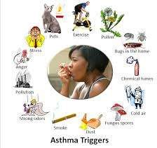

# Diagnosing Asthma :-

* + **Common symptoms and signs include :-**
  1. Wheezing coughing
  2. Breathing difficulty
  3. Tightness in the chest
  4. Worsening symptoms at night
  5. Worsening symptoms due to cold air
  6. Symptoms while exercising
  7. Symptoms after exposure to allergens.

It is also wise to make note of health conditions that interfere with asthma management such.

# Physical examination :-

Physical examinations will generally focus on the upper respiratory tract, chest and skin. A doctor will use a stethoscope to listen for signs of asthma in your lungs as you breathe. The high-pitched whistling sound while you exhale (or wheezing) is a key sign of both an obstructed airway

and asthma. Physicians will also check for a runny nose, swollen nasal passages and nasal polyps. Skin will be examined for conditions such as eczema and hives, which have been linked to asthma. Physical symptoms are not always present in asthma sufferers and it is possible to have asthma without presenting any physical maladies during an examination.

# Asthma Tests :-

Lung function tests or pulmonary function tests are the 3rd component of an asthma diagnosis. Spirometry is a non-invasive test that requires taking deep breaths and forcefully exhaling into a hose connected to a machine called a spirometer. The spirometer then displays 2 key measurements: Forced Vital Capacity (FVC) – the maximum amount of air one can inhale and exhale. Forced Expiratory Volume (FEV-1) – the maximum amount of air exhaled in one second. The measurements are compared against standards developed for a person’s age and measurements below normal may indicate obstructed airways. It is common for doctor to administer a bronchodilator drug to open air passages before retesting with the spirometer. If results improve after the drug, there is a higher likelihood of receiving an asthma diagnosis. Children younger than 5 years of age are difficult to test using spirometry, so asthma diagnoses will rely mostly on symptoms, medical histories and other parts of the physical examination. It is common or doctors to prescribe asthma medicines for 4 to 6 weeks to see how a young child responds.

# Other Tests :-

A “Challenge Test” (or Bronchi-provocation test) is when a physician administers an airway-constricting substance (or something as simple as cold air) to deliberately trigger airway obstruction and asthma symptoms. Similarly, a challenge test for exercise-induced asthma would consist of vigorous exercise to trigger symptoms. A spirometry test is then administered and if measurements are still normal, an asthma diagnosis is unlikely.

# Treatment :-

Asthma medications are generally considered to fall into 2 classes:- Bronchodilators, which stop asthma attacks after they’ve started and help in preventing the attacks and anti-inflammatories, which control the airway inflammation and prevent asthma attacks from starting.

# Bronchodilators :-

Bronchodilators provide relief during an asthma attack. They relax muscles in the air tubes, forcing them to open up and allowing the patient to breathe. Bronchodilators also may help to clear mucus from the lungs, allowing it to move more freely and be more easily coughed out. Some examples of bronchodilators include short-acting beta-agonist used to prevent exercise-induced asthma, anticholinergic used in addition to or as an alternative to short-acting beta-agonist and theophylline a long- acting drug used to treat severe asthma.

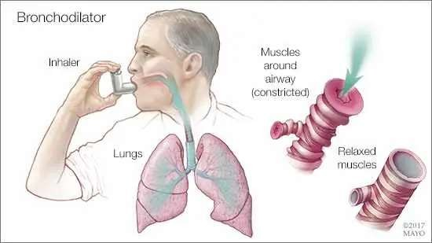

# Anti-Inflammatories :-

Anti-inflammatories prevent asthma attacks by keeping air tubes open all of the time. They are designed to reduce swelling in the air tubes and decrease the amount of mucus. Cronomly and nedocromil are 2 examples of anti-inflammatory medicines. Corticosteroids are the most popular class of anti-inflammatory and are the drug of choice for persistent asthma. Other anti-inflammatories include mast cell stabilizers.

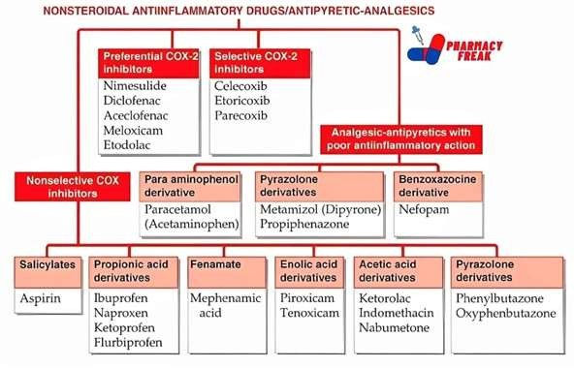

# Side Effects :-

There is always a risk of side effects associated with taking medicine. These may include sore throat, nervousness, nausea, and rapid heartbeat, loss of appetite or staying awake. A doctor will modify the treatment plans if side effects become severe.

# Over-The-Counter :-

Over-The-Counter asthma drugs such as “Primatene Mist” and “Bronchia” are widely available bronchodilators that provide short-term relief. These medicines, however, do not control long-term asthma and should not be used every day to relieve asthma symptoms. Check with a physician before using over-the-counter medicines.

# Metered-Dose Inhalers :-

The most common device used to deliver medicine to the lungs of asthmatics is the metered-dose inhaler. Inhalers have 2 parts: - (1) A canister consisting of a propellant, the medicine and stabilizers and (2) an actuator or mouthpiece consisting of a discharge nozzle and a dust cap. Inhalers are easily used by pressing down the top of the canister and inhaling the gas that is released. Usually the medicine administered by

metered-dose inhalers is a bronchodilator, corticosteroid or a mast cell stabilizer.

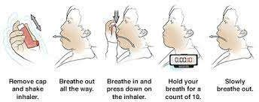

# Dry Powder Inhalers :-

As an alternative to the aerosol-based metered-dose inhalers, dry powder inhalers deliver medicine from a capsule in powder form. These devices require the patient to inhale forcefully to pull the powder from the association studies have identified variations in several devices into the lungs and can be more complicated to use than metered-dose inhalers.

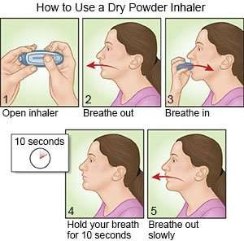

# Nebulizer :-

Medication may also be administered using a nebulizer, providing a larger, continuous dose. Nebulizers vaporize a dose of medication in a saline solution into a steady stream of foggy vapour that is inhaled by the patient. Nebulizers are more common in hospital settings for patients who have difficulty using a metered-dose inhaler.



# Asthma Spacer :-

Asthma spacers are attachments that can be added to metered-dose inhalers. The spacer goes between the patient’s mouth and the mouthpiece of the inhaler and it acts as a reservoir that briefly holds the medication. Spacers allow a patient to inhale the medicine without having to coordinate the breathing and mechanical needed to use an inhaler. Spacers also help patients deliver the medication directly to the lungs, avoiding medicine on the side of the mouth and the condition known as “thrush”.

# Managing Asthma :-

Identifying and avoiding asthma triggers will help you to maintain an active and healthy lifestyle with asthma. The following list discusses common triggers and suggests ways to handle them.

1. Tobacco smoke – Avoid inside and outside of the home.
2. Air pollution – Try antihistamine medications and staying indoors.
3. Pollen – Try antihistamine medications and staying indoors.
4. Animal dander – Keep pets outside, wash them often and find them a new home.
5. Viral infections – See a physician.
6. Heavy exercise – Lower the impact of your exercise routine and consult a doctor.
7. Stress – Many methods of stress reduction exist, including breathing, medication, progressive relaxation and exercise.
8. Dry or cold air – Wear a scarf over your mouth and nose during winter months.
9. Dust mites – Keep sheets, blankets, pillows and stuffed toys clean.

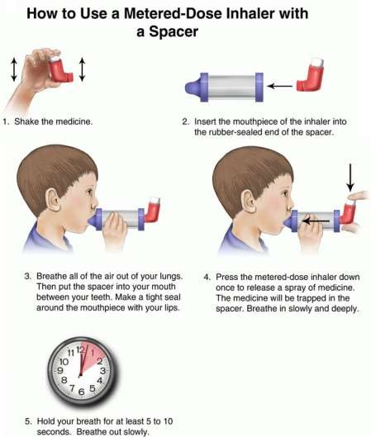

# Method :-

This paper arose from an extensive literature review under-taken in developing the Canadian Healthy Infant Longitudinal Development (CHILD) study, a multicenter national observational study that is currently in progress. The study, which will eventually recruit 5000 pregnant women, has the aim of determining the environmental, host, genetic and psychosocial risk factors for development of allergy and asthma in children. Although not a systematic review, the examination of epidemiologic risk factors in the development of asthma presented here began in 2004 with a search of MEDLINE, using the Medical Subject

Heading (MeSH) terms “asthma”, “longitudinal” and “cohort study”. One of us reviewed the abstracts of all studies identifies in the search, excluding those without at least one objective outcome measure and those in which the primary outcomes measure was not asthma. Studies examining the same outcome measure were tabulated but not combine, since most did not consider exactly the same outcome at the same age. We them performed specific searches to fill gaps in the information gathered via the original search, specifically nutrition, sex and gender effects and novel environmental exposures. The review was updated in July 2008. Although the present article includes some references to adult asthma, its primary focus is the epidemiology of and risk factors for his condition in children. A more extensive summary of the literature review for the Canadian Health Infant Longitudinal Development (CHILD) study has been published elsewhere.

# Epidemiology Of Asthma An Overview :-

The recent substantial increase in the reported prevalence of asthma worldwide (Fig.1) has led to numerous studies of the prevalence and characteristics of this condition.

1. Foremost among these are 2 major international initiatives that have collected data using validated questionnaires, one among children, the International Study of Asthma and Allergies in Childhood.
2. And the other among young adults, the European Community Respiratory Health Survey.
3. Follow-up investigations for both of these studies have exam-linked temporal trends within and across populations.

During a mean of 7 years phase I of the International Study of Asthma and Allergies in Childhood, which is most participating countries, was conducted between 1991 and 1993, the prevalence of asthma was stable or decreased in some areas of the world but increased substantially in many other areas, especially among children 13-14 years of age (Fig.2). Cross-sectional populations-based studies such as these highly dependent on recognition of symptoms, so they do not necessarily reflect the true heterogeneity of asthma. However, a wide variation in prevalence rates has been documented: Studies of both children and adults have revealed low prevalence rates (2%-4%) in Asian countries (especially China and India) and high rates (15%-

20%) in the Unites Kingdom, Canada, Australia, New Zealand and other developed countries.

Observations of migrating populations and of Germany after reunification have strongly supported the role of local environmental factors, including allergens but likely many lifestyles factors as well, in determining the degree of expression of asthma within genetically similar populations. Are cent analysis of data from the International Study of Asthma and Allergies in Childhood, comparing data from Vancouver, Canada with data from centres in China, showed significant differences in prevalence rates between children of similar genetic ancestry living in different environments, with evidence for an effect of duration of residence in the new environment? Prevalence rates for asthma among children 13-14 years old were lowest for Chinese children born and studied in China, intermediate for Chinese children who had migrated during their lifetime to Canada and highest for Chinese children who had been born in Canada. In addition, the prevalence rate for the 3rd of these groups was still lower than among non-Chinese children in the same environment. Together, these results strongly suggested gene-by-environment interactions.

Local and national studies have also provided insights into the epidemiology of exacerbations of asthma. For example, epidemics of asthma exacerbations in Barcelona, Spain were eventually linked to exposure to atmospheric soybean dust released during cargo handling at the local port. The highly predictable annual epidemic of asthma exacerbations in school age children in the northern hemi-sphere every September, peeking some 17 days after the return to school, appears to be predominantly driven by seasonal rhinovirus infection, probably compounded bother risk factors for asthma exacerbations, including reduction in use of asthma.

# Conclusions :-

Asthma is a heterogeneous group of conditions that result in recurrent, reversible bronchial obstruction. Although the disease can start at any age, the first symptoms occur during childhood in most cases. Asthma has a strong genetic component and genome-wide genes that slightly increase the risk of disease. In this review detailed discussion was made on the pathogenesis, causes, symptoms and management of chronic asthma.

# References :-

* 1. Frew AJ: Allergen immunotherapy. J Allergy Clin Immunol 2010, 125:S306-313. Kaplan AG, Balter MS, Bell AD, Kim H, McIvor RA: Diagnosis of asthma in adults. CMAJ 2009, 181:E210-E220.
  2. Kovesi T, Schuh S, Spier S, Berube D, Carr S, Watson W, McIvor RA: Achieving control of asthma in preschoolers. CMAJ 2010, 182:E172-E183.
  3. Global Initiative for Asthma (GINA): Global strategy for asthma management and prevention 2009.
  4. Lemanske RF, Busse WW: Asthma: Clinical expression and molecular mechanisms. J Allergy Clin Immunol 2010, 125:S95- 102.
  5. McFadden ER Jr. A century of asthma. Am J Respir Crit Care Med. 2004; 170(3):215-221.
  6. Wardlaw AJ, Bright ling C, Green R, Woltmann G, and Pavord I. Eosinophil’s in asthma and other allergic diseases. Br Med Bull. 2000; 56(4):985-1003.
  7. Djukanovic R, Home yard S, Gratziou C, et al. The effect of treatment with oral corticosteroids on asthma symptoms and airway inflammation. Am J Respir Crit Care Med. 1997; 155(3):826-832.
  8. Ten Brinke A, Zwinderman AH, terk PJ, Rabe KF, Bell EH. “Refractory” eosinophilic airway inflammation in severe asthma: effect of parenteral corticosteroids. Am J Respir Crit Med. 2004; 170(6):601605.
  9. O’Byme PM, Pedersen S, Lamm CJ, Tan WC, Busse WW. Severe exacerbations and decline in lung function in asthma. Am J Respir Crit Care Med. 2009; 179(1):19-24.
  10. Bousquet J, Bousquet PJ, Godard P, Daures JP. The public health implications of asthma.
  11. Holberg CJ, Elston RC, Halonen M, et al. Segregation analysis of physician-diagnosed asthma in Hispanic and non-Hispanic white families. A recessive component? Am J Respir Crit Care Med 1996; 154:144-50.
  12. Lawrence S, Beasley R, Doull I, et al. genetic analysis of atopy and asthma as quantitative traits and ordered polychotomies. Ann Hum Genet 1994; 58:359-68.
  13. Ober C, Hoffjan S. Asthma genetics 2006: the long and winding road to gene discovery. Gene Immun 2006; 7:95-100.
  14. Moffatt MF, Kabesh M, Lian L, et al. Genetic variants regulating ORMDL3 expression contribute to the risk of childhood asthma. Nature 2007; 448:470-03.
  15. Galanter J, Choudhary S, eng C, et al. ORMDL3 gene is associated with asthma in three ethnically diverse populations. Am J Respir Crit Care Med 2008; 177:1194-200.
  16. Tavendale R, Macgregor DF, Mukhopadhyay, et al. A polymorphism controlling ORMDL3 expression is associated with asthma that is poorly controlled by current medications. J Allergy Clin Immunol 2008;121:860
  17. Stein RT, Holberg CJ, Sherrill D, et al. Influence of parenteral smoking on respiratory symptoms during the first decade of life: the Tucson Children’s Respiratory Study. Am J Epidemiology 1999; 8:349-56.
  18. Lewis S, Richards D, Bynner J, et al. Prospective study of risk factors for early and persistent wheezing in childhood. Eur Respir J 1995;8:349-56
  19. Lau S, Nickel R, Niggemann B, et al. The development of childhood asthma: lessons from the German Multicenter Allergy Study (MAS). Pediatric Respir Rev 2002;3:265-72.
  20. Tariq SM. Hakim EA, Matthews SM, et al. Influence of smoking on asthmatic symptoms and allergen sensitization in early childhood. Postgrad Med J 2000;76:694-9.