FABRICATION OF NOVEL GRAPHENE HEAT FLUX SENSOR
Amit Kumar
Anna University, Chennai, Tamil Nadu 600025
ABSTRACT
A graphene-based heat flux sensor is fabricated on a laboratory scale using a reduction technique to synthesize graphene. Calibration of the sensor was conducted using an oil bath method to determine its temperature coefficient of resistance and sensitivity. The graphene sensor demonstrated effective performance in sensing both temperature and heat flux, indicating its utility in measuring thermal changes. Graphene effectively sensed the temperature and heat flux. The graphene sensor exhibits a good linear relationship between resistance and temperature. The temperature coefficient of resistance is 0.0013/ ⁰C. The sensitivity is 0.715 Ω/ ⁰C. The sensor showed reliable resistance changes under heat load, making it suitable for heat flux sensing applications.
Keywords: Graphene, RTD, Heat flux sensor, TCR, Sensitivity
- INTRODUCTION
A thin film-based heat flux sensor is a RTD made by depositing the thin layer of thermally sensitive material such as platinum and silver on thermally insulating material such as Macor and Quartz. The resistance of thermally sensitive material increases with temperature almost linearly. This property is useful in the prediction of surface temperature and thus heat flux. Platinum is widely accepted for heat flux sensor due to its inertness and good linear behavior with temperature compared to other materials. For maintaining the electrical connections, silver paint is generally used as medium due to its good adhesion to most of substrates.
Graphene is a potential candidate for sensing applications due to it’s properties. It is used in many sensing applications. The grapheme is used for temperature sensing in may studies. H.Kun et al. [1] it introduced a body temperature sensor made with laser-induced graphene (LIG). This sensor is noted for its high accuracy, simple production, and low cost. It is easier to fabricate and operate than traditional thermal resistance sensors. The LIG sensor accurately measures temperatures in the human body range (30°C to 40°C) with a linear correlation between resistance and temperature. It has an accuracy of ±0.15°C, compared to ±0.30°C for infrared thermometers.
V. Kedambaimoole et al. [2] described a new method to create temperature sensor arrays by screen printing a Graphene-Nickel (Ni) nanocomposite film on a flexible printed circuit board (PCB). This cost-effective technique ensures uniform film thickness. The sensor array, with a sensing thickness of about 50 μm, measures temperature variations via changes in resistance, exhibiting Negative Temperature Coefficient (NTC) behavior. The resistance decreases with increasing temperature, with a sensitivity of 2.455 Ω/K and a temperature coefficient of resistance (TCR) of -2.635 ×10⁻³ Ω/Ω/K. This simple fabrication process allows for mass production of sensors that can be easily integrated into electronic devices and worn as body temperature sensors.
J. Ynag et al. [3] demonstrated an ultrasensitive wearable temperature sensor using graphene nanowalls (GNWs) combined with polydimethylsiloxane (PDMS). The sensor is fabricated using a polymer-assisted transfer method, making it easy to produce, biocompatible, and cost-effective. It exhibits a high positive temperature coefficient of resistivity (TCR) of 0.214 °C⁻¹, three times higher than conventional sensors. This high sensitivity is due to the stretchability and thermal sensitivity of GNWs and the large expansion coefficient of PDMS. The sensor can monitor body temperature in real time, with fast response/recovery and long-term stability, making it suitable for personalized healthcare and human-machine interface systems.
G. Khurana et al.[4] described a reduced graphene oxide (rGO) temperature sensor made by drop casting a GO solution onto platinum inter-digital electrodes, followed by reduction with annealing and hydrazine vapor. Characterized by X-ray diffraction and Raman spectroscopy, the sensor's resistance decreases exponentially with temperature from 100 to 400 K. The rGO sensor shows high sensitivity, stability, and repeatability, making it effective for temperature sensing applications. Graphene is used for temperature sensing in many other studies [5-7].
Graphene is used in many other applications. R. Ghosh et al. [8] reported a flexible, low-cost ammonia sensor using multilayered graphene on filter paper, reduced from graphene oxide with glucose. It detects ammonia as low as 430 ppb and performs reliably across concentrations from 400 to 4000 ppm, in both flat and bent positions, demonstrating reproducible performance. P. Basu et al.[9] described a low-cost, reagent-free E coli sensor made with graphene on a flexible acetate substrate. Graphene is grown on copper foil using CVD and transferred to acetate, with gold electrodes forming a two-terminal capacitor. Impedance spectroscopy measures changes in impedance with E. coli concentration. Residual methyl groups on graphene bind E. coli, increasing hole doping and decreasing graphene resistance. The sensor achieves 60% sensitivity at 4.5 × 10⁷ cfu/ml. V. Kedambaimoole et al. [10] demonstrated a flexible proximity sensor with reduced graphene oxide (rGO) as the sensing layer, showing high sensitivity to electrostatic potential for detecting object proximity.
From the literature review, it is observed that graphene in reduced form is used in many applications such as temperature sensing, gas sensing, and others. But it is not used for heat flux sensing applications. The present study deals with the implementation of graphene for heat flux sensing applications.

- SYNTHESIS OF GRAPHENE
Graphene is a single layer of carbon atoms arranged in a two-dimensional honeycomb lattice. It is the basic building block of other carbon allotropes. Graphene consists of carbon atoms each bonded to three other carbon atoms, forming a hexagonal pattern. Graphene is incredibly strong, approximately 100 times stronger than steel by weight, yet it is also extremely lightweight. Graphene is an excellent conductor of electricity, surpassing many traditional conductive materials. It has a high electron mobility, meaning electrons can travel through it very quickly. It also has high thermal conductivity, making it efficient at conducting heat. Despite its strength, graphene is highly flexible and can be bent or stretched without breaking.
Graphene's remarkable properties make it a highly researched material with a wide range of potential applications in various industries. Graphene is used in many applications. Used in transistors, sensors, and other electronic devices due to its excellent electrical conductivity. It is employed in batteries and supercapacitors to enhance energy storage capacities. It is incorporated into materials to improve their strength and flexibility. Potentially it is useful in drug delivery systems, biosensors, and other medical applications.
Graphene can be synthesized using several methods, each with its advantages and limitations. Each method of graphene synthesis has its specific use cases depending on the desired properties of the graphene and the scale of production needed. Research continues to improve these methods and develop new techniques for more efficient and scalable graphene production. In the present work, graphene is synthesized in the laboratory using chemical reduction of graphene oxide. The more details about this method can be found in the literature.

- FABRICATION OF HEAT FLUX SENSOR
The main components of a heat flux sensor (HFS) are the substrate, sensing thin film, and connecting thin film, as depicted in Fig. 1. For TFG construction, substrates can be made from materials such as Macor, Pyrex, and Quartz, while the sensing thin film is typically made from platinum and nickel. Silver thin films are used for electrical connections. In this study, Quartz rod with a diameter of 10 mm and a depth of 20 mm was selected as substrate material. The substrate material is polished with 400, 1000, and 2000 grit size sand sequentially. After polishing, the substrates are washed with ethanol. Finally, the substrates are dried at 50°C to 60°C for 20 minutes.
To make a sensing thin film of graphene, it is first mixed with a suitable solvent in the required proportion to make a paste. This paste is applied to the top surface of the substrate as a thin layer. Sufficient care is taken to maintain the uniform thickness of the film. The thickness is around 100µm as measured by the instrument. Immediately after this step, the substrates are dried under a high-power heating lamp for 20 minutes to remove all chemical reagents, ensuring the film is completely dry. To relieve thermal stresses and stabilize the calibration parameters (Temperature Coefficient of Resistance (TCR) and sensitivity), the painted substrates undergo an annealing process in a microcontroller-based muffle furnace. The temperature is gradually increased to 350°C over a period of 1 hour at a constant heating rate, followed by natural cooling overnight to avoid crack formation.
The next step in the fabrication process is establishing electrical connections. For this purpose, silver based conductive paint is used. Two silver thin films are applied on opposite sides of the round surface of the substrates. These films are deposited in a single stroke while the substrates are in a horizontal position to counteract the effects of gravity, ensuring an adequate amount of material for effective conduction. The length of the silver thin film is maintained at approximately half the depth of the substrates and the films are made very thick to ensure that the resistance of the silver film is negligible compared to that of the graphene thin films. Care is taken to minimize the overlap between the graphene and silver thin films. The substrates are then annealed in a microcontroller-based muffle furnace at 300°C for 30 minutes and allowed to cool to room temperature overnight. For electrical connections, insulated tin coated copper wires are used. The tin coating facilitates the soldering process. These wires are carefully soldered to the silver thin films, and the soldered joints are insulated with Teflon tape to ensure structural stability. The fabricated final HFS is shown in Fig.2.


Figure 1: Schematic of heat flux sensor

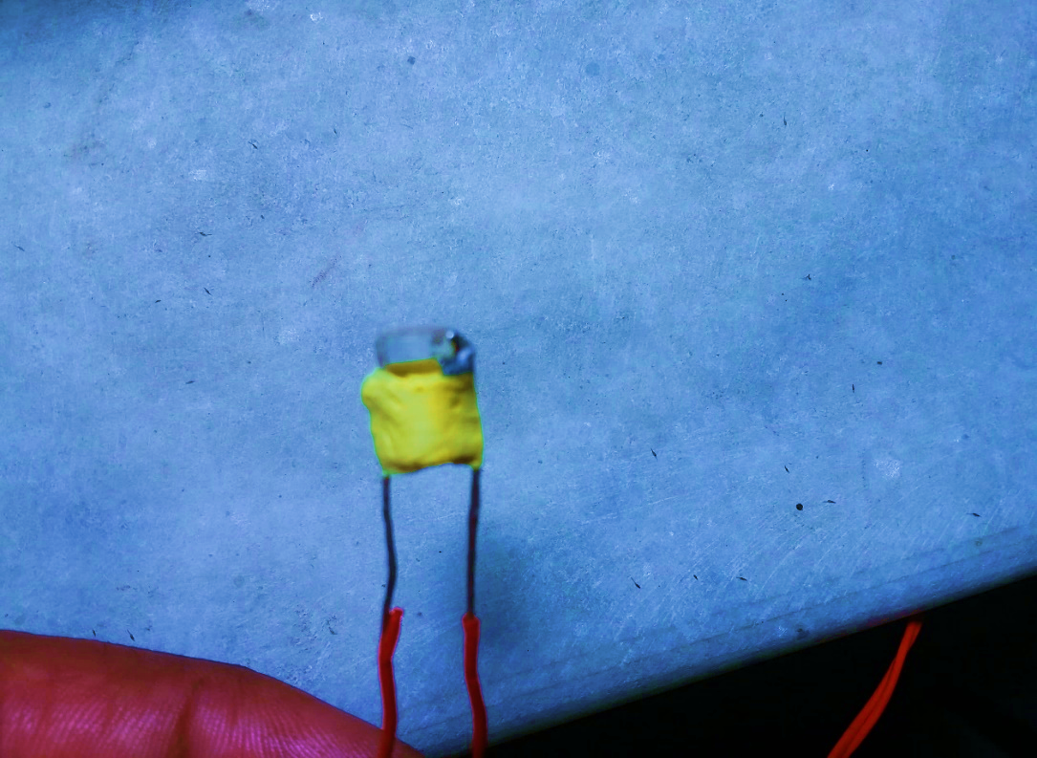
Figure 2: Fabricated heat flux sensor

- OIL BATH CALIBRATION
The fabricated heat flux sensor is calibrated to obtain the performance parameters such as TCR and sensitivity. The relation between resistance and the temperature change is given by
R(T) = R₀ [1+β (T-T₀)] | (1)

Here,
R(T) = Resistance at temperature T
R₀ = Resistance at ambient temperature T₀
β = Temperature coefficient of resistance

It is observed that resistance of heat flux sensor decreases with temperature as shown in Fig.3. This is due to the negative TCR of graphene. The value of TCR for the present sensor is found to be 0.0013 /°C. The sensitivity is found to be 0.715 Ω/°C.
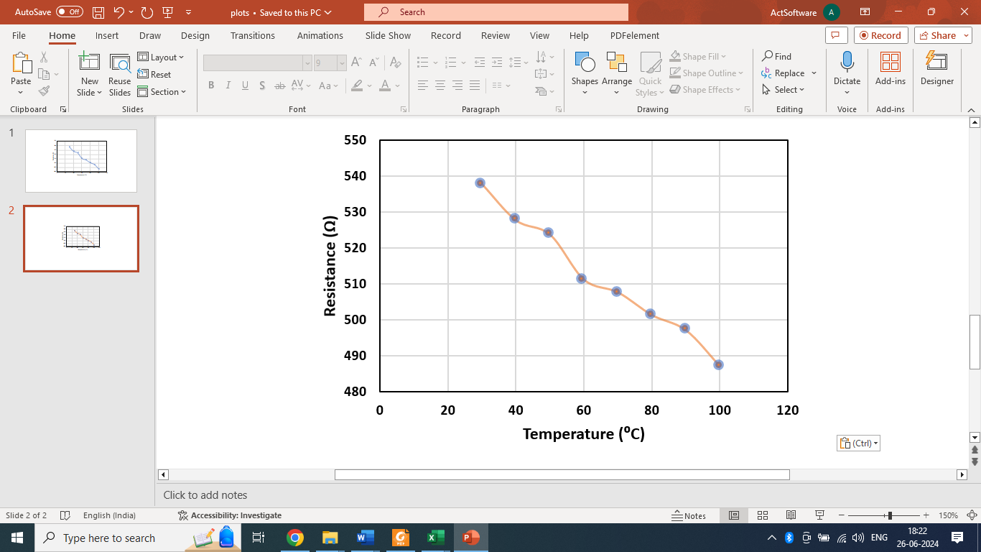
Figure 3: Variation of resistance with temperature

- TESTING UNDER HEAT LOAD

Various heat flux testing techniques are available in the literature such as the conduction technique, convention technique, and radiation technique. Radiation/LASER-based technique is a widely used and accepted technique. The details of the LASER setup used in the present study are given in Fig. 4. The LASER machine emits light which is coherent in nature and spatial coherence allows the LASER to stay focused which is a great advantage in terms of ease in testing. The monochromatic LASER of known wattage is used for testing purpose. The test is conducted for a period of 7 seconds. The obstacle plate is used to create the sudden impact of heat flux. After every 1 second, the obstacle plate is removed to get a sudden heat load for the sensor. The resistance change in the sensor is shown in Fig.5.It is observed that graphene heat flux sensor is very sensitive toward heat load.

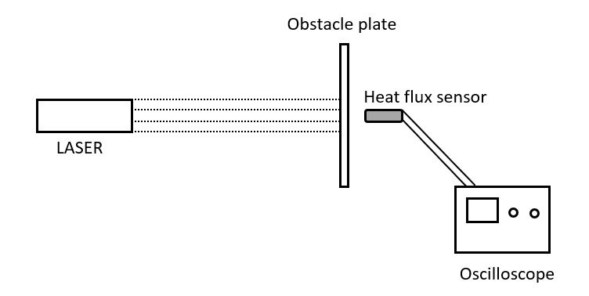
Figure 4: Heat flux testing setup

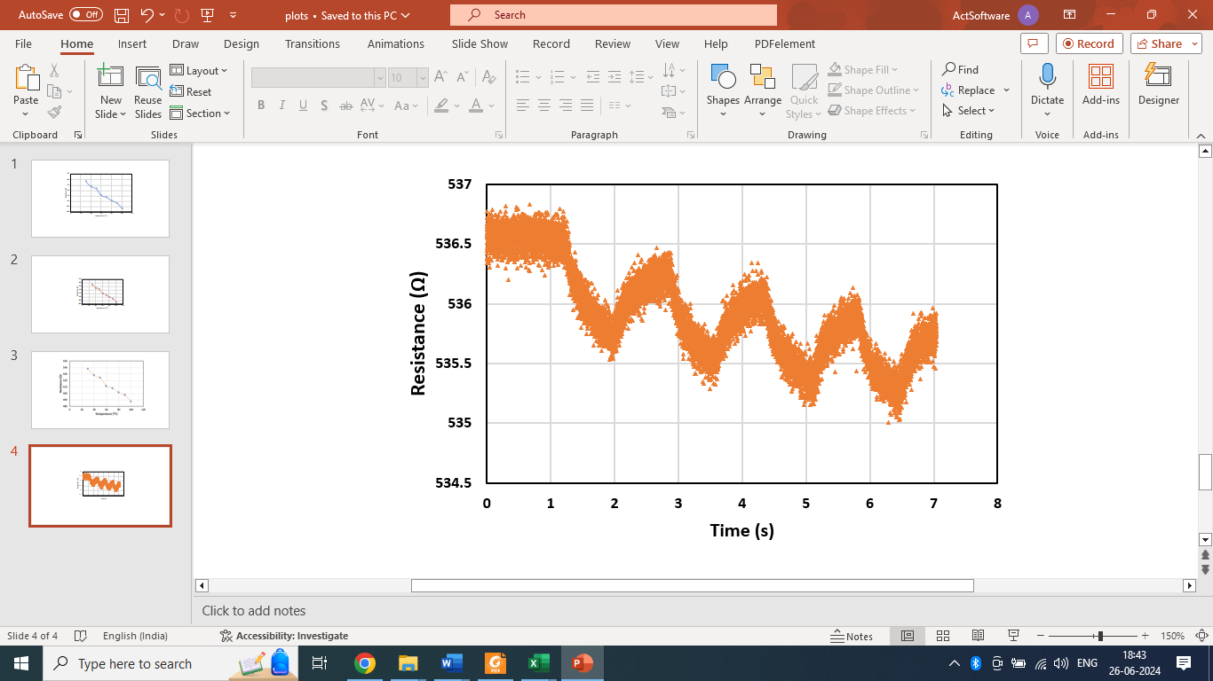
Figure 5: Variation of senor resistance under heat load

- CONCLUSIONS
Graphene based heat flux sensor is fabricated at laboratory scale. The graphene is synthesized at laboratory scale using reduction technique. The oil bath calibration technique is used to find out TCR of sensor. The important conclusions are
- The graphene is effective in sensing temperature and heat flux.
- The graphene-based heat flux showed good linear pattern between resistance and temperature.
- The TCR of graphene heat flux sensor is found to be 0.0013 /°C.
- The sensitivity of graphene heat flux sensor is found to be 0.715 Ω/°C.
- The graphene heat flux sensor showed good resistance change under the heat load conditions. Hence, it can be used for heat flux sensing applications.

- REFERENCES
[1] H. Kun, L. Bin, M. Orban, Q. Donghai, and Y. Hongbo, “Accurate Flexible Temperature Sensor Based on Laser-Induced Graphene Material,” Shock Vib., vol. 2021, 2021, doi: 10.1155/2021/9938010.
[2] V. Kedambaimoole, N. Neella, V. Gaddam, K. Rajanna, and M. M. Nayak, “Graphene-Nickel composite films on flexible PCB for temperature monitoring,” 2017 IEEE 12th Int. Conf. Nano/Micro Eng. Mol. Syst. NEMS 2017, no. August 2018, pp. 173–176, 2017, doi: 10.1109/NEMS.2017.8016999.
[3] J. Yang et al., “Wearable temperature sensor based on graphene nanowalls,” RSC Adv., vol. 5, no. 32, pp. 25609–25615, 2015, doi: 10.1039/c5ra00871a.
[4] G. Khurana, S. Sahoo, S. K. Barik, N. Kumar, and G. L. Sharma, “Reduced Graphene Oxide as an Ex-cellent Temperature Sensor,” J Nanosci Nanotechnol, vol. 2, no. 1, p. 101, 2018, [Online]. Available: www.scholarena.com
[5] M. Soni, M. Bhattacharjee, M. Ntagios, and R. Dahiya, “Printed Temperature Sensor Based on PEDOT: PSS-Graphene Oxide Composite,” IEEE Sens. J., vol. 20, no. 14, pp. 7525–7531, 2020, doi: 10.1109/JSEN.2020.2969667.
[6] N. Neella, V. Gaddam, K. Rajanna, and M. M. Nayak, “Negative temperature coefficient behavior of graphene-silver nanocomposite films for temperature sensor applications,” 2016 IEEE 11th Annu. Int. Conf. Nano/Micro Eng. Mol. Syst. NEMS 2016, pp. 329–332, 2016, doi: 10.1109/NEMS.2016.7758260.
[7] S. K. P. Parikshit Sahatiya, “Graphene-based wearable temperature sensor and infrared photodetector on a flexible polyimide substrate,” Flex. Print. Electron., 2016.
[8] R. Ghosh, A. Singh, S. Santra, S. K. Ray, A. Chandra, and P. K. Guha, “Highly sensitive large-area multi-layered graphene-based flexible ammonia sensor,” Sensors Actuators, B Chem., vol. 205, pp. 67–73, 2014, doi: 10.1016/j.snb.2014.08.044.
[9] P. K. Basu et al., “Graphene based E. coli sensor on flexible acetate sheet,” Sensors Actuators, B Chem., vol. 190, pp. 342–347, 2014, doi: 10.1016/j.snb.2013.08.080.
[10] V. Kedambaimoole et al., “Reduced Graphene Oxide Tattoo as Wearable Proximity Sensor,” Adv. Electron. Mater., vol. 7, no. 4, pp. 1–9, 2021, doi: 10.1002/aelm.202001214.

