**SOIL STRUCTURE INTERACTION OF FRAMED STRUCTURE SUPPORTED ON DIFFERENT TYPES OF FOUNDATION**

Navin Subhashchandji Kothari1, Prof. Vishal M. Sapate2

P.G. Student, Department of Civil Engineering, G. H. Raisoni University, Amravati, Maharashtra, India1

Assistant Professor, Department of Civil Engineering, G. H. Raisoni University, Amravati, Maharashtra, India2

**Abstract**: The understanding of the seismic performance of superstructure considering the complex dynamic interaction between superstructure. The Multi-storied building R.C.C.(G+5, G+10 &G +15 stories) for different footing, pile and raft foundation resting on the medium soil are analyzed for with the seismic load with IS 1893:2002 and comparing the dynamic responses in soil. The Complete Analysis is done on ETABS Software. Based on the analysis results, it has been concluded that the effect of soil-structure interaction plays a significant role to increase the time period, bending moment in X-X direction, bending moment in Y-Y direction, lateral displacement. As the flexibility of the soil increases the bending moment also increases. The study shows that, the SSI will affect the behavior of the structure, the structure-foundation-soil mass shows an effective approach.

**Keywords**: Soil-Structure Interaction (SSI), seismic analysis, finite element method (FEM), discrete support model

**INTRODUCTION**

ETABS is an engineering software product that caters to multi-story building analysis and design. Modelling tools and templates, code-based load prescriptions, analysis methods and solution techniques, all coordinate with the grid-like geometry unique to this class of structure. Basic or advanced systems under static or dynamic conditions may be evaluated using ETABS. For a sophisticated assessment of seismic performance, modal and direct-integration time-history analyses may couple with P-Delta and Large Displacement effects. Nonlinear links and concentrated PMM or fiber hinges may capture material nonlinearity under monotonic or hysteretic behavior. Intuitive and integrated features make applications of any complexity practical to implement. Interoperability with a series of design and documentation platforms makes ETABS a coordinated and productive tool for designs which range from simple 2D frames to elaborate modern high-rise.

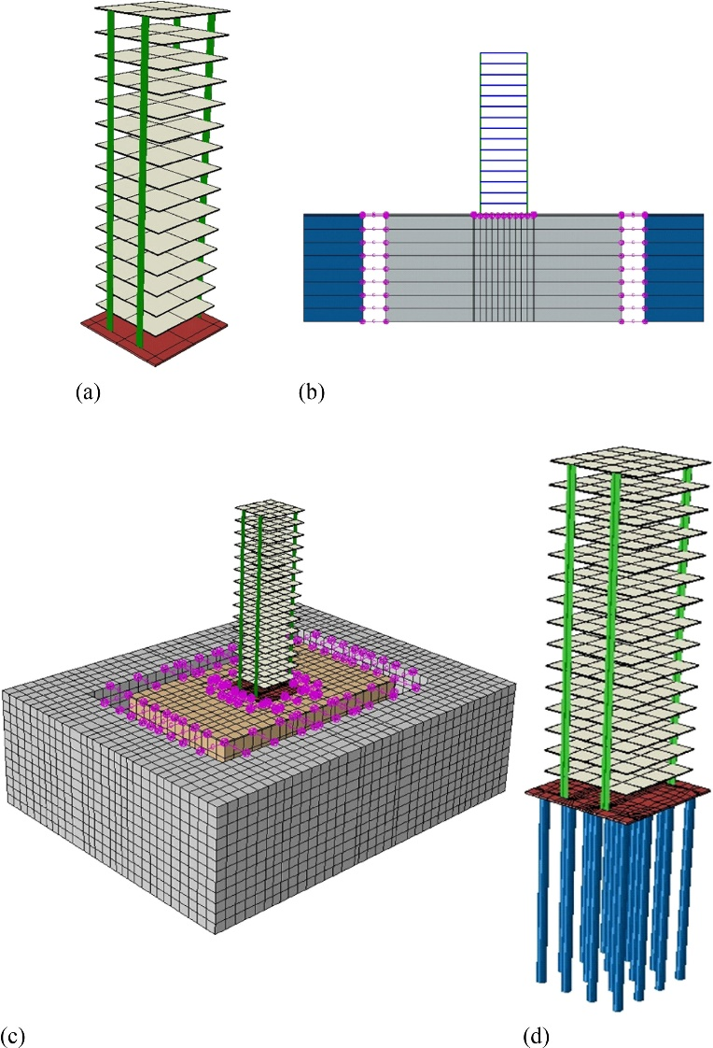

Figure 1: Types of Foundation

**METHODOLOGY**

A symmetrical building with ground plus five, ten, and fifteen floors, each with plan dimensions of 10.5m x 10.5m, was analyzed and designed using ETABS software. The analysis included the consideration of different foundation types: isolated footing, pile foundation, and raft foundation.

**Codes Used for Analysis and Design**

The following Indian Standards were utilized for the structural analysis and design of the building:

1. **IS 1893:2002** - Earthquake Resistant Design of Structures
2. **IS 456:2000** - Plain and Reinforced Concrete Structures
3. **IS 875** - Loading Standards:
   * Part 1: Dead Loads
   * Part 2: Imposed Loads
   * Part 3: Wind Loads

These codes provided the necessary guidelines and criteria to ensure the structural integrity, safety, and compliance with the relevant design standards for earthquake resistance, concrete construction, and load calculations.

Table 1: Structure Type

|  |  |
| --- | --- |
| Structure Type | Ordinary RC moment resisting frame |
| Number of storey | G+5 , G+10, G+15 |
| Typical Storey height | 3 m |
| Plinth height | 1.5 m |
| Type of building use | Commercial building |
| Seismic zone | V(Z=0.36 as per IS 1893-2002) |

Table 2: Material Properties

|  |  |
| --- | --- |
| Grade of concrete (fck) | M 25 |
| Grade of steel (fy) | Fe 500 |
| Youngs modules of concrete , Ec | 25 X 106 kN/m2 |
| Poisson ratio of reinforced concrete | 0.20 |
| Thickness of slab | 150mm |
| Specific weight of infill | 14.6 kN/m3 |

Table 3: Dead load intensities

|  |  |
| --- | --- |
| Roof finishes | 2.0 kN/m2 (as per IS 875-1987 part 1) |
| Floor finishes | 0.5 kN/m2 |

Table 4: Live load intensities

|  |  |
| --- | --- |
| Roof | 2 kN/m2 (as per IS 875-1987 part 2) |
| Floor | 1.5 kN/m2 |

3.2.1 Details of Soil Parameters Considered

The soil-flexibility effects on frame building resting on different types of soils, viz, hard, medium, soft is also trying to be studied in the present work. The valve of the spring’s stiffness of the varieties of soil, the shear modulus (G) is estimated to use the following expression.

G = Vs²xρ

Table 5: Details of soil parameters considered

|  |  |  |  |  |
| --- | --- | --- | --- | --- |
| Type of soil | N value considered | Mass density  ρ (kN/m3) | Shear wave velocity (m/sec) | Poisson ratio  (ν) |
| Hard | 40 | 21 | 111.2697 | 0.25 |
| Medium | 20 | 18.5 | 84.3349 | 0.33 |
| Soft | 09 | 17 | 54.5978 | 0.48 |

1. **Shear Wave Velocity (VsV_sVs​)**: This parameter represents the speed at which shear waves propagate through the soil. It is a measure of the soil's stiffness, with higher velocities indicating stiffer soils and lower velocities indicating softer soils.
2. **Mass Density (ρ\rhoρ)**: This parameter denotes the density of the soil, which influences its overall stiffness and ability to support structural loads. It is measured in units of kilonewtons per cubic meter (kN/m³).
3. **Poisson Ratio (ν\nuν)**: The Poisson ratio of the soil indicates its ability to deform in response to applied loads. It relates the lateral strain to the axial strain and provides insights into the soil's behavior under stress.

**Importance in Structural Analysis**

Understanding the shear modulus (G) of different soil types is crucial in structural analysis for several reasons:

* **Foundation Design**: The stiffness of the soil affects the design of foundations. Softer soils may require deeper or wider foundations to support the same load as compared to stiffer soils.
* **Seismic Analysis**: Shear modulus influences how soil responds to seismic waves. Stiffer soils can transmit seismic forces differently than softer soils, impacting building stability during earthquakes.
* **Settlement Analysis**: Soil stiffness affects how much settlement a building may experience over time. Stiffer soils typically result in less settlement compared to softer soils under the same loads.

By quantifying these soil parameters, engineers can accurately model and predict the behavior of structures resting on different types of soils, ensuring safe and efficient design practices in civil engineering projects.

**RESULT AND DISCUSSION**

This study aims to investigate the impact of Soil-Structure Interaction (SSI) on the dynamic characteristics of building frames supported by isolated footings, raft foundations, and pile foundations. The findings lead to several key conclusions:

1. **Pile Foundation with SSI:**
   * Incorporating SSI in RC frame structures with pile foundations results in an increase in the building's natural period and greater structural flexibility. Additionally, the frequency decreases under these conditions.
2. **Raft Foundation with SSI:**
   * For structures supported by raft foundations, the natural period decreases when considering SSI, particularly in areas with medium to soft soil conditions.
3. **Displacement Effects:**
   * In RC frame structures with pile foundations and SSI, displacements above ground level are more pronounced, while below ground level displacements are minimal.
   * Raft foundations with SSI exhibit minimal displacements overall. Without considering soil layer effects, maximum displacements occur above ground level, but they remain within permissible limits set by IS 1893-2002 Part I.
4. **Feasibility of Structural Enhancements:**
   * The study suggests that improving the stiffness of structural elements through infills or bracings can effectively mitigate displacements, ensuring compliance with seismic design standards.
5. The comparison between vertical of building supported by pile, raft & footing foundation with and without soil structure interaction.
6. Time period: For the Structure of Pile, raft & footing foundation model with and without soil structure interaction models time period in sec for G+5

Table 6: Time Period for the G+5 building

|  |  |  |  |
| --- | --- | --- | --- |
| Mode No’s | Pile | Raft | Footing |
| 1 | 0.71254 | 0.697265 | 0.642814 |
| 2 | 0.4042 | 0.403997 | 0.3638 |
| 3 | 0.39979 | 0.389005 | 0.36089 |
| 4 | 0.20046 | 0.201187 | 0.180341 |
| 5 | 0.13875 | 0.136412 | 0.125109 |
| 6 | 0.12865 | 0.129284 | 0.115722 |
| 7 | 0.127131 | 0.127972 | 0.114334 |
| 8 | 0.085936 | 0.080506 | 0.077885 |
| 9 | 0.082447 | 0.078662 | 0.074581 |
| 10 | 0.07914 | 0.067227 | 0.072417 |
| 11 | 0.078903 | 0.066392 | 0.072264 |
| 12 | 0.067097 | 0.052915 | 0.061806 |

Figure 2: Time Period for the G+5 building

Time period: For the Structure of Pile, raft & footing foundation model with and without soil structure interaction models time period in sec for G+10.

Table 7: Time period of G+10 building

|  |  |  |  |
| --- | --- | --- | --- |
| Mode No’s | Pile | Raft | Footing |
| 1 | 1.154432 | 1.258663 | 1.028566 |
| 2 | 0.356193 | 0.416646 | 0.314528 |
| 3 | 0.343799 | 0.39509 | 0.30429 |
| 4 | 0.189451 | 0.211855 | 0.168266 |
| 5 | 0.157322 | 0.163065 | 0.141016 |
| 6 | 0.129431 | 0.140021 | 0.115429 |
| 7 | 0.12337 | 0.139844 | 0.109386 |
| 8 | 0.089241 | 0.099421 | 0.079299 |
| 9 | 0.078835 | 0.08855 | 0.06998 |
| 10 | 0.068761 | 0.078139 | 0.060947 |
| 11 | 0.0598 | 0.064695 | 0.053331 |
| 12 | 0.055515 | 0.057464 | 0.049769 |

Figure 3: Time period of G+10 building

Time period: For the Structure of Pile, raft & footing foundation model with and without soil structure interaction models time period in sec for G+15.

Table 7: Time period of G+15 building

|  |  |  |  |
| --- | --- | --- | --- |
| Mode No’s | Pile | Raft | Footing |
| 1 | 1.269875 | 1.384529 | 1.131422 |
| 2 | 0.391812 | 0.458311 | 0.345981 |
| 3 | 0.378179 | 0.434599 | 0.334719 |
| 4 | 0.208396 | 0.233041 | 0.185092 |
| 5 | 0.173054 | 0.179372 | 0.155117 |
| 6 | 0.142374 | 0.154023 | 0.126972 |
| 7 | 0.135707 | 0.153828 | 0.120324 |
| 8 | 0.098165 | 0.109363 | 0.087229 |
| 9 | 0.086719 | 0.097405 | 0.076978 |
| 10 | 0.075637 | 0.085953 | 0.067042 |
| 11 | 0.06578 | 0.071165 | 0.058664 |
| 12 | 0.061067 | 0.06321 | 0.054745 |

Figure 4: Time period of G+15 building

The comparison between vertical of building supported by pile, raft & footing foundation with and without soil structure interaction for deflection

Table 7: deflection of G+5 building

|  |  |  |  |
| --- | --- | --- | --- |
| No of storeys | Pile | Raft | Footing |
| 1 | 0.02038 | 0.51747 | 0.620964 |
| 2 | 0.91485 | 1.65899 | 1.990788 |
| 3 | 1.94455 | 2.67829 | 3.213948 |
| 4 | 2.88252 | 3.60549 | 4.326588 |
| 5 | 3.80138 | 4.53749 | 5.444988 |

Figure 5: deflection of G+5 building

The table and graphs presents the natural periods (in seconds) of a G+5, G+10 and G+15 building modeled with different foundation types: pile, raft, and footing, both with and without considering soil-structure interaction (SSI). Each mode number corresponds to a specific vibration mode of the structure. For the pile foundation model, including SSI generally results in longer natural periods compared to the model without SSI, indicating greater structural flexibility. Conversely, the raft foundation model shows slightly shorter natural periods with SSI, especially in areas with medium to soft soil conditions. Footing foundations exhibit the shortest natural periods overall, reflecting their rigid support characteristics. These findings underscore how SSI influences the dynamic behavior of buildings, impacting their seismic response and structural design considerations.

**CONCLUSIONS**

The analysis of natural periods for the G+10 building with different foundation types and consideration of soil-structure interaction (SSI) reveals several significant conclusions. Pile foundations generally exhibit increased natural periods when SSI is considered, indicating greater structural flexibility and damping effects compared to models without SSI. In contrast, raft foundations tend to show slightly reduced natural periods with SSI, particularly in areas with softer soil conditions, highlighting the influence of soil characteristics on foundation response. Footing foundations consistently demonstrate the shortest natural periods, reflecting their stiffer support conditions. These findings underscore the importance of accounting for SSI in seismic analysis and design to accurately predict and enhance the structural response and performance of buildings under dynamic loading conditions. Such considerations are crucial for optimizing structural designs to meet safety and performance criteria in earthquake-prone regions.

**REFERENCES**

[1] Suman , Dr. Sunilkumar , Tengali[Study on torsional effects of irregular buildings under seismic loads](https://scholar.google.co.in/citations?view_op=view_citation&hl=en&user=vIuH1WcAAAAJ&citation_for_view=vIuH1WcAAAAJ:2osOgNQ5qMEC) International Journal of Applied Engineering Research

[2] Niteshkumar. S , , DR. Vijaya GS . Bhattacharya. K, and Dutta, S.C and Rana Roy, “Seismic Design Aids for Buildings incorporating Soil-flexibility”, Journal of Asian Architecture and Building Engineering, November 2006, pp 341-348.

[3].Umadevi R Byresh A Ravikumar C M, Babu Narayan K, Sujith B and VenkatReddy “Effect of Irregular Configurations on Seismic Vulnerability of RC Buildings”, Department of Civil Engineering, National Institute of Technology, Surathkal.

[4]. Bhattacharya. K, and Dutta, S.C, “Assessing lateral period of building frames incorporating Soil-flexibility”, Journal of Sound and Vibration, Dec-2004, pp 795-821.

[5] Parmalee R.A. and J.H.Wronkiewicz, “Seismic design of soil structure interaction systems”, Journal of Structural Div, proceedings of the American Society of Civil Engineers, ST 10, Oct1971,pp -2503-2517.

[6] H. Bolten Seed, J.Lysmer, and R.Hwang, “Soil structure interaction analysis for seismic response”, Journal of geotechnical Engineering Div., GTS, May 1975, pp-439-457.

[7]. Subramanyam KG Prabhat Kumar A.D. Pandey, and Sharad Sharma "Seismic soil- structure interaction of buildings on hill slopes", Journal of Civil and Structural Engineering, 2011.

[8]. Kraus & D. Dzakic, “Soil-structure interaction effects on seismic behaviour of reinforced concrete frames”, JosipJurajStrossmayer University of Osijek, Faculty of Civil Engineering Osijek, Croatia.

[9]Jenifer Priyanka, R.M. and Anand, N. 2012. Effect of lateral force On tall buildings with different type of irregularities. In Proceedings of the INCACMA.

[10]. Dr. S. A. Halkude, Mr. M. G. Kalyanshetti and Mr. S.H. Kalyani, “Soil Structure Interaction Effect on Seismic Response of R.C. Frames with Isolated Footing”, Civil Engg. Dept. Walchand Institute of Technology, Solapur, Solapur University, India Vol. 3 Issue 1, January – 2014

[11] Dr. Vivek Garg . Agarwal. P. and Shrikhande. M. 2006, “Earthquake resistant Design of Structures’ Prentice-Hall of India Private Limited New Delhi India.

[12]. IS: 456-2000, “Code of Practice for Plain and Reinforced Concrete”, Bureau of Indian Standards, New Delhi, India.

[13]. IS: 1893(part 1): 2002, “Criteria for Earthquake Resistant Design of Structures”, part 1-General provisions and buildings, fifth revision, Bureau of Indian Standards, New Delhi, India.

[14]. Wolf, J.P, Prentice Hall, Englewood Cliffs, N.J., 1985. “Soil- Structure Interaction”

[15]. Sekhar Chandara Dutta and Rana Roy (2002), A Critical Review on Idealization and Modeling for Interaction among Soil-Foundation-Structural System. Vol.80, Computers and Structural Division Page no. 1579-1594.