**SOIL STRUCTURE INTERACTION OF FRAMED STRUCTURE SUPPORTED ON DIFFERENT TYPES OF FOUNDATION: A REVIEW**

Navin Subhashchandji Kothari1, Prof. Vishal M. Sapate2

P.G. Student, Department of Civil Engineering, G. H. Raisoni University, Amravati, Maharashtra, India1

Assistant Professor, Department of Civil Engineering, G. H. Raisoni University, Amravati, Maharashtra, India2

**Abstract**: Conventional structural design methods often neglect the effects of Soil-Structure Interaction (SSI). While this oversight may be acceptable for light structures on hard, medium, or even soft soils, it becomes problematic for heavy structures on relatively soft soils, such as clay or silt. The neglect of SSI, especially during earthquake events, can lead to significant structural vulnerabilities. Many designers do not account for the complex interaction between soil layers and the structure, which plays a critical role during seismic activities. When a structure experiences ground motion, the foundation's coupling action with the soil alters the ground's response, potentially causing overturning and modifying the motion transmitted to the structure. Incorporating SSI into structural analysis enhances the robustness of the structure. By accounting for the interaction between the soil and the structure, engineers can achieve a more accurate assessment of the structure's behavior under seismic loads. This approach typically results in an increased natural period for the structure compared to a rigidly supported counterpart, which can significantly improve the structure's resilience during earthquakes. The present work underscores the critical importance of considering SSI in structural analysis, advocating for its inclusion to ensure safer and more resilient designs, particularly for heavy structures on soft soils.

**Keywords**: Soil-Structure Interaction, SSI, structural design, soft soils, heavy structures

**Introduction**

1.1 General

Reinforced concrete (RC) is a composite material designed to enhance the tensile strength and ductility of concrete by incorporating reinforcement. Typically, this reinforcement is in the form of steel reinforcing bars (rebar), which are embedded passively in the concrete before it sets. However, modern reinforced concrete can also use other materials, such as polymers or alternative composites, either alongside rebar or on their own. The primary purpose of the reinforcement is to resist tensile stresses in specific regions of the concrete, preventing unacceptable cracking and structural failure. Additionally, reinforced concrete structures can be permanently stressed in compression through methods such as pre-tensioning and post-tensioning, particularly common in the United States, to improve their behavior under working loads.

For over three to four decades, reinforced concrete structures have successfully met increasing demands in the civil and structural engineering sectors. The widespread application of reinforced cement concrete (RCC) in both structural and architectural contexts highlights its versatility and reliability. Composite construction involves binding two heterogeneous materials together so effectively that they function as a single structural element, a phenomenon known as composite action.

In developing countries like India, most building structures are low-rise, making conventional RCC and pure sectional steel constructions both convenient and economical. However, the need for vertical growth due to limited land space and rapid population increase has led to the emergence of medium to high-rise buildings as viable solutions. These taller structures address the need for urban expansion and efficient land use, further demonstrating the adaptability and importance of reinforced concrete in modern construction.

1.2 Soil-Structure Interaction

The study of soil-structure interaction (SSI) is a crucial aspect of earthquake engineering, focusing on how structures respond to seismic forces transmitted through the soil. It is essential to understand that the structural response to an earthquake is significantly influenced by the forces generated through soil-structure interaction, which impacts the structure during seismic excitation.

SSI becomes particularly important when the interaction forces significantly affect the motion of a building's foundation compared to the free-field ground motion. Free-field ground motion refers to the seismic motion recorded on the soil surface without the influence of any structure. The structural response to an earthquake is highly dependent on the interactions between three interconnected systems:

- The structure

- The foundation

- The underlying soil

Soil-structure interaction analysis involves evaluating the combined response of these three interconnected systems to a specified ground motion. SSI can be described as the process where the soil's response influences the motion of the structure, and conversely, the structure's motion affects the soil's response. This phenomenon results in a complex interplay where the displacements of the structure and the ground are interdependent.

It is important to note that while interaction forces occur for every structure, they do not always alter the soil motion under all conditions. However, in scenarios where these forces are appreciable, they must be considered to accurately predict and mitigate the structural response to earthquakes.

In summary, SSI analysis is a method to understand and evaluate how a structure, its foundation, and the underlying soil collectively respond to seismic events. This analysis is essential for designing earthquake-resistant structures that can better withstand the forces generated by soil-structure interactions during an earthquake.

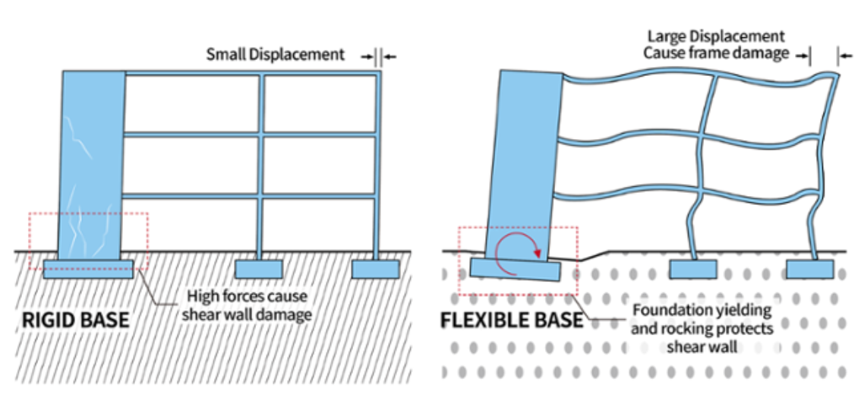

**LITERATURE REVIEW**

**Bhojegowda V T, Mr. K G Subramanya (2015):** In traditional analysis of framed structures, the base is typically assumed to be fixed, neglecting the influence of soil and foundation flexibility. This study explores the impact of different foundation types—isolated, mat, and pile—on buildings situated on various soil conditions, including soft, medium, and hard strata. It provides a comparative analysis between regular and irregular buildings, examining how these conditions affect the natural periods. The research also utilizes response spectrum analysis, offering valuable insights for seismic design.

**Suman, Dr. Sunil Kumar Tengali (2017):** Conventional structural design methods often overlook the effects of Soil Structure Interaction (SSI). This study underscores the importance of incorporating SSI in structural analysis. It examines a G+7 storeyed building with vertical irregularities in seismic zone IV, using SAP2000 software to account for different soil properties and foundation types. The study aims to determine the most suitable foundation to prevent structural failure by considering SSI effects.

**Kaushlesh Dangi, Dr. Vivek Garg (2018):** In conventional structural analysis and design, engineers typically assume a fixed base for R.C. buildings, ignoring the impact of soil structure interaction (SSI). SSI can cause non-uniform settlement of raft foundations, altering the forces and displacements in the structure-foundation-soil system. This research highlights the need to consider SSI to achieve more accurate analysis and design outcomes.

**Byresh A, Umadevi R (2016):** Soil Structure Interaction (SSI) refers to the interplay between soil response to earthquake ground motion and structural response, with each influencing the other. This study employs the finite element tool ETABS version 15 to model and analyze SSI effects. It compares parameters such as shear, modal time period, storey displacement, and storey drift under seismic conditions. Both linear static and nonlinear static analyses, including "Pushover analysis," are conducted on a G+20 storey structure. Findings indicate that the performance point for Fully Encased Composite structures is significantly superior to that of RCC models under nonlinear static analysis.

**Lavanya N. and Dr. Vijaya G.S. (2018)**

This study examined the effects of soil-structure interaction (SSI) on building structures. A total of 14 models, consisting of five- and eight-story buildings supported on isolated square and rectangular footings, were created. The analysis considered various soil types, including hard, medium, and soft soils. SSI was accounted for using point spring elements and fixed support conditions. The key findings include:

* The time period of buildings on soft soil was significantly higher compared to those on fixed supports, medium, and hard soil types.
* Story response values such as displacement, base shear, and overturning moment were consistently higher for structures on soft soil.

**Nitish Kumar S. (2016)**

This study focused on the behavior of building superstructures by modeling the nonlinearities of soil and the interface between raft foundations and soil. A time history analysis was performed to examine parameters such as base shear and roof displacement of building frames resting on raft foundations and soil media. Key conclusions from the analysis are:

* Soil-structure interaction has a significant impact on increasing the time period, bending moments in both the X-X and Y-Y directions, and lateral displacement.
* As soil flexibility increases, the bending moment also increases.

Dr. S. A. Halkude, Mr. M. G. Kalyanshetti, Mr. S. H. Kalyani, and Nitish Kumar S. (2014)

This study investigates the Soil-Structure Interaction (SSI) effects on symmetric space frames resting on isolated footings. The analysis considers two SSI models:

1. Discrete Support Model: This model replaces the soil with springs of equivalent stiffness, utilizing stiffness equations along all six degrees of freedom (DOF).
2. Elastic Continuum Model: This model considers the entire soil mass using the Finite Element Method (FEM).

The study evaluates frames with fixed and flexible bases across different configurations:

* 2 bay, 2 storey (2X2X2)
* 2 bay, 5 storey (2X2X5)
* 2 bay, 8 storey (2X2X8)

Three types of soil conditions are analyzed: hard, medium hard, and soft soil. The dynamic analysis employs the Response Spectrum method as per IS1893-2002. The findings demonstrate the effectiveness of FEM in considering the elastic continuum beneath the foundation.

Chaithra T. P. and Manogna H. N. (2015)

This study highlights the significant influence of Soil-Structure Interaction (SSI) on the seismic behavior of structures, emphasizing the combined response of the superstructure, foundation, and ground. The research focuses on a fifteen-storey reinforced concrete building with a piled raft foundation.

The seismic performance is evaluated using linear time history analysis conducted with the finite element-based software SAP 2000. Key metrics analyzed include:

* Time period
* Displacements
* Base shear
* Settlements

The study compares these results to evaluate the effect of the piled raft foundation on the building's seismic behavior, noting that SSI effects become more pronounced for heavy structures on relatively soft soils.

**CONCLUSIONS**

• Effectiveness of Soil-Structure Interaction (SSI) Models:

* The studies underscore the critical importance of incorporating SSI in seismic analysis of structures. Both the discrete support model (replacing soil with springs of equivalent stiffness) and the elastic continuum model (considering the whole soil mass using FEM) have shown to be effective approaches. Particularly, the Finite Element Method (FEM) has proven to be an effective method for accurately modeling the elastic continuum below foundations.

• Significance of Soil Conditions:

* The analysis reveals that the type of soil (hard, medium hard, and soft) significantly influences the seismic response of structures. Structures resting on softer soils exhibit more pronounced SSI effects, highlighting the necessity of considering soil flexibility in design and analysis.

• Influence of Structural Configuration:

* Different structural configurations (e.g., 2 bay 2 storey, 2 bay 5 storey, 2 bay 8 storey) exhibit varying responses to seismic forces when SSI is considered. This indicates that the height and complexity of the structure play a vital role in its seismic behavior.

• Importance of Foundation Type:

* The type of foundation, particularly the use of piled raft foundations, greatly affects the seismic performance of high-rise buildings. Piled raft foundations provide better support and reduce settlements, improving the overall stability of the structure during seismic events.

• Dynamic Analysis Using Response Spectrum:

* Employing the Response Spectrum method as per IS1893-2002 for dynamic analysis is effective in evaluating the seismic performance of structures with SSI considerations. This method helps in understanding the potential impacts on time period, displacements, base shear, and settlements.

**REFERENCES**

[1] Suman , Dr. Sunilkumar , Tengali[Study on torsional effects of irregular buildings under seismic loads](https://scholar.google.co.in/citations?view_op=view_citation&hl=en&user=vIuH1WcAAAAJ&citation_for_view=vIuH1WcAAAAJ:2osOgNQ5qMEC) International Journal of Applied Engineering Research

[2] Niteshkumar. S , , DR. Vijaya GS . Bhattacharya. K, and Dutta, S.C and Rana Roy, “Seismic Design Aids for Buildings incorporating Soil-flexibility”, Journal of Asian Architecture and Building Engineering, November 2006, pp 341-348.

[3].Umadevi R Byresh A Ravikumar C M, Babu Narayan K, Sujith B and VenkatReddy “Effect of Irregular Configurations on Seismic Vulnerability of RC Buildings”, Department of Civil Engineering, National Institute of Technology, Surathkal.

[4]. Bhattacharya. K, and Dutta, S.C, “Assessing lateral period of building frames incorporating Soil-flexibility”, Journal of Sound and Vibration, Dec-2004, pp 795-821.

[5] Parmalee R.A. and J.H.Wronkiewicz, “Seismic design of soil structure interaction systems”, Journal of Structural Div, proceedings of the American Society of Civil Engineers, ST 10, Oct1971,pp -2503-2517.

[6] H. Bolten Seed, J.Lysmer, and R.Hwang, “Soil structure interaction analysis for seismic response”, Journal of geotechnical Engineering Div., GTS, May 1975, pp-439-457.

[7]. Subramanyam KG Prabhat Kumar A.D. Pandey, and Sharad Sharma "Seismic soil- structure interaction of buildings on hill slopes", Journal of Civil and Structural Engineering, 2011.

[8]. Kraus & D. Dzakic, “Soil-structure interaction effects on seismic behaviour of reinforced concrete frames”, JosipJurajStrossmayer University of Osijek, Faculty of Civil Engineering Osijek, Croatia.

[9]Jenifer Priyanka, R.M. and Anand, N. 2012. Effect of lateral force On tall buildings with different type of irregularities. In Proceedings of the INCACMA.

[10]. Dr. S. A. Halkude, Mr. M. G. Kalyanshetti and Mr. S.H. Kalyani, “Soil Structure Interaction Effect on Seismic Response of R.C. Frames with Isolated Footing”, Civil Engg. Dept. Walchand Institute of Technology, Solapur, Solapur University, India Vol. 3 Issue 1, January – 2014

[11] Dr. Vivek Garg . Agarwal. P. and Shrikhande. M. 2006, “Earthquake resistant Design of Structures’ Prentice-Hall of India Private Limited New Delhi India.

[12]. IS: 456-2000, “Code of Practice for Plain and Reinforced Concrete”, Bureau of Indian Standards, New Delhi, India.