**LOW GUAGE STEEL FRAME TECHNOLOGY AND ANALYSIS OF RESIDENTIAL STRUCTURE**

Tanmay Sanjay Raut1, Prof. Ishant Dahat2

P.G. Student, Department of Civil Engineering, G. H. Raisoni University, Amravati, Maharashtra, India1

Assistant Professor, Department of Civil Engineering, G. H. Raisoni University, Amravati, Maharashtra, India2

**Abstract**: Low gauge steel frame technology involves the use of steel framing members with a thinner thickness or gauge compared to conventional steel structures. These frames predominantly utilize cold-formed steel sections, which are shaped at room temperature using roll-forming machines. Unlike hot-rolled steel, cold-formed sections have a reduced thickness, hence the designation "low gauge." Despite their thinner profile, these steel frames maintain robust strength and durability. Cold-formed steel members are engineered to withstand typical structural loads and stresses encountered in buildings. One of the notable advantages of low gauge steel frames is their lightweight nature compared to traditional construction materials like concrete and hot-rolled steel. This characteristic facilitates easier transportation, handling, and on-site erection. The manufacturing processes for cold-formed steel ensure precise dimensions and uniform quality, contributing to quicker construction times and minimized material wastage during fabrication. Steel frames offer flexibility in architectural design, accommodating various building layouts and configurations. They are compatible with diverse cladding materials and interior finishes, making them versatile in construction applications. Additionally, steel is a recyclable material, and the production of cold-formed steel generates minimal waste compared to other construction materials, aligning with sustainable building practices.

**Keywords**: Low gauge steel frame technology, cold-formed steel sections, roll-forming machines, structural loads, lightweight construction

1. **Introduction**

The design of industrial buildings is primarily driven by functional requirements and the imperative of construction economy. These buildings vary widely in cross-sections, spanning from large single or multi-bay structures like warehouses and aircraft hangars, to smaller span structures suitable for factories, assembly plants, and maintenance facilities. While operational needs largely dictate the main dimensions, structural designers play a crucial role in optimizing spans and selecting appropriate cross-section profiles to enhance overall cost-effectiveness.

One area where structural designers exert significant influence is in determining the lengthwise dimensions, particularly the bay lengths of the building. This decision requires balancing between larger bays that require fewer, heavier main components such as columns, trusses, purlins, and crane beams, versus smaller bays that necessitate more of these elements with lower individual mass. A critical factor here is the cost of foundations, as reducing the number of columns can significantly lower foundation expenses.

In practical engineering, structural engineers are tasked with designing structures that are both cost-effective and efficient in terms of material and technical resources. Optimization methods offer substantial opportunities in structural engineering, especially in the design of single-storey industrial steel buildings, which are among the most commonly constructed skeletal framed steel structures.

Recent advancements have introduced various optimization techniques tailored to these structures. These include constrained non-linear cost optimizations for steel portal framed buildings, linear programming approaches for designing optimal pitched roof frames, and genetic algorithms for optimizing pitched roof steel frames with hunched rafters, often incorporating light gauge sections into the structure.

By leveraging these modern optimization methods, structural engineers can achieve significant cost savings, improve structural efficiency, and meet the demanding requirements of industrial building projects more effectively. This underscores the evolving role of optimization in shaping the future of structural engineering practices.

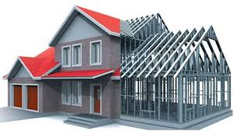

**Figure 1: General Low Guage Steel Frame Model**

1. **Methodology-**

Light gauge steel construction offers numerous advantages over traditional wood-frame structures. These include higher strength, allowing for greater spacing between members and faster construction times. Additionally, the flexibility to modify the building's shape and expand its footprint during its lifespan adds to its appeal.

The focus of this study is to evaluate the fire resistance capabilities of composite I-shaped and box-shaped thin-walled steel structures under compression, both with and without effective fire protection, when subjected to standard fire loads. The objectives of the research are as follows:

1. Conduct analytical calculations based on Eurocode 3 to assess the structural performance.
2. Perform finite-element modeling to analyze high-temperature fields for complex cross-sections.
3. Conduct fire tests based on theoretical calculations to validate the structural response under fire conditions.
4. Analyze deviations between analytical and finite element calculations and experimental results obtained from thermocouple data during fire tests.
5. Test profiles under load conditions to assess their performance.
6. Evaluate two specific cross-sections:
   * I-shaped section composed of two C-shaped profiles (380×125×30×3.5) connected with a 10 mm flange using bolt fastening.
   * Box-shaped section consisting of two Σ-shaped profiles (245×80×20×3) connected with a 1.5 mm flange using bolt fastening.
7. Test these profiles both with and without the application of specialized fire protection materials.

This comprehensive approach aims to provide empirical data and analytical insights into the fire resistance limits of these thin-walled steel structures, crucial for enhancing safety standards and informing future building practices in fire-prone environments.

**Table 1: Calculation characteristics of the composite structures**

|  |  |
| --- | --- |
| Scheme | Characteristics |
|  | *AgI* = 2 231063 462126⋅ *.* = *.* mm2 = 4621*.* cm2  *AeffI* = 2 125177 250354⋅ *.* = *.* mm2 = 2504*.* cm2  *IeffI* =143372*.* cm4    Length *l* = 3000 mm  Static load is equal *E fi,d* = 31.0 t  *AgI* = 2 129577 259154⋅ *.* = *.* mm2 = 2592*.* cm2  *AeffI* = 2 121275 242550⋅ *.* = *.* mm2 = 2426*.* cm2  *IeffI* = 288928*.* cm4  Length *l* = 3000 mm  Static load is equal *E fi,d* = 15.1 t |

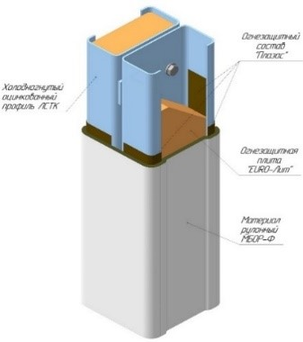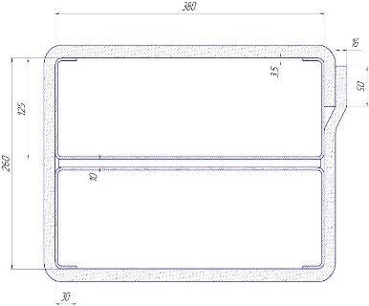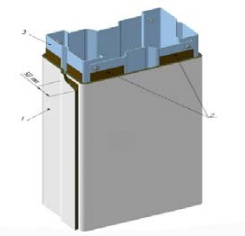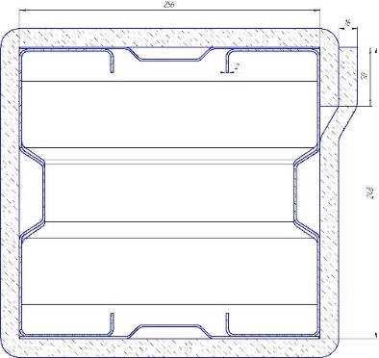

## **Figure 2: The solution of the column fire protection produced by TIZOL JSC and the calculation scheme of the composite section**

## **Modelling-**

The structural analysis of a steel rod construction was performed using finite element methods, employing a spatial model as depicted in Figure 3.3. The analysis utilized the Hydra module within the SOFiSTiK software package (version 2020) to study temperature distribution across the structure's cross-section. Data input was facilitated through CADINP, SOFiSTiK's internal programming language, accessed via the Teddy text editor. Boundary conditions were set to mirror those of the experimental program, with a reference temperature of 20°C and a thermal resistance of 9.000 W/K/m².

The computational grid employed quadrangular elements, with varying cell sizes to optimize resolution. A minimum grid resolution of 0.01 m was maintained, ensuring accuracy, particularly in regions of material changes and model boundaries. The study considered two models for sections lacking fire protection: one with an air gap and one without, exploring their respective impacts on thermal behavior.

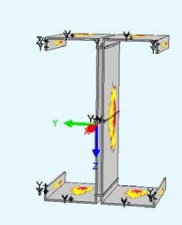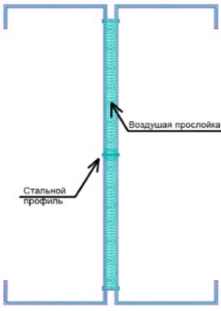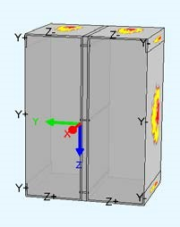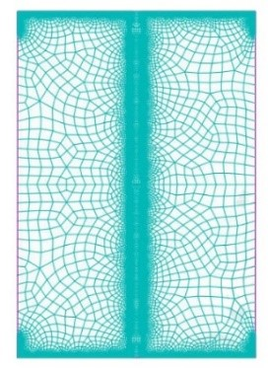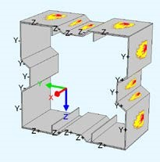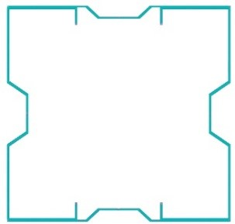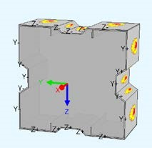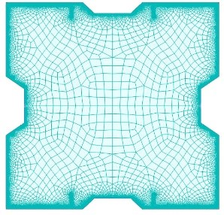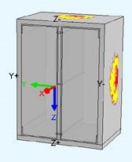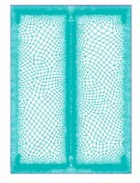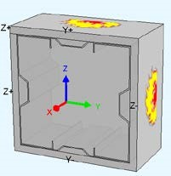

**Figure 3: Calculated finite element models**

The structural properties and geometric dimensions of the structures are defined based on actual material properties and overall dimensions of the samples. The thermal characteristics of the materials are explicitly outlined in the design model, including parameters such as Thermal Conductivity and Heat Capacity of steel, detailed in Figure . The numerical relationships governing fire protection are expressed through equations , illustrating dependencies crucial for ensuring structural safety and resilience under fire conditions.

1. **Results and Discussion-**

The following figures illustrate comparisons between traditional steel and light gauge steel (LGS) in structural applications. These comparisons are crucial for evaluating the performance, properties, and suitability of each material in various engineering contexts. The figures include analyses of beam characteristics, percentage differences in properties between steel and LGS, variations within the LGS category, and broader comparisons between steel types. Understanding these comparisons helps in making informed decisions regarding material selection for different structural requirements.

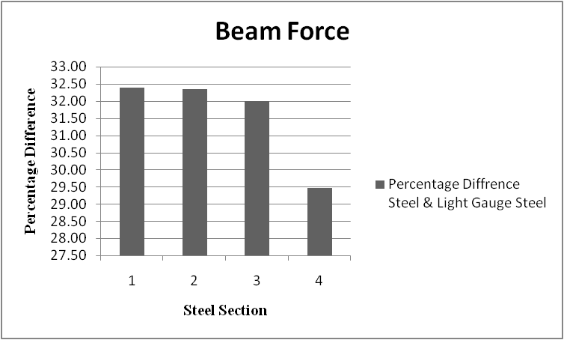

**Figure 4: Comprasion of Beam**

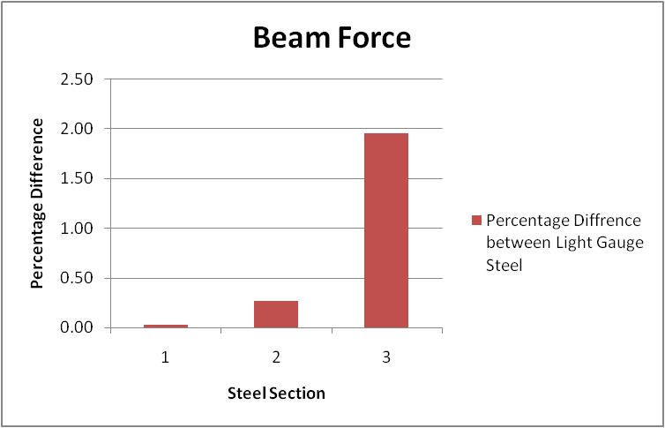

**Figure 5: Percentage Difference Between Steel & Light Guage Steel**

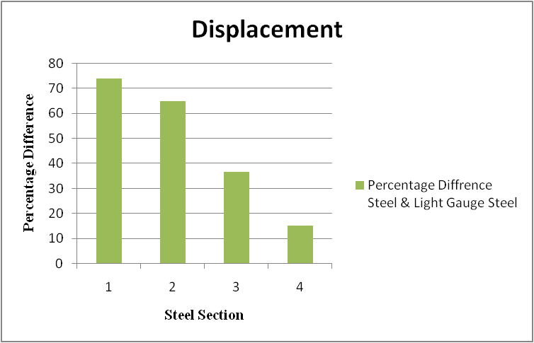

**Figure 6: Percentage Difference Between Light Guage Steel**

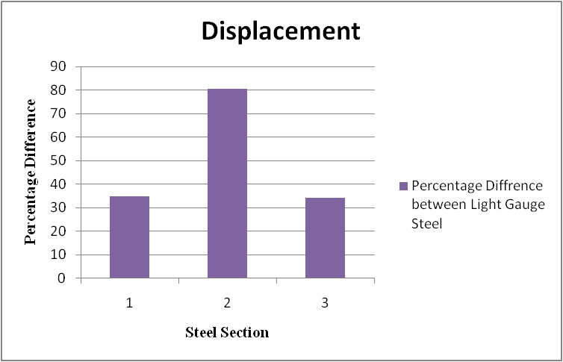

**Figure 7: Percentage Difference Steel & Light Guage Steel**

These figures collectively contribute to understanding the relative strengths, weaknesses, and applications of both traditional steel and light gauge steel in structural engineering. They provide visual insights into how these materials perform under different conditions, aiding engineers and designers in making informed choices for optimal structural solutions.

1. **Conclusions**

The conclusions drawn from the study emphasize several advantages and characteristics of using Light Gauge Steel Framing (LGSF) in construction:

1. Lightweight and Rapid Construction:
   * LGSF is lightweight compared to traditional steel and concrete structures. This characteristic facilitates rapid construction, reducing both material consumption and construction time. It also contributes to lower costs associated with structural steel and foundation requirements.
2. Cost Efficiency:
   * Lower gauge steel, being thinner and lighter than higher gauges, helps reduce material costs and transportation expenses. This cost-effectiveness extends to savings in labor costs due to easier handling during construction.
3. Design Flexibility:
   * Thinner steel used in LGSF allows for greater flexibility in design and architectural creativity. This flexibility enables architects and designers to create more intricate and innovative building designs.
4. High Strength-to-Weight Ratio:
   * Modern low gauge steels used in LGSF offer a high strength-to-weight ratio. This means that despite being lightweight, these materials provide structural integrity and strength, ensuring robustness in building construction.
5. Environmental Impact:
   * Using less steel per structure reduces the environmental impact associated with resource extraction and transportation emissions. This aligns with sustainable building practices aimed at minimizing carbon footprints and promoting eco-friendly construction.

**REFERENCES-**

1) “Structure, energy and cost efficiency evaluation of three different lightweight construction systems used in low-rise residential buildings”-Sareh Naji a, Oguz Cem C ˘¸ elik b, U. Johnson Alengarama, Mohd Zamin Jumaat a, Shahaboddin Shamshirband (2014)

2) "Light Gauge Steel Building System” - United States Patent (19)” by Sheppard, Jr. et al. (1986)

3) Structural Capacity of Light Gauge Steel Storage Rack Uprights” by Damien Koen (2008)

4) “Seismic Design of Light Gauge Steel Structures: a Discussion” by Reynaud, Serrett (1998)

5) "High-Rise Building System Using Light Gauge Steel Wall Panels -United States Patent (19)” by De Quesada (1996)

6) “STUDY OF VARIOUS DESIGN METHODS FOR COLD – FORMED LIGHT GAUGE STEEL SECTIONS FOR COMPRESIVE STRENGTH”- S.A.Kakade1, B.A.Bhandarkar2, S.K. Sonar3, A.D.Samare4

7) “THE STUDY OF LIGHT GAUGE STEEL FOR HIGH-RISE BUILDINGS AND BUSINESS CENTERS”-Alhalabi Zinah Shuman

8) “A General Study of Light Gauge Steel Building Case Study To cite this article”: V Venkatesan and R Ganesan 2021

9) “A General Study of Light Gauge Steel Structures – A Review” S. Vigneshkannan1, J.Abdul Bari2, P.Easwaran3

10) “Development of Lightweight Steel Framed Construction Systems for Nearly Zero Energy Buildings”- Marija Jelˇ ci´ c Rukavina 1, Davor Skeji´ c 2, *Anton Kralj 2, Tomislav Šˇ capec 1 and Bojan Milovanovi´ c 1