**STREET FOOD ORDERING SYSTEM**

**Sudhanva S1, Rohan Raj B G2, Sree Basava R3,Keerthana H R4**

1Student, Department Of BCA, BMS College Of Commerce And Management, Bengaluru, Karnataka, India

2Student, Department Of BCA, BMS College Of Commerce And Management, Bengaluru, Karnataka, India

3Student, Department Of BCA, BMS College Of Commerce And Management, Bengaluru, Karnataka, India

4Assistant Professor, Department Of BCA, BMS College Of Commerce And Management, Bengaluru, Karanataka, India

**ABSTRACT**

A proof of concept for small restaurants and street food vendors is called Street Bites. One of the unexplored areas of the food sector that is not covered by Web 3.0 is small restaurants and street food sellers. No company has made an effort to enter this market. Our website will serve the demands of foodies who enjoy purchasing street food to be delivered right to their home. With its cutting-edge web platform designed specifically for street food vendors and discriminating foodies alike, Street Bite is leading the charge to transform the street food scene. This platform will function as a vibrant marketplace that easily connects street food merchants with one another.While this platform's initial proof of concept focuses on linking small restaurants and street food vendors, it can also serve small vegetable shops, roadside vegetable vendors, small grocery stores, small car repair shops, medical shops, and other businesses.

**Keywords:** Web Development,HTML,CSS,Java Script,PHP,Online Street Food Ordering System

1. **INTRODUCTION**

The introduction should be typed in Times New with font size 10. In this section highlight the importance of topic, making general statements about the topic and Presenting an overview on current research on the subject. The simplest way is to replace(copy-paste) the content with your own material. Your introduction should clearly identify the subject area of interest.

It is widely recognized throughout the world that it is quite challenging to launch a new small business in today's market and survive the competition from the established and settled proprietors. In today's hectic world, when everyone most people are picky when it comes to ordering food because they are pressed for time. Modern consumers are drawn to online ordering not only because it's incredibly easy, but also because it allows them to see the products, prices, and order process in very. The online ordering mechanism I'm putting forth here makes ordering more easier for both customers and restaurants. The system offers a user-friendly, dynamic menu that is always updated and contains all of the options.

1. **METHODOLOGY**

**2.1 Design**

The Online street Food Ordering website is designed using a client-server architecture. The client-side is responsible for reliably displaying the client interface, while the server-side manages intelligent databases and trade logic. Practicality and adaptability are enhanced by the design, which ensures a clear separation of concerns. HTML is used for structure, CSS for styling, and JavaScript for interactivity in the front conclusion outline. In order to ensure compatibility across many devices, including PCs, tablets, and smartphones, the format employs a responsive design strategy. PHP is used on the backend for server-side preparation and communication with a MySQL database, managing session administration, client verification, and client demand preparation.

**2.2 Development Preprocess**

The Spry approach was used to arrange the progression plan, placing a strong emphasis on iterative improvement, constant criticism, and flexibility in response to changes. The process was divided into several phases: Organizing involved assembling and evaluating the necessary information to define the project's objectives and scope, identifying its salient features, and creating a schedule. During the Plan phase, database structures were described for effective information capacity, and wireframes and mockups were created for the front end to visualize the client interface. Utilization was done in iterative cycles, focusing on certain highlights, and continuous integration refinements ensured that modern code was included seamlessly.

* 1. **Principles**

The project adopts Skilled principles to foster partner input that is consistent, incremental advancement cycles, and adaptability to changing requirements. The meticulous planning and scoping that included a detailed precondition analysis and a description of significant breakthroughs marked the beginning of the iterative process. In order to improve client encounter streams and optimize database patterns for efficient information recovery and control, the plan stage included iterative wireframing and prototyping.

* 1. **Development LifeCycle**

A wide range of contemporary tools and inventions encouraged the project's success over its whole improvement lifecycle. The most popular integrated development environment (IDE) is now Visual Studio Code (VS Code), which provides engineers with efficient code editing and debugging tools. Git provided strict adaption control, promoting teamwork enhancement and skillful extension administration training. Utilizing the Light (Linux, Apache, MySQL, PHP) stack strengthened backend operations; MySQL powered the efficient capacity and retrieval of fundamental commerce data, while Apache functioned as a reliable web server.

**3.MODELING AND ANALYSIS**

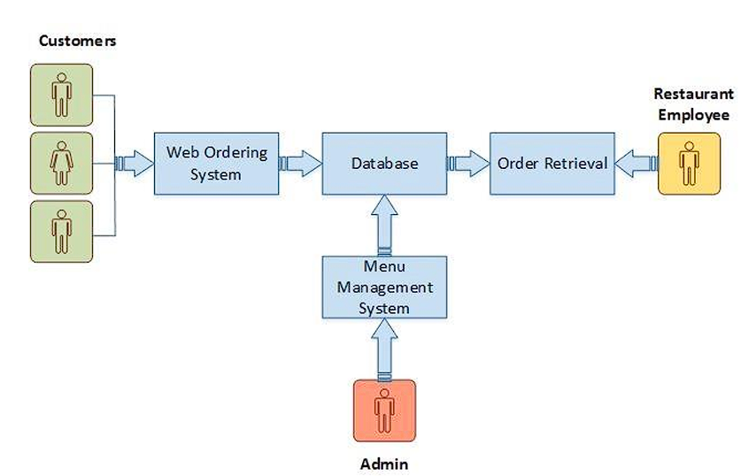

**Figure 1:Data Floe Diagram**

**4.RESULTS AND DISCUSSION**

Using HTML, CSS, JavaScript, and PHP, the food ordering website was implemented in a rigorous phase designed to satisfy the demands of sophisticated online purchasing. The user interface was painstakingly designed to ensure a natural and responsive experience across a variety of devices, satisfying users' preferences for consistent form submission and browsing. PHP handled server-side tasks effectively on the backend, including client confirmation, session management, and data manipulation using the MySQL database. The results of execution testing demonstrated acceptable response times and stack times, indicating that the system can support concurrent clients intelligently without sacrificing speed or unwavering quality.

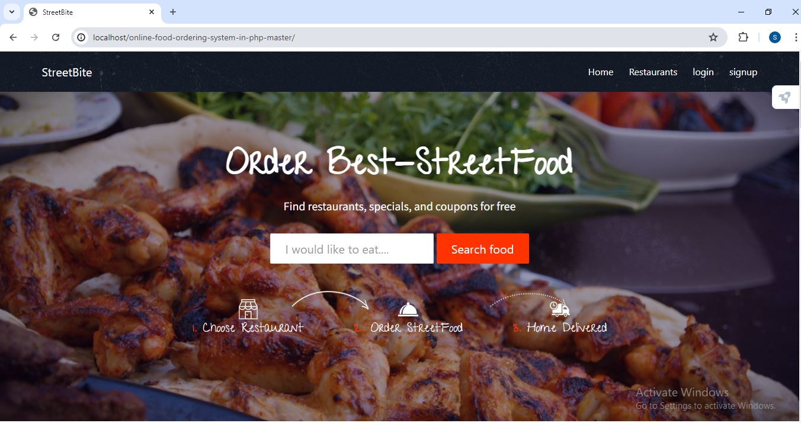

**Figure 1:** Home Page

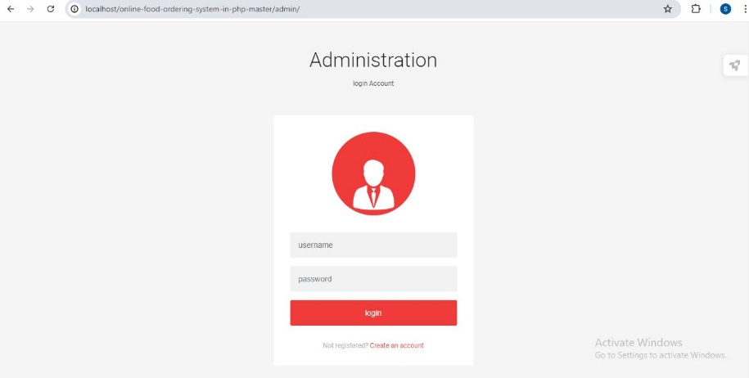

**Figure 2:** Admin Page

**5.CONCLUSION**

The creation of an online food delivery website marks a significant step forward in the digital transformation of how people order and enjoy food. This project aimed to provide a user-friendly and efficient platform that connects customers with a wide variety of local restaurants and food vendors. Throughout the development process, we focused on meeting both functional and non-functional requirements to ensure a robust, secure, and enjoyable user experience. The platform successfully incorporates essential features such as user registration, restaurant listings, detailed menus, order placement, real-time tracking, secure payment processing, and customer reviews. These elements work together to provide a seamless experience for users, making it easier than ever to explore culinary options and have meals delivered directly to their doorstep. One of the key achievements of this project is the comprehensive user management system, which allows customers to create and manage their profiles with ease. The restaurant and menu management features enable users to browse through a wide selection of eateries, complete with detailed menus and prices. Looking ahead, there are numerous opportunities for future enhancements that can further improve the platform. Geographical expansion to new regions can attract more customers and vendors, increasing the platform's reach and revenue. Developing dedicated mobile apps for iOS and Android will provide a more personalized and accessible user experience, leveraging mobile-specific features like push notifications and GPS. Implementing advanced machine learning algorithms can offer personalized recommendations, enhancing user satisfaction by suggesting dishes and restaurants based on individual preferences and order history.Integrating with voice assistants like Google Assistant, Alexa, and Siri can provide a convenient, hands-free ordering experience, catering to busy users who prefer quick and easy interaction.

**6.REFERENCES**

1. Kirti Bhandge, Tejas Shinde, Dheeraj Ingale, Neeraj Solanki, Reshma Totare,”A Proposed System for Touchpad Based Food Ordering System Using Android Application”, International Journal of Advanced Research in Computer Science
2. Khairunnisa K., Ayob J., Mohd. Helmy A. Wahab, M. Erdi Ayob, M. Izwan Ayob, M. Afif Ayob, ”The Application of Wireless Food Ordering System” MASAUM Journal of Computing 2009.Technology (IJARCST 2015).
3. Serhat Murat Alagoza, Haluk Hekimoglub,” A study on tam: analysis of customer attitudes in online food ordering system”, Elsevier Ltd. 2012.
4. Ashutosh Bhargave, Niranjan Jadhav, Apurva Joshi, Prachi Oke, S. R Lahane,“Digital Ordering System for Restaurant Using Android”, International Journal of Scientific and Research Publications 2013.
5. Resham Shinde, Priyanka Thakare, Neha Dhomne, Sushmita Sarkar, ”Design and Implementation of Digital dining in Restaurants using Android”, International Journal of Advance Research in Computer Science and Management Studies 2014.